AGUILAR, Brian A.  
2ECE-A

**PROGRAMMING ASSIGNMENT**

**PROBLEM 1**

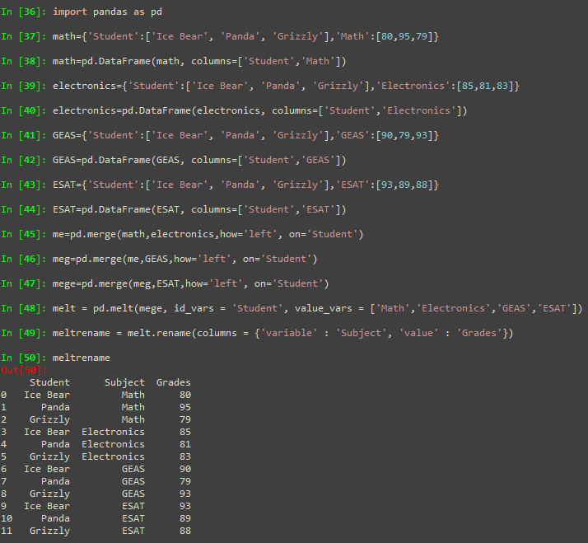

**PROBLEM 2**

