AGUILAR, BRIAN A.  
 2ECE-A

**Experiment 8: Pandas**

**Problem 1:**

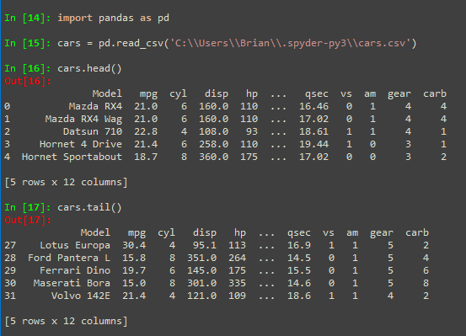

**Problem 2:**

**Problem 2:**

