AGUILAR, Brian A.

2ECE-A

**PROGRAMMING ASSIGNMENT: HANGAROO**

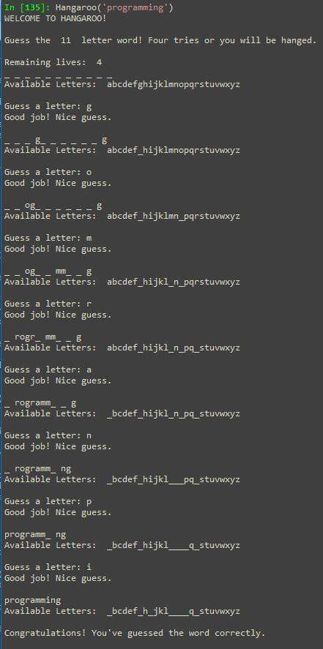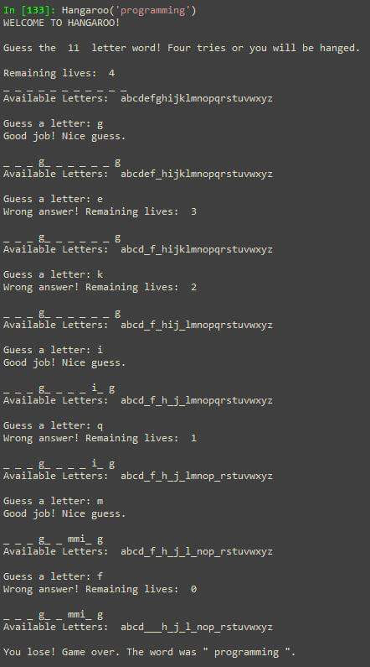

1. **Correctly guessing the word 2. Losing the game with 4 tries.**
2. 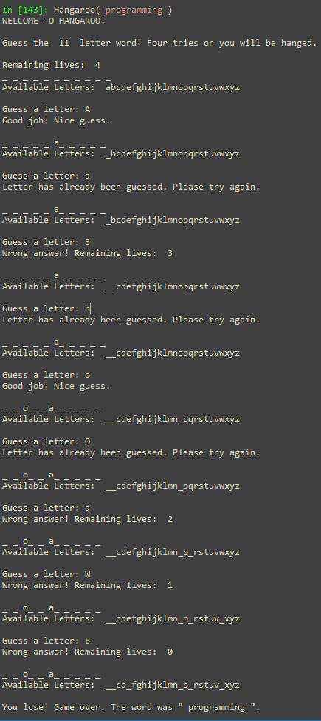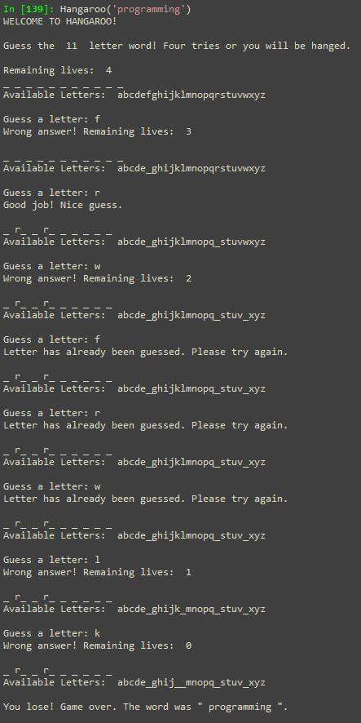**Letters that has been guessed already 4. Inputting capital letters**
3. 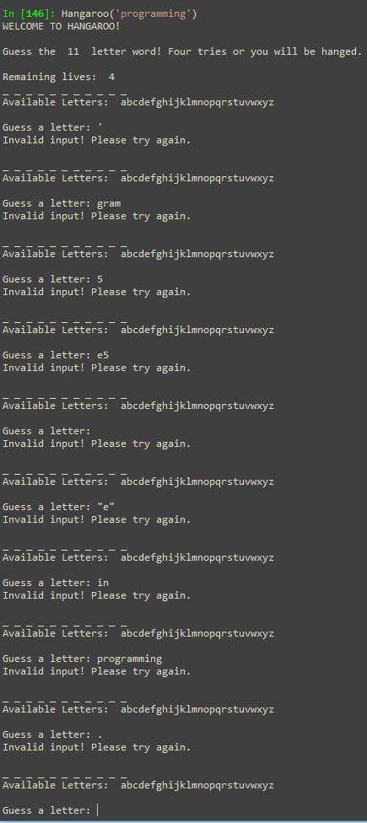**Invalid inputs**