* Name of the game: **Trivia** (for now, will think of something more creative)
* Rules
  + Goal: have the highest score possible (if playing alone), beat the other player if playing in “2 players” mode
  + Instructions:
    - Select a topic and within it a level of difficulty (the higher the points awarded, the more difficult the question)
    - The program will prompt a question,
      * if answered correctly, the number of points stated on the block will be awarded to the player
      * if answered incorrectly, no points will be given to the player
    - Once a player has answered a question, it will not be eligible again
    - Once all of the questions have been responded, the game will be over
    - In a 1 player mode, the total score will be revealed
    - In a 2 player mode, the player with the higher score wins
* Your MVP for this project
  + Upon entering the website, the player must be able to choose whether he/she wants to play a 1 player or 2 player trivia game.
  + Once the user chooses, a prompt will ask for their names and refer to the player’s by their names for the rest of the game.
    - 1 player mode:
      * player can choose from the grid (the top row of each column had a different topic, and each row within each column a different difficulty and hence different scores)
      * Once the question in answered, the correct answer will appear
      * Player can choose to go back to the main table
      * Already clicked on questions will be unavailable (and marked differently)
      * Once the game is over, the computer will announce the player scores and if on 2 player mode, the winner
* Reach Goals
  + Time limit on the 1 player mode so he can compete against himself
  + Add different categories (so far I have one category and many topics within the grid, but I would like to have many categories)
  + Add relevant animations
  + Let user pick a character/emoji that represents him throughout the game
  + Store the score in the computer for when future users play, they know who has the top scores in the game
* Foreseen challenges or obstacles
* Wireframes of your landing page and game page

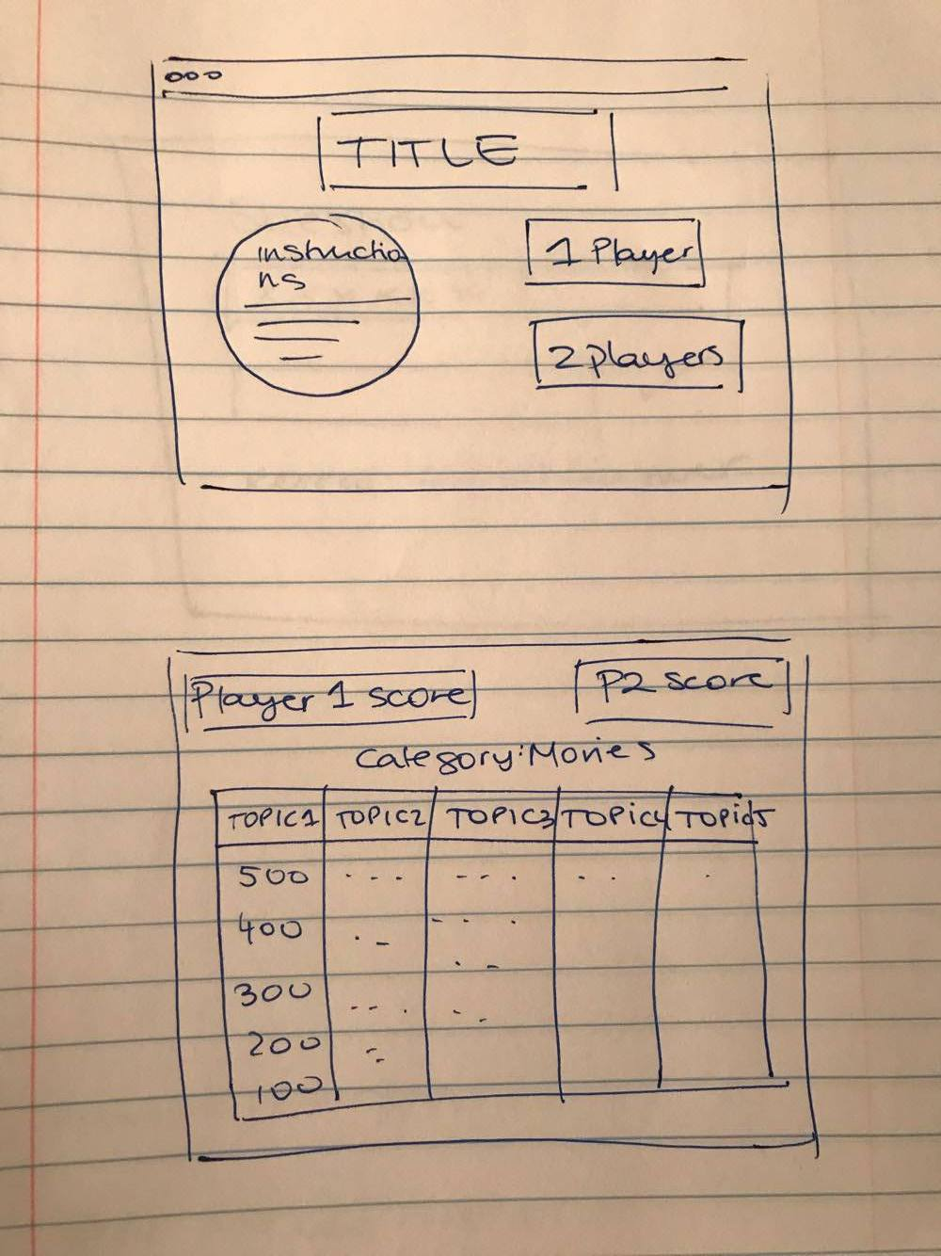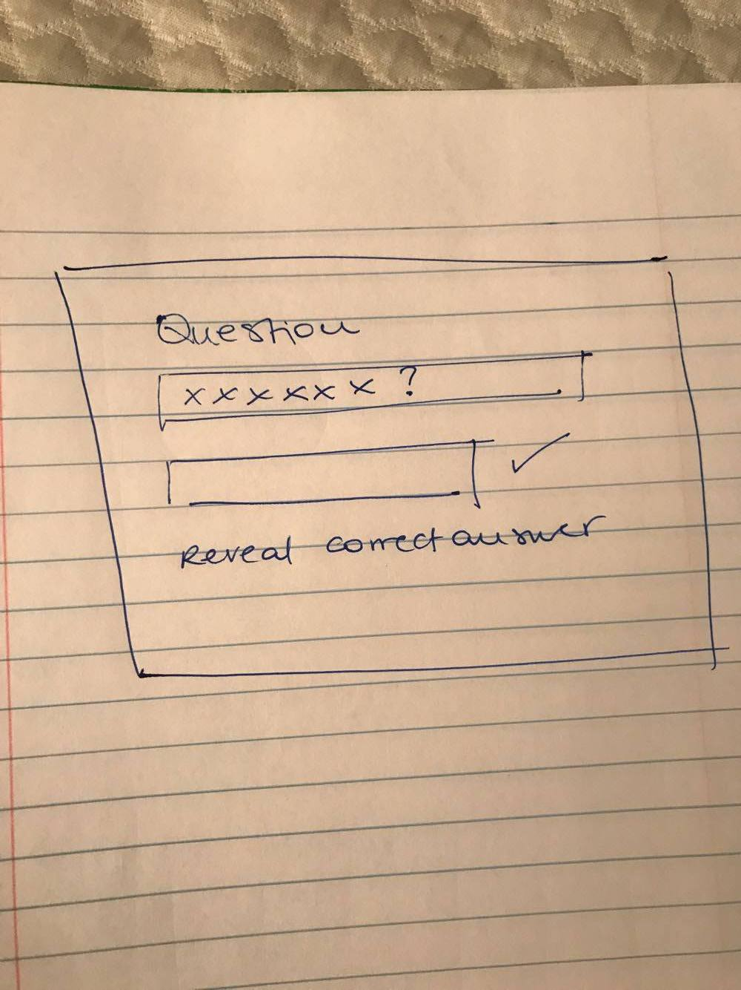

* Technology you intend to use
  + My trivia application will be built using HTML, CSS, JavaScript and jQuery.
  + I will use DOM manipulation, loops, event listeners, animations and use media queries to make my pages responsive to different devices.
* A link to your repo!
  + <https://github.com/aguirrebdaniela/WDI_project1.git>