Lab 6 – Morphological Variation -
Geometric Morphometrics

PRIOR TO LAB: Prior to lab, make sure to read this protocol and complete any pre-lab questions that are asked. You also need to download the program MorphoJ from the following site:

https://morphometrics.uk/MorphoJ_page.html

Please download the program well ahead of lab in case you have any issues. Note that MorphoJ may require you to download a particular version of Java and point you there before it installs. During lab, you will need access to D2L, including the ability to download and upload files.

LAB OBJECTIVES: In today’s lab, we will learn about the field of geometric morphometrics and how it is used to study variation in organismal form. We will continue working with the three Alaskan stickleback populations that we used in our modules on traditional morphometrics. While we only examined two variables before, now we will use a set of 16 landmarks to describe shape variation among the populations. We will start with a brief overview of geometric morphometrics, emphasizing its advantages and applications. You will learn how geometric morphometrics differs from traditional morphometrics and use a program called MorphoJ to analyze stickleback body shape data. You will also learn about common methods of multivariate data analysis like Principal Component Analysis (PCA).

The Data for today’s lab is in D2L. Got to Content/Data/Stickleback Geometric Morphometrics and download the 0_stickleback_evol_lab_data.TPS and grp_b.txt files. Note where you save them on your computer. Also, I have highlighted points that you have to answer in yellow. These will be graded.

Part A – An Introduction to Geometric Morphometrics: What is geometric morphometrics? Geometric morphometrics is the statistical study of shape variation and its covariation with other variables. It is used by scientists to study how form varies, and is broadly applied in evolutionary biology, ecology, paleontology, biomechanics, ecomorphology, anthropology, archeology, and health and medicine. Geometric morphometrics differs from traditional morphometrics in that it relies on the use of landmark data, which are collected from two dimensional digital pictures or three dimensional scans.

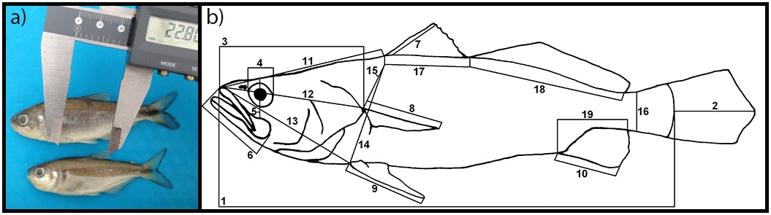
Fig. 1. Traditional morphometric methods involve the collection of linear measures along the body using calipers or related measurement instruments. Traditional morphometrics has significant limitations including issues with strong correlations among the variables, the confounding effects of body size, and difficulties with depicting the relationships among the different variables measured.
The landmarks are defined by their location on a coordinate system. For 2D geometric morphometrics, each landmark has a value on the X axis and a value on the Y axis. Because all landmarks are on the same coordinate system, they retain information on the geometric configuration of the shape of the specimens on which they are digitized.

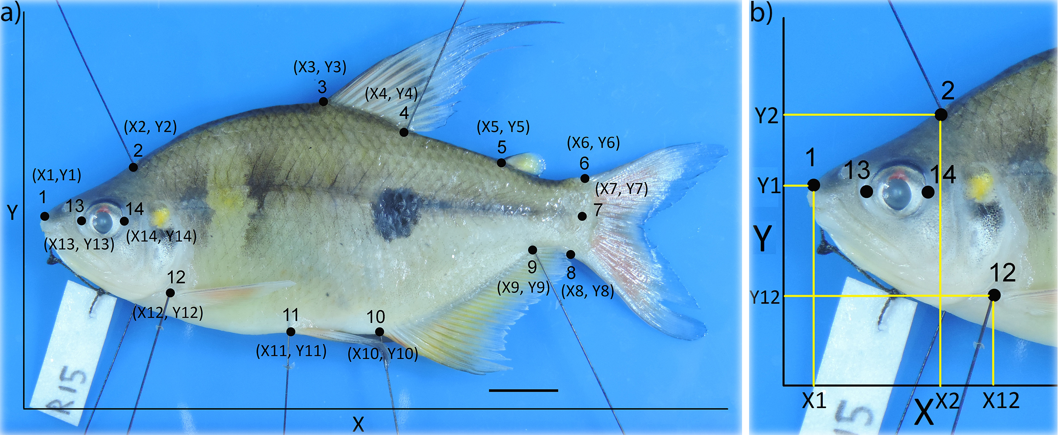
Fig. 2. Geometric Morphometrics landmark data. Digital picture of a specimen of the characid fish Rhoadsia with 14 landmarks that have been placed at different points along the body. Note that each landmark has an X and Y coordinate that define its location in this two dimensional space. The use of landmark data in geometric morphometrics allows retention of information on the geometry of the shape of the specimens on which they are digitized, allowing for analysis of shape as a whole and the creation of figures that visually depict shape differences among samples.

Because it is difficult to place specimens at exactly the same place and orientation in a picture and because specimens will differ in body size, which often affects body shape, the landmark data are aligned typically using the Procrustes superimposition method. This puts homologous landmarks of different specimens as close together as possible, without changing the relationships of the landmarks to one another within a specimen. That is, the landmark configuration of an individual specimen is rigidly rotated until the distance between homologous landmarks with a reference are as small as possible. The alignment is a mathematical procedure conducted via computer and eliminates variation among specimens in translation, rotation, and scale (body size).

Once aligned, the landmark data, or shape variables generated from them, can be used in statistical analyses of biological hypotheses using common multivariate methods like PCA, DFA, regression, etc. The landmark data also allow researchers to create graphical depictions of how shape differs among specimens, populations, or species, by showing the change in the location of the aligned landmarks. This is often done by creating transformation grids that allow interpolation of shape variation between landmarks by using a rectangular grid that is deformed in relation to the movement of the landmarks. Wireframe graphs or lollipop graphs are also often employed.

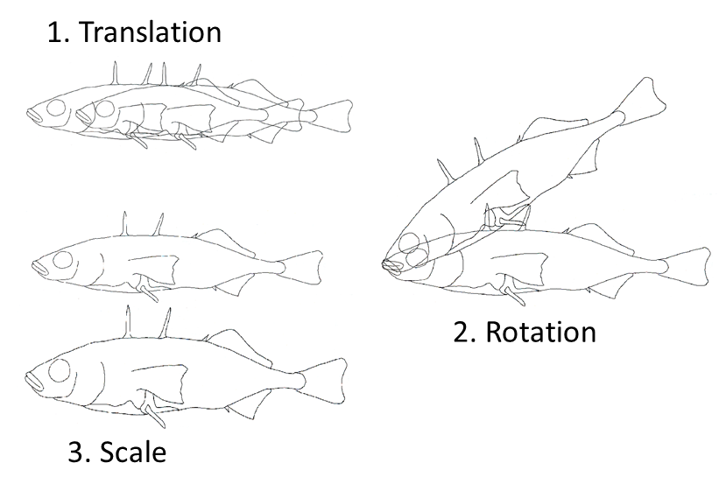
Fig. 3. Figure showing the type of variation in the landmark data that is eliminated during the alignment process. These include differences in the landmark positions that are artifacts of the location and orientation of the specimen in the picture, as well as its body size.

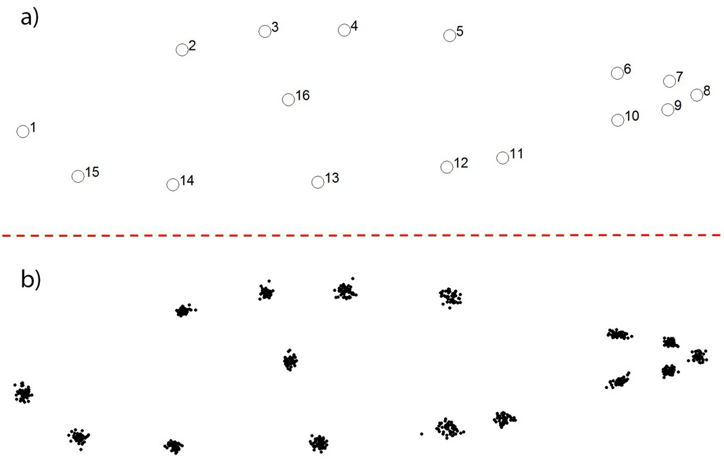

Fig. 4. Results of Procrustes alignment of landmark data. Top: consensus (average) configuration of aligned landmarks for a sample of stickleback fish. Bottom: Same aligned landmarks showing individual variation in landmark placement among specimens. Once aligned, differences in landmark position reflect differences in body shape.

The most common method of multivariate analysis is probably Principal Component Analysis (PCA). PCA is a simple ordination technique that simplifies complex data sets by creating new composite variables known as PC’s that summarize variation in the original data in a few new axes (Fig. 5). These represent the major axes of shape variation in the data and are created in such a way that PC1 represents the major axis of body shape variation in the study, PC2 represents the second most important axis of shape variation in the study that is at a right angle to the first, and so on with the remaining PC’s. PCA produces as many PC axes as there are variables in the study, but usually the first few summarize most of the variation and are the only ones interpreted. The method does not specifically seek to find dimensions that distinguish among groups of so if the groups segregate from one another in PCA plots, this indicates significant shape variation among groups.
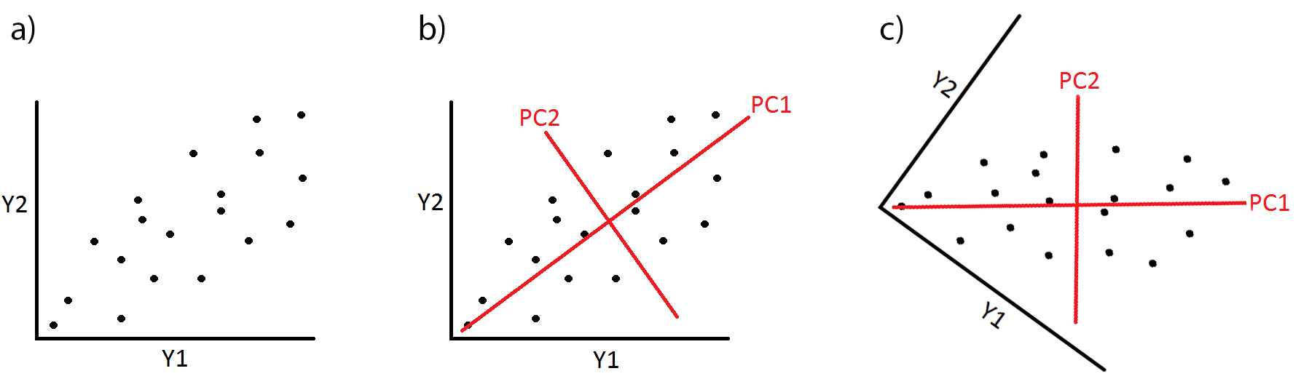
Fig. 5. Visual depiction of how PCA works. Y1 and Y2 represent two original variables. PC1 and PC2 are new axes created such that they represent the major axes of shape variation in the study. Note that PC1 is the longest axis one can draw through the scatter of points on Y1 and Y2. The original shape space is rotated so PC1 is transformed to the X axis and PC2 the Y axis. Individual specimens are assigned scores on the new coordinate system formed by the PC’s. This example has only two original Y variables to illustrate the logic of the method. Typically, there would be many original Y variables (>20) and only a few PC axes would be retained (2-5).

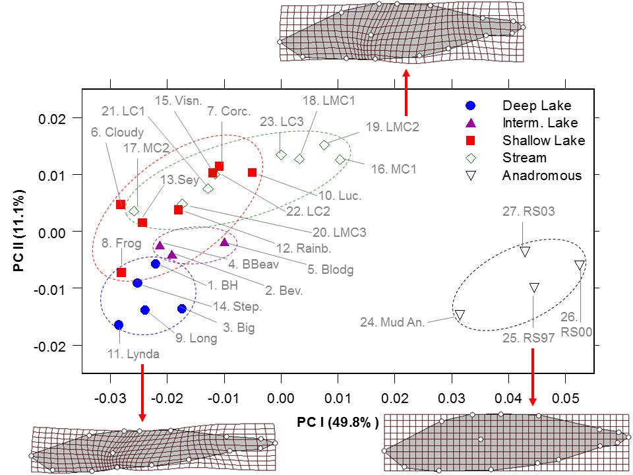
Fig.6. Example of PCA plot of 27 Alaskan stickleback populations collected in different habitat types. Points are the means of a sample that usually consisted of 20 specimens. Colors and symbols separate populations by habitat type. Note that populations cluster by habitat. The deformation grids represent predicted body shapes in different parts of the plot.
Part B – A Recap of the Study System: We will once again use the three populations of Alaskan threespine stickleback from labs 3 and 4. These include an anadromous population from Anchor River, a Benthic population from Tern Lake, and a Limnetic population from Stormy Lake. These samples were collected from the Kenai Peninsula region of Alaska. As a reminder, anadromous populations are larger, differ in body shape, and typically exhibit much more armor than resident freshwater populations. They are ancestral to the resident lake populations in the area. Benthic populations are deeper-bodied and are adapted to shallow water habitats, where they maneuver among the vegetation and debris eating larger macroinvertebrate prey. Limnetics are more stream-lined and are adapted to open water habitats in deep portions of the lake where they spend most of their time swimming in the water column feeding on small zooplankton.
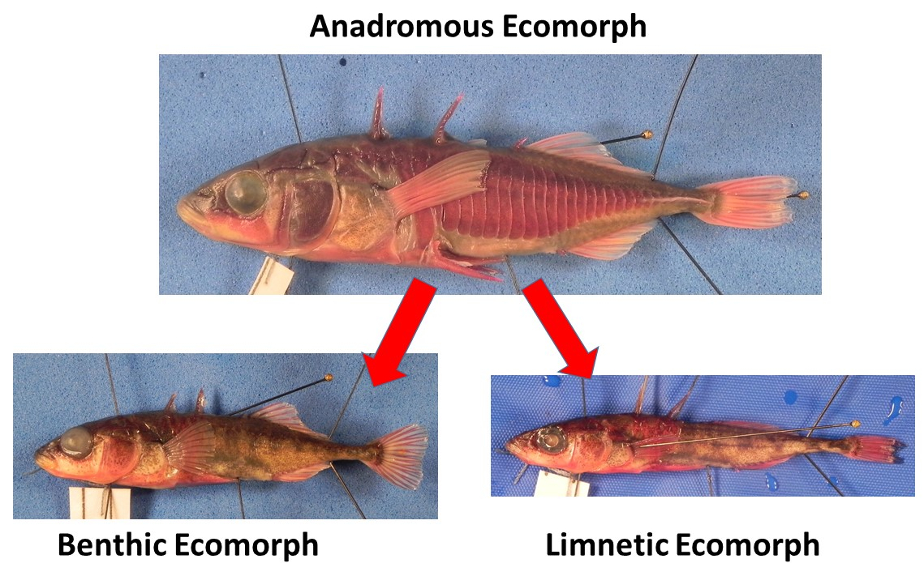
Fig. 7. Anadromous threespine stickleback are the ancestral ecomorph. They have established resident freshwater populations throughout the northern hemisphere that have adapted to local conditions and diverged morphologically. Resident freshwater populations also differ from one another depending on the characteristics of the lake or stream. The freshwater benthic ecomorph is adapted to live in structurally complex shallow lakes while the limnetic ecomorph is adapted to deep lakes where it swims in open water.

You will use a data file with 15 males and 15 females that have been photographed for each of the three populations (90 specimens total). To save time, a set of 16 landmarks have already been digitized on anatomical landmarks located around the body (Fig. 8). This was done with a program called TPSDig2, which runs on PCs. Your job will be examine how body shape differs among the three populations, test whether the difference in body shape is statistically significant, and create figures showing how body shape varies among populations.

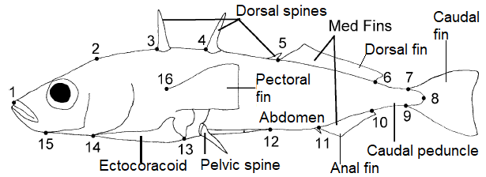

Fig. 8. Location of 16 landmarks digitized on each specimen and names of major anatomical structures.
Part C – Using Geometric Morphometrics to Analyze Body Shape Variation among Alaskan Oceanic, Benthic, and Limnetic Threespine stickleback Populations: We will use geometric morphometrics to study body shape variation among the three stickleback populations highlighted above. In previous labs, we examined differences in Standard Length and Body Depth using simple statistical methods and basic plots. Now we will use the program MorphoJ to examine body shape differences among these populations using geometric morphometric methods. There are quite a few programs to conduct geometric morphometric analyses. MorphoJ is a stand-alone program that does not require knowledge of other computational packages and has a very nice user interface, so we will use it. Other programs I would recommend are the TPS series from Stony Brook University and the Geomorph package, which runs in R. The instructor will guide you through the steps so please follow along.

1. Download the data files from D2L on to your computer. They are located in the Content/Data/Stickleback Geometric Morphometrics folder. Make sure to note where you download them so you can tell MorphoJ where they are. The two files that you need are:

-0_stickleback_evol_lab_data.TPS (this is the data file)
-grp_b.txt (this is our classifiers file, which indicates group membership)

2. Create a new project. Now we will create a new project to run our analyses.
2.1. Open MorphoJ on your computer.
2.2. Click on the File tab in the top left and select “Create New Project”. The following window will appear:

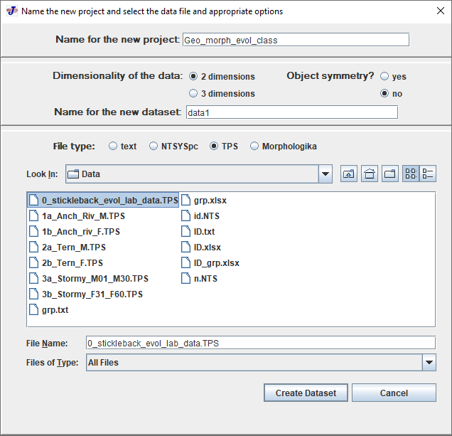
2.3. In “Name for the new project”, create a title for the project like “Geo_morph_evol_class”.
2.4. Under “Dimensionality of the data”, make sure “2 dimensions” is selected.
2.5. For “Name of the new data set”, input the name “data1”.
2.6. Under “File type:”, select TPS.
2.7. Now under “Look in”, find the “0_stickleback_evol_lab_data.TPS” file that you downloaded and select it. Once it is selected, click on “Create Dataset” in the bottom right. Once this is done, the new project will be set up.

3. Select the data1 matrix. We need to tell MorphoJ that we want to work with the data1 matrix that we created. To do this, go to the “Project Tree” tab and click on “data1”. It will be highlighted. Now MorphoJ is ready to work with this matrix.

4. Import the classifiers variable file. We need to import the classifier variable file that tells MorphoJ which specimens belong to which group.
4.1. Click on “File/Import Classifiers Variable”. A new window will appear.
4.2. Under “Match by”, Identifier should be selected.
4.3. Under “Look in”, find the file “grp_b.txt” that you downloaded on your computer and select it. Once this is done, click on “Open” in the bottom right.

5. Perform the Procrustes alignment of the landmark data. This step removes the variation in landmark positions that is related to the location and orientation of the specimens in the picture, and their body size.
5.1. Click on the “Preliminaries” tab and select “New Procrustes fit”.
5.2. By default, this should be set to the middle option “Align by principal axes”.
5.3. Click on “Perform Procrustes Fit” at the bottom of the window to align the landmark data.

6. Create the covariance matrix. We need to generate a covariance matrix, a matrix that presents the covariances among the shape variables, for the downstream multivariate analyses.
6.1. Click on the “Preliminaries” tab and then click on “Generate covariance matrix …”. A new window will appear.
6.2. Select “data1” under data sets selected and click “include”. Then click on “Execute at the bottom right”. This will create the covariance matrix and save it in the system’s memory.

7. Create the wireframe. Before we go on to conduct the PCA, we need to create a “Wireframe” guide that will tell MorphoJ how to unite the landmarks to facilitate visualization of the shape changes when we create figures. This step is so that our figures look better.
7.1. Click on “preliminaries”, and then click on “Create or edit wireframe…”, which is the second to last option in the menu. A new window like that below will appear.
7.2. On the right side you can select the landmarks to link. Change the second to Lmk 2 and then click on Link landmarks. This links LM 1 and LM2 as seen below. Continue to link each pair of adjacent landmarks through LM 1 - LM 15. Do not link LM 16, we only want to define the outline. Click “Accept”.
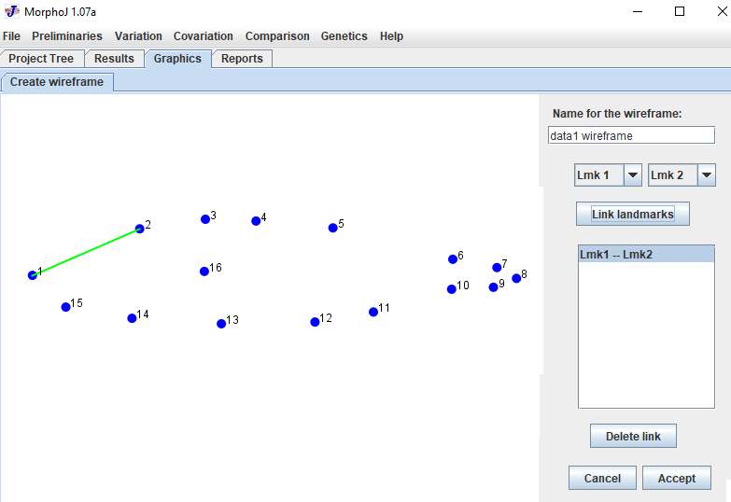
8. Conduct the Principal Component Analysis (PCA). Now we are ready to conduct the PCA. As a reminder, this multivariate method simplifies complex data sets. It creates new composite variables called principal components that repackage the shape variation and summarize it in a few variables. Multivariate methods like PCA are necessary to analyze data in geometric morphometrics because we typically have a good number of landmarks and each landmark is associated with an x coordinate and a y coordinate. So a data set with 16 landmarks will consist of 32 columns of numbers per specimen, an X and a Y variable for each of the 16 landmarks. No one can plot 32 variables against each other to make sense of how our samples vary. PCA typically reduces the number of variables that we will interpret to 2-5, which is manageable.
8.1. Click on the “Variation” tab and then click on “Principal Component Analysis”. The numerical results will be listed in the “Results” tab and the figures generated will be in the “Graphics” tab.
8.2. Click on the “Results” tab and look for the section that says “Principal Component Analysis: PCA: CovMatrix, data1, Procrustes coordinates”, if it is not at the top.

The only thing that we need from here is the percentage of the variance accounted for by each PC axis. This will be the column that says “%Variance” next to the column that says “Eigenvalue”. The numbers (1., 2., 3., etc., on the far left) indicate the PC number. So the first row indicates the % Variance in the data that is included in PC1. List these values for the first five PC axes:

PC1: _____________

PC2: _____________

PC3: _____________

PC4: _____________

PC5: _____________

The last column, “Cumulative %” indicates the cumulative variance explained.

8.3. What was the total percentage of the variance accounted for by the first 5 PC axes (cumulative variance)?

8.4. Did the first three PC axes account for more than 70% of the original variance in the data? If yes, how much?

8.5. Now click on the “Graphics” tab. Click on the middle tab under Graphics that says “Eigenvalues”. This shows the percentage of the variance in the original data in the form of a histogram. That is, these are the same data listed in the Results section we reviewed above, but presented in a histogram. This type of plot in PCA is called a Scree plot and is very useful for understanding the distribution of the shape variation in the different PC’s.

8.6. Right click on the histogram and select the middle option “Export graph to file”. Save the figure as a png type file in the same location on your computer where you saved the previous files that you downloaded. You can name it screeplot1.png. Insert it below:

8.7. Now interpret how the shape variation is distributed in the PC axes. Is there a single dominant PC axis (one PC axis that accounts for much more variation than any other)? Or two or three PC axes that are similar and account for most of the variation?

8.8. Now click on the “PC shape changes” tab. This shows the pattern of body shape variation associates with each PC axis. The landmarks mark the negative side of the PC axis and the lines indicate how the landmarks change position as you go to the positive side of PC1. This type of plot is called a lollipop graph. You can right click on it to see the body shape variation associated with other PC axes, one by one. Right click on the lollipop graph and click on “Export graph to file”. Name the figure lolipoppc1.png, save it to your computer and insert it below:

8.9. Right click on the figure again and click on “Change type of graph”. Select “Transformation grid”. This keeps the lollipop graph but overlays a transformation grid that lets you see how shape changes between landmarks as well. If there are no shape differences, the grid will consist of squares or uniform rectangles. Shape changes deform the rectangles, allowing you to see the parts of the body that are changing in shape the most. Save the file as a png file and pate it below:

8.10. Right click on the transformation grid image in MorphoJ (where you were before saving the last image file) and click on “Change the type of graph”. Select “Wireframe graph” and when the new window appears just click “OK”. Now there are two wireframes showing the extremes of PC1 with the landmarks united by the links you created previously. This allows you to compare the predicted shapes on the extremes of PC1 directly. Right click on this figure and click on “Export graph to file”. Save this file as a png file on your computer and paste it below:

8.11. Examine the three figures that you saved above. Which do you think best shows the shape variation associated with PC1? Why? Explain below. Note that there is really no right answer since this is a matter of preference.

8.12. For PC1, which landmarks are changing in position the most? Remember that the names of anatomical structures and fins are listed in Fig. 8.

8.13. Right click on the image file of the “PC Shape Changes” tab on MorphoJ. The first option says “Choose PC to display”. You can use this to display shape variation associated with other PCs. Using the type of graph you prefer (lollipop, transformation grid or wireframe), save plots for PC2 as a PNG file and paste it below:

8.14. In a sentence or two, indicate the type of body shape variation associated with PC2:

8.15. PC scores. Now go to the PC scores tab. This shows a plot of the 90 specimens included in our data set with PC1 on the X axis and PC2 on the Y axis. We can use this plot to see how our groups are related. However, all points are in blue so this plot is not very useful to evaluate how our populations differ. We need to tell MorphoJ to separate the points into groups based on population and sex. This is why we uploaded the Classifiers file, grp_b.txt, earlier in the lab. It indicates the group membership of each individual and separates them into six groups consisting of one group for each sex in each population.

To color code specimens by group, right click on the PC plot in the “PC Scores” tab. Click on “Color the data points”. Note that there is an unfortunate glitch in this function. You need to drag the right side of the window that appears to see all the buttons. Drag it right until you see the “OK” button (bottom right). See the figure below.

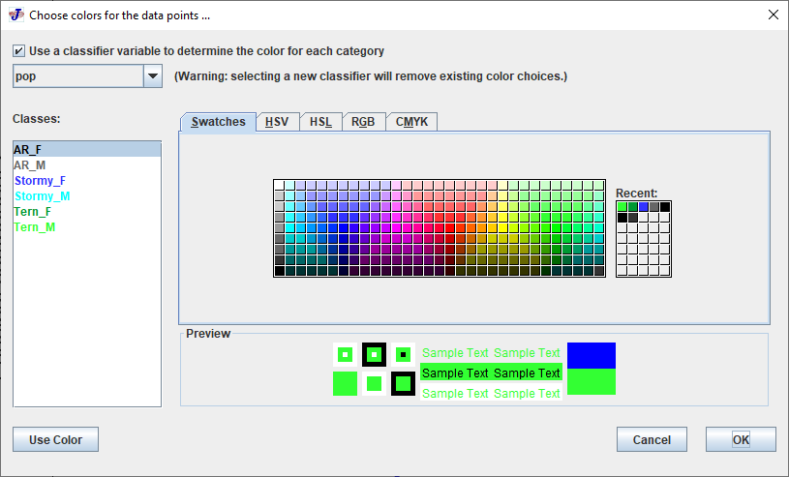

Once this is done, check the little box next to “Use a classifier variable to determine the color of each category”. In the white box on the bottom left, you will see the six classes listed as AR_F (the anadromous Anchor River females), AR_M (the anadromous Anchor River males), Stormy_F (the limnetic Stormy Lake females), Stomry_M (the limnetic Stormy Lake males), Tern_F (the benthic Tern Lake males), and Tern_M (the benthic Tern Lake males). MorphoJ gives each group a default color. I suggest making your own color scheme and giving females and males of the same population shades of the same color. See above for my color scheme.

To change a color, click on a group in the “Classes” window and then click on one of the colored boxes on the right. Then click the “Use Color” button on the bottom left. Repeat for each group. Once you are happy with the color selection for each group, click the “OK” button on the bottom right.

Now you should see different colors for different points in the plot. To help see things better, I recommend right clicking on the plot and clicking “resize” data points. Change the point size to 10 to make them larger. The points should be a lot easier to see. Right click on the plot, click on “Export graph to file”, and save it as a png file like before. Paste your PC scores plot below:

8.16. You can also draw confidence ellipses around your groups or group means. This is an ellipse that surrounds your group or group mean in the PC space at some probability level.
-Right click on the PC plot.
-Check the box that says “Draw ellipse(s)”.
-Keep it on “Equal frequency ellipse(s)”.
-Change the “Probability” value to 0.95 for a 95% confidence ellipse instead of the default 90%.
-Check on the box that says “Use a classifier as a criterion for grouping observations”, so you get a confidence ellipse around each group. Otherwise, you will get only one around the entire data set.
-Check on “Use this classifier to determine the colors of ellipses and data points”.
-Click the “OK” button in the bottom right.
-Save the plot as a png file and paste it below:

-Note that you can change what PCs you want to appear on the X and Y axes. For simplicity and to save time, we will only look at PC1 vs. PC2. These are the two main PC axes and explain over 60% of the variation anyway.
8.17. Now you are ready to interpret the PC scores plot. Do the populations separate in the space formed by PCs 1 and 2? If so, what groups are most distinct? Explain below.

8.18. Is there anything about the distribution of specimens that leads you to believe that males and females differ in body shape within populations? Explain.

9. Canonical Variate Analysis. PCA is an exploratory method. We can infer differences among groups based on the plots but we are not formally testing hypotheses. However, PCA is not looking for differences among groups nor is it testing any formal hypotheses.

So do our six groups (three populations and two sexes per group) differ significantly in body shape? There is another method called Canonical Variate Analysis that specifically looks for axes that differentiate between groups that we define and computes new composite variables that separate groups on these axes (Fig. 9). It also tests for pairwise differences among groups using distance data.

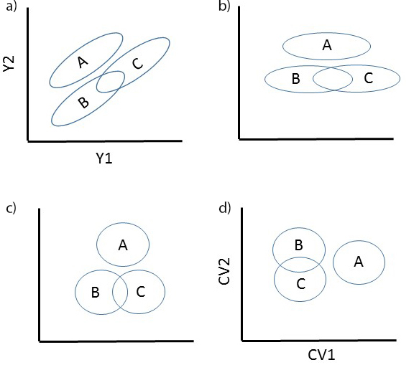
Fig. 9. Generalized depiction of how CVA works. This method looks for the axis that best distinguish between groups by minimizing within group variation and maximizes between group variation. It creates new composite axes like PCA that summarize shape variation.

9.1. Click on the “Comparison” tab in the very top menu.
9.2. Select the first option, “Canonical Variate Analysis”.
9.3. You can leave the default options. The one thing to change is Check the box next to “Permutation test for pairwise distances”. This does a better form of a test of significance than the typical parametric tests that are performed. Leave the default of 10,000 iterations.
9.4. Click the “Execute” button on the bottom right.
9.5. Go to the “Results” tab and find the section that says “Canonical Variate Analysis: CVA …”. This section gives the results of the analysis, listing sample sizes and also indicating the percentages of the variation accounted by each CV axis. Since we have six groups, there will be five CV axes. The middle column again indicates the percentage of variation accounted for by each axis and the last column (Cumulative %) indicates the cumulative percentage.
9.6. How much of the variation in the data does CV1 account for? CV2? Combined?

9.7. It also lists two different distance measures among groups: Mahalanobis and Procrustes distances. The details do not matter, what they represent is measures of differentiation between our 6 groups. You can use these comparatively to see which groups differ the most from which other groups.

9.7.1. Using the Mahalanobis distance measures, what to groups are the most similar (lowest distance values):

9.7.2. Using the Mahalanobis distance measures, what two groups are the most divergent (largest distance value):

9.8. Below each set of distance values, there are P values. These indicate whether groups differed from one another in a pairwise fashion. If P<0.05, then the two groups differ significantly. Did any groups differ significantly in body shape? Did all of them differ significantly?

9.9. Now switch to the Graphics tab. The first tab shows the CV shape changes. Right click to change graph type and select the type of graph you like the best (lollipop, transformation grid, or wireframe). Save the image file for CV1 as a png file and paste below as you did before.

9.10. Right click to change the display to CV2. Save the image file for CV2 as a png file and paste below as you did before.

9.11. Click on the CV scores tab. It shows your specimens separated by group in the space formed by CV1 and CV2. Make the plot look nice like you did for the PCA plot. Right click and color the data points with the same color scheme that you used for the PCA. Resize the data points to 10, and add group confidence ellipses like you did for the PCA plot. Save the plot as a png file and paste it below:

9.12. Interpret your results. Is their better separation among our groups than we saw with the PCA? Do all groups separate?

9.13. Note the pattern of divergence among groups. If you did things correctly, you will see that CV1 and CV2 are clearly interpretable as being associated with one of the factors we included, population or sex. Do groups separate by population or sex along CV1? Using the figure of shape deformation along CV1 that you created above, how does body shape change along CV1?

9.14. Do groups separate by population or sex along CV2? Using the figure of shape deformation along CV2 that you created above, how does body shape change along CV2?

10. Congratulations! You have successfully used geometric morphometrics to examine body shape variation among our stickleback populations. When you are done, you can save your project if you like. However, make sure you have pasted all your results into the protocol so you do not have to redo them.

MorphoJ is free software as is TPSDig2, the program used to digitize the landmarks on our pictures and generate the initial data file. All you need is a digital camera and you are ready to embark on your own geometric morphometrics study. For more information on the topic, I recommend the following book:

Zelditch, M.L., D.L. Swiderski, and H. David Sheets. 2012. Geometric morphometrics for biologists. A Primer. Academic Press.

