**What is .Net Framework?**

**What is a framework?**An essential supporting structure of a building, vehicle, or object.

**Then what is .Net Framework?**NET Framework (pronounced dot net) is a software framework developed by Microsoft that runs primarily on Microsoft Windows. It includes a large class library known as Framework Class Library (FCL) and provides language interoperability (each language can use code written in other languages) across several programming languages. Programs written for .NET Framework execute in a software environment (as contrasted to hardware environment) known as Common Language Runtime (CLR), an application virtual machine that provides services such as security, memory management, and exception handling. (As such, computer code written using .NET Framework is called "managed code".) FCL and CLR together constitute .NET Framework.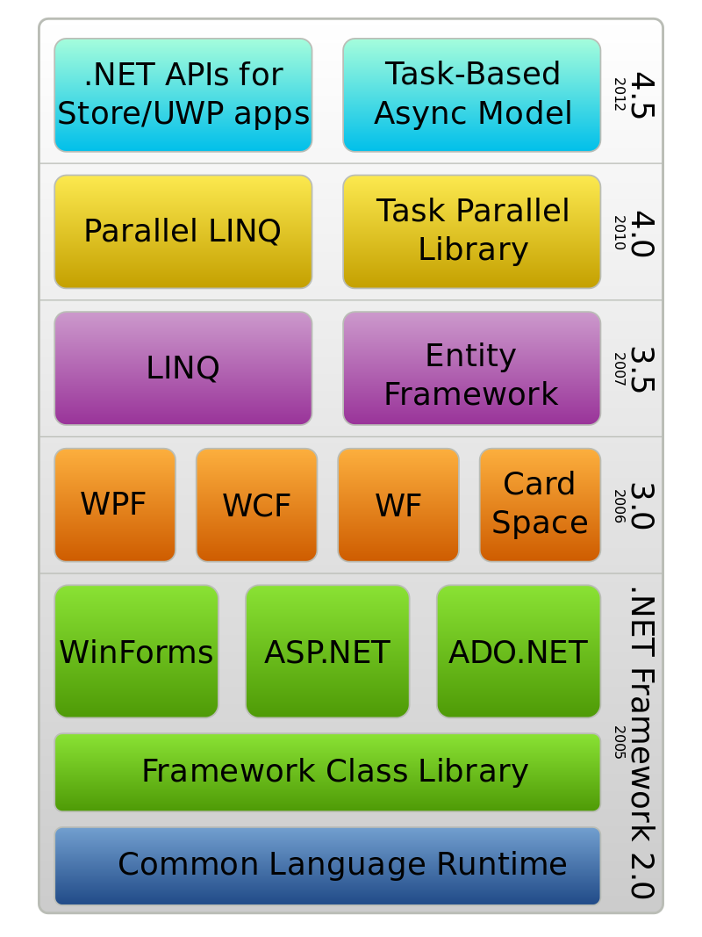

**How does .Net Framework work?**The JIT compiler is part of the Common Language Runtime (CLR). The CLR manages the execution of all .NET applications. In addition to JIT compilation at runtime, the CLR is also responsible for garbage collection, type safety and for exception handling.

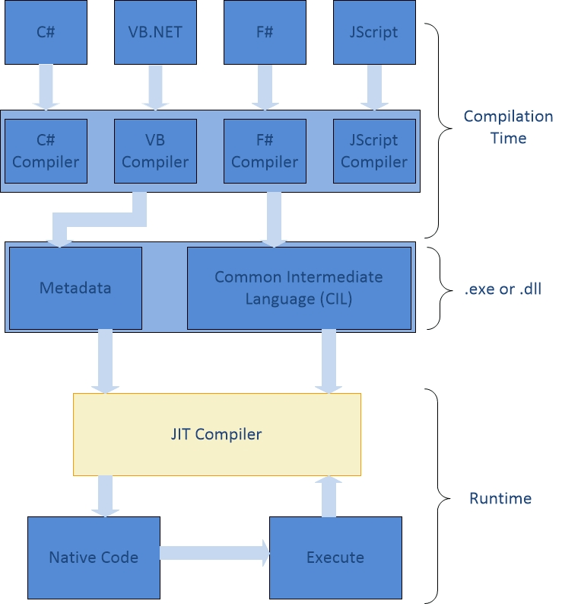

Understanding .NET Just-In-Time Compiler Figure 1 Figure 1

Different machine configurations use different machine level instructions. As Figure 1 shows, the source code is compiled to exe or dll by the .NET compiler. Common Intermediate Language (CIL) consists of instructions that any environment supporting .NET can execute and includes metadata describing structures of both data and code. The JIT Compiler processes the CIL instructions into machine code specific for an environment. Program portability is ensured by utilizing CIL instructions in the source code. The JIT compiler compiles only those methods called at runtime. It also keeps track of any variable or parameter passed through methods and enforces type-safety in the runtime environment of the .NET Framework.

There are three types of JIT compilation in the .NET framework:  
**Normal JIT Compilation** - methods compiled at runtime and stored in memory.  
**Econo JIT Compilation**  - methods compiled at runtime and removed from memory after execution.  
**Pre-JIT Compilation -** use Ngen.exe (Native Image Generator) to compile all CIL (Common Intermediate Language) before startup.