Table of Contents
Beyond Recall: Behavioral Specification as the Missing Primitive for AI Personalization 1
1. Introduction 1
1.1 Recall Is Not Interpretation. Interpretation Can Be Measured. 1
1.2 What We Tested 2
1.3 What We Found 5
1.4 Why the Gradient Matters for Real Users 13
1.5 Behavioral Alignment and the Human-AI Interaction Problem 14
2. Related Work 14
2.1 Memory systems for LLM agents 15
2.2 Traceability 18
2.3 Memory and personalization benchmarks 18
2.4 Cognitive and representational foundations 19
2.5 LLM-as-judge 21

Beyond Recall: Behavioral Specification as the Missing Primitive for AI Personalization
Author: Aarik Gulaya, Base Layer Date: April 2026 Preprint (Apache 2.0) Data + Code: github.com/agulaya24/base-layer Study Repository: github.com/agulaya24/memory-study-repo

v7 working draft — appended section by section as each locks in review. v6 (beyond_recall_v6_draft.md) remains the reference source for sections not yet re-locked.

1. Introduction

1.1 Recall Is Not Interpretation. Interpretation Can Be Measured.
State of the art AI memory has been optimizing for recall as the success metric. The four leading systems (Zep, Letta, Mem0, and Supermemory) compete on standard recall benchmarks such as LOCOMO and LongMemEval, reporting accuracies in roughly the 68% to 85% range depending on provider, model, and benchmark variant. Optimizing further on recall leaves something more fundamental unmeasured. This research paper explores how recall is one part of memory, and how the function of memory is dictated by how an individual processes the facts and experiences of their life.
We use interpretation to refer to this human-side property: the way a specific person processes facts and experiences into judgments, decisions, and reactions. Think of how viewing situations from different lenses can lead to entirely different interpretations of the same set of facts. This has been shown across the human experience, from the sciences to religion to political affiliations, and by extension to the relative experiences of any individual. Memory is deeply personal. For an AI memory system to serve a specific person, it must be personalized to how that person interprets, not just to what facts they have produced.
We introduce representational accuracy as the corresponding AI-side property: how well a system’s internal model of a specific person captures that person’s interpretive patterns. It is not recall, preference matching, or persona consistency; it is a distinct property of the AI system, and no current benchmark is built to measure it.
The core hypothesis of this research is that representational accuracy predicts alignment between an AI system’s behavior and the intent and behavior of the person it serves. If an AI system’s model of a person accurately captures how they interpret situations, its responses should align with that person’s intent and behavior in situations the system has never seen. The operational test is behavioral prediction on held-out situations, used here as a proxy for this alignment.
We test this hypothesis on the leading state-of-the-art AI memory systems and on a diverse set of 14 autobiographies from authors across the world. For this initial examination we use baselined and calibrated LLM judges to evaluate the performance of each memory system, on its own and in combination with a behavioral specification: a static document that extracts and encodes a stable representation of a corpus’s behavioral patterns.

1.2 What We Tested
We tested the Behavioral Specification across 14 historical subjects, each with a public domain autobiography. For every subject we split the source corpus in half: the training half was used to generate the specification, to seed each memory system, and to provide the retrievable fact pool. The held-out half was used only to produce behavioral prediction questions. No held-out passage was ever shown to a response model. The test was whether each system could predict how that specific person would respond in situations drawn from text it had never seen.
The experiment has two main splits. The first is a controlled test: each memory system is given an identical, pre-extracted fact pool drawn from the training half of the corpus. Holding the input constant lets us measure whether the providers converge on what is most relevant when they see the same facts. The second is a native test: each memory system ingests the raw corpus through its own pipeline, as it would in production. This measures real-world performance when each system is allowed to do what it is designed to do. Running in parallel across both splits is the Behavioral Specification, tested alone and layered on top of each configuration.
Inside this structure, every meaningful combination of inputs was evaluated as its own condition:
Condition | Inputs given to the model | Purpose
No context (C5) | Nothing. The model answers from pretraining alone. | Pretraining baseline. Measures what the model already knows about the subject from public sources.
Retrieval alone, controlled (C1) | Top-k facts retrieved by each memory system (Mem0, Letta, Supermemory, Zep, Base Layer) from the shared fact pool. | Tests retrieval sufficiency, and whether providers converge on which facts are most relevant given identical input.
Retrieval alone, native (C1 native) | Top-k results from each memory system’s own ingestion pipeline operating over the raw training corpus. | Real-world comparison of each memory system’s full ingestion-plus-retrieval stack.
All facts, no specification (C4) | Every extracted fact for the subject, loaded into context at once. | Tests whether information sufficiency alone drives prediction, independent of structure.
Raw corpus, no specification (C8) | The entire training corpus loaded into context. | Tests whether unstructured source text can substitute for an interpretive representation.
Specification alone (C2a) | The Behavioral Specification, with no retrieval, no facts, and no corpus. | Tests whether structure without retrieval is sufficient on its own.
Retrieval + specification, controlled (C3) | Memory system retrieval from the shared fact pool, plus the specification. | Tests whether the specification layers cleanly on retrieval when the input is held constant.
Retrieval + specification, native (C3 native) | Memory system’s own ingestion and retrieval, plus the specification. | Tests whether the specification improves the real-world deployment of each memory system.
Facts + specification (C4a) | Every extracted fact plus the specification. | Combines full information and structure to test the upper bound of context-provided prediction.
Corpus + specification (C9) | Raw training corpus plus the specification. | Tests whether structure is additive to unstructured source text.
Wrong-specification control (C2c) | A different subject’s specification applied to this subject. Two variants: v1 uses Franklin’s specification for all other subjects; v2 applies a random derangement, seed-fixed, so no subject receives its own. | Tests whether the effect is driven by the content of the correct specification, or by the mere presence of structured prompting.
Additional testing for Letta. Of the four commercial memory systems, Letta is architecturally distinct: alongside retrieval, it maintains a persistent memory block that its agent self-edits during multi-turn conversation. Because this path is not exercised by the retrieval conditions above, we ran a separate test on three subjects spanning a 9× corpus-size range (Hamerton, Ebers, Babur). A fresh Letta agent ingested each training corpus turn-by-turn and was allowed to self-edit. The resulting memory block was then served to the same response model used throughout the main study for a matched comparison against the Behavioral Specification. Full methodology and results are in §4.3.1.
The 14 subjects span four continents and roughly two millennia of written human experience. Ordered chronologically: Saint Augustine (North Africa, 4th-5th c.), Babur (Central Asia and India, 15th-16th c.), Bernal Diaz del Castillo (Spain and Mexico, 15th-16th c.), Benvenuto Cellini (Italy, 16th c.), Jean-Jacques Rousseau (France, 18th c.), Olaudah Equiano (West Africa and Britain, 18th c.), Mary Seacole (Jamaica and Britain, 19th c.), Elizabeth Keckley (United States, 19th c.), Yung Wing (China and the United States, 19th c.), Philip Gilbert Hamerton (Britain, 19th c.), Fukuzawa Yukichi (Japan, 19th c.), Georg Ebers (Germany, 19th c.), Sunity Devee (India, late 19th c.), and Zitkala-Sa (Yankton Dakota, early 20th c.). Source corpora range from 25,231 words (Hamerton) to 422,772 words (Babur). Full source references are in §3.2.
Predictions were scored on a 1-5 rubric: 1 means the response refuses or is wholly wrong; 2 means the model got the right topic but the wrong prediction; 3 means the right domain with no specifics; 4 means the right direction with specifics; 5 means the model predicted the specific outcome the held-out text records. One-point differences on this scale are qualitative shifts, not small numerical adjustments. Moving from 1 to 2 is the movement from “cannot engage” to “orients to what the question is about.” Moving from 2 to 3 is “wrong prediction” to “in the neighborhood.” Moving from 3 to 4 is “reasonable but unspecified” to “right direction with specifics.” Absolute point gains, not percentages, are the informative metric for cross-subject comparison.
The baseline we refer to throughout is the no-context condition (C5): the response model’s score on the prediction battery when given no external information. It operationalizes how much the model already knows about a subject from pretraining alone. A subject with a low baseline (C5 ≤ 2.0 on the rubric) is one the model has thin pretraining representation of; a subject with a high baseline is one the model already predicts reasonably well on its own. The population relevant for real AI deployment, living individuals whose private reasoning was never indexed by any training corpus, is low-baseline by construction. We therefore report results separately on the low-baseline slice (n=9) alongside the full 14-subject analysis.
Each condition was evaluated with 6 response models across 3 providers (Anthropic, OpenAI, Google) and a 7-judge LLM-as-judge panel (Claude Haiku, Sonnet, and Opus; GPT-4o and GPT-5.4; Gemini Flash and Gemini Pro). Judges were calibrated on known verbatim matches, paraphrase variants, off-target responses, and length-padded responses to measure each judge’s ceiling behavior, paraphrase sensitivity, and length bias. The judges agree strongly on condition rankings (pairwise Spearman ρ = 0.89-0.98). The two Gemini judges systematically inflate absolute scores by approximately 1 point relative to the other five, so we report both 7-judge and 5-judge non-Gemini aggregates throughout; no subject’s improvement direction changes between them. Full condition definitions, response model list, and judge calibration protocol are in §3.

1.3 What We Found
The Behavioral Specification improves representational accuracy, but not universally. The effect is a continuous gradient against baseline: strong where the model knows little about the subject, negligible or mildly counterproductive where the model already knows the subject well. The 14 subjects in this study are public-domain authors whose work is well-represented in training corpora, so their baselines are higher than those of typical living users whose private reasoning is in no training corpus. Nearly every real AI user is a low-baseline case by construction, which makes the low-baseline slice of our results the population of relevance. The improvement is content-specific rather than format-driven, and the specification layers additively on every commercial memory system we tested, most strongly on that slice.
Primary result: the gradient. The less the model already knows about a person from pretraining, the more the specification helps. Linear regression of the facts-plus-spec effect against baseline gives slope −0.98 [95% CI −1.30, −0.74]; Wilcoxon signed-rank p = 0.0063 (N=14, C5 vs. C4a); 12 of 14 subjects improve. As a sensitivity check on the population of relevance, the 9 subjects with baselines resembling typical real users (C5 ≤ 2.0) all improve without exception, with a mean gain of +1.04 points on the 1-5 scale.
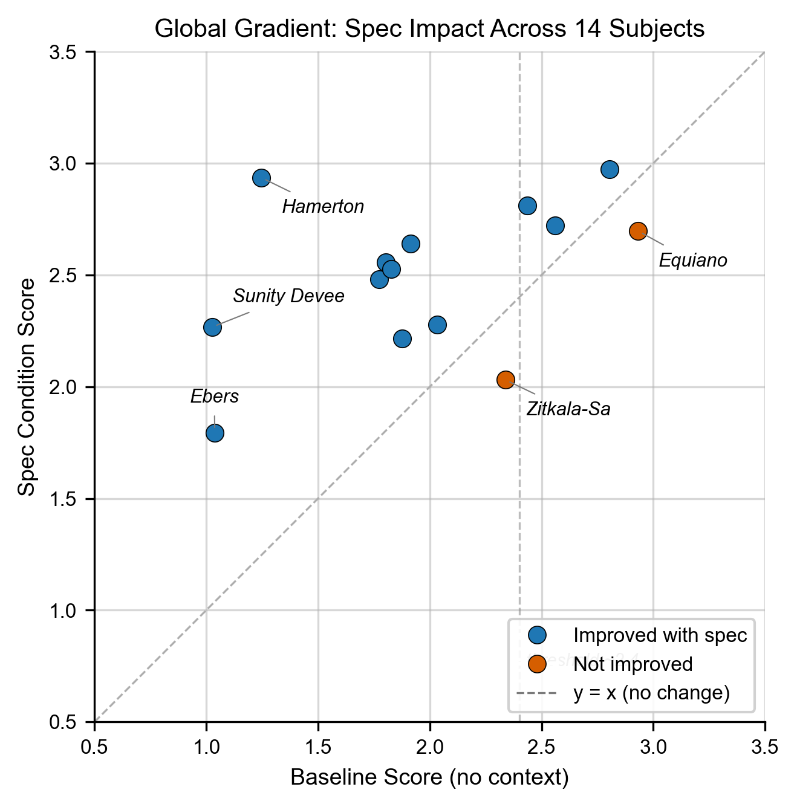
Figure 1: Per-subject C5 baseline vs. C4a (facts+spec) across all 14 subjects. The gradient result.
Figure 1: Per-subject C5 baseline vs. C4a (facts+spec) across all 14 subjects. The gradient result.
Compression: structure beats raw source at a fraction of the context. At the same context size, a compact specification outperforms the full source material. On Hamerton, a 7,300-token Behavioral Specification alone scores 3.04 on the 1-5 rubric. The same subject’s full 34,168-token training corpus loaded into context without a specification scores 2.32. The specification beats the raw source at roughly one-fifth the context size. A 7,300-token specification also matches the full 16,874-token facts-plus-specification condition (score 3.22) within margin. Information availability is not the bottleneck; interpretive structure is.
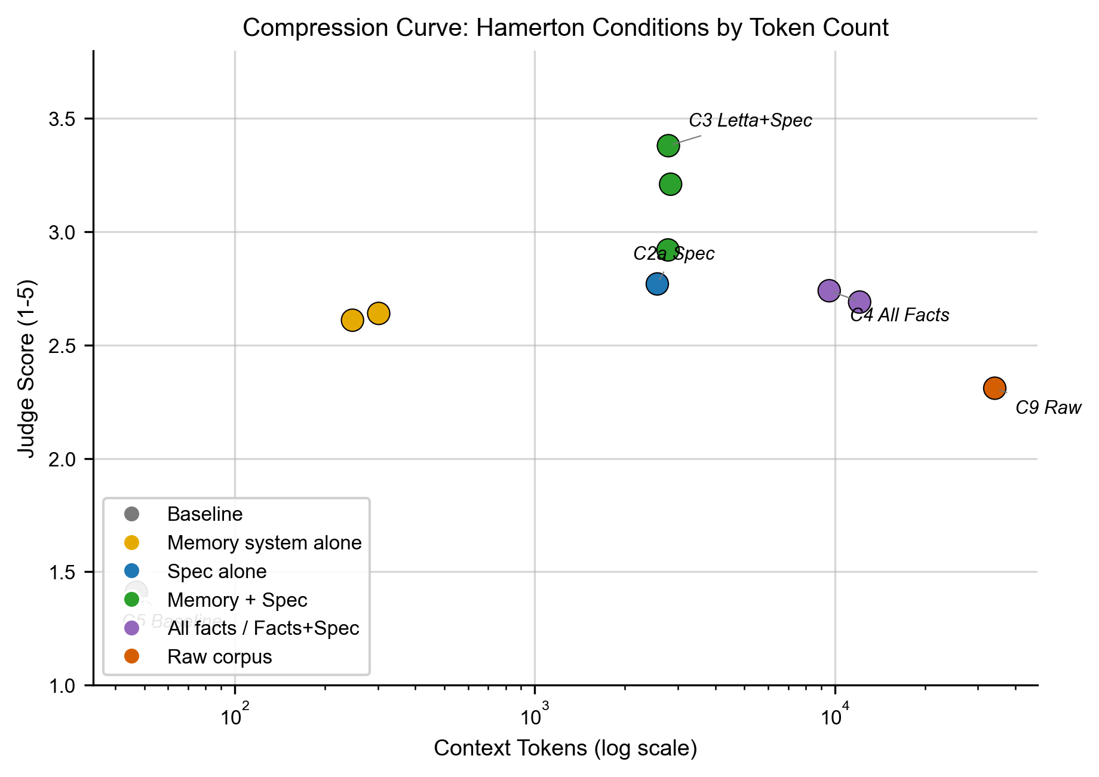
Figure 2: Log-tokens vs. normalized prediction score (Hamerton). 7,300-token spec beats 34,168-token corpus.
Figure 2: Log-tokens vs. normalized prediction score (Hamerton). 7,300-token spec beats 34,168-token corpus.
Mechanism: content, not format. The improvement comes from the right content for the right person. Any structured prompt is not enough; only the correct specification for the correct subject produces the effect. A wrong specification (random derangement, seed-fixed) scores near baseline with a mean Δ of +0.28 vs. +0.53 for the correct spec. A more extreme control, one subject’s specification (Franklin) applied to all 13 others, scores below baseline at Δ −0.16: strongly mismatched specifications actively degrade prediction. Across 587 wrong-spec responses classified (validated against a 30-response stratified manual spot check), the response distribution is bimodal: 60.6% explicitly flagged the mismatch (example, from one Keckley wrong-spec response: “This is a behavioral model of a 16th-century Central Asian military ruler, almost certainly Babur”) and either refused or produced a hedged response; 36.5% attempted to apply the mismatched specification and produced a low-quality prediction; 2.0% hedged implicitly; 0.9% were ambiguous. The 60.6% is an upper bound on behaviorally-grounded detection: specifications in this study are named rather than anonymized, so name-mismatch alone can trigger recognition. A name-blind version of this control is flagged as follow-up (§7). The core finding survives either way: the specific content of the correct specification drives improvement, generic structured prompting does not substitute for it, and sufficiently mismatched content actively degrades performance. The correct specification shifts response models in the opposite direction: baseline hedging of 25.0% drops to 2.6% with the specification alone and 0.6% with facts plus specification.
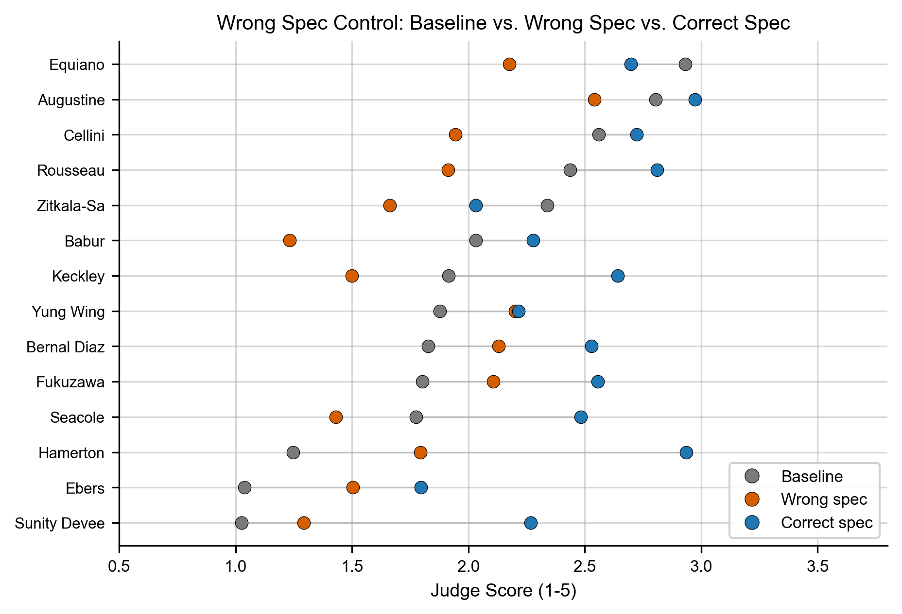
Figure 6: Correct-spec vs. wrong-spec score per subject. Wrong-spec lands near baseline.
Figure 6: Correct-spec vs. wrong-spec score per subject. Wrong-spec lands near baseline.
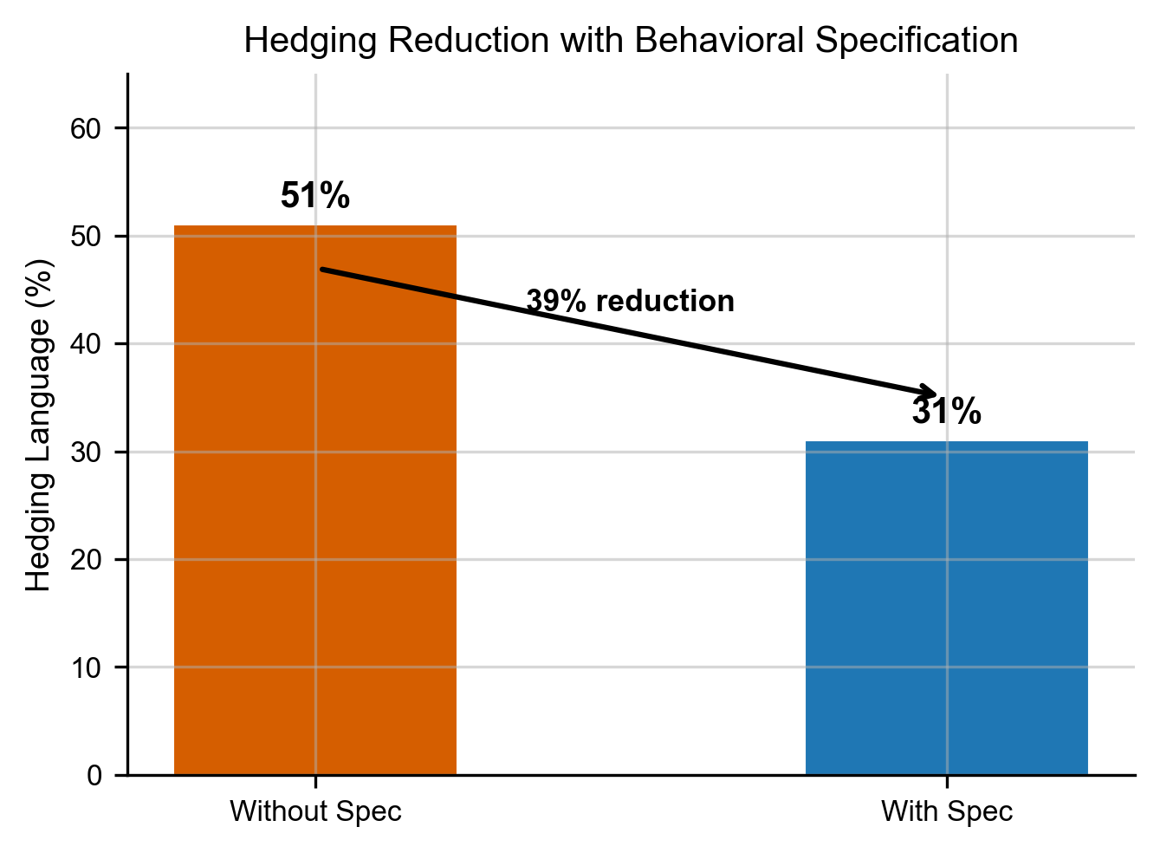
Figure 4: Hedging/refusal rate drops 25.0% → 2.6% → 0.6% across C5 → C2a → C4a.
Figure 4: Hedging/refusal rate drops 25.0% → 2.6% → 0.6% across C5 → C2a → C4a.
Additivity: the specification layers on three of four commercial memory systems. Adding the specification on top of a commercial memory system improves its behavioral prediction, on three of the four systems we tested. In the controlled configuration (each system given an identical pre-extracted fact pool), the specification produces positive mean delta on the low-baseline slice for Mem0 (+0.13), Letta (+0.23), and Zep (+0.20). Supermemory’s delta is near zero (+0.00). Across all 14 subjects, Mem0 (+0.15), Letta-controlled (+0.25), and Zep (+0.22) remain positive; Supermemory aggregates slightly negative (−0.04). One-line per-system read:
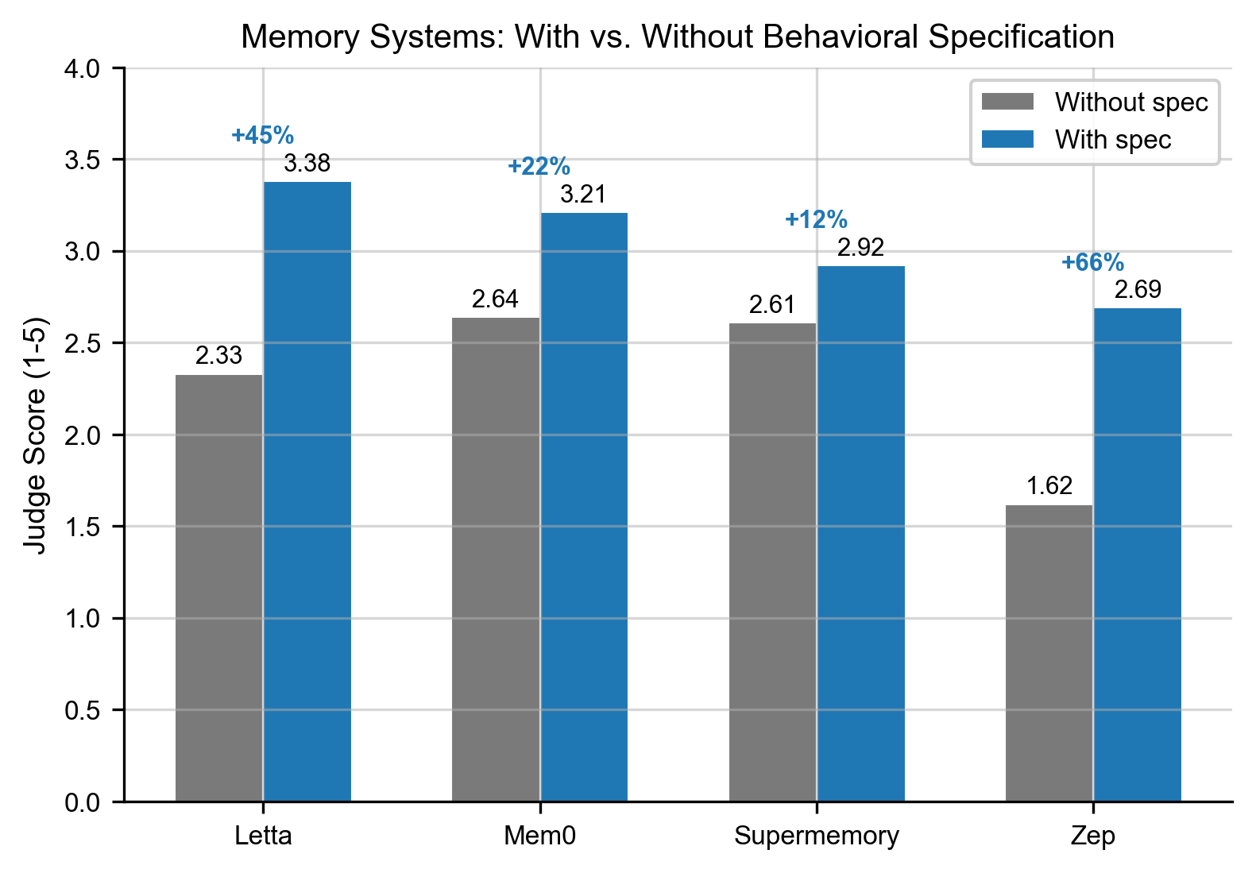
Figure 7: Per-system spec delta (C3 − C1) across low-baseline subjects.
Figure 7: Per-system spec delta (C3 − C1) across low-baseline subjects.
- Mem0: most reliable baseline. Positive spec delta in both configurations (+0.15 controlled, +0.38 native). Layers cleanly.
- Letta: architecturally most ambitious. Native archival-retrieval path is spec-null (−0.01); the signature stateful-agent path is examined separately below.
- Zep: strongest and most consistent spec delta (+0.22 controlled, +0.38 native). Positive on 9 of 9 low-baseline subjects in the native configuration.
- Supermemory: strongest standalone retrieval (C1 mean ~2.65 vs. ~2.30 for the others on the 1-5 scale). The near-zero aggregate spec delta hides wild per-question swings in both directions; treated in the next finding.
- Base Layer: included as the zero-cost open-source retrieval floor (MiniLM-L6-v2 + ChromaDB). Mean C1 ~2.30 across 14 subjects, in the same band as the commercial systems. Spec delta +0.13 on the low-baseline slice. Not positioned as a memory product; it is what an open-source retrieval stack produces at zero marginal cost.
Where the specification helps and where it hurts. The specification’s effect on a given memory system is not uniform across questions. Supermemory’s near-zero aggregate delta is a mixture: the specification helped on many questions and hurt on many others, in roughly equal measure, so the two sides cancel at the average. On Ebers (aggregate Δ +0.21), it helps on 19 of 39 questions and hurts on 10. On Keckley (aggregate Δ −0.26), it helps on 10 and hurts on 17. The per-question effects are often large (>0.3 points); averaging them hides strong disagreement at the individual-question level. This mixture pattern is not unique to Supermemory: Mem0, Letta, Zep, and Base Layer’s own retrieval substrate each show per-question swings of similar shape at varying magnitudes, and the Keckley Q21 refusal response below recurs across every memory system we tested, with the penalty size proportional to how strong each system’s retrieval-only counterfactual was. This tells us the refusal is a specification-level dynamic, not a memory-system artifact.
Three patterns emerge. The specification adds signal retrieval alone cannot on interpretation-heavy questions where a generalized pattern from the source has to transfer to a novel situation.
- Ebers Q3: “How would Ebers characterize the emotional impact of natural beauty combined with a mentor’s persuasive words?” Supermemory-alone returned discrete facts about nature, teachers, and loyalty and gave a generic “transformative” answer (score 1.17). With the specification added, the model recognized the specific pattern that beauty and mentor’s words function as a single formative mechanism rather than two additive inputs, and scored 3.00 (Δ +1.83).
- Sunity Devee Q35: “What does she believe was the consequence of following official advice that conflicted with her own judgment regarding her son’s education?” Supermemory-alone answered generically about negative consequences (score 2.33). The specification carried an explicit anchor (“spiritual integrity over social cost”) that let the model frame her recollection as self-accusation rather than as criticism of officials, and scored 4.33 (Δ +2.00).
The specification hurts on literal-recall questions where a plain answer is available and spec-driven theorizing drifts past it, and on refusal-triggering questions where the specification’s honesty axioms produce epistemically-honest refusals that the content-match rubric scores as off-base.
- Keckley Q21: “How does Elizabeth explain her decision not to visit her mother’s grave despite having the opportunity?” Supermemory retrieval alone acknowledged the gap in the retrieved facts and speculated productively from what it had about Elizabeth’s relationship with her mother, scoring 3.83. With the specification added, the model invoked the spec’s documented-dignity axioms, declined to fabricate interior motive, and told the user it could not answer without the specific passage; score 1.50. The rubric treats an epistemically-honest refusal identically to an off-base guess.
This is not a specification defect. It is a measurable feature of specification-based reasoning that content-match benchmarks do not reward. A differentiated battery that separates interpretive prediction from literal recall would sharpen the comparison, and is flagged as follow-up in §7.
Robustness: the effect is not an artifact of Claude talking to Claude. The specification’s effect holds when non-Anthropic models generate the test questions and non-Anthropic models read the specification. On three subjects spanning the effect gradient, 5 of 6 (subject × response model) cells reproduce the specification direction when Sonnet or Gemini Pro reads questions generated by GPT-5.4. The one mismatch (Zitkala-Sa × Gemini Pro) is consistent with the gradient mechanism rather than a replication failure. This addresses within-Anthropic circularity, the concern that Anthropic-generated questions scored with Anthropic judges might favor Anthropic-produced specifications. LLM-as-judge circularity at the evaluation level remains a broader limitation of this study, flagged in §6.
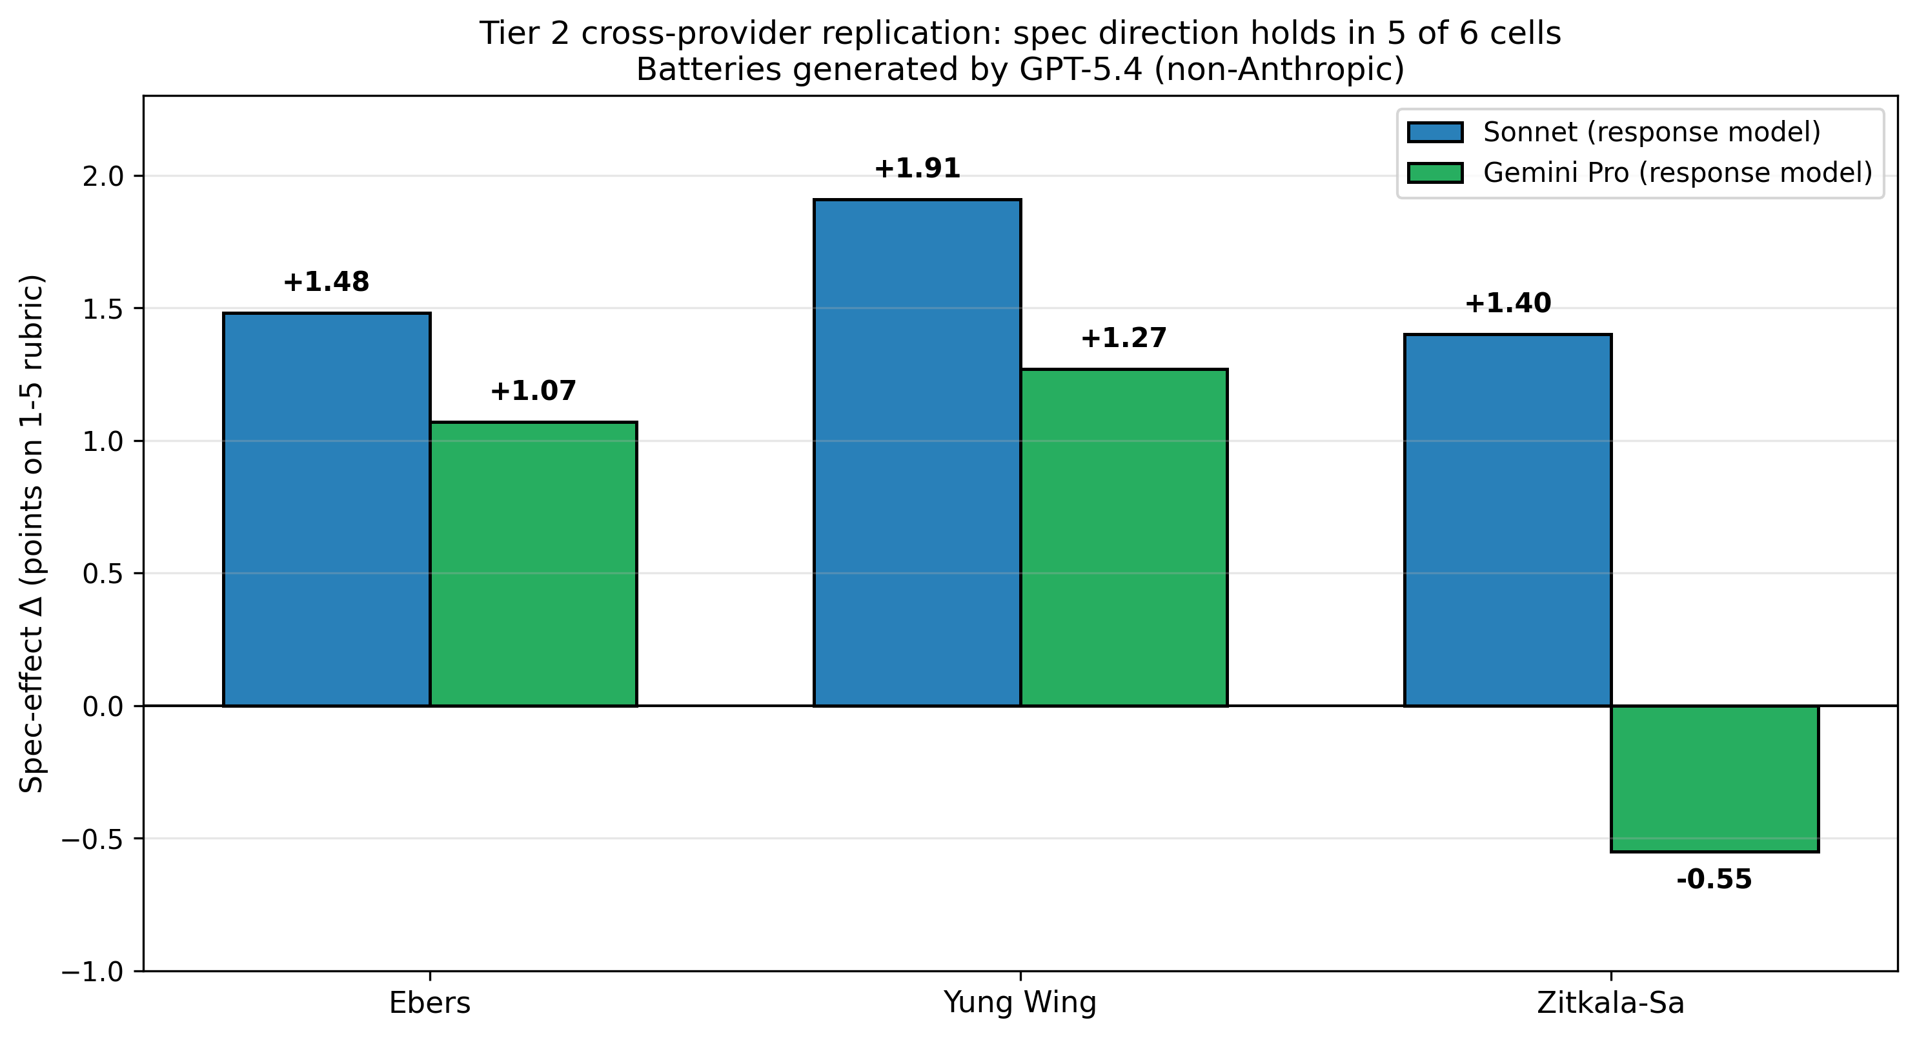
Figure 11: Tier 2 cross-provider replication — 5 of 6 (subject × response model) cells positive.
Figure 11: Tier 2 cross-provider replication — 5 of 6 (subject × response model) cells positive.
Architectural observation: Letta’s stateful-agent path. Letta is the only memory system whose architecture allows the AI itself to write and revise a persistent memory block during conversation. When we invoked this path directly, the AI produced a representation resembling the Behavioral Specification in what it captured, but not in how it compressed. On three subjects spanning a 9× corpus-size range, Letta’s stateful-agent architecture (the self-editing memory block from the original MemGPT design, not the archival retrieval path our main conditions exercise) produces an interpretive representation that scores modestly higher than the Behavioral Specification at matched response model on all three subjects tested, with matched batteries and named-subject specifications throughout (Hamerton: 3.24 vs. BL 3.04, Δ +0.20; Ebers: 3.00 vs. BL 2.25, Δ +0.75; Babur: 2.73 vs. BL 2.44, Δ +0.29). This is architectural convergence: two independently-designed systems target the same property. Letta’s memory block appears to grow roughly linearly with source corpus size: 22,472 characters (~5,600 tokens) at 25,231 words of source (Hamerton), 68,413 characters (~17,000 tokens) at 48,161 words (Ebers), and 335,349 characters (~84,000 tokens) at 222,742 words (Babur). At the largest corpus we tested, Letta’s API began rejecting ingestion requests after the block reached approximately 333,000 characters; the final block, after 22 consecutive failed ingestion attempts, measured 335,349 characters. We noted 25% verbatim sentence duplication as the block approached that ceiling. Base Layer’s compose step keeps the specification at 34,000-40,000 characters (~8,000-10,000 tokens) across the same range. For reference, 335,000 characters is roughly 67,000 words: less than a single short book, and substantially less than ten years of daily journaling or the full accumulated session history of a long-running personal AI assistant. The stateful-agent path encountered a structural compression ceiling on the largest corpus we tested; the Behavioral Specification’s compose step did not. The gap at matched conditions is content-driven, not refusal-driven: Letta’s larger block carries corpus-derived narrative the response model can cite, while the 7,000-token specification carries interpretive scaffolding only. We report this as a frontier question for stateful-agent memory architectures, not as a claim of superiority.
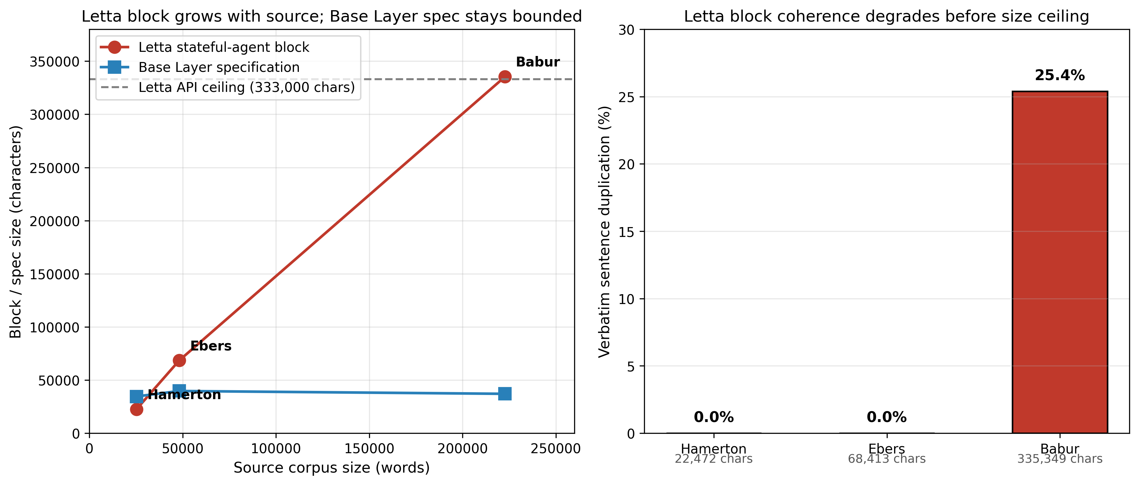
Figure 10: Letta block size vs. corpus size (vs. Base Layer flat line); duplication % at scale.
Figure 10: Letta block size vs. corpus size (vs. Base Layer flat line); duplication % at scale.

1.4 Why the Gradient Matters for Real Users
What the gradient means for people who use AI in the real world. Nearly every real AI user starts from a baseline lower than any historical subject in this study. Our 14 subjects are public-domain authors whose writing was preserved, digitized, and indexed into training corpora. By construction, they sit well above the pretraining representation of a typical living person. Even within this biased-up sample, the specification helped most where baseline was lowest: the 9 subjects below C5 ≤ 2.0 all improved, and the two subjects where the specification did not help were the two with the highest baselines in the study. Our lowest subject (Sunity Devee) scores 1.03, near the floor of the rubric, a score that indicates the model either refuses or produces an unrelated answer. For a typical living user whose private decisions were never indexed, the baseline is at or below 1.0 by construction. The structural implication is direct: if the specification was uniformly beneficial for the lowest-baseline historical figures we could test, it should be at least as beneficial for the typical real AI user.
What we did not prove. This is an extrapolation argument, not a direct measurement. We did not test living users with private data at scale. We have run initial pilots with two real users on their private corpora, enough to see the baseline behavior the gradient predicts, but not enough for a generalizable claim. In one such pilot on the paper’s author (N=10, single judge), Haiku’s no-context baseline was 1.90 (95% CI 1.16–2.64) with 60% of responses scoring at or near the rubric floor, placing the baseline in the same regime as our lowest historical subjects and consistent with the gradient’s prediction for individuals whose private reasoning was never indexed. A properly-scoped living-user study is the single most important piece of follow-up work for this paper (§7). We are also exploring alternative testbeds that isolate reasoning structure without requiring private data, including U.S. Supreme Court opinions where documented decisions provide a public record of individual interpretive patterns that can be held out and predicted. Two other boundary claims belong here: our wrong-spec control is named rather than name-blind, so some of the detection effect in §1.3 is trivial name-mismatch rather than behavioral recognition, and our judging remains LLM-as-judge at evaluation, so broader LLM-circularity concerns are not fully addressed by the cross-provider replication. We state these here because §1.3’s claims rest on extrapolation past them.
What this implies for AI personalization infrastructure. If nearly every real AI user is low-baseline, the gap cannot be closed by pretraining. Every major model is trained on the public record. The private record (a person’s reasoning, decision patterns, and interpretive lens) is not in any training corpus, and will not be in any training corpus, because that record does not exist in a form that can be trained on. The structural options are narrow. Either each user supplies their own representation to whatever AI system serves them, or personalization remains surface-level (style, voice, preference) without the interpretive substrate that makes an agent’s actions actually reflect the person. The Behavioral Specification is one implementation of the first option, not the only one. What we claim is that personalization infrastructure of this shape is what the next generation of human-AI interaction will require: user-held, portable, inspectable, traceable, representation-grade. §1.5 develops this connection to behavioral alignment more fully.

1.5 Behavioral Alignment and the Human-AI Interaction Problem
How this paper connects to the broader question of human-AI alignment. Behavioral alignment is one concrete, measurable instance of human-AI alignment: whether a specific AI system’s actions accord with a specific person’s reasoning, values, and decision-making when acting on that person’s behalf. The AI safety community typically uses “alignment” to mean preventing harmful behavior at the model level. That is one property. Behavioral alignment is a different property, and the two axes are orthogonal, not a hierarchy.
A model that is safely aligned in the safety sense can still be behaviorally misaligned with any given user: it will act reasonably, but not the way you would act. The inverse is also true and important. A perfectly behaviorally-aligned agent, acting exactly as a specific user would act, can be catastrophically safety-misaligned if that user would act maliciously, recklessly, or against third-party interests. Behavioral alignment is not a safety property. It is a personalization property that safety constraints must sit above.
Representational accuracy is a necessary condition for behavioral alignment, but not sufficient. A system cannot act the way someone would act if it lacks an accurate internal model of how that person reasons. Having the model is required; translating the model into aligned action, subject to safety constraints, is a separate problem we do not address in this paper. We focus on the representation layer because it is the piece that is under-studied and empirically tractable. An agent that acts on your behalf without an accurate representation of you is not serving you; it is averaging over some population the model happens to resemble.
The question this paper asks, operationally: can the AI act the way you would act, given how you think? The question the field should take up, more generally: how do we know when an AI’s internal model of a specific person is accurate enough for the agent to act on that person’s behalf, and by what means do we improve and audit that representation?

2. Related Work
Memory systems today optimize for recall. Some efforts build memory architectures modeled on human memory, but their targets remain general rather than individual. A separate body of research studies human reasoning itself: how people form representations of others, how schemas compress experience. The gap between these directions is the translation. How do we apply what we know about human reasoning to the direct interaction between an AI system and a specific individual, and how does the system’s internal model of that individual take shape in a way that serves them rather than serving an average?
Language models optimize for the median. By construction, a model tuned for the average fails every individual on the distribution. We do not want an unbiased system for personalization; we want a system biased to the individual. That kind of intentional bias, toward a specific person rather than toward a population mean, is the missing thread in current AI memory and human-AI interaction research.

2.1 Memory systems for LLM agents
The four commercial memory systems we evaluate (Mem0, Letta, Supermemory, Zep) have converged on a shared set of capabilities: semantic retrieval over embedded content, source attribution, multi-level memory structures, and benchmark-validated recall performance. They differ in how each of these is architected. None positions representational accuracy or behavioral prediction of a specific individual as a design target.
Table 2.1 — Memory system comparison. Verified against primary sources.
Provider | Core architecture | Retrieval method | Memory types | Published recall score
Mem0 | Extract → consolidate → retrieve pipeline; Mem0g graph variant adds a directed labeled knowledge graph alongside the vector store | Hybrid: semantic + keyword + entity | Conversation, session, user, organizational | Current algorithm: 91.6 LOCOMO, 93.4 LongMemEval (vendor-reported; evaluation harness open-sourced at github.com/mem0ai/memory-benchmarks). Peer-reviewable paper (Chhikara et al., arXiv:2504.19413) reports 68.44 LOCOMO for the Mem0g variant with GPT-4o-mini.
Letta / MemGPT | LLM-as-operating-system; virtual context management with main context plus external context | Archival via archival_memory_search; main-context memory blocks self-edited via core_memory_append, core_memory_replace | persona and human blocks in main context; archival and recall memory external | 74.0% on LOCOMO with GPT-4o-mini (Letta blog, 2025-08-12)
Supermemory | Five-component architecture: chunk-based ingestion, relational versioning, temporal grounding, hybrid search, session-based ingestion | Hybrid with reranking and query rewriting; source chunks injected at retrieval | Contextual memories, relational versions, session data | 81.6% / 84.6% / 85.2% on LongMemEval_s with GPT-4o / GPT-5 / Gemini-3-Pro (self-reported)
Zep | Built on Graphiti (Apache 2.0, open source). Bi-temporal knowledge graph | Hybrid: semantic + BM25 + graph traversal | Episodes (ground-truth source), Entities, Facts-as-triplets with temporal validity windows | 71.2% on LongMemEval with GPT-4o (Rasmussen et al., arXiv:2501.13956)
Mem0 (Chhikara et al., 2025): An extract-consolidate-retrieve pipeline that surfaces memories across four levels (conversation, session, user, organizational). The Mem0g graph variant builds a directed labeled knowledge graph alongside the vector store, with entity extraction and relation inference. Retrieval is hybrid (semantic, keyword, entity lookups). Mem0’s peer-reviewable paper reports 68.44 on LOCOMO with GPT-4o-mini for the Mem0g variant. Mem0’s current production algorithm, as reported on their research page, scores 91.6 on LOCOMO and 93.4 on LongMemEval; the evaluation methodology is open-sourced at github.com/mem0ai/memory-benchmarks for independent reproduction.
Letta / MemGPT (Packer et al., 2023, arXiv:2310.08560): An LLM-as-operating-system paradigm. The agent’s main context is divided into structured memory blocks (persona, human) that the agent edits during its inference loop via tools such as core_memory_append and core_memory_replace. External context includes archival memory (semantically searchable) and recall memory (prior conversation history). The MemGPT paper describes memory edits as autonomous agent actions, triggered by the LLM’s own decisions during conversation turns. Of the four memory systems we test, Letta is the only one whose core architecture treats memory as something an agent synthesizes during conversation rather than stores for later retrieval. Letta’s published LOCOMO score is 74.0% with GPT-4o-mini; no LongMemEval score has been published.
Supermemory: A five-component architecture per the vendor’s published research page: chunk-based ingestion, relational versioning, temporal grounding, hybrid search with reranking and query rewriting, and session-based ingestion. Retrieval returns both high-level memory summaries and original source chunks. Scores on LongMemEval_s (the 500-question subset, not the full suite) are 81.6% with GPT-4o, 84.6% with GPT-5, and 85.2% with Gemini-3-Pro; all self-reported.
Zep: A bi-temporal knowledge graph built on Graphiti (Apache 2.0, open source). Ingested data flows through three tiers: episodes as ground-truth source data, entities extracted from episodes, and facts represented as triplets with temporal validity windows tracking when information became true and when it stopped being true. Retrieval is hybrid across semantic, BM25, and graph traversal. In Zep’s production deployment, retrieval latency is reported under 200 ms. Zep’s arXiv paper reports 71.2% on LongMemEval with GPT-4o (Rasmussen et al., arXiv:2501.13956). An earlier Zep claim of 84% on LOCOMO was publicly disputed by Mem0 in a GitHub issue (see dispute note below).
A note on benchmark scores in this field. The recall-benchmark landscape for memory-for-agents is contested. Mem0 and Zep have publicly disputed each other’s LOCOMO methodology in a GitHub issue (getzep/zep-papers#5), with Mem0 alleging that Zep’s 84% claim included adversarial question categories the benchmark specification explicitly excludes, that the evaluation prompt and retrieval templates differed from baselines, and that Zep reported one run where Mem0 reported the mean of ten. Zep contested the correction. The issue was closed with corrected evaluation code provided as a pull request, but the methodological disagreement remains unresolved in the broader community. Supermemory publishes a direct comparison against Zep showing a ~10-point gap on LongMemEval_s in Supermemory’s favor. Mem0’s current production algorithm claims 91.6 on LOCOMO and 93.4 on LongMemEval with an open-sourced evaluation harness; third-party reproduction efforts (Vectorize.io) have produced a different set of numbers again. In short: benchmark construction for conversational memory is immature, methodology varies significantly between evaluators, and single-number comparisons across vendors should be read with caution. Independent third-party evaluation would help settle this. This paper does not attempt that adjudication. We measure on a different axis (behavioral prediction on held-out situations drawn from public-domain autobiographies), report our own numbers against primary sources, and position the Behavioral Specification as an additive layer regardless of where each memory system lands on recall.
All four are sophisticated systems that solve real problems in memory management. They optimize for storing, organizing, and retrieving what a person said or did. None of them takes representational accuracy, the property of interest to this paper, as an explicit design target. This is not a criticism of their architectures; it is a different problem. The Behavioral Specification targets the interpretive layer that sits above retrieval, which three of the four do not model at all, and which the fourth (Letta) models implicitly through agent-initiated memory editing that our main study configuration did not exercise (see §4.3 and §4.3.1).

2.2 Traceability
Traceability is not a feature of the Behavioral Specification. It is a necessity. A system that represents how a person reasons must be auditable by that person, or the representation is a black box they cannot verify. The memory systems we evaluate provide traceability at the fact level. Zep has the strongest explicit provenance of the four: every entity and relationship traces back to the episode IDs that produced it. Supermemory returns source chunks alongside retrieved memories. Mem0 tracks ingestion provenance through timestamps. Letta focuses on agent state rather than audit trails.
Fact-level traceability answers where a retrieved claim came from. That is necessary but not sufficient for a representation of how a person reasons. What is also required is traceability at the reasoning level: why the system believes this about this person, not just which fact it pulled. The Behavioral Specification is structured so that every claim is a piece of reasoning, not just a piece of content. An axiom (for example, “A1: Dual-ledger authority”) is an assertion about how the person reasons in a domain, grounded in the facts that imply it (F-001, F-047), which are themselves grounded in the exact source passages that produced those facts. Walking this chain backward shows not only where a belief originated but what line of reasoning connects the source text to the interpretive claim.
This matters because a person should be able to inspect the system’s model of them, challenge any step in the reasoning, and correct it if it is wrong. A fact-attribution memory system lets the person audit what the system stores. A reasoning-attribution specification lets the person audit what the system believes. The first is a feature. The second is the minimum bar for a representation that acts on someone’s behalf.

2.3 Memory and personalization benchmarks
Existing memory and personalization benchmarks measure recall, persona consistency, preference alignment, or conversational quality. None measures behavioral prediction: whether a system can anticipate how a specific person would respond in situations the system has never seen. This paper’s battery tests that directly. Below, we position each existing benchmark against what this paper measures; an extended benchmark-by-benchmark analysis is in Appendix E.
- LongMemEval (Wu et al., ICLR 2025, arXiv:2410.10813). Long-term memory across multiple sessions with five capability dimensions: single-session, multi-session reasoning, temporal reasoning, knowledge updates, and abstention. Heavily recall-weighted. Does not test whether the system represents how the person reasons. This paper’s battery is orthogonal: every held-out question asks about behavior, not about retrieved content.
- PersonaGym (Samuel et al., Findings of EMNLP 2025, arXiv:2407.18416). Tests persona fidelity: whether a model maintains a described persona during conversation. Evaluates consistency of persona presentation, not prediction of held-out behavior. A persona-fidelity system can maintain voice without ever accurately predicting decisions, and a representationally-accurate system can change voice while continuing to predict accurately. Our battery measures the second axis.
- AlpsBench (Xiao et al., 2026, arXiv:2603.26680). Evaluates whether explicit memory mechanisms improve preference-aligned and emotionally resonant responses. Their central finding, that explicit memory mechanisms improve recall but do not inherently guarantee more preference-aligned or emotionally resonant responses, is independently arrived at and complementary to ours: they find the gap in preference alignment, we find it in behavioral prediction. Both results point toward recall-solving being insufficient for what memory is ultimately for.
- Twin-2K (Toubia et al., 2025, arXiv:2505.17479). Behavioral prediction at scale: 2,000 participants; their headline accuracy is 71.72% using GPT-4.1-mini with a full-text persona. The closest prior work to our battery on the prediction-as-evaluation axis. In a preliminary run of our Behavioral Specification against the Twin-2K battery (N=100 subjects), we obtained 71.83% accuracy at 18:1 compression (p=0.008). This is a proxy indication that the specification performs competitively at the full-persona level Twin-2K measures, while achieving it at roughly one-eighteenth the context size. Differences between Twin-2K and this paper’s battery: Twin-2K does not test compression versus raw-content baselines, does not isolate the role of interpretive structure (the wrong-spec control in our study is the test for that), and does not layer evaluations on commercial memory systems.
- LoCoMo (Maharana et al., ACL 2024, arXiv:2402.17753). Conversational memory quality; the recall benchmark seen in memory-system comparisons throughout §2.1. Does not evaluate behavioral reasoning.

2.4 Cognitive and representational foundations
Six prior research directions shaped how we designed this paper’s test. Each motivates a specific choice about what to measure, what to compare against, or what failure mode to expect.
Bartlett (1932) established that human memory is reconstructive and schema-driven rather than literal playback. Reconstruction follows the organizing structures a person has built up over time, not a record of the original event. The Behavioral Specification is computationally analogous: a structured compression meant to carry the signal of a person’s reasoning without storing every fact about them. We designed the specification with a schema-like architecture (anchors, core, predictions) precisely so we could test whether it does the work a human schema does: enable accurate anticipation of behavior in situations never encountered in the source data. Our 50/50 train/held-out split is the experimental realization of this question.
Hinton et al. (2015) showed that compressing a large neural network into a smaller one preserves “dark knowledge,” the relationships between outputs that carry more information than the outputs themselves. This result motivates one of our central experimental comparisons: on matched token budgets, does a compressed interpretive artifact carry more predictive signal than the raw content it was derived from? The Hamerton condition in §4.2 (7,300-token spec vs. 34,168-token training corpus at 3.04 vs. 2.32) is a direct test of that question in the personal-representation setting.
Chen et al. (2025) (Chen, Arditi, Sleight, Evans, Lindsey; arXiv:2507.21509) extract persona representations as steerable vectors inside model activations, enabling direct monitoring and control of character traits through internal activation surgery. Their approach modifies the model; ours informs the model from outside via context. Both validate that persona is a real, manipulable structure: one reachable through weights, the other through context. We chose the context route because it produces a portable artifact users can own and audit, which activation surgery does not. This choice shows up in the experiment as using a static response model (Haiku) served a variable context, rather than a fine-tuned or activation-steered model.
Jiang et al. (COLM 2025, arXiv:2504.14225) find that frontier models achieve only ~50% accuracy on dynamic user profiling tasks even with full conversation access. The paper documents the failure empirically; our reading is that the cause is the gap between having facts and having the interpretive structure to apply them to novel situations. Jiang’s paper is the most direct existing evidence for the gap this paper studies, and our test design inherits from it: behavioral prediction on scenarios drawn from held-out text that the model has not seen, with all relevant facts retrievable, measures exactly the interpretive-application gap.
Jain et al. (2025, arXiv:2509.12517) find that adding conversation context to LLMs makes them more sycophantic: more likely to agree with the user even when the user is wrong (+45% on Gemini 2.5 Pro) and more likely to adopt the user’s perspective on a question. Their result shows that context without the right structure pushes the model toward what the user appears to want rather than toward a grounded answer. This is why our experiment includes a wrong-spec control (§1.3 Mechanism): we hand the model a structured interpretive context that does not match the actual subject. If models drifted purely toward whatever context they are given, the wrong-spec should behave like any other structured prompt. Instead, the model either flags the mismatch explicitly (60.6% of responses) or attempts a low-quality application, neither of which is sycophantic drift. Jain’s finding plus our wrong-spec result bracket the question from both sides: context shape matters (Jain), and content matters too (ours).
Lu et al. (2026, arXiv:2601.10387) identify what they call the Assistant Axis: a dominant internal direction that anchors assistant models’ default behavior toward generic helpfulness and harmlessness. This default operates even when no specific user is involved. The Behavioral Specification can be read as an external override to the Assistant Axis on a per-user basis: a structured anchor that shifts the model from “generic helpful assistant” toward “reasons as this specific person would reason.” This framing motivated our choice to measure hedging as a primary outcome alongside accuracy: if the spec shifts the model off the generic Assistant Axis, the behavioral change should show up both in what the model predicts and in what it is willing to commit to. Our hedging-reduction finding (§1.3 Mechanism, §5.5) is consistent with this reading: the generic Assistant Axis produces hedging as a safe default, while a specific interpretive anchor enables commitment. The inference that hedging is downstream of the Assistant Axis is ours; Lu et al. identify the axis and leave the specific behavioral manifestations open.

2.5 LLM-as-judge
LLM-as-judge evaluation is an established methodology with known biases. Zheng et al. (NeurIPS 2023 Datasets and Benchmarks Track, arXiv:2306.05685) demonstrated that LLM judges agree with human judges at rates comparable to inter-human agreement (over 80% on the MT-Bench and Chatbot Arena benchmarks), establishing the approach as viable for tasks that would otherwise require expensive human annotation. This paper extends their work by calibrating each judge in our seven-judge panel for three specific biases: ceiling behavior (what score each judge assigns to verbatim matches), paraphrase sensitivity (how each judge handles semantically equivalent but differently-worded responses), and length bias (whether each judge rewards or penalizes longer responses). We report every primary finding twice, once with all seven judges and once with the five non-Gemini judges, because the two Gemini judges systematically inflate scores by approximately one point. Full calibration methodology is in §3.7.

§2 Related Work complete. Next: §3 Study Design, or loop back to Abstract.

