Adnan Gültekin LAB3-Report
a-)
N Mean Std Dev Min Max 1st Quartile Median 3rd Quartile Skewness
16 54.4419 21.1386 1.3600 98.4100 48.9900 55.6450 61.8275 -0.6142
Without Outliers
N Mean Std Dev Min Max 1st Quartile Median 3rd Quartile Skewness
13 57.4346 8.8869 44.7700 78.4100 51.4300 56.7500 61.4300 0.8440

b-)
When we buy it with outliers, the standard deviation is very high. When the standard deviation is this high, the accuracy of the data decreases. Therefore, we have to continue without outlier.
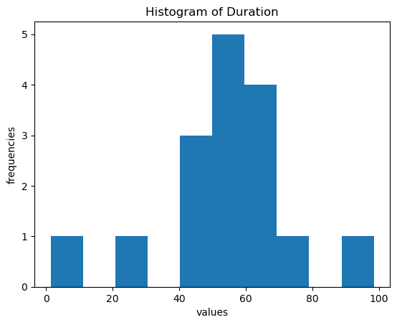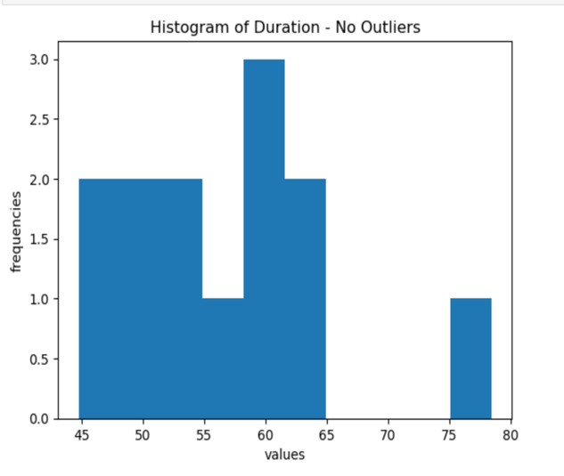
The second graph which has no outliers is seen much more regular.
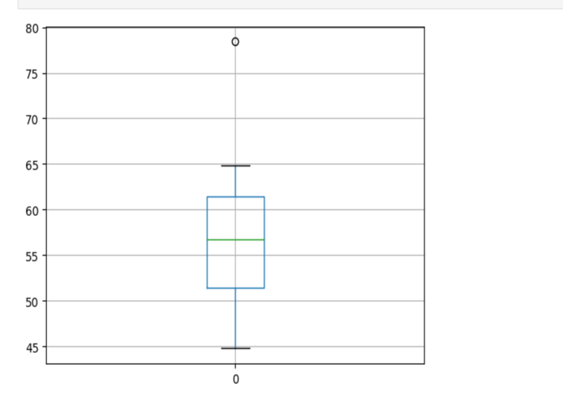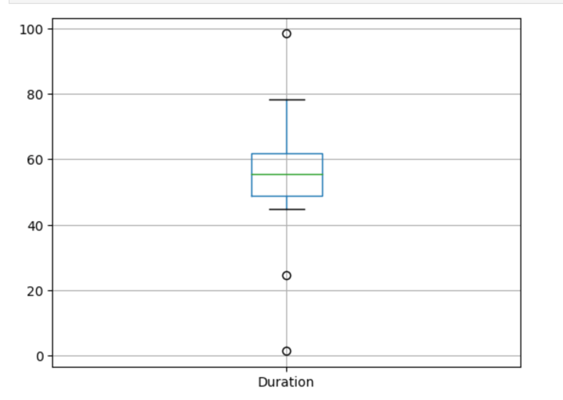
Data cleared from outliers gives us a much more precise and accurate view. The standard deviation is higher when outliers are included.
We should exclude the outliers. Without outliers graphs or datasets will give much more precise informations.
With outliers
0 2017-11-16 Thursday 64.83
1 2017-11-20 Monday 61.35
2 2017-11-22 Wednesday 56.75
3 2017-11-23 Thursday 59.44
4 2017-11-24 Friday 44.77
5 2017-11-27 Monday 78.41
6 2017-11-28 Tuesday 54.54
7 2017-11-29 Wednesday 63.02
8 2017-12-04 Monday 61.43
9 2017-12-06 Wednesday 49.66
10 2017-12-10 Sunday 24.65
11 2017-12-11 Monday 46.98
12 2017-12-14 Thursday 98.41
13 2017-12-18 Monday 1.36
14 2017-12-21 Thursday 51.43
15 2017-12-22 Friday 54.04

Without outliers

0 2017-11-16 Thursday 64.83
1 2017-11-20 Monday 61.35
2 2017-11-22 Wednesday 56.75
3 2017-11-23 Thursday 59.44
4 2017-11-24 Friday 44.77
5 2017-11-27 Monday 78.41
6 2017-11-28 Tuesday 54.54
7 2017-11-29 Wednesday 63.02
8 2017-12-04 Monday 61.43
9 2017-12-06 Wednesday 49.66
10 2017-12-10 Sunday 24.65
11 2017-12-11 Monday 46.98
12 2017-12-21 Thursday 51.43
13 2017-12-22 Friday 54.04

c-)
It's hard to believe that this dataset will create a random sample when you're with the outliers because on some days the traffic blocked the reach, so it's extraordinary. But when we exclude Outliers, it turns into a much more normal dataset. The decrease in standard deviation from 21.1386 to 8.8869 is a convincing reason to create a random sample.

d-)
For the average duration time of travel I prefer to say average without outliers(54.44). Since outliers distort the balance and accuracy of graphs. I can easily say same thing for standart deviaton(8.8869). I think sample size is not enough to decide estimate average or standart deviation.
If my friends give importance to time management he should move to Maslak to not stay in traffic congestion. 2 hour per day is too much. It means 10 hours per week which is 1/17 for one week. But for more social and entertainment life maybe he can choose Teşvikiye.

