Adnan Gültekin

Let X be an exponential random variable with parameter ¼. Then E[X]= μ_{X}=4, σ²_{X}=16, q1=4 ln(4/3)=1.49, q2=median=4ln(2)=2.614, q3=4ln(4)=6.833, and the skewness of X is 2.

- Generate 500 exponential random variables with parameter ¼ and store them in Exp5[100,5], so that the matrix has 5 columns and 100 rows. Hence, we have 100 samples, each having a sample size of 5. 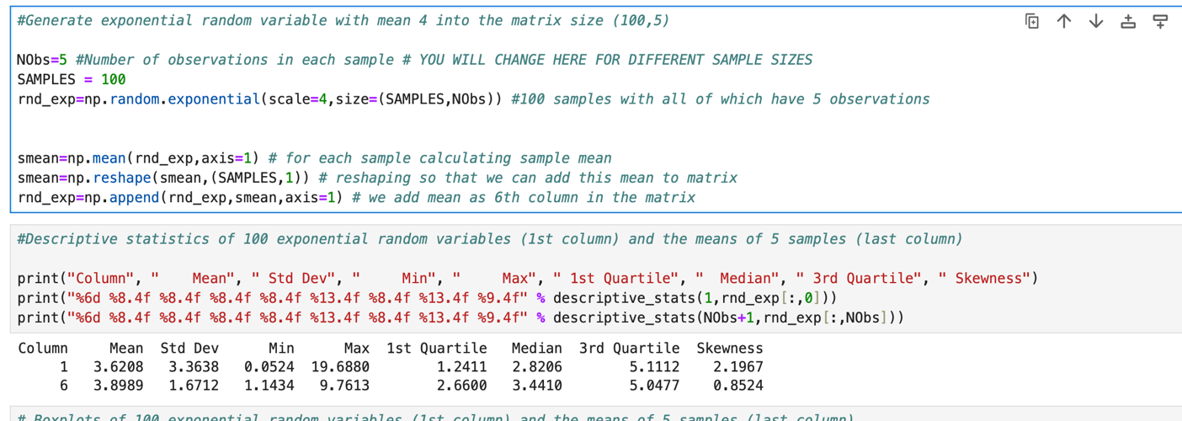
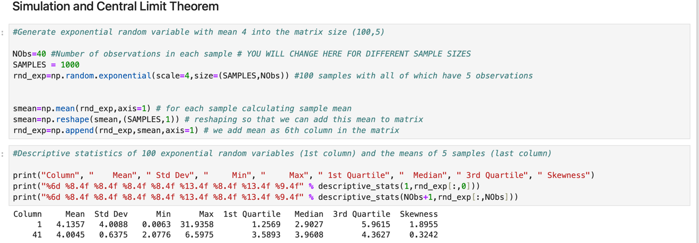
When we increase sample and nobs mean approaches much more the theoretical value of expected value 4. Also standart deviation approaches to 4 which should be 4 in optimistic scenario. Median is also approaches to 4. Skewness is lower than other scenario since when we increase sample it approaches optimal graph design. 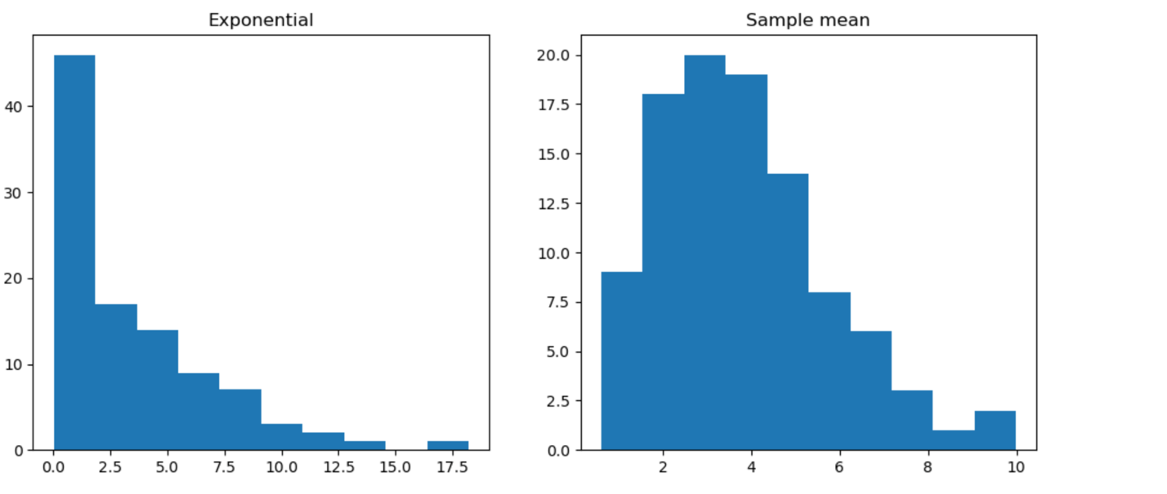
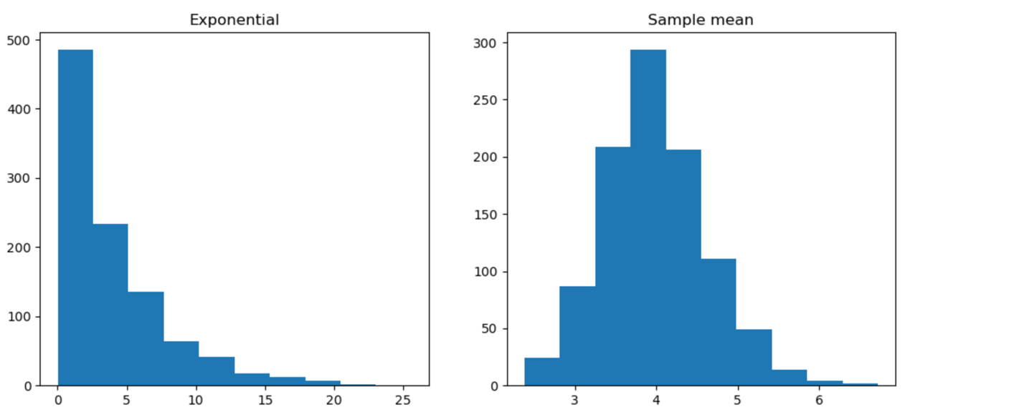

For the 1000 samples it looks like normal random variable graph since there are much more samples. We can easily see that from histogram graph. 1000 samples’ graph’s mean is like normal random variable .
- Repeat the experiment in part 1) when the sample size is 40: In part (1), you generated 100 samples, each with a sample size of 5. Now you will generate 1000 samples, each with a sample size of 40. Find the descriptive statistics of the sample means, and plot them. Specify the approximate distribution (along with its parameters) of the sample means that you expect. Compare the statistics and the shapes of the sample plots with those of this approximate distribution.

For the 1000 samples it looks like normal random variable graph since there are much more samples. We can easily see that from histogram graph. 1000 samples’ graph’s mean is like normal random variable . When we increase sample and nobs mean approaches much more the theoretical value of expected value 4. Also standart deviation approaches to 4 which should be 4 in optimistic scenario. Median is also approaches to 4. Skewness is lower than other scenario since when we increase sample it approaches optimal graph design.

CONFIDENCE INTERVALS
Let X be a normal random variable with mean μ=5 and σ=1. Generate 100 samples of n=10 from the random variable X.

Z score: 1.959963984540054, Width of the interval [0.87652254] for n=10

Z score: 1.959963984540054, Width of the interval [1.23959006] for n=20

Number of intervals that covers mean: 95.0 for n=10

Number of intervals that covers mean: 98.0 for n=20

5-) Write the necessary formulas to count the number of intervals that contain the population mean μ=5. Repeat the experiment to observe the changes in the confidence intervals and the number of intervals that contain the population mean μ=5. What are your observations?

When n increases confidence interval will increase as a result.

6-) How many of the intervals contain the population mean μ=5? Interpret your experiment by relating your observations to the definition of confidence intervals.

Z score: 1.959963984540054, Width of the interval [0.87652254] for n=10

Z score: 1.959963984540054, Width of the interval [1.23959006] for n=20

As you can see in these examples when n increases width of interval increases. Also according to definition we are trying to find some true values from all the above. So that n increases our confidence interval should be decreased. Z score does not change since it only depends on confidence interval.

7-)Change the confidence level 1-α, take α=0.01, 0.1. What is the effect of α on the width of confidence intervals? Explain. How does the number of intervals that contain the population mean μ=5 change by α=0.01, 0.05, 0.1? Why? Repeat the experiment if necessary to observe the changes in the confidence intervals. Interpret your experiment by relating your observations to the definition of confidence intervals.
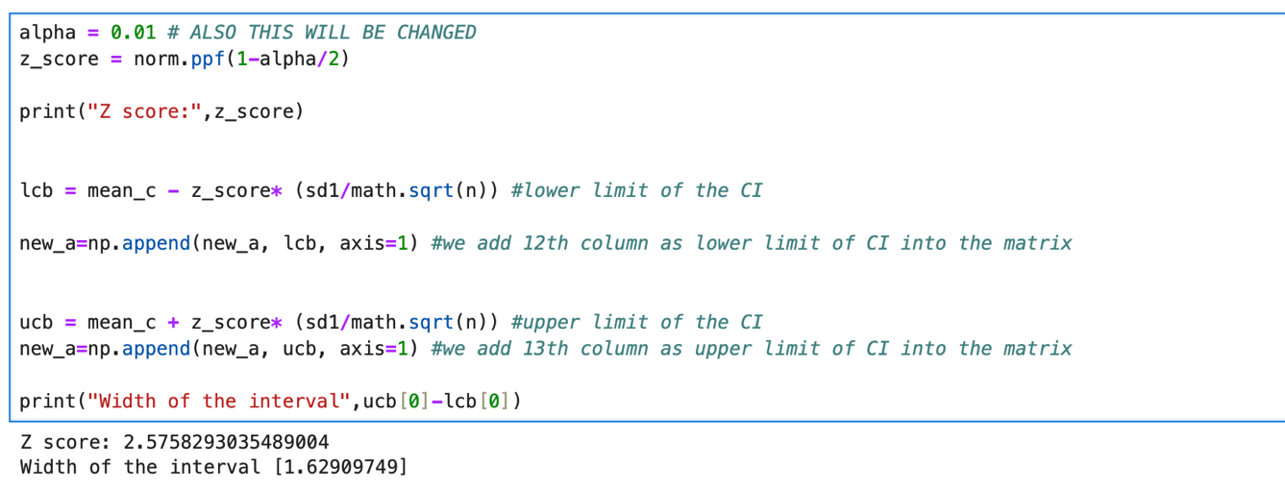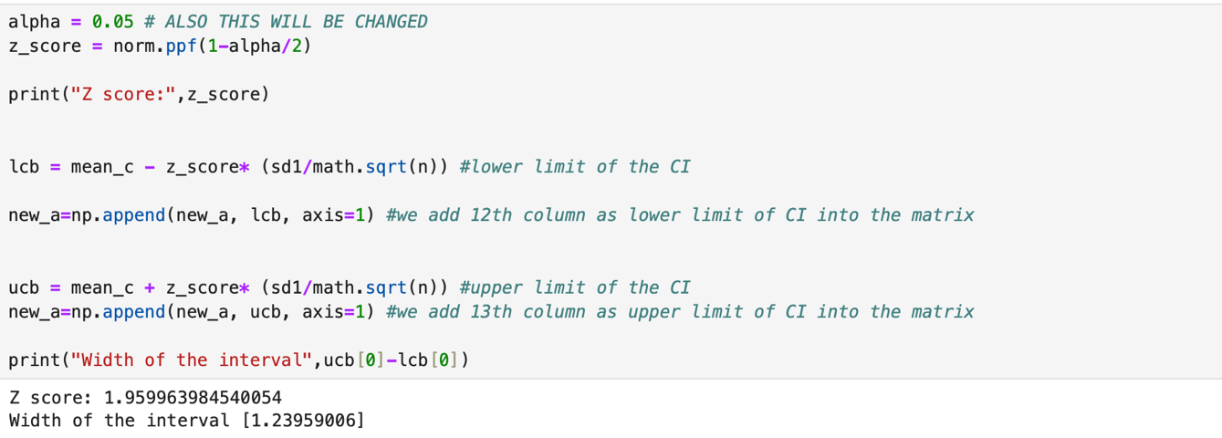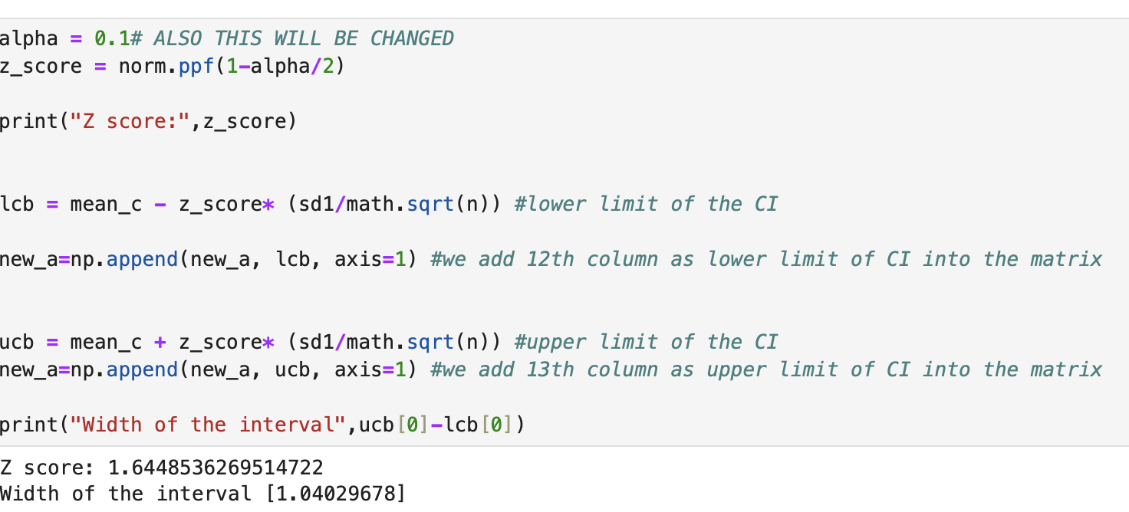

When alpha is constant and n increases width of interval increases. Also you can easily see from these three pictures, when we increase the alpha width of interval increases.
8-)Change the number of observations in the sample, n, take n=2, 30. How many of the intervals contain the population mean at α=0.05? Does it change by n? Why or why not? Explain. What is the effect of n on the width of confidence intervals? Explain.

Number of intervals that covers mean: 95.0 for n=2

Number of intervals that covers mean: 96.0 for n=30

Theorotically It should not be changed. By formula since confidence interval is measured by 1-alpha they should be same. But since randomness it differs. Width of confidence interval is only depends on n. Since sample size increases it should be much more wider.

