Adnan Gültekin LAB-5 86816

I.3-) Test Statistics = (Xbar – mu0) / (sigma / squareroot(n))
Rejection = abs(Z0) > z (a/2)
Type-I error rate = #rejectedH0 / total simulation number

since 0.02 is less than 0.05 we cannot reject the H0. Soy es they can suggest that u=50.

I.4-) I changed the alpha to 0.01. To conclude:
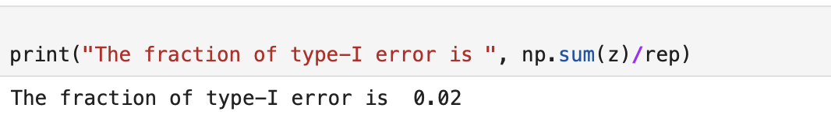
I mistakenly rejected 0.02 of the values when a=0.01.
I changed the alpha to 0.1. To conclude:
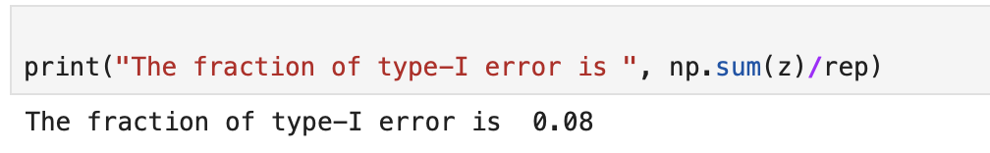
I mistakenly rejected 0.08 of the values when a=0.1.
These values are normal simce they are close to alpha.
Alpha value indicates the interval of rejection. So that if we increase the alpha type the probability of the sample average falling into this region increases.

I.5-) When alpha=0.05 , n = 5, sigma = 5
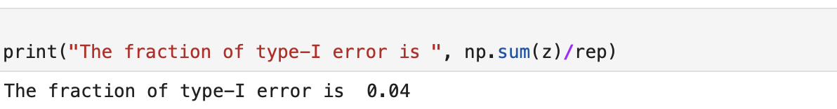
When alpha=0.05 , n = 50, sigma = 15
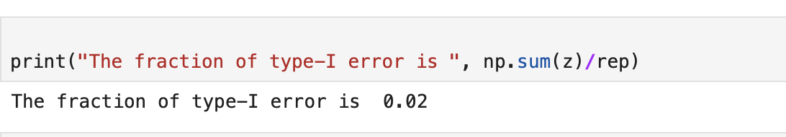
So that we can see easily type-I error does not change so much even if we change values that much.

I-6) 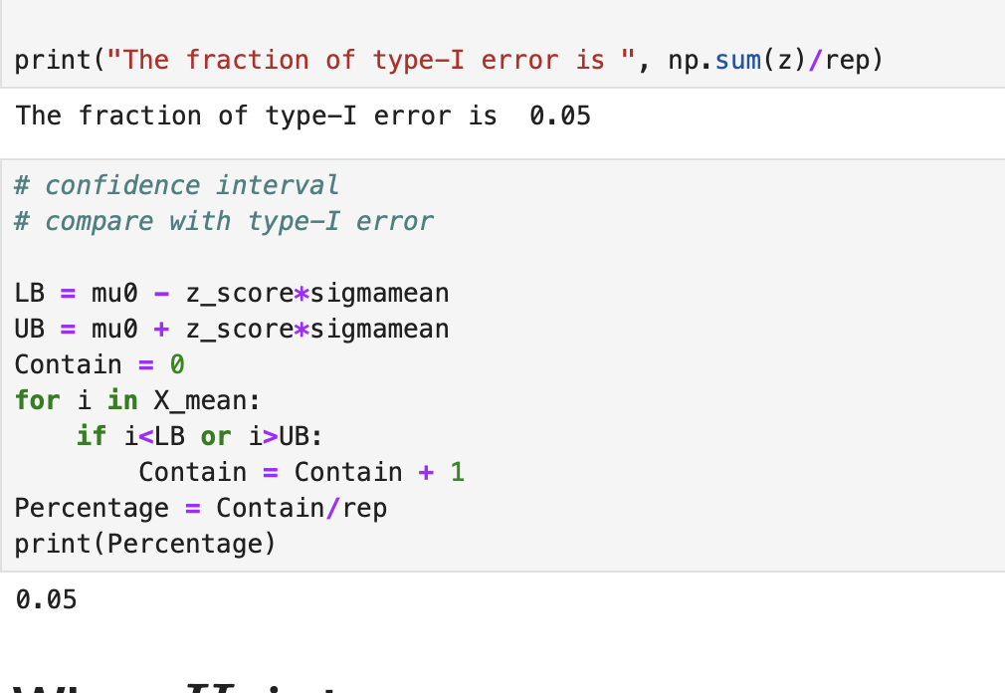
We can see that percentage and type I error are same since their formula is same.

II. 3-) Zalt = (Ybar – mu0) / (sigma/squareroot(n))
-z(alpha/2) =< Zalt <= z(alpha/2)
TYPE II Error rate = 1- (the rejection rate of H0)
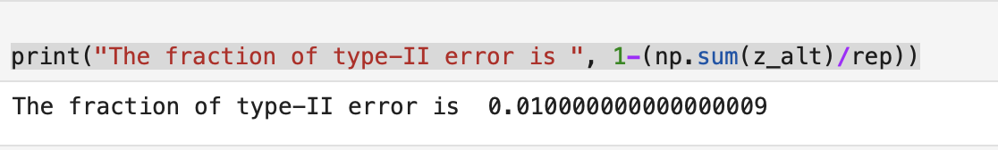
They cannot suggest that u=50 since typeII error is so low.
II. 4-) When u=40;
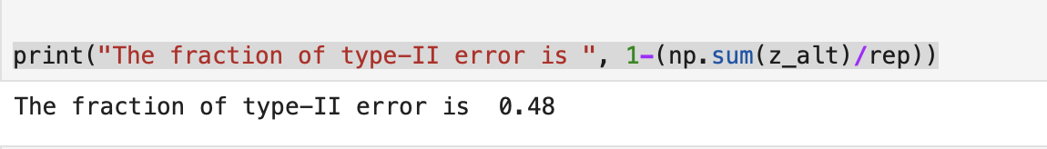

When u=45;
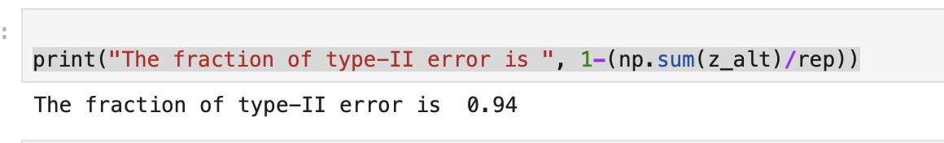

When u=35;
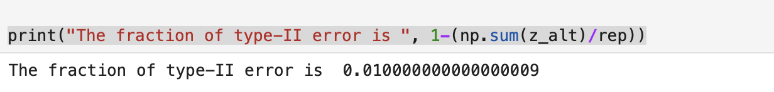
By the increasing value on Ua type II error increases.

II4-) Alpha value indicates the interval of rejection. So that if we increase the alpha type the probability of the sample average falling into this region increases.

I-5.) n=5 and sigma = 5
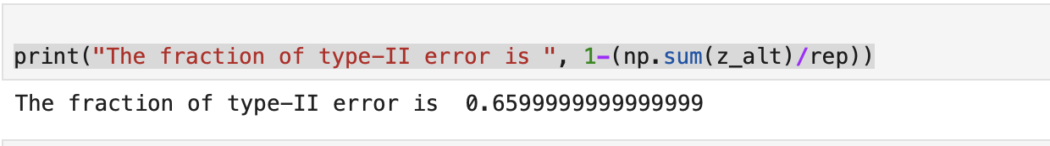

n=50 sigma = 15
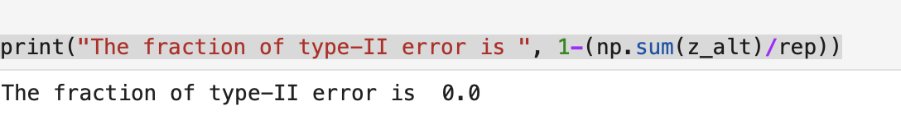

This proves the importance of working with larger sample groups for more reliable and powerful statistical results.

I-7.)Since both value is calculated by the same boundary values they must be same.

