Adnan Gültekin - 86816
LAB-6

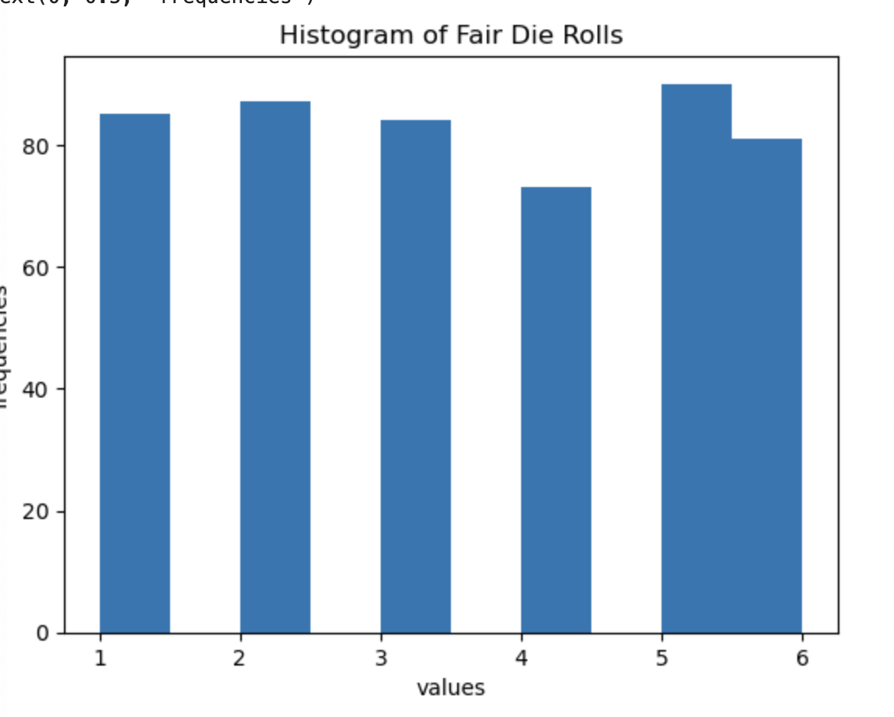

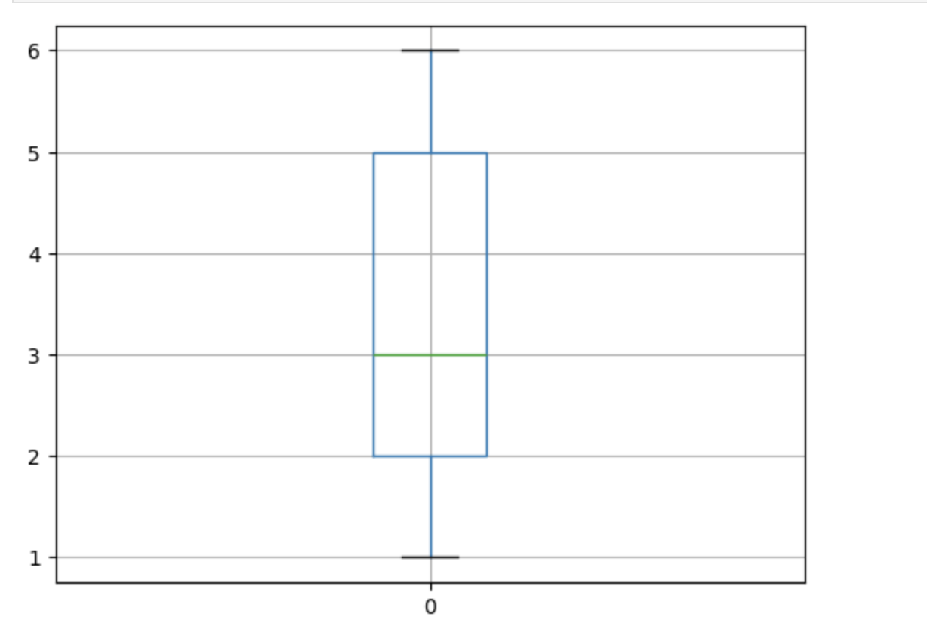
Yes, the results suggest that the outcomes come from a fair die because the frequencies of the numbers 1–6 are close to each other. The mean is also close to 3.5, which is expected for a fair die. Small differences are normal due to randomness.
3-)
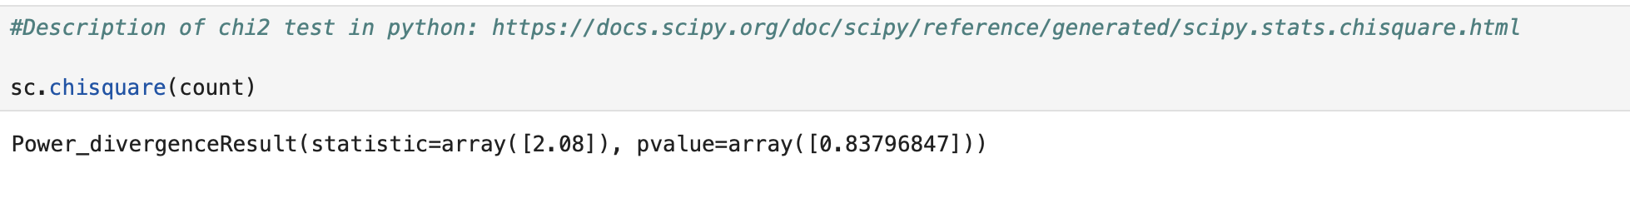
Since p-value is so big when compared to 0.05, 0.10 and 0.15 we cannot reject the hypothesis. So we can say the die is fair.

B-)
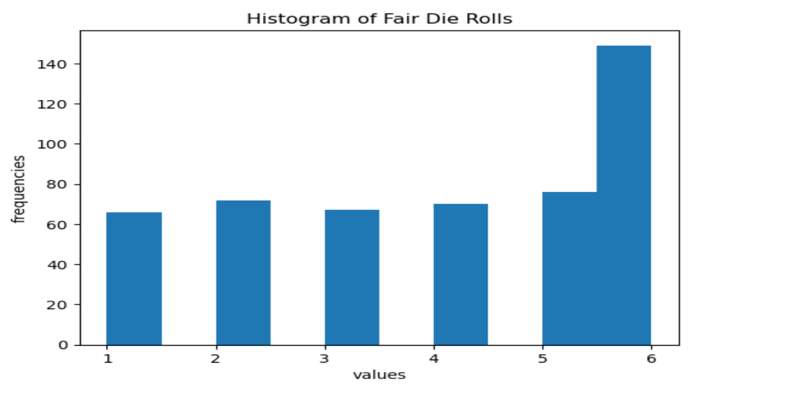
When we look at the histogram graph we can easily see the big difference between frquencies of 6 and others’. So we cannot say this information is enough to reject hypothesis. These distribution is not suitable to be fair.
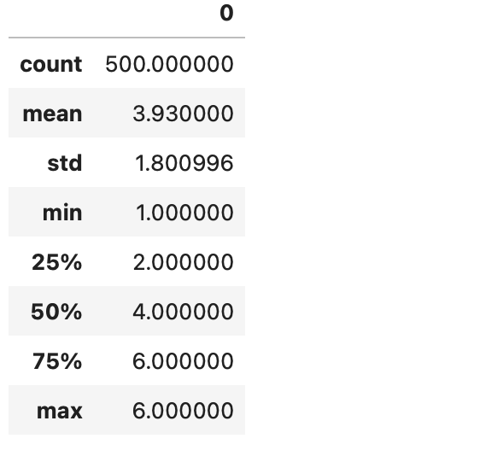
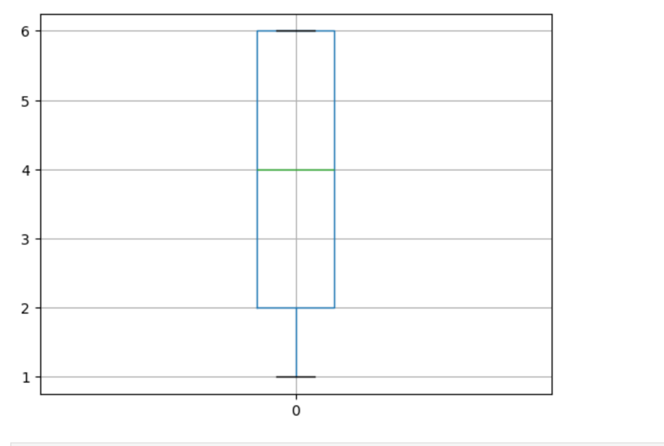
We cannot say this distribution comes from a fair die. For example when we looked to boxplot mean is 4 now and there is no upper tail which means an issue for boxplot. And also we can see from the histogram frequencies of 6 really higher than other numbers which can easily show that the unfair die distribution.
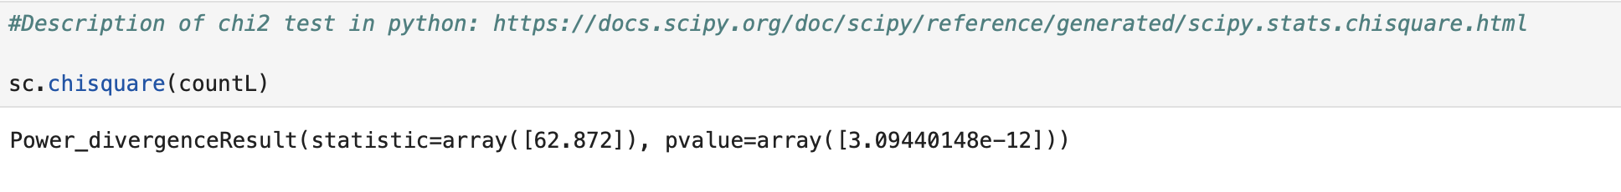
The p value is significantly lower than 0.05 which means we can reject the null hypothesis. Null hypothesis was “fair is die.” According to part B distribution we can say the die is not fair.

C-)
When p=500
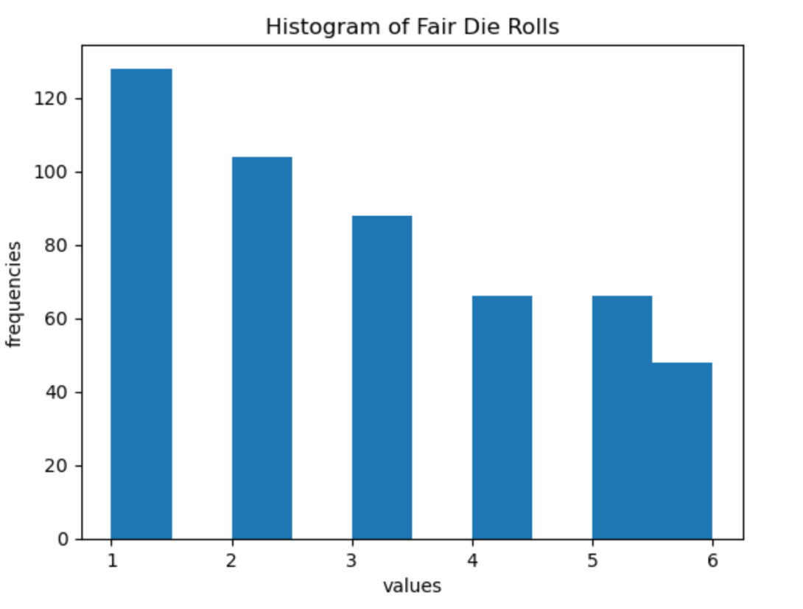
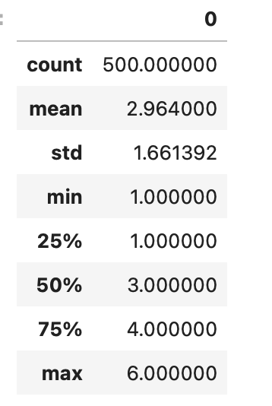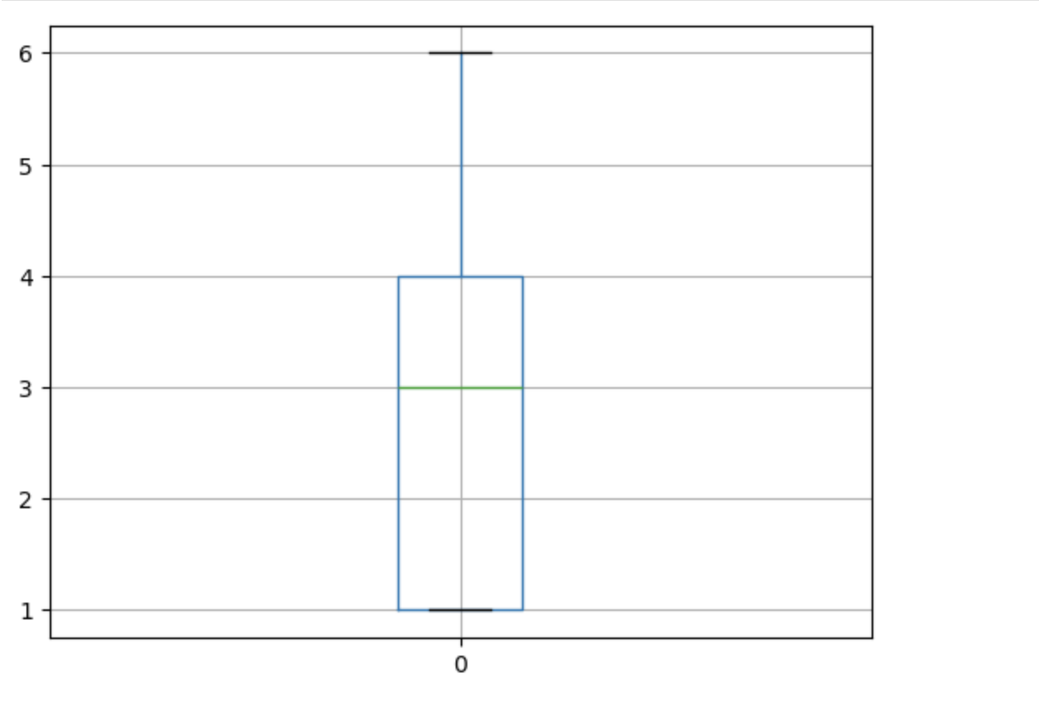
When p=1000:
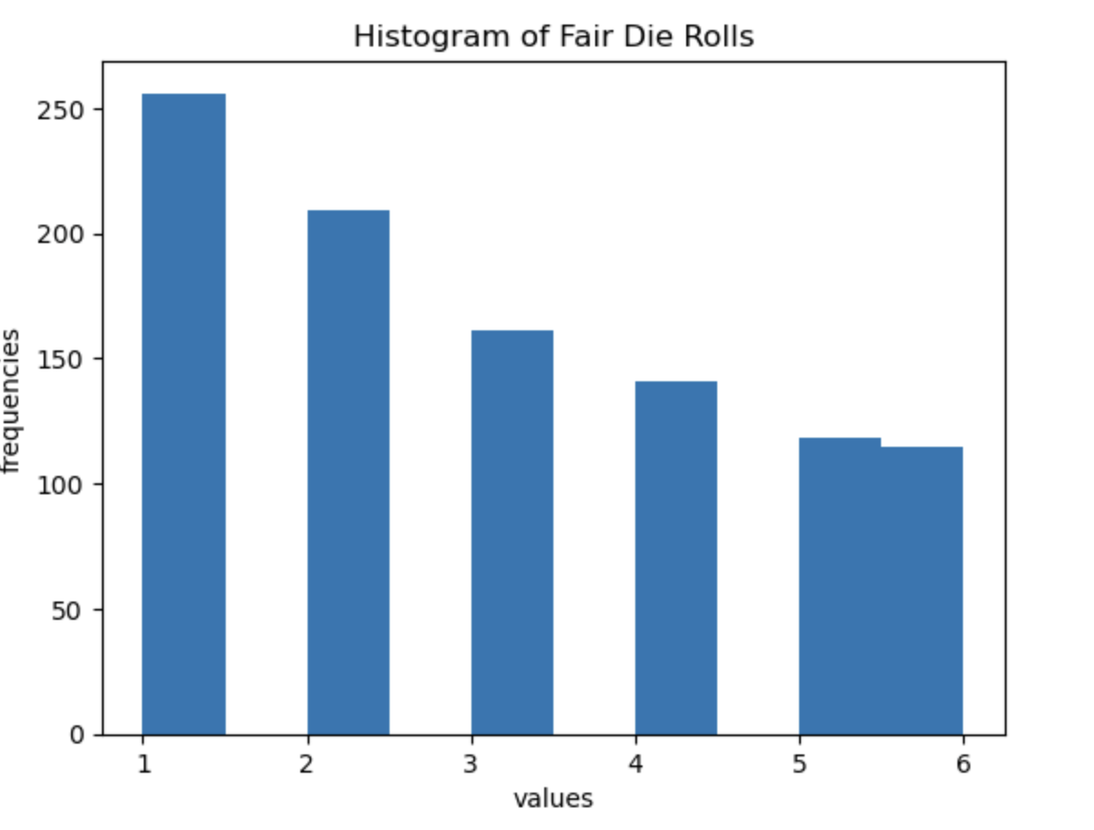
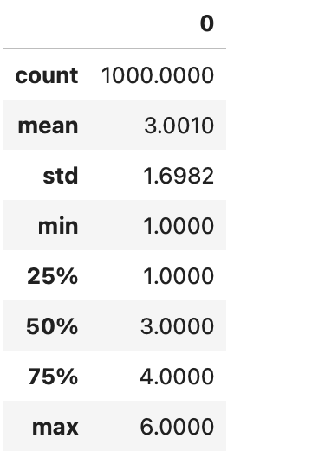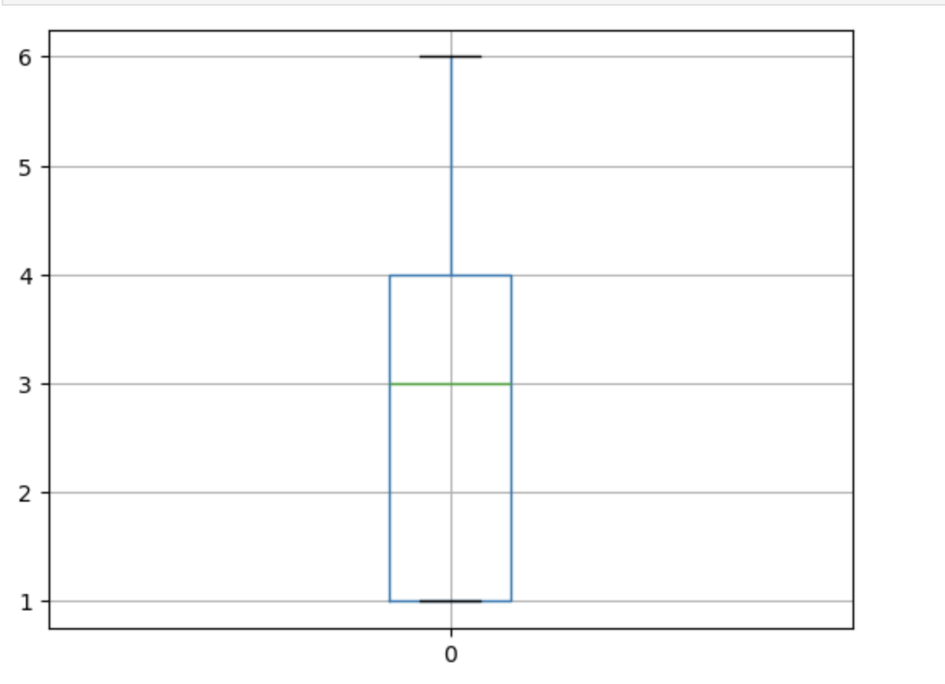
When I changed the repeat number 500 to 1000 approximately all the values stay same out of mean and standart deviation since when we increase the number of repeatition its randomness increases. So mean and standart deviation can change but the quartiles stay same since they are independent from number after a specific number.
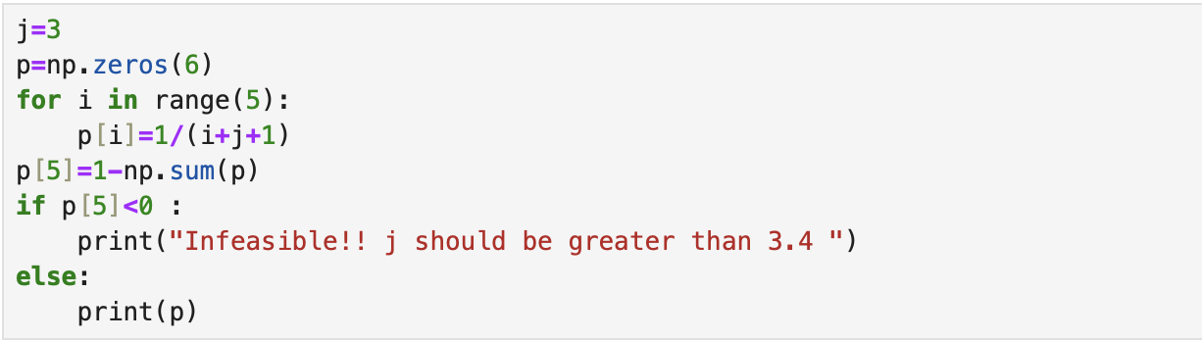
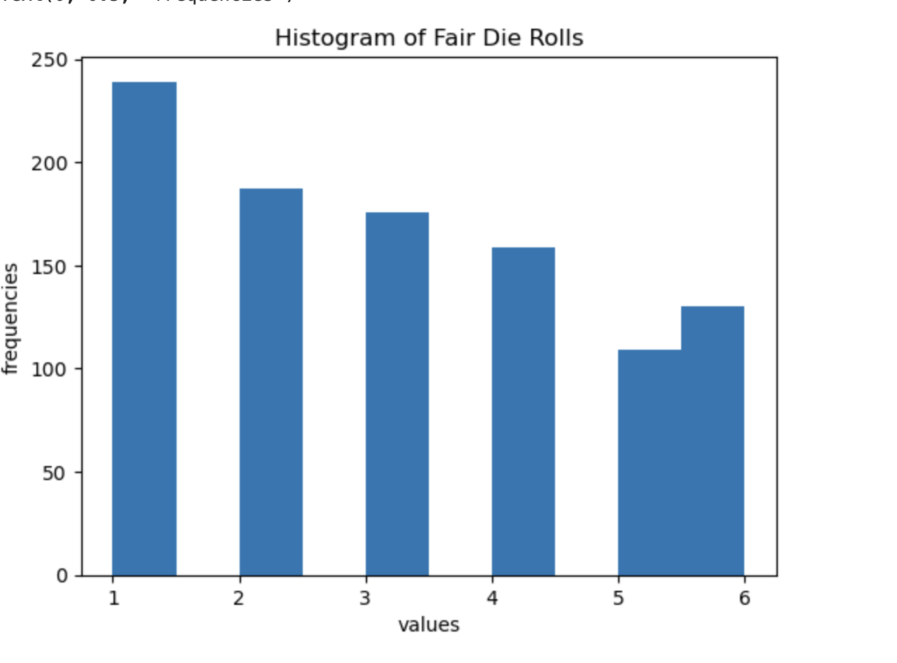
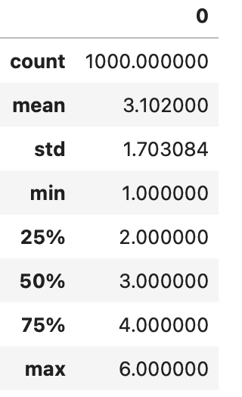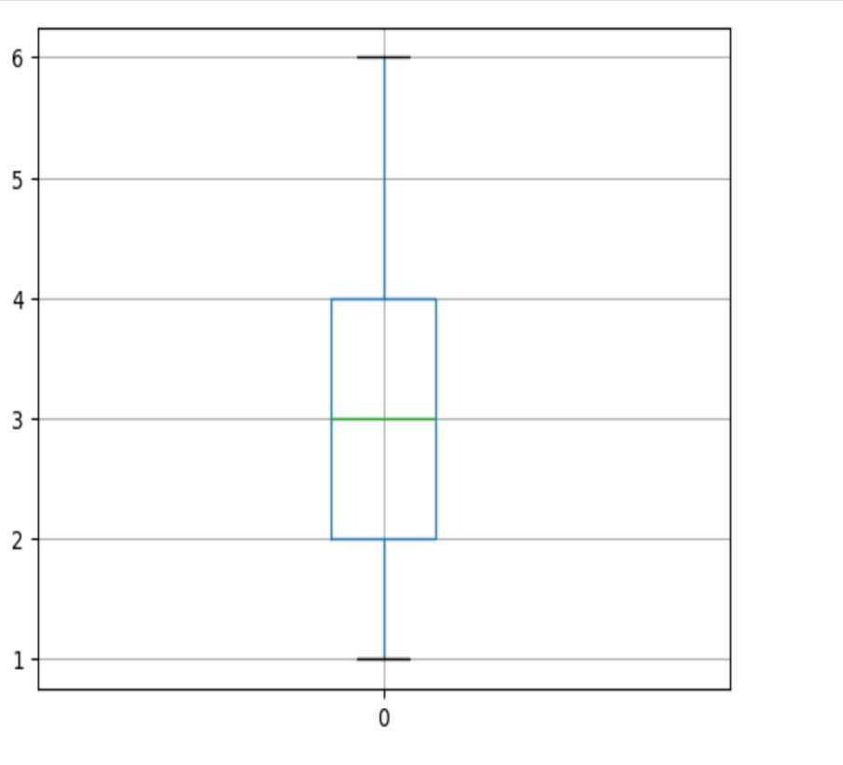
pvalue=array([3.09440148e-12]

8-) Now it is also really near the part B values but the mean is a bit higher since we changed the formula of probability mass function. Probability of P(6) is now a bit higher than the previous one since we do not apply the formula to p(6) (1-sum of others). Also we can not say fair die since the p value is really lower than 0.05. Fair is not die.

- We can use the histogram graph to decide the homogenity and independence. If the values are not distributed equally likely we can say there is no homogenity or vica versa. To test the independency we can change the prob of mass function. If there is a big change we can say there is a depedency relation with the numbers.

