LAB – 7
a-)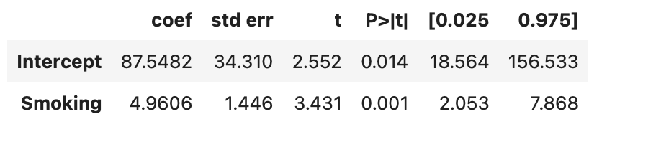
H0: smoking is effected on cancer
H1: smoking is not effected on cancer
Since smoking p-value which şs 0.001 smaller than 0.05, smoking is significant for death rates.
b-) 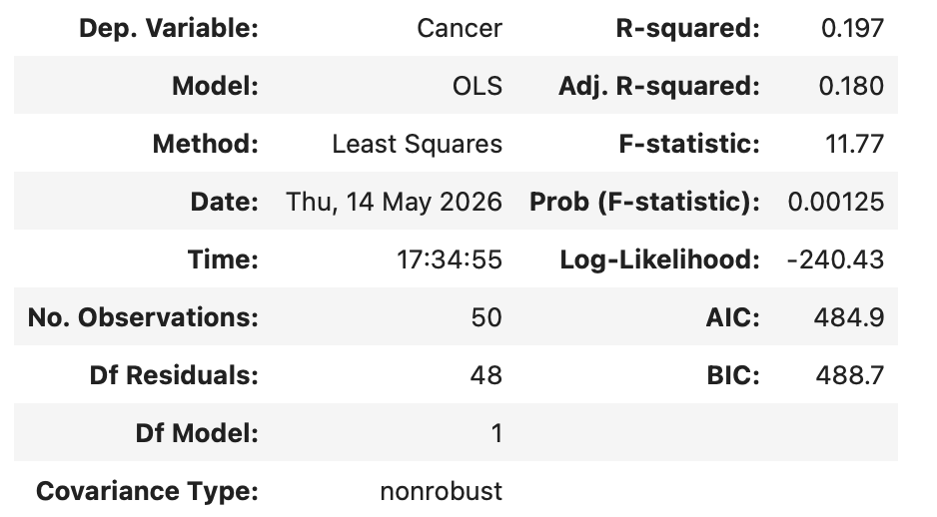
R^2 error rate is 19.7%. That rate is not much high. So we cannot say this is enough. There might be some other reaosons of cancer.

c-)
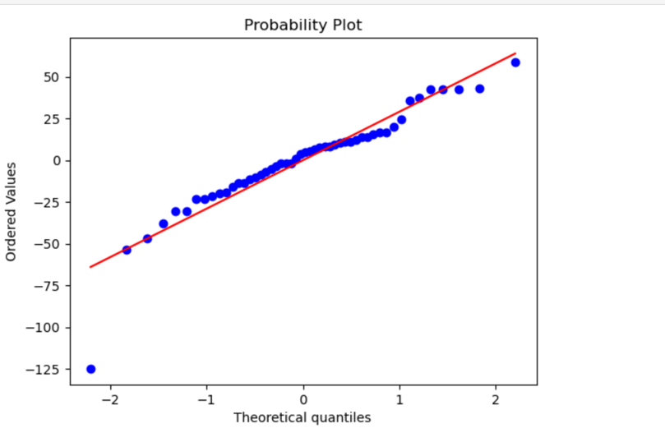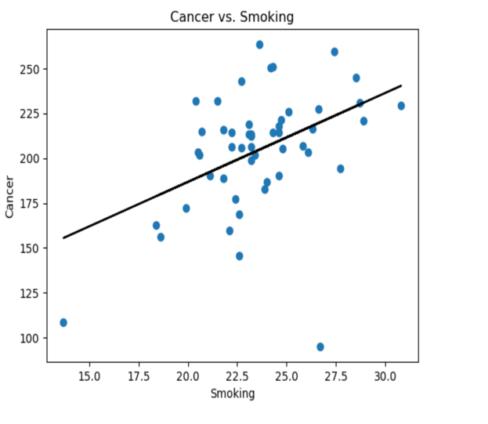
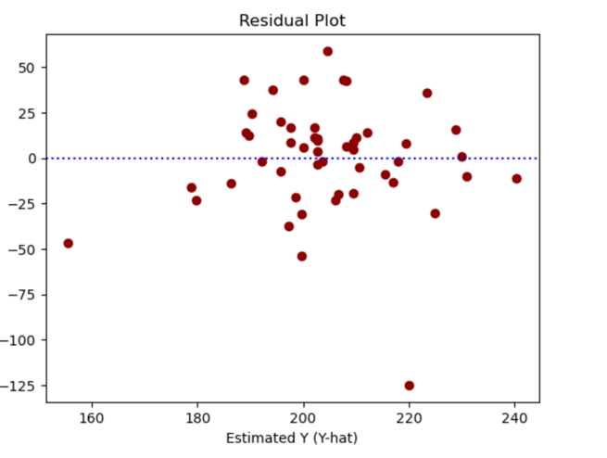
As we can see from graph 2 as smoking increases cancer rate also increases. We can say from that interpretation they are correlated. But that correlation is not too strong since in first graph there are deviatons from red line. Also from third line we can say they clustered among the 0 so conditions are provided.
B-)
a-) 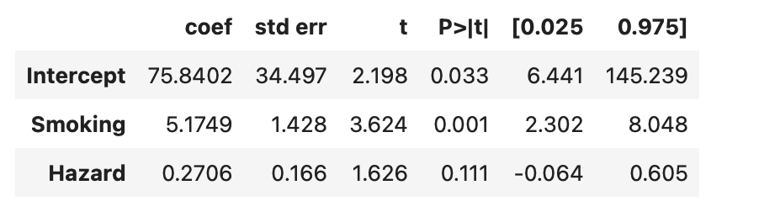
We can say model is significant to predict variable cancer. Since p value is smaller than 0.05.
b-) Since p value is smaller than 0.05 for smoking it is significant to predict variable cancer. Since p value of hazard is greater than 0.05 we can say it is not significant to predict variable cancer.

c-)
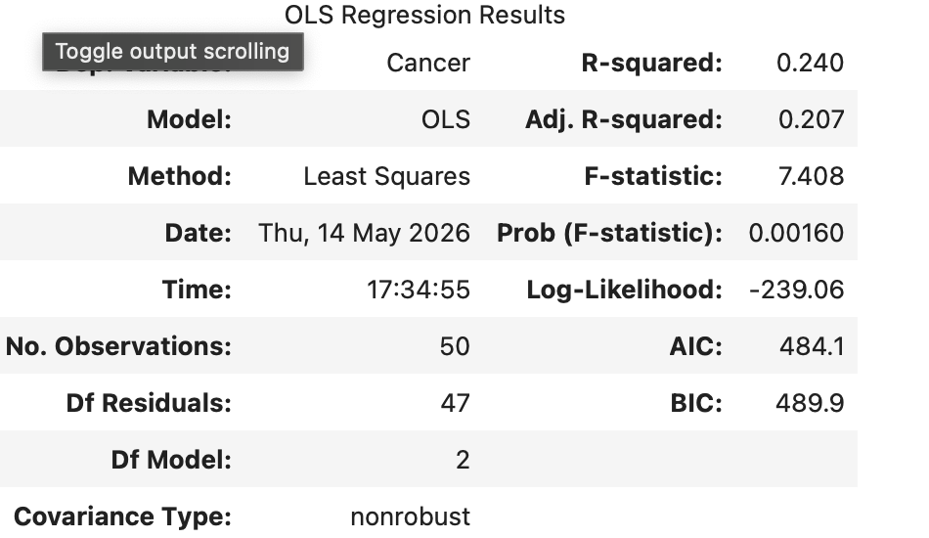
R-squared is 24% which cannot be said enough significant to predict variable cancer. Since percantage is small we can think that there are additional sources other than smoking and hazard. It is higher than 19.7% so model is more meaningful right now.
d-)
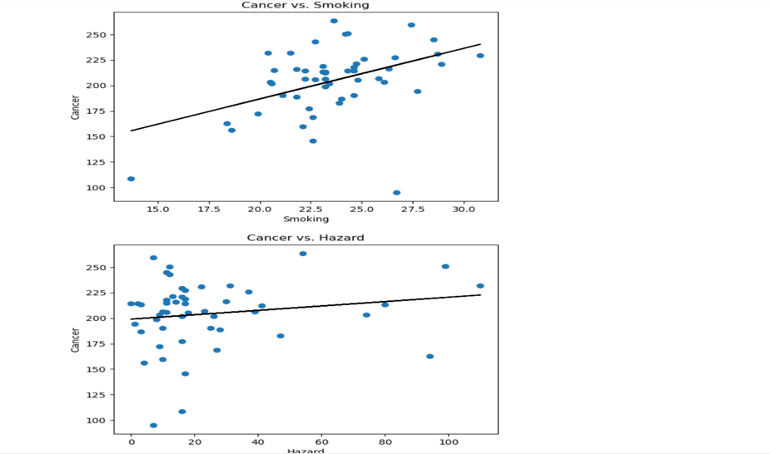
We can interpret that graph as smoking is significant to predict cancer since they are on the same line approximately. However for hazard we cannot say same notion since the datas are clustered in the beginning of plot.
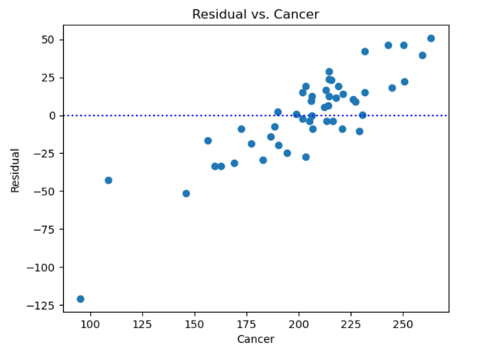
We can see from that graph There is no random distribution on cancer which is not good for our model.
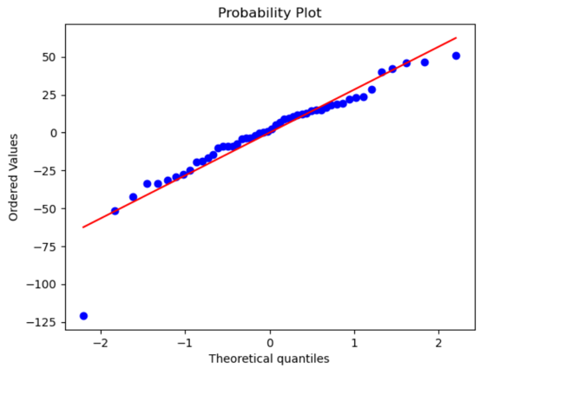
It shows big similarity on red line but there are also some deviatons, outliers which say it is not 100% significant.

3-) I prefer to use model 2 since it contains more than first model. First model’s R-squared rate is 19.7% and model 2’s R-sqaured rate is 24%. Also in second. Model there are more than 1 variable which leads to more general information about cancer.
4-)
a-) There might be 7 linear regression model and this is the best one since its R-squared rate is the highest. We can say that meodel is significant to predict variable cancer.
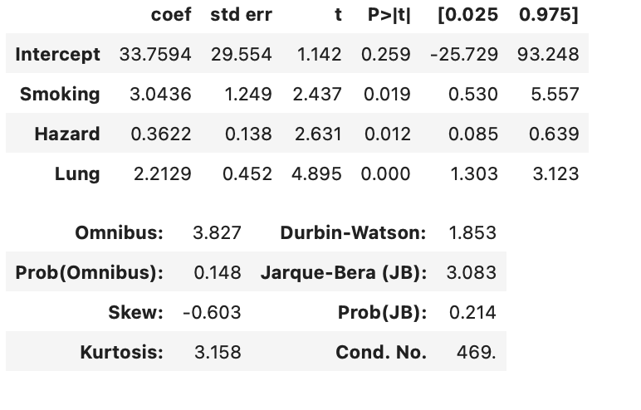

b-)
Smoking, hazard and lung are significant on model since their p values are smaller than 0.05.
c-)
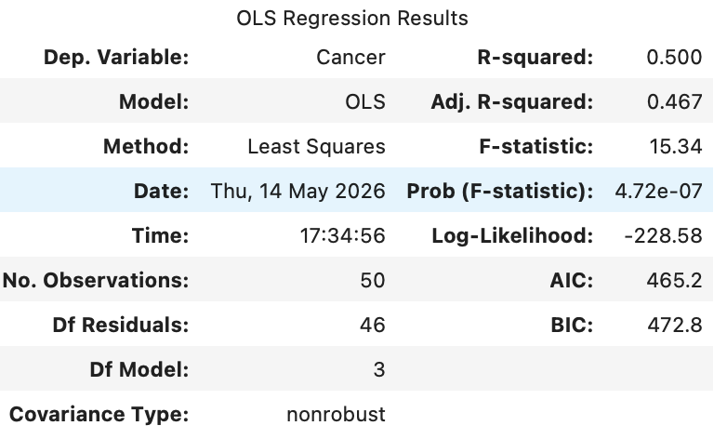
R-squared rate is 50% which is good rate to be enough. Since there are three variable and R-squared rate is higher than other models.
Ü

d-)
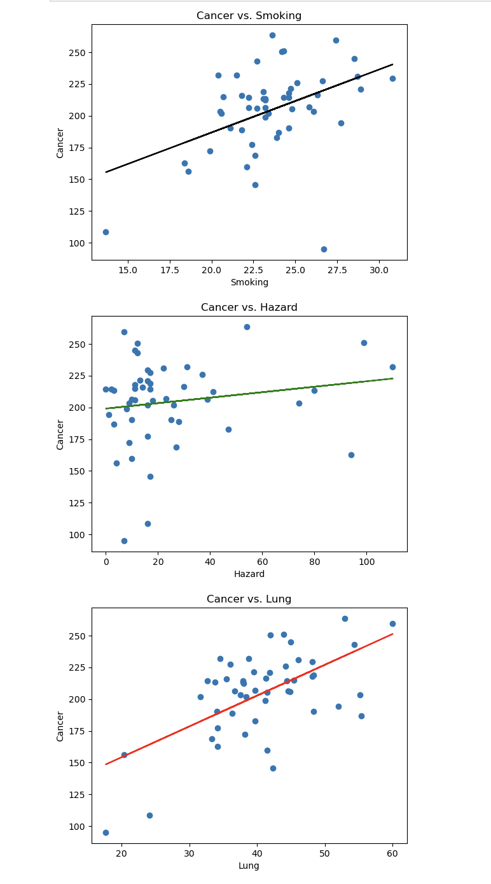
As like in other models there is a significant relationship with between smoking, lung and cancer but there is no significant relationships between hazard and cancer.
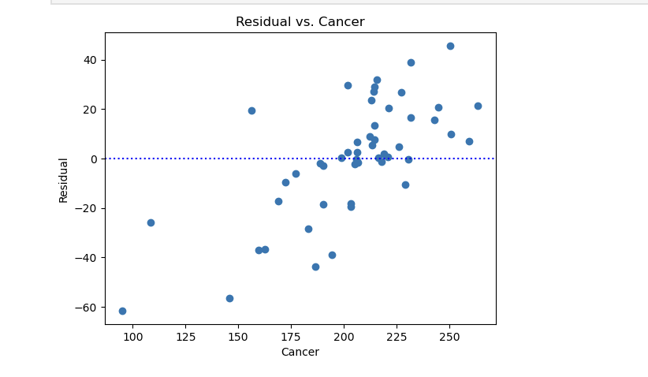
Residual and cancer have correlation so they are not random which is not good for our model.
e-) We need to prefer that model since its R-squared rate is much more higher than other two models and it focuses on three variables which is really good and comprehensive for significance of model.

