buatkan tutorial lengkap dari nol: Node.js → Docker → GitHub Actions → AWS EKS (2 node) → NGINX Ingress → DuckDNS → HTTPS Let's Encrypt.
Berikut adalah tutorial end-to-end untuk membuat aplikasi Node.js dan melakukan deployment otomatis ke AWS EKS (2 node) menggunakan GitHub Actions, NGINX Ingress, DuckDNS, dan Let's Encrypt SSL.

Arsitektur
Developer
│
▼
GitHub Repository
│
▼
GitHub Actions (CI/CD)
│
├── Build Docker Image
├── Push ke Docker Hub
└── Deploy ke EKS
│
▼
AWS EKS Cluster
│
▼
NGINX Ingress
│
▼
AWS Load Balancer
│
▼
agunglab.duckdns.org
│
▼
HTTPS (Let's Encrypt)

1. Prasyarat
Install:

AWS CLI
aws --version

kubectl
kubectl version --client

eksctl
eksctl version

Docker
docker version

Git
git --version

2. Buat Aplikasi Node.js
Buat folder:
mkdir nodejs-app
cd nodejs-app

package.json
{
"name": "nodejs-app",
"version": "1.0.0",
"main": "app.js",
"dependencies": {
"express": "^4.18.2"
}
}

app.js
const express = require('express');
const app = express();
app.get('/', (req,res)=>{
res.send('Hello from Kubernetes EKS');
});
app.listen(3000, ()=>{
console.log('Server running');
});
Install dependency:
npm install
Run:
node app.js
Test:
curl localhost:3000
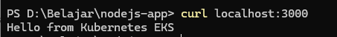

3. Dockerize Application

Dockerfile
FROM node:20-alpine
WORKDIR /app
COPY package*.json ./
RUN npm install
COPY . .
EXPOSE 3000
CMD ["node","app.js"]
Build:
docker build -t nodejs-app .
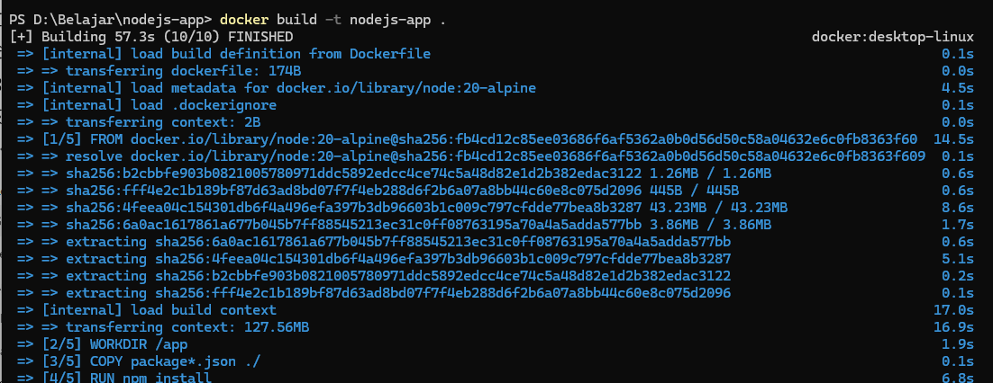
Run:
docker run -p 3000:3000 nodejs-app
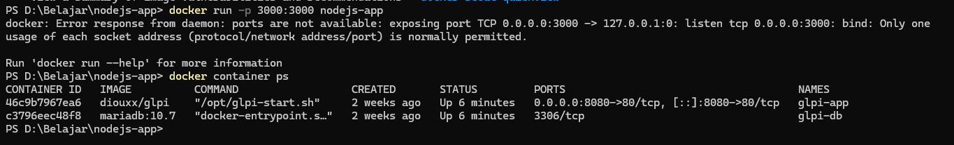

4. Push ke Docker Hub
Login:
docker login
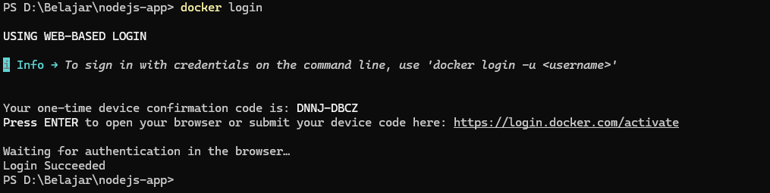
Tag:
docker tag nodejs-app username/nodejs-app:v1

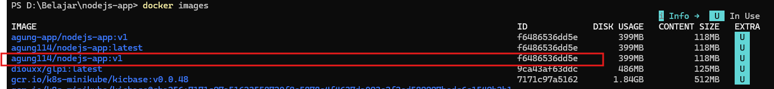
Push:
docker push username/nodejs-app:v1
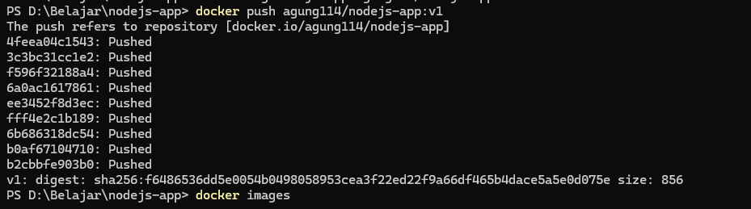

5. Buat AWS EKS Cluster

Buat VPC dan Cluster
eksctl create cluster \
--name devops-cluster \
--region ap-southeast-1 \
--nodegroup-name workers \
--node-type t3.medium \
--nodes 2
Verifikasi:
kubectl get nodes
Output:
ip-10-0-1-10 Ready
ip-10-0-2-20 Ready

6. Deploy Application ke Kubernetes
Buat folder:
mkdir k8s

deployment.yaml
apiVersion: apps/v1
kind: Deployment
metadata:
name: nodejs-app
spec:
replicas: 2
selector:
matchLabels:
app: nodejs-app
template:
metadata:
labels:
app: nodejs-app
spec:
containers:
- name: nodejs-app
image: username/nodejs-app:v1
ports:
- containerPort: 3000

service.yaml
apiVersion: v1
kind: Service
metadata:
name: nodejs-service
spec:
selector:
app: nodejs-app
ports:
- port: 80
targetPort: 3000
type: ClusterIP
Apply:
kubectl apply -f deployment.yaml
kubectl apply -f service.yaml

7. Install AWS Load Balancer Controller
Buat IAM OIDC:
eksctl utils associate-iam-oidc-provider \
--cluster devops-cluster \
--approve
Install Helm:
curl https://raw.githubusercontent.com/helm/helm/main/scripts/get-helm-3 | bash
Tambah repo:
helm repo add eks https://aws.github.io/eks-charts
helm repo update
Install controller:
helm install aws-load-balancer-controller eks/aws-load-balancer-controller \
-n kube-system \
--set clusterName=devops-cluster

8. Install NGINX Ingress
Tambah repo:
helm repo add ingress-nginx https://kubernetes.github.io/ingress-nginx
Install:
helm install nginx-ingress ingress-nginx/ingress-nginx \
--namespace ingress-nginx \
--create-namespace
Cek:
kubectl get svc -n ingress-nginx
Output:
EXTERNAL-IP
a1234.elb.amazonaws.com

9. Buat Domain DuckDNS
Buka:
DuckDNS
Login menggunakan GitHub.
Buat:
agunglab
Maka domain:
agunglab.duckdns.org

10. Point Domain ke AWS Load Balancer
Ambil ELB:
kubectl get svc -n ingress-nginx
Misal:
ab123.ap-southeast-1.elb.amazonaws.com
Masukkan IP atau target yang diberikan DuckDNS sesuai petunjuk dashboard mereka.
Tunggu propagasi DNS.
Test:
nslookup agunglab.duckdns.org

11. Install Cert-Manager
Install CRD:
kubectl apply -f https://github.com/cert-manager/cert-manager/releases/latest/download/cert-manager.yaml
Verifikasi:
kubectl get pods -n cert-manager

12. Buat ClusterIssuer
issuer.yaml
apiVersion: cert-manager.io/v1
kind: ClusterIssuer
metadata:
name: letsencrypt-prod
spec:
acme:
email: admin@example.com
server: https://acme-v02.api.letsencrypt.org/directory
privateKeySecretRef:
name: letsencrypt-prod
solvers:
- http01:
ingress:
class: nginx
Apply:
kubectl apply -f issuer.yaml

13. Buat Ingress
ingress.yaml
apiVersion: networking.k8s.io/v1
kind: Ingress
metadata:
name: nodejs-ingress
annotations:
cert-manager.io/cluster-issuer: letsencrypt-prod
spec:
ingressClassName: nginx
tls:
- hosts:
- agunglab.duckdns.org
secretName: nodejs-tls
rules:
- host: agunglab.duckdns.org
http:
paths:
- path: /
pathType: Prefix
backend:
service:
name: nodejs-service
port:
number: 80
Apply:
kubectl apply -f ingress.yaml

14. Verifikasi SSL
Cek:
kubectl get certificate
Output:
READY True
Buka:
https://agunglab.duckdns.org
Harus muncul:
Hello from Kubernetes EKS
dengan HTTPS valid.

15. CI/CD dengan GitHub Actions
Struktur:
.github/
└── workflows/
└── deploy.yml

deploy.yml
name: Deploy EKS
on:
push:
branches:
- main
jobs:
deploy:
runs-on: ubuntu-latest
steps:
- uses: actions/checkout@v4
- name: Login DockerHub
uses: docker/login-action@v3
with:
username: ${{ secrets.DOCKER_USERNAME }}
password: ${{ secrets.DOCKER_PASSWORD }}
- name: Build Image
run: |
docker build -t ${{ secrets.DOCKER_USERNAME }}/nodejs-app:${{ github.sha }} .
- name: Push Image
run: |
docker push ${{ secrets.DOCKER_USERNAME }}/nodejs-app:${{ github.sha }}
- name: Configure AWS
uses: aws-actions/configure-aws-credentials@v4
with:
aws-access-key-id: ${{ secrets.AWS_ACCESS_KEY }}
aws-secret-access-key: ${{ secrets.AWS_SECRET_KEY }}
aws-region: ap-southeast-1
- name: Update kubeconfig
run: |
aws eks update-kubeconfig \
--name devops-cluster \
--region ap-southeast-1
- name: Deploy
run: |
kubectl set image deployment/nodejs-app \
nodejs-app=${{ secrets.DOCKER_USERNAME }}/nodejs-app:${{ github.sha }}

16. GitHub Secrets
Tambahkan di repository GitHub:
AWS_ACCESS_KEY
AWS_SECRET_KEY
DOCKER_USERNAME
DOCKER_PASSWORD

Hasil Akhir
Setelah git push:
Developer
↓
GitHub
↓
GitHub Actions
↓
Docker Hub
↓
AWS EKS
↓
NGINX Ingress
↓
DuckDNS
↓
Let's Encrypt SSL
↓
https://agunglab.duckdns.org
Ini sudah mencerminkan arsitektur DevOps yang umum digunakan di perusahaan untuk demonstrasi CI/CD, Kubernetes, Ingress, dan SSL otomatis. Untuk portofolio yang lebih kuat, langkah berikutnya adalah menambahkan Argo CD (GitOps) sehingga alurnya menjadi:
Developer
↓
GitHub Actions (Build)
↓
Docker Hub
↓
Update Manifest GitOps
↓
Argo CD
↓
AWS EKS
Model GitOps dengan Argo CD sangat sering ditanyakan pada interview DevOps dan Cloud Engineer.

