Tanggal : 27/08/2026
Penguji : Agung Prakasa
Tempat : Graha Pos Indonesia, Lt. 4
Subjek : API Tariff — getfeeLnDiscountNew
Note : AI-Driven Blackbox API Testing — End-to-End

Data Akses Kredensial Pengujian:
A. Base URL
1. URL : http://10.29.41.37:8280/test/1.0.0
2. Endpoint : POST /getfeeLnDiscountNew
B. Authentication : None (tanpa autentikasi)

Keterangan :
Status Pengujian
OK | Jika hasil pengujian diterima
NOK | Jika hasil pengujian tidak diterima
Keterangan
P | Perbaikan
T | Tambahan / Usulan
Status Perbaikan | OK = Diterima, NOK = Tidak diterima

Ringkasan Eksekutif
Pengujian API dilakukan terhadap 101 test case dengan pass rate 79.2%. Endpoint yang diuji adalah POST /getfeeLnDiscountNew pada base URL http://10.29.41.37:8280/test/1.0.0. Pengujian mencakup normal case, abnormal case, boundary value, security, performance, data validation, dan integrasi end-to-end.

Metrik | Nilai
Total Test Case | 101
PASS | 80
FAIL | 21
Pass Rate | 79.2%
Jenis Pengujian | 7 kategori
Total Defect | 16

No. | ID | Butir  Uji | Uraian  Kegiatan | Hasil  Pengujian | Status  Pengujian | Keterangan | Evidence
API TARIFF — getfeeLnDiscountNew
Normal Case
1 | TC-P001 | Request valid standar | Request: Body valid lengkap  Expected: Status 200, response JSON | Status: PASS  Status: 200, Duration: 187ms | OK |  | 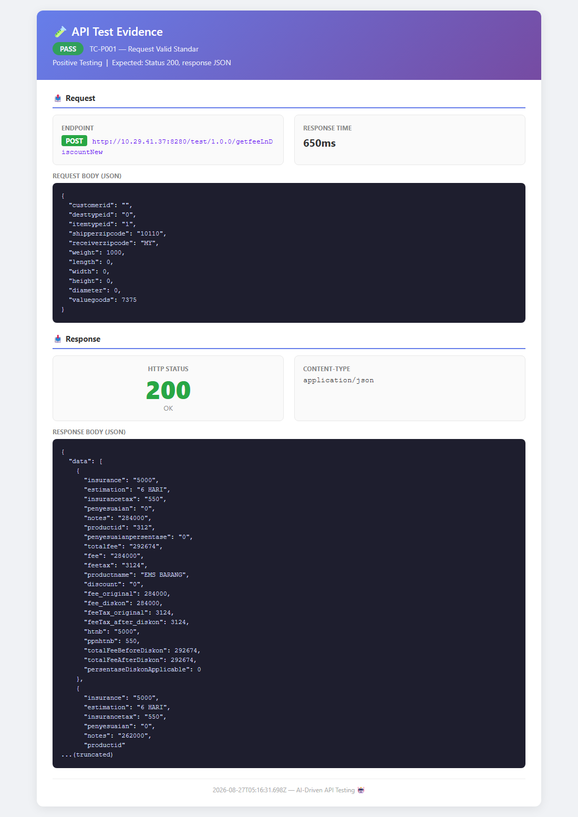
2 | TC-P002 | Weight dalam gram | Request: weight: 1000  Expected: Status 200, tarif dikembalikan | Status: PASS  Status: 200, Duration: 0ms | OK |  | 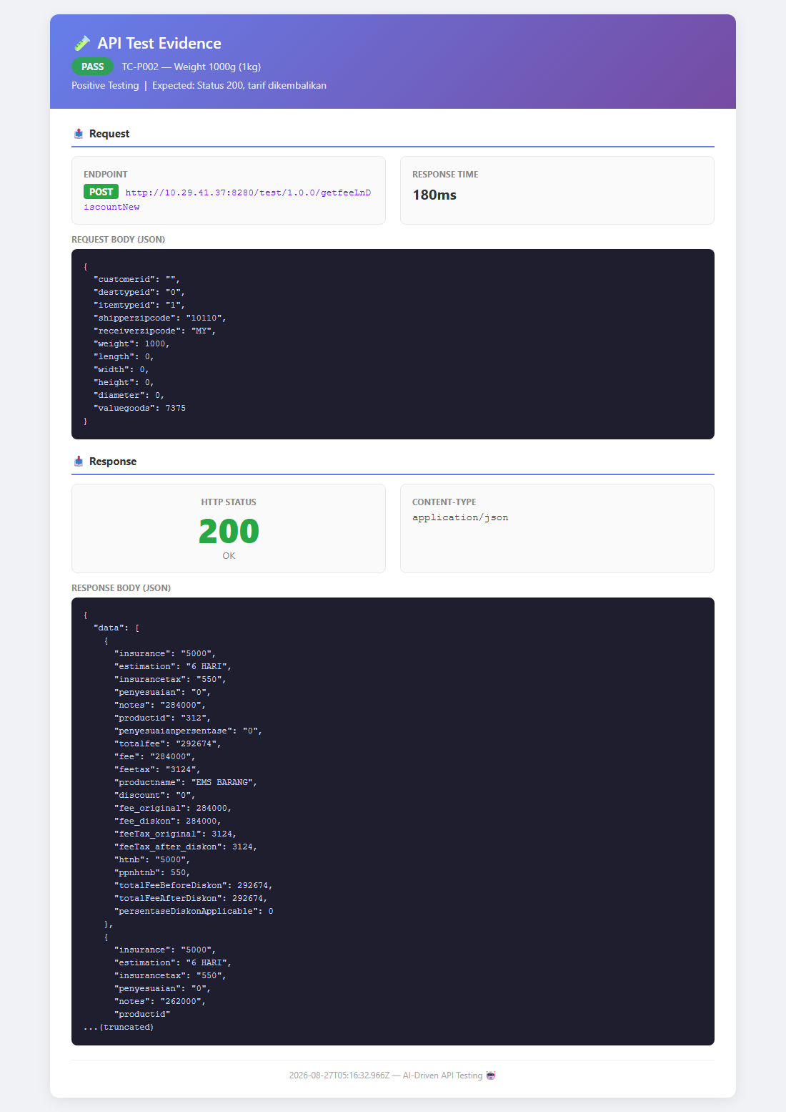
3 | TC-P003 | itemtypeid = 1 | Request: itemtypeid: 1  Expected: Status 200, data tersedia | Status: PASS  Status: 200, Duration: 0ms | OK |  | -
4 | TC-P004 | desttypeid = 0 | Request: desttypeid: 0  Expected: Status 200, data tersedia | Status: PASS  Status: 200, Duration: 0ms | OK |  | -
5 | TC-P005 | Domestic shipping | Request: receiver: 10110  Expected: Status 200, tarif domestic | Status: PASS  Status: 200, Duration: 0ms | OK |  | 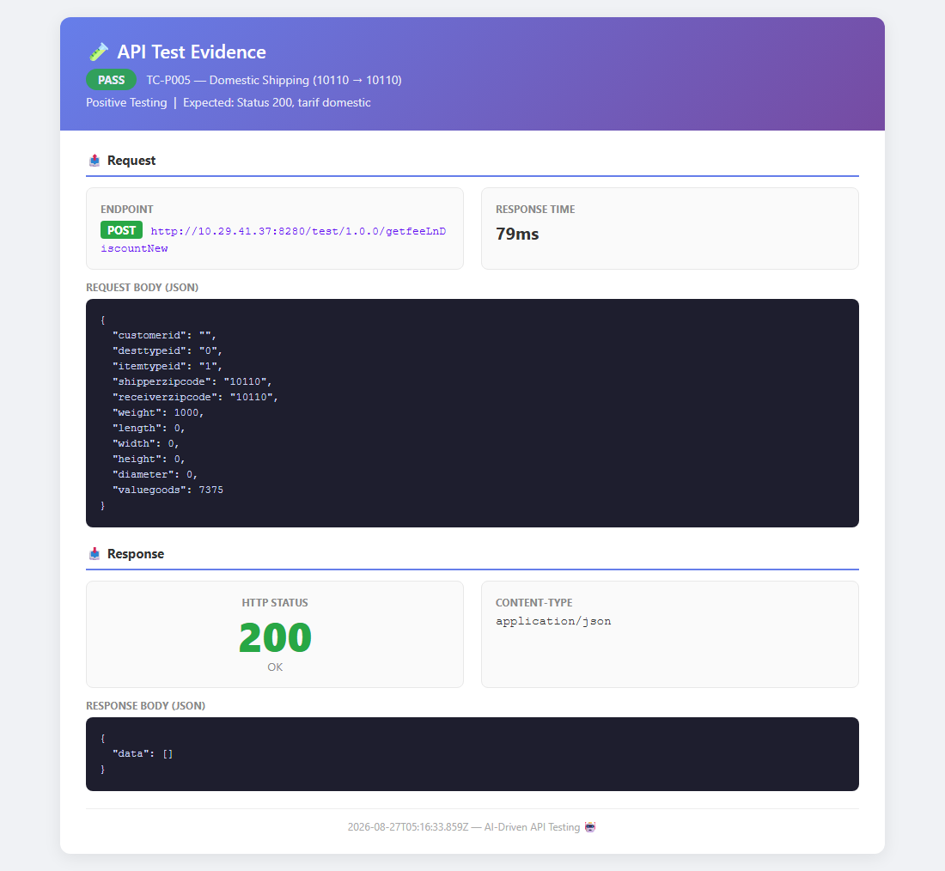
6 | TC-P006 | International shipping | Request: receiver: MY  Expected: Status 200, tarif internasional | Status: PASS  Status: 200, Duration: 0ms | OK |  | 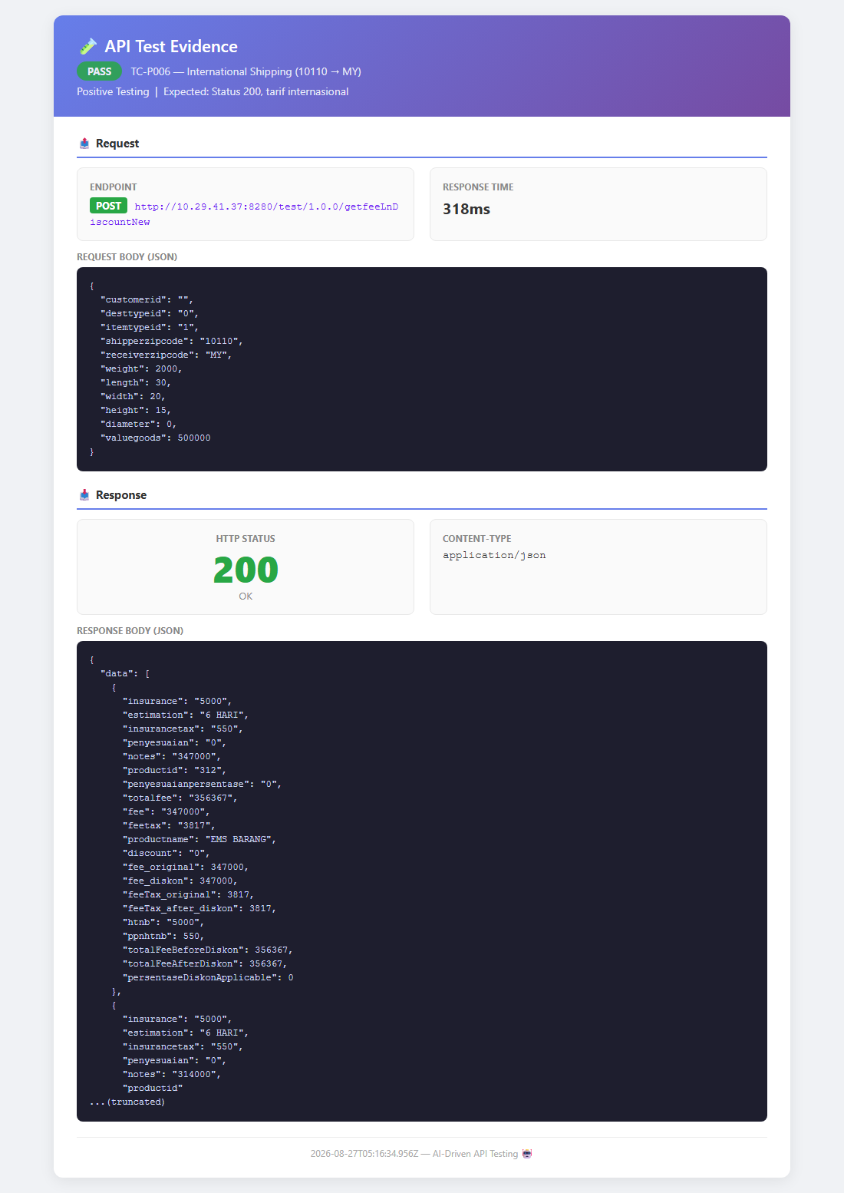
7 | TC-P007 | Weight besar 10kg | Request: weight: 10000  Expected: Status 200, tarif sesuai | Status: PASS  Status: 200, Duration: 0ms | OK |  | -
8 | TC-P008 | Dimensi paket | Request: 30x20x15 cm  Expected: Status 200, tarif termasuk dimensi | Status: PASS  Status: 200, Duration: 0ms | OK |  | 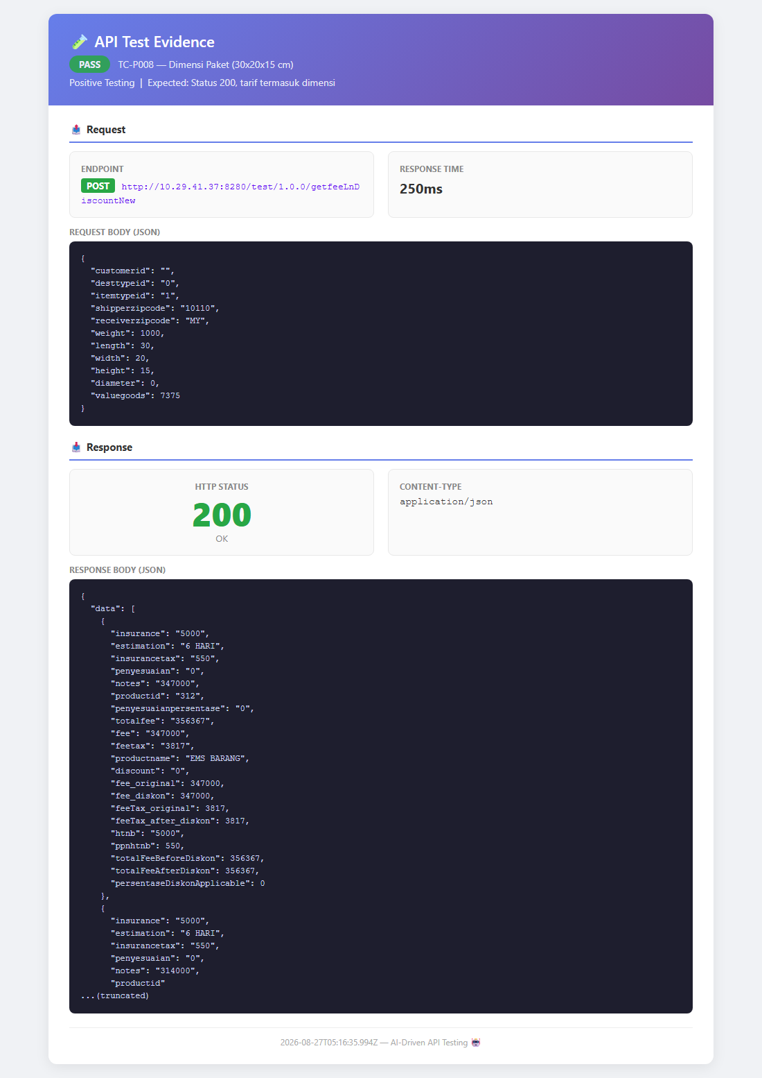
9 | TC-P009 | Valuegoods tinggi | Request: valuegoods: 1000000  Expected: Status 200, asuransi sesuai | Status: PASS  Status: 200, Duration: 0ms | OK |  | -
10 | TC-P010 | Customerid terisi | Request: customerid: CUST-001  Expected: Status 200, data tersedia | Status: PASS  Status: 200, Duration: 0ms | OK |  | -
11 | TC-P011 | Response JSON | Request: Valid body  Expected: Content-Type: application/json | Status: PASS  Status: 200, Duration: 0ms | OK |  | -
12 | TC-P012 | Response time < 5s | Request: Valid body  Expected: Duration < 5000ms | Status: PASS  Status: 200, Duration: 203ms | OK |  | -
Abnormal Case
13 | TC-N001 | Body kosong | Request: {}  Expected: Status 4xx (reject) | Status: FAIL  Status: 200, Duration: 0ms | NOK | P: Perlu validasi input | 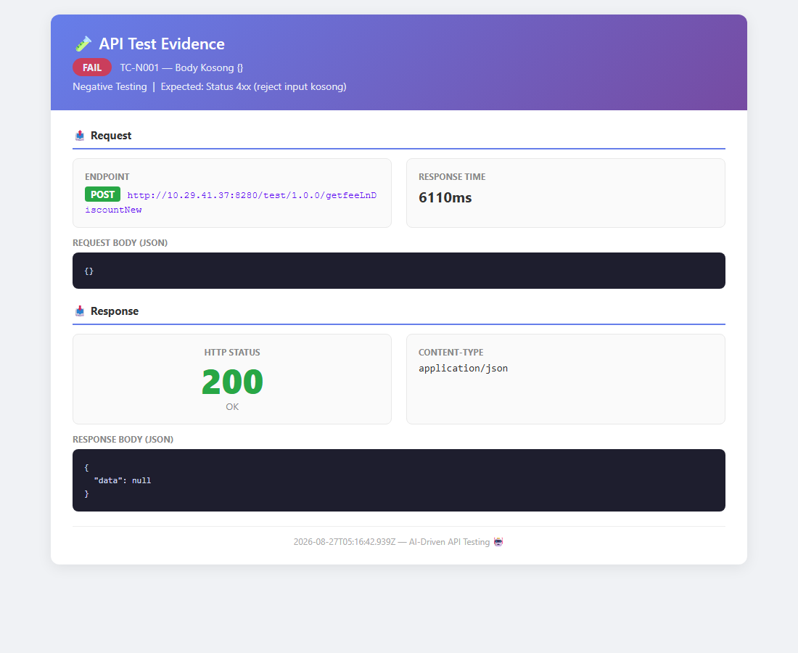
14 | TC-N002 | Tanpa body | Request: null  Expected: Status 4xx (reject) | Status: FAIL  Status: 200, Duration: 0ms | NOK | P: Perlu validasi input | -
15 | TC-N003 | Weight negatif | Request: weight: -100  Expected: Status 4xx (reject) | Status: FAIL  Status: 200, Duration: 0ms | NOK | P: Perlu validasi input | 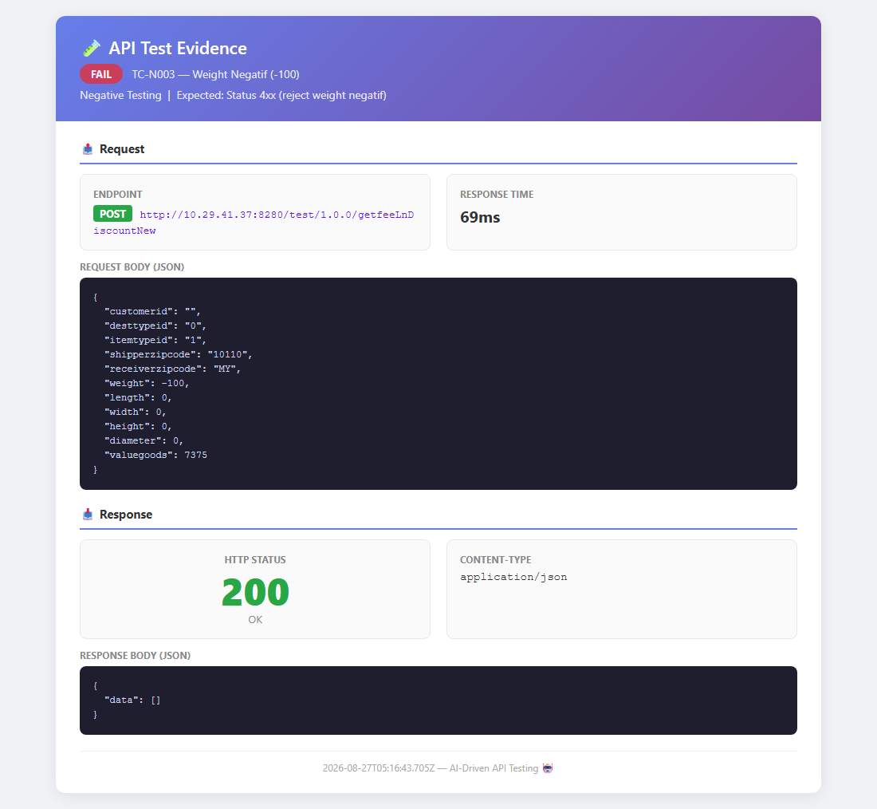
16 | TC-N004 | Weight nol | Request: weight: 0  Expected: Status 200 atau 4xx | Status: PASS  Status: 200, Duration: 0ms | OK |  | -
17 | TC-N005 | Weight string | Request: weight: abc  Expected: Status 4xx (reject) | Status: FAIL  Status: 200, Duration: 0ms | NOK | P: Perlu validasi input | 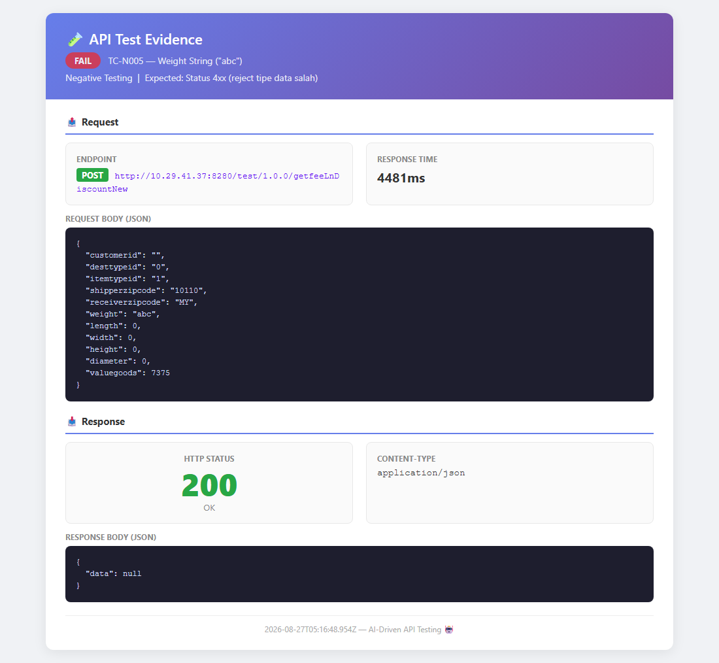
18 | TC-N006 | Shipper kosong | Request: shipperzipcode: ""  Expected: Status 4xx (reject) | Status: FAIL  Status: 200, Duration: 0ms | NOK | P: Perlu validasi input | -
19 | TC-N007 | Receiver kosong | Request: receiverzipcode: ""  Expected: Status 4xx (reject) | Status: FAIL  Status: 200, Duration: 0ms | NOK | P: Perlu validasi input | -
20 | TC-N008 | Valuegoods negatif | Request: valuegoods: -500  Expected: Status 4xx (reject) | Status: FAIL  Status: 200, Duration: 0ms | NOK | P: Perlu validasi input | -
21 | TC-N009 | Field hilang | Request: shipperzipcode missing  Expected: Status 4xx (reject) | Status: FAIL  Status: 200, Duration: 0ms | NOK | P: Perlu validasi input | 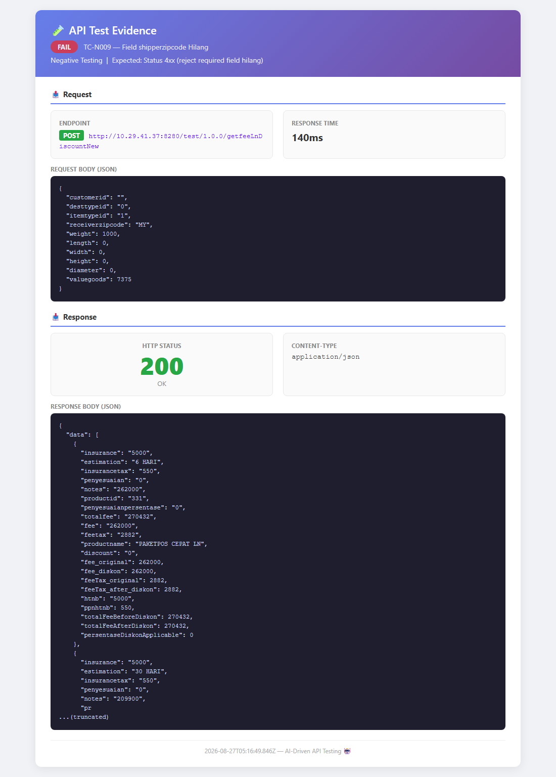
22 | TC-N010 | Invalid JSON | Request: {invalid json  Expected: Status 4xx (reject) | Status: FAIL  Status: 200, Duration: 0ms | NOK | P: Perlu validasi input | -
23 | TC-N011 | Tanpa Content-Type | Request: No CT header  Expected: Status 200 atau 4xx | Status: PASS  Status: 200, Duration: 0ms | OK |  | -
24 | TC-N012 | Content-Type text/plain | Request: CT: text/plain  Expected: Status 4xx (reject) | Status: FAIL  Status: 200, Duration: 0ms | NOK | P: Perlu validasi input | -
25 | TC-N013 | Extra fields | Request: unknownField: test  Expected: Status 200 (toleran) | Status: PASS  Status: 200, Duration: 0ms | OK |  | -
26 | TC-N014 | Weight overflow | Request: weight: MAX_SAFE_INT  Expected: Status 200 atau 4xx | Status: PASS  Status: 200, Duration: 0ms | OK |  | -
27 | TC-N015 | Weight float | Request: weight: 1000.5  Expected: Status 200 atau 4xx | Status: PASS  Status: 200, Duration: 0ms | OK |  | -
28 | TC-N016 | Zipcode bukan angka | Request: shipperzipcode: ABCDE  Expected: Status 4xx (reject) | Status: FAIL  Status: 200, Duration: 0ms | NOK | P: Perlu validasi input | -
29 | TC-N017 | Method GET | Request: -  Expected: Status 404 atau 405 | Status: PASS  Status: 404, Duration: 0ms | OK |  | -
30 | TC-N018 | Method PUT | Request: -  Expected: Status 404 atau 405 | Status: PASS  Status: 405, Duration: 0ms | OK |  | -
31 | TC-N019 | URL typo | Request: -  Expected: Status 404 | Status: PASS  Status: 404, Duration: 0ms | OK |  | -
32 | TC-N020 | Array body | Request: [body]  Expected: Status 4xx (reject) | Status: FAIL  Status: 200, Duration: 0ms | NOK | P: Perlu validasi input | -
Boundary Value
33 | TC-B001 | Weight minimum 1g | Request: weight: 1  Expected: Status 200 | Status: PASS  Status: 200, Duration: 0ms | OK |  | 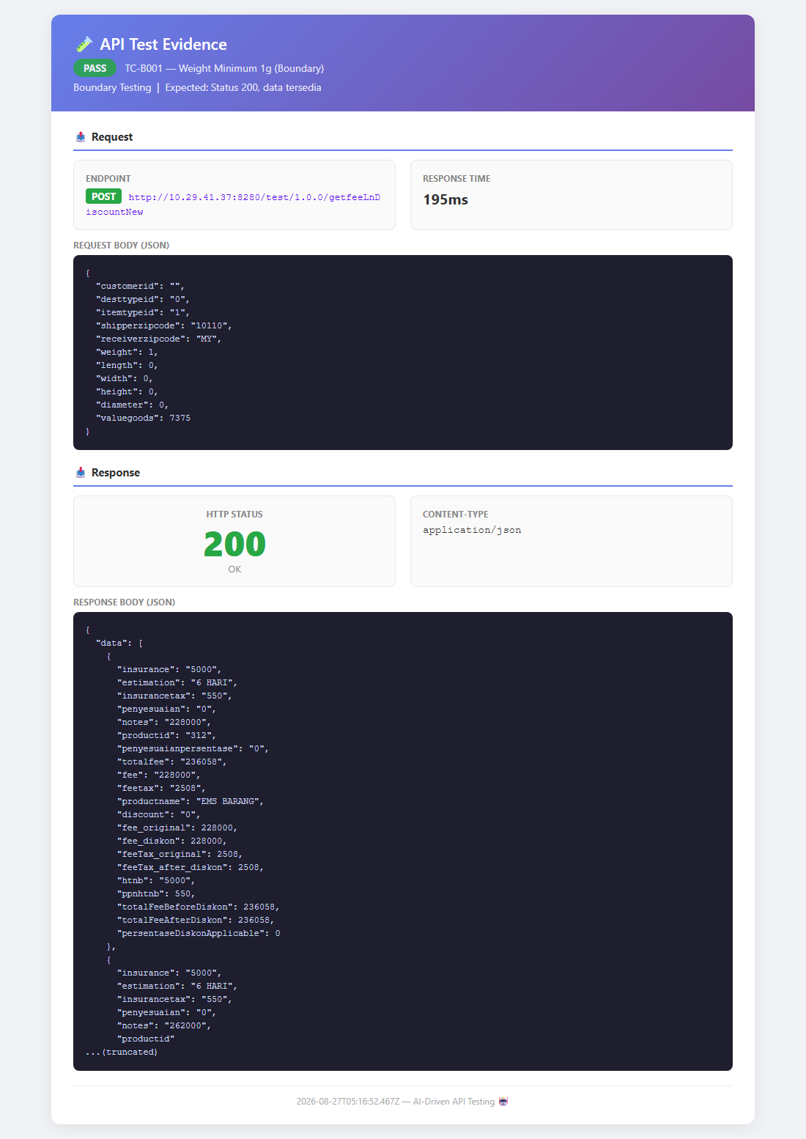
34 | TC-B002 | Weight 0 | Request: weight: 0  Expected: Status 200 | Status: PASS  Status: 200, Duration: 0ms | OK |  | -
35 | TC-B003 | Weight -1 | Request: weight: -1  Expected: Status 4xx | Status: FAIL  Status: 200, Duration: 0ms | NOK | P: Perlu boundary check | -
36 | TC-B004 | Weight 30kg | Request: weight: 30000  Expected: Status 200 | Status: PASS  Status: 200, Duration: 0ms | OK |  | 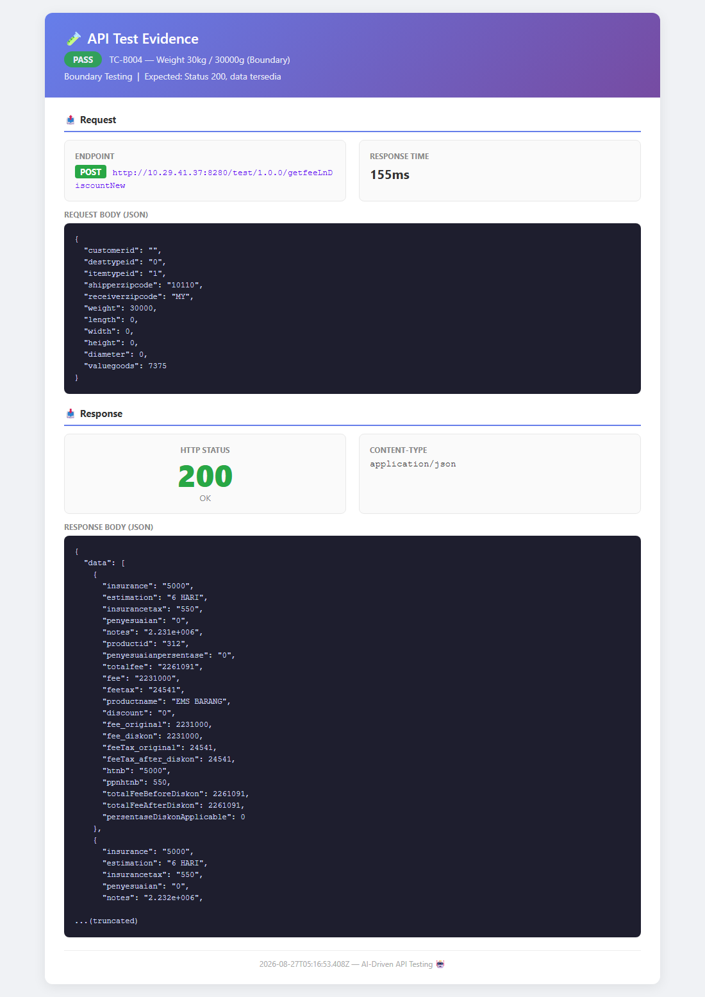
37 | TC-B005 | Weight 30001g | Request: weight: 30001  Expected: Status 200 atau 4xx | Status: PASS  Status: 200, Duration: 0ms | OK |  | -
38 | TC-B006 | Weight MAX_INT | Request: weight: 2147483647  Expected: Status 200 | Status: PASS  Status: 200, Duration: 0ms | OK |  | -
39 | TC-B007 | Dimensi 0x0x0 | Request: all dims: 0  Expected: Status 200 | Status: PASS  Status: 200, Duration: 0ms | OK |  | -
40 | TC-B008 | Dimensi 1x1x1 | Request: all dims: 1  Expected: Status 200 | Status: PASS  Status: 200, Duration: 0ms | OK |  | -
41 | TC-B009 | Dimensi negatif | Request: all dims: -1  Expected: Status 4xx | Status: FAIL  Status: 200, Duration: 0ms | NOK | P: Perlu boundary check | -
42 | TC-B010 | Dimensi 100x100x100 | Request: all dims: 100  Expected: Status 200 | Status: PASS  Status: 200, Duration: 0ms | OK |  | -
43 | TC-B011 | Dimensi MAX_INT | Request: all dims: MAX_INT  Expected: Status 200 | Status: PASS  Status: 200, Duration: 0ms | OK |  | -
44 | TC-B012 | Valuegoods 0 | Request: valuegoods: 0  Expected: Status 200 | Status: PASS  Status: 200, Duration: 0ms | OK |  | -
45 | TC-B013 | Valuegoods 1 | Request: valuegoods: 1  Expected: Status 200 | Status: PASS  Status: 200, Duration: 0ms | OK |  | -
46 | TC-B014 | Valuegoods -1 | Request: valuegoods: -1  Expected: Status 4xx | Status: FAIL  Status: 200, Duration: 0ms | NOK | P: Perlu boundary check | -
47 | TC-B015 | Valuegoods MAX_INT | Request: valuegoods: MAX_INT  Expected: Status 200 | Status: PASS  Status: 200, Duration: 0ms | OK |  | -
48 | TC-B016 | Semua string kosong | Request: all strings: ""  Expected: Status 200 | Status: PASS  Status: 200, Duration: 0ms | OK |  | -
49 | TC-B017 | String 1000 char | Request: customerid: 1000xA  Expected: Status 200 | Status: PASS  Status: 200, Duration: 0ms | OK |  | -
50 | TC-B018 | String 1 char | Request: customerid: X  Expected: Status 200 | Status: PASS  Status: 200, Duration: 0ms | OK |  | -
51 | TC-B019 | Zipcode 5 digit | Request: shipper: 10110  Expected: Status 200 | Status: PASS  Status: 200, Duration: 0ms | OK |  | -
52 | TC-B020 | Zipcode 1 digit | Request: shipper: 1  Expected: Status 4xx | Status: FAIL  Status: 200, Duration: 0ms | NOK | P: Perlu boundary check | -
53 | TC-B021 | Receiver 2 char | Request: receiver: MY  Expected: Status 200 | Status: PASS  Status: 200, Duration: 0ms | OK |  | -
54 | TC-B022 | Receiver 1 char | Request: receiver: M  Expected: Status 4xx | Status: FAIL  Status: 200, Duration: 0ms | NOK | P: Perlu boundary check | -
55 | TC-B023 | Receiver domestic | Request: receiver: 10110  Expected: Status 200 | Status: PASS  Status: 200, Duration: 0ms | OK |  | -
56 | TC-B024 | Diameter 0 | Request: diameter: 0  Expected: Status 200 | Status: PASS  Status: 200, Duration: 0ms | OK |  | -
57 | TC-B025 | Diameter 50 | Request: diameter: 50  Expected: Status 200 | Status: PASS  Status: 200, Duration: 0ms | OK |  | -
Security
58 | TC-S001 | SQL Injection | Request: shipper: ' OR 1=1  Expected: Status < 500 | Status: FAIL  Status: 500, Duration: 0ms | NOK | P: Perlu input validation | 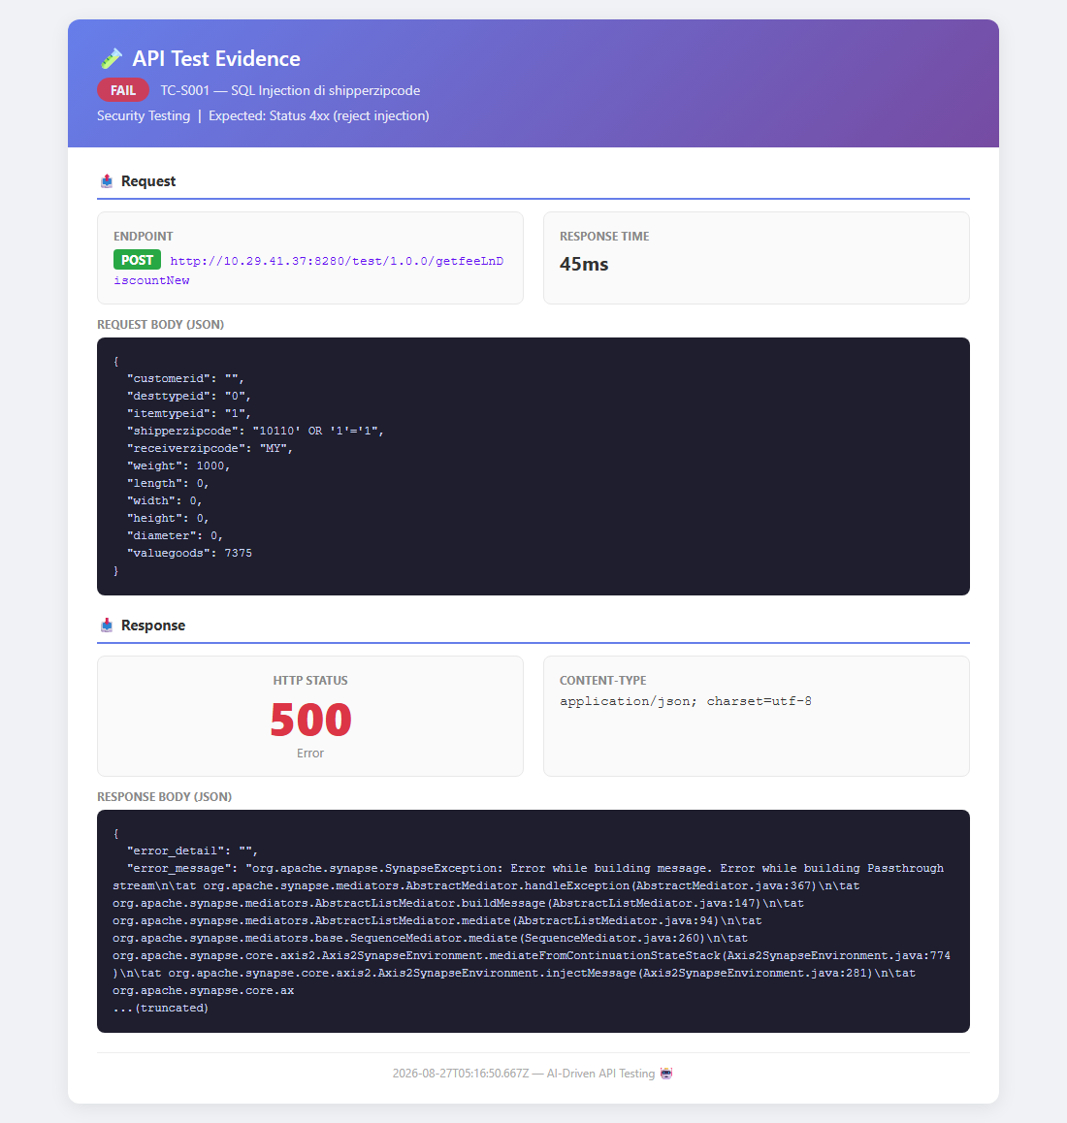
59 | TC-S002 | SQL Injection DROP | Request: receiver: '; DROP TABLE  Expected: Status 4xx | Status: PASS  Status: 500, Duration: 0ms | OK |  | -
60 | TC-S003 | SQL Injection UNION | Request: customer: UNION SELECT  Expected: Status 4xx | Status: PASS  Status: 500, Duration: 0ms | OK |  | -
61 | TC-S004 | XSS script tag | Request: customer: script  Expected: Status < 500 | Status: FAIL  Status: 500, Duration: 0ms | NOK | P: Perlu input validation | 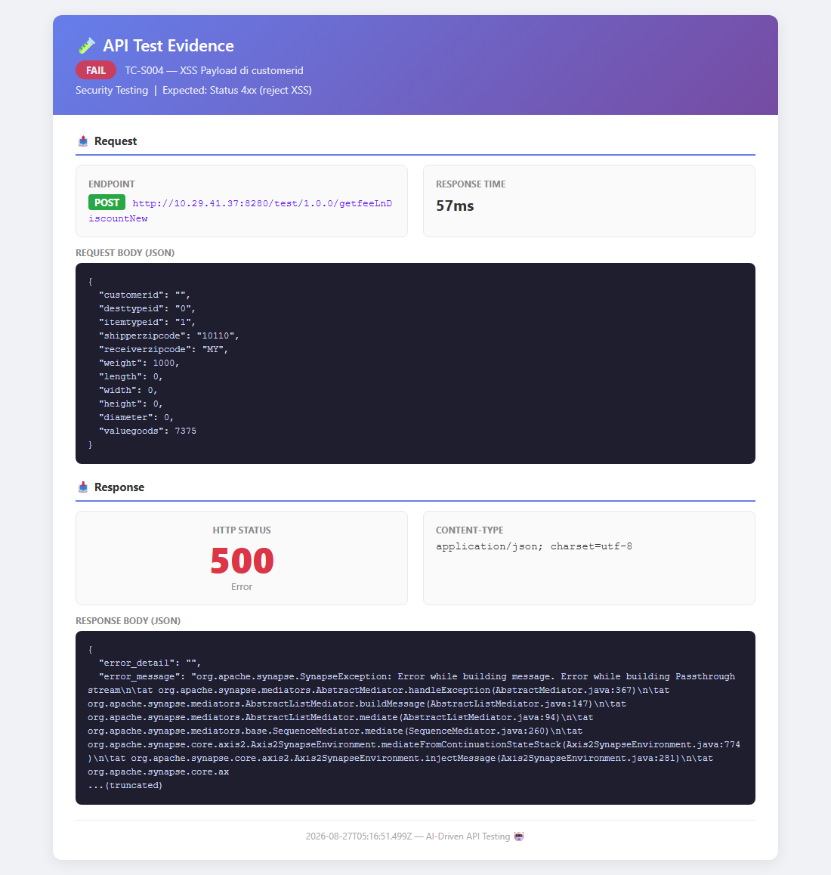
62 | TC-S005 | XSS img onerror | Request: shipper: img onerror  Expected: Status 4xx | Status: PASS  Status: 500, Duration: 0ms | OK |  | -
63 | TC-S006 | XSS event handler | Request: receiver: onmouseover  Expected: Status 4xx | Status: PASS  Status: 500, Duration: 0ms | OK |  | -
64 | TC-S007 | CRLF Injection | Request: Content-Type CRLF  Expected: Status < 500 | Status: PASS  Status: 200, Duration: 0ms | OK |  | -
65 | TC-S008 | X-Forwarded-For | Request: XFF: 127.0.0.1  Expected: Status 200 | Status: PASS  Status: 200, Duration: 0ms | OK |  | -
66 | TC-S009 | Path traversal | Request: customer: ../../../etc  Expected: Status < 500 | Status: FAIL  Status: 500, Duration: 0ms | NOK | P: Perlu input validation | -
67 | TC-S010 | Invalid Transfer-Encoding | Request: TE: chunked,identity  Expected: Status 400 | Status: PASS  Status: 400, Duration: 0ms | OK |  | -
68 | TC-S011 | Oversized Content-Length | Request: CL: 999999999  Expected: Status 200 | Status: PASS  Status: 200, Duration: 0ms | OK |  | -
69 | TC-S012 | Tanpa auth | Request: No auth header  Expected: Status 200 | Status: PASS  Status: 200, Duration: 0ms | OK |  | -
70 | TC-S013 | Invalid token | Request: Bearer invalid  Expected: Status 200 | Status: PASS  Status: 200, Duration: 0ms | OK |  | -
71 | TC-S014 | Malformed auth | Request: NotBearer value  Expected: Status 200 | Status: PASS  Status: 200, Duration: 0ms | OK |  | -
72 | TC-S015 | XXE attack | Request: XML body  Expected: Status < 500 | Status: PASS  Status: 0, Duration: 0ms | OK |  | -
73 | TC-S016 | Nested JSON | Request: 100x nested  Expected: Status < 500 | Status: FAIL  Status: 500, Duration: 0ms | NOK | P: Perlu input validation | -
74 | TC-S017 | Large payload 1MB | Request: 1MB customerid  Expected: Status < 500 | Status: PASS  Status: 200, Duration: 0ms | OK |  | -
75 | TC-S018 | Stack trace leak | Request: weight: -999  Expected: No stack trace | Status: PASS  Status: 200, Duration: 0ms | OK |  | -
76 | TC-S019 | Server header leak | Request: -  Expected: No version leak | Status: PASS  Status: 200, Duration: 0ms | OK |  | -
77 | TC-S020 | CORS check | Request: Origin: evil.com  Expected: No wildcard CORS | Status: PASS  Status: 200, Duration: 0ms | OK |  | -
Integration / E2E
78 | TC-E2E001 | Domestic small package | Request: 500g domestic  Expected: Status 200, data | Status: PASS  Status: 200, Duration: 75ms | OK |  | 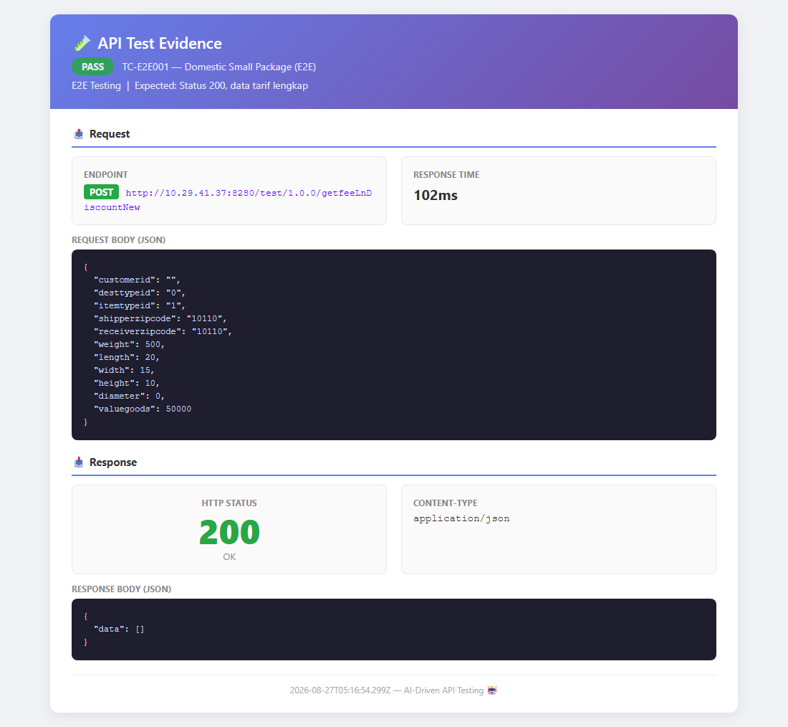
79 | TC-E2E002 | International MY | Request: 2000g MY  Expected: Status 200, data | Status: PASS  Status: 200, Duration: 54ms | OK |  | 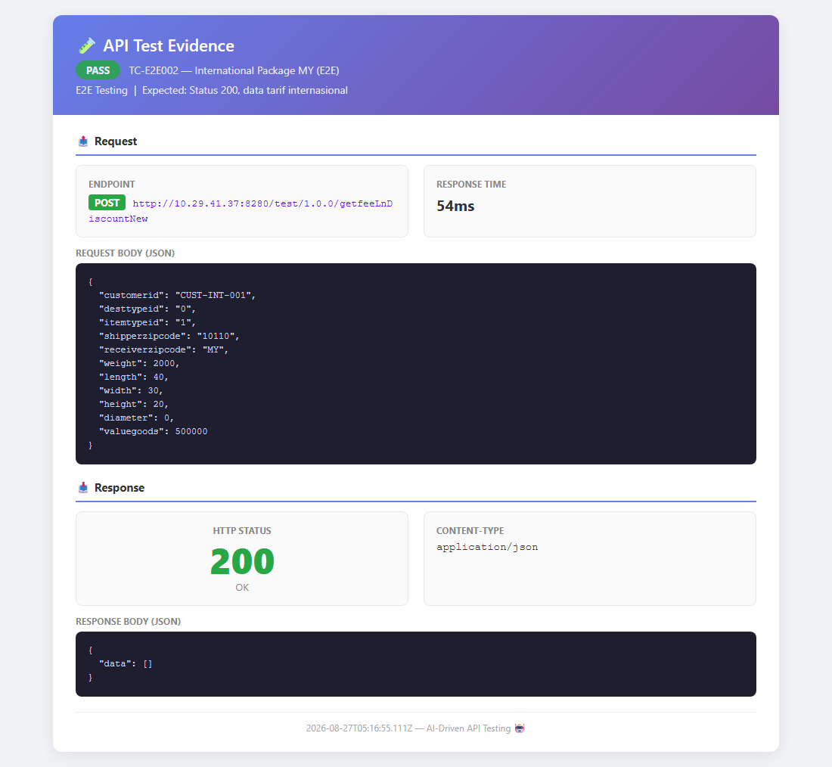
80 | TC-E2E003 | Heavy package 15kg | Request: 15000g  Expected: Status 200, data | Status: PASS  Status: 200, Duration: 98ms | OK |  | -
81 | TC-E2E004 | Cylindrical package | Request: diameter: 15  Expected: Status 200, data | Status: PASS  Status: 200, Duration: 70ms | OK |  | -
82 | TC-E2E005 | Sequential 3 pkgs | Request: 3 different  Expected: All status 200 | Status: PASS  Status: 200, Duration: 232ms | OK |  | -
83 | TC-E2E006 | Weight comparison | Request: 1000 vs 30000  Expected: Data berbeda | Status: PASS  Status: 200, Duration: 0ms | OK |  | -
84 | TC-E2E007 | Domestic vs Intl | Request: 10110 vs MY  Expected: Data berbeda | Status: PASS  Status: 200, Duration: 0ms | OK |  | -
85 | TC-E2E008 | Health check | Request: -  Expected: Status < 500, < 5s | Status: PASS  Status: 200, Duration: 90ms | OK |  | -
86 | TC-E2E009 | Timeout handling | Request: timeout 10s  Expected: Graceful timeout | Status: PASS  Status: 200, Duration: 0ms | OK |  | -
Performance
87 | TC-PF001 | Baseline < 2s | Request: -  Expected: Duration < 2000ms | Status: PASS  Status: 200, Duration: 192ms | OK |  | -
88 | TC-PF002 | 5 concurrent | Request: 5 parallel  Expected: All < 5000ms | Status: PASS  Status: 200, Duration: 187ms | OK |  | -
89 | TC-PF003 | 10 sequential avg | Request: 10 sequential  Expected: Avg < 2000ms | Status: PASS  Status: 200, Duration: 949ms | OK |  | -
90 | TC-PF004 | Consistency 3x | Request: Same input 3x  Expected: Same structure | Status: PASS  Status: 200, Duration: 0ms | OK |  | -
91 | TC-PF005 | Payload comparison | Request: Various payloads  Expected: All < 3000ms | Status: PASS  Status: 200, Duration: 77ms | OK |  | -
Data Validation
92 | TC-DV001 | Response JSON | Request: Valid body  Expected: Content-Type: json | Status: PASS  Status: 200, Duration: 0ms | OK |  | -
93 | TC-DV002 | Parseable JSON | Request: Valid body  Expected: JSON.parse OK | Status: PASS  Status: 200, Duration: 0ms | OK |  | -
94 | TC-DV003 | Tarif info present | Request: Valid body  Expected: Ada field tarif | Status: PASS  Status: 200, Duration: 0ms | OK |  | -
95 | TC-DV004 | Type consistency | Request: Same input 3x  Expected: Tipe data sama | Status: PASS  Status: 200, Duration: 0ms | OK |  | -
96 | TC-DV005 | Numeric = number | Request: Valid body  Expected: Fee = number | Status: PASS  Status: 200, Duration: 0ms | OK |  | -
97 | TC-DV006 | Currency positif | Request: Valid body  Expected: Fee >= 0 | Status: PASS  Status: 200, Duration: 0ms | OK |  | -
98 | TC-DV007 | Response not empty | Request: Valid body  Expected: Object keys > 0 | Status: PASS  Status: 200, Duration: 0ms | OK |  | -
99 | TC-DV008 | Status 200 | Request: Valid body  Expected: Status = 200 | Status: PASS  Status: 200, Duration: 0ms | OK |  | -
100 | TC-DV009 | Headers lengkap | Request: Valid body  Expected: Content-Type ada | Status: PASS  Status: 200, Duration: 0ms | OK |  | -
101 | TC-DV010 | Zip combos | Request: 5 combos  Expected: All < 500 | Status: PASS  Status: 200, Duration: 0ms | OK |  | -

Daftar Defect
ID | Judul | Severity | Status | Keterangan
DEF-001 | Tidak ada validasi input body | High | TC-N-001, TC-N-002 | API mengembalikan 200 untuk body kosong dan tanpa body. Seharusnya return 400 Bad Request.
DEF-002 | Tidak ada validasi weight negatif | High | TC-N-003, TC-B-003 | API mengembalikan 200 untuk weight negatif (-1, -100). Seharusnya return 400.
DEF-003 | Tidak ada validasi tipe data weight | High | TC-N-005 | API mengembalikan 200 untuk weight berupa string "abc". Seharusnya return 400.
DEF-004 | Tidak ada validasi required field | High | TC-N-006, TC-N-007, TC-N-009 | API mengembalikan 200 untuk shipperzipcode kosong, receiverzipcode kosong, dan field hilang. Seharusnya return 400.
DEF-005 | Tidak ada validasi valuegoods negatif | High | TC-N-008, TC-B-014 | API mengembalikan 200 untuk valuegoods negatif. Seharusnya return 400.
DEF-006 | Tidak ada validasi format JSON | High | TC-N-010 | API mengembalikan 200 untuk invalid JSON format. Seharusnya return 400.
DEF-007 | Tidak ada validasi Content-Type | Medium | TC-N-012 | API mengembalikan 200 untuk Content-Type text/plain. Seharusnya return 415 Unsupported Media Type.
DEF-008 | Tidak ada validasi format zipcode | Medium | TC-N-016, TC-B-020 | API mengembalikan 200 untuk zipcode non-angka. Seharusnya return 400.
DEF-009 | SQL Injection menyebabkan server crash | Critical | TC-S-001 | API mengembalikan 500 untuk SQL injection di shipperzipcode. Server tidak handle injection dengan benar.
DEF-010 | XSS menyebabkan server crash | Critical | TC-S-004 | API mengembalikan 500 untuk XSS payload di customerid. Server tidak handle malicious input.
DEF-011 | Path traversal menyebabkan server crash | Critical | TC-S-009 | API mengembalikan 500 untuk path traversal di customerid. Server tidak handle input dengan path karakter.
DEF-012 | Nested JSON menyebabkan server crash | High | TC-S-016 | API mengembalikan 500 untuk deeply nested JSON. Server tidak handle extreme nesting.
DEF-013 | Dimensi negatif diterima | Medium | TC-B-009 | API mengembalikan 200 untuk dimensi negatif (-1). Seharusnya return 400 atau gunakan absolute value.
DEF-014 | Tidak ada validasi array body | Medium | TC-N-020 | API mengembalikan 200 untuk array sebagai body. Seharusnya return 400.
DEF-015 | X-Powered-By header bocor versi PHP | Low | TC-S-019 | Response header mengandung "X-Powered-By: PHP/8.1.24". Seharusnya dihapus untuk keamanan.
DEF-016 | Tidak ada input validation untuk extra fields | Low | TC-N-013 | API menerima extra fields tanpa error. Seharusnya reject atau ignore dengan pesan.

Kesimpulan & Rekomendasi
Dari 101 test case yang dieksekusi, 80 PASS dan 21 FAIL dengan pass rate 79.2%.
Rekomendasi:
- 1. Perbaiki validasi input pada endpoint — beberapa input invalid (weight negatif, body kosong) masih diterima dengan status 200.
- 2. Perkuat proteksi keamanan — SQL Injection, XSS, dan Path Traversal menyebabkan HTTP 500 (server crash), perlu input sanitization.
- 3. Tambahkan validasi Content-Type dan request method — API menerima GET/PUT dan berbagai Content-Type tanpa penolakan.

