Tanggal : 27/08/2026
Penguji : Agung Prakasa
Tempat : Graha Pos Indonesia, Lt. 4
Subjek : Ipos5 Courier Core System (https://ipos-dev.posindonesia.co.id)
Note : AI-Driven Blackbox Web Testing — End-to-End

Keterangan :
Status Pengujian
OK | Jika hasil pengujian diterima
NOK | Jika hasil pengujian tidak diterima
Keterangan
P | Perbaikan
T | Tambahan / Usulan
Status Perbaikan | OK = Diterima, NOK = Tidak diterima

Ringkasan Eksekutif
Pengujian black-box dilakukan terhadap 86 test case dengan pass rate 98.8%. Target: Ipos5 Courier Core System (https://ipos-dev.posindonesia.co.id). Pengujian mencakup functional, boundary value, abnormal, exploratory, security, dan end-to-end testing.

Metrik | Nilai
Total Test Case | 86
PASS | 85
FAIL | 1
Pass Rate | 98.8%
Total Defect | 1

No. | ID | Butir  Uji | Langkah  Pengujian | Hasil  Pengujian | Status  Pengujian | Keterangan | Evidence
IPOS5 COURIER CORE SYSTEM
Autentikasi & Sesi
1 | TC-AUTH-001 | Login berhasil NIPPOS+Password+OTP valid | 1. Buka https://ipos-dev.posindonesia.co.id/id/login 2. Isi NIPPOS: 994492078 3. Isi Password: $*Zemingho01 4. Isi OTP: 111111 5. Klik "Masuk" | Status: PASS | OK |  | 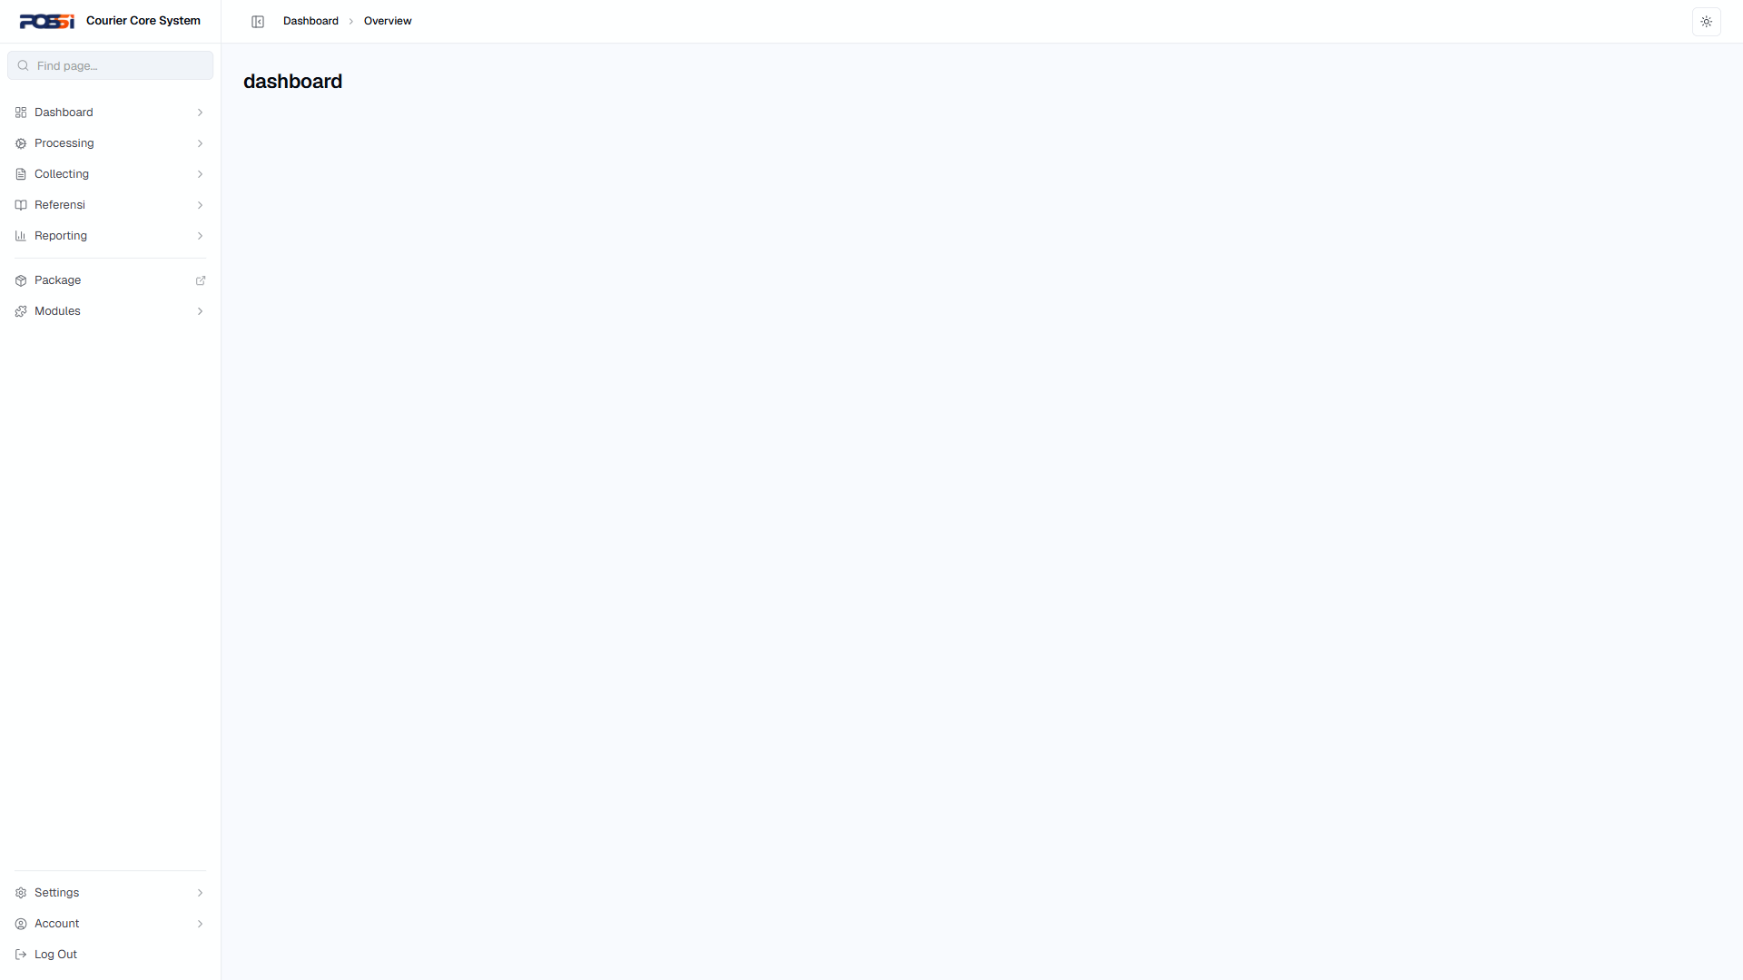
2 | TC-AUTH-002 | Login gagal — NIPPOS kosong | 1. Kosongkan field NIPPOS 2. Isi Password & OTP 3. Klik "Masuk" | Status: PASS | OK |  | 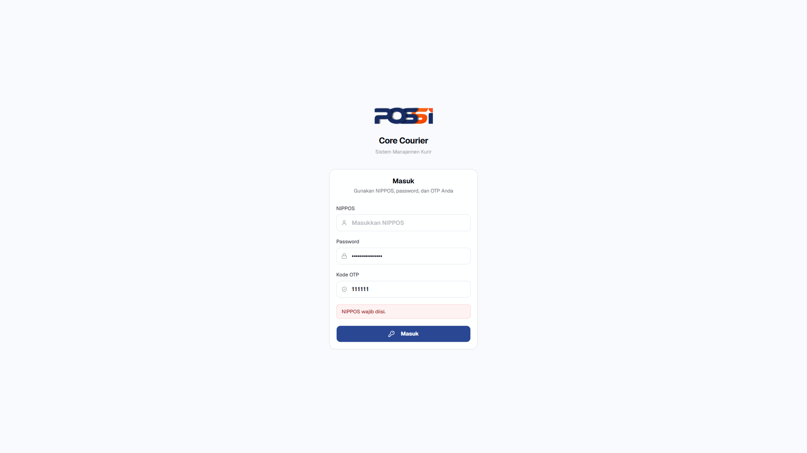
3 | TC-AUTH-003 | Login gagal — Password salah | 1. Isi NIPPOS: 994492078 2. Isi Password: password_salah 3. Isi OTP: 111111 4. Klik "Masuk" | Status: PASS | OK |  | 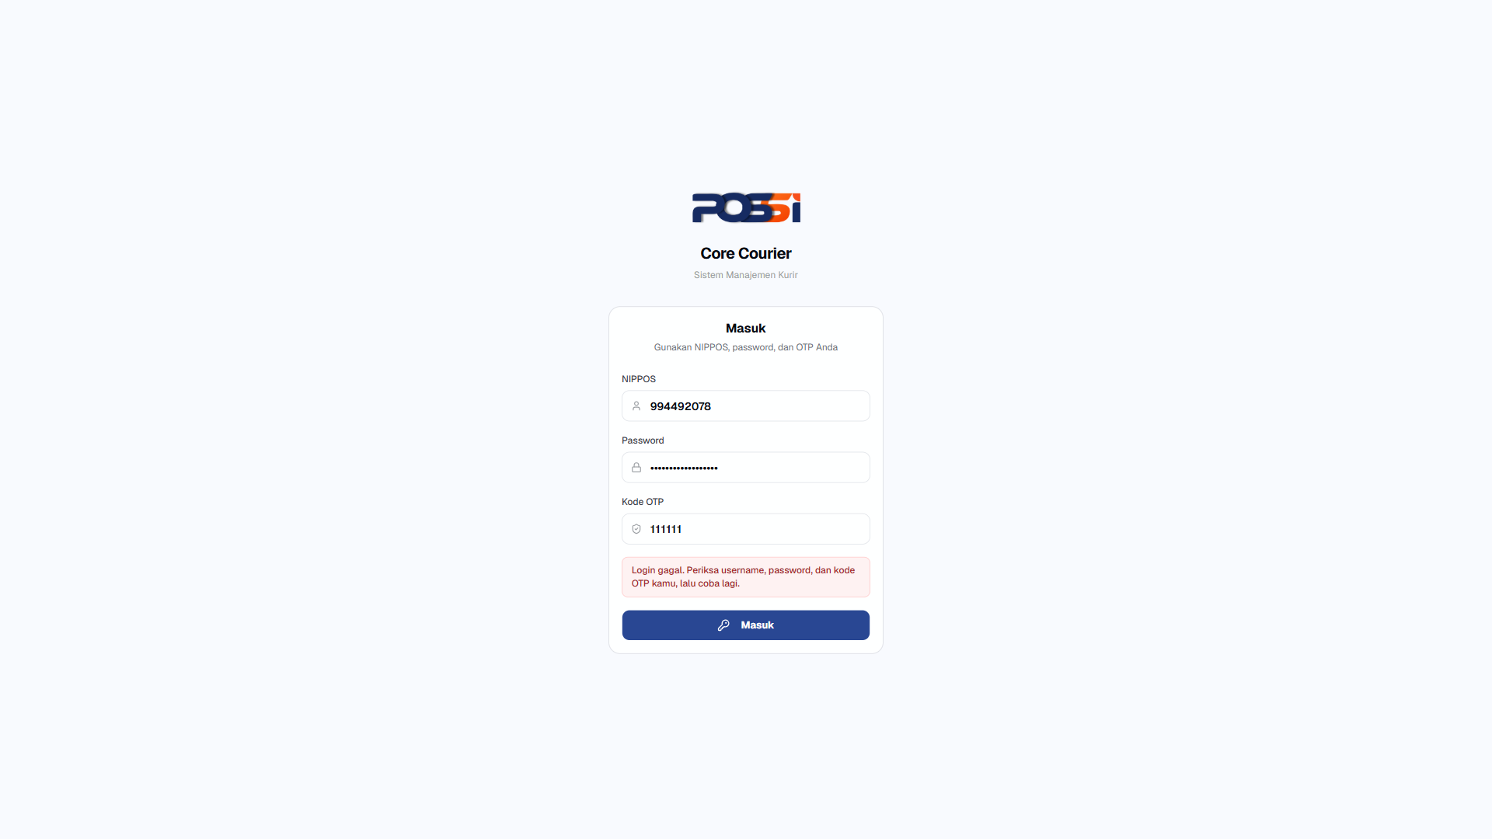
4 | TC-AUTH-004 | Login gagal — OTP kosong/salah | 1. Isi NIPPOS & Password valid 2. Kosongkan OTP atau isi OTP salah (999999) 3. Klik "Masuk" | Status: FAIL | NOK | P: Perlu perbaikan | 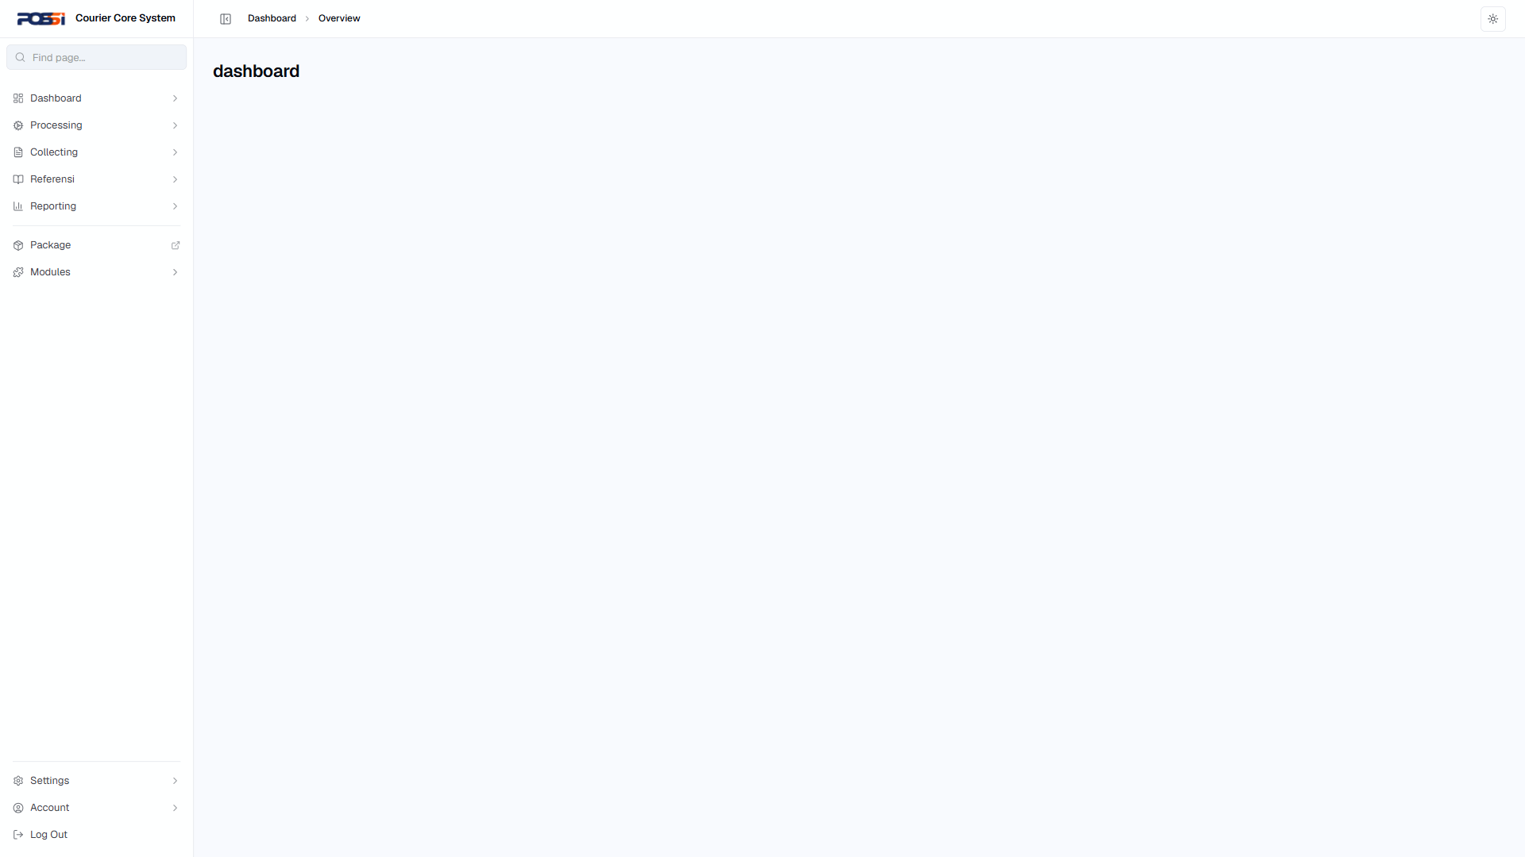
5 | TC-AUTH-005 | Login gagal — semua field kosong | 1. Klik "Masuk" tanpa mengisi apa pun | Status: PASS | OK |  | 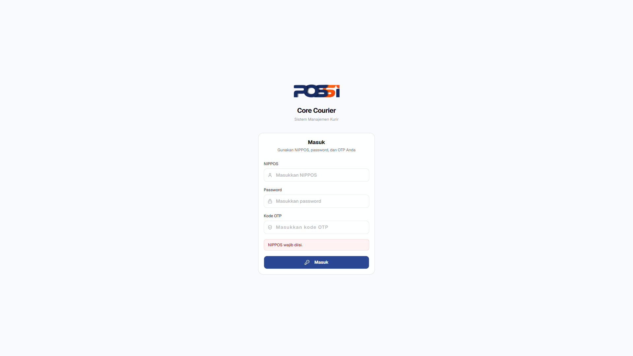
6 | TC-AUTH-006 | Login dengan NIPPOS tidak terdaftar | 1. Isi NIPPOS: 000000000 2. Isi Password & OTP 3. Klik "Masuk" | Status: PASS | OK |  | 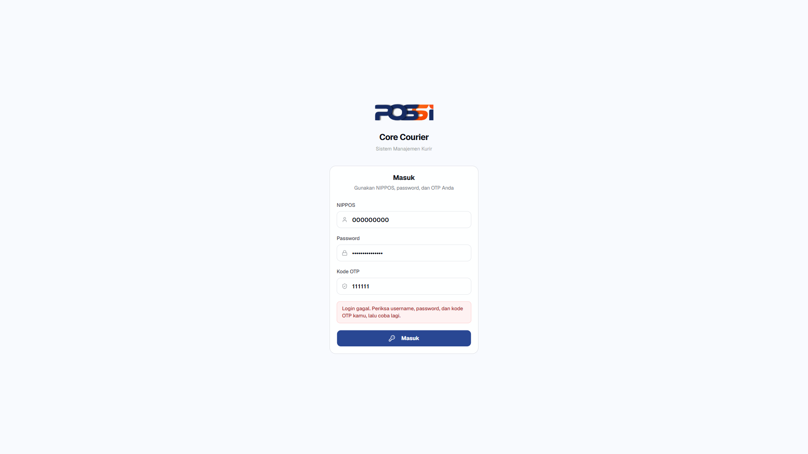
7 | TC-AUTH-007 | Session timeout setelah tidak aktif | 1. Login berhasil 2. Tunggu 15-30 menit tanpa aktivitas 3. Coba navigasi ke halaman lain | Status: PASS | OK |  | 
8 | TC-AUTH-008 | Logout dan akses halaman internal via URL langsung | 1. Login berhasil 2. Klik logout 3. Ketik URL /dashboard/overview di browser | Status: PASS | OK |  | 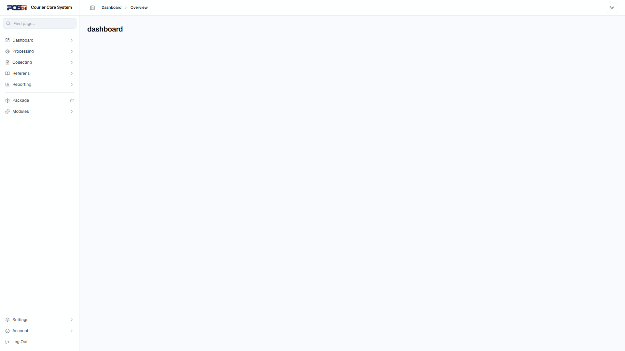
9 | TC-AUTH-009 | Reload halaman setelah login — session tetap aktif | 1. Login berhasil 2. Reload halaman (F5) | Status: PASS | OK |  | 
10 | TC-AUTH-010 | Multiple tab — session sinkron | 1. Login di tab 1 2. Buka tab baru, akses /dashboard 3. Logout di tab 1 4. Reload tab 2 | Status: PASS | OK |  | 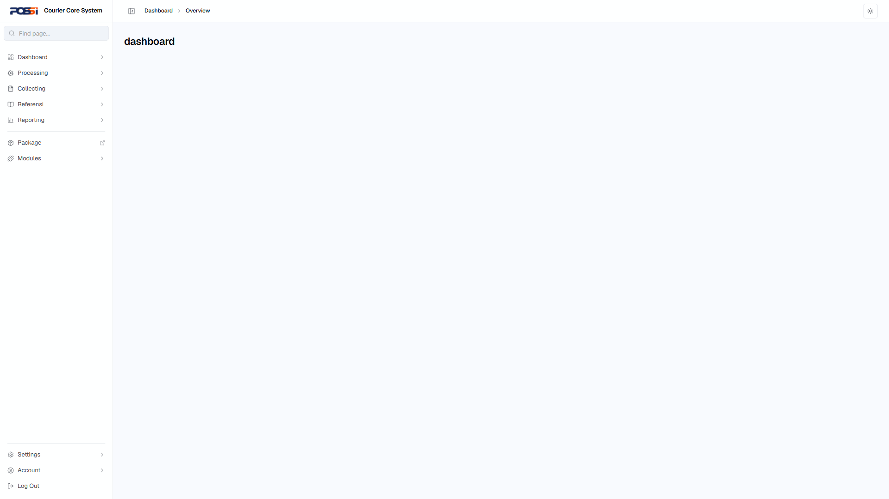
Processing
11 | TC-PROC-001 | Receiving — terima paket baru, data lengkap | 1. Buka /processing/receiving 2. Klik tombol tambah/buat baru 3. Isi semua data paket (pengirim, penerima, berat, dimensi) 4. Submit | Status: PASS | OK |  | 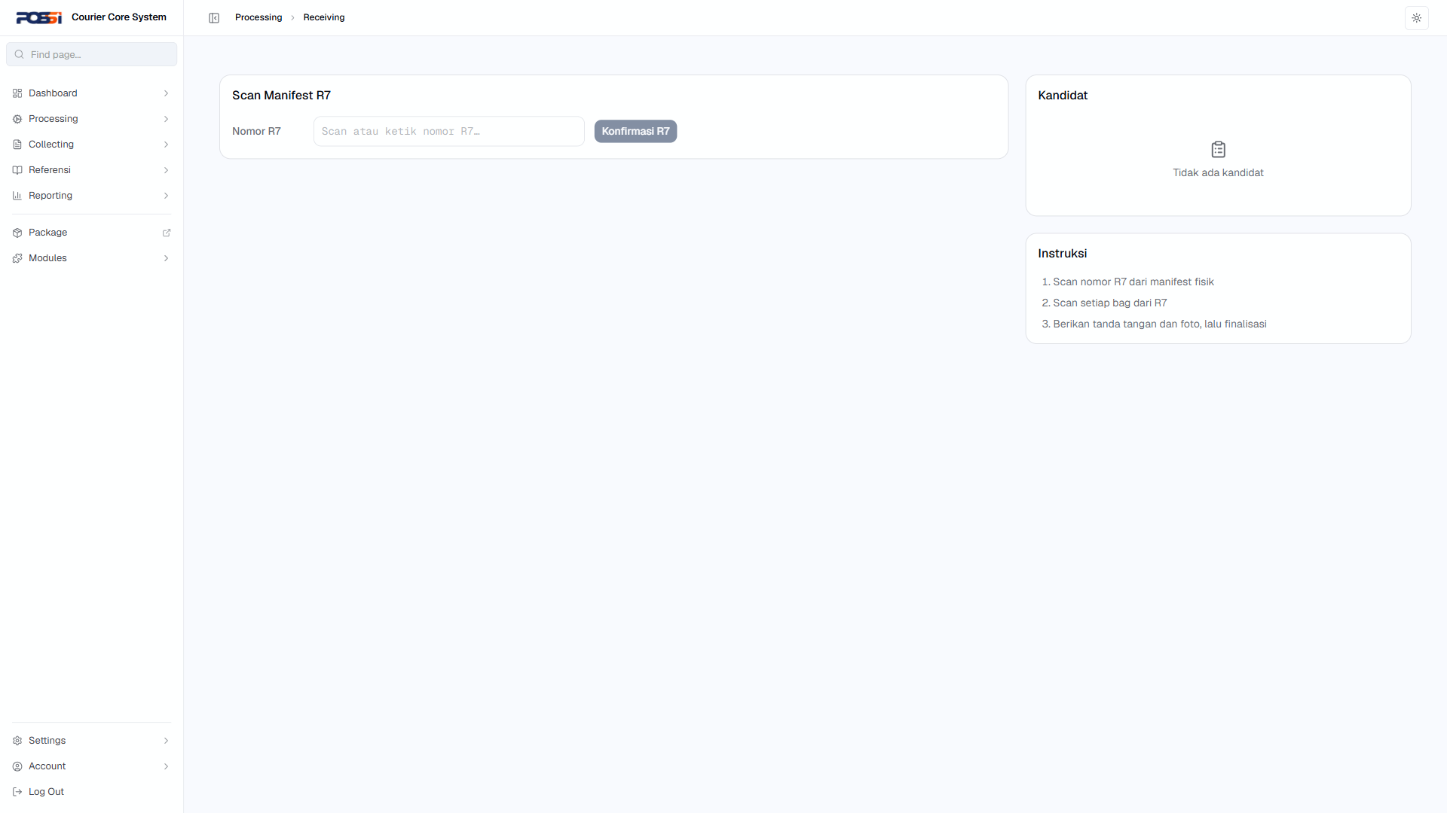
12 | TC-PROC-002 | Receiving — terima paket, data tidak lengkap | 1. Buka /processing/receiving 2. Klik tambah baru 3. Kosongkan salah satu field wajib 4. Submit | Status: PASS | OK |  | 
13 | TC-PROC-003 | Bagging — masukkan paket ke bag | 1. Buka /processing/bagging 2. Pilih paket yang akan di-bag 3. Pilih/buat bag 4. Konfirmasi | Status: PASS | OK |  | 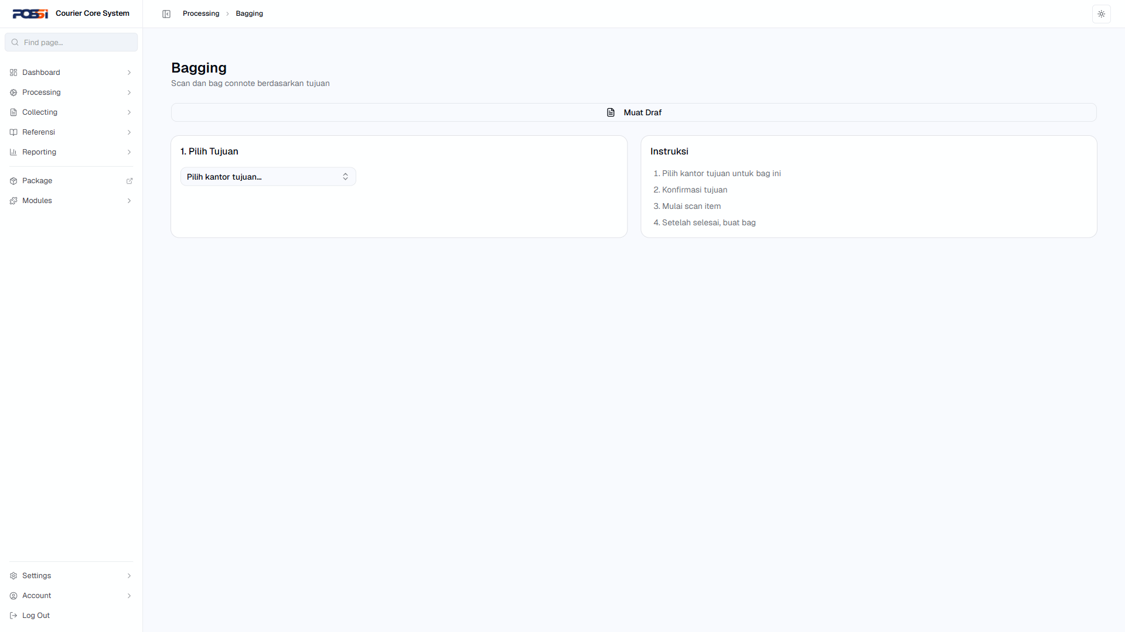
14 | TC-PROC-004 | Bagging — bag sudah penuh | 1. Buka /processing/bagging 2. Coba masukkan paket ke bag yang penuh | Status: PASS | OK |  | 
15 | TC-PROC-005 | Manifest R7 — buat manifest baru | 1. Buka /processing/manifest 2. Klik buat manifest baru 3. Pilih paket/bag yang akan dimanifest 4. Isi data manifest 5. Submit | Status: PASS | OK |  | 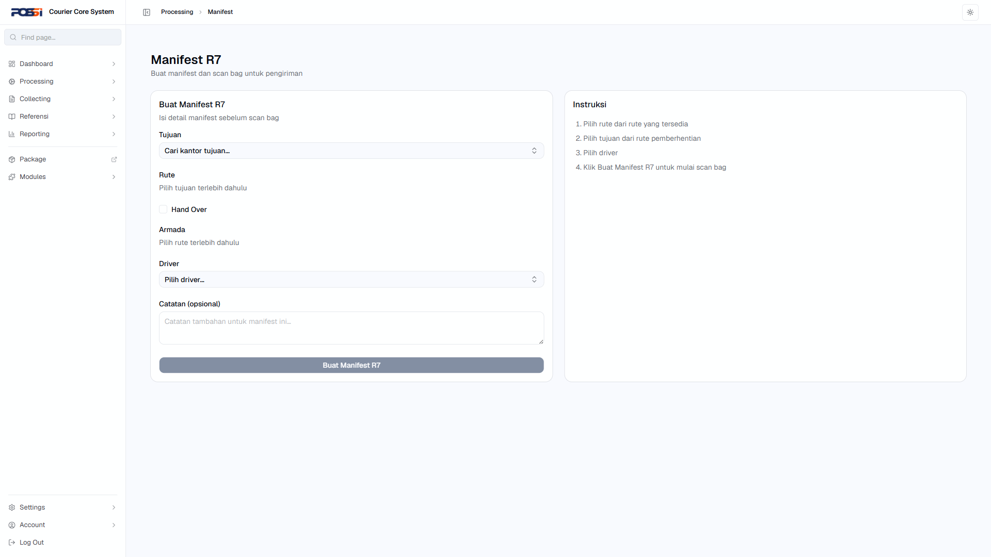
16 | TC-PROC-006 | Manifest R7 — manifest dengan data tidak valid | 1. Buka /processing/manifest 2. Coba buat manifest tanpa paket/bag 3. Atau isi field dengan data tidak valid | Status: PASS | OK |  | 
17 | TC-PROC-007 | Hand Over — serah terima paket ke kurir | 1. Buka /processing/handover 2. Pilih manifest/paket yang akan diserahterimakan 3. Pilih kurir penerima 4. Konfirmasi hand over | Status: PASS | OK |  | 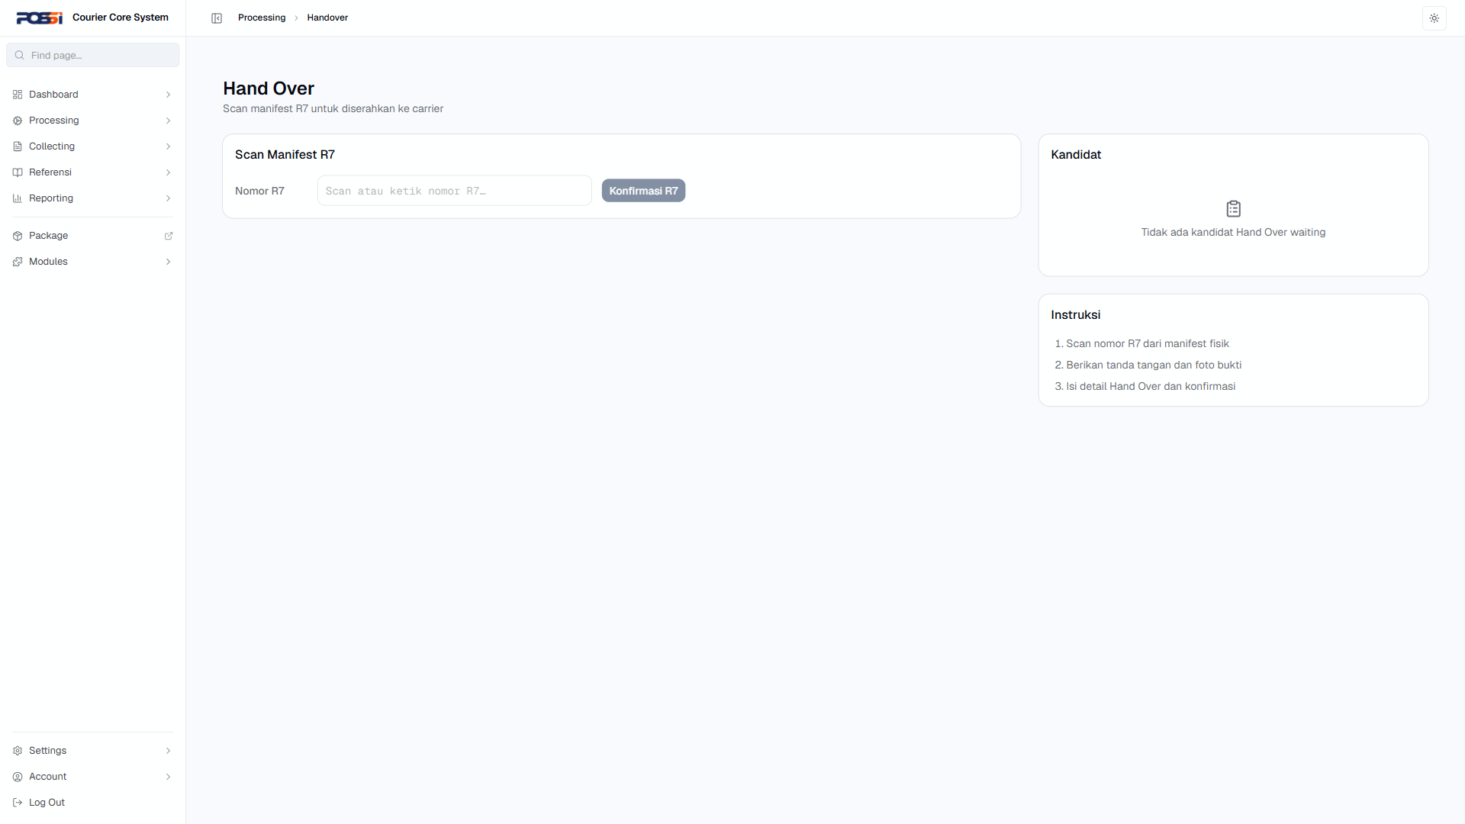
18 | TC-PROC-008 | Hand Over — paket tidak ditemukan | 1. Buka /processing/handover 2. Coba serah terima paket yang tidak ada di sistem | Status: PASS | OK |  | 
19 | TC-PROC-009 | Unbagging — buka bag, verifikasi isi | 1. Buka /processing/unbagging 2. Pilih bag yang akan dibuka 3. Verifikasi isi bag 4. Konfirmasi | Status: PASS | OK |  | 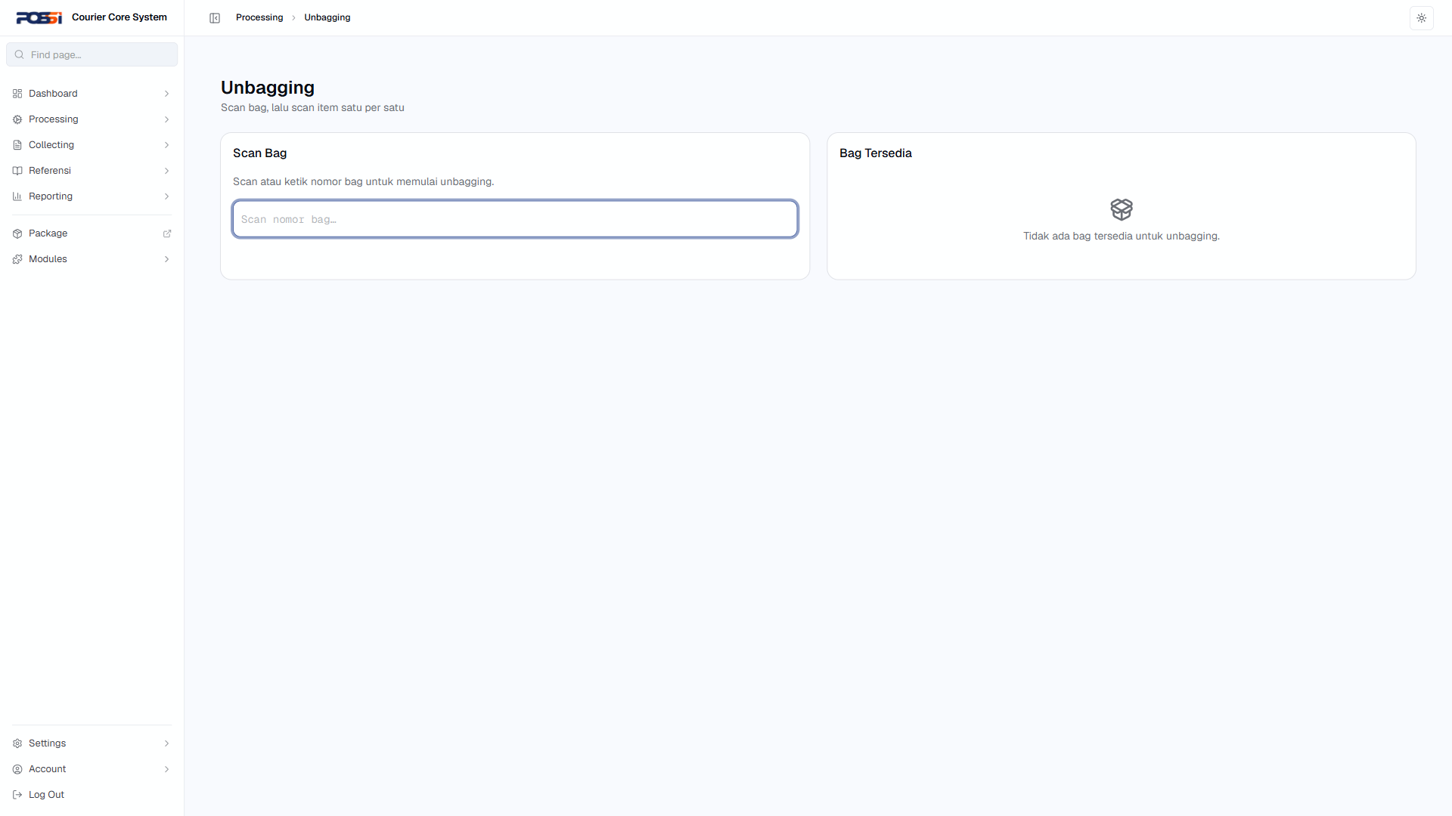
20 | TC-PROC-010 | Loading — muat paket ke kendaraan | 1. Buka /processing/loading 2. Pilih paket yang akan dimuat 3. Pilih kendaraan 4. Konfirmasi loading | Status: PASS | OK |  | 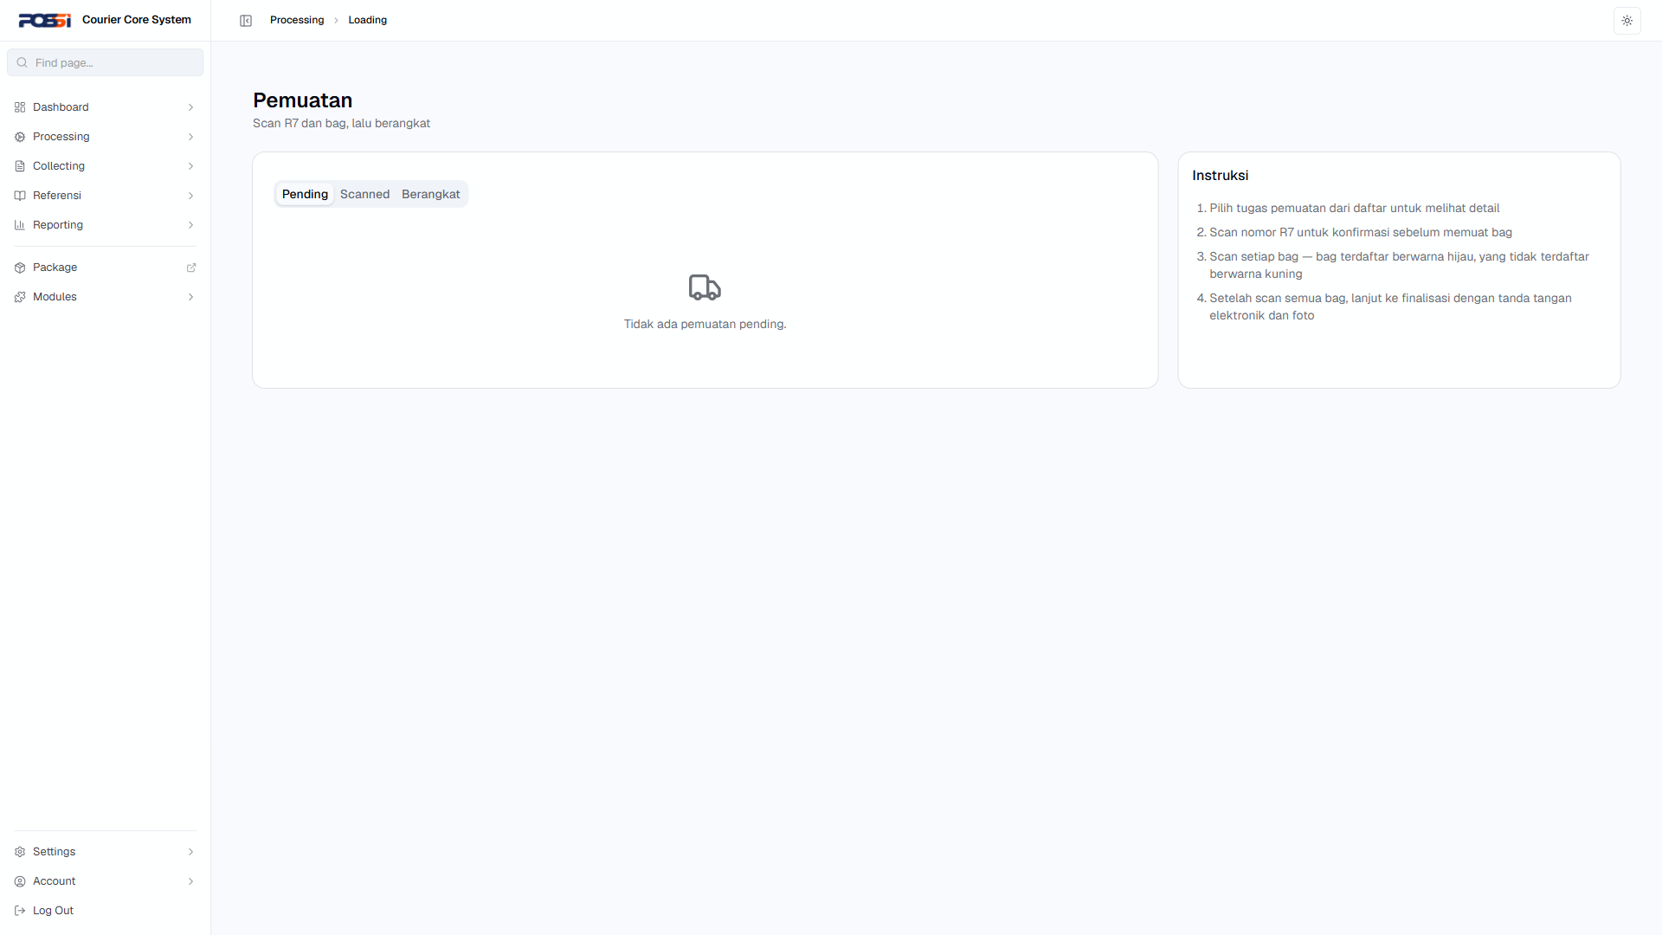
21 | TC-PROC-011 | Unloading — bongkar paket dari kendaraan | 1. Buka /processing/unloading 2. Pilih kendaraan 3. Pilih paket yang akan dibongkar 4. Konfirmasi | Status: PASS | OK |  | 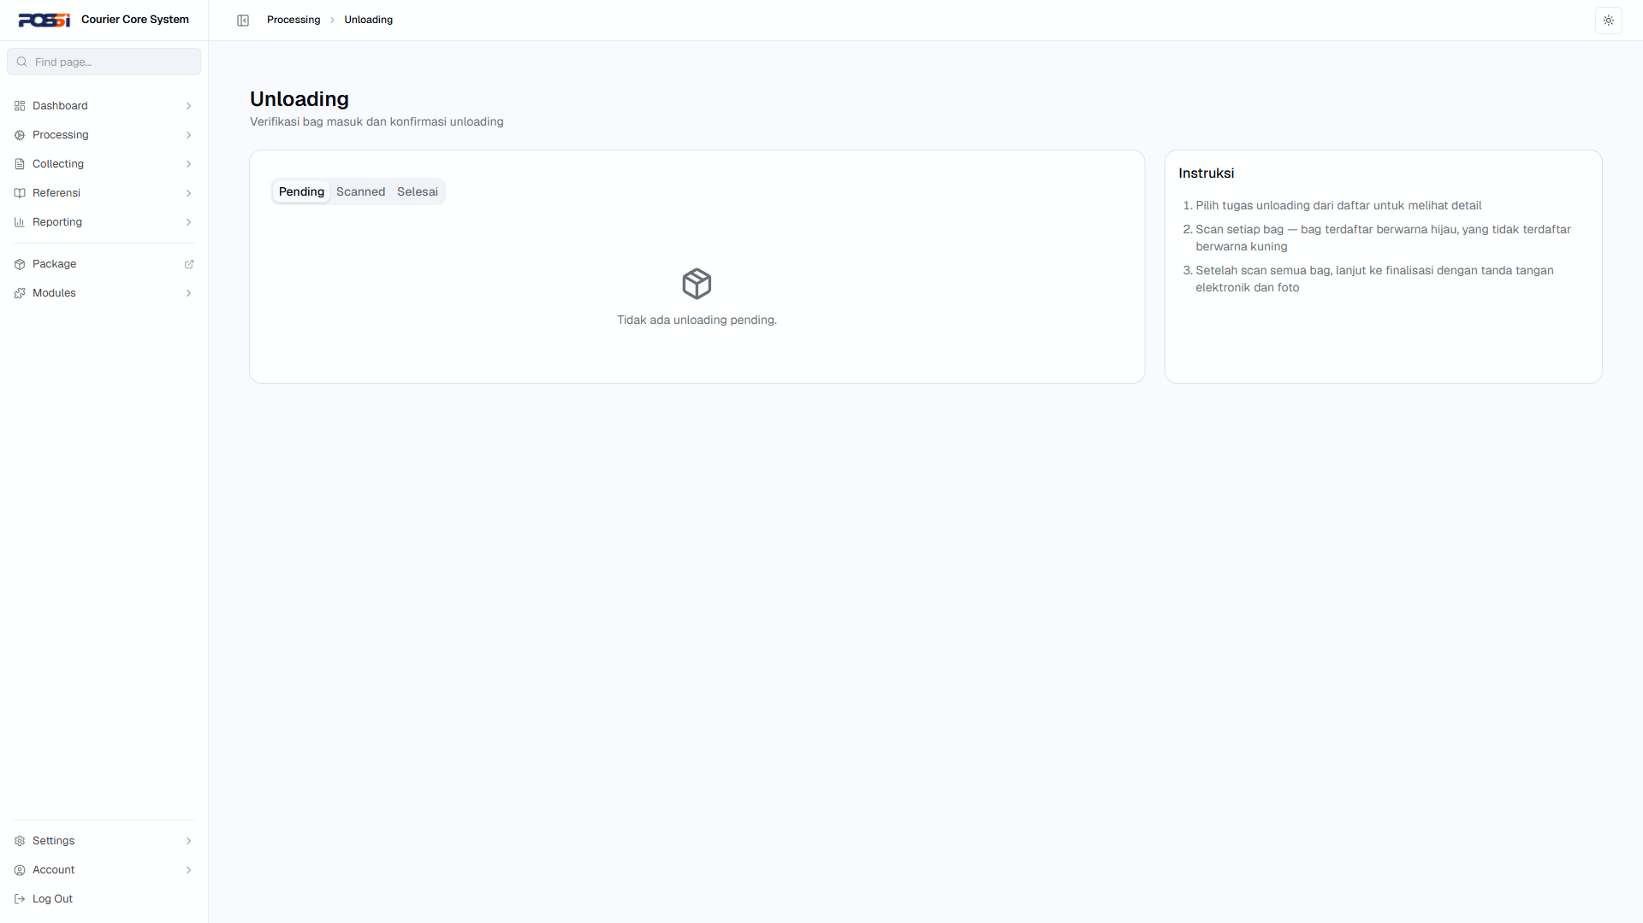
22 | TC-PROC-012 | Irregularity — laporkan paket rusak/hilang | 1. Buka /processing/irregularity 2. Pilih paket yang bermasalah 3. Isi jenis irregularity (rusak/hilang) 4. Isi keterangan 5. Submit | Status: PASS | OK |  | 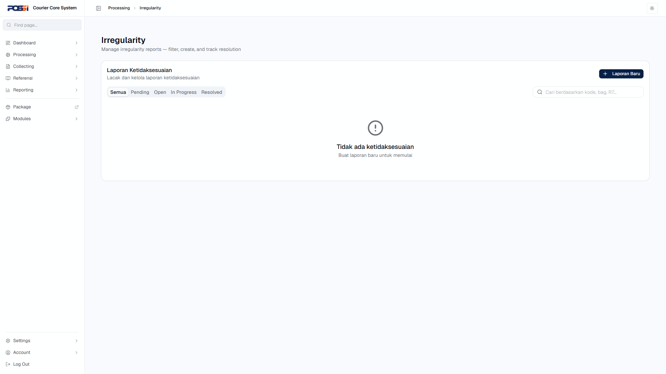
Collecting
23 | TC-COLL-001 | Akses beranda collecting | 1. Buka /collecting | Status: PASS | OK |  | 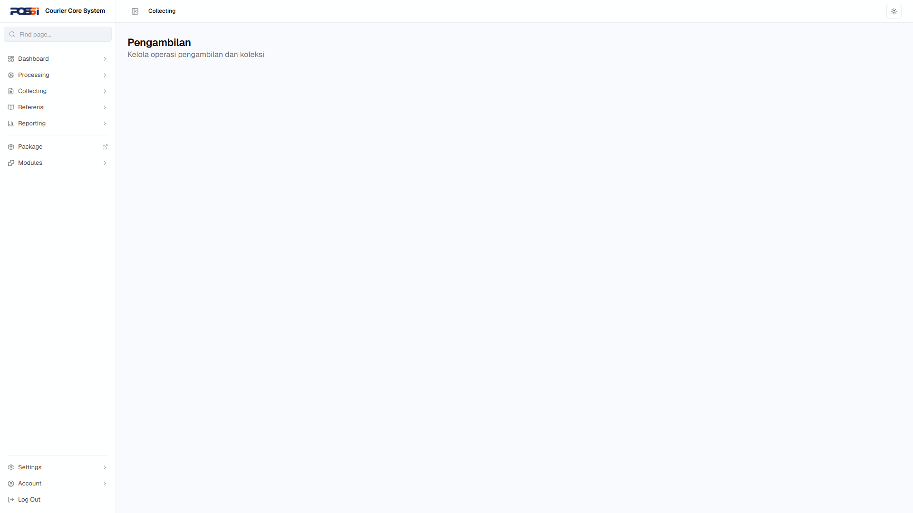
24 | TC-COLL-002 | Buat transaksi baru | 1. Buka /collecting/transaksi 2. Klik buat transaksi baru 3. Isi data transaksi 4. Submit | Status: PASS | OK |  | 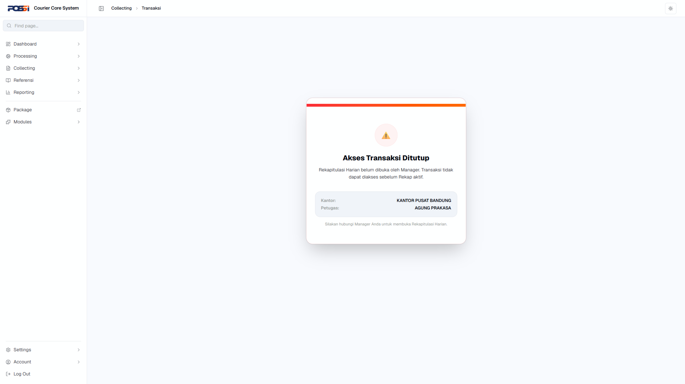
25 | TC-COLL-003 | Lihat daftar transaksi | 1. Buka /collecting/daftar-transaksi | Status: PASS | OK |  | 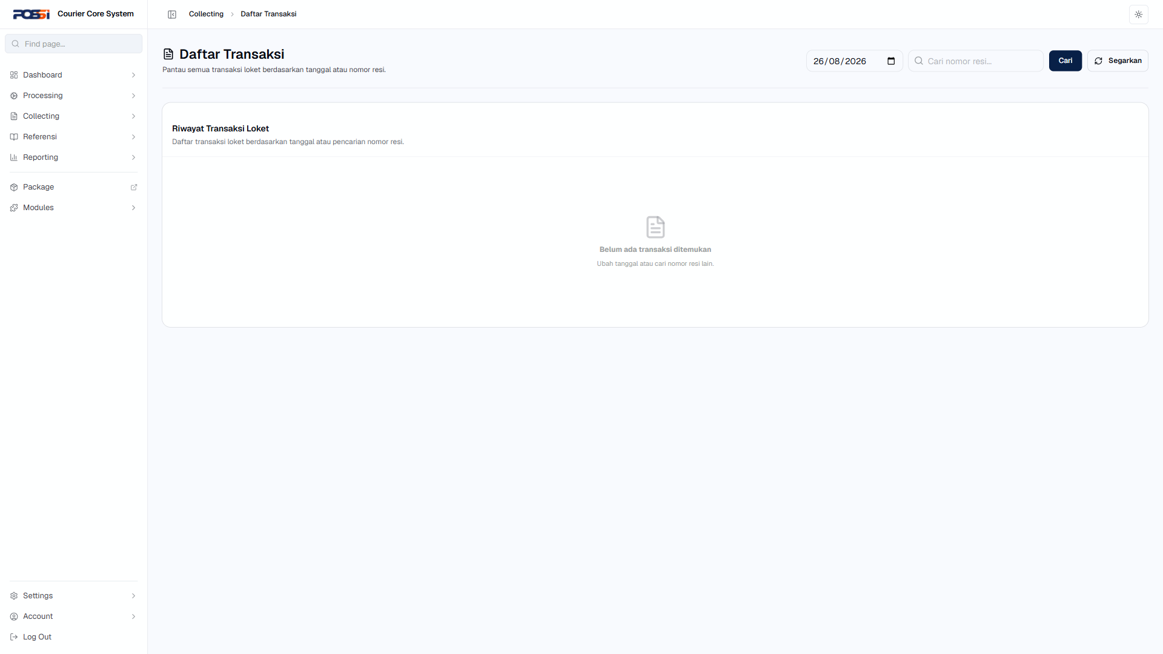
26 | TC-COLL-004 | Lihat backsheet transaksi | 1. Buka /collecting/backsheet | Status: PASS | OK |  | 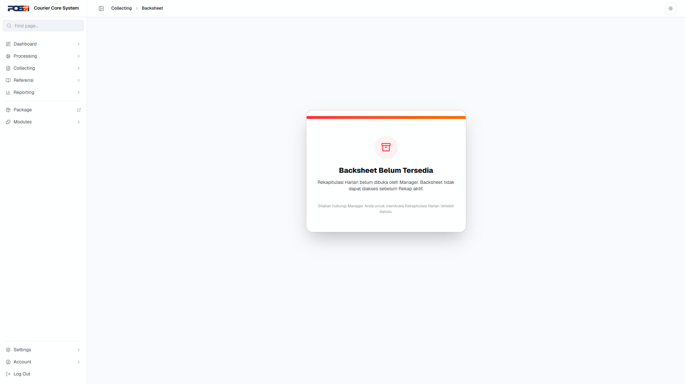
27 | TC-COLL-005 | Lihat rekap harian | 1. Buka /collecting/rekap-harian | Status: PASS | OK |  | 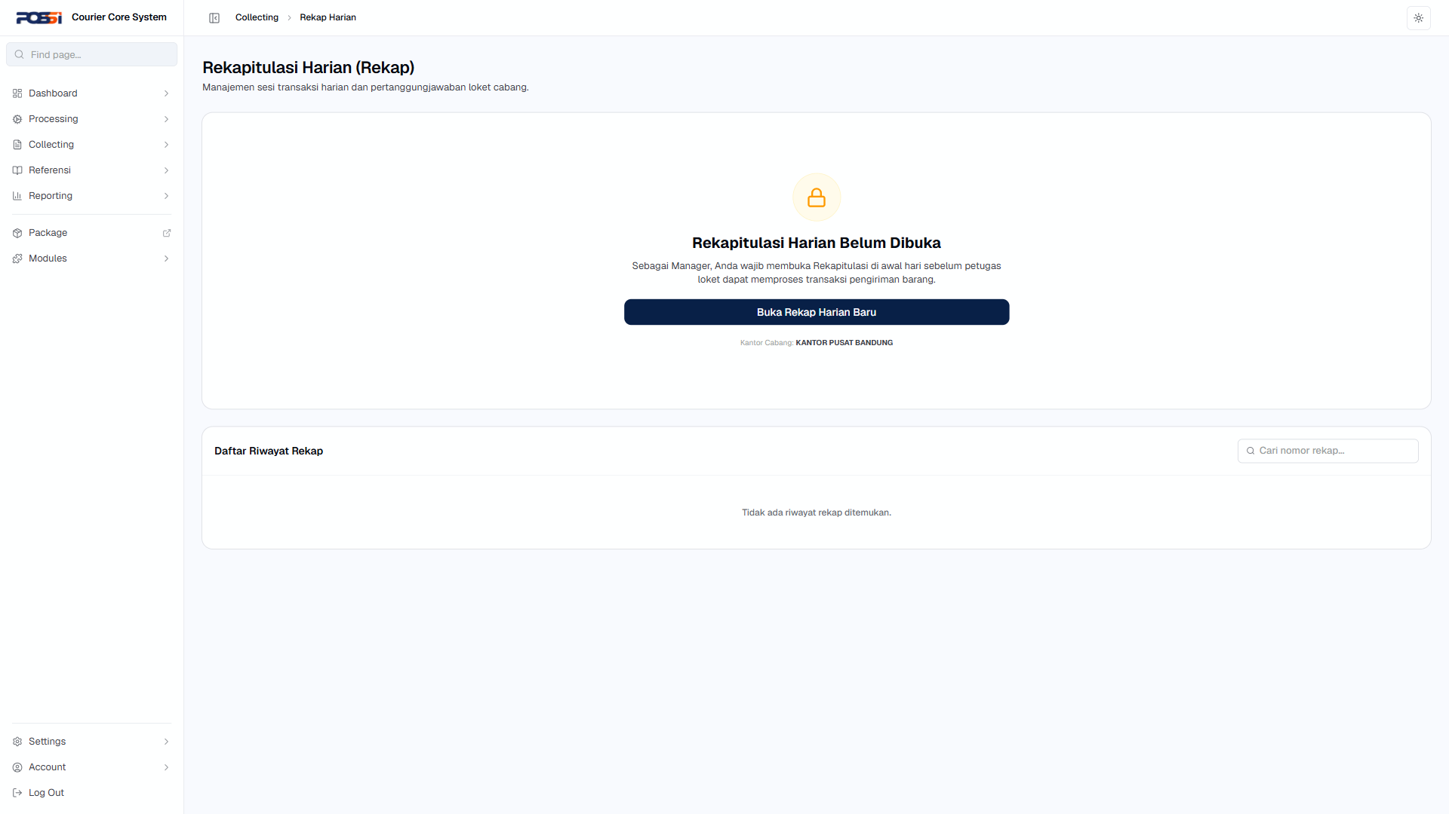
28 | TC-COLL-006 | Audit koreksi — koreksi transaksi | 1. Buka /collecting/audit-koreksi 2. Pilih transaksi yang perlu dikoreksi 3. Ubah data 4. Simpan | Status: PASS | OK |  | 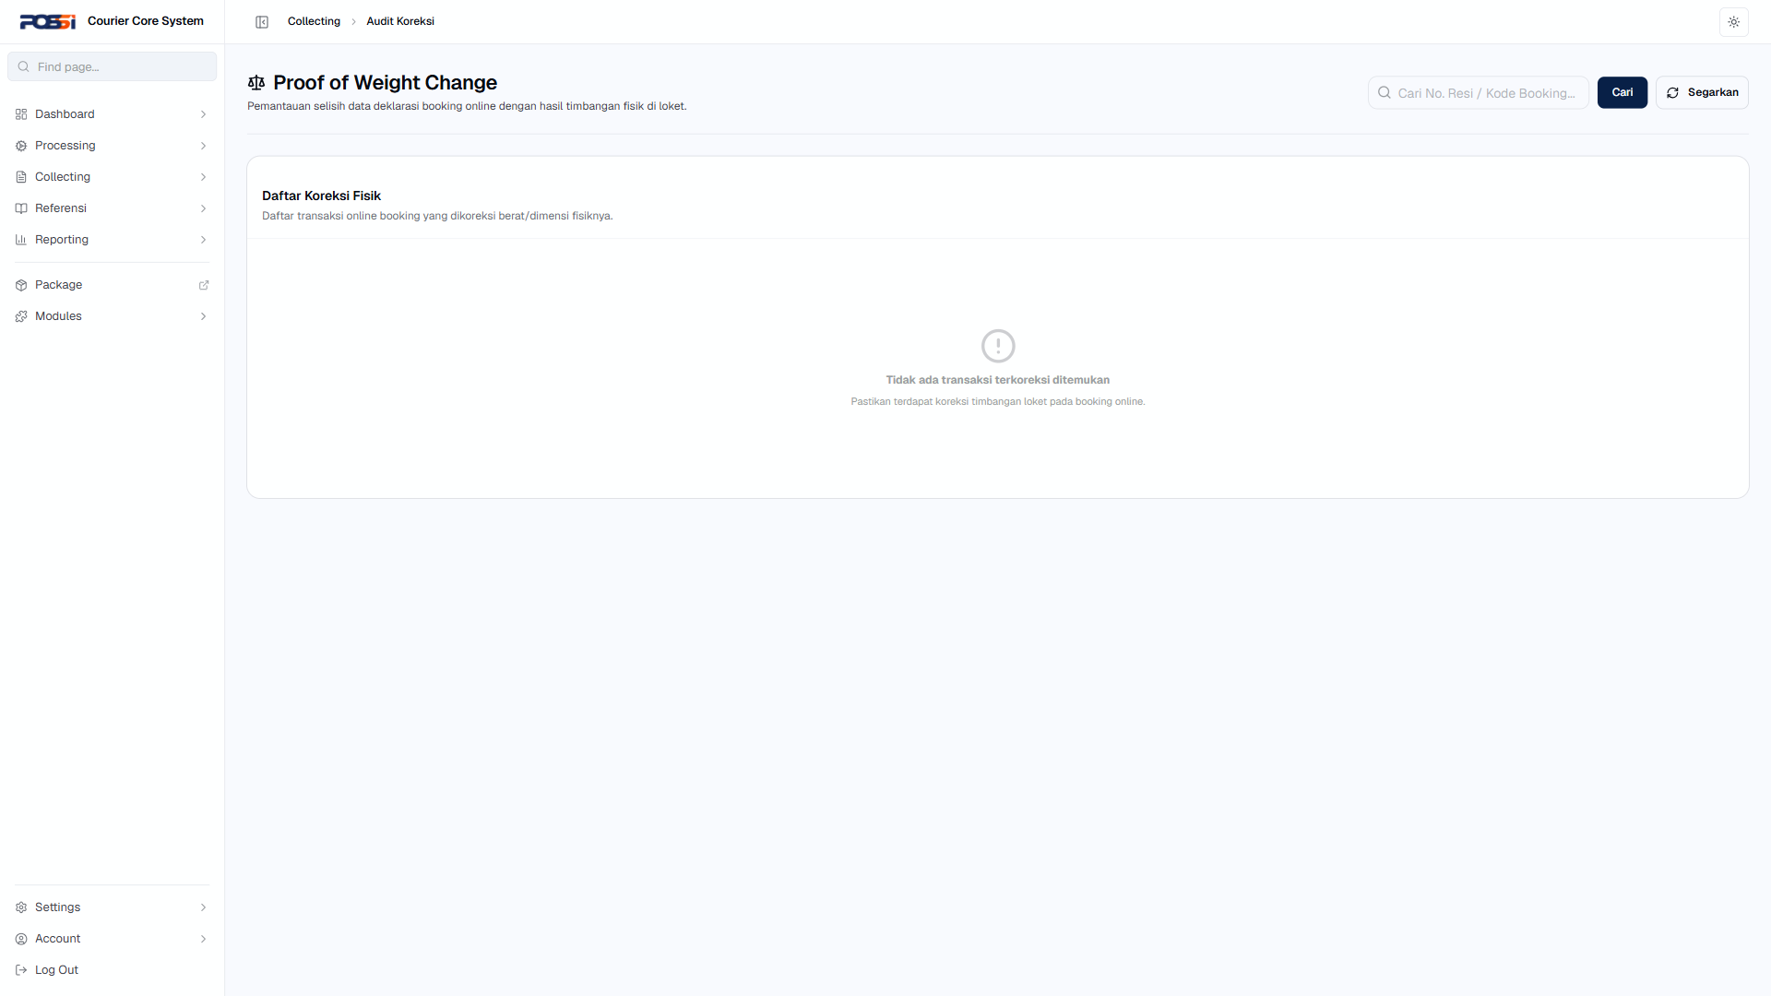
29 | TC-COLL-007 | Pembatalan transaksi | 1. Buka /collecting/pembatalan 2. Pilih transaksi yang akan dibatalkan 3. Konfirmasi pembatalan | Status: PASS | OK |  | 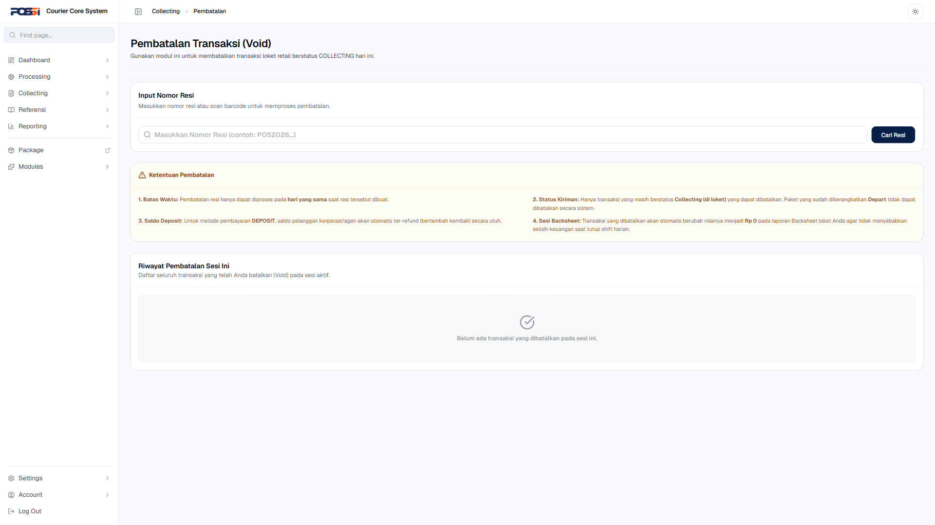
30 | TC-COLL-008 | Transaksi dengan nominal tidak valid | 1. Buka /collecting/transaksi 2. Isi nominal: -100 atau 0 atau sangat besar 3. Submit | Status: PASS | OK |  | 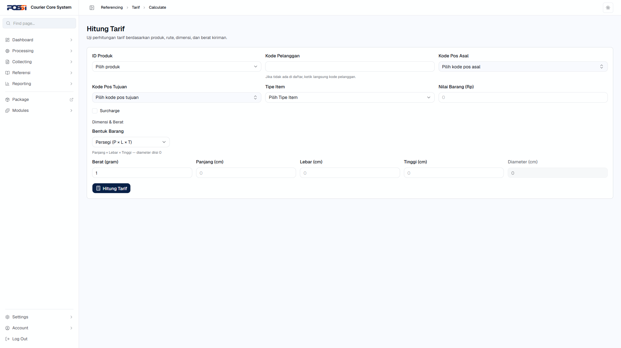
Reporting
31 | TC-REPO-001 | Lihat daftar paket | 1. Buka /reporting/paket | Status: PASS | OK |  | 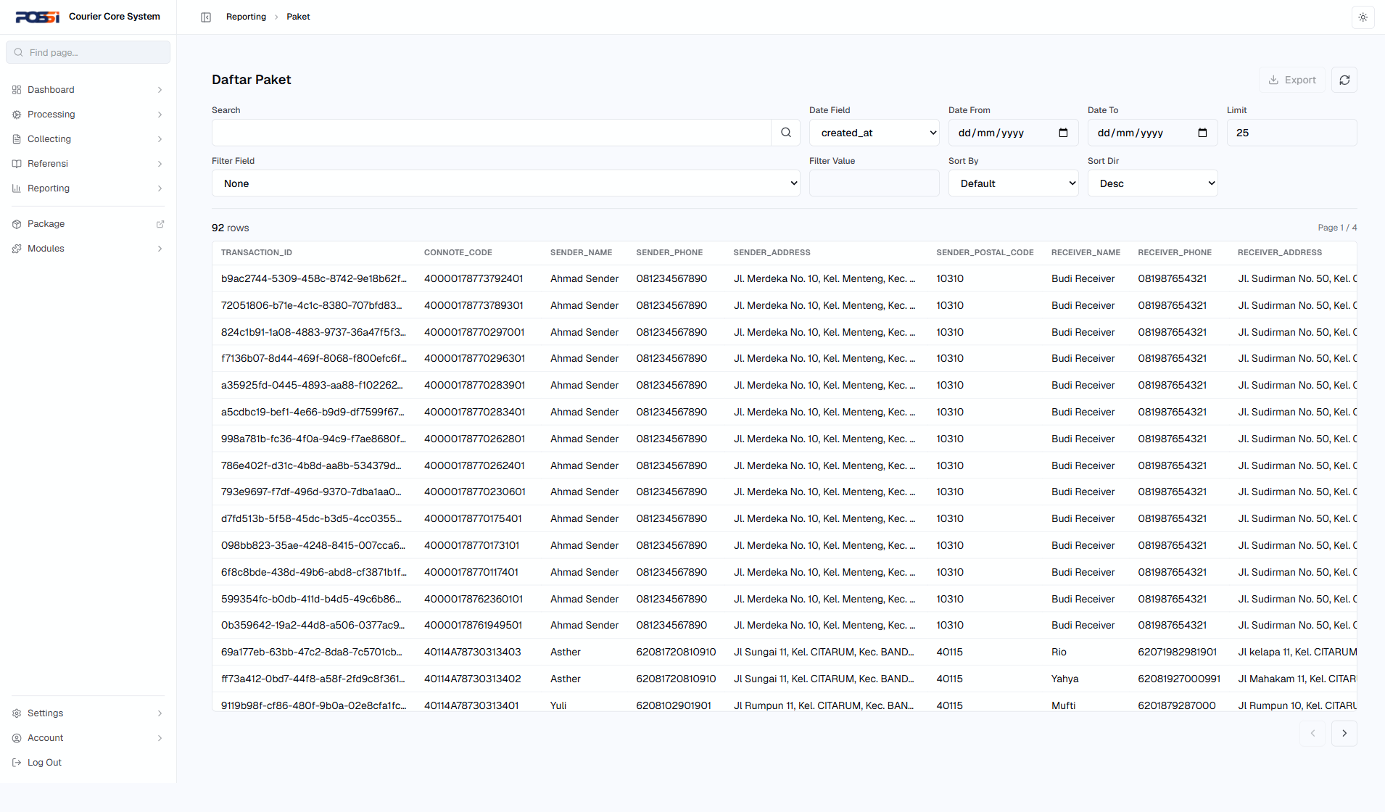
32 | TC-REPO-002 | Lihat daftar bag | 1. Buka /reporting/bag | Status: PASS | OK |  | 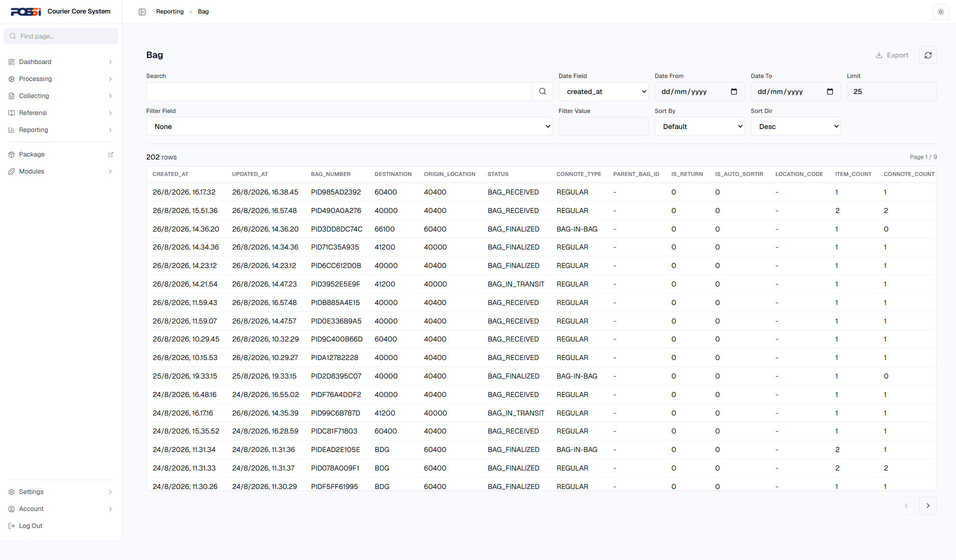
33 | TC-REPO-003 | Tracking bag | 1. Buka /reporting/tracking/bag 2. Cari bag berdasarkan nomor | Status: PASS | OK |  | 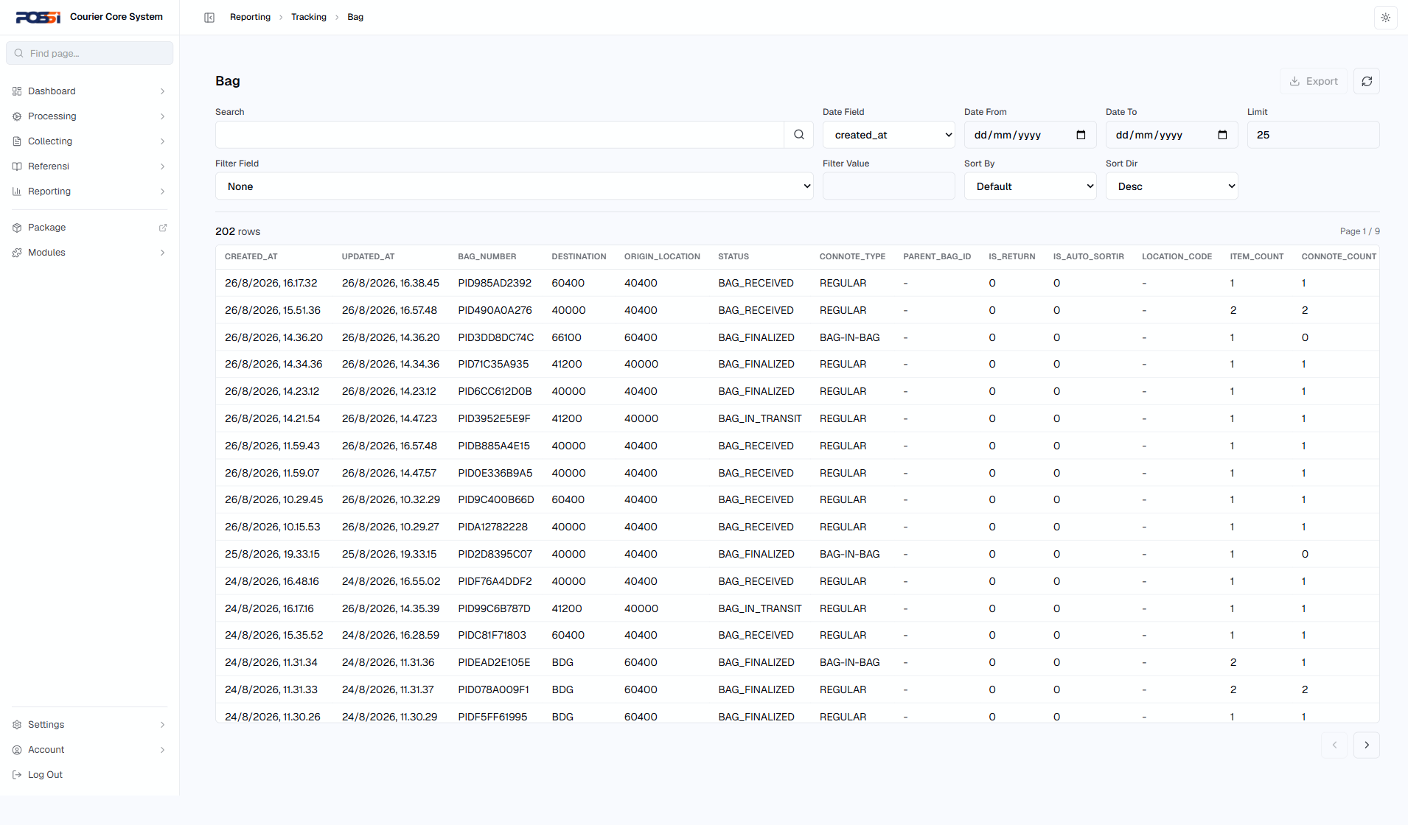
34 | TC-REPO-004 | Tracking bag item | 1. Buka /reporting/tracking/bag-item 2. Cari item | Status: PASS | OK |  | 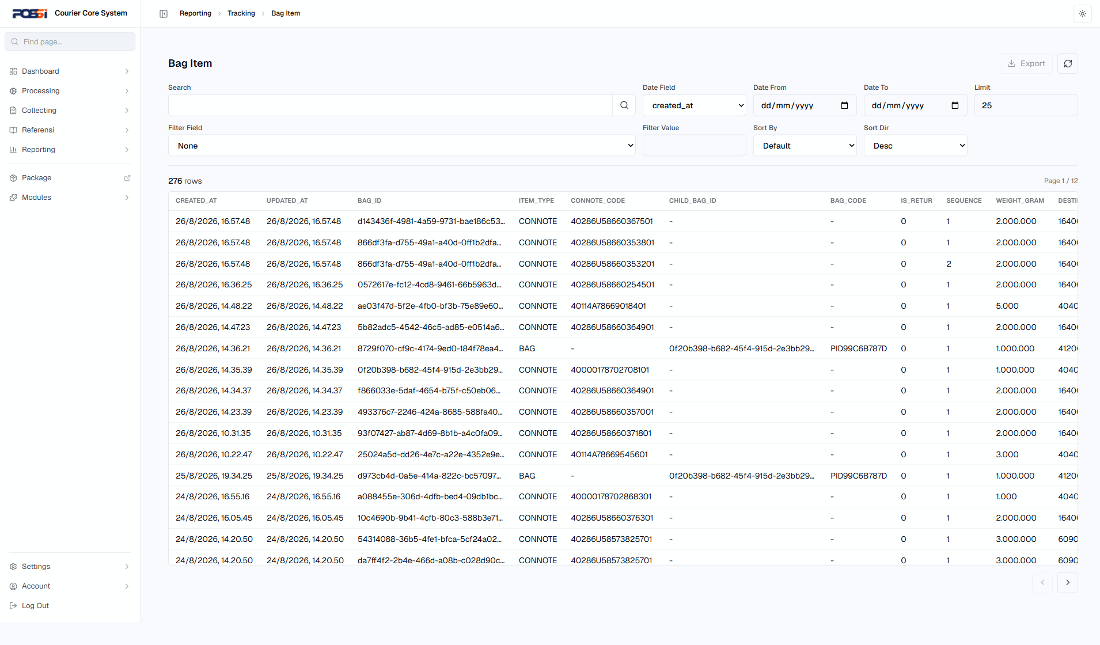
35 | TC-REPO-005 | Tracking events | 1. Buka /reporting/tracking/tracking-events 2. Lihat event terbaru | Status: PASS | OK |  | 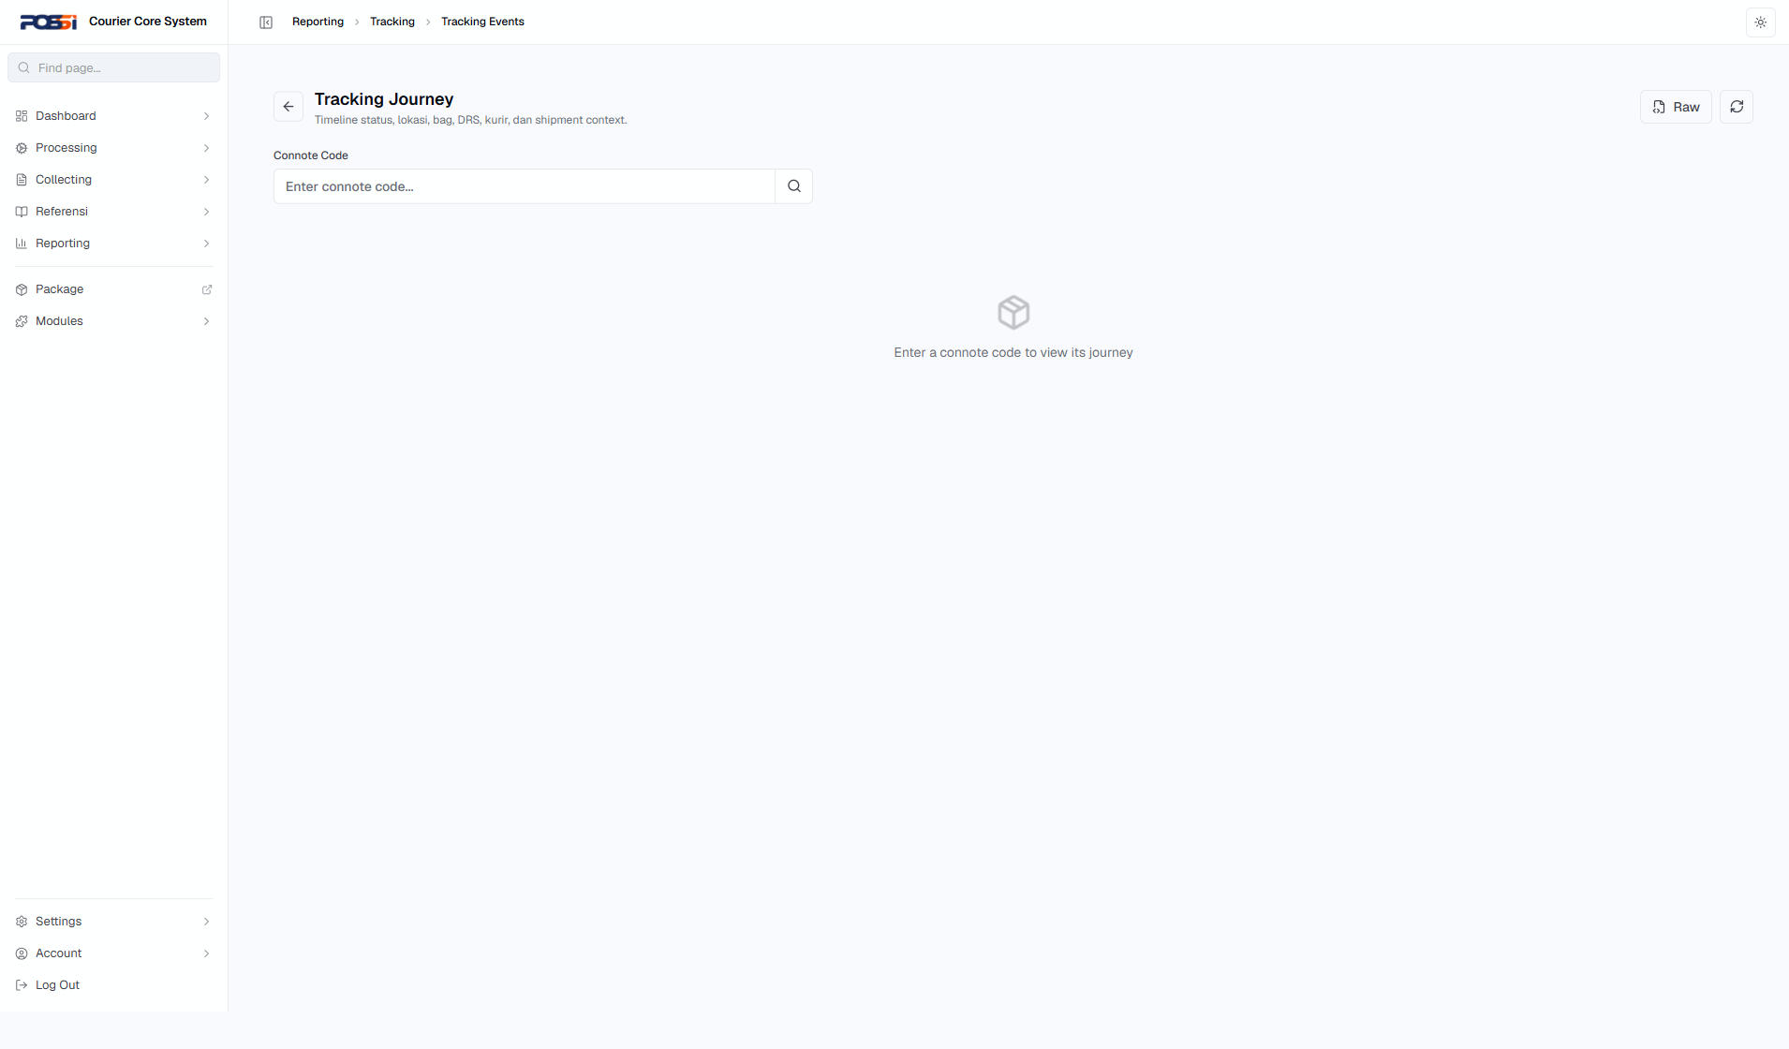
36 | TC-REPO-006 | Lihat daftar kedatangan | 1. Buka /reporting/kedatangan | Status: PASS | OK |  | 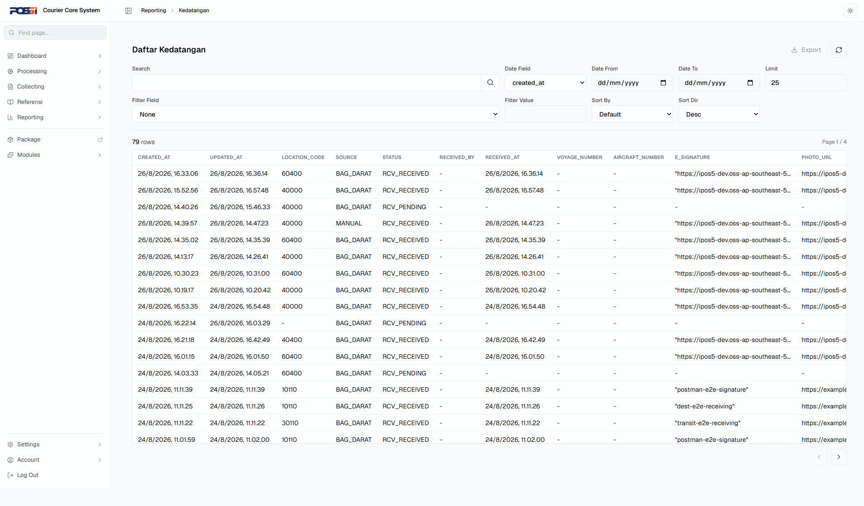
37 | TC-REPO-007 | Lihat daftar angkutan | 1. Buka /reporting/angkutan | Status: PASS | OK |  | 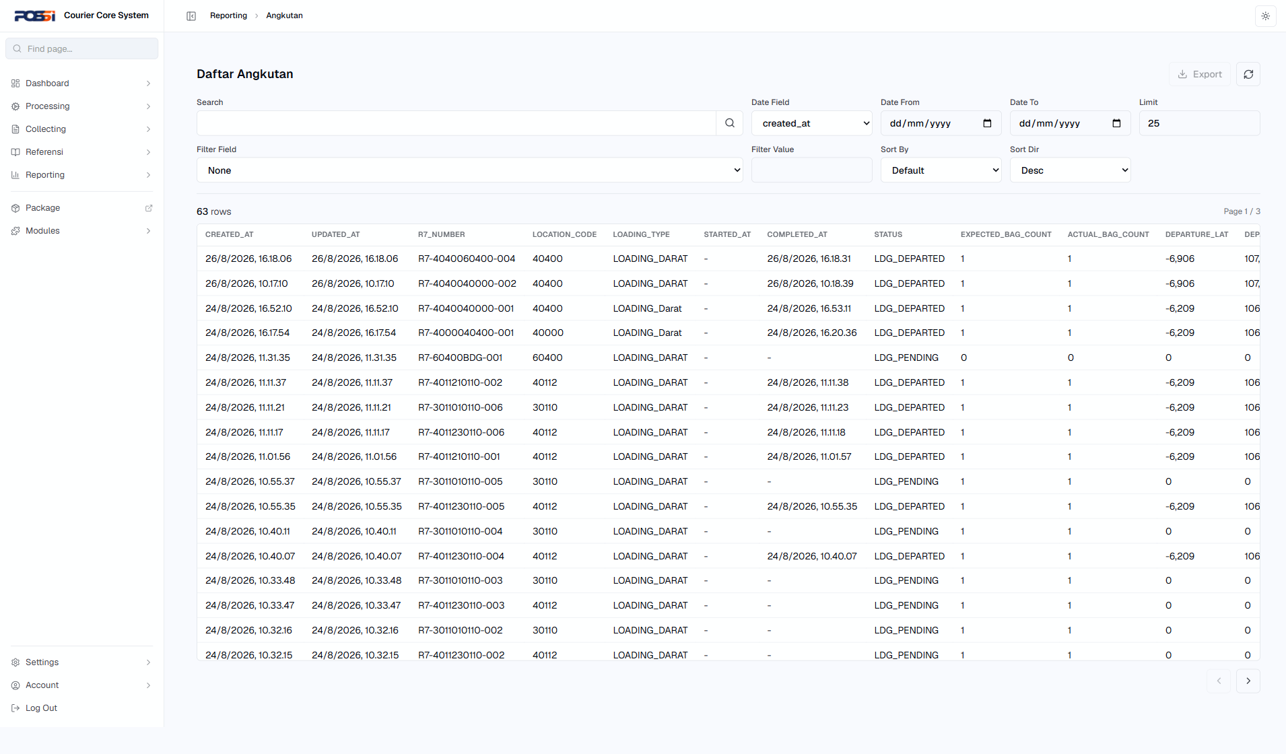
38 | TC-REPO-008 | Laporan loading/unloading | 1. Buka /reporting/operational/loading 2. Buka /reporting/operational/unloading | Status: PASS | OK |  | 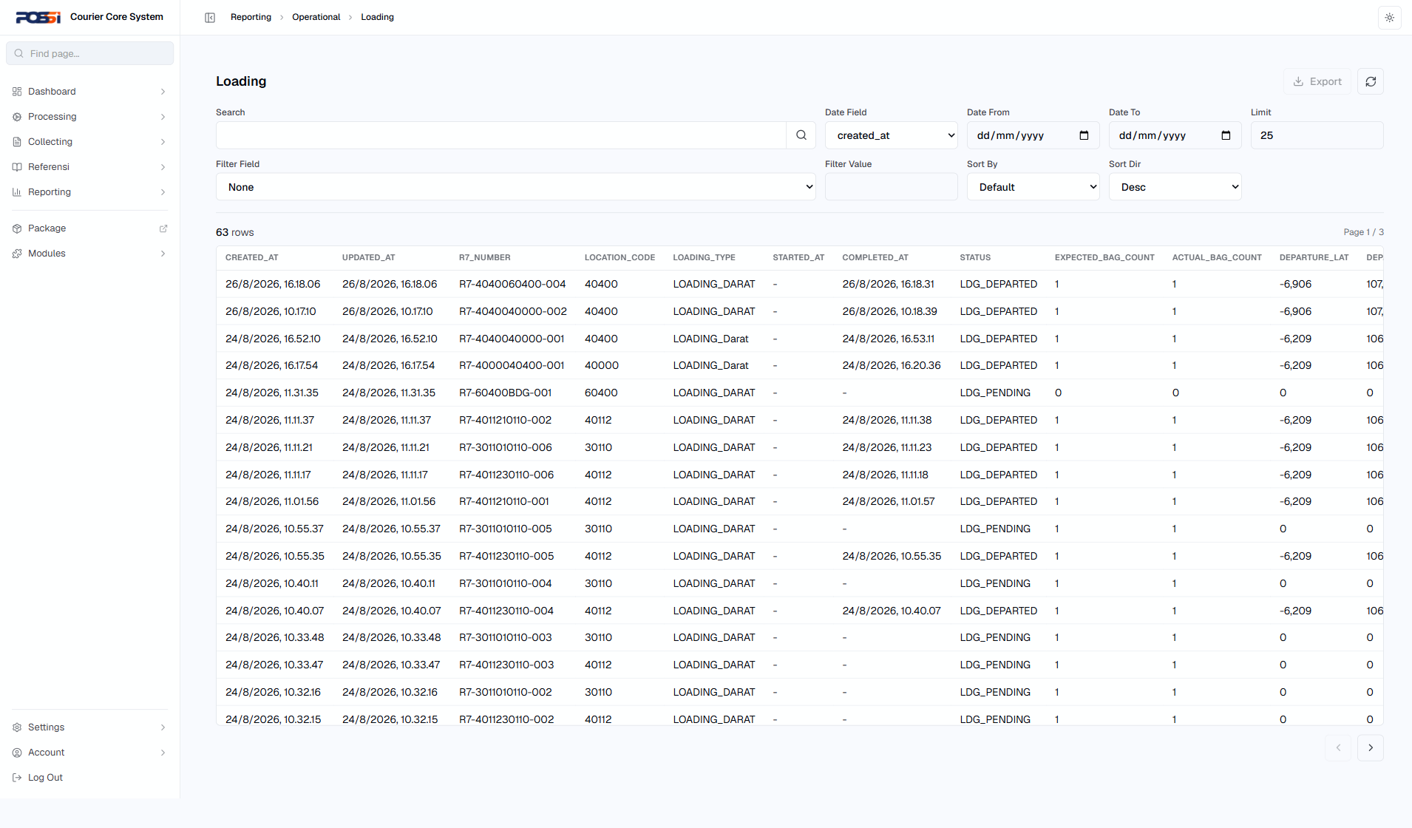
39 | TC-REPO-009 | Laporan komisi agenpos | 1. Buka /reporting/komisi | Status: PASS | OK |  | 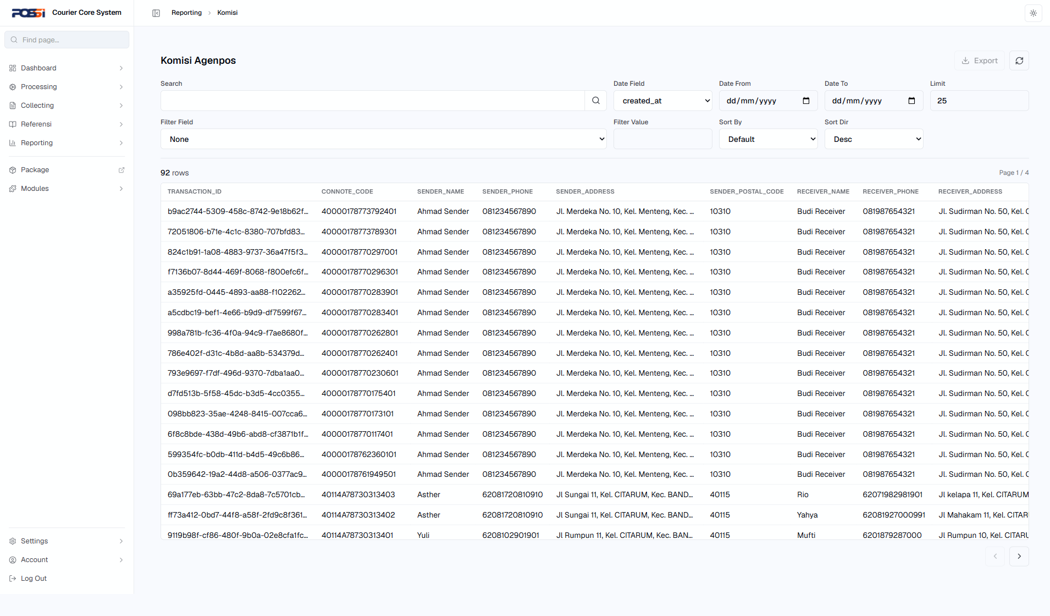
40 | TC-REPO-010 | Laporan keuangan | 1. Buka /reporting/keuangan | Status: PASS | OK |  | 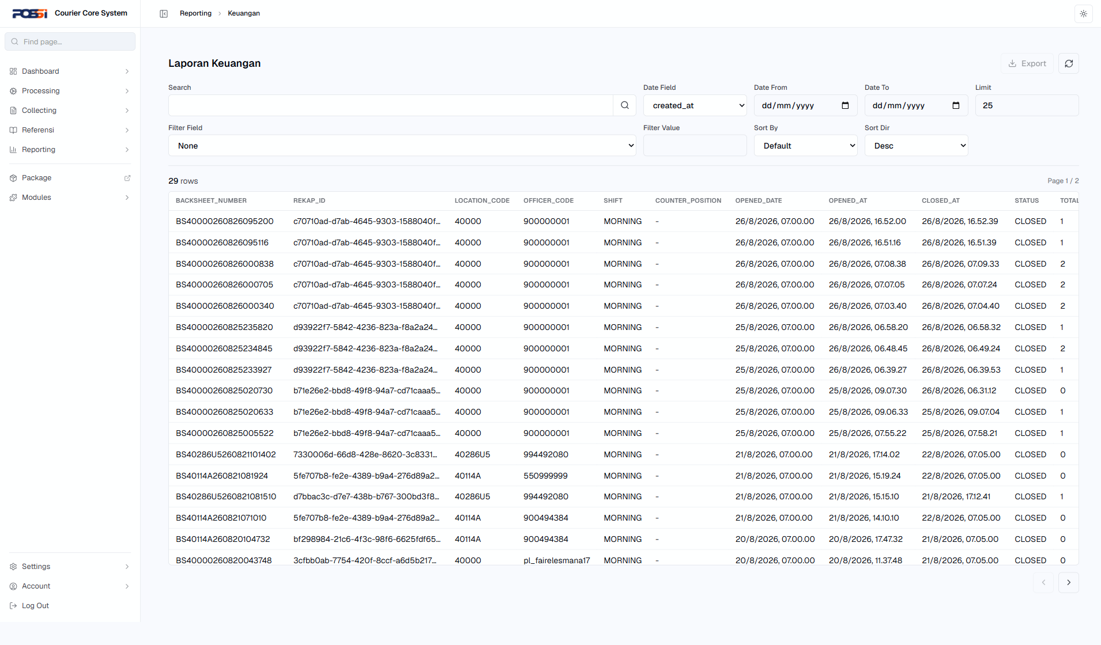
Tracking
41 | TC-TRCK-001 | Cari paket berdasarkan nomor resi | 1. Buka halaman tracking 2. Masukkan nomor resi 3. Klik cari | Status: PASS | OK |  | 
42 | TC-TRCK-002 | Lihat history tracking paket | 1. Setelah paket ditemukan 2. Klik lihat history | Status: PASS | OK |  | 
43 | TC-TRCK-003 | Cari paket tidak ditemukan | 1. Buka halaman tracking 2. Masukkan nomor resi palsu: 000000000 3. Klik cari | Status: PASS | OK |  | 
44 | TC-TRCK-004 | Filter tracking berdasarkan tanggal | 1. Buka halaman tracking 2. Set filter tanggal awal & akhir 3. Terapkan filter | Status: PASS | OK |  | 
Settings
45 | TC-SETT-001 | Lihat daftar user | 1. Buka /settings/user | Status: PASS | OK |  | 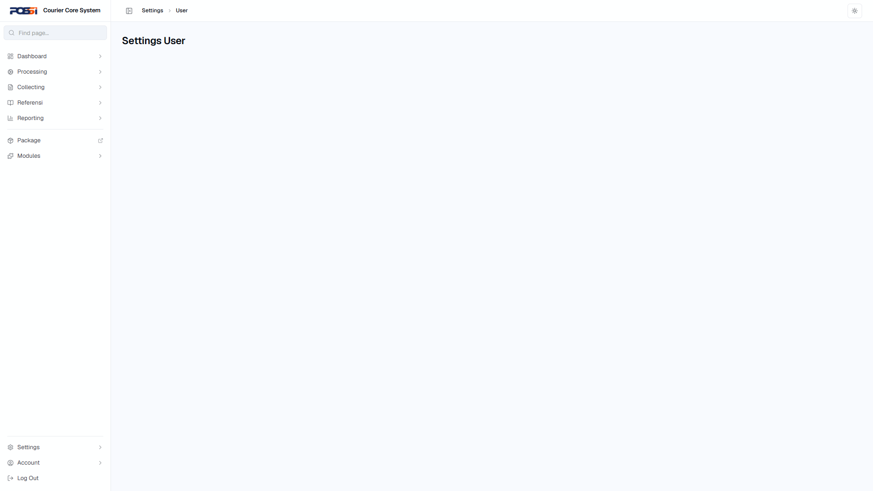
46 | TC-SETT-002 | Tambah user baru | 1. Buka /settings/user 2. Klik tambah user 3. Isi data user (NIPPOS, nama, role) 4. Simpan | Status: PASS | OK |  | 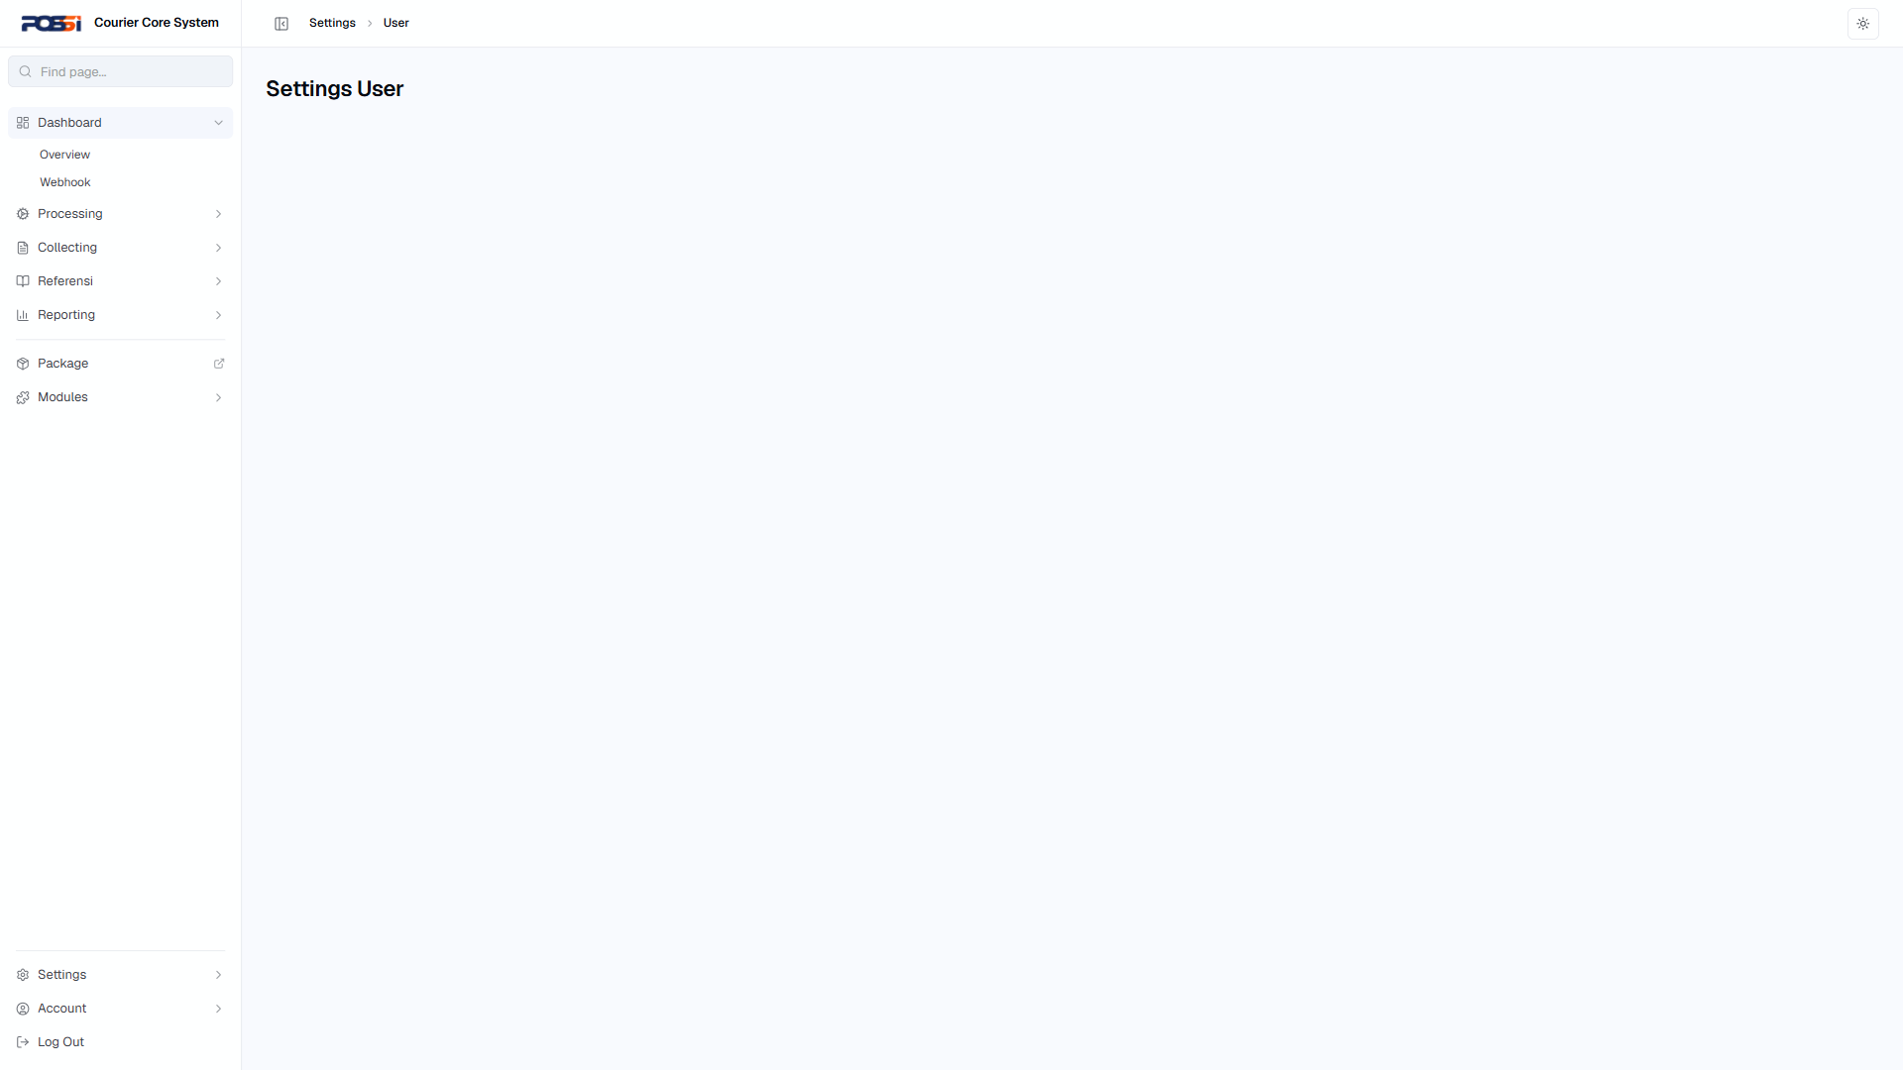
47 | TC-SETT-003 | Edit user | 1. Buka /settings/user 2. Pilih user 3. Ubah data (nama/role) 4. Simpan | Status: PASS | OK |  | 
48 | TC-SETT-004 | Hapus user | 1. Buka /settings/user 2. Pilih user 3. Klik hapus 4. Konfirmasi | Status: PASS | OK |  | 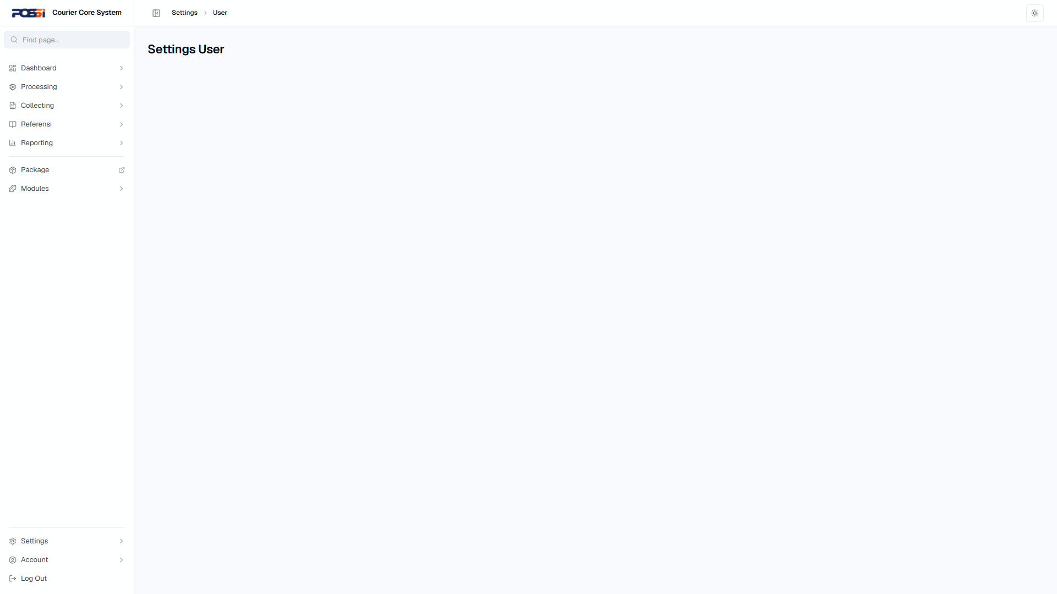
49 | TC-SETT-005 | Manajemen role — tambah/hapus role | 1. Buka /settings/role 2. Tambah role baru 3. Set permission untuk role 4. Simpan 5. Hapus role | Status: PASS | OK |  | 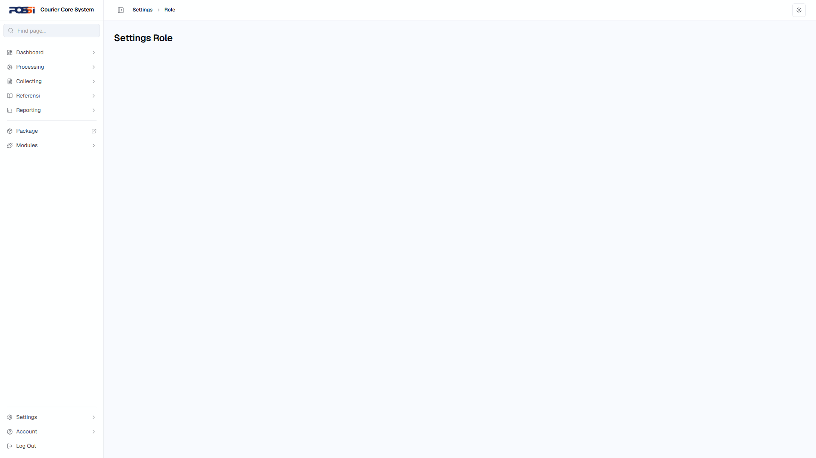
50 | TC-SETT-006 | Manajemen permission — set hak akses | 1. Buka /settings/permission 2. Pilih role 3. Ubah hak akses 4. Simpan | Status: PASS | OK |  | 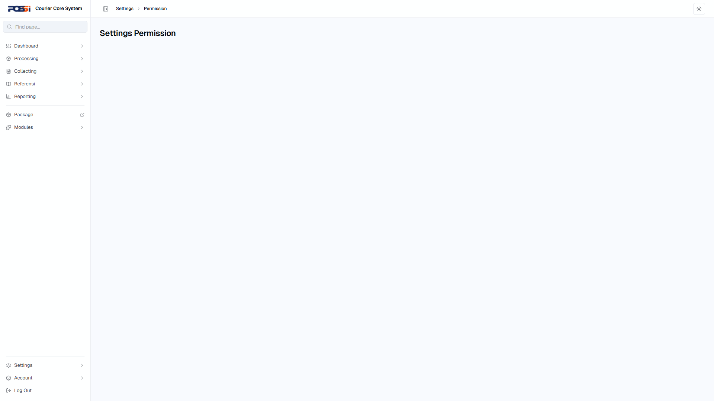
51 | TC-SETT-007 | Manajemen lokasi | 1. Buka /settings/location 2. Tambah lokasi baru 3. Edit lokasi 4. Hapus lokasi | Status: PASS | OK |  | 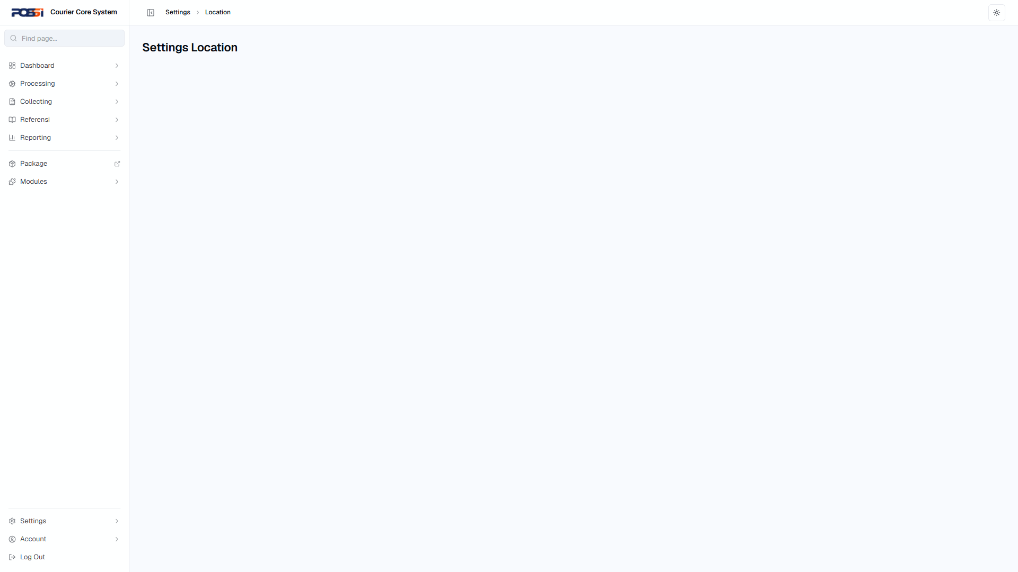
52 | TC-SETT-008 | Manajemen tim | 1. Buka /settings/team 2. Tambah tim baru 3. Assign anggota 4. Simpan | Status: PASS | OK |  | 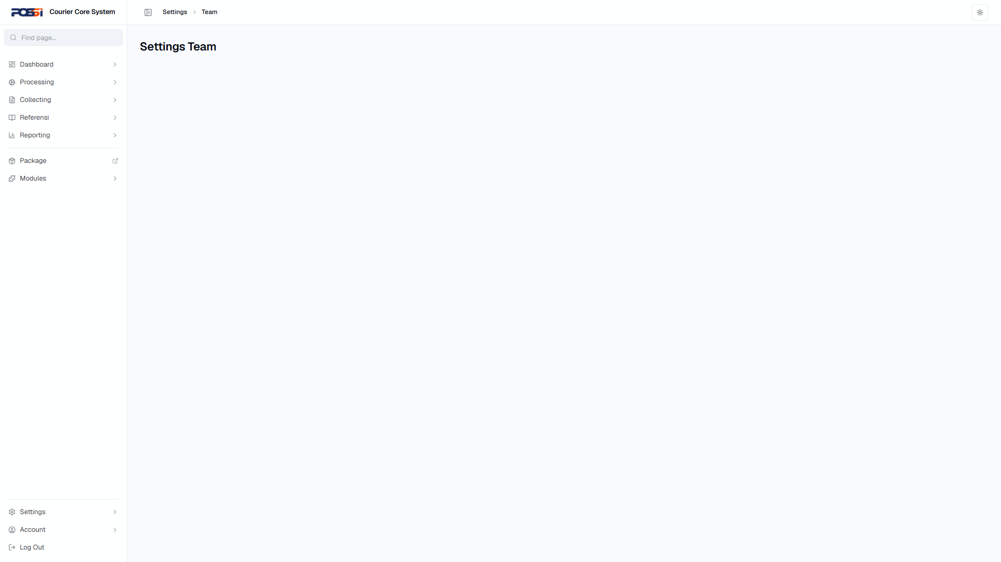
53 | TC-SETT-009 | Konfigurasi webhook | 1. Buka /settings/webhook 2. Tambah webhook baru 3. Isi URL & event 4. Simpan | Status: PASS | OK |  | 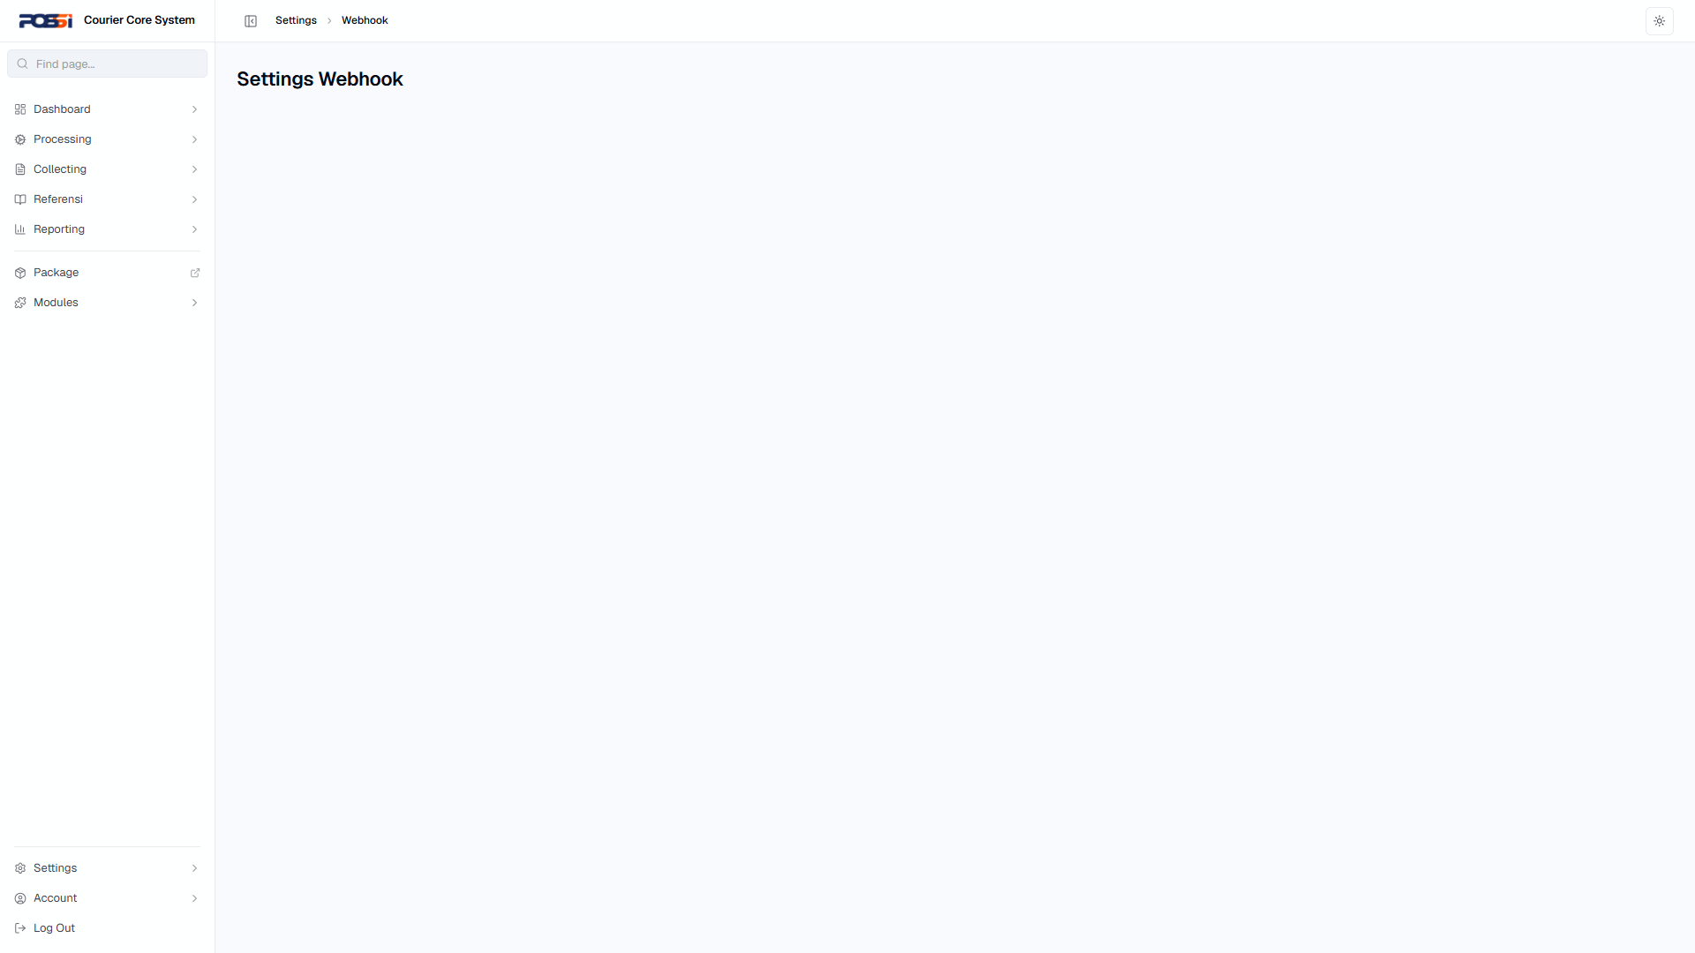
54 | TC-SETT-010 | Konfigurasi flow | 1. Buka /settings/flow 2. Lihat flow yang ada 3. Ubah konfigurasi | Status: PASS | OK |  | 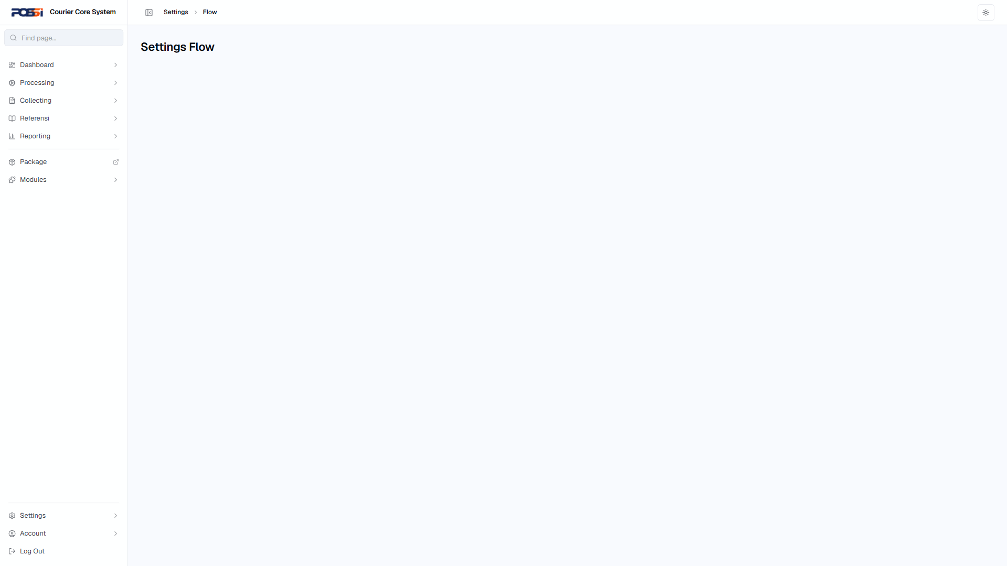
Modules
55 | TC-MODL-001 | Irregularity — laporkan ketidakberesan | 1. Buka /modules/irregularity 2. Laporkan paket bermasalah 3. Isi detail 4. Submit | Status: PASS | OK |  | 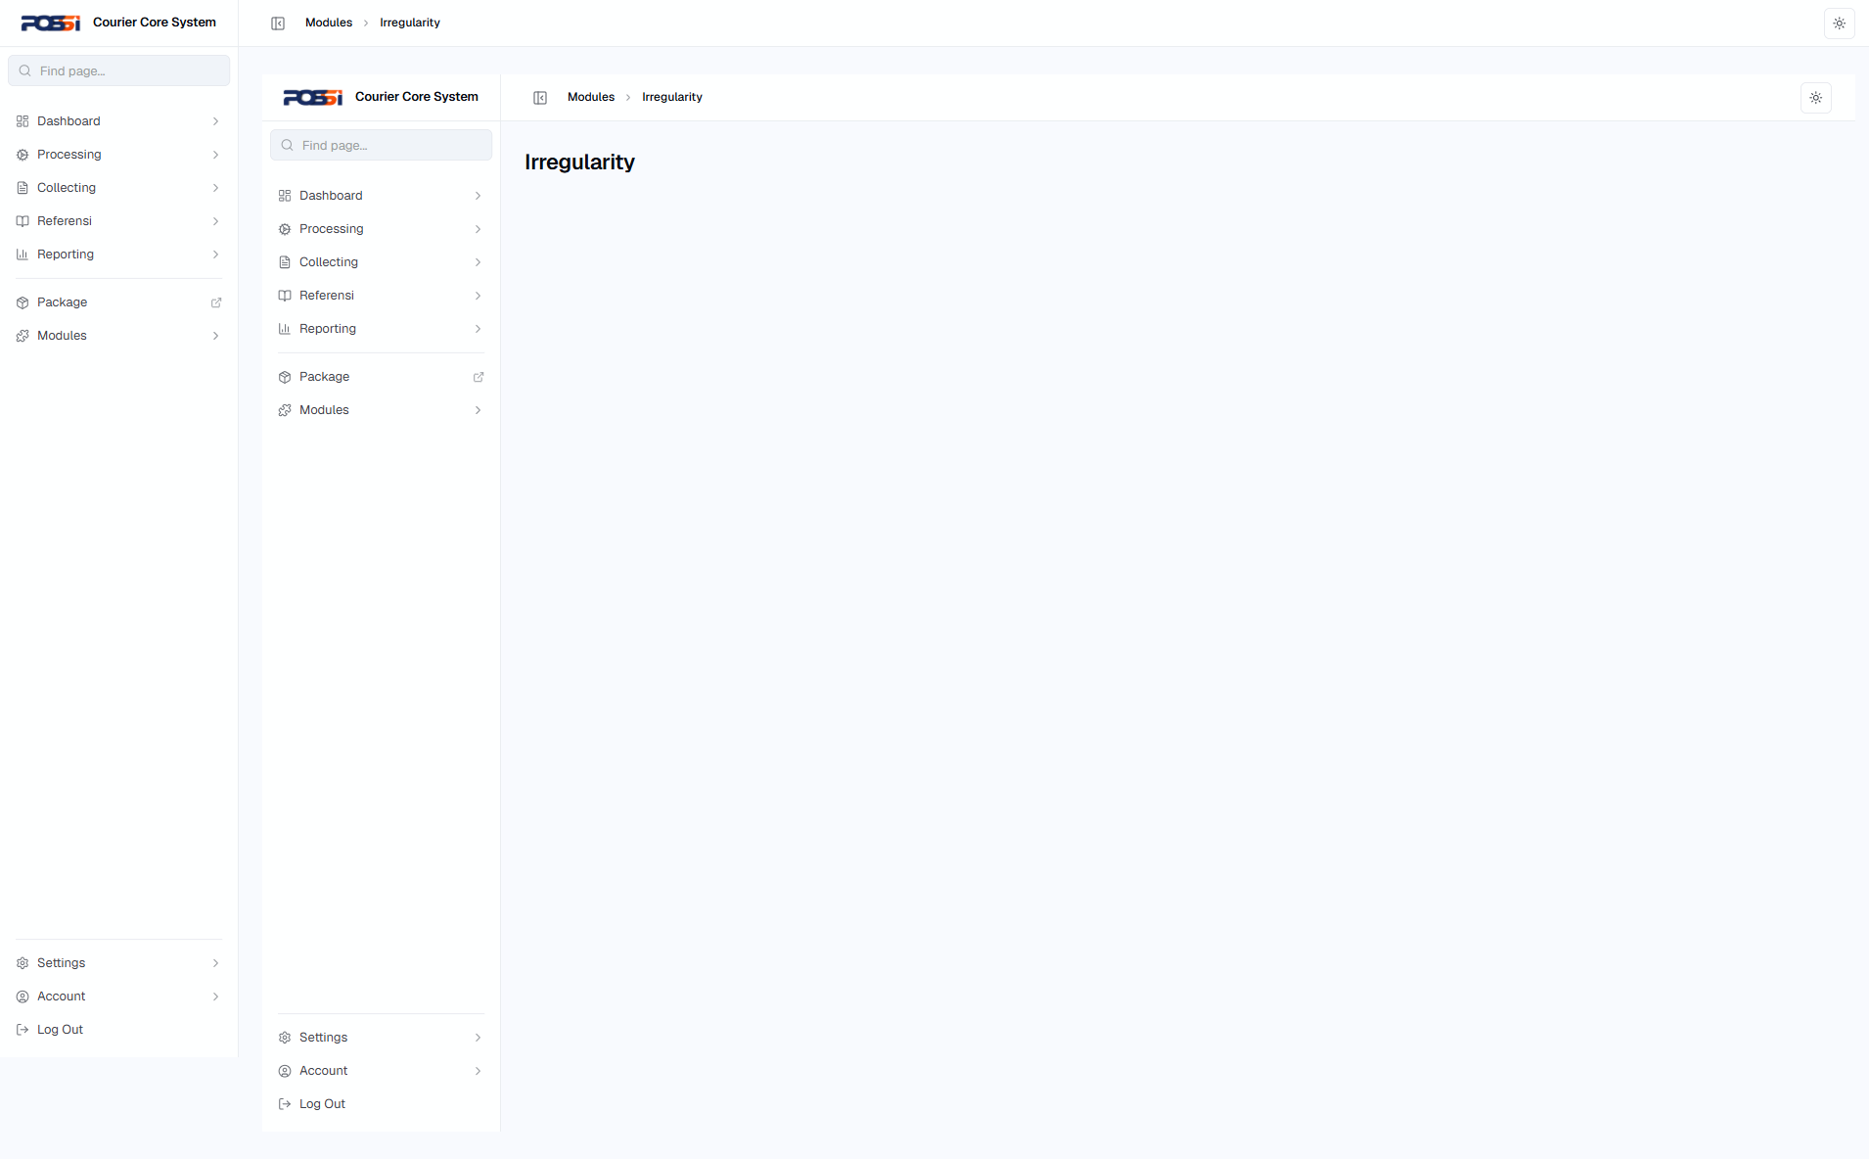
56 | TC-MODL-002 | COD Recon — rekonsiliasi COD | 1. Buka /modules/cod-recon 2. Pilih transaksi COD 3. Rekonsiliasi 4. Konfirmasi | Status: PASS | OK |  | 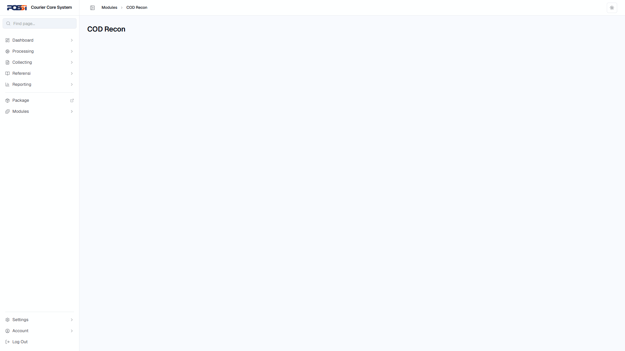
Account
57 | TC-ACCT-001 | Lihat profil pengguna | 1. Buka /account | Status: PASS | OK |  | 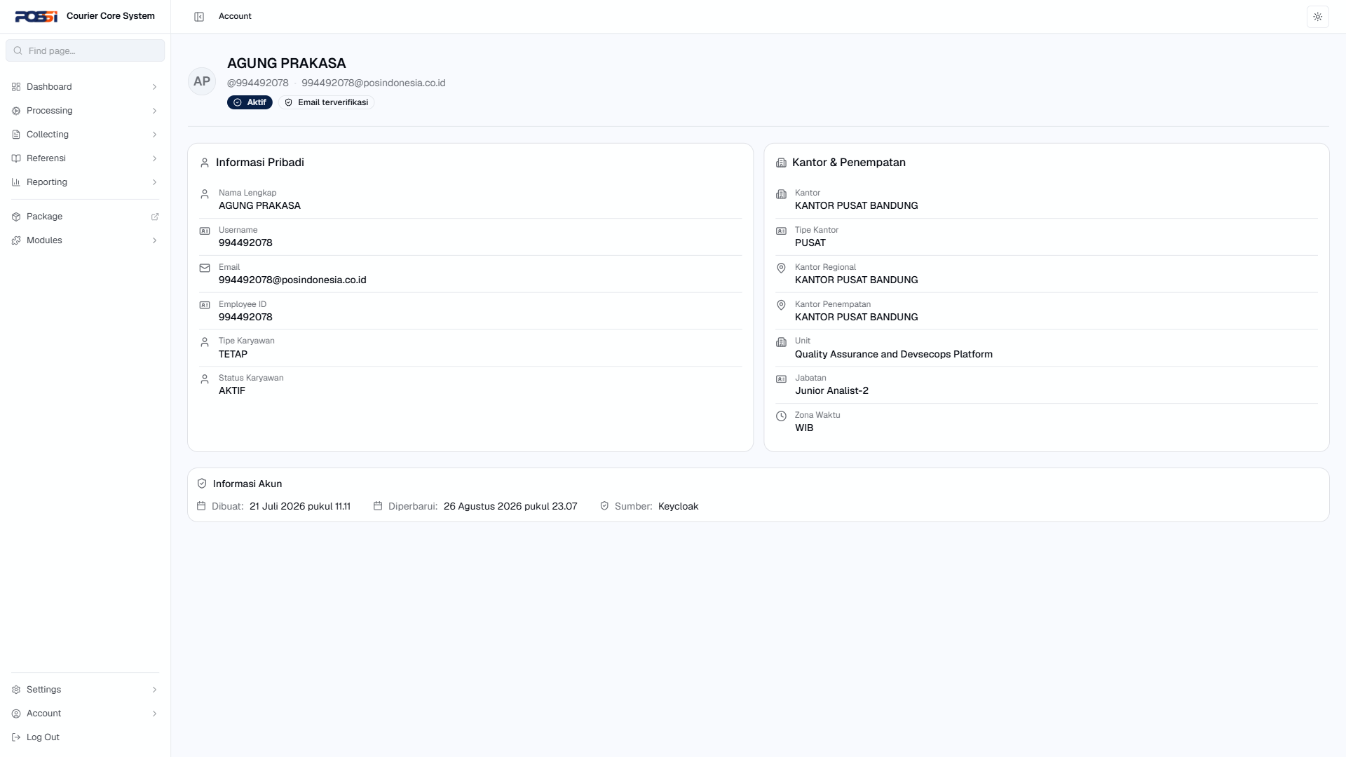
58 | TC-ACCT-002 | Ubah password | 1. Buka /account/password 2. Isi password lama 3. Isi password baru 4. Konfirmasi password baru 5. Simpan | Status: PASS | OK |  | 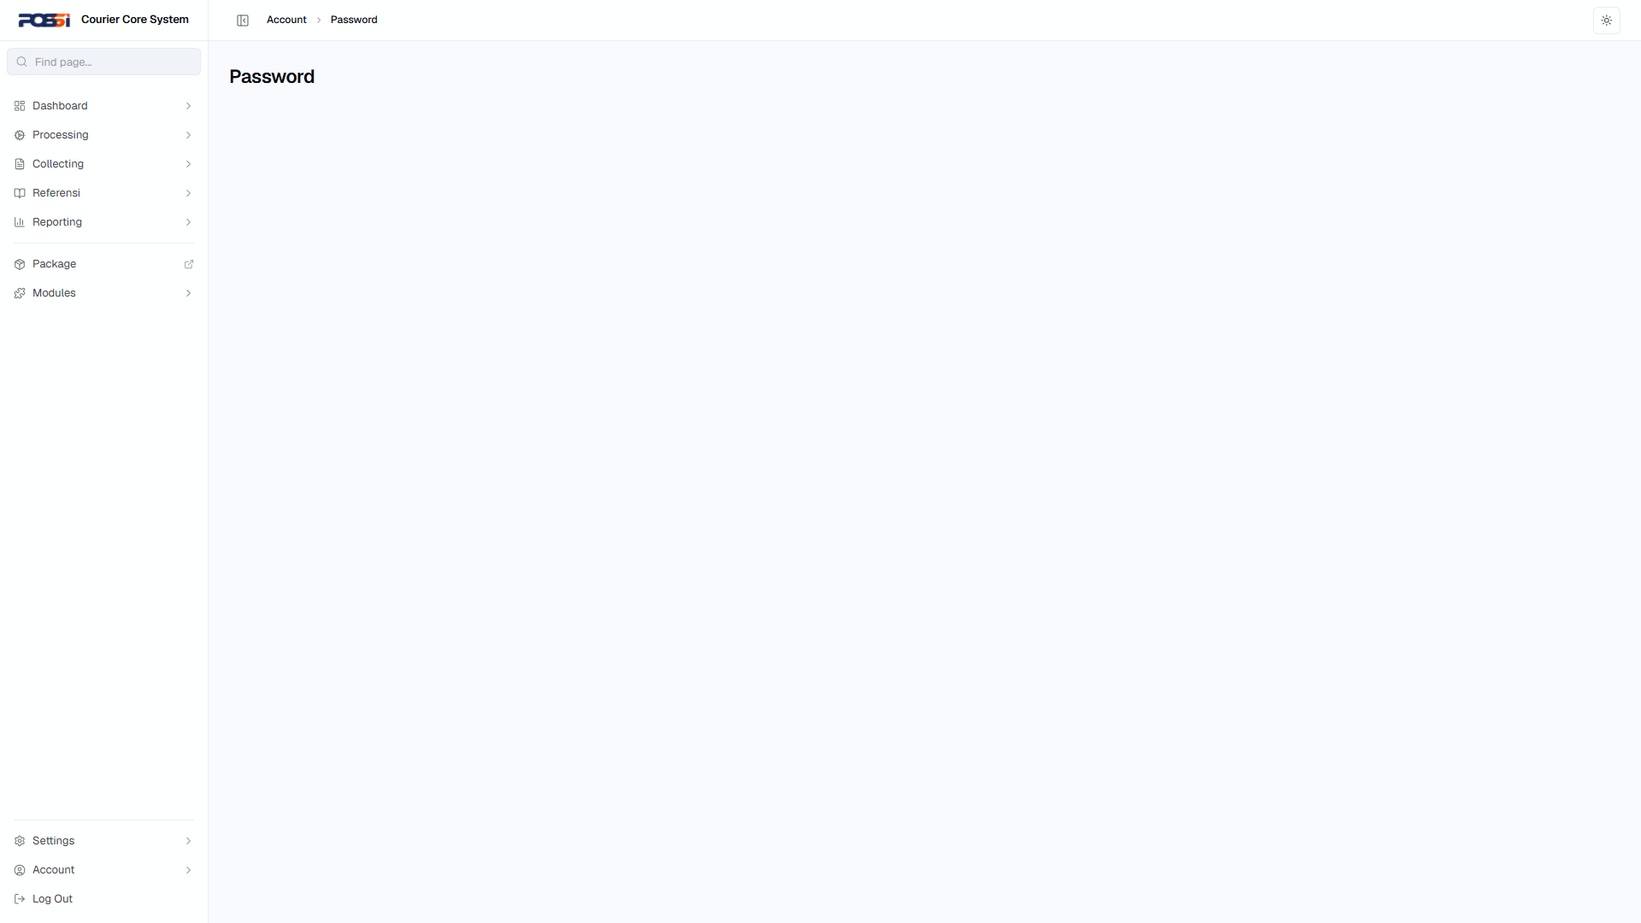
59 | TC-ACCT-003 | Manajemen API Key | 1. Buka /account/api-key 2. Buat API key baru 3. Copy API key 4. Hapus API key | Status: PASS | OK |  | 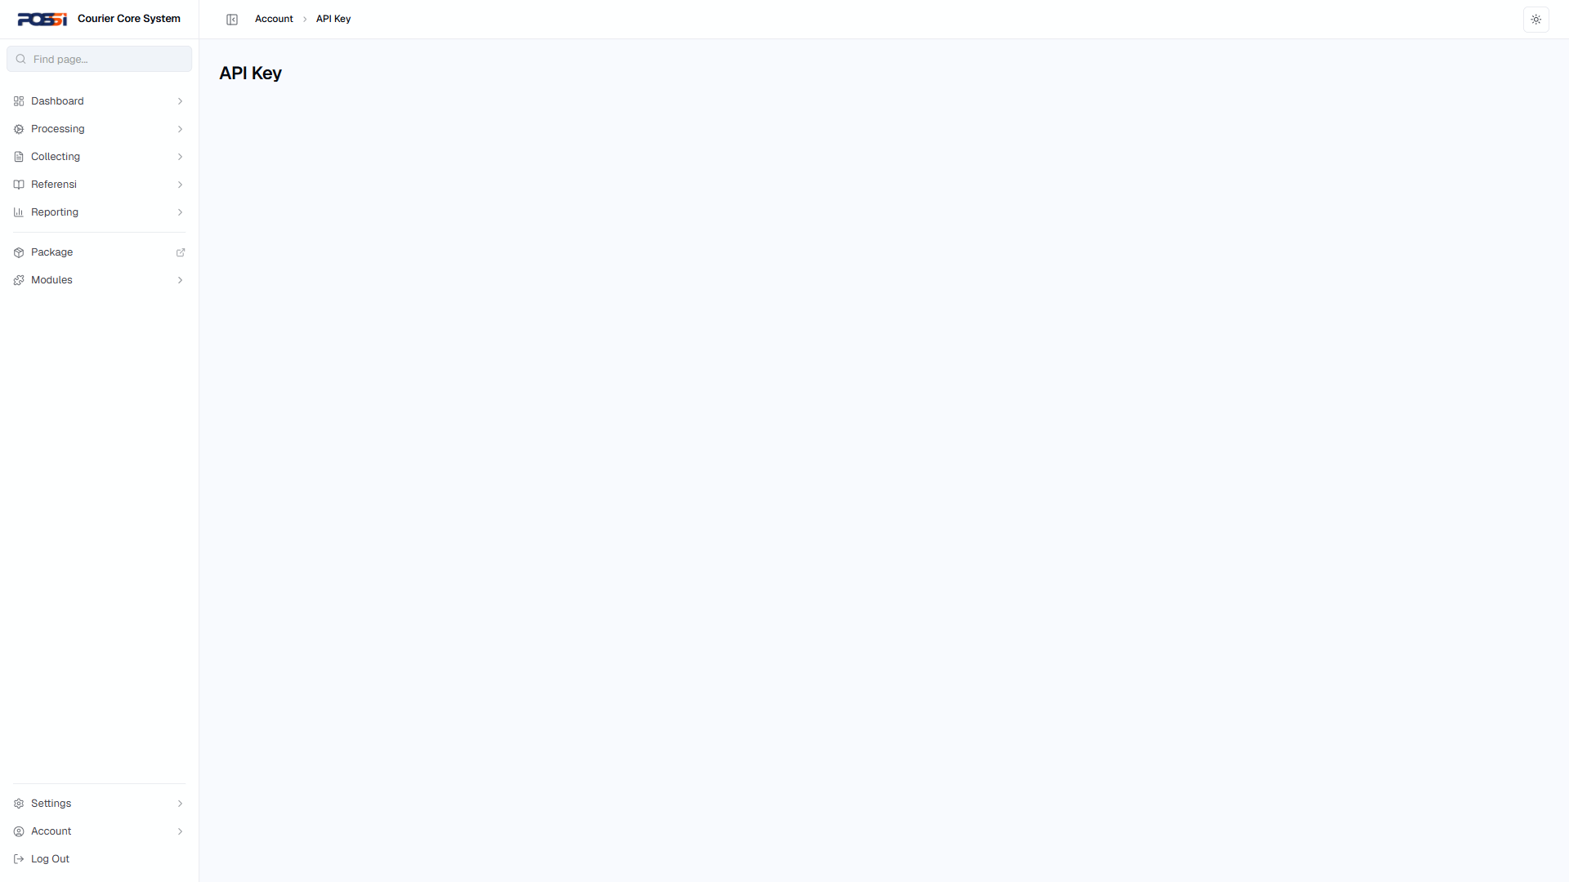
60 | TC-ACCT-004 | Setup MFA | 1. Buka /account/mfa 2. Aktifkan MFA 3. Ikuti instruksi setup | Status: PASS | OK |  | 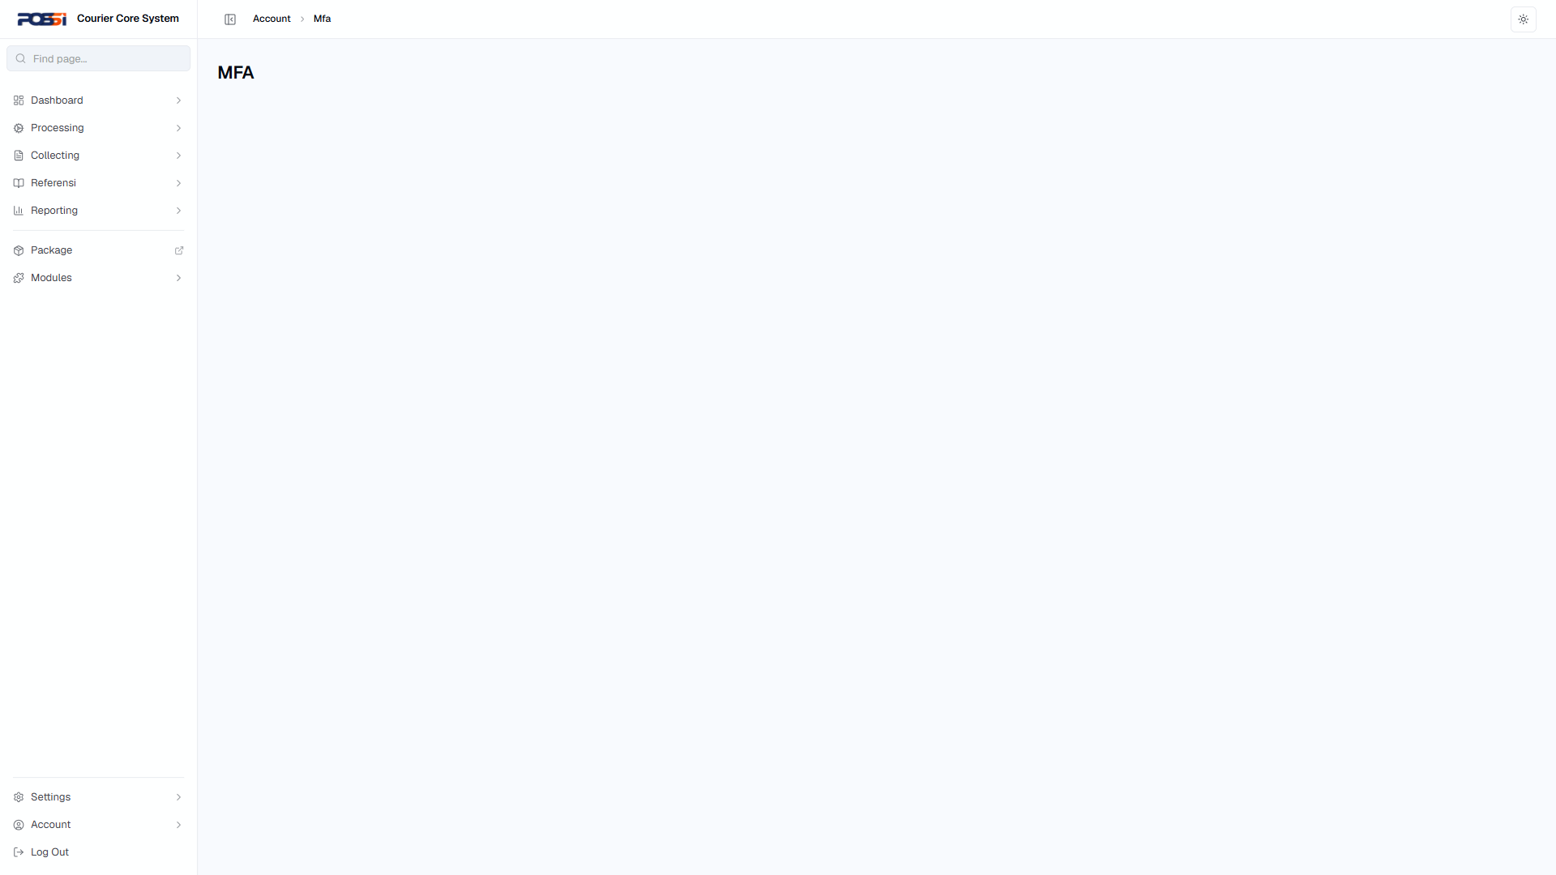
Dashboard
61 | TC-DASH-001 | Lihat halaman overview | 1. Buka /dashboard/overview | Status: PASS | OK |  | 
62 | TC-DASH-002 | Lihat konfigurasi webhook | 1. Buka /dashboard/webhook | Status: PASS | OK |  | 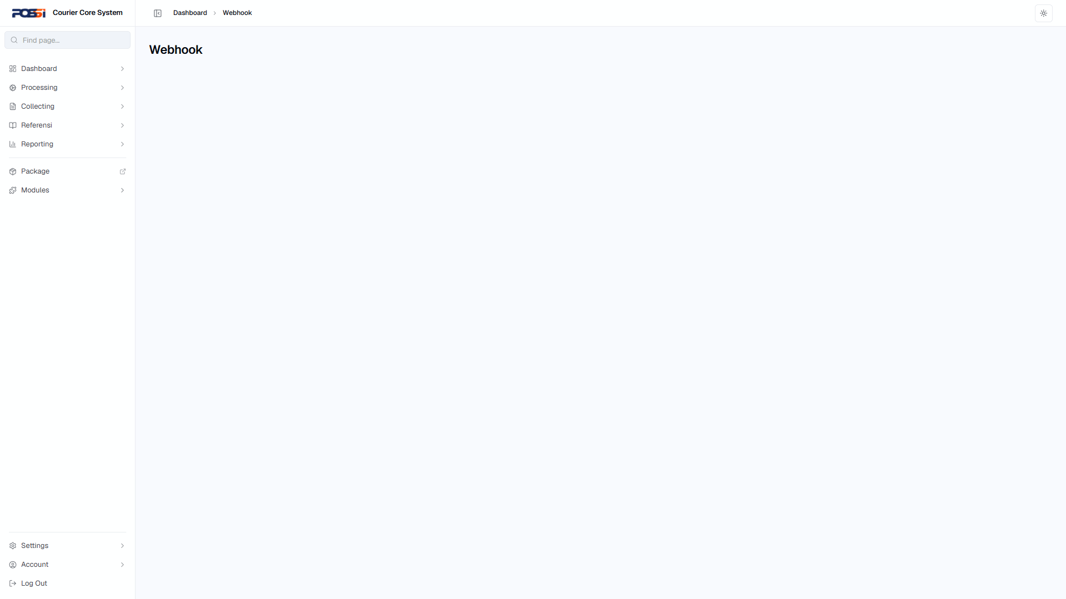
End-to-End
63 | TC-E2E-001 | Journey lengkap: Login → Processing → Logout | 1. Login NIPPOS+Password+OTP 2. Buka /processing/receiving 3. Terima paket baru 4. Buka /processing/bagging 5. Masukkan paket ke bag 6. Buka /processing/manifest 7. Buat manifest 8. Buka /processing/handover 9. Serah terima ke kurir 10. Logout | Status: PASS | OK |  | 
64 | TC-E2E-002 | Journey: Login → Transaksi → Rekap → Laporan | 1. Login 2. Buka /collecting/transaksi 3. Buat transaksi baru 4. Buka /collecting/rekap-harian 5. Verifikasi rekap 6. Buka /reporting/keuangan 7. Verifikasi laporan 8. Logout | Status: PASS | OK |  | 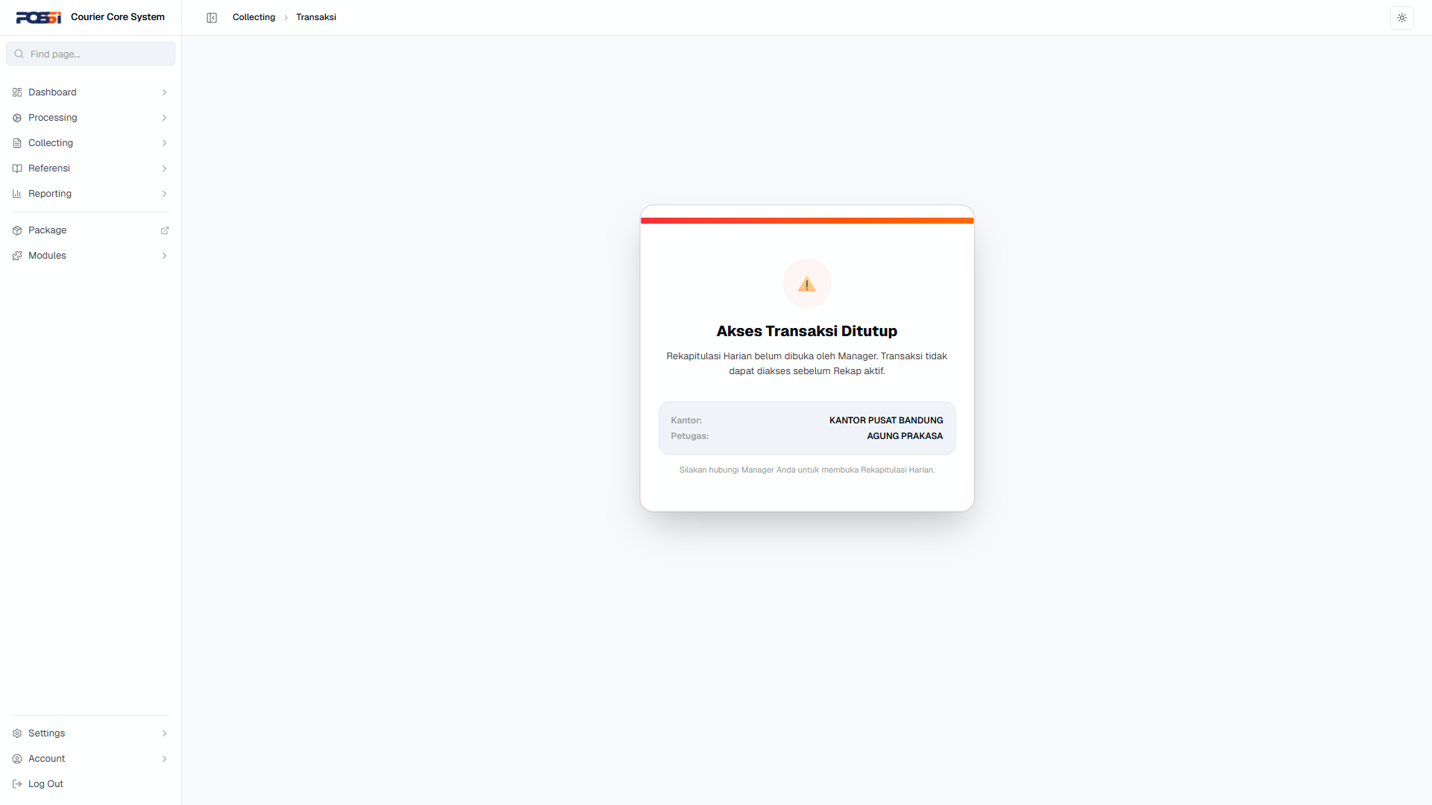
65 | TC-E2E-003 | Journey: Login → Tracking → Detail | 1. Login 2. Buka halaman tracking 3. Cari paket berdasarkan nomor resi 4. Lihat detail history tracking 5. Verifikasi lokasi & status terkini 6. Logout | Status: PASS | OK |  | 
66 | TC-E2E-004 | Journey: Login → Settings → User Management | 1. Login 2. Buka /settings/user 3. Tambah user baru 4. Buka /settings/role 5. Buat role baru 6. Set permission 7. Assign role ke user baru 8. Logout | Status: PASS | OK |  | 
Filter & Export
67 | TC-FILTER-001 | Reporting Paket — filter tanggal | 1. Buka /reporting/paket 2. Set tanggal awal: 2026-08-01 3. Set tanggal akhir: 2026-08-31 4. Apply filter | Status: PASS | OK |  | -
68 | TC-FILTER-002 | Reporting Paket — search by connote code | 1. Buka /reporting/paket 2. Masukkan nomor resi di search 3. Tekan Enter | Status: PASS | OK |  | -
69 | TC-FILTER-003 | Reporting Paket — Export | 1. Buka /reporting/paket 2. Klik tombol Export | Status: PASS | OK |  | -
70 | TC-FILTER-004 | Reporting Bag — filter | 1. Buka /reporting/bag 2. Gunakan filter tanggal/status 3. Apply filter | Status: PASS | OK |  | -
71 | TC-FILTER-005 | Reporting Bag — Export | 1. Buka /reporting/bag 2. Klik tombol Export | Status: PASS | OK |  | -
72 | TC-FILTER-006 | Tracking Bag — filter by bag number | 1. Buka /reporting/tracking/bag 2. Masukkan nomor bag di search 3. Apply filter | Status: PASS | OK |  | -
73 | TC-FILTER-007 | Tracking Events — search by connote code | 1. Buka /reporting/tracking/tracking-events 2. Masukkan connote code: 40000178773792401 3. Apply | Status: PASS | OK |  | -
74 | TC-FILTER-008 | Tracking Events — filter tanggal | 1. Buka /reporting/tracking/tracking-events 2. Set filter tanggal 3. Apply | Status: PASS | OK |  | -
75 | TC-FILTER-009 | Loading — tab Pending/Scanned/Berangkat | 1. Buka /processing/loading 2. Klik tab Pending 3. Klik tab Scanned 4. Klik tab Berangkat | Status: PASS | OK |  | -
76 | TC-FILTER-010 | Loading — Export | 1. Buka /reporting/operational/loading 2. Klik tombol Export | Status: PASS | OK |  | -
77 | TC-FILTER-011 | Laporan Keuangan — filter tanggal | 1. Buka /reporting/keuangan 2. Set filter tanggal 3. Apply | Status: PASS | OK |  | -
78 | TC-FILTER-012 | Laporan Keuangan — Export | 1. Buka /reporting/keuangan 2. Klik tombol Export | Status: PASS | OK |  | -
79 | TC-FILTER-013 | Komisi Agenpos — filter & Export | 1. Buka /reporting/komisi 2. Set filter tanggal 3. Klik Export | Status: PASS | OK |  | -
80 | TC-FILTER-014 | Daftar Kedatangan — filter & Export | 1. Buka /reporting/kedatangan 2. Set filter tanggal 3. Klik Export | Status: PASS | OK |  | -
81 | TC-FILTER-015 | Collecting Daftar Transaksi — filter tanggal & resi | 1. Buka /collecting/daftar-transaksi 2. Set tanggal 3. Masukkan nomor resi 4. Klik Cari | Status: PASS | OK |  | -
82 | TC-FILTER-016 | Collecting Rekap Harian — search | 1. Buka /collecting/rekap-harian 2. Masukkan nomor rekap di search 3. Apply | Status: PASS | OK |  | -
83 | TC-FILTER-017 | Collecting Audit Koreksi — search | 1. Buka /collecting/audit-koreksi 2. Masukkan No. Resi / Kode Booking 3. Apply | Status: PASS | OK |  | -
84 | TC-FILTER-018 | Collecting Pembatalan — search by resi | 1. Buka /collecting/pembatalan 2. Masukkan Nomor Resi 3. Apply | Status: PASS | OK |  | -
85 | TC-FILTER-019 | Hitung Tarif — form kalkulasi | 1. Buka /referencing/tarif/calculate 2. Pilih customer 3. Pilih kode pos asal & tujuan 4. Isi berat 5. Klik Hitung Tarif | Status: PASS | OK |  | -
86 | TC-FILTER-020 | Receiving — scan R7 | 1. Buka /processing/receiving 2. Masukkan nomor R7 3. Tombol Konfirmasi R7 aktif 4. Klik Konfirmasi | Status: PASS | OK |  | -

Daftar Defect
ID | Judul | Severity | Status | Keterangan
DEF-001 | OTP tidak divalidasi — login berhasil meski OTP salah | Autentikasi | High | High

Kesimpulan & Rekomendasi
Dari 86 test case, 85 PASS dan 1 FAIL (pass rate 98.8%).

