Search at 0

0 Q ***\* A*** c(1) **• • • CI**



111 Q Search

14:37

(/') '44. 09-08-2024

O

|  |  |  |
| --- | --- | --- |
| a | 0 Save for later @ Watch < Share | ••• |

|  |
| --- |
| **ABC 2024 Technology Deliverables**   1. Scope to be expanded to all Regulator-Regulation-LE-Product type- Product Subtype combination for US, UK, APAC,EMEA . Assess technology build required based on requirements from increased scope. 2. Automate business validations based on business requirements & Technical validations . Identify BAU reports that can be used for benchmarking and highlight any discrepancies between retrieved data 3. Hermes Build out - Hydrate all relevant post trade data into Hermes 4. Clear Water data mesh strategy build out. To bring different data domains into one place. 5. Enable as of time data joining with a greater level of confidence 6. Consolidate validation of Retrieved data stripes. 7. Build a Reg Response store that will hold all versions of data submitted to the regulator and respective   Reg requests/Exams/Questions/Inquiries. Capture and persist all validation results.   1. Build a self-serve portal for compliance, Reg relations and Reg Response teams to use. 2. MI dashboard to improve business sign off   **ABC Roadmap**  ABC-Tech-RoadMap.ppix  4 |

Cor X 3,1 ABC - c X + **0 X**

|  |  |  |  |
| --- | --- | --- | --- |
|  |  |  |  |

|  |
| --- |
| FINDS S Systems  NFA 4 Systems  **ABC 2023 Technology Deliverables**  II Scope Improve Data retrieval Time and Quality — 168 Data Elements across 4 data domains that were in scope for the 2022 FINRA Exam   * Improve time taken to retrieve data * Improve quality of the data * Have a repeatable standard process  1. Consolidation of Reporting IDs (TRACE and MSRB) into a common store 2. Build out Interim store for BPS to enable quick retrieval of historical BPS data 3. Build out Interim stores for Day 1 PnL & Sales Credit 4. One Reg hot store to identify CFTC reportable trades 5. Clean up and automation of Data extraction scripts 6. Automation of technical data integrity checks ■ 7. FINRA Exam Readiness - Creation of Run Books (Meet 2 day / 7 day regulatory data retrieval timelines) 8. E2E Dry Run completed - Data retrieved and technical validations completed within SLA   4 |

,At.' Search

14:37

**(15) '44.** 09-08-2024

Programs

**v ABC -** I

* Regulatory Exams
* Regulatory Inquiries

> Other Exam and Inquiries

> Technology Framework

* Project Management
* Service Vision
* Runbook
* Security Vision Document
* Test Strategy
* Product Vision

Cr Space tools

**4**

Save for later @ Watch < Share

f on Feb 09, 2024

**Objective - Improve quality of Reg response**

* Improve time taken to retrieve data
* Improve quality of the data
* Have a repeatable standard process

**Approach**

* Define Operating model and governance
* Standard Run book with clearly defined steps and scripts to be executed across all systems
* Rationalize the number of systems from which we retrieve data
* Create interim stores for joining discrete data sets (TRACE and MSRB ID) and for third party systems (BPS) that are not able to provide historic data in a timely fashion.
* Create library of data retrieval scripts
* Automated technical data validations

O

%-k" Search

14:36

4>)).(14. 09-08-2024

- 19 X

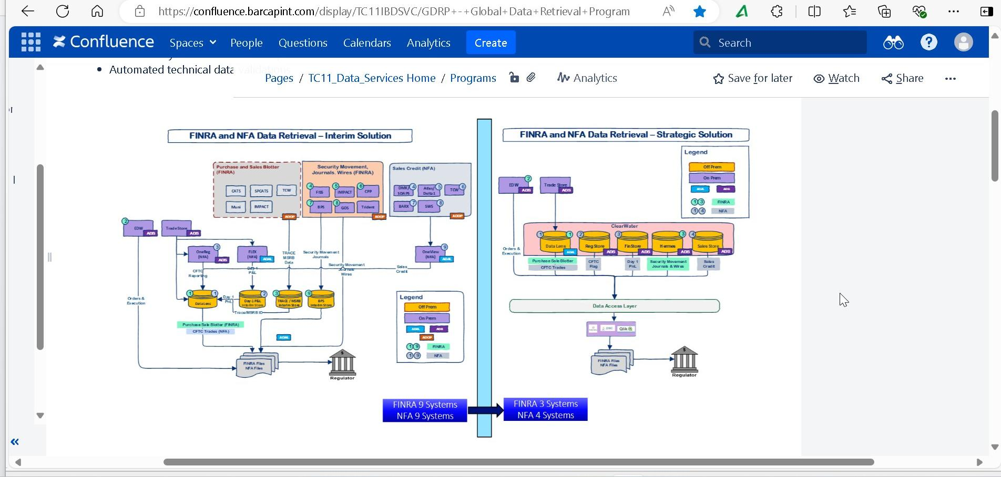

o

**El**

**X Confluence Spaces** •■ People Questions Calendars Analytics Create

Search

at 0 •

* Automated technical date

Save for later @ Watch < Share

Pages / TC11_Data_Sereices Home / Programs & *ift►* Analytics

•

•

°cm

mrr

FINRA 3 Systems   
NFA 4 Systems