TECHNOLOGY · INDIA · PRICING STRATEGY
B2B SaaS pricing for India: why discounting is not a strategy
A flat percentage off your US list price is not an India pricing model. It is a placeholder for the segment definition, value metric, and price architecture that a real India go-to-market requires.
Technology · India · GTM & Monetisation | August 2026 · 11 min read
Every SaaS sales conversation in India eventually arrives at the same request: what can you do on price. The instinct that usually follows, shave 20 to 30% off the US list price and call it the India rate, is not a pricing strategy. It is an admission that the price architecture was built for one market and stretched to cover another.
The stakes for getting this right are not small. Gartner forecasts that software spending in India will grow 17.6% in 2026 to reach $24.7 billion, inside a broader IT spending market projected to cross $176 billion (Gartner, November 2025). That growth is concentrated in enterprises and mid-market companies that are increasingly sophisticated buyers of software, not a single undifferentiated price-sensitive market waiting for a discount. Vendors who treat India pricing as a line-item markdown on a global price book are leaving structured revenue on the table in the segments that can pay full freight, and losing deals they should win in the segments that cannot.
This piece covers four things: why a flat percentage discount fails structurally, why India's mid-market and large-enterprise buyers need different price architectures rather than one number, why usage-based pricing beats seat-based in most India SaaS contexts, and what Indian enterprise buyers are actually comparing your price against.
01 Why flat percentage discounts fail
A flat India discount treats an entire country as one buyer. In practice, willingness to pay for the same SaaS category can differ by a factor of five or more between an Indian mid-market company and a large enterprise or a global capability centre, buyers a flat percentage cannot distinguish between. That has three specific consequences.
It invites negotiation theater instead of a value conversation. When both sides understand list price to be inflated, procurement's only job becomes finding the real number. OpenView Partners' enterprise SaaS benchmarks put typical discount levels at 15 to 25% for high-growth category leaders, 20 to 35% for established solutions in competitive markets, and 30 to 40% for mature, commoditised products (OpenView Partners). Once a pattern like this becomes known behaviour inside a buyer community as small and well-networked as enterprise IT and CFO circles across Delhi, Mumbai and Bengaluru, every renewal conversation starts from what the last account got, not what the product is worth.
The discount becomes the new list price. RAIN Group's 2026 negotiation research puts the median discount on closed-won B2B SaaS deals at 12 to 22%, with enterprise deals trending toward the higher end (RAIN Group, 2026). Whatever a rep gives to close a deal quickly becomes the number procurement anchors to at renewal, and the number the next prospect's CFO hears about before your rep is even in the room.
It ignores that discount depth should track deal risk and structure, not geography. A three-year commit, a multi-product attach, or a reference-account arrangement all justify a deeper price than list. A flat India percentage collapses all of that into a single number applied regardless of what the buyer is actually offering in return.
FIGURE 1
Enterprise SaaS discount ranges are structural, not geographic
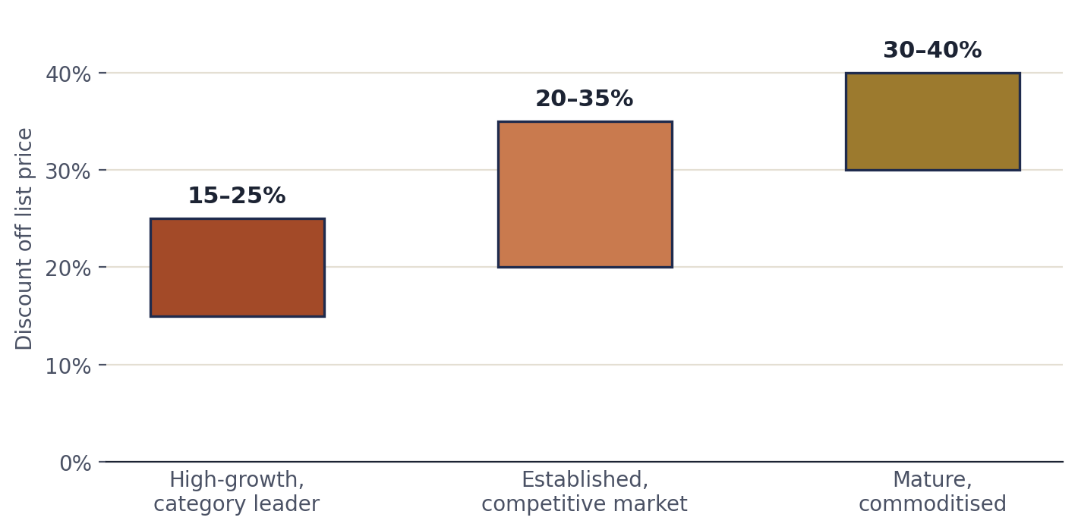
Source: OpenView Partners enterprise SaaS discounting benchmarks; RAIN Group 2026 negotiation research on closed-won B2B SaaS deals. Ranges reflect product maturity and competitive position, not country of buyer.
A single India percentage sits somewhere inside these ranges by accident. The discount that is correct for a mature, commoditised product competing on price is not the discount that is correct for a category leader with no real India substitute, and both of those are different again from what a specific mid-market or enterprise buyer segment should see.
02 Mid-market and large enterprise are not the same India buyer
Indian mid-market companies, broadly in the ₹100 to 1,000 crore revenue band, typically run a lean buying process: a business head who owns the budget, a finance or IT lead who validates the number, and rarely a formal RFP. Decisions move in weeks. The comparison set is whatever else the founder or CXO has recently priced, usually a mix of India-built SaaS and global tools a peer company is already using.
Large enterprise, ₹1,000 crore-plus groups, and India-based global capability centres operate on a different clock entirely. Procurement is formal and RFP-driven, and the procurement function's mandate, cost reduction, runs independently of the business case the requesting department built. Security review, data residency checks and legal redlining routinely add eight to twelve weeks to a cycle that would close in days at mid-market, and the final signatory has often never spoken to your sales rep.
Dimension | Indian mid-market | Large enterprise / GCC
Typical revenue band | ₹100–1,000 crore | ₹1,000 crore+ / global parent
Buying committee | 2–3 people, business-led | 6–10 people, procurement-led
Decision cycle | 2–6 weeks | 3–6 months
Budget owner | Department head, close to P&L | Central IT / procurement budget
Comparison set | Peer-company tools, India SaaS | Formal RFP, named competitors, incumbent contracts
What moves the deal | Speed to value, founder-level trust | Compliance fit, contract terms, reference accounts

These two buyers do not respond to the same price architecture. A single flat discount applied uniformly across both either overcharges the mid-market buyer, who could close at a leaner structure with a lighter contract, or leaves enterprise value uncaptured because procurement will always find room to negotiate against a number it does not respect.
03 Why usage-based beats seat-based in most India SaaS contexts
Global pricing has already been moving away from seats for several years. Gartner projects that 70% of businesses will prefer usage-based pricing over per-seat models, and OpenView Partners' benchmark of roughly 600 SaaS companies found usage-based pricers growing 29.9% year over year against 21.7% for seat-based peers, close to 38% faster, with net dollar retention near 120% against 110% for seat-based companies (OpenView Partners; Gartner). A January 2025 survey of 100 SaaS companies by Metronome and Greyhound Capital found 85% already had some form of usage-based pricing in place.
FIGURE 2
Usage-based pricers outgrow seat-based peers on both growth and retention
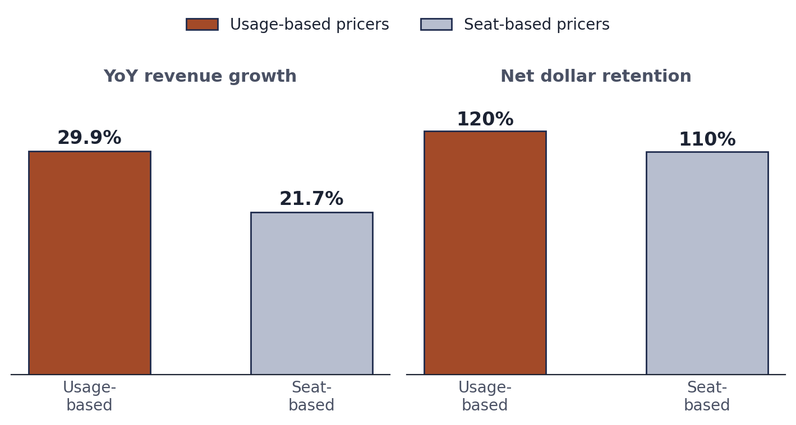
Source: OpenView Partners benchmark of approximately 600 SaaS companies. NDR = net dollar retention.
That global shift matters more in India than the average market, for a reason that has little to do with global trends and everything to do with how Indian finance teams manage software cost. Indian mid-market and enterprise finance functions scrutinise seat utilisation aggressively, because unused licenses are one of the easiest line items for a CFO to cut in an annual budget review, and because "we are paying for seats nobody uses" is treated as a personal credibility problem for whoever approved the purchase. A seat-based price invites exactly that scrutiny at every renewal. A usage-based or outcome-aligned price, where the bill moves with transactions processed, records synced, or results delivered, ties cost visibly to value received and removes the recurring seat-audit conversation that quietly kills seat-based renewals in India.
This is not an argument for pure usage-based pricing everywhere. Hybrid pricing, a predictable base fee plus a usage or outcome-based layer, is now the most common structure globally: Chargebee's 2025 State of Subscriptions Report found 43% of SaaS companies already using hybrid models, projected to reach 61% by the end of 2026 (Chargebee, 2025). In India specifically, hybrid does more work than pure usage-based pricing: the base fee gives finance teams the budget predictability their approval processes are built around, and the usage layer gives the vendor a growth mechanism that does not require a fresh negotiation every time a customer's consumption expands. Seat-based pricing still makes sense for genuinely seat-bound workflows where there is no meaningful consumption axis to price against. For most B2B SaaS categories selling into India today, a value metric tied to usage, outcomes or transaction volume will out-negotiate a seat count.
The Indian CFO's objection is rarely “your price is too high.” It is “I cannot defend this line item at the next budget review.” Usage-based pricing answers that objection. Seat-based pricing invites it.
04 Building an India price architecture that doesn't undermine global pricing
Five mechanics keep an India-specific price from leaking into, or undercutting, the global price book.
- Price on a different unit than the global list, where possible. A per-seat price in INR is trivially comparable to a USD per-seat price with a currency converter. A usage or outcome-based unit, priced independently against India-specific value delivered, is far harder for a global prospect's procurement team to cross-reference, because it is not the same unit of measure.
- Anchor the India number to research, not a discount off the US number. Purchasing power differences between India and developed markets are real and documented, the World Bank's International Comparison Program is the standard reference for cost-of-living differentials, but a defensible India price is built from India-specific willingness-to-pay research and India-specific cost-to-serve, not a blanket percentage applied to the US list. Zoho's INR pricing for products like Zoho Desk, for example, runs at roughly 70 to 75% of the USD-equivalent list rather than a round-number markdown, priced independently by market.
- Keep the India price book operationally separate, with its own SKUs, quote templates and approval workflow, so a rep selling into Singapore or Dubai cannot casually apply the India number to a deal outside India. Deal desk should treat any cross-border quote referencing the India price sheet as an escalation, not a routine exception.
- Verify buyer geography before applying India pricing, particularly in self-serve or product-led motions where checkout can be gamed with a billing address or a VPN. Enterprise deals carry lower risk here, since procurement geography is verifiable through the contracting legal entity, but any self-serve India tier needs a verification step.
- Document the rationale internally. When a global account team or a board member asks why the India number is a third of the US number, “an India-specific willingness-to-pay study put the number at X, and India cost-to-serve at Y” survives scrutiny. “Sales wanted to close the deal” does not, and that difference is what separates a price architecture from an ad hoc discount that happened to repeat itself forty times.
05 What Indian enterprise buyers actually compare your price against
This is where most global SaaS vendors misread the India conversation. The default assumption is that the Indian buyer is comparing your price against a competitor's price card. Across GreyRadius mandates involving India buyer research, the more consequential comparison is rarely competitor-to-competitor. It is build-versus-buy, and the build side of that comparison is unusually cheap in India.
Indian offshore engineering talent bills at $20 to $45 an hour, a 50 to 85% reduction against equivalent US hires depending on role seniority (Wisemonk India IT Services Analyst Report, 2026). For an Indian IT leader evaluating a six or seven-figure annual SaaS contract, the mental comparison is not “what does the closest global competitor charge.” It is “what would it cost to build and staff a team that covers 80% of this internally.” That comparison favours the internal-build option far more in India than it would for the same buyer in the US or Europe, simply because the input cost of the alternative, engineering headcount, is a fraction of what it costs elsewhere. A price that looks defensible against Salesforce or Workday in a US sales deck can look expensive next to “we could staff four engineers for a year” in an Indian boardroom.
FIGURE 3
The India price ceiling: what buyers benchmark against
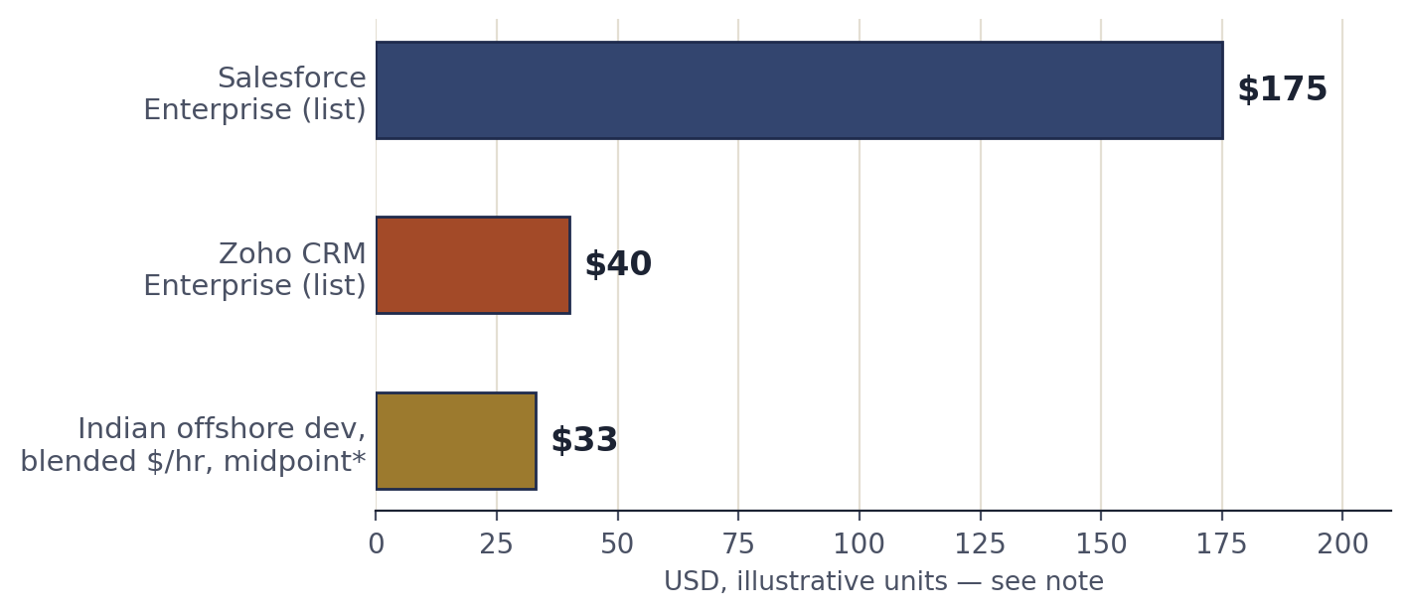
Source: Zoho CRM published pricing vs. Salesforce Sales Cloud published pricing, Enterprise tier, per user per month (checkthat.ai pricing analysis, 2026); Wisemonk India IT Services Analyst Report 2026 on offshore engineering cost differentials ($20–45/hr range, midpoint shown). *Offshore rate is a $/hour figure, not a SaaS seat price, shown for illustrative contrast only, not a like-for-like unit comparison.
The second comparison Indian buyers reach for is the domestically-built SaaS alternative, priced for exactly this market. Zoho's CRM Enterprise tier lists at $40 per user per month against Salesforce Enterprise at $175, a gap of roughly 77% at list price (checkthat.ai pricing analysis, 2026). Freshworks, Kissflow and a deep bench of India-built SaaS products occupy similar territory. Global vendors rarely lose to these products on features. They lose because these products have set the reference price point in the Indian buyer's head for what enterprise software costs. A global vendor's India price does not need to match that number, but it needs a credible answer for why it costs multiples more, and “because that's our global price converted to rupees” is not that answer.
The quieter comparison:
the cost of the status quo. Excel, a legacy on-premise tool already paid for, or a smaller regional point solution. Indian mid-market buyers are often more willing than US counterparts to tolerate a workflow inefficiency rather than pay a premium to remove it, because the cost of the workaround, usually someone's time, reads as cheap relative to the SaaS spend being proposed. A pricing conversation benchmarked only against named competitors, without accounting for build-it-ourselves and do-nothing, will consistently misjudge what the Indian buyer considers expensive.

THE GREYRADIUS PERSPECTIVE
The India work happens before the price sheet, not during the negotiation
Across the pricing and market-entry mandates we run for SaaS companies evaluating India as a growth market, the pattern above shows up almost every time: the vendors that struggle in India are rarely the ones with the wrong product. They are the ones whose price architecture was built once, for one market, and never rebuilt for this one. A flat discount is what a global pricing team reaches for when nobody has done the India-specific work, segment definition, value-metric research, and price-book separation, that a real India go-to-market requires.
If you are evaluating India as a growth market, or rebuilding pricing for an India expansion already underway, the first conversation is 30 minutes with a partner, not a discount calculator.
Get in touch → www.greyradius.com/contact.html

FAQ Frequently asked questions
How much lower should India SaaS pricing be vs global pricing?
There is no single correct percentage, and any answer offered without segment and product context should be treated with caution. In practice, India price points for comparable B2B SaaS categories span a wide range: domestic alternatives like Zoho price 70 to 75% below equivalent global competitors at list (checkthat.ai pricing analysis, 2026), while global category leaders with limited India substitutes often hold within 20 to 30% of US list price on large-enterprise India deals, where budget authority is less price-sensitive. The defensible number comes from India-specific willingness-to-pay research for your category and segment, not a percentage borrowed from another vendor's India strategy.
Should India SaaS pricing be usage-based or seat-based?
For most B2B SaaS categories, a hybrid structure, a predictable base fee plus a usage or outcome-based layer, outperforms pure seat-based pricing in the Indian market. Indian finance and procurement teams scrutinise seat utilisation closely, and unused licenses are a routine target in annual budget reviews, which leaves seat-based pricing vulnerable at renewal. Usage-based and hybrid pricers grew 29.9% year over year against 21.7% for seat-based peers in OpenView Partners' benchmark of roughly 600 SaaS companies, and Gartner projects 70% of businesses will prefer usage-based pricing over per-seat models. Seat-based pricing still fits narrowly seat-bound workflows without a meaningful consumption axis to price against.
How do I prevent India pricing from being used in global negotiations?
Price India on a different metric or SKU structure than the global list wherever possible, so the numbers cannot be cross-referenced directly with a currency converter. Keep the India price book operationally separate, with its own quote templates and an approval workflow that flags any cross-border quote referencing India pricing. Anchor the India price to documented India-specific willingness-to-pay and cost-to-serve research rather than a discount off the global number, so the rationale holds up if a global account team asks why the numbers differ. Verify buyer geography for any self-serve India tier, since checkout-level pricing can be gamed with a billing address or VPN in a way enterprise contracts, verified through the signing legal entity, cannot.

