The Stack | GreyRadius Weekly Infrastructure Intelligence
Weekly Infrastructure Intelligence


The Stack
Data Centres • Cloud Infrastructure • AI Infrastructure
Published by GreyRadius Consulting | Issue 004 | June 29 – July 5, 2026

Executive Highlights
Global / North AmericaBloom Energy and Brookfield expand AI infrastructure partnership to $25 billion
United StatesDigital Realty acquires larger stake in Northern Virginia hyperscale campuses
Uk / United StatesNational Grid invests $1.75 billion in AI power infrastructure platform
United KingdomXlinks proposes 1.5GW AI data centre campus in Devon
GermanyGermany sees proposal for 150MW new data centre

This Week’s Briefing Spans
- AI infrastructure investment increasingly tied to dedicated power infrastructure.
- Hyperscale capital continues to concentrate around Northern Virginia.
- Utilities and energy developers moving closer to data centre expansion strategy.
- Integrated AI campus models combining compute, power and storage.
- Permitting and local acceptance emerging as execution risks across Europe.
Explore by Topic
All
Infrastructure & Compute
Data Centre Energy
Policy & Permitting
AI INFRASTRUCTURE | DATA CENTRE POWER

Bloom Energy and Brookfield expand AI infrastructure partnership to $25 billion
30 JUNE 2026 | GLOBAL / NORTH AMERICA | BLOOM ENERGY, BROOKFIELD
Bloom Energy and Brookfield expanded their financing partnership from $5 billion to $25 billion to accelerate deployment of Bloom fuel cells supporting AI and cloud data centres. The investment is aligned with Brookfield's AI Infrastructure Fund targeting $100 billion and reflects growing demand for alternative power sources for hyperscale AI deployments. Bloom has already deployed systems with partners including Equinix and Oracle.
Source: Bloom Energy / Brookfield announcement | Reuters

Strategic Watch
The expansion from a $5 billion to a $25 billion financing partnership signals that power infrastructure is becoming a core investment class alongside AI compute. Enterprises planning large AI deployments should monitor how dedicated power assets, fuel-cell technologies and alternative energy financing influence future data centre location decisions and deployment timelines.

GreyRadius Insight
The competitive advantage in AI infrastructure is shifting beyond GPUs to assured energy availability. Brookfield's increased commitment reflects growing investor confidence that integrated power and compute ecosystems will become essential for supporting hyperscale AI growth where grid capacity remains constrained.

Chart: Funding scale behind AI power infrastructure
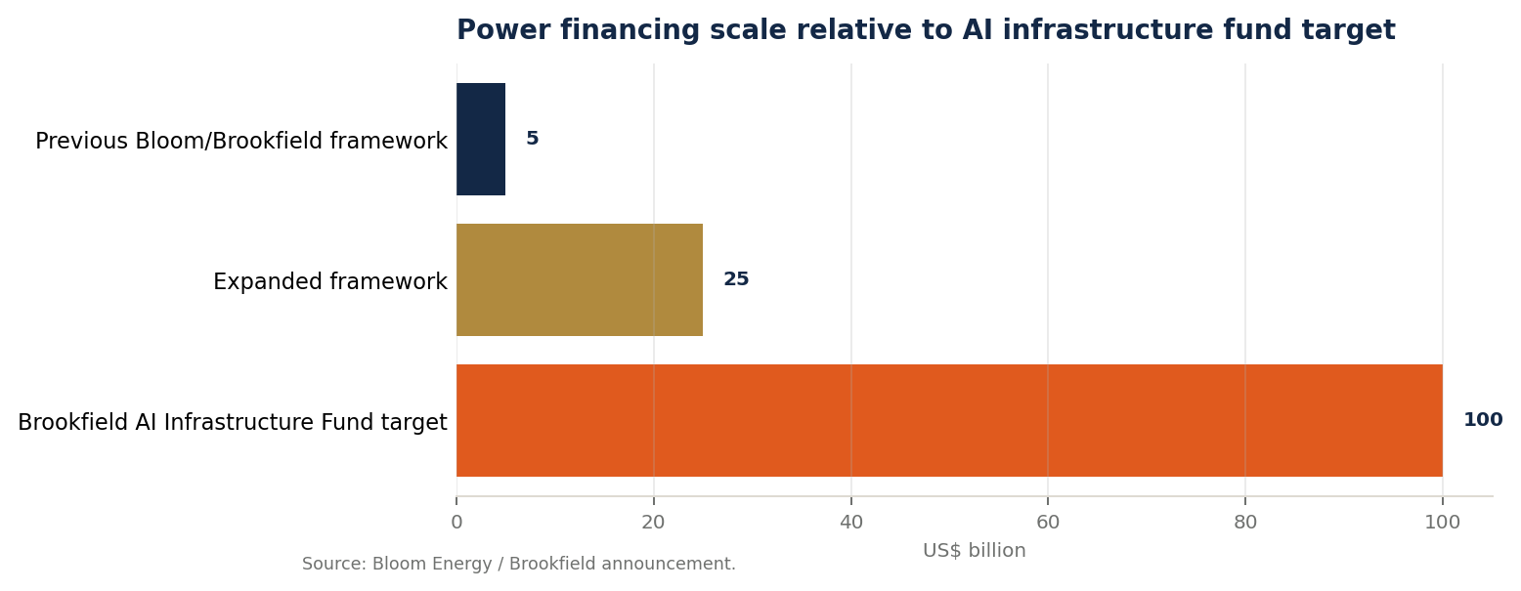
The visual shows the scale-up from the original power financing framework to the expanded commitment, set against Brookfield’s broader AI infrastructure fund target.
Chart source: Bloom Energy / Brookfield announcement
COLOCATION | HYPERSCALE INVESTMENT

Digital Realty acquires larger stake in Northern Virginia hyperscale campuses
29 JUNE 2026 | UNITED STATES | DIGITAL REALTY, BLACKSTONE
Digital Realty agreed to acquire Blackstone's interests in three Northern Virginia data centres in a $3.5 billion transaction. The assets comprise two 96MW facilities in Manassas and a 96MW facility in Sterling. Total asset valuation reaches $7.8 billion including development commitments.
Source: Digital Realty | Reuters

Strategic Watch
The transaction reinforces continued investor confidence in mature hyperscale markets with proven demand, available connectivity and established cloud ecosystems. Infrastructure investors should monitor whether similar consolidation occurs in other strategic data centre regions.

GreyRadius Insight
Ownership concentration around high-quality hyperscale assets reflects the long-term value of established digital infrastructure. As AI workloads continue to expand, existing campuses with scalable power and network connectivity are likely to command increasing strategic premiums.

Chart: Capacity composition of the acquired assets
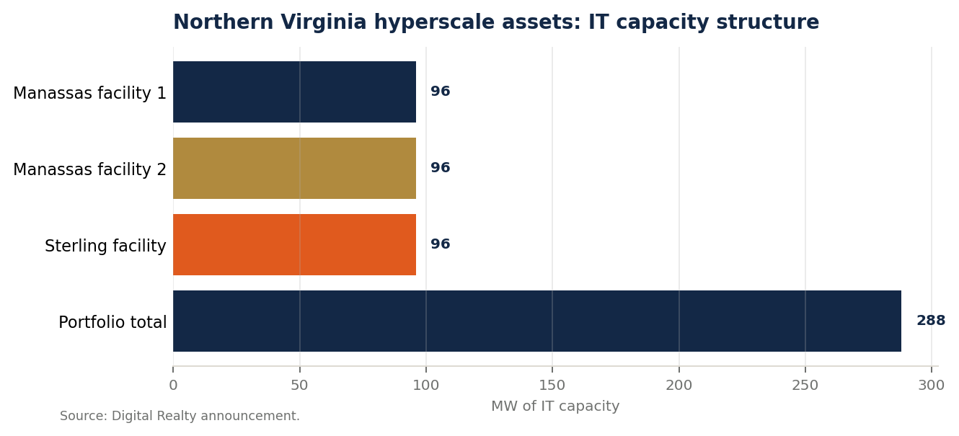
The chart adds asset-level context by showing that the transaction is not a single facility but three equal-scale 96MW hyperscale campuses totaling 288MW.
Chart source: Digital Realty announcement
DATA CENTRE ENERGY

National Grid invests $1.75 billion in AI power infrastructure platform
1 JULY 2026 | UK / UNITED STATES | NATIONAL GRID, JOULENT
National Grid acquired a 35% stake in U.S. energy developer Joulent for $1.75 billion. The first project is a 2.67GW gas-fired generation facility in Texas supplying a Microsoft-operated data centre under a 20-year power purchase agreement. National Grid expects to connect more than 10GW of data centre capacity over the next five years.
Source: National Grid | Reuters

Strategic Watch
The investment highlights how long-term power agreements are becoming fundamental to hyperscale AI expansion. Enterprises should monitor increasing collaboration between utilities, energy developers and cloud providers as electricity availability becomes a prerequisite for new AI capacity.

GreyRadius Insight
The AI infrastructure race is increasingly being shaped by access to reliable electricity rather than compute hardware alone. Utilities capable of delivering dedicated generation capacity may emerge as strategic partners in enabling the next wave of hyperscale AI deployments.

Chart: From first project to connection pipeline
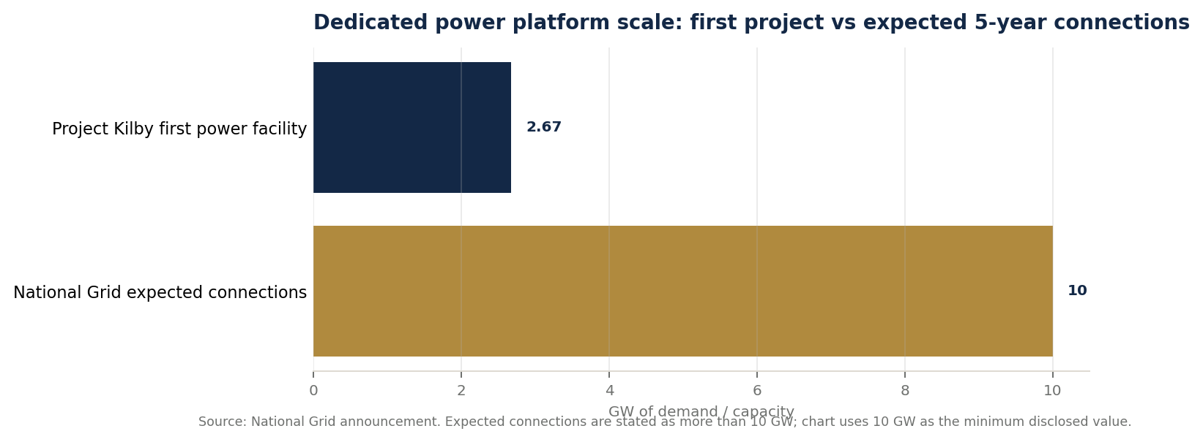
The chart places the 2.67GW Kilby facility in the context of National Grid’s stated expectation to connect more than 10GW of data centre demand across the UK and U.S. over five years.
Chart source: National Grid announcement
AI INFRASTRUCTURE

Xlinks proposes 1.5GW AI data centre campus in Devon
29 JUNE 2026 | UNITED KINGDOM | XLINKS
Xlinks, previously known for its Morocco–UK power cable project, announced plans for a 1.5GW AI-focused data centre and energy storage campus at Alverdiscott, Devon. The proposal represents one of the UK's largest planned AI infrastructure developments.
Source: Xlinks | DatacenterDynamics

Strategic Watch
The proposed development illustrates growing interest in combining power generation, energy storage and AI infrastructure within a single integrated campus. Similar models could reduce deployment risk while improving long-term energy resilience for AI operators.

GreyRadius Insight
Future AI campuses are likely to compete on integrated energy strategies rather than data centre capacity alone. Projects that combine compute, storage and dedicated energy infrastructure may become increasingly attractive as power constraints intensify across major markets.

Chart: Integrated campus power architecture
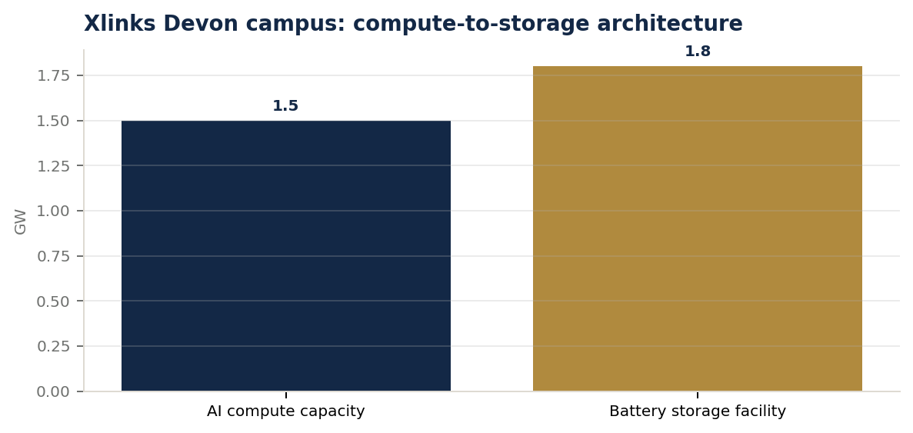
The chart adds context beyond the headline by comparing the proposed AI compute capacity with the on-site battery storage facility designed to support campus reliability and grid balancing.
Chart source: Xlinks Devon data campus
DATA CENTRES | PERMITTING

Germany sees proposal for 150MW new data centre
1 JULY 2026 | GERMANY | SCHLESWIG-HOLSTEIN
Plans were announced for a 150MW data centre development in Schleswig-Holstein. The proposal has already generated local opposition around planning, illustrating increasing permitting challenges for large-scale facilities across Europe.
Source: Project announcement | DatacenterDynamics

Strategic Watch
The proposal demonstrates that planning approvals and community acceptance are becoming increasingly significant factors in data centre delivery. Developers should expect permitting timelines and local stakeholder engagement to play a larger role in project execution across Europe.

GreyRadius Insight
As demand for AI infrastructure accelerates, regulatory approvals may become a greater constraint than investment capital. Successful operators will need to balance expansion ambitions with environmental considerations, local engagement and long-term infrastructure planning.

Market Data & Intelligence
Metric | Latest Value | Reporting Period | Region | Source | Executive Implication
Bloom/Brookfield AI infrastructure power financing | $25B | 29 Jun–1 Jul 2026 | Global / North America | Bloom Energy / Brookfield | Power infrastructure is becoming a parallel investment requirement for AI-scale compute.
Digital Realty Northern Virginia transaction | $3.5B | 29 Jun–1 Jul 2026 | United States | Digital Realty / Reuters | Capital continues to concentrate around proven hyperscale data centre markets.
National Grid stake in Joulent | 35% for $1.75B | 29 Jun–1 Jul 2026 | UK / United States | National Grid / Reuters | Utilities are moving upstream into dedicated infrastructure for data centre power demand.
Xlinks proposed AI data centre campus | 1.5GW | 29 Jun–1 Jul 2026 | United Kingdom | Xlinks / DatacenterDynamics | Integrated power, storage and compute campuses are becoming a strategic infrastructure model.
Schleswig-Holstein proposed data centre | 150MW | 29 Jun–1 Jul 2026 | Germany | Project announcement / DatacenterDynamics | Permitting and community acceptance are material execution risks for European projects.

Turn Infrastructure Strategy Into Execution
GreyRadius helps leadership teams translate AI infrastructure signals into investment strategy, execution cadence, partner selection and measurable business value.
Book a Free Strategy Call Visit Our Website
GreyRadius | The Stack | Weekly Infrastructure Intelligence | June 29 – July 5, 2026

