Charged
GreyRadius | Weekly EV & Battery Intelligence | June 22–28, 2026

Executive Highlights
Region | Highlight
India | Tata Motors PV set FY31 growth targets backed by EV/CNG portfolio expansion
China | CATL pushed sodium-ion batteries into commercial energy storage and near-term EV deployment
Europe | Nissan–Valeo and Volkswagen–Elli advanced bidirectional charging/V2G commercialization
Europe | PowerCo selected OCSiAl nanotubes for its Unified Cell battery platform
U.S. | Polestar faces U.S. restrictions on new model-year 2027 vehicles under connected-vehicle rules
Global | Lithium producers are increasingly looking towards stationary battery storage as EV demand growth moderates

This Week’s Briefing
- OEM strategy and long-term EV/CNG portfolio expansion
- Commercialisation of sodium-ion battery technology for storage and early EV deployment
- Vehicle-to-Grid and bidirectional charging moving from pilots toward customer offers
- Battery-material innovation for next-generation cell platforms
- Regulatory fragmentation affecting global EV market access
- Global EV demand growth moderating while stationary storage becomes more strategically relevant

Explore by Topic
Market Strategy | Battery Technology | Charging & V2G | Battery Materials | Regulation | Market Data & Intelligence

Market Strategy

Tata Motors PV targets near-doubling of revenue and volumes by FY31
June 23, 2026 • India
Executive Summary: Tata Motors Passenger Vehicles used its June 23 investor day to outline a growth plan targeting materially higher revenue and volumes by FY31. Reuters reported the plan includes nearly doubling revenue and sales volumes, supported by electric and gas-powered vehicles, as Tata seeks to capture a 20% share of the world's third-largest car market. The company expects revenue to exceed 6 trillion rupees ($63.32 billion) by FY31, up from 3.36 trillion rupees in FY26, and expects sales volumes to rise to over 1.2 million units from 640,000. The company is also targeting higher market share in India’s passenger vehicle market. This is relevant because Tata remains a key Indian EV incumbent facing rising competition from Mahindra and JSW MG Motor. Official Source: Tata Motors Investor Relations
Secondary Source: Reuters

Strategic Watch
Tata Motors PV’s FY31 roadmap should be tracked as a test of whether India’s incumbent passenger-vehicle leaders can scale EV and CNG portfolios while defending share against faster-moving challengers. Over the next 6–18 months, executives should monitor portfolio rollout cadence, affordability positioning, channel execution and whether higher market-share ambitions translate into measurable demand momentum.

GreyRadius Insight
For CEOs and Strategy Heads, Tata’s targets reinforce that India remains a strategic EV growth market, but one where product breadth and affordability will matter as much as brand strength. CFOs should test capex and margin assumptions against portfolio expansion needs, COOs should prepare for multi-powertrain complexity, Sales Heads should sharpen segment-level execution, and investors should watch whether volume growth is supported by sustainable share gains.

Executive Chart
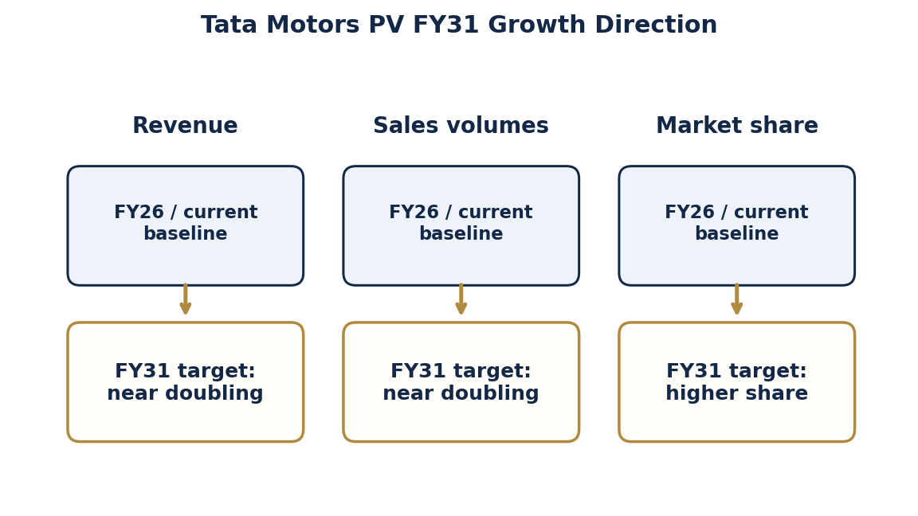
Chart Source: Tata Motors Investor Relations

Battery Technology

CATL launches field-validated sodium-ion energy storage system
June 22, 2026 • China
Executive Summary: CATL unveiled its TENER Sodium Energy Storage System in Munich on June 22, calling it a real-world validated sodium-ion energy storage solution. CATL expects cumulative shipments to reach 1 GWh by end-2026, with global deliveries beginning in June 2027. The announcement positions sodium-ion as a commercial chemistry for storage applications, with supply-chain advantages versus lithium-dependent chemistries.
Official Source: CATL
Secondary Source: Renewables Now

Strategic Watch
CATL’s sodium-ion storage launch should be monitored as an early commercial test of chemistry diversification beyond lithium-dependent systems. Over the next 6–18 months, executives should track shipment execution, customer adoption, global delivery readiness and whether sodium-ion begins to win use cases where cost stability, safety and supply-chain resilience outweigh maximum energy density.

GreyRadius Insight
For CEOs and Strategy Heads, sodium-ion storage expands the strategic battery toolkit for stationary energy and charging-linked infrastructure. CFOs should evaluate whether alternative chemistries can reduce lithium-price exposure, COOs should assess sourcing and integration readiness, Sales Heads should identify storage-led customer segments, and investors should watch whether sodium-ion moves from announced capacity to repeat commercial demand.

Executive Chart
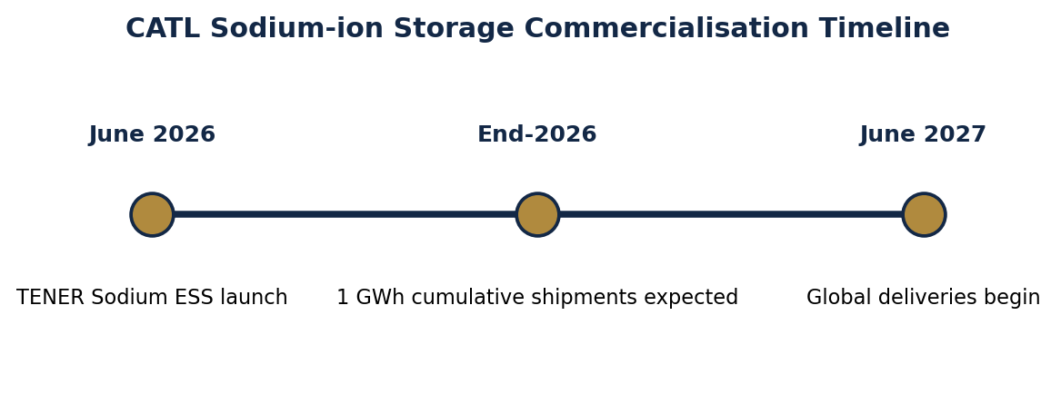
Chart Source: CATL

Battery Technology

CATL expects 10,000–20,000 EVs with sodium-ion batteries in 2026
June 24–26, 2026 • China
Executive Summary: CATL executives said 10,000–20,000 EVs could use its sodium-ion batteries in 2026. The company has positioned sodium-ion as a hedge against lithium price volatility and a technology suited to cold-weather performance. Electrive reported the comments alongside CATL’s sodium-ion storage launch and broader sodium/lithium dual-track strategy.
Official Source: CATL
Secondary Source: Electrive

Strategic Watch
CATL’s expected sodium-ion EV deployment should be watched as a practical indicator of whether sodium-ion can move from storage applications into selected vehicle segments. Over the next 6–18 months, executives should monitor production volumes, model adoption, cold-weather performance, customer acceptance and whether OEMs use sodium-ion to hedge lithium-price volatility.

GreyRadius Insight
For CEOs and Strategy Heads, sodium-ion creates a potential option for cost-sensitive or climate-specific EV applications rather than a universal replacement for LFP or NMC. CFOs should model chemistry optionality against raw-material exposure, COOs should prepare for multi-chemistry validation and sourcing, Sales Heads should clarify customer value propositions, and investors should track which use cases prove commercially durable.

Executive Chart
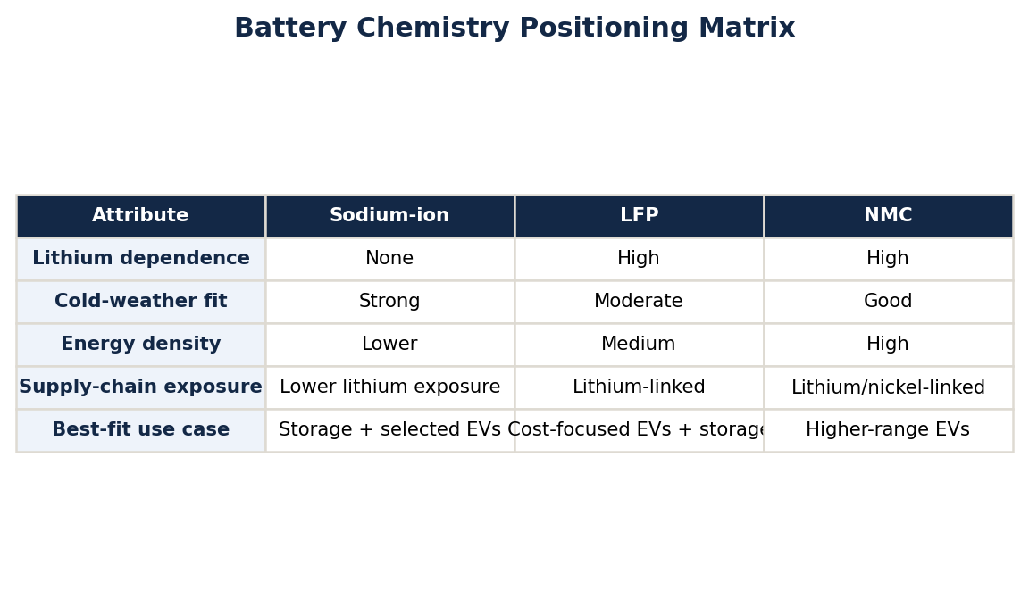
Chart Source: CATL

Charging & V2G

Nissan and Valeo collaborate on bidirectional charging in Europe
June 23, 2026 • Europe
Executive Summary: Nissan and Valeo signed an agreement to market Valeo’s bidirectional AC charging station in Europe. The collaboration supports Nissan’s V2G roadmap, beginning with Nissan Energy in Europe and initially targeting the UK. The partnership was showcased at Power2Drive in Munich and positions compatible Nissan EVs as grid-interactive energy assets.
Official Source: Electrive report citing Nissan and Valeo announcement
Secondary Source: Electrive

Strategic Watch
Nissan and Valeo’s agreement should be monitored as part of Europe’s broader shift toward grid-interactive EV ecosystems. Over the next 6–18 months, executives should track early UK deployment, charger compatibility, utility integration, customer economics and whether bidirectional AC charging becomes a mainstream feature or remains limited to niche energy-aware households.

GreyRadius Insight
For CEOs and Strategy Heads, bidirectional charging turns EVs into platform assets connected to home and grid value pools. CFOs should assess recurring-service economics, COOs should evaluate charger and software interoperability, Sales Heads should prepare energy-led customer messaging, and investors should watch whether OEM-energy partnerships create defensible ecosystem revenue beyond vehicle sales.

Charging & V2G

Volkswagen and Elli launch V2G offer with customer bonus
June 23, 2026 • Europe
Executive Summary: Volkswagen and Elli launched a Vehicle-to-Grid offer that allows EVs to charge intelligently, feed power back and generate customer value while parked. Electrive reported the offer includes a potential annual bonus of up to €720. The move expands Volkswagen’s charging and energy ecosystem beyond basic charging access.
Official Source: Electrive report citing Volkswagen Group / Elli programme
Secondary Source: Electrive

Strategic Watch
Volkswagen and Elli’s V2G offer should be tracked as a commercial proof point for turning parked EVs into monetisable energy assets. Over the next 6–18 months, executives should monitor customer uptake, realised bonus levels, charging-cost offsets, grid-partner participation and whether V2G economics can scale beyond early adopters.

GreyRadius Insight
For CEOs and Strategy Heads, V2G creates a route to recurring customer engagement and energy-platform differentiation. CFOs should examine incentive economics and margin contribution, COOs should ensure reliable charging and grid integration, Sales Heads should translate the annual bonus into simple customer value, and investors should assess whether energy services improve lifetime value and retention.

Chart Source: Electrive report citing Volkswagen Group / Elli programme

Battery Materials

PowerCo selects OCSiAl nanotubes for Unified Cell battery platform
June 25–26, 2026 • Europe
Executive Summary: OCSiAl said it will supply single-wall carbon nanotubes to PowerCo’s Salzgitter facility for Volkswagen Group’s Unified Cell platform. The nanotubes are intended for graphite anodes and are designed to improve safety, charging performance and battery service life. Electrive reported the supplier selection on June 26.
Official Source: OCSiAl
Secondary Source: Electrive

Strategic Watch
PowerCo’s supplier selection should be monitored as a signal that battery differentiation is increasingly moving into materials engineering and additive choices. Over the next 6–18 months, executives should track Salzgitter ramp-up progress, qualification outcomes, charging-performance claims, safety validation and whether nanotube additives become a wider cell-platform standard.

GreyRadius Insight
For CEOs and Strategy Heads, the Unified Cell platform highlights how materials decisions can influence product performance, lifecycle value and manufacturing scalability. CFOs should assess supplier concentration and cost-performance trade-offs, COOs should monitor qualification and production readiness, Sales Heads should translate performance gains into customer value, and investors should watch whether material innovation improves competitive battery economics.

Regulation

Polestar faces U.S. sales restrictions for new model variants from 2027
June 26, 2026 • United States
Executive Summary: Polestar said U.S. connected-vehicle rules will prevent sales of new model-year 2027 vehicles in the U.S. Reuters and Electrive reported that model-year 2026 and earlier vehicles can continue to be sold. Polestar is expected to focus more heavily on Europe, where most of its sales already occur.
Official Source: Electrive report citing Polestar statement
Secondary Source: Reuters EV Strategy

Strategic Watch
Polestar’s U.S. restriction should be monitored as a warning that connected-vehicle regulation can reshape market access as much as tariffs or emissions rules. Over the next 6–18 months, executives should track implementation details, model-year exposure, software and supply-chain compliance pathways, and whether other automakers face similar geographic constraints.

GreyRadius Insight
For CEOs and Strategy Heads, regulatory resilience is now part of EV market strategy. CFOs should stress-test revenue exposure by geography, COOs should map connected-vehicle supply-chain dependencies, Sales Heads should prepare regional prioritisation plans, and investors should evaluate whether companies have enough flexibility to redirect volume when policy blocks access to key markets.

Market Data & Intelligence
Indicator | Latest Data Point | Region | Strategic Meaning | Source
Global EV registrations | 1.8 million in May 2026; up 3% YoY | Global | EV demand still growing, but uneven by region | Reuters / BMI
India EV retail sales | 1.28 million EVs from Jan 1–June 4, 2026; 40% growth | India | India remains a high-growth two-/three-wheeler-led EV market | Autocar Professional
Global EV sales outlook | 23 million passenger EVs expected globally in 2026, up 11% from 2025 | Global | Supports cautious capacity planning and affordability focus | BloombergNEF
CATL sodium-ion storage shipments | 1 GWh expected by end-2026 | China / Global | Sodium-ion becoming commercially relevant for storage and charging-linked energy systems | CATL

Turn EV Strategy Into Execution
GreyRadius helps leadership teams translate electrification, battery, charging and energy-system shifts into practical operating decisions, investment priorities and measurable execution plans.
Book a Strategy Call | Visit Our Website
GreyRadius | Charged | Weekly EV & Battery Intelligence | 22 June 2026 – 28 June 2026

