Weekly Enterprise AI Intelligence | 
The Signal
AI Adoption • Tools • Enterprise Intelligence
Published by GreyRadius Consulting | Issue 003 | June 22–28, 2026
Executive Highlights
Global  OpenAI and Broadcom unveiled a custom LLM inference chip | United States  Microsoft announced a 2 GW AI datacenter campus in Pecos, Texas | Europe  NVIDIA announced 35 AI HPC supercomputers across 23 countries | United States / Global  IBM joined OpenAI’s Daybreak Cyber Partner Program | United States  Oracle Health expanded Baystate Health’s AI-enabled platform partnership
This Week’s Briefing Spans
• Frontier AI moving into enterprise cyber defense and managed services
• AI infrastructure expansion across silicon, datacenters and sovereign compute
• Enterprise adoption progressing from pilots toward scaled deployment
• Government and macroeconomic evidence on AI adoption depth
• Agentic AI deployment in customer service and fan engagement
IBM and OpenAI bring frontier AI to enterprise cyber defense
ENTERPRISE AI | 22 June 2026 | United States / Global | IBM, OpenAI
Executive Summary
IBM announced it joined OpenAI’s Daybreak Cyber Partner Program and launched an application security service using OpenAI cyber capabilities to identify, validate, and prioritize software vulnerabilities. The service operates within client environments with controlled, read-only access and is delivered as a managed enterprise service. IBM said the effort builds on Project Lightwell, supported by a $5 billion IBM and Red Hat commitment for open-source security remediation.
Official Source: IBM Newsroom
Strategic Watch  Frontier AI is moving from experimentation into managed enterprise cyber workflows. Security leaders should monitor how Daybreak partner integrations, controlled-access models, liability expectations and managed service adoption evolve as AI-assisted vulnerability discovery becomes operational inside client environments. | GreyRadius Insight  Cyber defense is becoming a race between machine-speed attackers and machine-speed remediation. IBM’s managed-service framing suggests that large enterprises may prefer frontier AI delivered through trusted integrators rather than direct model experimentation, especially where governance, auditability and environment-level controls are required.
OpenAI highlights HP enterprise AI adoption
ENTERPRISE AI | 28 June 2026 | United States / Global | OpenAI, HP
Executive Summary
OpenAI listed “How HP is scaling early AI wins across the enterprise” as a company announcement dated 28 June 2026, indicating an enterprise deployment case focused on scaling AI adoption inside HP. The available indexed source confirms date and topic but provides limited public detail in search-accessible text.
Official Source: OpenAI Newsroom
Strategic Watch  Large-enterprise AI adoption is increasingly shifting from isolated pilots toward repeatable operating models. Technology buyers should monitor whether HP’s approach emphasizes internal workflow redesign, employee enablement, governance, or measurable productivity outcomes, because these details will influence how peer enterprises scale AI beyond proof-of-concept phases. | GreyRadius Insight  The strategic signal is not merely that HP is using AI, but that OpenAI is positioning scaled enterprise adoption as a reference motion. As frontier AI vendors compete for enterprise trust, customer proof points will become central to procurement confidence, use-case prioritization and executive sponsorship.
OpenAI and Broadcom unveil LLM-optimized inference chip
AI INFRASTRUCTURE | 24 June 2026 | United States / Global | OpenAI, Broadcom
Executive Summary
OpenAI unveiled an LLM-optimized inference chip developed with Broadcom to strengthen its AI infrastructure and reduce reliance on external GPU supply. The custom silicon is designed to improve inference efficiency, lower operating costs and support greater control over compute capacity as AI demand scales.
Official Source: OpenAI • Reuters
Strategic Watch  OpenAI’s move toward proprietary inference silicon reflects a broader shift among frontier AI companies toward vertically integrated compute infrastructure. Cloud, semiconductor, packaging, memory and datacenter suppliers should monitor how custom inference silicon changes procurement cycles, accelerator demand, and the balance between merchant GPUs and bespoke AI processors. | GreyRadius Insight  The AI industry is entering a phase where compute ownership becomes as strategically important as model capability. Custom inference chips can reduce deployment cost, improve workload efficiency and create tighter control over latency, power and supply-chain exposure. This may intensify competition between AI labs, hyperscalers and semiconductor partners.
Microsoft announces 2 GW AI datacenter campus in Pecos, Texas
AI INFRASTRUCTURE | 22 June 2026 | United States | Microsoft
Executive Summary
Microsoft announced a new datacenter campus in Pecos, Texas, adding approximately 2 GW of global datacenter capacity for AI and cloud services. Microsoft described it as one of the largest single capacity additions in its history and said the multibillion-dollar investment will occur over five to seven years.
Official Source: Microsoft Official Blog
Strategic Watch  AI infrastructure growth is increasingly constrained by power availability, interconnection timelines, local permitting and long-duration capital deployment. Enterprises dependent on cloud AI capacity should monitor how regional power partnerships and datacenter buildouts affect pricing, availability zones and latency-sensitive AI workloads. | GreyRadius Insight  The Pecos announcement reinforces that AI scaling is no longer only a compute procurement issue. Power strategy, land availability and regional economic development are becoming core to AI infrastructure competitiveness. Cloud customers should expect capacity planning to become more strategic and geographically differentiated.

NVIDIA announces 35 new AI HPC supercomputers across Europe
AI INFRASTRUCTURE | 22 June 2026 | Europe | NVIDIA, European AI/HPC centers
Executive Summary
NVIDIA announced that 35 AI HPC supercomputers are in development across Europe, spanning 23 countries and supporting more than 3 million researchers. NVIDIA said its infrastructure powers over 90% of Europe’s AI factory buildout, with 800 AI exaflops deployed or announced since the prior year. Named systems include Barcelona Supercomputing Center’s EuroHPC AI Factory, BavariaAI’s Blue Swan, IT4LIA, HLRS HammerHAI, and NAISS Mimer.
Official Source: NVIDIA Newsroom
Strategic Watch  Europe’s sovereign AI strategy is moving from policy ambition into infrastructure execution. AI hardware suppliers, cloud providers, research institutions and public-sector technology partners should monitor procurement programs, national AI factory models and public-private funding mechanisms across the region. | GreyRadius Insight  NVIDIA’s role across European AI factories shows that sovereignty does not always mean domestic hardware independence. Europe is building local compute capacity, but much of that infrastructure still depends on U.S.-origin accelerator platforms. This creates a strategic balance between regional control and global supplier dependence.
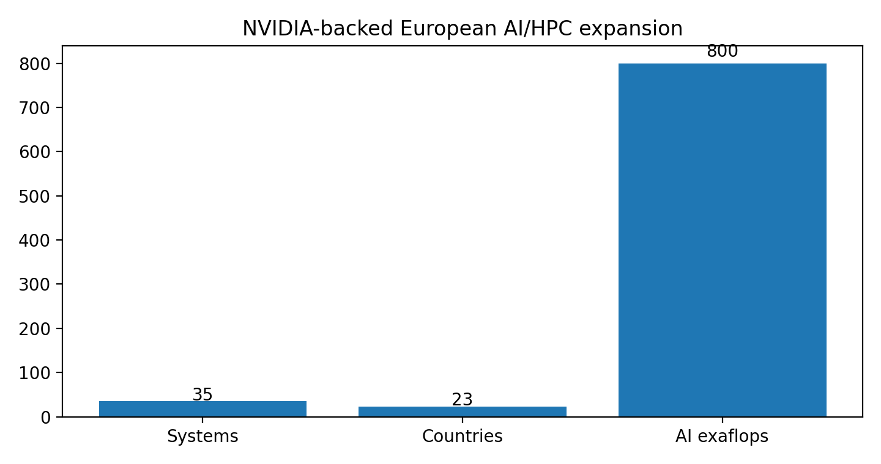
ECB researchers find intensive AI use remains limited among euro-zone firms
GOVERNMENT AI & POLICY | 24 June 2026 | Europe | European Central Bank
Executive Summary
Reuters reported an ECB research finding that more than 70% of euro-zone firms use AI, but only 7% use it intensively. The survey covered more than 5,000 companies and found intensive use concentrated among smaller, younger, service-oriented, and high-tech firms.
Official Source: ECB Blog • Reuters
Strategic Watch  AI adoption is broad but still shallow across much of the euro-zone economy. Policymakers, enterprise software vendors and transformation leaders should monitor whether adoption deepens into workflow redesign, process automation and customized AI systems rather than remaining limited to moderate or occasional usage. | GreyRadius Insight  The productivity impact of AI will depend less on whether firms try AI and more on whether they reorganize work around it. The ECB data suggests that Europe’s AI opportunity is still early, with the largest gains likely to come from adoption depth, skills investment and operational integration.
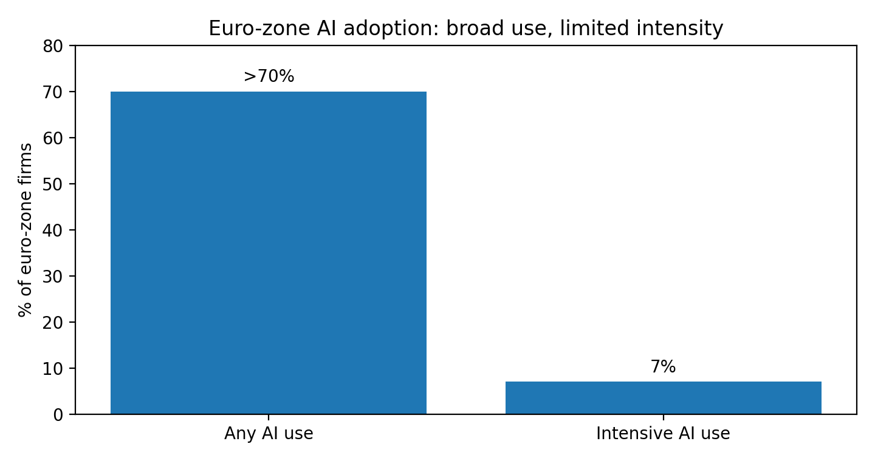
Oracle Health and Baystate Health expand AI-enabled healthcare platform partnership
ENTERPRISE SOFTWARE & CLOUD | 22 June 2026 | United States | Oracle Health, Baystate Health
Executive Summary
Oracle announced that Baystate Health will expand adoption of Oracle Health technologies, including Oracle Health EHR, Oracle Health AI Data Platform, Oracle Health Patient Accounting, Oracle Health Patient Portal, and Oracle Health Clinical AI Agent. Baystate serves more than 800,000 people across five hospitals, over 80 medical practices, a health plan, and home care and hospice services.
Official Source: Oracle / PR Newswire
Strategic Watch  Healthcare AI is moving into core system-of-record and clinical workflow modernization. Providers, payers and health technology vendors should monitor whether AI documentation, patient accounting and data-platform deployment produce measurable improvements in clinician burden, interoperability and financial operations. | GreyRadius Insight  Baystate’s broader platform adoption shows that healthcare AI value is increasingly tied to integrated operating systems rather than standalone tools. The highest-impact deployments will likely combine EHR modernization, unified data, revenue-cycle automation and clinical documentation support.

Salesforce launches Agentforce Help Agent
ENTERPRISE SOFTWARE & CLOUD | 25 June 2026 | United States / Global | Salesforce
Executive Summary
Salesforce listed the launch of Agentforce Help Agent, described as deploying in minutes and charging only for resolutions, under its Agentforce announcements dated 25 June 2026. The announcement falls within enterprise software and agentic AI customer support automation.
Official Source: Salesforce Newsroom
Strategic Watch  Outcome-based AI agent pricing may become an important enterprise software monetization model. Customer service leaders should monitor how resolution-based charging affects ROI calculations, deployment velocity, service quality metrics and vendor accountability. | GreyRadius Insight  Agentforce Help Agent signals a move toward packaged AI agents that reduce implementation friction. The strategic question for enterprises is whether preconfigured agents can deliver reliable outcomes at scale while still respecting brand tone, escalation logic, compliance requirements and knowledge-base quality.
Salesforce and VCARB deploy Agentforce 360 for AI fan engagement
STRATEGIC PARTNERSHIPS | 22 June 2026 | Global | Salesforce, VCARB
Executive Summary
Salesforce listed the launch of Agentforce Help Agent, described as deploying in minutes and charging only for resolutions, under its Agentforce announcements dated 25 June 2026. The announcement falls within enterprise software and agentic AI customer support automation.
Official Source: Salesforce Newsroom
Strategic Watch  Agentic AI is expanding into high-volume customer engagement environments where personalization, real-time data and operational storytelling matter. Brands should monitor how AI agents combine CRM, analytics and live-event data to create interactive experiences. | GreyRadius Insight  VCARB’s deployment illustrates how agentic AI can become part of brand experience, not only back-office automation. For enterprises, the commercial lesson is that AI agents may increasingly serve as customer-facing interfaces that translate data into engagement, loyalty and differentiated digital experiences.
Funding & Investment
No verified funding rounds or AI investment announcements within 22–28 June 2026 met the inclusion threshold with official-source confirmation.
Turn AI Strategy Into Execution
GreyRadius helps leadership teams move from AI experimentation to governed operating models, use-case prioritization, execution cadence and measurable business value.

Book a Free Strategy Call|Visit Our Website
Market Data & Intelligence
Metric | Latest Value | Reporting Period | Region | Source | Executive Implication
Microsoft new AI/cloud datacenter capacity | ~2 GW | 22–28 Jun 2026 | US | Microsoft (The Official Microsoft Blog) | AI infrastructure growth is increasingly constrained by power and dedicated energy supply.
NVIDIA-backed European AI HPC systems | 35 systems | 22–28 Jun 2026 | Europe | NVIDIA (NVIDIA Newsroom) | Europe is scaling sovereign AI infrastructure through AI factories and HPC centers.
NVIDIA AI exaflops deployed or announced in Europe | 800 AI exaflops | 22–28 Jun 2026 | Europe | NVIDIA (NVIDIA Newsroom) | AI compute capacity is becoming a strategic regional competitiveness metric.
Euro-zone firms with intensive AI usage | 7% | 22–28 Jun 2026 | Europe | Reuters / ECB (Reuters) | Adoption depth remains limited despite widespread experimentation.
Euro-zone firms reporting any AI use | >70% | 22–28 Jun 2026 | Europe | Reuters / ECB (Reuters) | AI is widely present but not yet deeply embedded in most firms.

Sources: Microsoft Official Blog • NVIDIA Newsroom • Reuters / ECB

