# CS 3733 B 2018 **Scheduler** Group Project

Have you ever used <http://when2meet.com> to try to find a convenient time for a group of people to meet? This kind of web site allows a **meeting organizer** (the **organizer** for the rest of this discussion)to set up potential dates for **meeting participants** (the **participants** for the rest of this discussion) to register their availability for a particular meeting.

Your goal for **Meeting Scheduler** (called **Scheduler** for the rest of this discussion) **is** to make it possible for an **organizer** to make some time slots available on specific dates in the year (i.e., from February 12th 2018 through February 23rd 2018). These time slots are constructed based on a specific fixed meeting duration that evenly divides into sixty (i.e., 10 minutes, 15, 20, 30 or 60). The following is a sample:

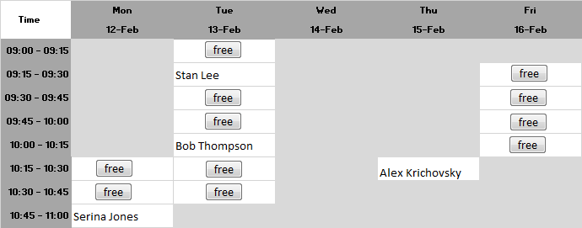

Here the **organizer** has created a schedule of 15-minute meetings, spread out over two possible weeks. No meeting starts before 9:00 AM and no meeting is scheduled at 11:00 AM or later; thus the daily start hour is 9 and the daily end hour is 11.

The organizer has closed (in light gray) time slots during which no meetings are available. The other timeslots (with white background) can have scheduled meetings, and four **participants** have already signed up for a meeting. In this week, there are eleven additional open time slots that are available for a participant to schedule a meeting.

All meetings are to be scheduled only on Monday – Friday (that is, it excludes Saturday and Sunday). It is assumed that each meeting schedule has a unique ID by which it can be discovered.

## Organizer Desired Features

The organizer wants to be able to carry out the following tasks:

* Create a new meeting schedule (with its own user-friendly name, such as “Advising Schedule”) with a fixed timeslot duration (of 10,15,20,30, or 60 minutes) that is active from a given start date up until given ending date. For each day there is a daily start hour (such as 9:00 AM or 12:00 PM) and there is a daily end hour (such as 5:00 PM or 8:00 PM). No meeting can be schedule before the start hour; no meeting can be scheduled at or later than the end hour. Upon successful creation of a meeting schedule, the organizer is given a “secret code” that will be used to authenticate all future edit/delete requests.
* Close/Open an individual time slot on a specific day (i.e., 9:30 – 9:45 on 14-Feb-2018)
* Close/Open all time slots at a given time (i.e., 9:15 – 9:30 on any day)
* Close/Open all time slots on a given day (i.e., all timeslots on 12-Feb-2018)
* Cancel any individual meeting at any time
* Review weekly schedule of meetings for a given calendar week (i.e., above is the result for the week of 12-Feb-2018) to see what meetings have been scheduled
* Once a meeting schedule is created, the organizer must tell participants about the scheduled meeting so they can start to register for meetings
* Extend the ending date of a meeting schedule to a future date
* Extend the starting date of a meeting schedule to an earlier date
* Delete a meeting schedule once it no longer is useful. Note that organizers can only delete meeting schedules that they had previously created

## Participant Desired Features

Participants want to be able to carry out the following tasks:

* Review weekly schedule of meetings for a given meeting schedule, based on information from an organizer
* Create a meeting in a given open timeslot in a meeting schedule. For each such meeting, the participant can provide a string that will be recorded with the timeslot. Typically this would be just a user name, but it could also be an email address. Upon the successful creation of a meeting, the participant is given a “secret code” that will be used to authenticate all future edit/delete requests
* Cancel a previously scheduled meeting; this must be restricted so participants can only cancel a meeting that they had previously created
* Search for a list of open time slots (filtered by Month, Year, Day-Of-Week, Day-Of-Month, or Timeslot). These individual search filters can be combined to reduce the search results. Within the search results, the participant can simply create a meeting from one of the returned timeslots

## System Administrator Feature

The system administrator is responsible for maintaining the system and would like to carry out the following tasks:

* Retrieve a list of meeting schedules more than N days old and delete them from the system
* Retrieve a list of meeting schedules created in the past N hours

# End Notes

As changes occur, I will amend this document and summarize those changes here.