**ITOL**

**Issue Tracker Add-in for Microsoft Outlook**

Version 1.0.0

Designed by Wolfgang Imig

2017-05-01

Contents

1 Overview 4

2 Feature List 5

3 Requirements 6

4 Installation 6

4.1 Verify Installation 6

4.2 Uninstall 7

4.3 License 7

5 Connect to JIRA 7

5.1 First Time Connecting to JIRA 7

5.2 Edit Connection to JIRA 8

6 Save Selected Project, Issue Type and Priority as Default 9

7 Create and Edit Issue 9

7.1 Create Issue Based on Mail 9

7.2 Create New Issue (Without Mail) 9

7.3 Edit an Existing Issue 9

7.4 Create a Sub-Task 10

8 Edit Issue Description and Comment 10

8.1 Markup and Links 11

8.2 Mentions 12

9 Edit Issue Properties 13

9.1 Sub-Dialogs for Multi-Value Properties 14

9.2 Time Tracking 16

10 Update Issue Status 17

11 Attachments 18

11.1 Attach Mail as … 18

11.2 Add Attachments to Blacklist 18

11.3 Export Attachments to Directory 19

12 Configuration 20

12.1 Configure How to Process Mail Properties 20

12.2 Manage Mail Attachments to Ignore 22

12.3 Configure Export of Issue Attachments 23

12.4 Logging 23

13 Appendix 24

13.1 Configuration Files 24

13.2 Configuration File “user.json” 25

13.3 Configuration File “application.json.templ” 25

13.4 Additional Logging 25

# Overview

ITOL allows to create an issue from a mail with a few clicks.

Since it seamlessly integrates with the Outlook user interface, ITOL lets you feel like working in a single program instead of jumping back and forth between two different worlds.

Issues can be created inside the Outlook explorer window as shown in Figure 1. Button “Issue Pane” shows or hides the pane “Issue” (1). To initialize an issue based on the selected mail, click button “Assign” (2), which performs the following actions:

* The mail subject is copied into issue summary. (3)
* If the mail subject contains the project name or shortcut, the issue is assigned to this project. (4)
* HTML mail body content is converted into JIRA markup. (5)
* Embedded images are replaced by thumbnails. (5)
* Mail attachments are added as issue attachments.
* Issue fields are initialized with default values.

Review the prepared issue data and click on button “Create” to create the issue in JIRA.

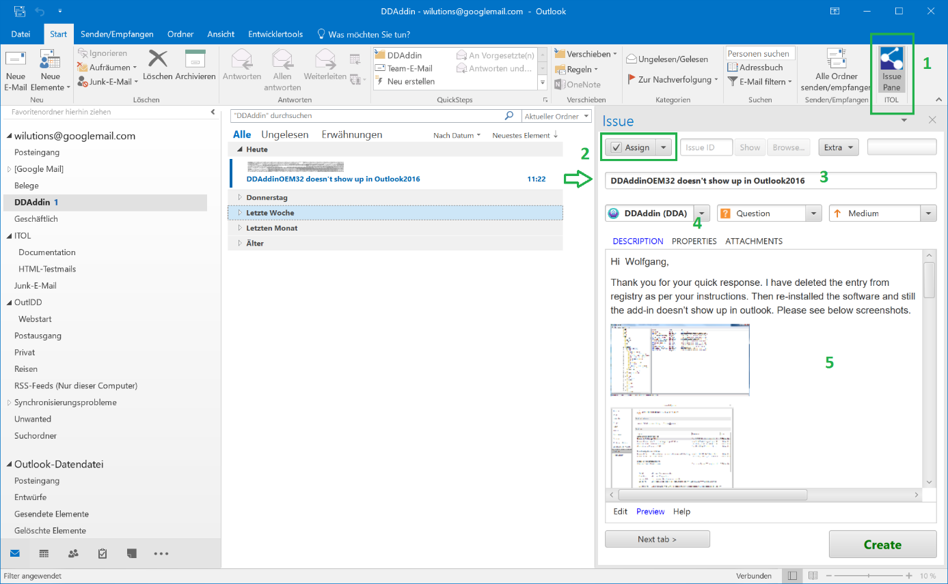

Figure 1, ITOL displayed in an Outlook explorer window

The ITOL Add-in is also integrated with the Outlook mail inspector window, as shown in Figure 2.

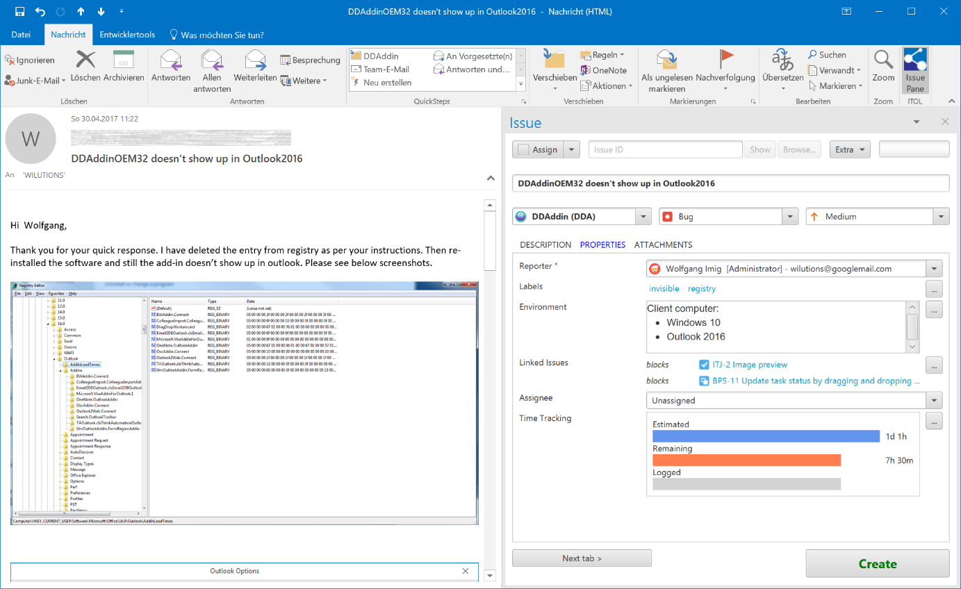

Figure 2, ITOL displayed in an Outlook mail inspector window

# Feature List

* Seamless integration into Outlook user interface as a task pane.
* Create, update and view issues. Create subtasks of issues.
* Scan mail subject for issue ID. If an ID is found, load the issue into the add-in.
* For a new issue, scan mail subject for project name or shortcut and copy mail body to description.
* For an existing issue, copy mail body into a new comment – provided that the mail is newer than the last comment.
* Convert HTML mail body into JIRA markup.
* Add all mail attachments to the issue. Exclude attachments listed in a blacklist (e.g. company logos).
* Add the original mail as an attachment to the issue. The mail can be added in format MSG, RTF or plain text.
* Provides an editor for text fields that behaves most like JIRA’s markup editor – inclusive user mentions and file links, which can be inserted via drag & drop, too.
* Add issue attachments from clipboard, by drag & drop, from recent file list or by selecting files from the filesystem.
* Show thumbnails for attachments if available.
* One click to export issue attachments to a directory on the filesystem and open Windows Explorer or your favorite file manager. This functionality is especially useful when examining log files.
* Insert the issue ID into the mail subject. If you answer that mail and the receiver replies in turn, ITOL can display the associated issue.
* Store the mail sender address into a custom field. When an issue comment is added in ITOL, a new mail to this address is automatically prepared.
* Support for custom fields.
* Support for time tracking fields.
* Show history of issue comments.
* Navigate to the issue in JIRA.

# Requirements

* Windows 7 or newer
* Outlook 2010, 2013, 2016
* JIRA 7.0.0 or newer
* JIRA 7.2.8 or newer when using time tracking
* Users should be familiar with JIRA

# Installation

Go through the following steps to install the software:

* Close Outlook
* Execute ITOL.msi. This setup installs the add-in under user permissions.
* Start Outlook

## Verify Installation

1. Outlook should show this button on the “Start” toolbar:

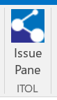

Figure 3 Outlook Toolbar Button Issue Pane

1. Three Add-ins should be listed at File – Options – Add-ins – Active Add-ins:

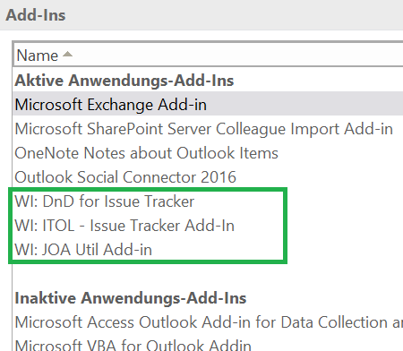

1. Windows Control Panel should list ITOL:

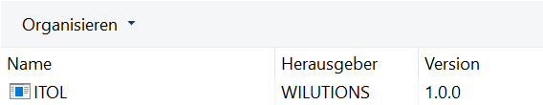

## Uninstall

* Close Outlook
* Uninstall via Windows Control Panel

## License

ITOL runs for 30 days without a license key for demonstration and testing.

The license key for a production version can be entered at “Extra – License...” after the connection to JIRA has been configured.

Another option to specify the license is to add the following registry keys:

Windows Registry Editor Version 5.00

[HKEY_LOCAL_MACHINE\SOFTWARE\WILUTIONS\ITOL\License]

@="your license"

[HKEY_LOCAL_MACHINE\SOFTWARE\Wow6432Node\WILUTIONS\ITOL\License]

@="your license"

# Connect to JIRA

## First Time Connecting to JIRA

The first time ITOL is used, it opens automatically the dialog “Connect to JIRA” when the toolbar button “Issue Pane” (see Figure 3 Outlook Toolbar Button Issue PaneFigure 3) is clicked.

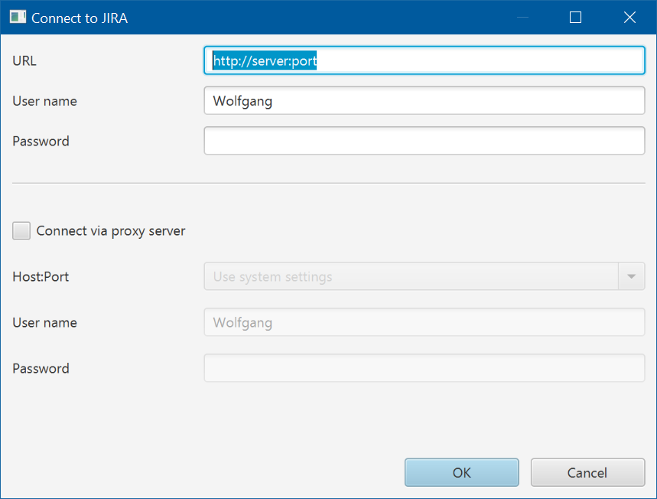

Figure 4 Dialog Connect to JIRA

Enter the URL of your JIRA server and the logon credentials.

To use a proxy server, check “Connect via proxy server” and enter the proxy server data. If your JIRA server is accessed by HTTPS, your proxy server must support digest authentication.

After successfully connected, a so called “Outlook Task Pane” should be displayed in the Outlook explorer window, see Figure 1.

## Edit Connection to JIRA

To change the connection to JIRA, click “Extra – Connect…”:

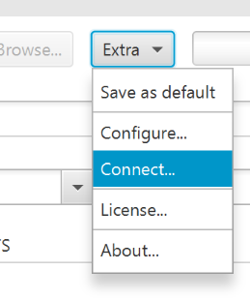

# Save Selected Project, Issue Type and Priority as Default

Menu “Extras – Save as default” allows to save the selected project, issue type and priority as default for new issues.

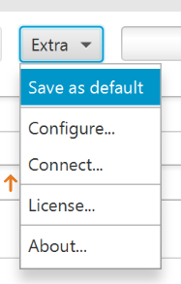

# Create and Edit Issue

## Create Issue Based on Mail

To create an issue based on a mail, select the mail in the explorer window and click button “Assign” in the ITOL pane.

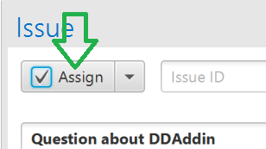

## Create New Issue (Without Mail)

To create a new issue without assigning a mail, click the arrow button next to “Assign” and select “New issue”.

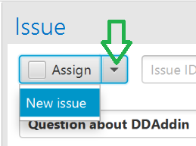

## Edit an Existing Issue

To load an existing issue into the dialog, enter the issue ID next to the “Assign” button and click “Show”, see Figure 5.

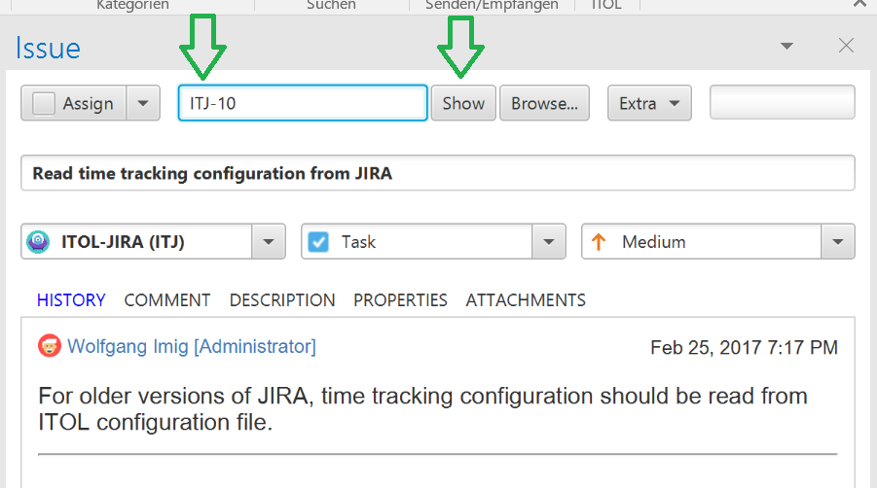

Figure 5, Show Existing Issue

Button “Browse…” shows the issue in JIRA.

Another way to load an existing issue is to select a mail that contains an issue ID in its subject. Select such a mail and click the “Assign” button.

## Create a Sub-Task

A sub-task can be created by the menu “Create Sub-task” which is available when the arrow button next to “Assign” is clicked - as far as the issue type supports sub-tasks.

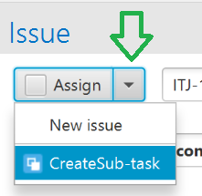

# Edit Issue Description and Comment

If a mail is assigned, the mail body is copied into the issue description. By default, this window is in “Preview” mode. To edit the description, click on the tab “Edit” at the bottom of the window.

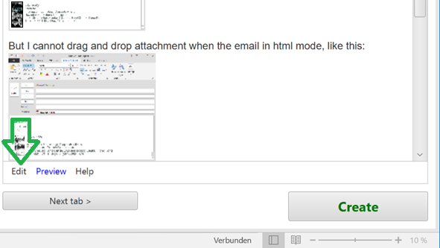

## Markup and Links

The editor provides most of the JIRA markup functionality. In addition, it allows to add and link to an attachment from the “recent file list” managed by Windows.

Attachments can also be added by dragging a file into the editor window. Furthermore, shortcut STRG+V adds an image from the clipboard (e.g. screenshot) as a new issue attachment.

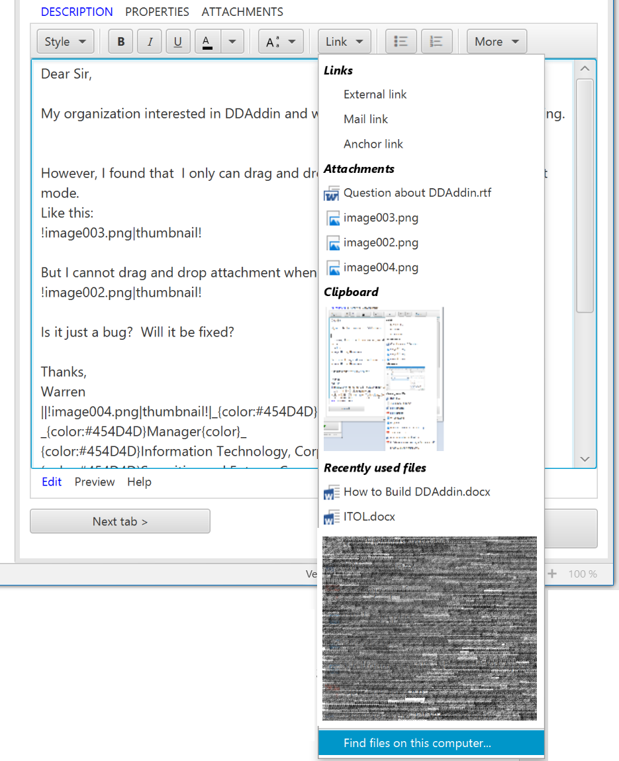

## Mentions

To mention a user in a description, press “@” (at) and then start tying a user name.

At the bottom of the editor window, a list of suggestions for the mention is displayed. Press RETURN to select the first suggestion or double-click on one of the suggestions.

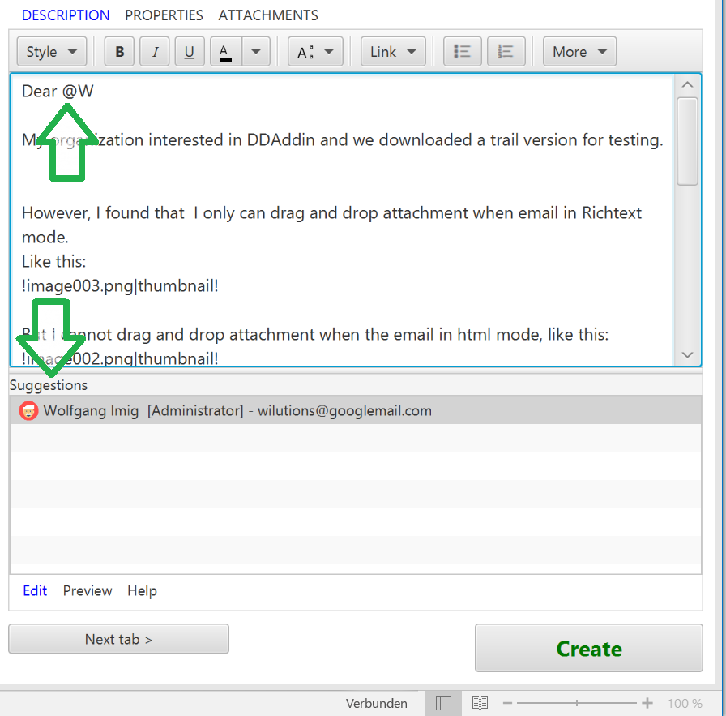

# Edit Issue Properties

Click on tab “PROPERTIES” to view the properties available for the new issue. The project and issue type configuration in JIRA defines which properties, inclusive custom properties, can be edited.

Mandatory properties, like “Reporter” are marked with an Asterisk (*).

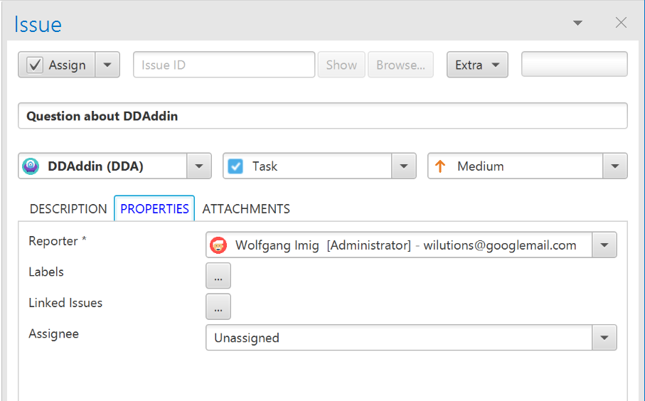

Figure 6, Edit issue properties

## Sub-Dialogs for Multi-Value Properties

For multi-value properties, like “Labels” and “Linked Issues”, ITOL shows a “…” button which replaces the property list by a sub-dialog.

E.g. the sub-dialog for “Linked Issues” is shown in Figure 7.

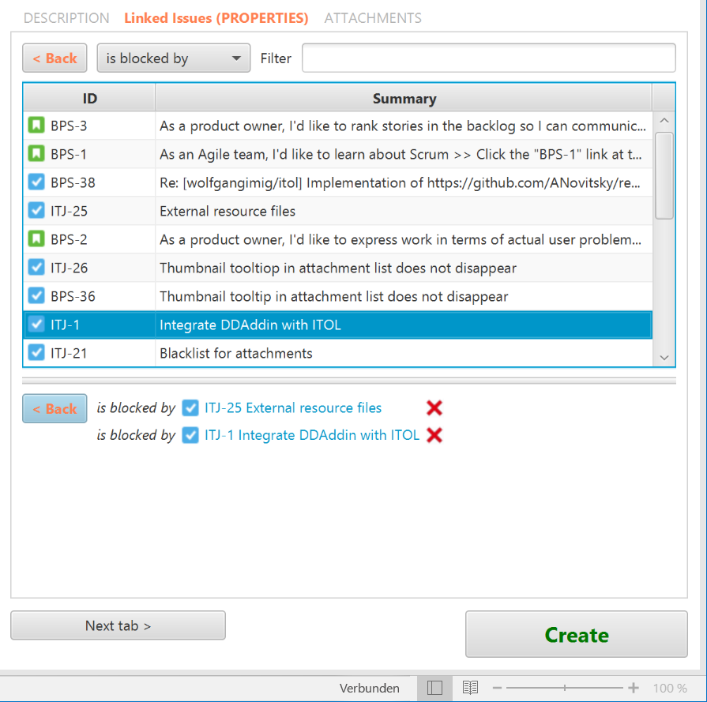

Figure 7, Linked Issues Sub-Dialog

A sub-dialog has usually a “Filter” edit box and a list of suggested items. The “Filter” field triggers an auto completion query in JIRA and the returned items are listed below.

To select an item, either double-click on a list item, or select an item and hit the SPACE key.

If the property allows to assign arbitrary values, that do not have to be taken from a list, e.g. “Labels”, the “Filter” is added to the selection when pressing RETURN in the “Filter” field. Subsequently, the dialog is closed.

Click on one of the “<Back” buttons to leave the sub-dialog. Keys ESC and RETURN also return to the properties list. The ESC key does not revert the changes.

The selected item(s) are listed below the list of suggested items. To remove an item from the selection, click the button “X” next to the item. Or use the TAB key to navigate the focus to the item and press DEL.

After the sub-dialog has been closed, the properties tab shows the selected items, see Figure 8.

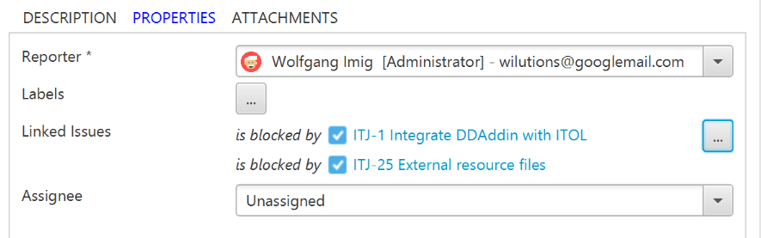

Figure 8, Showing Multi-Value Properties

## Time Tracking

Time tracking is displayed on the “PROPERTIES” tab. As for multi-value fields, a sub-dialog allows to edit its data. Figure 9 shows the time tracking section for a new issue.

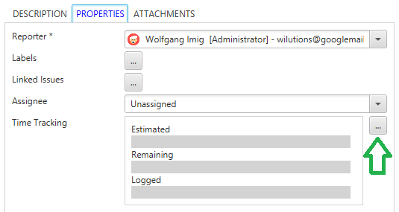

Figure 9, Time tracking for new issue

To initialize time tracking values for a new issue, click button “…”. The “PROPERTIES” tab is replaced by a sub-dialog that allows to edit “Estimated” and “Remaining” time, see Figure 10.

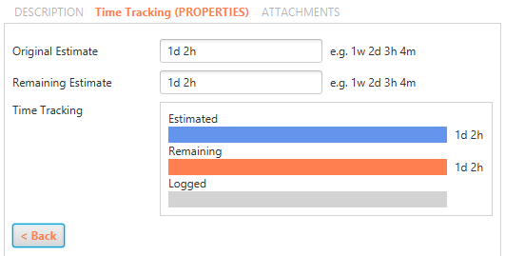

Figure 10, Edit time tracking, estimated and remaining time

Button “< Back” or key ESC accepts the changes and restores the view of the “PROPERTIES” tab.

If the time tracking values of an existing entry are edited, the sub-dialog looks like Figure 11.

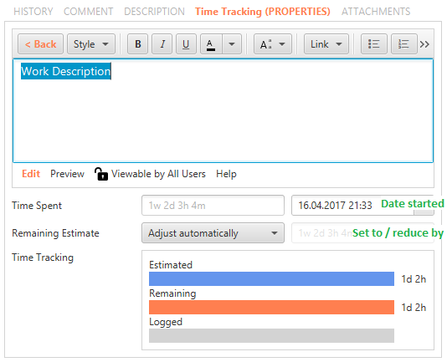

Figure 11, Time tracking sub-dialog for exisiting issue

*Hint: ITOL can take the time tracking configuration into account only when connected to JIRA 7.2.8 or newer.*

# Update Issue Status

To move the issue workflow to another status, select the new status in the combo-box found between button “Next tab >” and button “Update”. Then click button “Update”.

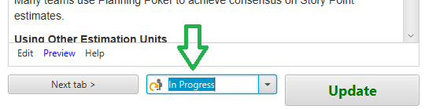

# Attachments

When assigning a mail to an issue, the mail attachments are automatically handed over as issue attachments. This includes attachments embedded in the mail body.

## Attach Mail as …

As configured in field “Attach mail as”, see 12.1, the mail content is added as an issue attachment too. Figure 12 shows the list of attachments for a mail example whereby the field “Attach mail as” is set to “RTF”.

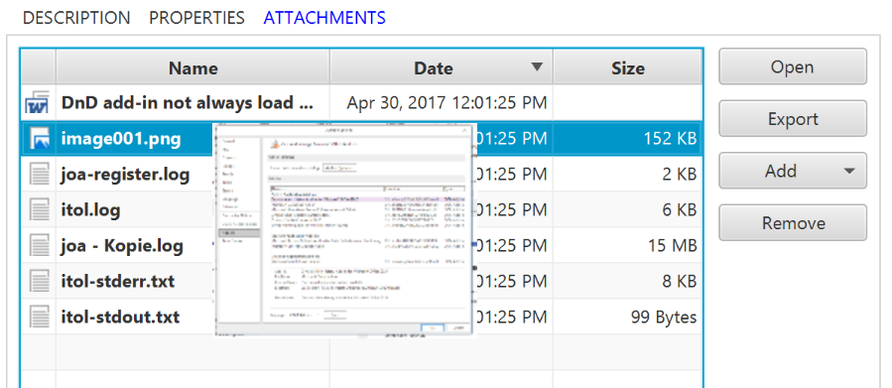

Figure 12, Issue Attachments

Tab „ATTACHMENTS“ provides the following functionality:

* To show a thumbnail for an image file, move the mouse pointer over the file name column of an attachment. If the thumbnail is not displayed, make sure the attachment list has the keyboard focus. Click somewhere in the list to focus it. Thumbnails are provided by JIRA not for all file types. Only a selection of image file types is supported.
* Open attachment by double-click in the viewer that is assigned to the file extension. Click button “Open” to view the first selected attachment.
* Export attachments to a preconfigured directory (see 11.3)
* Menu “Add” allows to add attachments from Windows clipboard, recent file list and file system.
* Button “Remove” removes attachments of new issues.
* Add selected image to blacklist of attachments (see 11.2).
* Copy selected attachments to clipboard by STRG+C or “Copy” in context menu.
* Paste files or images from clipboard by STRG+V or “Paste” in context menu.

## Add Attachments to Blacklist

Mails often contain a company logo at the bottom of the body. Usually, those logos should not be attached to the issue. To unburden the user from removing the logo manually, it can be added to a blacklist. For every mail subsequently assigned to an issue, the mail attachments are checked against the black list. Therein listed files are automatically removed.

To add an attachment to the blacklist, right-click somewhere in the attachment row and select “Add to backlist…”.

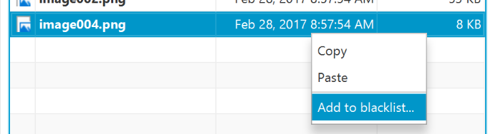

This opens a dialog where a name can be assigned to the logo.

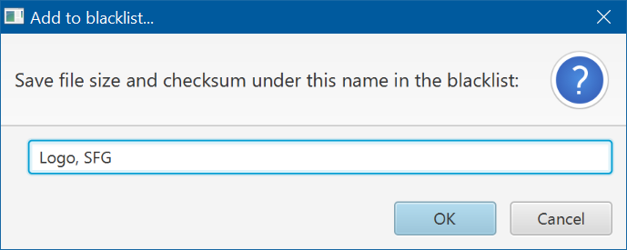

Only the checksum and the file size is memorized, not the entire image.

To remove files from the blacklist, see 12.2.

## Export Attachments to Directory

To save attachments into a preconfigured directory (see 12.3) click button “Export”, see Figure 13 Export attachments and start Command window. If the list has no selection, all attachments are exported. Otherwise, the selected items are exported.

Following the export, Windows explorer is opened at the export directory. Another program, e.g. the command window, can be specified in the configuration (see 12.3).

If the mail content is attached as “Microsoft Outlook, MSG” (see 12.1), the export function unpacks the MSG file. It saves the mail body into an RTF file and copies each attachment to the export directory.

The attachment’s last modified date, which is shown in the date column of Windows Explorer, is set to the date when it was attached to the issue.

An issue can contain attachments with the same name. Since file names must be unique in a file system directory, ITOL might rename the attachments by appending a number.

The destination directory for export is a sub-directory of the configured export directory. For existing issues, the sub-directory name is the issue ID. Attachments of new issues are exported into a sub-directory that is built by the project key plus a timestamp.

Only those attachments are exported that do not already exist in the destination. They are not deleted automatically.

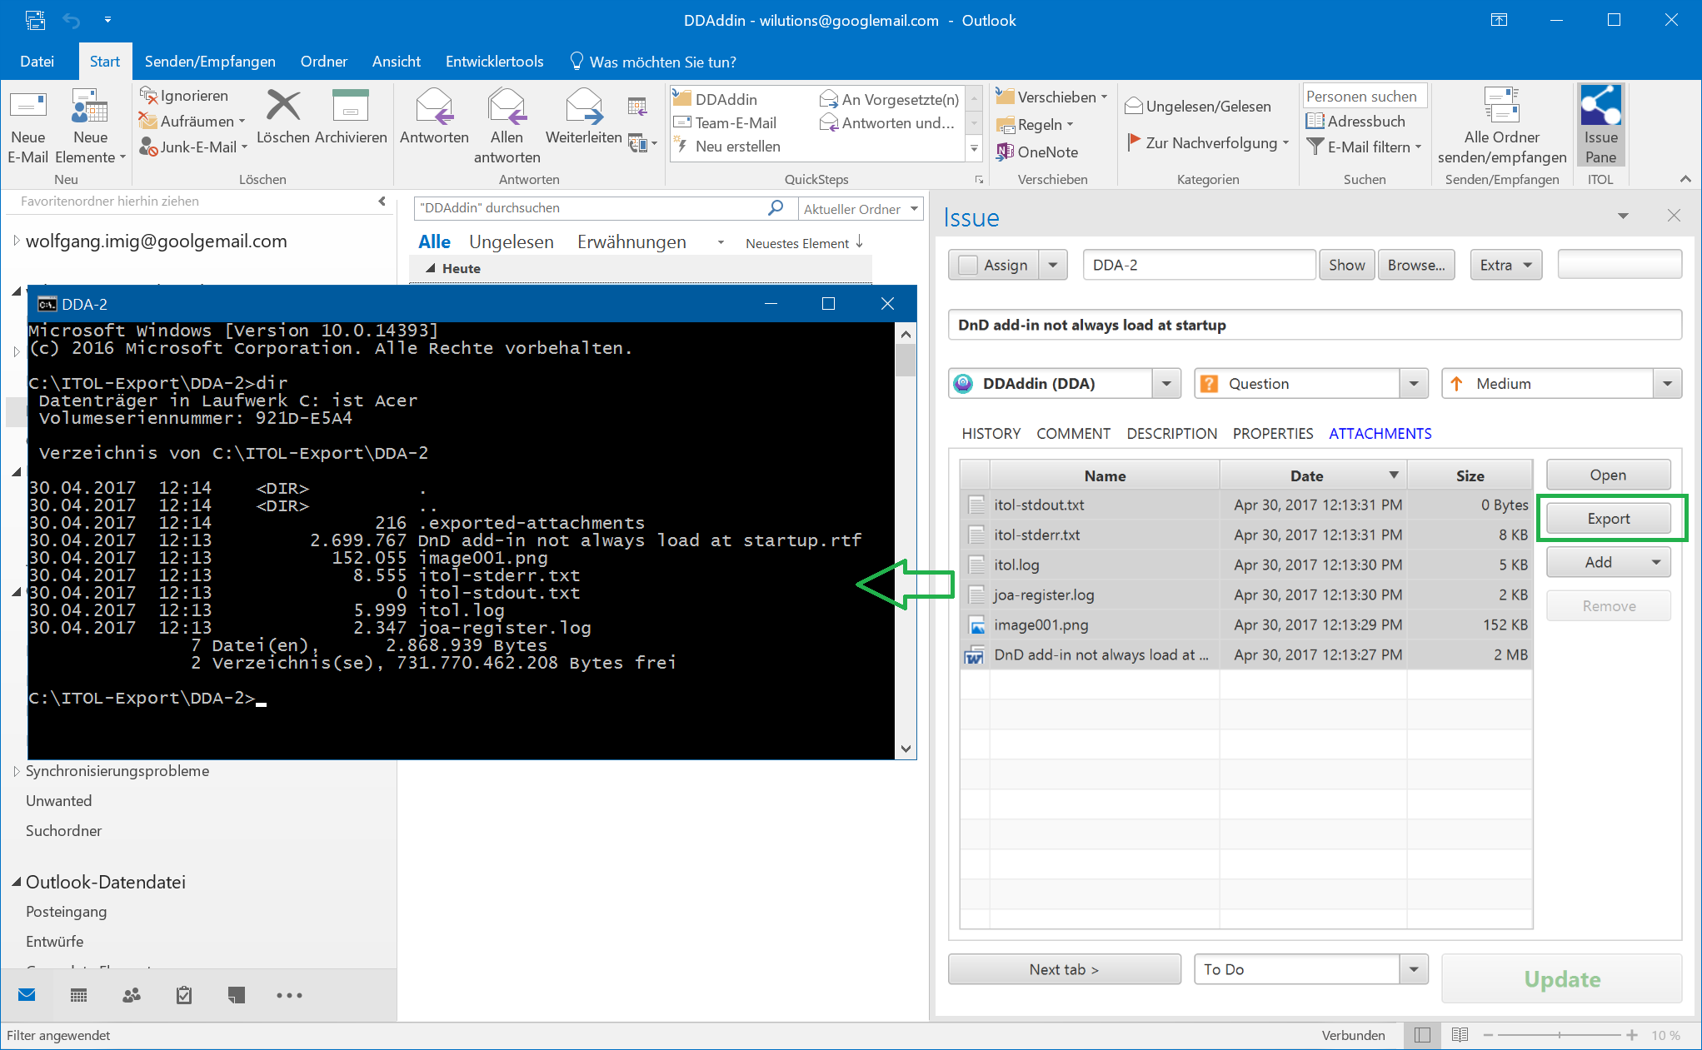

Figure 13 Export attachments and start Command window

# Configuration

After a connection to JIRA has been established, further configuration options can be defined. To open the configuration dialog, click “Extra – Configure…”

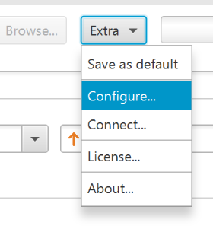

## Configure How to Process Mail Properties

The first tab “Mail to Issue” of the configuration dialog allows to define, how mail properties are evaluated.

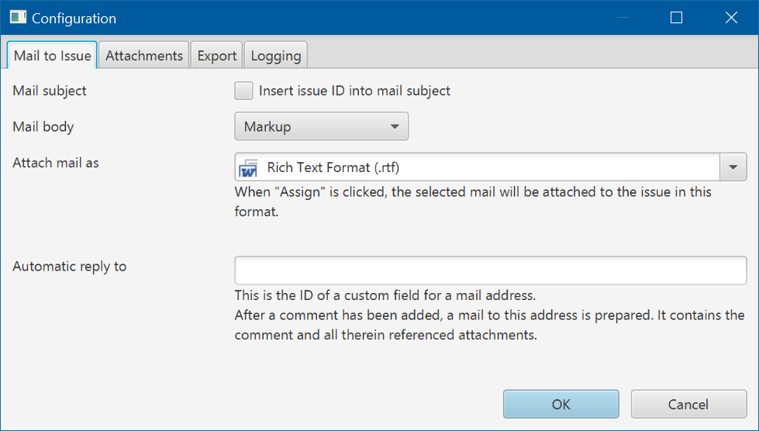

**Mail subject**

If this option is checked, the ID of the created issue is inserted into the mail subject. If the mail is replied, it contains the issue ID in the subject - which in turn, when the reply is answered, allows to find the issue related to the mail.

**Mail body**

Choose “Markup” if mail content text should be converted into JIRA markup language before being assigned to the issue description or comment. If formatting is not required select “Text”.

Mail content text is copied into the issue description or into a new comment. If no issue ID is found in the mail subject, ITOL assumes that a new issue should be created and copies the body into the description field of the issue. In case of an existing issue ID is found, the content text is suggested as a new comment to the issue.

**Attach mail as**

Select the format in which the original mail is saved as an attachment to the issue. Possible options are:

* Nothing: Neither the mail nor the attachments are added to the issue
* Outlook: Save the original mail in MSG format into the issue. If option “Mail subject” is checked, the file name added contains the new issue ID. This option allows to reply to the mail by someone who works on the issue but does not have the mail in her input box. Since the mail attachments are stored inside the MSG file, they are not added separately to the issue.
* Ritch Text Format: Add the mail content in RTF format, which is independent from Outlook but saves most text formatting features. The mail attachments are added separately to the issue.
* Plain Text: Add the mail body as a plain text file. The mail attachments are added separately to the issue.
* Only Attachments: Do not add the mail body, add only mail attachments.

**Automatic reply to**

This option allows to send a reply mail when an issue comment has been added. For using this feature, a custom text field must be created where a mail address can be stored. The field’s ID like “customfield_10200” must be entered here. It can be found in the browser address when assigning the field to screens in JIRA.

Example: Create a custom field of type “Text Field (single line)” and navigate to the page that allows to assign the field to screens:

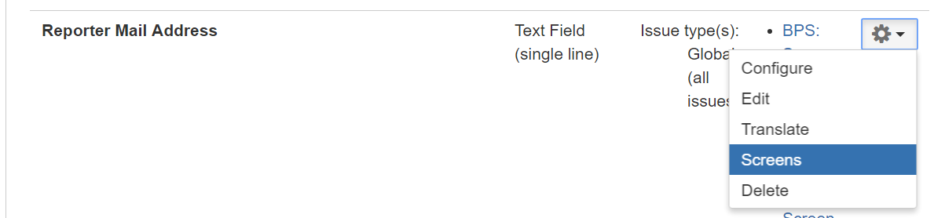

The browser address contains the field ID which is to be entered in the edit field.

https://wilutions.atlassian.net/secure/admin/AssociateFieldToScreens!default.jspa?fieldId=**customfield_10200**&returnUrl=ViewCustomFields.jspa

When an issue is created, ITOL sets the mail sender address into this field.

## Manage Mail Attachments to Ignore

When preparing an issue with the data of a mail, the mail attachments are automatically handed over as issue attachments. Since mails often contain company logos which should not be added to the issue, it is possible to add them to a blacklist of files that should be ignored. The Tab “Attachments” shows this blacklist and allows to remove a file from the list.

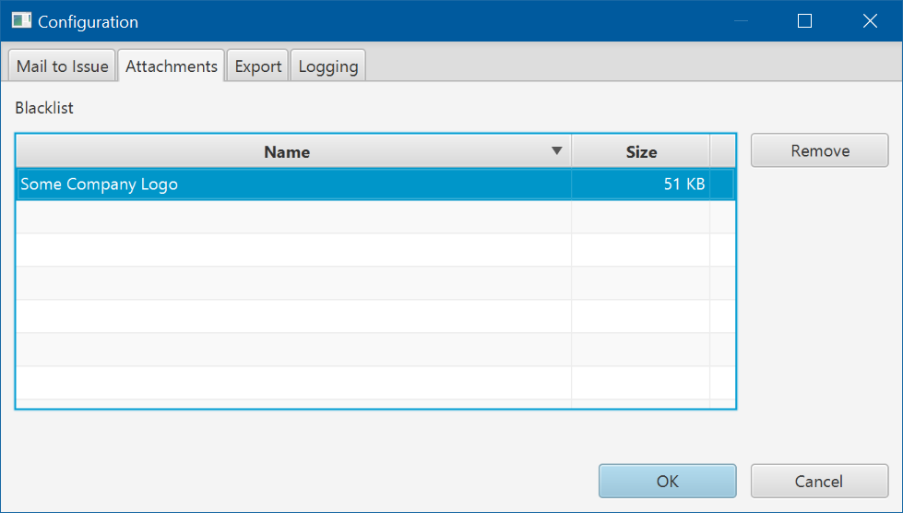

Files are added to the blacklist in the issue pane on tab “ATTACHMENTS”: right-click on an entry and select “Add to blacklist…”.

Only the file size and the MD5 hash value are stored in ITOL configuration, not the file itself.

## Configure Export of Issue Attachments

An issue might contain several log files of different software components that together e.g. document a misbehavior. In this case, it is often required to analyze the log files with special diagnostic tools.

Since those programs usually work on files stored in a directory on the computer, ITOL provides the download of all or a selection of attachments into the file system by one mouse click. This function is available on tab “ATTACHMENTS”: button “Export” saves all or only the selected files into a directory.

The destination directory can be configured on the tab “Export” of the configuration dialog.

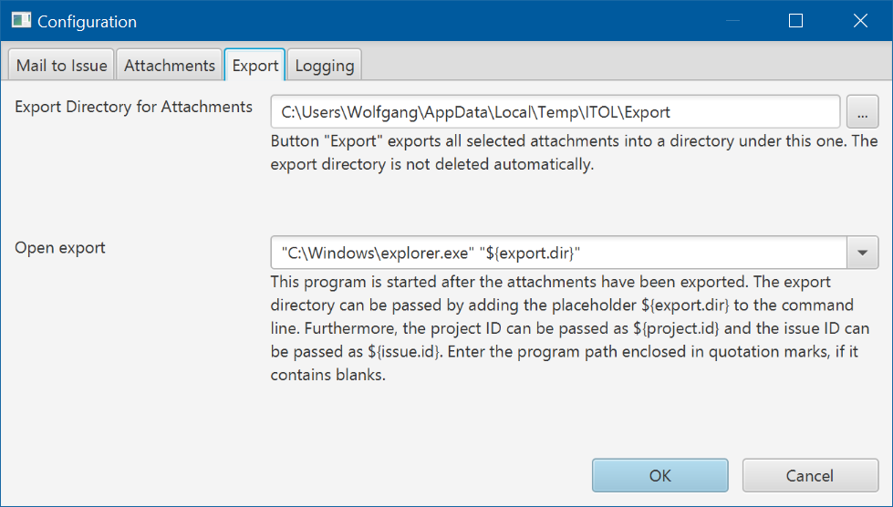

**Export Directory for Attachments**

Button “Export” exports all selected attachments into a sub-directory of this one. The sub-directory is the named as the issue ID, if an existing issue is loaded in the issue pane. For a new issue, the sub-directory is named as: project key plus “-NEW_” plus timestamp.

**Open export**

A command line to start a program that opens the exported directory.

## Logging

A log file with information about the executed operations and how the program state changes thereby is written into the user’s temporary directory by default. This file can be very helpful to find the reason for a misbehavior.

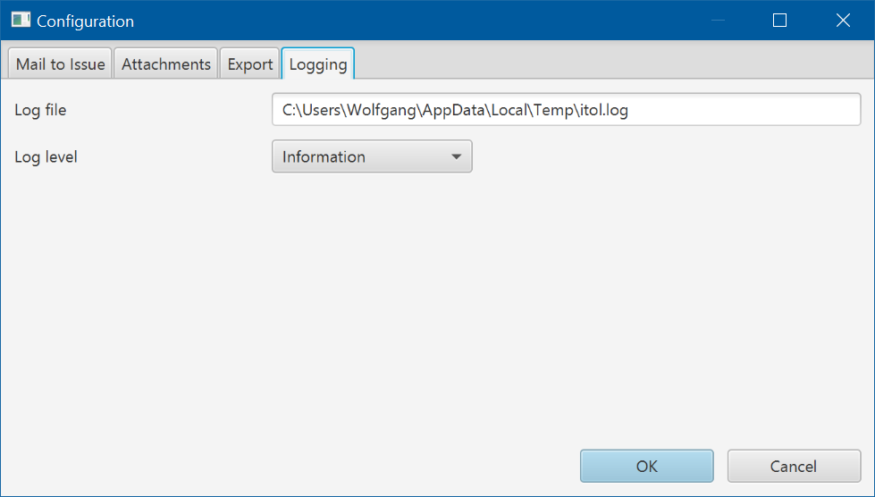

**Log file**

The name of a file in an existing directory where the logging information is written.

**Log level**

Controls how verbose the logging information is written. Keep the level on “Information” for normal usage. Select level “Debug” only when it is necessary for debugging.

# Appendix

## Configuration Files

ITOL configuration data is stored in files in the user’s application data directory, e.g. “C:\Users\Wolfgang\AppData\Roaming\WILUTIONS\ITOL”.

Windows defines the environment variable “APPDATA” as a placeholder for the application data directory.

In order to navigate in Windows Explorer to the configuration data directory, enter **%APPDATA%\WILUTIONS\ITOL** in the address field.

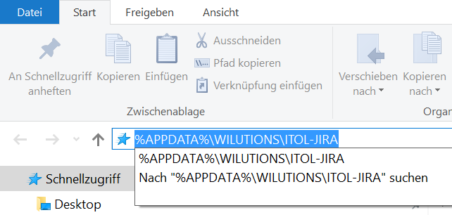

## Configuration File “user.json”

All configuration values are stored in the file user.json. Rarely used values can only be edited directly in this file.

The configuration options are written into the file at the time when Outlook is closed.

This file also contains passwords which are AES-encrypted with a static key. Since the key is contained in the ITOL program code, the passwords are only weakly protected. The major part of projection is provided by Windows, while “user.json” is stored in the user’s private area. However, be careful by copying this file on a storage location that is accessible for others.

## Configuration File “application.json.templ”

Values, that are not user specific are saved into the file “application.json.templ”. This file can be used to share configuration options with other users. Therefore, it has to be renamed as “user.json” in the destination directory.

File “application.json.templ” does not contain passwords.

## Additional Logging

In addition to the log file that can be defined in the configuration dialog (see 12.4), two further log files can contain useful information for debugging: itol-stderr.txt and itol-stdout.txt. Both files are always written in the temporary directory of the user.