A Power Harvesting, Dynamic and Reliable Wireless Body Area Networks Model Deployment for Health Care Applications

|  |  |  |
| --- | --- | --- |
| Hassine Moungla | Nora Touati | Ahmed Mehaoua |
| University of Paris Descartes,  Sorbonne Paris Cite´ | LIX,  E´ cole Polytechnique | University of Paris Descartes,  Sorbonne Paris Cite´ |
| 45 rue des saints pe`res, 75006, Paris, France | 91128 Palaiseau Cedex, France | 45 rue des saints pe`res, 75006, Paris, France |

Email: [hassine.moungla@parisdescartes.fr](mailto:moungla@parisdescartes.fr)

Email: [touati@lix.polytechnique.fr](mailto:touati@lix.polytechnique.fr)

Email: [ahmed.mehaoua@parisdescartes.fr](mailto:mehaoua@parisdescartes.fr)

Abstract—This paper presents our conducting research and describes a new optimal deployment model for medical wireless body area network (WBAN) sensor devices (without mobility) and the relevant possible trade-offs between coverage, connectivity and network life time.

We also integrate the effect of interference in wireless medium, and try to devise many-to-one and many-to-many model, that minimize the interference throughout the network and thus increase signal quality of wireless communication. The decrease in interference also facilitates energy efficiency, by increasing reliability, i.e. success ratio of wireless links.

Topologies generated from our proposed model exhibit min- imum energy consumption at maximum sensing coverage. The results show that significant improvements of initial deployments using feasible and cost-efficient solutions are possible. Our model leads to significantly optimized initial network deployments which can be subsequently used with other existing optimization techniques in literature. Overall operational lifetime and sensing coverage of WBSNs are strongly improved by our suggested deployment model.

I. IN T RO D U C T I O N

Sensor networks can be and are currently used in multi- ple ways in the health-care sector. Applications cover tele- monitoring of patients state of health, tracking and monitoring the movements of patients and doctors, drug administration and diagnostic applications [4] [1]. In the field of patients state of health, WBAN are particularly useful for patients under medical observation. It allows the integration of intelligent, miniaturized, low-power, invasive/non-invasive sensor nodes in/around a human body that are used to monitor body func- tions. Each intelligent node has enough capability to process and forward information to the sink for diagnosis and pre- scription. A WBAN provides long term health monitoring of patients under natural physiological states without constraining their normal activities. It is used to develop a smart and affordable health care system and can be a part of diagnostic procedure, maintenance of a chronic condition, supervised recovery from a surgical procedure, and can handle emergency events.

In order to realize communication between body sensors, techniques from WSN and ad hoc networks could be used.

However, because of the typical properties of a WBSN, current protocols designed for these networks are not always well suited to support a WBSN.

The following illustrates some important differences be- tween a Wireless Sensor Network and a Wireless Body Sensor Network: (1) The devices used have limited energy resources available as they have a very small form factor. Furthermore, for most devices it is impossible to recharge or change the batteries although a long lifetime of the device is wanted (up to several years or even decades for implanted devices). Hence, the energy resources and consequently the computational power and available memory of such devices will be limited; (2) An extremely low transmit power per node is needed to minimize interference and to cope with health concerns; (3) The propagation of the waves takes place in or on a (very) lossy medium, the human body. As a result, the waves are attenuated considerably before they reach the receiver; (4) The devices are located on the human body that can be in motion. WBSNs should therefore be robust against frequent changes in the network topology; (5) The data mostly consists of medical information. Hence, high reliability and low delay is required; And (6) finally the devices are often very heterogeneous, may have very different demands or may require different resources of the network in terms of data rates, power consumption and reliability.[29].

In these mission-critical applications, a set of parameters requirement on network performance and constraints should be satisfied. This poses a number of challenges on the design and analysis of WBSNs. Wireless body sensors nodes have a severe limitation in their storage, radio communication, capabilities, bandwidth, and energy, the most important design consideration for WBSN is to extend their operational lifetime by minimizing power consumption. This is the reason why, protocols with low energy consumption has been an important research orientation in this field. Maximizing lifetime and other constraints are conflicting objectives and thus warrant a trade-off. Thereby, the problem should be formulated as a Multi-objective Optimization Problem (MOP).

The effectiveness of WBSNs is often determined to a

large extent by the sensing coverage provided by the actual node deployment. The locations of the sensor nodes strongly affect energy consumption, operational lifetime and sensing coverage[14], [16]. Maximizing lifetime, sensing coverage and other constraints are conflicting objectives and thus warrant a trade-off [8]. Thereby, the problem should be formulated as a Multi-objective Optimization Problem (MOP) [7]; since all objectives are considered and there is not a single solution to optimize them at the same time (the set of Pareto optimal or non-dominated solutions is usually called Pareto Front (PF) [7]).

In this work, we focus on two important objectives that have to be taken into account in sensor deployment prob- lem. The energy consumption is minimized using a MinMax function and the coverage area is maximized by minimizing the distance between sensors. This latter objective, deals with maintaining connectivity between sensor nodes, in the case of multi-hop communication, and between nodes and the sink in the case of many-to-one communication.We propose a multi- objective optimization model and solve it using the open source software Couenne [2].

The remainder of this paper is as follows: in section II, we present works related to our problem. The section III presents the preliminaries for our optimal deployment pattern exploration. In section IV, we describe the deployment model and propose a mathematical formulation. Finally, we present an experimental comparative studies in section V and we conclude this paper in section VI. The section VII presents the future trends of our approach.

II. RE L AT E D WO R K

In this section we briefly discuss the related work on the deployment strategies and their impact on lifetime of wireless sensor networks. Deployment strategies research is aimed at proving concepts underlying distributed micro sensor networks, such as cooperative processing and low power communication protocols. A fundamental assumption is that the system deployment concept is based on using many expendable nodes, instead of a few high-value sensing assets. Scenarios, such as monitoring areas are accomplished by positioning the sensors close to the areas of interest in high densities. Close spacing permits low-power sensing and short- range radio links.

Deployment strategies can be divided into two classes, concurrent and incremental class. In concurrent class, nodes are deployed in a single step against the incremental class where nodes are placed one by one. Incremental algorithms in which nodes are deployed in an adaptive fashion have been studied in [9], [10]. Each new placement is based on the information sensed by all prior deployed nodes. In concurrent schemes no intermediate information is available. Limitations are that all node locations are to be determined beforehand. The main motivation is to maximize the sensing coverage of the network. The proposed solutions in the papers [14] consider unlimited node movement to improve the sensing coverage of an initial deployment. Most of the studies in the

field assume an initial totally random node deployment that is sampled from a uniform distribution. In this work, we follow the concurrent scheme for initial pseudo-random deployment but do not restrict ourselves to uniform distributions.

In medical sensing application, optimal deployment to maximizing the WSNs life time, to achieve permanent connectivity and full coverage WSN under different ratios of sensors communication range to their sensing range, is one of an important issue in WSN. The energy-saving sensor networks is based generally on :

• Communication range: the maximum distance that a node can communicate with another node is characterized by the communication unit on the sensor node, e.g., for the RF sensors used in the Berkeley mote [17], the maximum communication range is approximately 100 ft.

• Sensing coverage: the sensing area of a sensor node depends on the type of physical sensors used on that node, e.g., a range sensor such as the Polaroid 6500 ultrasonic ranging module, which is commonly used in robotics applications, is able to detect a target from 6 inches away up to a distance of

35 feet [18].

An important consideration in sensor networks is the amount of energy required for sensing, computation, and com- munication. Except for physical damage and system failures (e.g., software bugs), the lifetime of a sensor node depends exclusively on battery capacity; hence information exchange and data dissemination must be carried out using efficient communication protocols. A number of system architectures, communication protocols, and data aggregation algorithms have been proposed in the literature for retrieving and pro- cessing sensed data with low energy consumption [19], [21]. WSNs are typically organized in an ad hoc manner, e.g., through random sensor deployment and ad hoc networking protocols. Nevertheless, a number of methods have recently been developed to organize the sensor network in hierarchical clusters [22] to improve the sensing coverage [23], [24] and reduce the energy consumption in information processing [25]. Other efforts [26], [27] have been based on the sleep period management approaches to save energy. A sleep management approach turn off unneeded nodes while keeping a minimum number of active nodes that will assure the required degree of coverage and the relay for multi-hop communication. We don’t take account the sleep period management approaches

in our proposition.

Our work is principally motivated by the BIOSENSORS project (Funded by The University Paris Descartes, Sorbonne Paris City). It aims to reduce power consumption at the lowest, to improve usage acceptance and ease enhance lifetime for medical and sport domains applications.

Furthermore, in this area applications network, a restricted number of WBAN medical sensors node are deployed; it is unlikely that the designer will determine the position of each node approximately in the concerned body’s part. WBAN medical sensor nodes require input from medicine discipline,

in addition to consideration of the numerous application- specific constraints. We propose a feasible solution to the position deployment estimation problem for WBAN medical using non-convex optimization.

III. PR E L I M I NA RY

In this section, we present the preliminaries for our optimal

base station (sink)

Rcom1

Rcov1

X1

Rcov3

X3

Rcov2

X2

Rcov4

Rcov Rcov

X1

X2

deployment pattern exploration. When considering wireless sensor transmission around and on the body for heath-care applications, one of important issues are radiation absorption and heating effects on the human body.

X4

Rcom sink

A

X3

Rcov

X4

Rcov

Like cells phone radio frequency (RF) heating of body tissues and possible others alteration (mutation) happens to

100% of the people exposed to RF [28]. The amount of

Fig. 1. An example of sensors

deployment system with 4 sensors

Fig. 2. Feasible region

heating is determined by a combination of the four factors below :

1. Frequency - Certain frequencies are absorbed in the body more than others.

2. Duration - How long you are exposed to the radiation, or how long the transmitter is ”on.”

3. Distance- How close you are to the antenna. Energy levels decrease with the square of the distance.

4. Power Level- What the strength of the signal is.

Modern medical science knows there are limits to how much of an assault on the body. The immune system can deal with to reduce tissue heating. The radio’s transmission power can be limited or traffic control algorithms can be used.

In [28] rate control is used to reduce the bioeffects. Adapt a transmission and respectively reception range of all the nodes is taking into account in order to reduce tissue heating the radio’s transmission power, there are no clear studies on the amount of energy, frequency are absorbed in the body to reduce the bioeffects.

IV. SY S T E M M O D E L

and j, i, j ∈ {1, ..., n} ∪ {sink}. Under these assumptions, we formulate the problem of finding an optimal sensors deployment by minimizing the energy consumption and by maximizing the region coverage.

We consider in this paper two system models. The first is based on a many-to-one configuration, where sensors com- municate only with the sink station and the second is based on a many-to-many configuration in which each sensor can communicate with either another sensor or the sink node.

A. Many-to-one model

Objectives

• Minimize the transmission energy: Energy optimization is a significant component of WBANs. It is well known that energy increases linearly with transmission distance [3]. Minimizing the transmission distance also has to be performed to avoid a strong radiation caused by long emission. We consider here a MinMax formulation which consists of minimizing the maximum distance between the sink and all the sensors. This objective is given as follows:

i=1

Sensor deployment aims to find the best location of a set of sensors in a given region, taking into account several constraints. We consider in this paper n sensors to deploy

min maxn kXi − Xsink k

This objective can be formulated as follows:

min Z

on a square region network of length A (figure 1). Note that we can equivalently consider rectangular or circle regions. We consider a two dimensional continuous space, each sensor i ∈ {1, ..., n} is located at Xi = (xi , yi ), where xi refer to the x-coordinate of the sensor location and yi refer to the y-coordinate, respectively. The function of each sensor i is to collect data from a region, defined as a disc of center Xi and radius Rcovi (called radius coverage). These data are

Z 2 ≥ kXi − Xsink 2 , ∀i ∈ {1, ..., n}

• Maximize the covered space: It is important in a deploy-

k

ment strategy to maximize the coverage area of WSN. For this purpose we choose to maximize the distance between each pair of sensors. This can be given by n × (n − 1) objectives:

max kXi , Xj k, ∀i, j ∈ {1, ..., n}, i = j.

2

These objectives can be formulated as follows:

sent to the sink of coordinates sink = (xsink , ysink ) which

max D, kXi − Xj k

≥ D2 , ∀i, j ∈ {1, ..., n}, i = j.

receives informations from all sensors and treat them. The

sink can detect and communicate with sensor i if the sum of the communication radio range of the sink Rcomsink and the communication radio range of node i Rcomi is lower than a given upper bound R=Rcomi +Rcomsink .

We use the Euclidean distance kXi − Xj k =

p(xi − Xj )2 + (yi − yj )2 to express the distance between i

Note that this objective function permits also the mini- mization of overlapping regions.

B. Constraints

In addition to the constraints formulated in the last section, we introduce the following constraints:

1) Connectivity constraint: A sensor i can communicate with the sink if the Euclidean distance between them is less than or equal to the sum of their communication radius denoted by Rcomi,sink = Rcomi + Rcomsink . The communication radii

max Pij Cij

2) Connectivity constraints: Two sensors, i and j, are able to communicate with each other if the Euclidean distance between them is less than or equal to the sum of their

k

2

might vary depending on the residual battery power (energy)

of an individual sensor. In this work, we assume that the

communication radius denoted by Rcom

i,j = R

com

i + R

comj .

communication radii for all the nodes are the same, and denote

This can be formulated by the following constraint:

Rcomi,sink , ∀i ∈ {1, ..., n} by Rcom (figure 1). Connectivity between the sink and sensors is necessary to perform the

Cij (kXi − Xj 2

− Rcomi,j ) ≥ 0, ∀i, j ∈ {1, ..., n}, i = j.

communication. This is expressed by the following constraints:

When kXi − Xj k2 − Rcom

i,j ≥ 0, the variable Cij

takes the value 1 (see the objective function) and when

2 2 2

kXsink − Xi k

≤ Rcom , ∀i ∈ {1, ..., n}

kXi − Xj k

− Rcomi,j < 0, the variable Cij takes

As the variable Z introduced in section (IV-A) is defined as the maximum distance between the sinkand all sensors, these constraints can be formulated as follows:

the value 0. We consider also the feasible deployment

region constraints (section IV-B2) and obtain the following multi-objective nonlinear non-convex programming problem:

max βD + γ Pij Cij

2 2

Z ≤ R

com

, ∀i ∈ {1, ..., n}

kXi − Xj k2 ≥ D2 , ∀i, j ∈ {1, ..., n}, i = j

Cij (kXi − Xj 2

k

2

− Rcomi,j ) ≥ 0, ∀i, j ∈ {1, ..., n}, i = j

2) Feasible deployment region: A feasible region consists

of all points in the space where a sensor can be deployed. In

xsink + Rcov

i ≤ xi

≤ xsink

+ A − R

cov

i , ∀i = 1, ..., n

figure 1 for example, Xi is a feasible location of sensor i if and only if xsink ≤ xi ≤ (xsink + A) and ysink ≤ yi ≤ (ysink + A). Where A is the width of the given square area. When a sensor is located on the border of the square region (for example X = (xsink + A, ysink + A) or x = (0, ysink + A)), the sensor can cover only a half of its capacity coverage the feasible region. To avoid these bad positions, we consider another feasible region called the restricted feasible region. For sake of simplicity, we consider that Rcovi = Rcov , ∀i ∈

{1, ..., n}. The restricted feasible region satisfy the following constraints (see figure 2):

ysink + Rcovi ≤ yi ≤ ysink + A − Rcovi , ∀i = 1, ..., n

Cij ∈ {0, 1}, ∀i, j ∈ {1, ..., n}, i = j.

V. PE R F O R M A N C E R E S U LT S

As our models are nonlinear non-convex programs, we solve them using Couenne software (Convex Over and Under ENvelopes for Nonlinear Estimation) [2].

Couenne is an Open Source branch&bound algorithm for solving Mixed-Integer Nonlinear Programming (MINLP) problems. It implements linearization, bound reduction, and branching methods within a Branch&Bound framework.

This is particularly required for the the many-to-many model.

We Consider in this section a test instance with n = 13,

√

∀i ∈ {1, ..., n}, xsink + Rcov ≤ xi ≤ xsink + A − Rcov ,

A = 50, Rcovi = 7, ∀i ∈ {1, ..., 13}, Rcom = 50

2 and

ysink + Rcov ≤ yi ≤ ysink + A − Rcov

C. The optimization problem

We obtain the following bi-objective non- linear non-convex programming problem: min Z, max D

2

2

Rcomi,j = 35, ∀i, j ∈ {1, ..., 13}. Our objective is the

deployment of sensors using the two considered models.

Figures 3, 4 and 5 present the deployment of sensors on the considered area for different weights α and β for the many- to-one model. We observe that the distribution with the lower

Z 2 − kXi − Xsink k

≥ 0, ∀i ∈ {1, ..., n}

maximum distance between sensors and the sink (with lower

kXi − Xj k

2

≥ D , ∀i, j ∈ {1, ..., n}, i = j

energy consumption) is obtained with (α, β) = (0.2, 0.8). This

2 2

Z ≤ R

com

, ∀i ∈ {1, ..., n}

distribution ensures the worst coverage with Z = 53.92. The

xsink + Rcovi ≤ xi ≤ xsink + A − Rcovi , ∀i = 1, ..., n

ysink + Rcovi ≤ yi ≤ ysink + A − Rcovi , ∀i = 1, ..., n

and we consider the single objective version by aggregating

the two objective functions as follows: min(αZ − βD), with

α and β suitably chosen such as α + β = 1.

D. Many-to-many model

We consider a many-to-many model, where each sensor can communicate with another one. We aim to maximize the covered space and the number of connected sensors.

1) Objectives: In addition to the coverage objective (section IV-A), the number of connected sensors has to be maximized. Lets Cij be a binary variable equal to 1 if sensor i can communicate with sensor j and 0 otherwise. The objective function is:

optimal coverage is obtained with the distribution associated to (α, β) = (0.0, 1.0), but with a greater energy consump- tion. The best compromise between energy consumption and coverage is obtained with parameters (α, β) = (0.1, 0.9).

Figures 6 and 7 present the deployment of sensors on the

considered area for different weights β and γ for the many- to-many model. The distribution obtained with parameters (β, γ) = (0.8, 0.2) ensure a good connectivity (the number

of possible connexions between sensors is Pij Cij = 78).

With parameters (β, γ) = (0.9, 0.1) the coverage is better, but with less connectivity (Pij Cij = 76).

A. Evaluation of Estimated Deployment Models

The optimal deployment is based on the complete knowl- edge of the points of interest and has been designed using

50

"data_13_02_08" using 1:2:3

"data_13_02_08" using 1:2

50 50

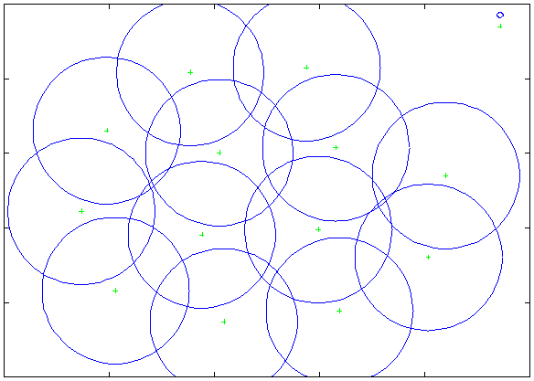

"data_13_08S20_02S78_R35" using 1:2:3

"data_13_08S20_02S78_R35" using 1:2

"data_13_09S20_01S78_R35" using 1:2:3 "data_13_09S20_01S78_R35" using 1:2

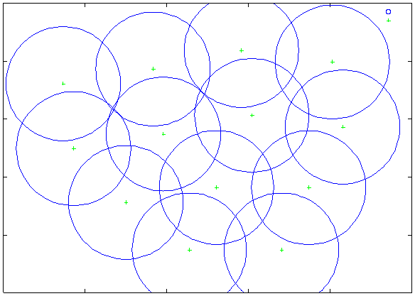

40 40

40

30 30

30

20 20

20 10 10

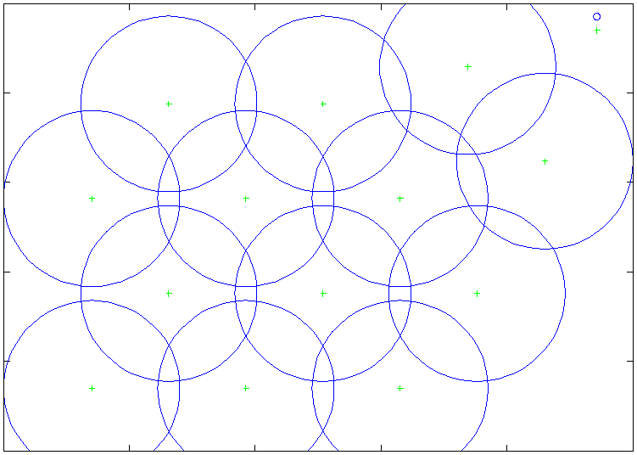

0

10 0 10 20 30 40 50

0

0 10 20 30 40 50

0

0 10 20 30 40 50

Fig. 3. The deployment of sensors on the considered area for differ- ent weights α and β for the many-to-one model. (α, β) = (0.2, 0.8),

Z = 53.92, D = 12.08

Fig. 6. The deployment of sensors on the considered area for different weights α and β for the many-to- many mode. (β, γ) = (0.8, 0.2),

D = 11.10, P C ij = 78

Fig. 7. The deployment of sensors on the considered area for different weights α and β for the many-to- many mode. (β, γ) = (0.9, 0.1),

D = 11.28, P C ij = 76

50

"data_13_01_09" using 1:2:3

"data_13_01_09" using 1:2

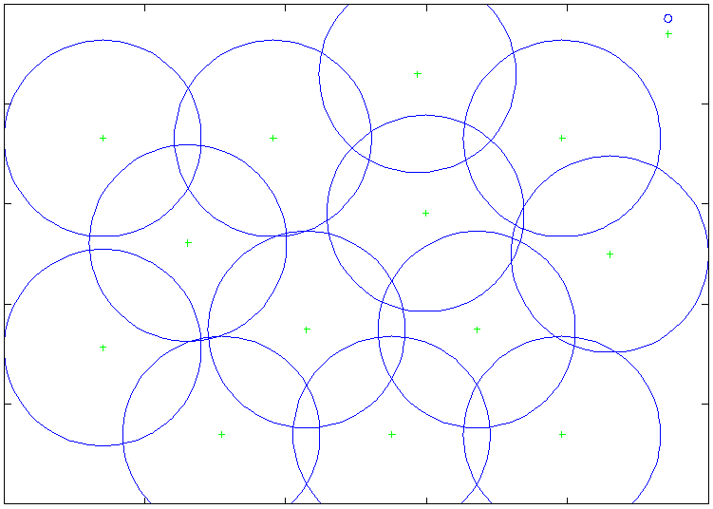

40

30

20

10

0

0 10 20 30 40 50

Fig. 4. The deployment of sensors on the considered area for differ- ent weights α and β for the many-to-one model. (α, β) = (0.1, 0.9),

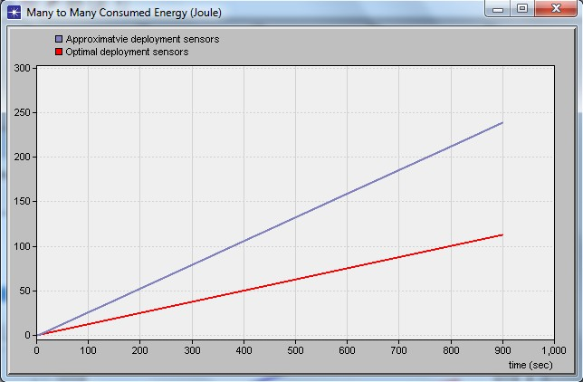

Z = 54.05, D = 12.24

optimal node positioning. This design is optimized as to achieve best trade-off between energy-efficiency by mini- mizing power communication, reducing tissue heating and sensing coverage. This specific topology serves as an upper performance bound in our evaluation. For comparison, we have to ensure that all deployment models exhibit the same overall area density. The deployment models introduced ex- hibit different characteristics and contains different amounts of a priori information. In order to make reliable statements about their performance we conducted extensive simulations using the well-known AMPL environment and OPNET. The following evaluation of the estimated proposed deployment models is based on two performance criteria. First criterion

Fig. 8. Many-to-Many Network energy consumption comparison between an approximative and the optimal sensor deployment

is the energy saving and second the sensing coverage. We develop the unifying performance metric which serves as a lightweight evaluation tool. The simulation results averaged over 30 runs, related duration of sensing and the number of deployed sensor, because of the page number restricting we will not present all realized experimentations. Incorporating a-priori knowledge into the topology sampling introduces bias to the modeling. In order to evaluate our solution’s energy

50

"data_13_00_10" using 1:2:3

"data_13_00_10" using 1:2

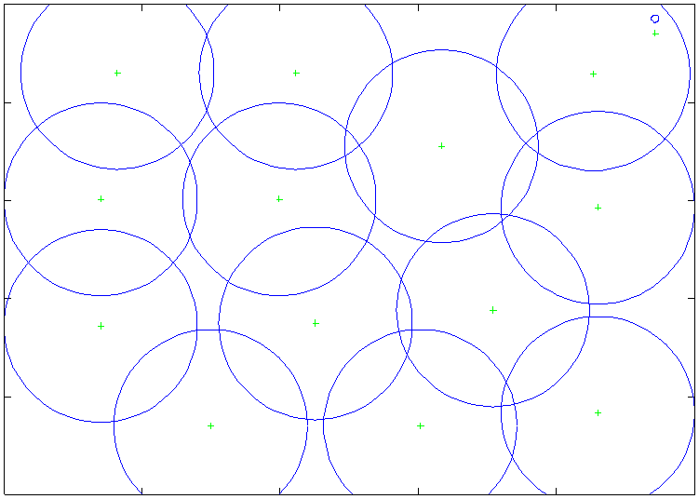

40

30

20

10

0

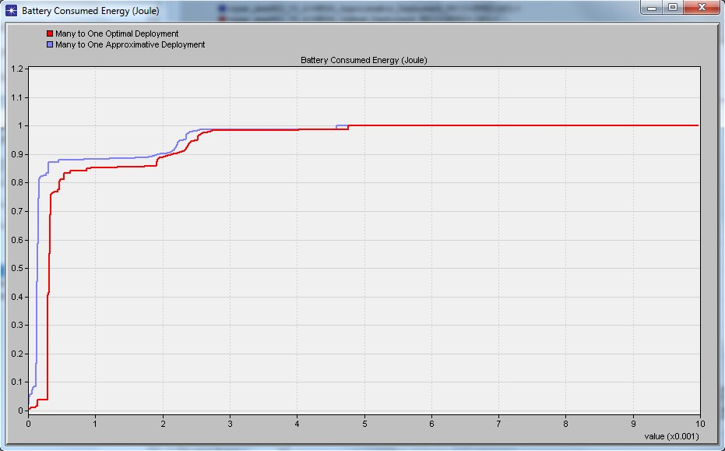

0 10 20 30 40 50

Fig. 5. The deployment of sensors on the considered area for differ- ent weights α and β for the many-to-one model. (α, β) = (0.0, 1.0),

Z = 60.91, D = 12.92

Fig. 9. Many-to-One Network energy consumption comparison between an approximative and the optimal sensor deployment

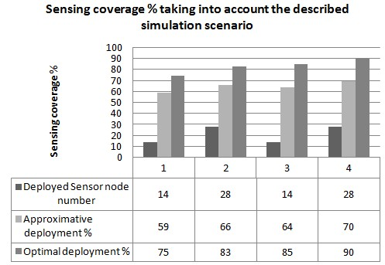

Fig. 10. comparison between an approximative and the optimal deployment for Many-to-One and Many-to-Many configuration sensing coverage

performance, we implemented it and compared its maximum area coverage, network connectivity and energy consumption (network lifetime) with the approximative strategy deployment (which mean that sensors will be deployed with approximative precision in the interested area).

We develop a simulator on the basis of the wireless module of the OPNET simulation environment. The simulation pa- rameters are the following. The area of interest is a rectangle of size 1.80 × 1m (1.80m2 ). Scenarios, such as monitoring body areas, as all body area of approach, are accomplished by positioning fourteen (n = 14) sensors deployed on the areas of interest. Close spacing permits low-power sensing and short-range radio links. We fix Dcomsink,i = 20cm and Rcovi = 10cm. Finally, the sink was deployed at the center of deployment field. Note that a network is connected and a full satisfaction rate (100%) is obtained for all scenarios.

We compared the proposed solutions to the related approx- imative deployment strategies in both configurations many-to- one and many-to-many. The maximum number of sensors that could be deployed was set to fourteen, as obtained with the proposed method. We can notice that our method proposal ensures both connectivity and maximum coverage in two configurations. To compare the energy consumption (lifetime).

Note that in existing literature, we found many different definitions of WBSN lifetime. Most of the research considered the network to be dead when the first sensor fails. However, in our work, we considered the network dead when no sensors were able to communicate with the sink. Our proposed deployments already leads to strong energy savings of 15% and 35% respectively for both configurations many-to-one and for many-to-many (cf. figure 9 and 8 ) and to slightly better sensing coverage as we can see in the figure10. We observe that our optimal deployment models clearly outperform the approximative model. Significant improvements of the sensing coverage can be achieved if the other objective will be relaxed. According to the objective that we would to perform we could meet to adjust the weights α and β to improve the sensing coverage or reduce the energy consumption or/and tissue heating. We evaluate also the accuracy of our computations

Fig. 11. WBAN relay numbers vs. sensor numbers

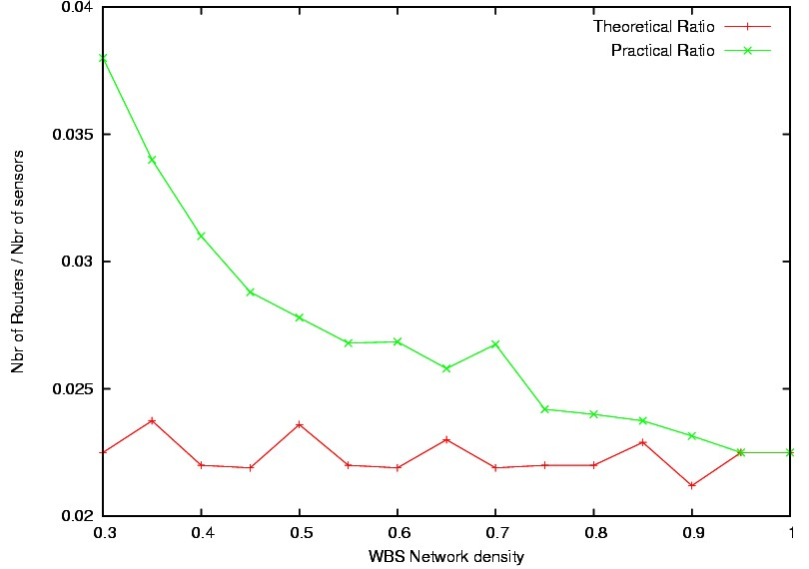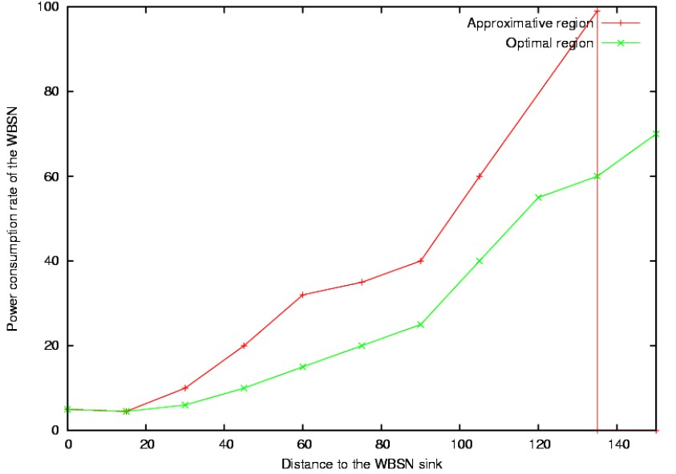

Fig. 12. WBAN Relay lifetime distribution

for the relay-sensor ratio for many-to-many configuration and the relay sensor power consumption rate for many-to- one configuration. Figure 11 compares the practical relay- sensor ratio with the theoretical results. The relay-sensor ratio should be not sensitive to the network density which is shown in figure 11. Considering the effect from remedy relays in practice, the practical relay-sensor ratio is larger than the theoretical one but when the density is increased to 0.9 they will quickly converge. Another important observation is even when the network density is as low as 0.3, the Wireless Body relay-sensor ratio is just around 0.04 and from more than 20 sensors just a few relays are needed to forward the packets. In figure 12 our solution is demonstrated to achieve an even energy consumption rate theoretically regardless of the distance between the Wireless Sensors relay to the sink. This property makes it easy to estimate the lifetime of the relays and recharge them periodically.

VI. CO N C L U S I O N

We are addressing the issues regarding minimum energy consumption, and maximum area coverage by the network. A bi-objective nonlinear non-convex model based on a Min- Max formulation is proposed. This problem is then solved

using the open source software Couenne. We also integrate the effect of interference in wireless medium, and try to devise many-to-one and many-to-many model that minimize the interference throughout the network and thus increase signal quality of wireless communication and reduce tissue heating. The decrease in interference also facilitates energy efficiency, by increasing reliability, i.e. success ratio of wire- less links. Topologies generated from our proposed model exhibit minimum energy consumption at maximum sensing coverage. The results show that significant improvements of initial deployments using feasible and cost-efficient solutions are possible. Our model leads to significantly optimized initial network deployments. Overall operational lifetime and sensing coverage of WBSNs are strongly improved by our suggested deployment model. The obtained results show that the model propose good solutions, with suitable parameters α and β.

VII. FU T U R E WO R K

This section presents the future trends of our approach, we plan to extend the model for grown modeling preciseness and features. One of the major extensions is the inclusion of interferences communication and sensing phenomenon for each sensor, which is very useful for modeling realistic scenar- ios. Elsewhere,the model can be extended for different types of sensors with different communication and sensing range. Finally, we target to adapt our formulation optimization for multi-sink networks and probability routing path.

AC K N OW L E D G M E N T

This work is part of the Biosensors collaborative project and has been funded by the Paris Descartes University and French ministry of research.

RE F E R E N C E S

[1] Julien Penders, Chris van Hoof and Bert Gyselinckx, ”Bio-Medical Application of WBAN: Trends and Examples”, Bio-Medical CMOS ICs Integrated Circuits and Systems, 2011, Part 2, 279-302, DOI:

10.1007/978-1-4419-6597-4-8.

[2] https://projects.coin-or.org/Couenne

[3] A.A. Somasundara and A. Kansal and D. Jea and D. Estrin and M.B.

Srivastava, Controllably mobile infrastructure for low energy embedded networks, IEEE Trans. Mobile Comput., 5(8):958-973, 2006.

[4] R. Verdone and R., D. Dardari and G. Mazzini and A. Conti, Wireless

Sensor and Actuator Networks, Academic Press/Elsevier, London, 2008. [5] EU Framework VI project, [www.healthyaims.org.](http://www.healthyaims.org)

[6] J. H. Chang and L. Tassiulas, Maximum lifetime routing in wireless sensor networks, IEEE/ACM Trans. on Network 12(4):609-619, 2004.

[7] K. Deb, Multi-Objective Optimization Using Evolutionary Algorithms.

Wiley and Sons, 2002.

[8] B. Jourdan and O. L. de Weck, Layout optimization for a wireless sensor network using a multi-objective genetic algorithm, In IEEE Semiannual Vehicular Technology, 5:2466-2470, 2004.

[9] K. D. K. Kalpakis and P. Namjoshi, Efficient algorithms for maximum lifetime data gathering and aggregation in wireless sensor networks, Computer Networks 42(6):697-716, 2003.

[10] A. Sankar and Z. Liu, Maximum lifetime routing in wireless ad hoc networks, In: Proceedings of the IEEE Infocom, pp. 1089-1097, 2004.

[11] R. Madan and Z. Q. Luo and S. Lall, A distributed algorithm with linear convergence for maximum lifetime routing in wireless sensor networks, In: Proceedings of the Allerton Conference on Communication, Control and Computing, 2005.

[12] P. Santi, Topology control in wireless ad hoc and sensor networks, ACM Computing Surveys, 37(2):164-194, 2005.

[13] Y. Xue and Y. Cui and K. Nahrstedt, A utility-based distributed maximum lifetime routing algorithm for wireless networks, In: Proceedings of the Second International Conference on Quality of Service in Heterogeneous Wired/Wireless Networks (QSHINE’05), p. 18, 2005.

[14] S. Yang and M. Li and J. Wu, Scan-Based Movement-Assisted Sensor Deployment Methods in Wireless Sensor Networks, IEEE Trans. On Paral-lel and Distributed Systems, 18(8):1108-1121, 2007.

[15] G. Wang, G. Cao, and T. L. Porta, Movement-assisted sensor deploy- ment, IEEE Trans. on Mobile Computing, vol. 5, no. 6, pp. 640652, 2006.

[16] F. Oldewurtel, J. Riihijarvi, and P. Mahonen, Impact of Correlation in Node Locations on the Performance of Distributed Compression, in Proceedings of the WONS, Snowbird, USA, 2009, pp. 135142.

[17] Tinyos, University of California at Berkeley, [http://www.tinyos.net,](http://www.tinyos.net) page accessed on Mar. 13, 2008.

[18] Polaroid Sonar, Technical specifications for 6500 series sonar ranging module, <http://www-inst.eecs.berkeley.edu/>

[19] Emergent Surveillance Plexus (ESP): A Multidisciplinary University Research Initiative (MURI), http://strange.arl.psu.edu/ESP, page accessed on Nov. 13, 2008.

[20] N. Heo and P. K. Varshney, A Distributed self spreading algorithm for mobile wireless sensor networks, Proc. IEEE Wireless Communications and Networking Conference, paper ID: TS484, 2003.

[21] Xiaoling Wu, Jinsung Cho, Brian J. d’Auriol, Sungyoung Lee, and Yong- koo Lee, ”An integrated sleep scheduling and routing in USN,” IEICE Trans. on Communications, 2007.

[22] R. Min, M. Bhardwaj, S. H. Cho, A. Sinha, E. Shih, A. Wang and A.

Chandrakasan, Lowpower wireless sensor networks, VLSI Design, 2001. [23] Xiaoling Wu, Jinsung Cho, Brian J. d’Auriol, and Sungyoung Lee,

”Optimal Deployment of Mobile Sensor Networks and Its Maintenance Strategy,” Proc. of International Conference on Grid and Pervasive Computing (GPC 2007, LNCS), Paris, France, May, 2007.

[24] Xiaoling Wu, Lei Shu, Min Meng, Jinsung Cho, and Sungyoung Lee, ”Coverage-driven Self-deployment for Cluster Based Mobile Sensor Networks”, CIT-06, IEEE Computer Society, Seoul, Korea

[25] J. Liu, P. Cheung, L. Guibas and F. Zhao, A dual-space approach to tracking and sensor management in wireless sensor networks, Proc.

1st ACM International Workshop on Wireless Sensor Networks and

Applications, pp. 131139, September 2002.

[26] Cerpa, A. and Estrin, D., Ascent: Adaptive self-configuring sensor networks topologies, IEEE Transactions on Mobile Computing, Trier, vol

3, pp. 272-285, July-Aug. 2004

[27] Stankovic, J.A., Abdelzaher, T.E., Chenyang Lu, Lui Sha, Hou, J.C., Real-time communication and coordination in embedded sensor networks, Proceedings of the IEEE, Chicago, vol 91, pp. 1002-1022, July 2003.

[28] H. Ren and M. Q. H. Meng, ”Rate control to reduce bioeffects in wireless biomedical sensor networks,” in Mobile and Ubiquitous Systems

- Workshops, 2006. 3rd Annual International Conference on, San Jose, CA,, Jul. 2006, pp. 1-7.

[29] S. Ullah, H. Higgins, B. Braem, B. Latre, C. Blondia, I. Moerman, S.

Saleem, Z. Rahman and K.S. Kwak, A Comprehensive Survey of Wireless Body Area Networks: On PHY, MAC, and Network Layers Solutions, Journal of Medical Systems, IN PRESS,2010, DOI: 10.1007/s10916-010-

9571-3.