**How Do You Prepare for Presentations?**

Preparing for presentations isn’t easy. Even team meetings with your colleagues can be stressful and challenging. Few of us are true extroverts, and even fewer of us are comfortable with public speaking. Awhile ago, I joked a bit about [things you shouldn’t say in a presentation](http://www.instigatorblog.com/5-phrases-you-never-want-to-hear-in-a-presentation/2007/03/06/) but really, it’s no laughing matter.

One of the most anticipated parts of [launching Standout Jobs at DEMO](http://www.instigatorblog.com/sprinting-to-start-up-how-to-launch-a-startup/2008/01/11/) is the 6-minute presentation you have to give on-stage. The DEMO people are great at preparing you and letting you know what to expect, but ultimately it’s up to you. And for most presenters it will be the most important, most stressful, and biggest presentation they’ve ever given in their lives.

Some people have asked me, *“What about all the*[*VC and angel investor pitches*](http://www.instigatorblog.com/5-lessons-learned-from-pitching-vcs/2007/05/10/)*you’ve done? Those must be pretty tough?”* Yes, they are. But once you’ve done a few of them, you learn [what to expect fairly quickly](http://www.instigatorblog.com/10-questions-venture-capitalists-and-angel-investors-are-going-to-ask/2007/07/20/), and often they’re more conversations than presentations. You’re hoping to engage the potential investors in a healthy discussion. The format is typically less formal than going on-stage in front of hundreds (if not thousands) of people and doing your thing.

***So how do you prepare for a big presentation?***

There’s no straightforward answer. And there’s [lots](http://wekie.wordpress.com/2008/01/12/proven-tips-to-boost-your-public-speaking-and-presentation-skills-part-7/) of [great](http://flooringtheconsumer.blogspot.com/2007/12/50-top-tips-to-not-trip-up-speech.html) [advice](http://blog.ericfeng.com/250-things-i-have-learnt-that-will-make-you-become-a-highly-successful-speaker/) on [public](http://www.mpdailyfix.com/2007/11/ten_tips_to_not_trip_up_a_spee.html)[speaking](http://customersrock.wordpress.com/2007/11/28/speaker-tips/) and [presenting](http://makeitgreat.typepad.com/) out there. Some people recommend memorizing a script and practicing it intensely for as long as you possibly can. Other people suggest having key talking points and riffing on those. I’m not sure anyone would suggest going *totally unprepared*, because that would be tantamount to presentation-suicide … but from heavy-duty preparation to minimal preparation, you’ll get it all, and everything in-between.

**Here’s my suggestion: Do what you need to in order to feel *confident*and *comfortable* giving the presentation.**

If you’re not sure what to do in order to feel confident and comfortable, thenI’d lean towards being more prepared than not.1

Here are some tips for things you can do:

1. **Start with your key talking points.** There’s no point writing a full script or presentation until you know what points you want to hammer home. Then, you can stick with a standard format: (a) tell them what you’re going to show them; (b) show them; and, (c) tell them what you just showed them.
2. **Write a script.** I think this is a good idea. It lets you write everything out and start massaging the words the way you want. It also gives you a benchmark against which you can practice and refine things.
3. **Don’t get hung up on specific words.** It’s unlikely that missing or changing any one word will totally ruin your presentation, so don’t worry about perfection. The only person that knows you “screwed up” is you…
4. **Find your speaking style.3** Over time with enough practice you can learn to speak and present in any style, but if you’re in crunch mode and don’t have enough time, just try and find your own speaking style. Find your groove. Some people are ultra-enthusiastic. Some are much calmer. For DEMO, I’m aiming for *calm confidence*. I’m not a flashy guy. I want people to see the practice I’m putting in, my enthusiasm and my confidence – but I’m not going “Tony Robbins” on them.
5. **Practice in front of people.** I haven’t done this yet, but I’ll be doing it soon. If you haven’t given a lot of presentations this *will feel awkward* but it’s better to get over those feelings now rather than when you’re on stage. So practice in front of others. But be careful about taking their advice, especially if the presentation is fast approaching. The risk is that you try to incorporate changes you’re not really comfortable with, whether it’s in the actual script or in your presentation style, and you end up causing more damage than good. Given the opportunity you should seek expert help with your presentation, but be careful about how you take any advice, especially late in the game.
6. **Practice with distractions.2** It’s great to sit in a bubble with no distractions whatsoever and practice. You need the quiet time to memorize things and get a feel for what you’re doing. But I’m also practicing while distracted – be it by other sounds or visually (people walking by my office door, for example) because it makes me feel more confident that I can pull it off. On the DEMO stage there will be distractions. One person told me there’s a huge clock facing you counting the seconds menacingly. There are big lights, TV screens and oh ya … the people. I have to be prepared for anything, and practicing with distractions is helpful.
7. **Practice piece by piece.** I’ve found it quite helpful to practice each section of my presentation in pieces. I’ll focus on one part, memorize the core elements, run through it till I’m comfortable and then move to the next piece. Then it’s just a matter of stringing the pieces together, which is easier.
8. **Think ahead.** While practicing my DEMO presentation I’ve found my comfort zone when I can think of the next 1 or 2 sentences while speaking. So I’m on sentence #5 but my mind is already bringing up sentence #6 and #7. I don’t have to think *too far ahead* but just enough that the transition from sentence-to-sentence is ultra-smooth and simple. Each sentence triggers a reminder for the next one.
9. **Practice hand gestures.** If you’re giving a “naked” presentation (with nothing in front of you like a table, etc.) then you need to be aware of what you’re doing with your hands. And your feet. So think about your hand gestures and how they relate to what you’re saying. If you plan to move around, pace in sync with your words. I’ve been practicing this for a few days with great success. The hand gestures and where I’m walking are triggers cuing what I should be saying.
10. **Find your comfort zone.** All the advice in the world won’t help if you can’t get comfortable with your preparation, practice techniques and ultimately, the presentation itself. *Do whatever makes you feel comfortable.* The more comfortable you feel, the more confident you feel, and the better things will go.

**Source :** http://www.instigatorblog.com/how-do-you-prepare-for-presentations/2008/01/16/

# [How to Reduce Stress Before Giving a Speech](http://www.wikihow.com/Reduce-Stress-Before-Giving-a-Speech)

Getting nervous before giving a speech is normal. Even great personalities get nervous before giving a speech. But that doesn’t mean there is no remedy for it. Here is how you can reduce stress before giving a speech.

## Steps

1. [](http://www.wikihow.com/Reduce-Stress-Before-Giving-a-Speech#/Image:Avoid-Being-Seen-As-Easy-Step-07.jpg)

**1**

**Give up the belief that you have to be perfect.** Most people are afraid of public speaking because they fear the embarrassment of making mistakes in front of others. Anxiety over mistakes only makes mistakes more likely. Having anxiety could be the biggest mistake of all! Even professional speakers occasionally make mistakes. The difference is that they don't consider mistakes major obstacles to success. The secret is to accept that mistakes are going to happen sometimes, and to develop the ability to recover from them quickly. Dr. L. Michael Hall, author of Secrets of Personal Mastery, advises, "Give yourself permission to be gloriously fallible!"

* + The way to recover from a mistake is to observe it dispassionately, take whatever corrective action is appropriate, regain your composure, focus on what to say next, and get on with it. Dwelling on an error and feeling bad about it only adds to your confusion. Leave the mistake behind and move forward.
  + You can't please everyone in your audience. Sure-some listeners may think you are a moron for making a mistake. Some won't even notice it. Others may admire the way you recover so easily. Some may be relieved to know you are human. Some won't care one way or the other.
  + Mistakes can provide excellent feedback for improvement. Mistakes often promote single-trial learning, so it's almost certain you will never make the same mistake twice. Ask yourself "What is the worst that can happen if I make a mistake during this speech?"Making a mistake does not carry a death sentence.

1. [](http://www.wikihow.com/Reduce-Stress-Before-Giving-a-Speech#/Image:Prevent-Anxiety-Step-11.jpg)

**2**

**Visualize the outcome you want.People who fear public speaking visualize their upcoming speaking opportunities as abysmal failures.** They see themselves fumbling clumsily with notes, stammering, becoming mute, turning red, possibly crying, horrifying audiences with their stupidity, and slinking away to live out the remainder of their miserable lives in exile, reviled as a social reject. Psychologists call this method of preparation "negative anticipation."

* + STOP IT! Each time you engage in this mental flagellation, shake yourself out of it. Say "STOP" loudly to yourself. Do anything to get your mind out of the failure trap. Sing, whistle, recite poetry, walk around the block, or talk to a friend. You can even make those scary images seem silly and laughable, by imagining your audience in clown costumes, or seeing your performance in fast motion.
  + In The Seven Habits of Highly Effective People, author Steven Covey tells his readers to "begin with the end in mind." Visualize yourself giving that speech the way you want to. If you anticipate success, you are more likely to get it. Mentally rehearse that you are speaking confidently with a smooth delivery to an appreciative audience. Hear the words coming out of your mouth in a flowing cadence. See yourself with an erect posture, breathing free and easy. By visualizing this way, you are programming your mind and body for the results you want.

1. [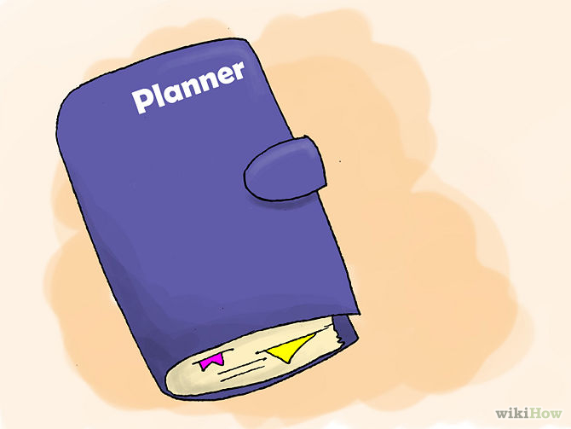](http://www.wikihow.com/Reduce-Stress-Before-Giving-a-Speech#/Image:Tell-if-a-Guy-Likes-You-More-Than-a-Friend-Step-12.jpg)

**3**

**Prepare Positively.Stop worrying about yourself and get excited about your subject!** You have something important to say and others want to hear about it. If you can, pick a subject you enjoy. Speak on topics you know well. Even if you are delivering dreary statistics about last year's crop failure, put something of yourself into your speech. Include an anecdote, or a quotation. Bring in the human interest perspective. Practice and preparation are easier if your subject matter is important and/or enjoyable to you. If you think your material is interesting and meaningful, your audience will catch your enthusiasm and appreciate your sincerity.

1. [](http://www.wikihow.com/Reduce-Stress-Before-Giving-a-Speech#/Image:Influence-People-Step-10.jpg)

**4**

**Love your listeners.Once, just before I was about to speak to classroom of 70 students, a colleague asked me, "How can you be so confident will all those people judging you and finding fault with you?**" Now there is a defeatist presupposition, if I ever heard one! It had never even occurred to me to think of my students in that way! "I am confident," I answered, "because I don't think that way. I assume my audiences are friendly. I assume they are here because they are interested in what I have to say. I love my audiences and I assume they love me." You get back what you put out---and nowhere is this adage more true than in public speaking. If you want your audiences to like you, you have to like them first.

1. [](http://www.wikihow.com/Reduce-Stress-Before-Giving-a-Speech#/Image:Prevent-Anxiety-Step-14.jpg)

**5**

**Put the past behind you—at least the ugly parts.Some people have speaking anxiety because of some humiliating incident of the past—often in childhood.** Such events can be highly traumatizing for children (and not a joyride for adults, either) and can cause life-long, paralyzing fear. If such an incident is the basis of your fear, visit a therapist or counselor who specializes in phobias. Phobias are nothing to be ashamed of. Researchers estimate that 80 percent of the population has at least one in a lifetime. Contrary to popular belief, many phobias can be cured, usually in three or four therapy sessions.

* + Maybe your fear isn't a true phobia, but still relates to past flops and embarrassments. Remember: All good speakers started out as not-so-good speakers. They improved because they resolved to do better the next time.

1. [](http://www.wikihow.com/Reduce-Stress-Before-Giving-a-Speech#/Image:Induce-Nightmares-Step-04.jpg)

**6**

**Get some rest and avoid hassles.Plan ahead and get a good night's sleep before your presentation.** If you have trouble falling asleep, drink some warm milk (yes, it does work), and think some pleasant, relaxing thoughts. It may help to listen to a relaxation tape or soft music, or do some light reading before going to sleep. If you can, clear your calendar of stressful events that could interfere with your ability to concentrate and speak confidently and sincerely. In other words, don't schedule a job interview, a dentist visit, or a meeting with your ex-spouse's lawyer on the same day you are going to deliver that all-important speech!

1. [](http://www.wikihow.com/Reduce-Stress-Before-Giving-a-Speech#/Image:Lose-Belly-Fat-(for-Men)-Step-04.jpg)

**7**

**Avoid mood-altering substances.Some people mistakenly think that drinking lots of coffee or alcohol, smoking cigarettes or popping a tranquilizer before speaking will improve their delivery.** They do it to pep up or calm down. Mood-altering substances are an emotional crutch you don't need. The problem is that you can't regulate the dosage. You don't know how much is too much. Once it is in your bloodstream, there is little you can do about it. Your relaxation may turn to sluggishness. Your pep may turn to jitters. It's best to avoid these substances altogether.

* + Additionally, eat lightly, or not at all, one hour before speaking. A full stomach can lower your energy level and concentration, because your body is busy digesting food. Any nervousness can make digestion difficult. You don't want a belch or a gurgling stomach interrupting your speech!

1. [](http://www.wikihow.com/Reduce-Stress-Before-Giving-a-Speech#/Image:Attract-Men-in-Public-Step-04.jpg)

**8**

**Look your best.Take some time with your appearance.** Polish your shoes and comb your hair. Wear attractive, flattering, professional-looking clothing. When you look good, you feel confident. If you aren't sure what looking good is all about, do what professional speakers do. Have a few sessions with an image consultant to learn about the colors and styles that look best on you. Women can get personalized advice on hair and make-up. A good image consultant can tell you how to look fantastic without spending a fortune.

1. [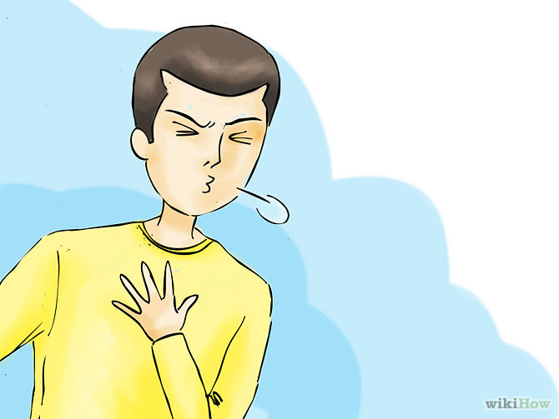](http://www.wikihow.com/Reduce-Stress-Before-Giving-a-Speech#/Image:Prevent-Anxiety-Step-01.jpg)

**9**

**Remember to breathe.Anxiety tightens the muscles in the chest and throat.**With a restricted airway and without enough oxygen, your voice can come out as a squeak! Deep breathing, on the other hand, sends oxygen to the lungs and brain and expands the throat and chest, promoting relaxation. As you approach the platform, take a deep breath and relax.

1. [](http://www.wikihow.com/Reduce-Stress-Before-Giving-a-Speech#/Image:Be-a-Good-Friend-Step-08.jpg)

**10**

**Focus on friendly faces.While speaking, maintain eye contact with your listeners.** Find friendly faces and focus on them. Smiles and approving nods will give you extra encouragement.

1. [](http://www.wikihow.com/Reduce-Stress-Before-Giving-a-Speech#/Image:Manipulate-Others-Step-02.jpg)

**11**

**It's ironic that some people are more afraid of public speaking than of driving on the highways.** Yet, vastly more casualties and fatalities result from traffic accidents than from public speaking. Fear is a natural survival mechanism. It can motivate us, or stop us in our tracks. In situations that pose a threat to life and limb, fear motivates us to be careful. On the other hand, fear is a problem when it interferes with our goals and achievements. These ten tips will help you progress toward confidence on the platform. Ultimately we succeed when we conduct ourselves according to the rewards we want, rather than the things we fear.

## Tips

* Prepare a good ending line. Avoid an awkward moment at the end. Don't back away, mumbling "Well, I guess that's all."
* Get plenty of sleep the night before your speech. Being fatigued during your speech can make you feel more stressed.
* Focus on someone in the back of the room. This has a calming effect on some speakers. It feels weird, but it doesn't look weird.
* On one of the days before your speech, try this: Set up a camera and practice on camera. Play it back and watch it to see what you can improve or do better. It's always good to fix your problem before doing your speech!
* On the morning of your speech, eat something but don't drink soda. Carbonated beverages will give you dry mouth.
* If you start to speak and your voice is shaky, take a pause. Clear your throat. Take a drink of water if it's available.
* If there is a microphone, talk to it. Many speakers concentrate on the microphone and pretend it's the only person in the room. This works well.Forget that the audience is looking at you.
* Prepare an "I don't know" answer if people will be asking questions. Don't be afraid to say you don't know. You can say something like, "That is a great question. I'll look into that."
* It's okay to forget a line or so in between. No one's going to eat you up. Just continue with what you know, no one in the audience knows the content of your speech!
* Walk up to your speaking location early to give your nerves time to calm down.

## Warnings

* Practice the speech out loud, preferably with another person listening. Make it second nature.
* Don't pick the day of your report to experiment with a new style! It may give you an extra reason to feel nervous in front of a crowd.
* Know your topic well,if not you could get embarrassed in front of the audience.

http://www.wikihow.com/Reduce-Stress-Before-Giving-a-Speech