NAMA : AGUS HANAN
NIM : 177200038
KELAS : TI 6, Reguler sore
DATA BASE
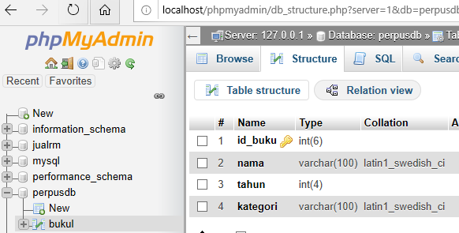
INPUT DATA
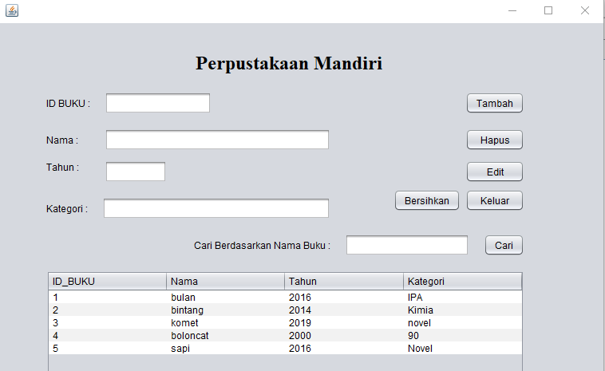

HAPUS DATA
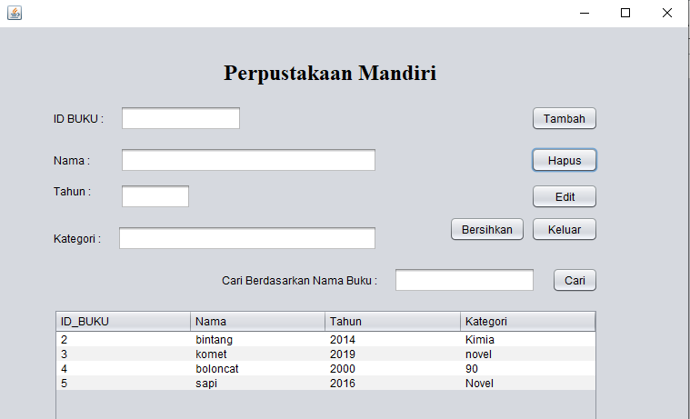
EDIT DATA
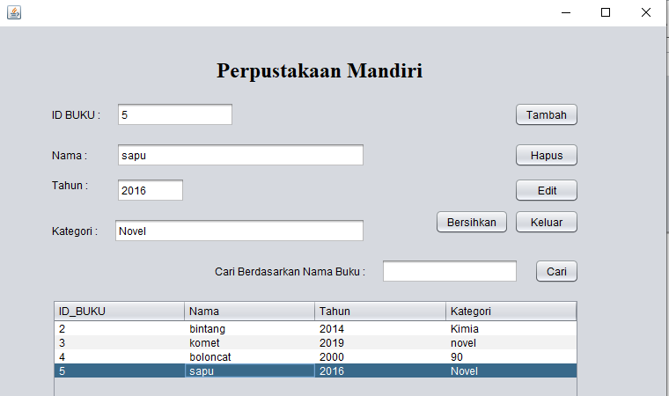

SYNTAXS PERPUS
/*
* To change this license header, choose License Headers in Project Properties.
* To change this template file, choose Tools | Templates
* and open the template in the editor.
*/
package tugascrud;

import java.sql.Connection;
import java.sql.DriverManager;
import java.sql.ResultSet;
import java.sql.SQLException;
import java.util.logging.Level;
import java.util.logging.Logger;
import javax.swing.table.DefaultTableModel;

/**
*
* @author chaba
*/
public class formbuku extends javax.swing.JFrame {
DefaultTableModel model;
/**
* Creates new form formbuku
*/
public formbuku() {
initComponents();
String []judul={"ID_BUKU","Nama","Tahun","Kategori"};
model = new DefaultTableModel(judul,0);
jTable1.setModel(model);
tampilkan();
}

/**
* This method is called from within the constructor to initialize the form.
* WARNING: Do NOT modify this code. The content of this method is always
* regenerated by the Form Editor.
*/
@SuppressWarnings("unchecked")
// <editor-fold defaultstate="collapsed" desc="Generated Code">
private void initComponents() {

jLabel1 = new javax.swing.JLabel();
jLabel2 = new javax.swing.JLabel();
jLabel3 = new javax.swing.JLabel();
jLabel4 = new javax.swing.JLabel();
jLabel5 = new javax.swing.JLabel();
Text1 = new javax.swing.JTextField();
Text2 = new javax.swing.JTextField();
btntam = new javax.swing.JButton();
btnhap = new javax.swing.JButton();
btnedi = new javax.swing.JButton();
btnkel = new javax.swing.JButton();
jScrollPane1 = new javax.swing.JScrollPane();
jTable1 = new javax.swing.JTable();
Text5 = new javax.swing.JTextField();
btncar = new javax.swing.JButton();
jLabel6 = new javax.swing.JLabel();
Text3 = new javax.swing.JTextField();
Text4 = new javax.swing.JTextField();
btnber = new javax.swing.JButton();

setDefaultCloseOperation(javax.swing.WindowConstants.EXIT_ON_CLOSE);
setBackground(java.awt.SystemColor.controlHighlight);

jLabel1.setFont(new java.awt.Font("Times New Roman", 1, 24)); // NOI18N
jLabel1.setText("Perpustakaan Mandiri");

jLabel2.setText("ID BUKU :");

jLabel3.setText("Nama :");

jLabel4.setText("Tahun :");

jLabel5.setText("Kategori :");

Text1.addActionListener(new java.awt.event.ActionListener() {
public void actionPerformed(java.awt.event.ActionEvent evt) {
Text1ActionPerformed(evt);
}
});
Text1.addKeyListener(new java.awt.event.KeyAdapter() {
public void keyTyped(java.awt.event.KeyEvent evt) {
Text1KeyTyped(evt);
}
});

btntam.setText("Tambah");
btntam.addActionListener(new java.awt.event.ActionListener() {
public void actionPerformed(java.awt.event.ActionEvent evt) {
btntamActionPerformed(evt);
}
});

btnhap.setText("Hapus");
btnhap.addActionListener(new java.awt.event.ActionListener() {
public void actionPerformed(java.awt.event.ActionEvent evt) {
btnhapActionPerformed(evt);
}
});

btnedi.setText("Edit");
btnedi.addActionListener(new java.awt.event.ActionListener() {
public void actionPerformed(java.awt.event.ActionEvent evt) {
btnediActionPerformed(evt);
}
});

btnkel.setText("Keluar");
btnkel.addActionListener(new java.awt.event.ActionListener() {
public void actionPerformed(java.awt.event.ActionEvent evt) {
btnkelActionPerformed(evt);
}
});

jTable1.setModel(new javax.swing.table.DefaultTableModel(
new Object [][] {
{null, null, null, null},
{null, null, null, null},
{null, null, null, null},
{null, null, null, null}
},
new String [] {
"Title 1", "Title 2", "Title 3", "Title 4"
}
));
jTable1.addMouseListener(new java.awt.event.MouseAdapter() {
public void mouseClicked(java.awt.event.MouseEvent evt) {
jTable1MouseClicked(evt);
}
});
jScrollPane1.setViewportView(jTable1);

btncar.setText("Cari");
btncar.addActionListener(new java.awt.event.ActionListener() {
public void actionPerformed(java.awt.event.ActionEvent evt) {
btncarActionPerformed(evt);
}
});

jLabel6.setText("Cari Berdasarkan Nama Buku :");

btnber.setText("Bersihkan");
btnber.addActionListener(new java.awt.event.ActionListener() {
public void actionPerformed(java.awt.event.ActionEvent evt) {
btnberActionPerformed(evt);
}
});

javax.swing.GroupLayout layout = new javax.swing.GroupLayout(getContentPane());
getContentPane().setLayout(layout);
layout.setHorizontalGroup(
layout.createParallelGroup(javax.swing.GroupLayout.Alignment.LEADING)
.addGroup(layout.createSequentialGroup()
.addGroup(layout.createParallelGroup(javax.swing.GroupLayout.Alignment.LEADING)
.addGroup(layout.createSequentialGroup()
.addGap(246, 246, 246)
.addComponent(jLabel1))
.addGroup(layout.createSequentialGroup()
.addGap(59, 59, 59)
.addGroup(layout.createParallelGroup(javax.swing.GroupLayout.Alignment.TRAILING)
.addGroup(javax.swing.GroupLayout.Alignment.LEADING, layout.createSequentialGroup()
.addGroup(layout.createParallelGroup(javax.swing.GroupLayout.Alignment.LEADING, false)
.addGroup(layout.createSequentialGroup()
.addGroup(layout.createParallelGroup(javax.swing.GroupLayout.Alignment.LEADING)
.addComponent(jLabel2)
.addComponent(jLabel3)
.addComponent(jLabel4))
.addGap(18, 18, 18)
.addGroup(layout.createParallelGroup(javax.swing.GroupLayout.Alignment.LEADING)
.addComponent(Text1, javax.swing.GroupLayout.PREFERRED_SIZE, 134, javax.swing.GroupLayout.PREFERRED_SIZE)
.addComponent(Text2, javax.swing.GroupLayout.PREFERRED_SIZE, 283, javax.swing.GroupLayout.PREFERRED_SIZE)
.addComponent(Text3, javax.swing.GroupLayout.PREFERRED_SIZE, 78, javax.swing.GroupLayout.PREFERRED_SIZE)))
.addGroup(layout.createSequentialGroup()
.addComponent(jLabel5)
.addGap(18, 18, 18)
.addComponent(Text4)))
.addPreferredGap(javax.swing.LayoutStyle.ComponentPlacement.RELATED, 79, Short.MAX_VALUE)
.addComponent(btnber)
.addPreferredGap(javax.swing.LayoutStyle.ComponentPlacement.RELATED)
.addGroup(layout.createParallelGroup(javax.swing.GroupLayout.Alignment.LEADING, false)
.addComponent(btntam, javax.swing.GroupLayout.DEFAULT_SIZE, javax.swing.GroupLayout.DEFAULT_SIZE, Short.MAX_VALUE)
.addComponent(btnhap, javax.swing.GroupLayout.DEFAULT_SIZE, javax.swing.GroupLayout.DEFAULT_SIZE, Short.MAX_VALUE)
.addComponent(btnedi, javax.swing.GroupLayout.DEFAULT_SIZE, javax.swing.GroupLayout.DEFAULT_SIZE, Short.MAX_VALUE)
.addComponent(btnkel, javax.swing.GroupLayout.DEFAULT_SIZE, javax.swing.GroupLayout.DEFAULT_SIZE, Short.MAX_VALUE)))
.addComponent(jScrollPane1, javax.swing.GroupLayout.Alignment.LEADING)
.addGroup(layout.createSequentialGroup()
.addGap(0, 0, Short.MAX_VALUE)
.addComponent(jLabel6)
.addGap(18, 18, 18)
.addComponent(Text5, javax.swing.GroupLayout.PREFERRED_SIZE, 156, javax.swing.GroupLayout.PREFERRED_SIZE)
.addGap(18, 18, 18)
.addComponent(btncar)))))
.addGap(99, 99, 99))
);
layout.setVerticalGroup(
layout.createParallelGroup(javax.swing.GroupLayout.Alignment.LEADING)
.addGroup(layout.createSequentialGroup()
.addGap(36, 36, 36)
.addComponent(jLabel1)
.addGap(22, 22, 22)
.addGroup(layout.createParallelGroup(javax.swing.GroupLayout.Alignment.BASELINE)
.addComponent(jLabel2)
.addComponent(Text1, javax.swing.GroupLayout.PREFERRED_SIZE, javax.swing.GroupLayout.DEFAULT_SIZE, javax.swing.GroupLayout.PREFERRED_SIZE)
.addComponent(btntam))
.addGap(18, 18, 18)
.addGroup(layout.createParallelGroup(javax.swing.GroupLayout.Alignment.BASELINE)
.addComponent(jLabel3)
.addComponent(Text2, javax.swing.GroupLayout.PREFERRED_SIZE, javax.swing.GroupLayout.DEFAULT_SIZE, javax.swing.GroupLayout.PREFERRED_SIZE)
.addComponent(btnhap))
.addGap(12, 12, 12)
.addGroup(layout.createParallelGroup(javax.swing.GroupLayout.Alignment.LEADING)
.addComponent(jLabel4)
.addGroup(layout.createParallelGroup(javax.swing.GroupLayout.Alignment.BASELINE)
.addComponent(btnedi)
.addComponent(Text3, javax.swing.GroupLayout.PREFERRED_SIZE, javax.swing.GroupLayout.DEFAULT_SIZE, javax.swing.GroupLayout.PREFERRED_SIZE)))
.addGroup(layout.createParallelGroup(javax.swing.GroupLayout.Alignment.LEADING)
.addGroup(layout.createSequentialGroup()
.addGap(18, 18, 18)
.addGroup(layout.createParallelGroup(javax.swing.GroupLayout.Alignment.BASELINE)
.addComponent(jLabel5)
.addComponent(Text4, javax.swing.GroupLayout.PREFERRED_SIZE, javax.swing.GroupLayout.DEFAULT_SIZE, javax.swing.GroupLayout.PREFERRED_SIZE)))
.addGroup(layout.createSequentialGroup()
.addGap(8, 8, 8)
.addGroup(layout.createParallelGroup(javax.swing.GroupLayout.Alignment.BASELINE)
.addComponent(btnkel)
.addComponent(btnber))))
.addPreferredGap(javax.swing.LayoutStyle.ComponentPlacement.RELATED, 18, Short.MAX_VALUE)
.addGroup(layout.createParallelGroup(javax.swing.GroupLayout.Alignment.BASELINE)
.addComponent(Text5, javax.swing.GroupLayout.PREFERRED_SIZE, javax.swing.GroupLayout.DEFAULT_SIZE, javax.swing.GroupLayout.PREFERRED_SIZE)
.addComponent(btncar)
.addComponent(jLabel6))
.addGap(18, 18, 18)
.addComponent(jScrollPane1, javax.swing.GroupLayout.PREFERRED_SIZE, 255, javax.swing.GroupLayout.PREFERRED_SIZE)
.addContainerGap())
);

pack();
}// </editor-fold>

private void Text1ActionPerformed(java.awt.event.ActionEvent evt) {
// TODO add your handling code here:
}

private void btntamActionPerformed(java.awt.event.ActionEvent evt) {
try {
// TODO add your handling code here:
Connection cn= DriverManager.getConnection("jdbc:mysql://localhost:3306/perpusdb","root","");
cn.createStatement().executeUpdate("insert into bukul values"+"('"+Text1.getText()+"','"+Text2.getText()+"','"+Text3.getText()+"','"+Text4.getText()+"')");
tampilkan();
reset();
} catch (SQLException ex) {
Logger.getLogger(formbuku.class.getName()).log(Level.SEVERE, null, ex);
}
}

private void Text1KeyTyped(java.awt.event.KeyEvent evt) {
// TODO add your handling code here:
if (Text1.getText().length() == 6){
evt.consume();
}
}

private void btnediActionPerformed(java.awt.event.ActionEvent evt) {
try {
// TODO add your handling code here:
Connection cn= DriverManager.getConnection("jdbc:mysql://localhost:3306/perpusdb","root","");
cn.createStatement().executeUpdate("update bukul set nama='"+Text2.getText()+"', tahun='"+Text3.getText()+"', kategori='"+Text4.getText()+"' where id_buku='"+Text1.getText()+"'");
tampilkan();
reset();
} catch (SQLException ex) {
Logger.getLogger(formbuku.class.getName()).log(Level.SEVERE, null, ex);
}

}

private void jTable1MouseClicked(java.awt.event.MouseEvent evt) {
// TODO add your handling code here:
int i = jTable1.getSelectedRow();
if(i>-1){
Text1.setText(model.getValueAt(i, 0).toString());
Text2.setText(model.getValueAt(i, 1).toString());
Text3.setText(model.getValueAt(i, 2).toString());
Text4.setText(model.getValueAt(i, 3).toString());

}
}

private void btnberActionPerformed(java.awt.event.ActionEvent evt) {
// TODO add your handling code here:
reset();
tampilkan();
}

private void btnhapActionPerformed(java.awt.event.ActionEvent evt) {
try {
// TODO add your handling code here:
Connection cn= DriverManager.getConnection("jdbc:mysql://localhost:3306/perpusdb","root","");
cn.createStatement().executeUpdate("delete from bukul where id_buku='"+Text1.getText()+"'");
tampilkan();
reset();
} catch (SQLException ex) {
Logger.getLogger(formbuku.class.getName()).log(Level.SEVERE, null, ex);
}
}

private void btnkelActionPerformed(java.awt.event.ActionEvent evt) {
// TODO add your handling code here:
System.exit(0);
}

private void btncarActionPerformed(java.awt.event.ActionEvent evt) {
// TODO add your handling code here:
int row = jTable1.getRowCount();
for(int a=0;a<row;a++){
model.removeRow(0);
}
try {
Connection cn= DriverManager.getConnection("jdbc:mysql://localhost:3306/perpusdb","root","");
ResultSet rs = cn.createStatement().executeQuery("select * from bukul where nama='"+Text5.getText()+"'");
while(rs.next()){
String data[]={rs.getString(1),rs.getString(2),rs.getString(3),rs.getString(4)};
model.addRow(data);
}
} catch (SQLException ex) {
Logger.getLogger(formbuku.class.getName()).log(Level.SEVERE, null, ex);
}
}

/**
* @param args the command line arguments
*/
public static void main(String args[]) {
/* Set the Nimbus look and feel */
//<editor-fold defaultstate="collapsed" desc=" Look and feel setting code (optional) ">
/* If Nimbus (introduced in Java SE 6) is not available, stay with the default look and feel.
* For details see http://download.oracle.com/javase/tutorial/uiswing/lookandfeel/plaf.html
*/
try {
for (javax.swing.UIManager.LookAndFeelInfo info : javax.swing.UIManager.getInstalledLookAndFeels()) {
if ("Nimbus".equals(info.getName())) {
javax.swing.UIManager.setLookAndFeel(info.getClassName());
break;
}
}
} catch (ClassNotFoundException ex) {
java.util.logging.Logger.getLogger(formbuku.class.getName()).log(java.util.logging.Level.SEVERE, null, ex);
} catch (InstantiationException ex) {
java.util.logging.Logger.getLogger(formbuku.class.getName()).log(java.util.logging.Level.SEVERE, null, ex);
} catch (IllegalAccessException ex) {
java.util.logging.Logger.getLogger(formbuku.class.getName()).log(java.util.logging.Level.SEVERE, null, ex);
} catch (javax.swing.UnsupportedLookAndFeelException ex) {
java.util.logging.Logger.getLogger(formbuku.class.getName()).log(java.util.logging.Level.SEVERE, null, ex);
}
//</editor-fold>

/* Create and display the form */
java.awt.EventQueue.invokeLater(new Runnable() {
public void run() {
new formbuku().setVisible(true);
}
});
}

// Variables declaration - do not modify
private javax.swing.JTextField Text1;
private javax.swing.JTextField Text2;
private javax.swing.JTextField Text3;
private javax.swing.JTextField Text4;
private javax.swing.JTextField Text5;
private javax.swing.JButton btnber;
private javax.swing.JButton btncar;
private javax.swing.JButton btnedi;
private javax.swing.JButton btnhap;
private javax.swing.JButton btnkel;
private javax.swing.JButton btntam;
private javax.swing.JLabel jLabel1;
private javax.swing.JLabel jLabel2;
private javax.swing.JLabel jLabel3;
private javax.swing.JLabel jLabel4;
private javax.swing.JLabel jLabel5;
private javax.swing.JLabel jLabel6;
private javax.swing.JScrollPane jScrollPane1;
private javax.swing.JTable jTable1;
// End of variables declaration

private void tampilkan() {
int row = jTable1.getRowCount();
for(int a=0;a<row;a++){
model.removeRow(0);
}
try {
Connection cn= DriverManager.getConnection("jdbc:mysql://localhost:3306/perpusdb","root","");
ResultSet rs = cn.createStatement().executeQuery("select * from bukul");
while(rs.next()){
String data[]={rs.getString(1),rs.getString(2),rs.getString(3),rs.getString(4)};
model.addRow(data);
}
} catch (SQLException ex) {
Logger.getLogger(formbuku.class.getName()).log(Level.SEVERE, null, ex);
}
}
private void reset(){
Text1.setText("");
Text2.setText("");
Text3.setText("");
Text4.setText("");
Text5.setText("");
}

}

