

Presents:

**SUNGKA**

**Web Server and Android Game Application**

**A Project in Enterprise Java II**

*Professor*:

**Sir Noel Anonas**

*Members*:

**Janver B. Codilan Jay Venson F. Gencianeo**

**Christian Michael G. Arizala Paul Jared O. Cadelina**

I. **Project Specification**

**Purpose and Objectives**

To develop a game that will give knowledge and preserve the Filipino culture. Our objective is to encourage all the people especially the Asians to love their own culture game. We want to develop a mobile game version of SUNGKA using Android.

**Scope**

The version of our SUNGKA is more portable than the original game because it can be played in mobile phones. Our game can be played through Android phones. Our application can be played by 1 to 2 players. Certain elements can be customized such as the background of the game and stones. Players have skill which can alter the tide of the game such as switching and emptying of pits.

**Assumption**

People:

* Learning.
* Can do the assign task.

Process:

* User-friendly interface.
* Customizable features.

Technology

* Our application runs on Android devices.
* Internet for connecting in the database.
* Bluetooth connection.

**Constraints**

People:

* Challenging.
* Delay in developing the application by the developers.

Process:

* Limited to two players.
* Users have limited features.

Technology

* Android device Froyo 2.2 and higher.

II. **Prototype**

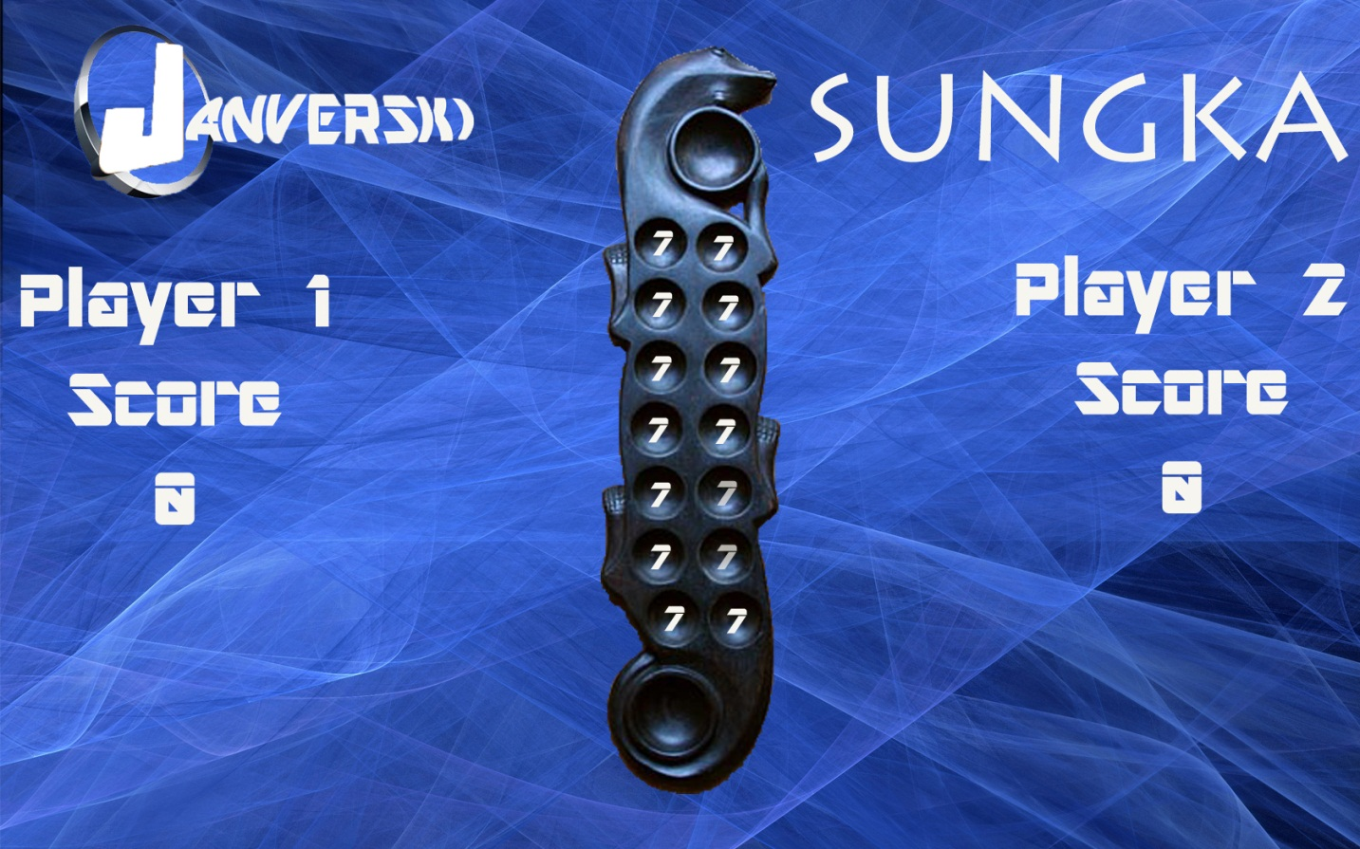

III. **Use-Cases**

**Unified Modeling Language (UML)**

**USER2**

**USER1**

Use Phone

Open Application

Multi Player

Single Player

Play Game

Register

Login

Store Scores

Verify User Account

Store Database Account

View/ Maintenance

**DATABASE ADMIN**

**Fully-dressed Use Case**

**USE CASE 1 : Registration**

**PRIMARY ACTOR:** Player

**STAKEHOLDERS & INTERESTS:**

* Player – want to register an account for the game

**PRE-CONDITIONS:** Internet-enabled Android phone

**SUCCESS GUARANTEE (POST CONDITION):**

* Player successfully created an account.

**MAIN SUCCESS SCENARIO (Basic Flow):**

1. Player access Registration Form
2. Player inputs account username and password
3. Player inputs certain personal information
4. Information stored in Database

**EXTENSIONS (Alternative Flows):**

1. **Typographical error (Post-Registration)**
2. Access Account Panel
3. Edit Account Information

**SPECIAL REQUIREMENTS:**

* Application must be compatible with Android Froyo version

**TECHNOLOGY & DATA VARIATIONS:**

**FREQUENCY OF OCCUERENCE:**

**USE CASE 2 : Login**

**PRIMARY ACTOR:** Player

**STAKEHOLDERS & INTERESTS:**

* Player – access using Account information

**PRE-CONDITIONS:** Android phone

**SUCCESS GUARANTEE (POST CONDITION):**

* Player logged-in using own Account

**MAIN SUCCESS SCENARIO (Basic Flow):**

* + 1. **Player logged-in using personal account**
    2. **Application checks Database to match username and password**
    3. **Application receives additional Account information**
    4. **Player chooses “Single Player” or “Multiplayer”**
    5. **Player plays Game**

**EXTENSIONS (Alternative Flows):**

1. **Wrong Username/Password**
2. Player re-attempt to enter correct Account information
3. **Application checks Database to match username and password**

**SPECIAL REQUIREMENTS:**

* Player must have an account

**TECHNOLOGY & DATA VARIATIONS:**

**FREQUENCY OF OCCUERENCE:**

**USE CASE 3 : Game – Single Player**

**PRIMARY ACTOR:** Player

**STAKEHOLDERS & INTERESTS:**

* Player – wants to play the game

**PRE-CONDITIONS:** Android phone

**SUCCESS GUARANTEE (POST CONDITION):**

* Player played the game without problems

**MAIN SUCCESS SCENARIO (Basic Flow):**

* + 1. **Player chooses difficulty**
    2. **Records score (?)**

**EXTENSIONS (Alternative Flows):**

**SPECIAL REQUIREMENTS:**

**TECHNOLOGY & DATA VARIATIONS:**

**FREQUENCY OF OCCUERENCE:**

**USE CASE 4 : Game – Multiplayer**

**PRIMARY ACTOR:** Player

**STAKEHOLDERS & INTERESTS:**

* Player – wants to play the game

**PRE-CONDITIONS:** Android phone

**SUCCESS GUARANTEE (POST CONDITION):**

* Player played the game without problems

**MAIN SUCCESS SCENARIO (Basic Flow):**

**EXTENSIONS (Alternative Flows):**

**SPECIAL REQUIREMENTS:**

* Internet required

**TECHNOLOGY & DATA VARIATIONS:**

**FREQUENCY OF OCCUERENCE:**

**USE CASE 4 : Rankings**

**PRIMARY ACTOR:** Player

**STAKEHOLDERS & INTERESTS:**

* Player – wants to see player rankings

**PRE-CONDITIONS:** Android phone

**SUCCESS GUARANTEE (POST CONDITION):**

* Application displayed rankings without error

**MAIN SUCCESS SCENARIO (Basic Flow):**

**EXTENSIONS (Alternative Flows):**

**SPECIAL REQUIREMENTS:**

* Internet required

**TECHNOLOGY & DATA VARIATIONS:**

**FREQUENCY OF OCCUERENCE:**