Error saat menjalankan emulator

FAILURE: Build failed with an exception.

* What went wrong:
Could not initialize class org.codehaus.groovy.reflection.ReflectionCache

* Try:
Run with --stacktrace option to get the stack trace. Run with --info or --debug option to get more log output. Run with --scan to get full insights.

* Get more help at https://help.gradle.org

BUILD FAILED in 10s

error Failed to install the app. Make sure you have the Android development environment set up: https://reactnative.dev/docs/environment-setup. Run CLI with --verbose flag for more details.
Error: Command failed: ./gradlew app:installDebug -PreactNativeDevServerPort=8081
java.lang.NoClassDefFoundError: Could not initialize class org.codehaus.groovy.vmplugin.v7.Java7
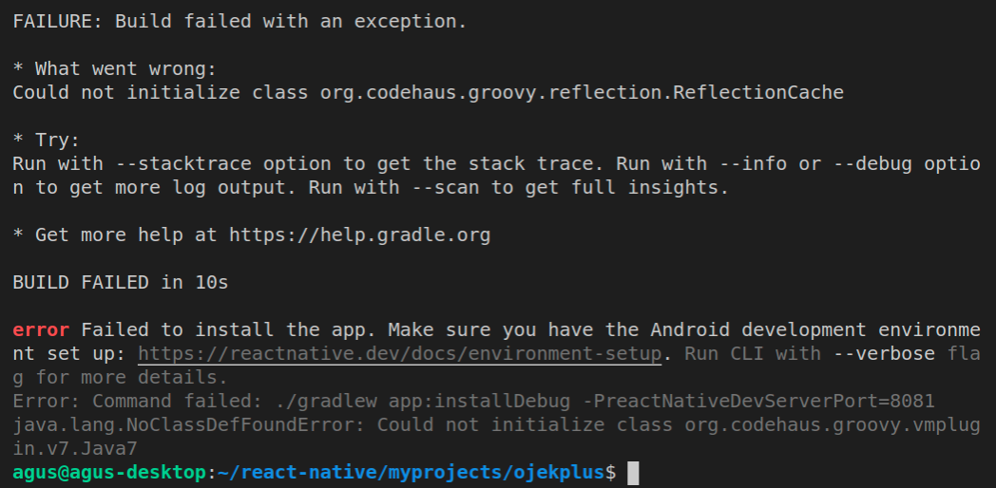
Solusi :

- Go to /android/gradle/wrapper/gradle-wrapper.properties file in your RN project.
- Find this line that starts with distributionUrl. Change the gradle version into gradle-6.3-all.zip. Atau versi yang terbaru di https://gradle.org/releases/

source:
https://stackoverflow.com/questions/60844245/how-solve-could-not-initialize-class-org-codehaus-groovy-reflection-reflectionc

