LexChain Advanced Seminar
Sean Agustine Esparagoza, Marvin Pescos, and Badygin Sinco
Repository: LexChain on GitHub
Task branch: feature/advanced-seminar-agent-skills

Branch and base
The task branch was created from the fetched origin/main at 40923b1. Repository guidance and docs/adr/0001-main-dev-branch-flow.md identify main as the released source of truth and dev as the integration branch, so main was selected as the base. The branch was pushed to GitHub after commit, and the linked branch page shows its files. An isolated worktree kept the unrelated changes in the original dev checkout untouched.

Agent guidance
README.md, docs/ARCHITECTURE.md, and the existing root AGENTS.md were reviewed before editing. The root guidance keeps its frontend/backend, API contract, security, and workflow rules. A small Project skills section links contributors to the two focused LexChain skills and to the React/Next.js provider skill.

LexChain-specific skills
- lexchain-document-workflows gives a route-to-feature workflow for library, upload, review, lifecycle, verification, activity, and participant access. It keeps client role checks in the UI and backend authorization authoritative.
- lexchain-api-integration traces browser calls through shared clients and same-origin route handlers, and server-rendered or action calls through server-only backend helpers. It covers request/response contracts, cookies, validation, React Query behavior, and generated OpenAPI type boundaries.

Provider skill
Vercel React Best Practices was installed as the single provider skill from Vercel Labs' vercel-labs/agent-skills repository. Its skill metadata identifies Vercel as author and MIT as its license; the included provider README preserves its acknowledgment that @shuding originally created the guidance at Vercel. The provider README declares MIT, but the upstream repository has no standalone LICENSE file; the project copy retains the available attribution and license metadata.
Source: vercel-react-best-practices/SKILL.md
Provider repository and license reference: vercel-labs/agent-skills README
Installation used pnpm dlx skills add vercel-labs/agent-skills --skill vercel-react-best-practices --agent codex --copy --yes. The project copy is under .agents/skills/vercel-react-best-practices/ and skills-lock.json records its source and path.

Verification
The two LexChain skills and the installed provider skill passed the skill creator's quick_validate.py check. Markdown links, skill structure, screenshot readability, report font and rendering, and staged-file scope were checked. git diff --cached --check flags upstream trailing spaces in the provider copy’s AGENTS.md and rule pages; its SKILL.md and authored files are clean. Those provider source files were kept unchanged. No runtime code changed, so application tests and builds were not run. This editable DOCX preserves Arial 12 pt and the evidence images; a separate PDF was unnecessary.
Evidence screenshots are direct browser captures of GitHub pages on the pushed task branch. They show the branch and committed files, the skills directory, root AGENTS.md links, both LexChain skills, and the provider skill. Screenshots were not altered, and no credentials or tokens are visible.

Evidence
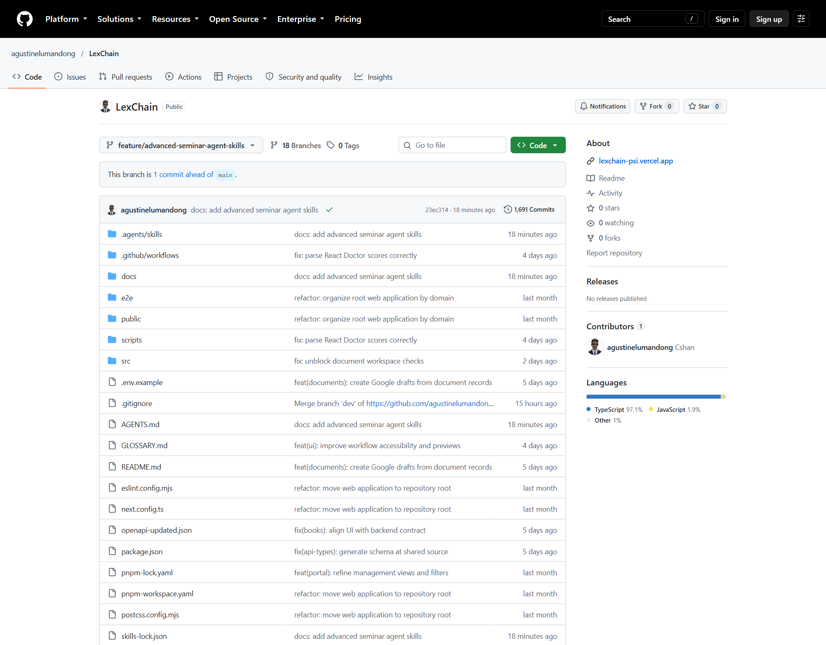
Figure 1. GitHub branch page showing the pushed task branch and committed files.
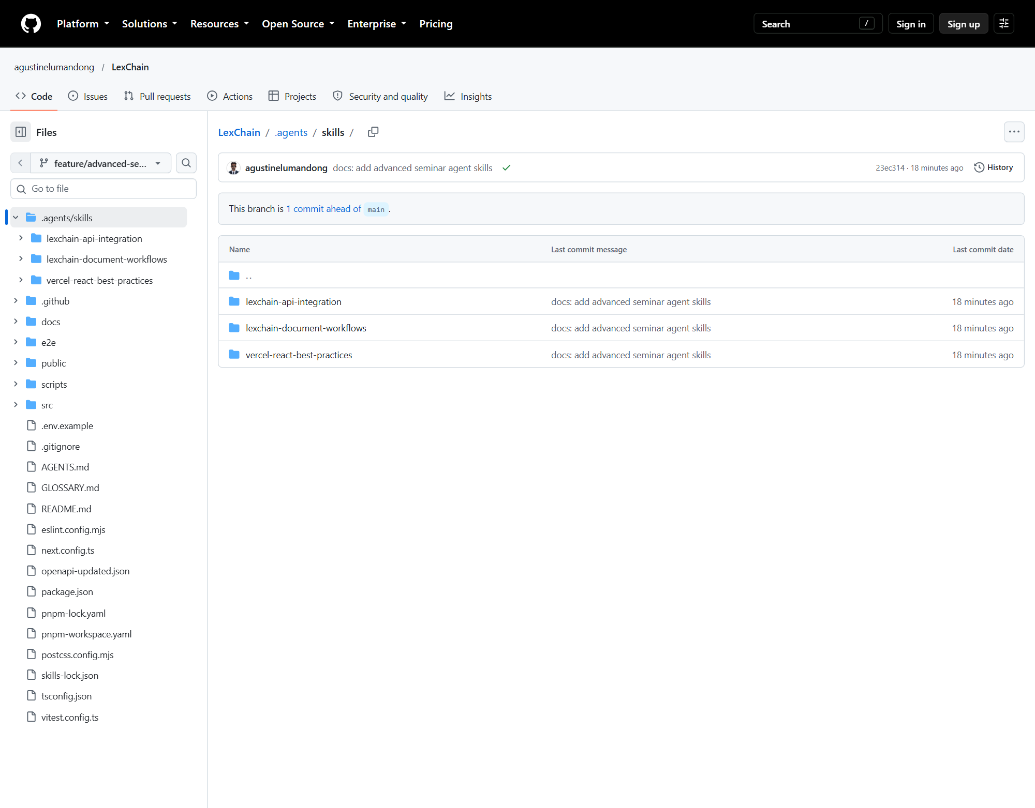
Figure 2. GitHub .agents/skills directory listing the three project skills.

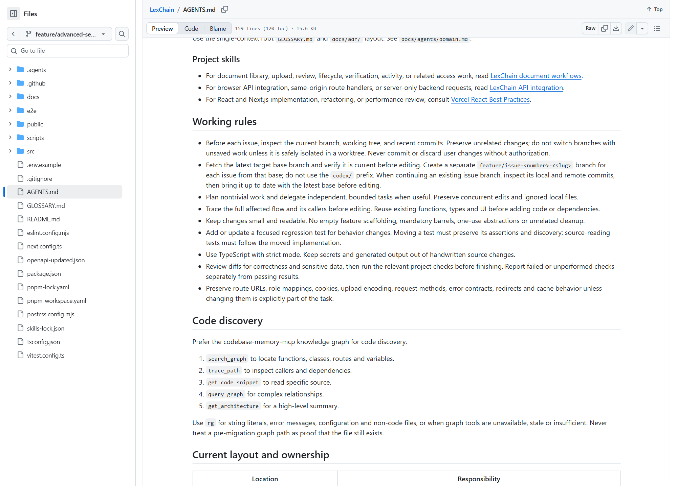
Figure 3. Root AGENTS.md Project skills section on GitHub.

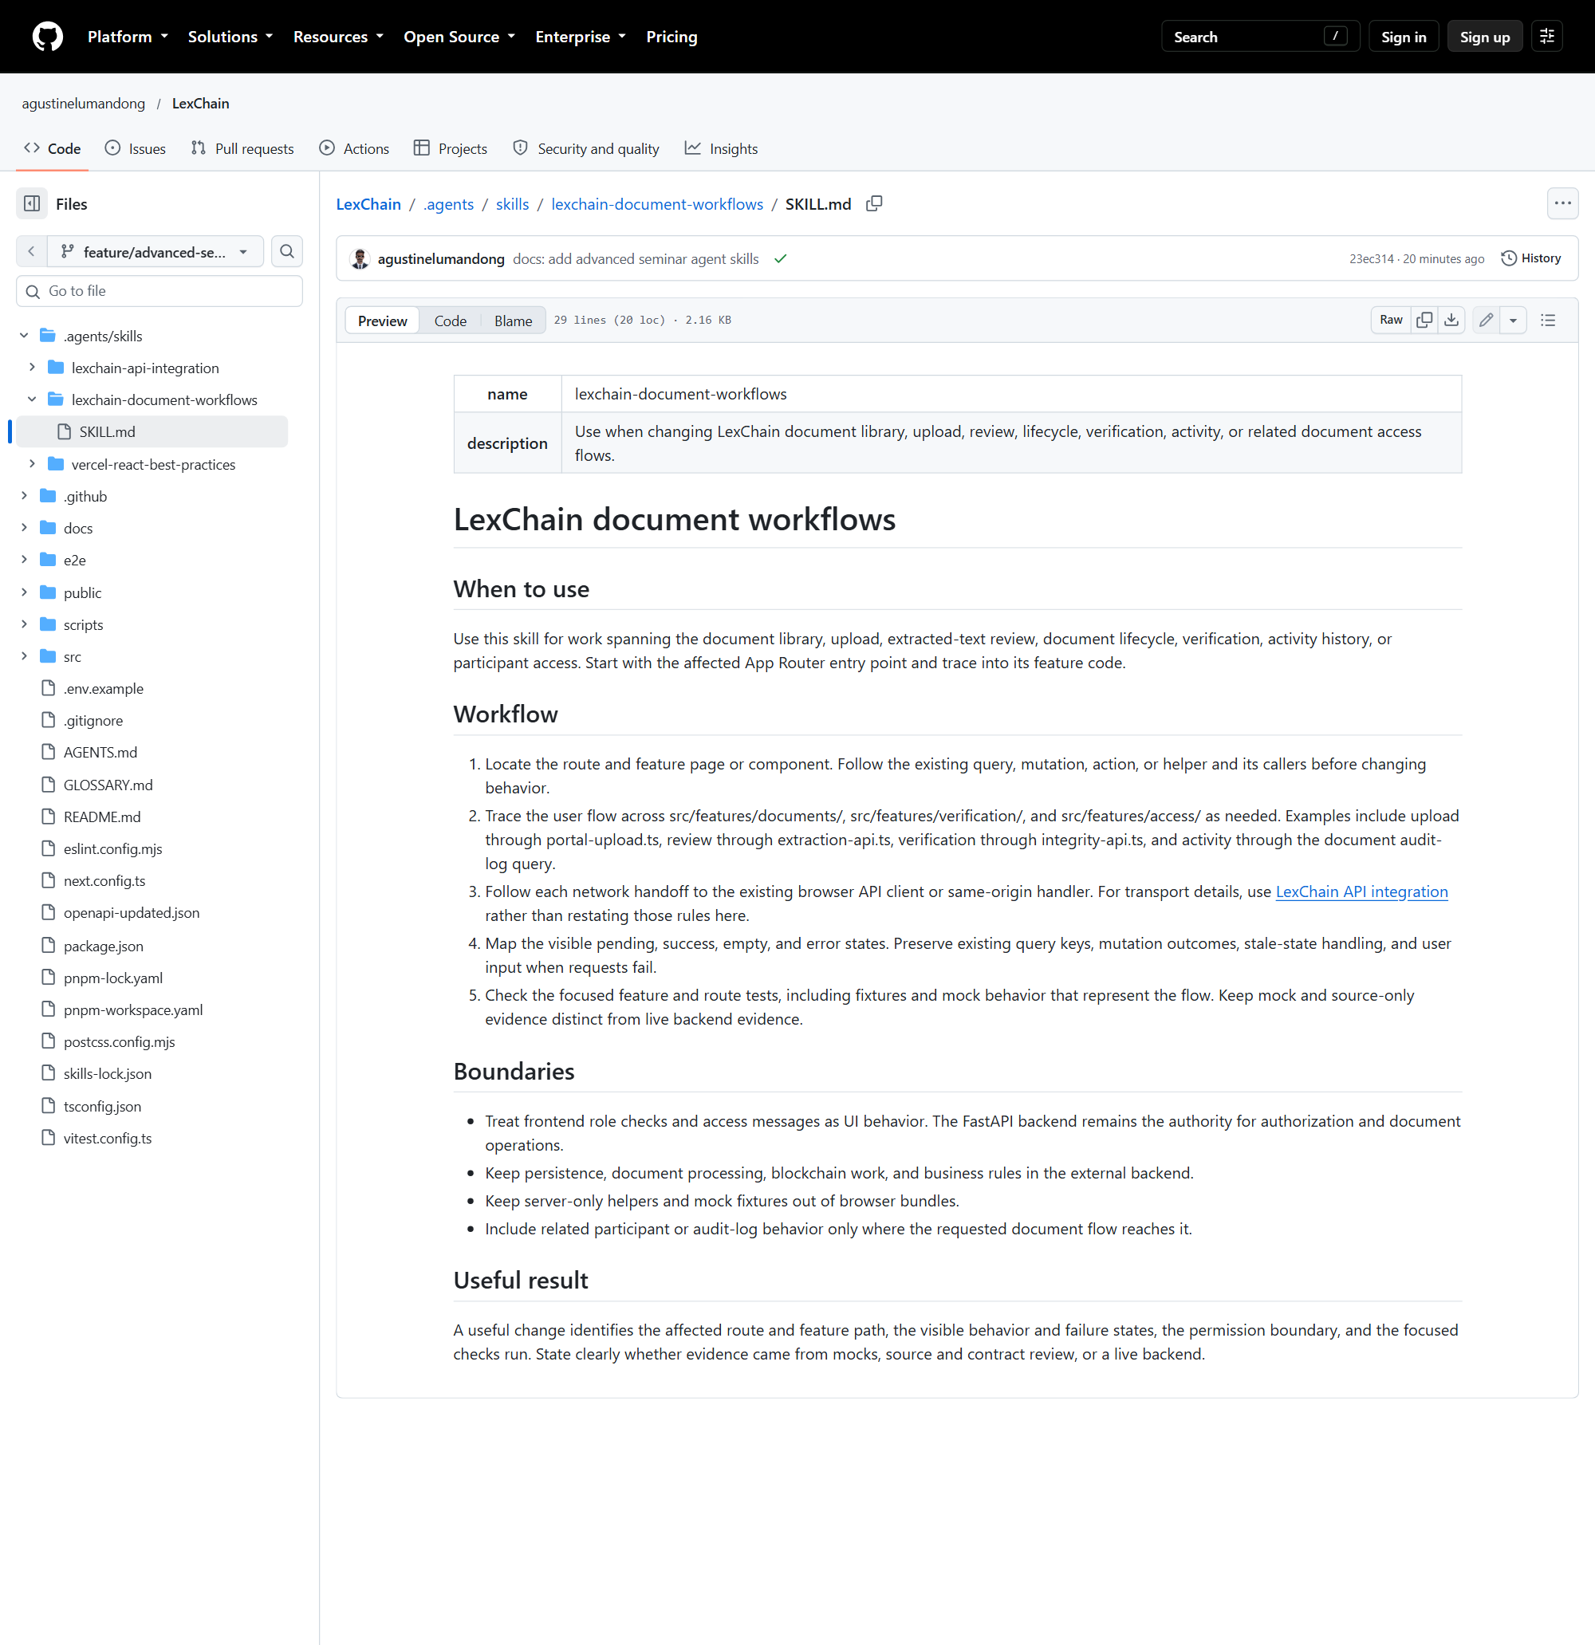
Figure 4. LexChain document workflows skill on GitHub.

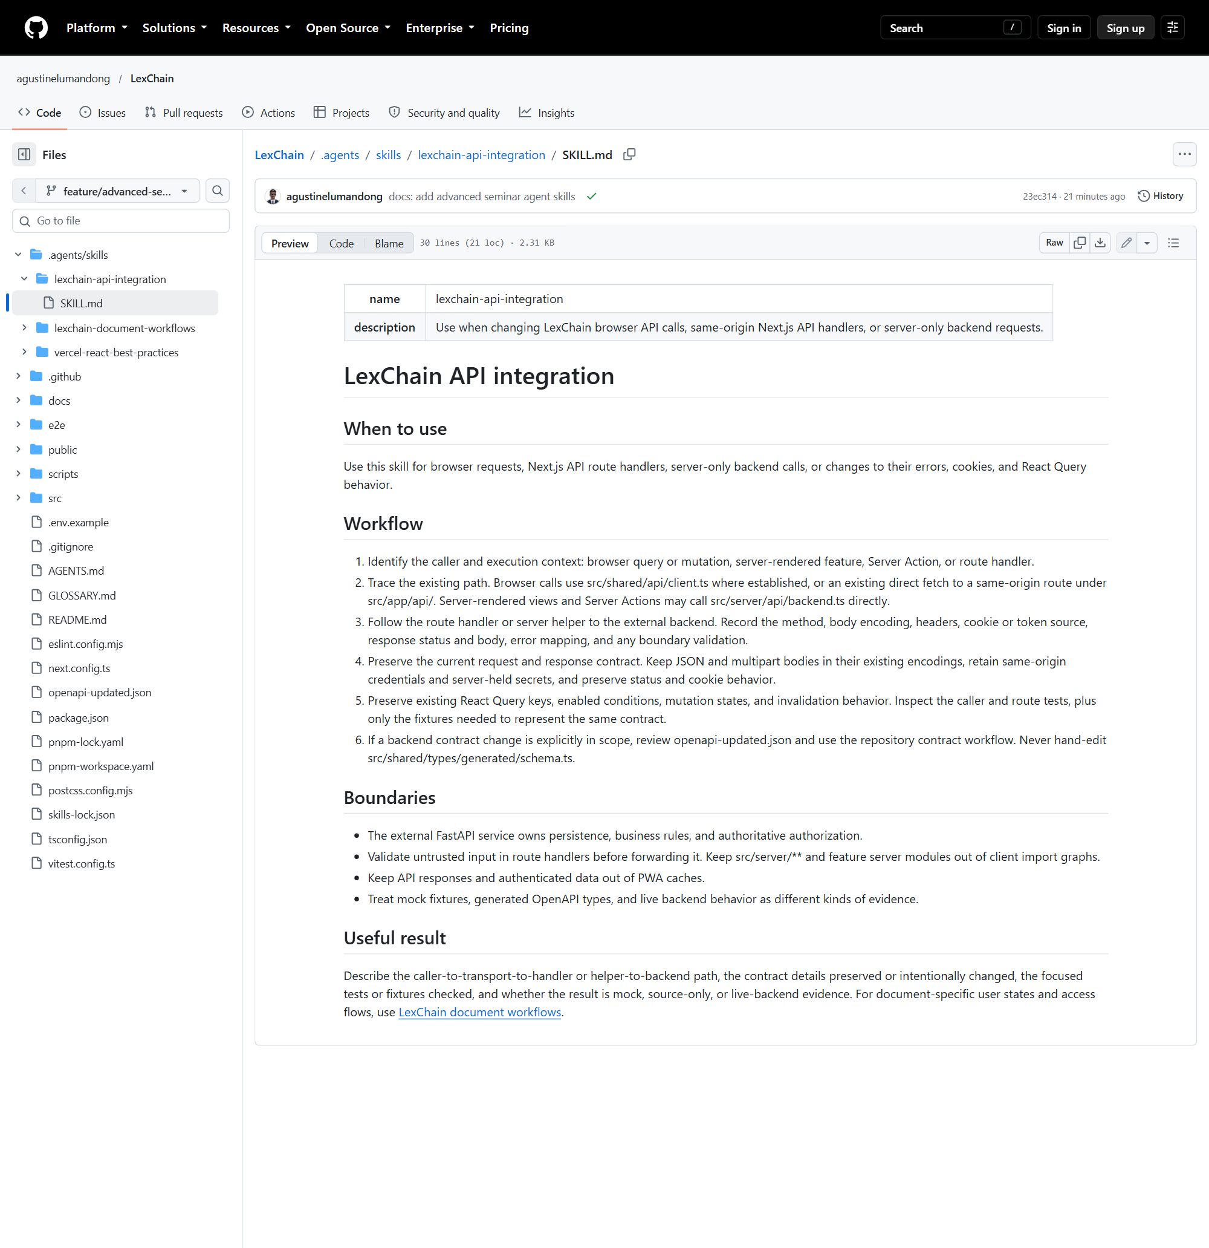
Figure 5. LexChain API integration skill on GitHub.
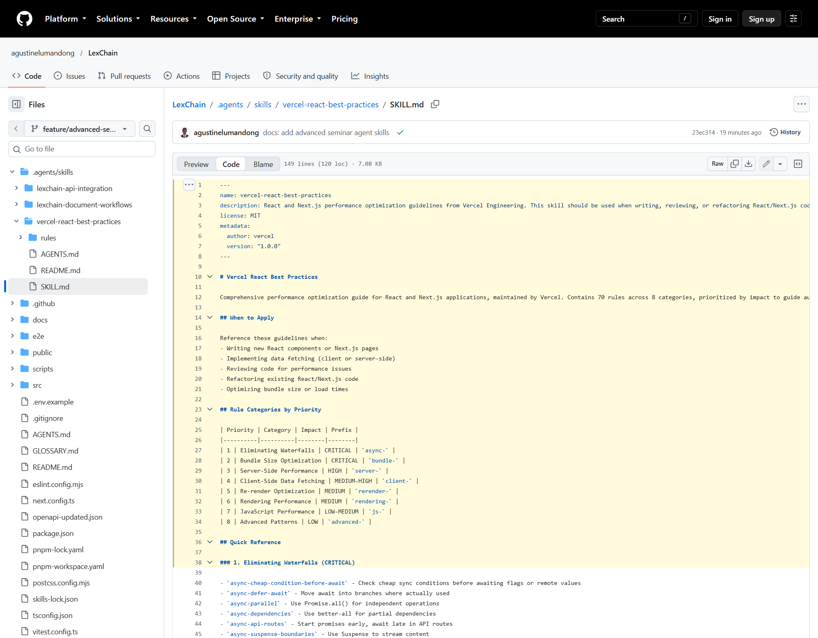
Figure 6. Vercel React Best Practices provider skill on GitHub.

