**Se visualiza banner principal  
  
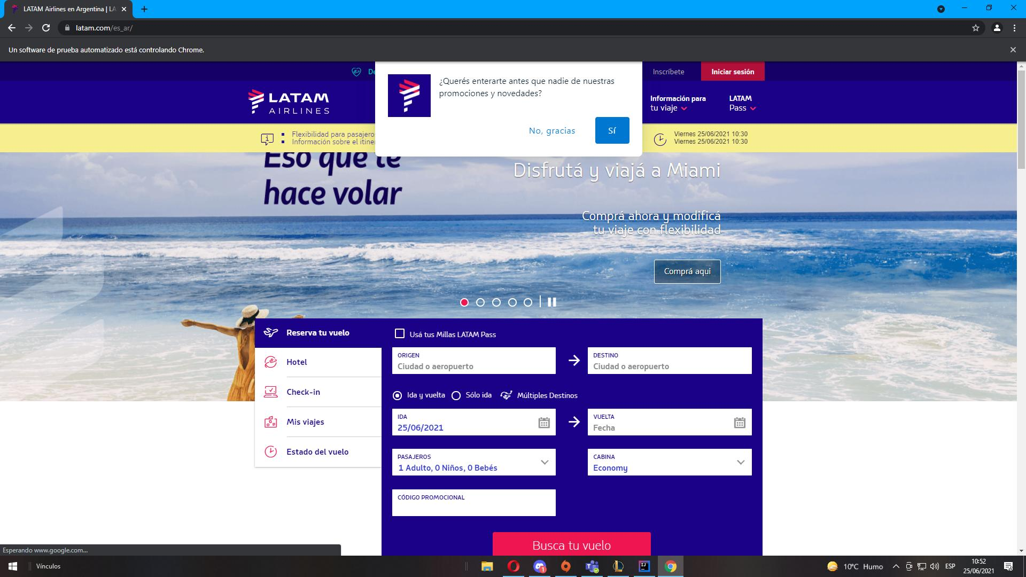  
  
Se cierra banner principal  
  
