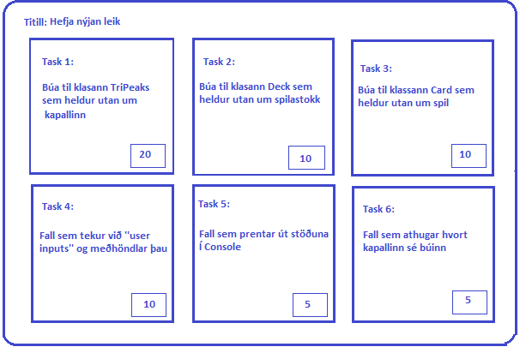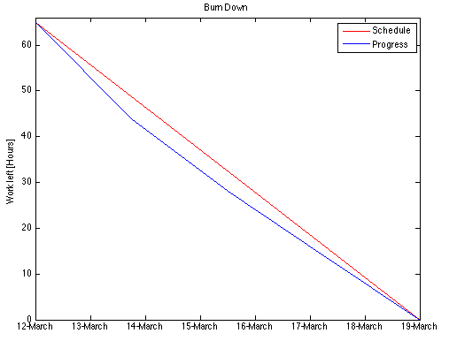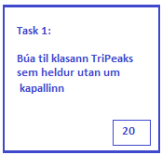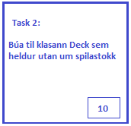

Burn Down

Complete

In Progress

User Stories

**llllllllllllllllllllllllllllllllllll**

**llllllllllllllllllllllllllllllllllll**

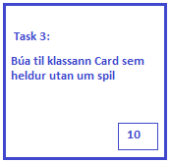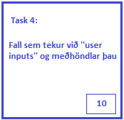

- - - - - - - - - - - - - - - - - - - - - - - - - - - - - - -

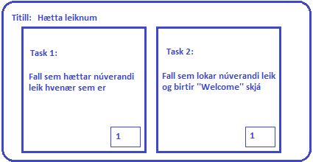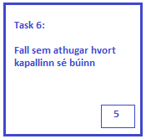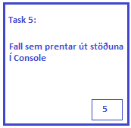

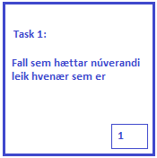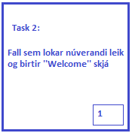

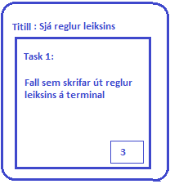

- - - - - - - - - - - - - - - - - - - - - - - - - - - - - - - - - - - - - - - - - - - - - -

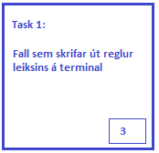

next

- - - - - - - - - - - - - - - - - - - - - - - - - - - - - - - - - - - - - - - - - - - - - - - - - - - - - - - - - - - - - - - - - - - - - - - - -- -

Completed



