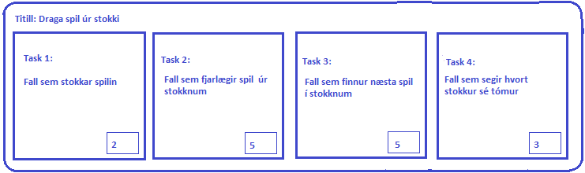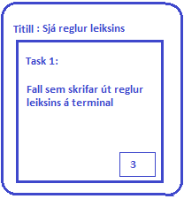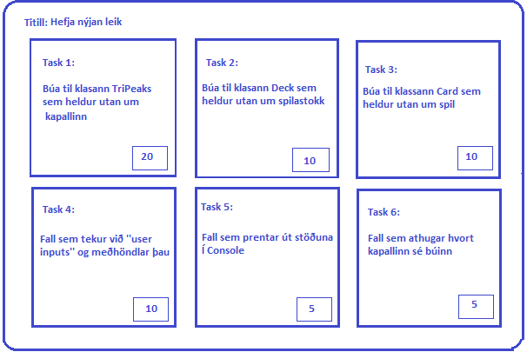

Burn Down

Complete

In Preogress

User Stories

**llllllllllllllllllllllllllllllllllll**

**llllllllllllllllllllllllllllllllllll**



- - - - - - - - - - - - - - - - - - - - - - - - - - - - - - - - - - - - - - - - - - - - - - -

- - - - - - - - - - - - - - - - - - - - - - - - - - - - - - -



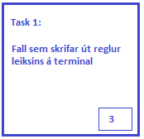

Next

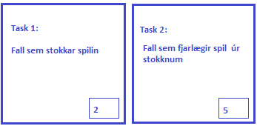

next

- - - - - - - - - - - - - - - - - - - - - - - - - - - - - - - - - - - - - - - - - - - - - - -

- - - - - - - - - - - - - - - - - - - - - - - - - - - - - - - - - - - - - - - - - - - - - - - - - - - - - - - - - - - - - - - - - - - - - - - - -- -

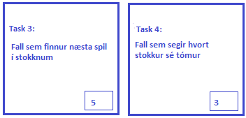

Completed





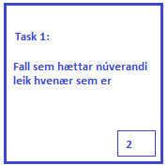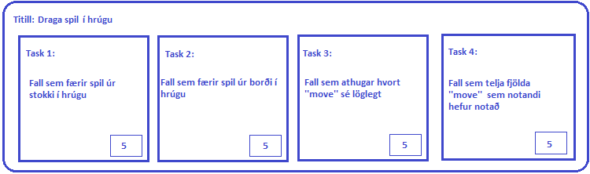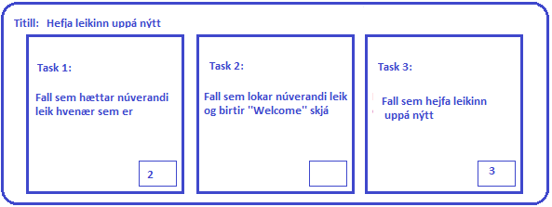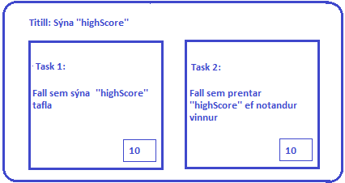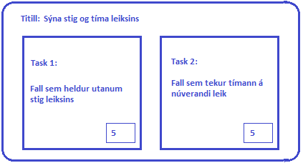

Burn Down

Complete

In Preogress

User Stories

**llllllllllllllllllllllllllllllllllll**

**llllllllllllllllllllllllllllllllllll**

- - - - - - - - - - - - - - - - - - - - - - - - - -

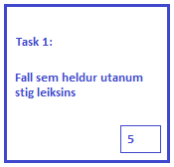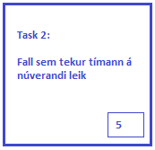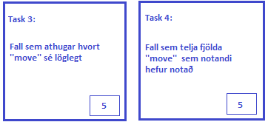

next

Completed

- - - - - - - - - - - - - - - - - - - - - - - - - - - - - - - - - - - - - - - - - - - - - - -

- - - - - - - - - - - - - - - - - - - - - - - - - - - - - - - - - - - - - - - - - - - - - - - - - - - - - - - - - - - - - - - - - - - - - - - - -- -