Engagement Terhadap Konten Negatif Terkait aa di Wilayah Merpati-14

No. | Tautan Konten | Nama Akun | Narasi | Eviden
1 | https://vt.tiktok.com/ZSPgHqRpw/ | @Indiyana1 |  | 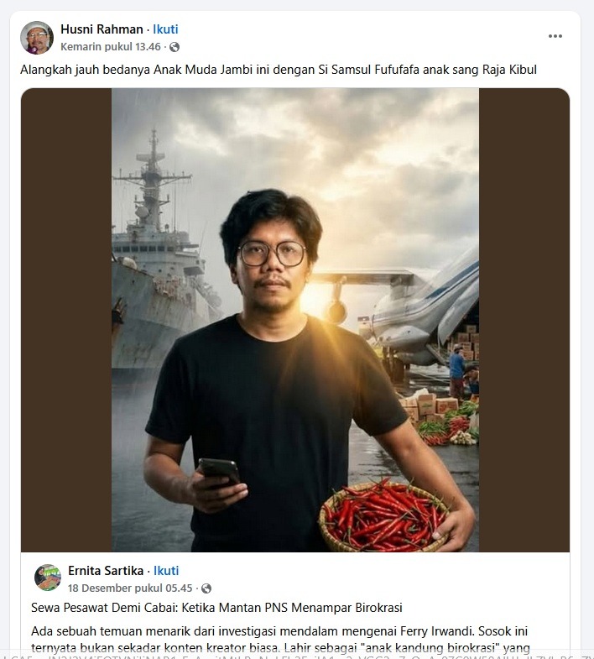
2 | https://vt.tiktok.com/ZSPgHqRpw/ | @Indiyana1
3 | https://vt.tiktok.com/ZSPgHqRpw/ | @Indiyana1
4 | https://vt.tiktok.com/ZSPgHqRpw/ | @Indiyana1
5 | https://vt.tiktok.com/ZSPgHqRpw/ | @Indiyana1

