**Team 1: Precision Beacon Navigation**

**Requirements Document**

**Tahir Aziz**

**Adeel Khan**

**Sabur Khan**

**Alejandro Guzman**

**Casey Boyle**

**02/09/17**

**TABLE OF CONTENTS**

**ABSTRACT**

**FUNCTIONAL REQUIREMENTS**

**NON-FUNCTIONAL REQUIREMENTS**

**CONSTRAINTS**

**CONTEXT DIAGRAM**

**USE CASE MODEL FOR FUNCTIONAL REQUIREMENTS:**

* GRAPHIC USE CASE MODEL
* TEXTUAL DESCRIPTION FOR EACH USE CASE
  + Use Case Name
  + Participating Actors
  + Entry Condition(s)
  + Normal Flow of Events
  + Exit Condition(s)
  + Exceptions (Alternate Flow of Events)
  + Special Requirements
* RATIONALE FOR THE USE CASE

**EVIDENCE OF REQUIREMENTS DOCUMENT CONFIGURATION MANAGEMENT**

**ABSTRACT**

This requirments plan will outline the full requirements for our beacon precision application, we will utilize what we know about the project, and what the customer (Dr.Hill) tells us are in regards to the Functional, Non-Function, and constraint requirements for this project. Also this document will include our use case models, and some descriptions including the rationale for why we made our use case model the way we did. Additionally, to better outline the systems this product will interact with, we will be making a business context diagram.

**FUNCTIONAL REQUIREMENTS**

1. Navigation from 2 points in an indoor location
   1. **The user shall be able to navigate between 2 locations in a building**
   2. The user shall select a starting point
   3. **The user shall select a destination**
   4. The user shall be able to use current location as a starting point
2. Navigation Feedback
   1. **The application shall provide constant haptic (or auditory) feedback when the user is within the path**
   2. **The application shall also provide varying amounts of haptic or auditory feedback when the user is going off course and is off course**
3. Image Processing
   1. The application should have the ability to take in new map images
   2. **The application should be able to determine “walls vs. floors”**
   3. The application should have the option to choose between maps//additional not necessary now
   4. **The application should be able to determine the location of the user in relation to the wall.**
4. Location Display
   1. **The application shall be able to display where the beacons are placed**
   2. **The application shall display the current location of the user**
   3. The application shall turn on and handle location permissions automatically
5. GUI
   1. The GUI of the application shall have the map as the primary user interface
   2. The map should take up 75% of the screen space
   3. **The GUI shall display the beacons and user location per 4.1 and 4.2**
   4. The user shall be able to add beacons the map by selecting from a broadcasting list of beacons
   5. The user shall be able to remove beacons on the map placed per 5.3

**Note: The bolded requirements are the key requirements desired by the customer.**

**NON-FUNCTIONAL REQUIREMENTS**

1. Usability
   1. The application shall be usable for people who are blind
   2. The application shall start navigation in 2 steps - selecting origin and destination
   3. The application shall be simple to use
   4. Initial configuration of beacons shall be simply adding broadcasting beacons to the GUI
   5. The user should not have to reconfigure beacon location after initial setup
   6. The user interface should follow proper UI design guidelines
2. Performance
   1. The application should react to a user getting a TBD distance away from a wall and react according to Functional Requirement 2.2
   2. The beacons should be on at all times in case a user is using the application
   3. The application should not take longer than 3 seconds to load navigation between 2 points
3. Modifiability
   1. The application should be able to evolve from being a visual application to one that can actually be used by people with visual impairments
4. Reliability
   1. The application should not crash when choosing new maps
   2. The application shall not crash in the middle of navigation
   3. The application shall not have delayed haptic feedback
   4. The application should not provide haptic feedback at the wrong times
   5. The application should be able to function regardless of what kind of building they're in.

**CONSTRAINTS**

1. Operating System
   1. The application shall be developed only on the Android OS
2. Hardware
   1. Beacons shall be the hardware used to help with trilateration and navigation guidance
   2. The Beacons will need to be configured before usage.
3. Navigation Scope
   1. This application will be used in indoor navigation only
4. Image Processing
   1. The maps will need to be preprocessed before usage
   2. The maps will have to follow color guidelines to differentiate between walls and floors
5. Beacons
   1. The beacons must constantly be broadcasting
   2. The device must always be polling for the beacons’ signals
   3. The device must always pick up the signal from the beacons

**CONTEXT DIAGRAM**

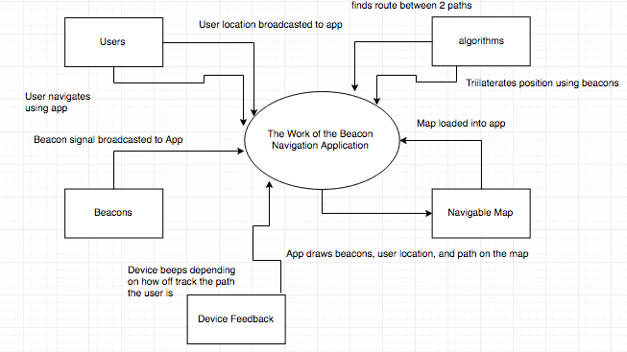

**USE CASES**

1. Navigation: Refer to figure 1
   1. Actors:
      1. Users
   2. Entry Condition(s)
      1. User Opens Application
   3. Normal Flow of Events
      1. User Opens App
      2. User selects start point
      3. User selects destination
      4. User follows directions
      5. User reaches destination
   4. Exit Condition(s)
      1. User reaches destination
   5. Exceptions (Alternate Flow of Events)
      1. User quits app mid-navigation
      2. User changes mind and re-routes
      3. User gets lost
   6. Special Requirements
      1. None
   7. Rationale:
      1. Navigation is a key function of this product so it should be a use case
2. Navigation Feedback: Refer to Figure 2
   1. Actors:
      1. Users
   2. Entry Condition(s)
      1. User enters navigation
   3. Normal Flow of Events
      1. User navigates
      2. While user is on path, constant haptic/audio feedback (beeping) is given
   4. Exit Condition(s):
      1. User completes navigation
   5. Exceptions:
      1. If user deviates, more alerted beeping is done
   6. Special requirements:
      1. None
   7. Rationale:
      1. Since we want to display feedback to users who are blind, giving auditory or haptic feedback based on their navigation must also be a use case
3. Image Processing: Refer to Figure 3
   1. Actors:
      1. Users
   2. Entry Condition(s):
      1. Map has not been loaded into the application or has not been selected
   3. Normal Flow of Events
      1. User Opens App
      2. User adds map to the app
         1. User loads in an existing map
      3. Map is displayed on screen
   4. Exit Conditions
      1. User completes adding of map to app
   5. Exceptions:
      1. User takes a picture of a map to load it in
   6. Special Requirements:
      1. None
   7. Rationale: The primary way to see a map through which one can navigate is through loading one in. Thus, having a use case for that is necessary.
4. Location Display: Refer to Figure 4
   1. Actors:
      1. Users
   2. Entry Conditions(s):
      1. User hasn’t begun navigating yet
   3. Normal Flow of Events
      1. User opens app
      2. Device asks for user location
      3. User grants device location access
   4. Exit Conditions(s):
      1. User gives device location access
   5. Exceptions:
      1. Quit app or display error if location access is not granted
   6. Special Requirements:
      1. None
   7. Rationale:
      1. Knowing the user location needs to be a use case because that will help with trilateration with the beacons, which is the key step in order to navigate with the beacons.
5. GUI: Refer to Figure 5
   1. Actors:
      1. Users
   2. Entry Condition(s):
      1. No beacons have been placed on the map
   3. Normal Flow of Events:
      1. User detects no beacons are connected on the app
      2. User clicks add button to see available beacons
      3. User selects beacons to add
      4. Map displays beacons
   4. Exit Conditions:
      1. User completes selection of beacons to add to map
   5. Exceptions
      1. User deletes beacons off the map
   6. Special Requirements:
      1. None
   7. Rationale: Since the app requires an initial setup to have beacons loaded on the map in order to navigate, having that step as a use case is important.

**USE CASE FIGURES**

Figure 1: Navigation

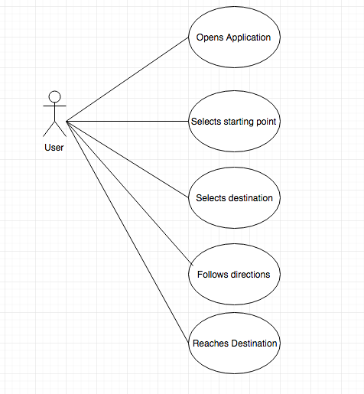

Figure 2: Navigation Feedback

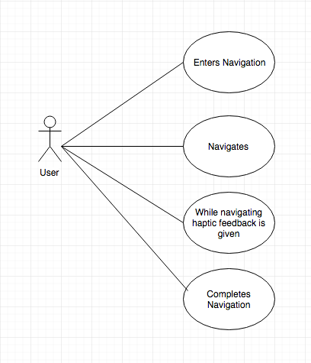

Figure 3: Map

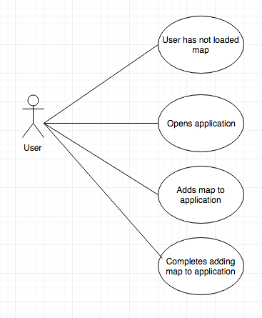

Figure 4:

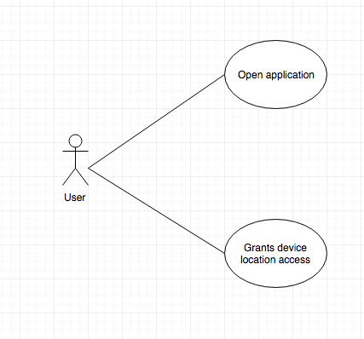

Figure 5:

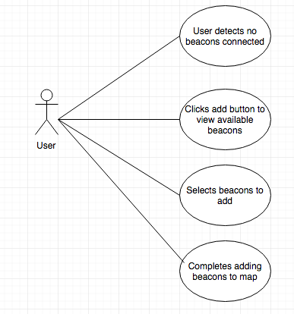

**EVIDENCE OF REQUIREMENTS DOCUMENT CONFIGURATION MANAGEMENT**

1. The requirements were drafted
2. The requirements were refined after talking to team members and the industry sponsor
3. The requirements were recorded in Google Documents
4. The requirements documentation was shared via Slack for feedback from team members