**Team 1: Precision Beacon Navigation**

**Detailed Design Documentation**

**Tahir Aziz**

**Adeel Khan**

**Sabur Khan**

**Alejandro Guzman**

**Casey Boyle**

**3/17/17**

**TABLE OF CONTENTS**

**INTRODUCTION**

**GUI Design**

**STATIC MODEL CLASS DIAGRAMS**

**DYNAMIC MODEL SEQUENCE DIAGRAMS**

**TRACEABILITY FROM REQUIREMENTS TO DETAILED DESIGN MODEL**

**EVIDENCE THE DESIGN MODEL HAS BEEN PLACED UNDER CONFIGURATION**

**INTRODUCTION**

This document serves as the detailed design document for the project. The purpose of this document is to outline the requirements of the project in terms of the technical design that the high level requirements entail. For this document, we will be showing the the graphical user interface, the static model class diagrams, the dynamic model sequence diagram, the rationale for our detailed design, and the traceability from the the requirements to the detailed design. This will allow us to ensure that the project remains in scope by tying the technical components to the actual requirements, and that will make it easier for ensuring that all requirements are met.

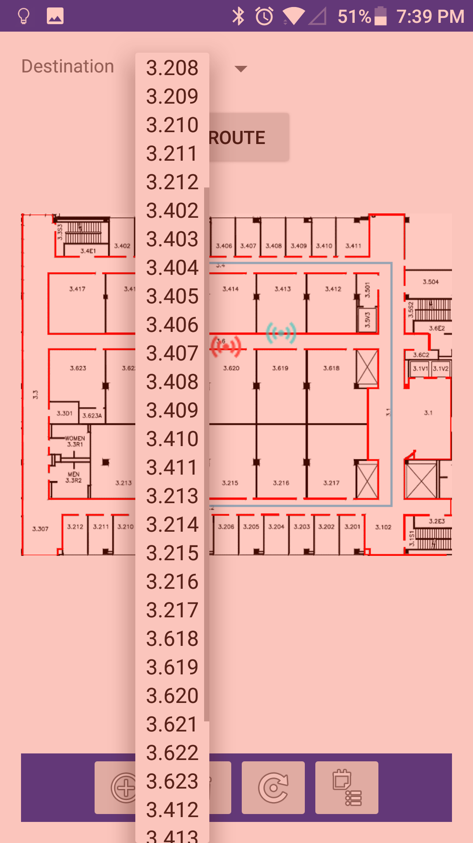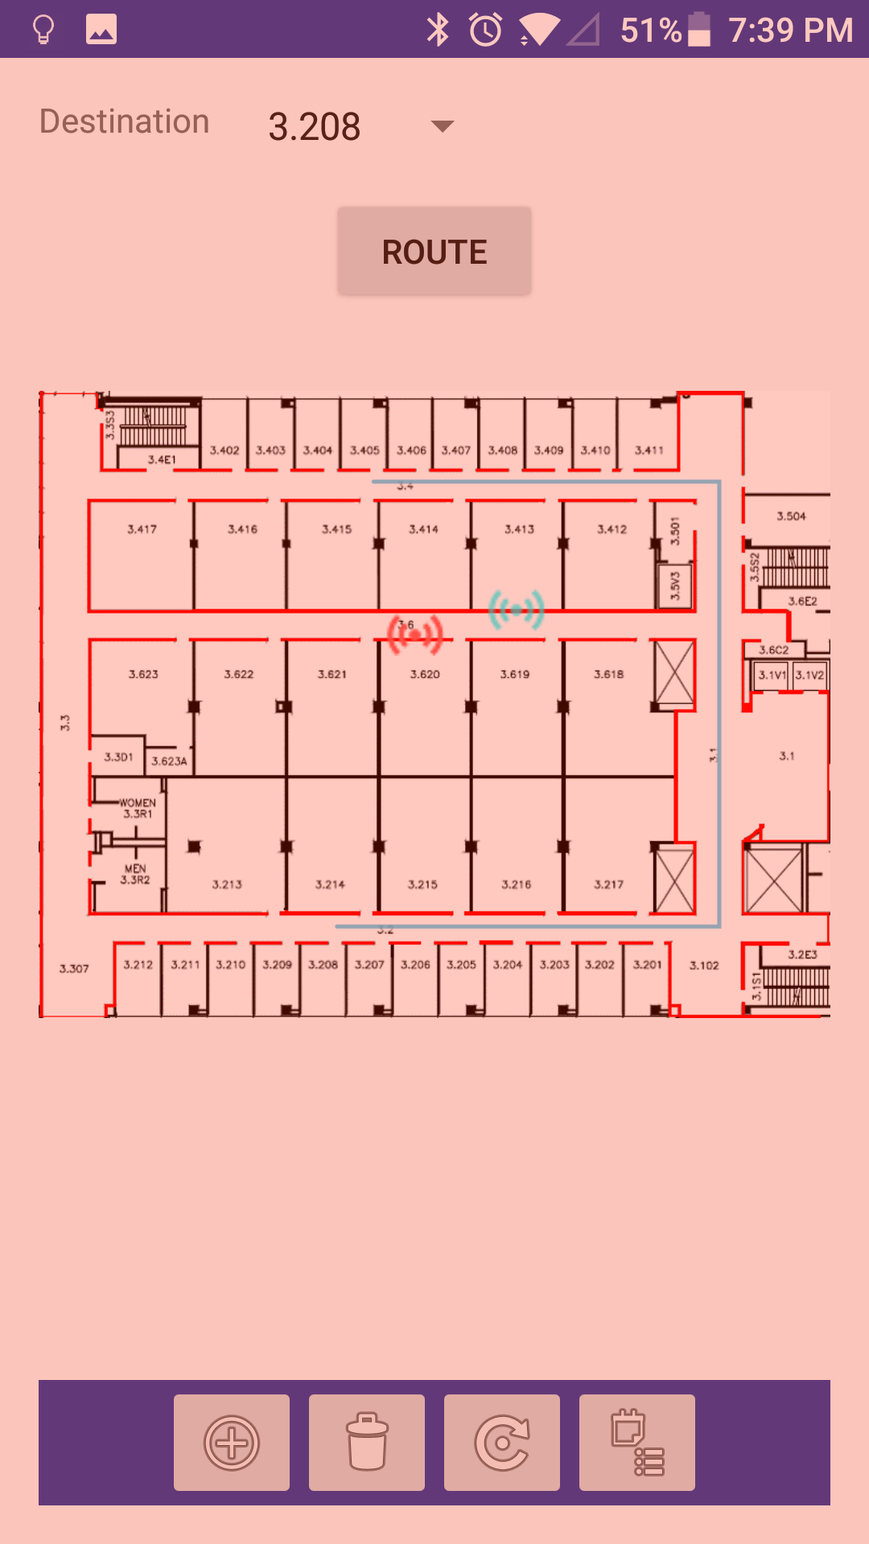

**GUI (Graphical User Interface) Design**

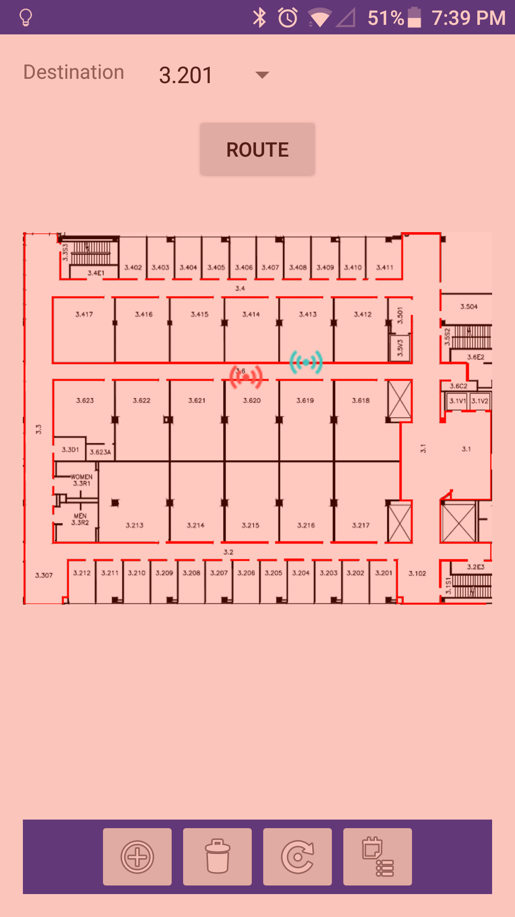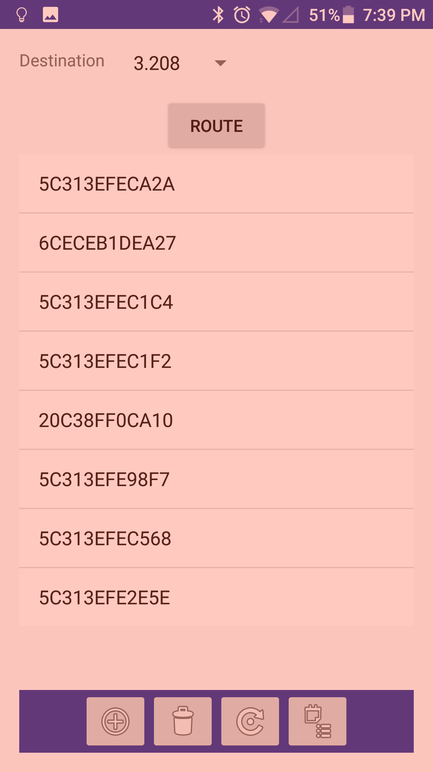

**STATIC MODEL CLASS DIAGRAMS**

DetailedDesignUML.png

**DYNAMIC MODEL SEQUENCE DIAGRAMS // captured in Rose**

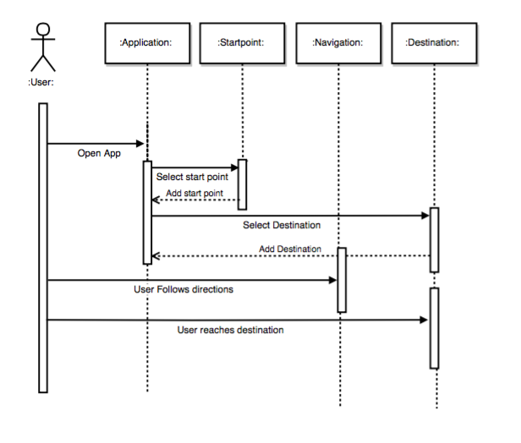

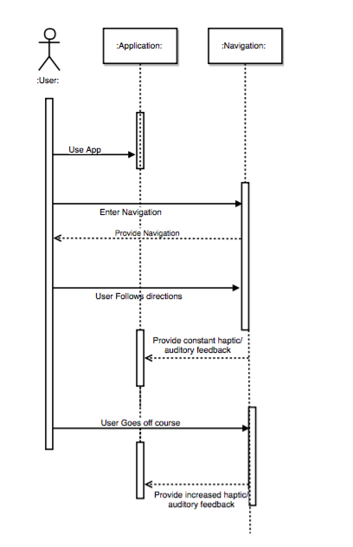

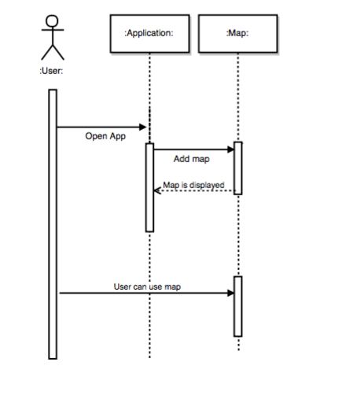

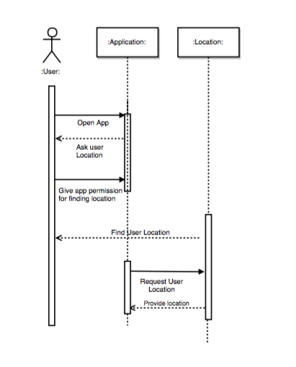

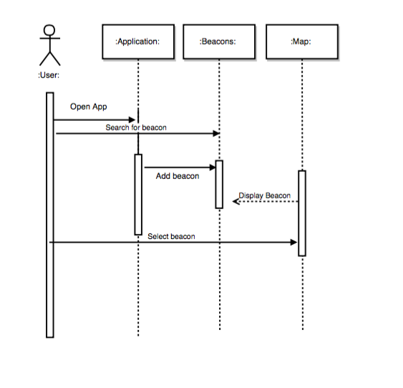

**TRACEABILITY FROM REQUIREMENTS TO DETAILED DESIGN MODEL**The sequence diagrams that were drawn in this document were taken directly from the Use cases that we came up with in the requirements document. We see a lot of the features that we had first thought of as just requirements “come to life” in this document.

Specifically sequence diagram one correlates with the first use case “Navigation”, sequence diagram two correlates with the second use case “Navigation feedback”, sequence diagram three correlates with the third use case “Image Processing”, sequence diagram four correlates with the fourth use case “Location Display”,  
sequence diagram five correlates with the fifth use case “GUI”.

**EVIDENCE THE DESIGN MODEL HAS BEEN PLACED UNDER CONFIGURATION**

The outline of the document was taken from the template provided on the senior design website. Then, the outline was edited to include elements relevant to our project, and then the document was filled out and completed on Google Docs so it could be worked on and shared by multiple people on the team. For drawing diagrams, draw.io was used to draw the diagrams because it also allowed real time collaboration with team members so it was more convenient to use for the team while still being able to draw the diagrams.