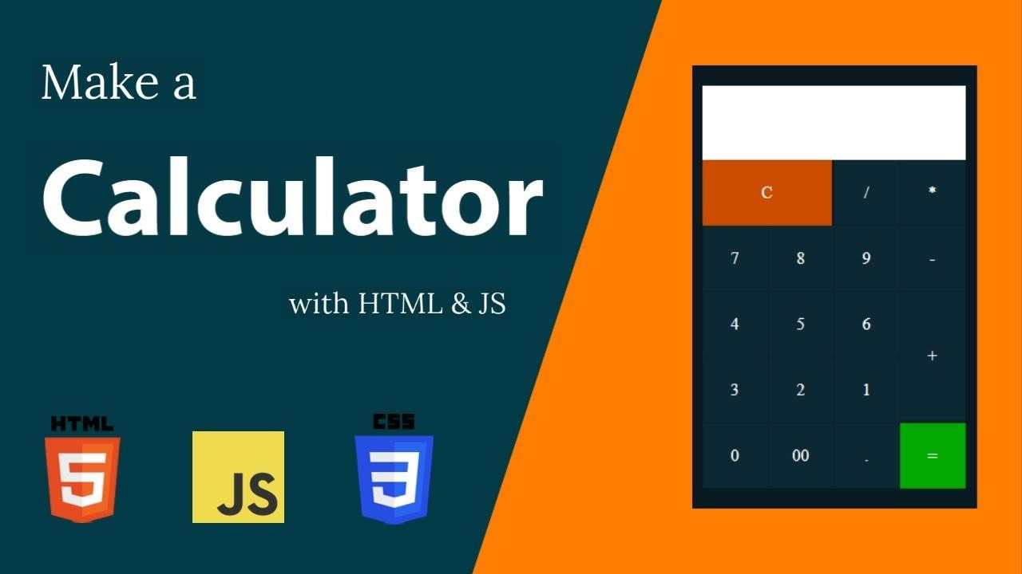

**MINI PROJECT**

# CALCULATOR

**SUBMITTED BY**

**AGVEENA XAVIER (312322205005)**

**IT-A**

INTRODUCTION:

In the realm of web development, creating a calculator using HTML, CSS, and JavaScript is a fundamental project that combines frontend design with interactive functionality. This project aims to build a user-friendly calculator interface that performs basic arithmetic operations such as addition, subtraction, multiplication, and division.

ABSTRACTION:

A calculator interface is designed with HTML and styled using CSS. JavaScript handles user interactions, appending input to the display and evaluating expressions. Functions include appending values, clearing the display, and calculating results. The design is responsive, featuring buttons for digits, operators, and a clear function. CSS ensures a visually pleasing layout. This abstraction encapsulates a basic calculator's functionality in a concise manner, integrating HTML, CSS, and JavaScript.

PROJECT SCOPE :

The project aims to develop a simple web-based calculator using HTML, CSS, and JavaScript. The scope includes creating a user interface with input display and buttons for digits, operators, and functions such as clear and calculate. The calculator should handle basic arithmetic operations (+, -, *, /) and display results accurately. The design should be responsive and visually appealing across different devices. The focus is on functionality, usability, and code simplicity. Future enhancements may involve adding advanced operations, improving error handling, and optimizing performance. The project's goal is to provide a functional and intuitive calculator for everyday use on the web.

SOURCE CODE:

|  |
| --- |
| <!DOCTYPE html>  <html>  <head>    <title>CALCULATOR</title>      <style> @import url('https://fonts.googleapis.com/css2?family=Nunito:wght@200;300;400;500;600;  700;800;900;1000&display=swap');  *{ margin: 0px; padding:0px; font-family: Arial, Helvetica, sans-serif; box-sizing: border-box; user-select: none;  } body{  height:100vh; Background: #240046; display:grid;  }  .container{ width: 100%;  height: 100%;  display: flex;  }  .calculator{  background: #023e7d; padding: 10px; box-shadow: 0px 0px 10px 3px rgba(0, 0, 0, 0.219); margin:auto;    border-radius: 10px;  }    .calculator form input { border: 0; outline: 0; width: 60px; height:60px; border-radius: 10px; |

|  |
| --- |
| font-family: Nunito; font-weight: 700; font-size:1.7em; color: white; cursor: pointer; margin: 10px;    }  .calculator form input.NumpadBtns{ background: #012a4a;  } form .display{ display: flex; justify-content: flex-end; margin: 20px 0;  } form .display input{ text-align: right; flex: 2; font-size: 45px; box-shadow: none; padding:20px; box-sizing: border-box; background: #218380; box-shadow: 0 0 10px 3px #00000033; height:80px; color: white;  } form input.equal{ width: 145px; background: #005f08  } form input.ac,form input.del{ background: #5f0000  }    .symbols{  background-color: #edae49;  }  .special{ background: #248277;  }    .calculator form input:hover { box-shadow: 0px 0px 5px 3px #00000025; }  </style> |
| <body>  <div class="container">  <div class="calculator">  <form>  <div class="display">  <input type="text" name="display" disabled>  </div>  <div>  <input type="button" value="AC" onclick="display.value =''" class="ac">  <input type="button" class="del" value="Del" onclick="display.value =display.value.toString().slice (0,-1)"> <input type="button" class="symbols" value="." onclick="display.value +='.'">  <input type="button" class="symbols" value="/" onclick="display.value +='/'">  </div>  <div>  <input type="button" class="NumpadBtns" value="7" onclick="display.value +='7'">  <input type="button" class="NumpadBtns" value="8" onclick="display.value +='8'">  <input type="button" class="NumpadBtns" value="9" onclick="display.value +='9'">  <input type="button" class="symbols" value="*" onclick="display.value +='*'">  </div>  <div>  <input type="button" class="NumpadBtns" value="4" onclick="display.value +='4'">  <input type="button" class="NumpadBtns" value="5" onclick="display.value +='5'">  <input type="button" class="NumpadBtns" value="6" onclick="display.value +='6'">  <input type="button" class="symbols" value="-" onclick="display.value +='-'">  </div>  <div>  <input type="button" class="NumpadBtns" value="1" onclick="display.value +='1'">  <input type="button" class="NumpadBtns" value="2" onclick="display.value +='2'">  <input type="button" class="NumpadBtns" value="3" onclick="display.value +='3'">  <input type="button" class="symbols" value="+" onclick="display.value +='+'"> | |

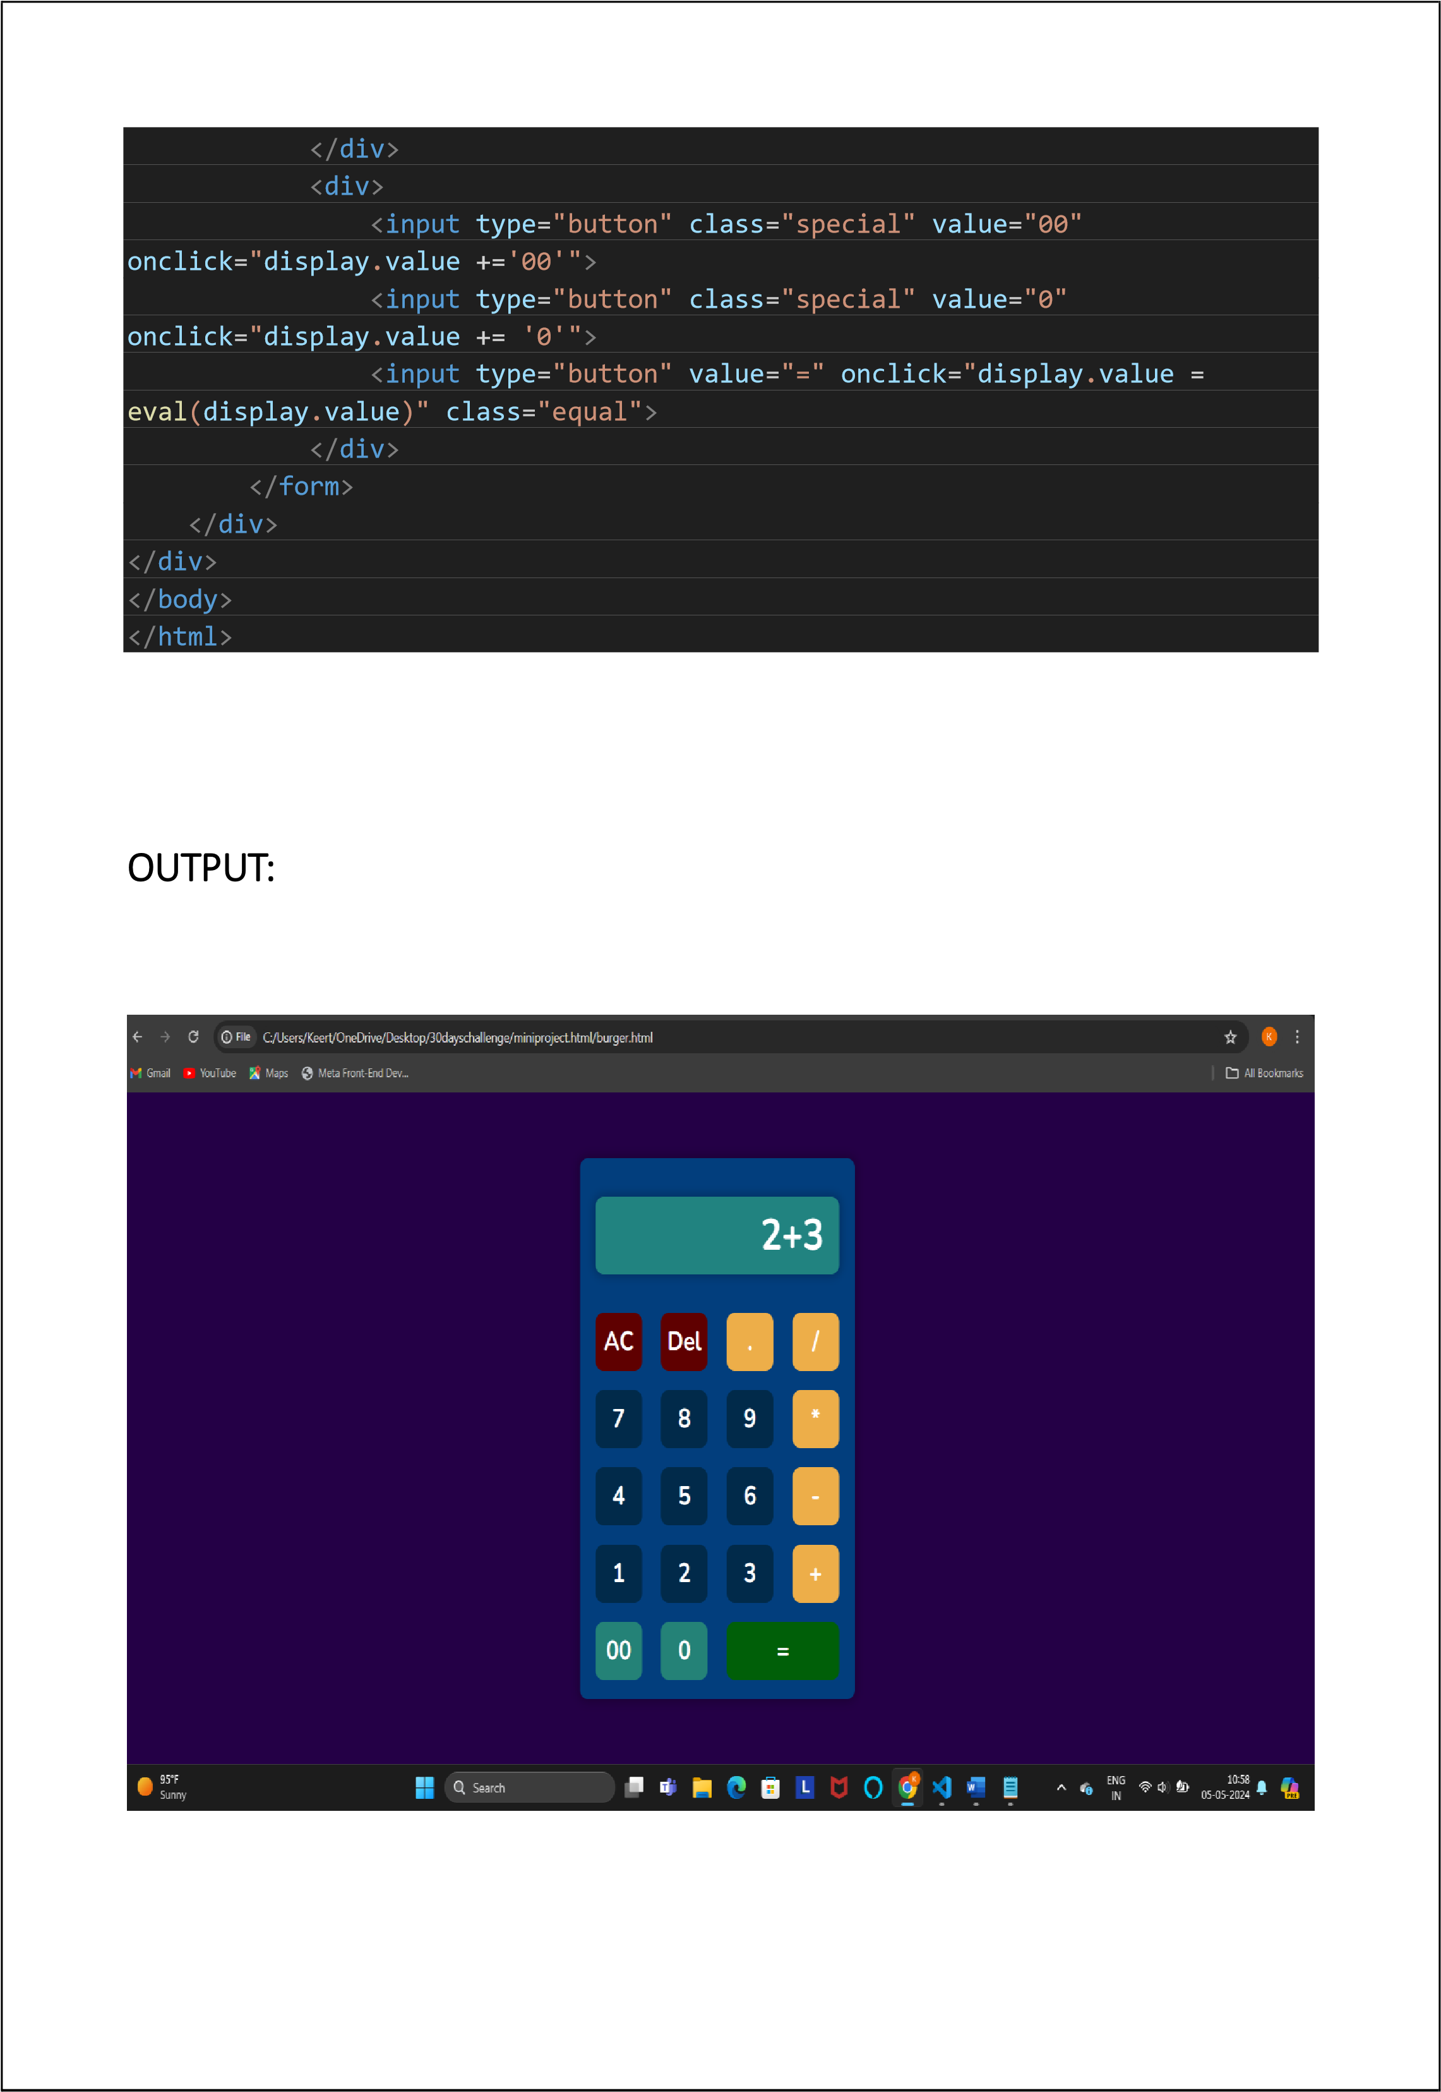

CONCLUSION : In conclusion, the project successfully accomplishes the development of a basic web-based calculator using HTML, CSS, and JavaScript. The calculator features a responsive and visually appealing interface with buttons for digits, operators, and essential functions like clear and calculate. Despite its simplicity, the calculator effectively handles basic arithmetic operations and accurately displays results. While the project meets its primary objectives, there is room for further enhancements such as adding advanced operations, improving error handling, and optimizing performance. Overall, the project demonstrates the integration of front-end technologies to create a functional and intuitive calculator for everyday use on the web