**EXPERIMENT NO: 1**

**TITLE:** TO USE DDL COMMANDS IN MYSQL TO DESIGN THE GIVEN DATABASE SCHEMA

1. **THEORY**

DDL stands for Data Definition Language. It can be sued to define some constraints as well. It basically defines the column (attributes) of the table. Basic command present in DDL are CREATE, DROP, RENAME, ALTER, etc. SQL DDL provides commands for defining relation schemas, deleting schema, deleting relations and modifying relational schemas.

Example:

CREATE TABLE stud

(

stu_no NUMBER(2) PRIMARY KEY,

sname VARCHAR(20) NOT NULL

);

CREATE TABLE class

(

Class_id NUMBER(5) PRIMARY KEY,

class NUMBER(3),

section VARCHAR(10) NOT NULL,

sname varchar(20) NOT NULL,

FOREIGN KEY(sname) REFERENCES stud(sname)

);

1. **PROBLEM**

Create database schemas as shown below and also insert the data.

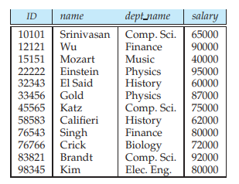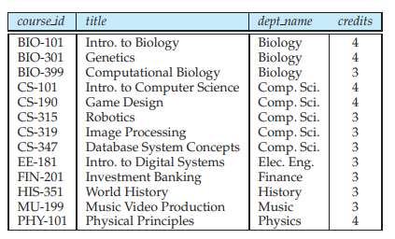

Relation: instructor Relation: course

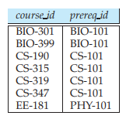 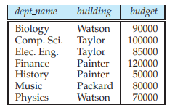

Relation: prereq Relation: department

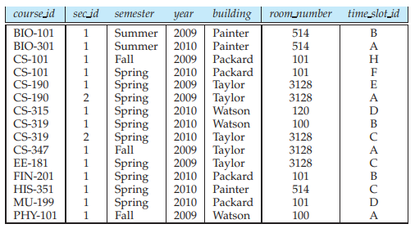

Relation: section

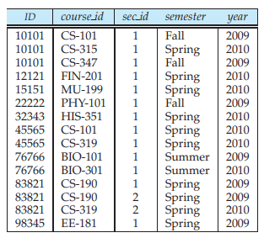

Relation: teaches

1. **PROGRAM**
2. Create data base university



1. Create table instructor

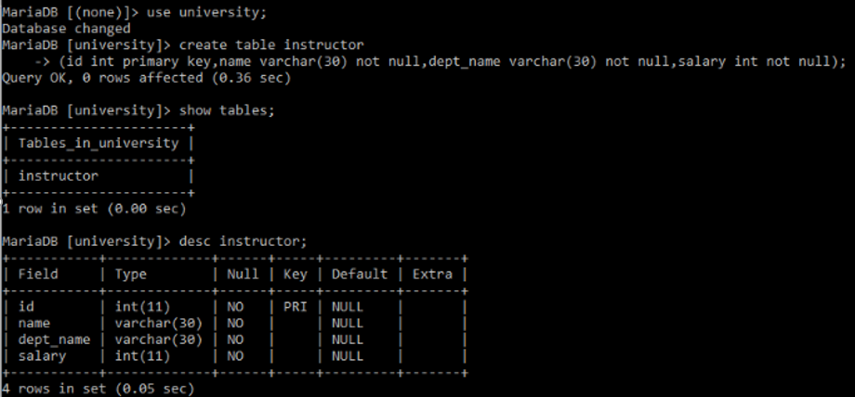

1. Create table course

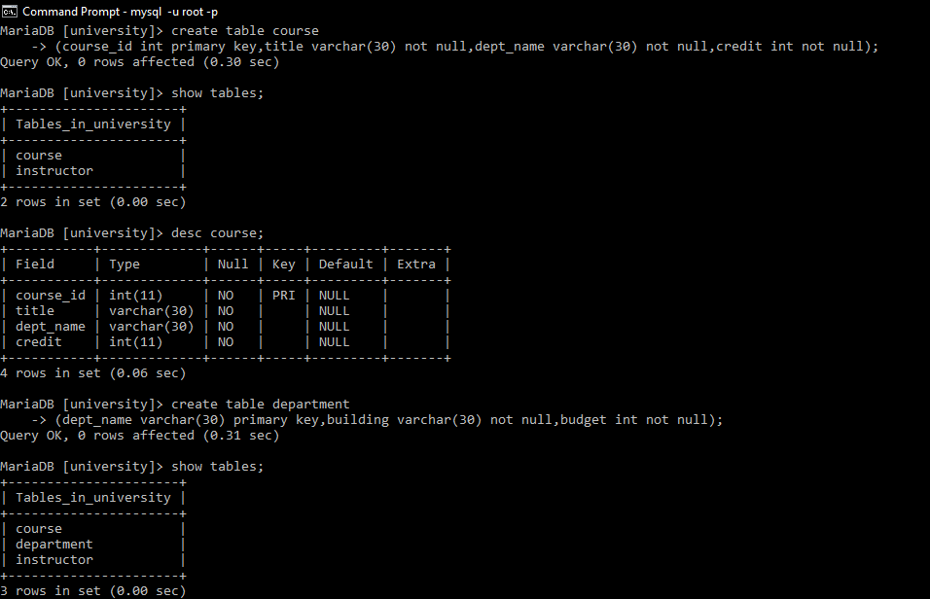

1. Drop tables instructor and course

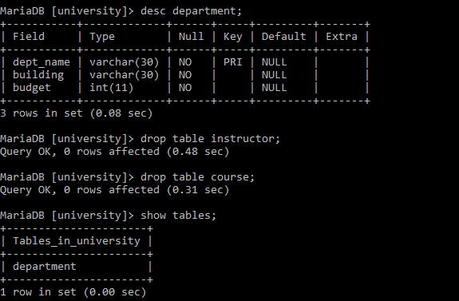

1. Create table instructor and course

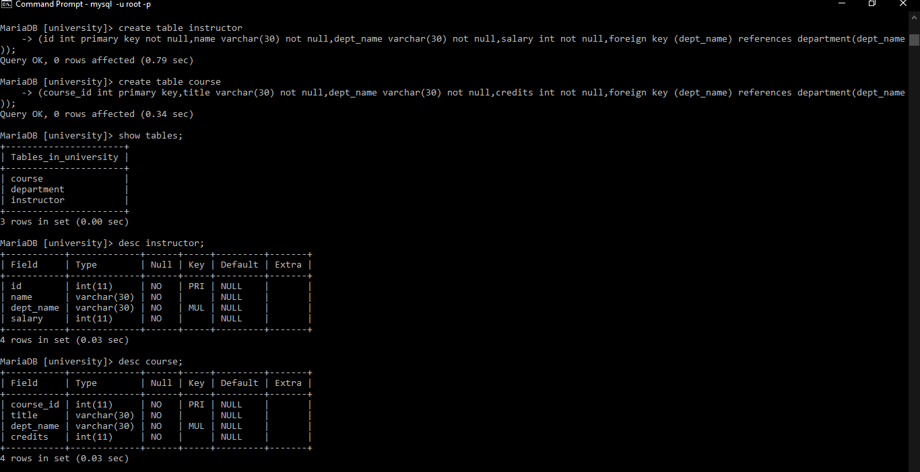

1. Insert record in table department

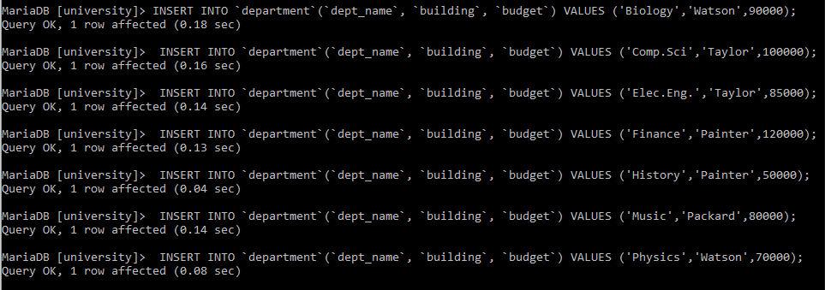

1. Insert record in table instructor

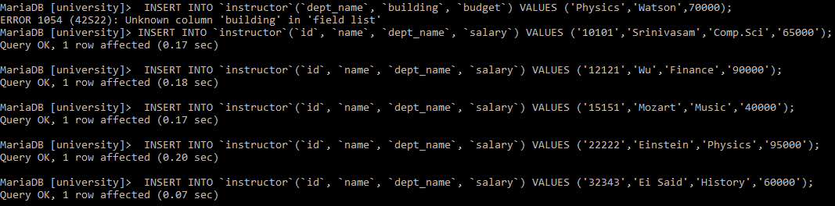

1. Insert record in table course





1. Create table prereq and insert record

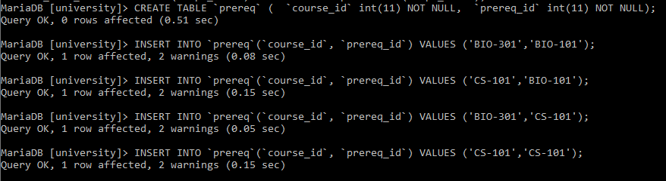

1. Create table section and insert records

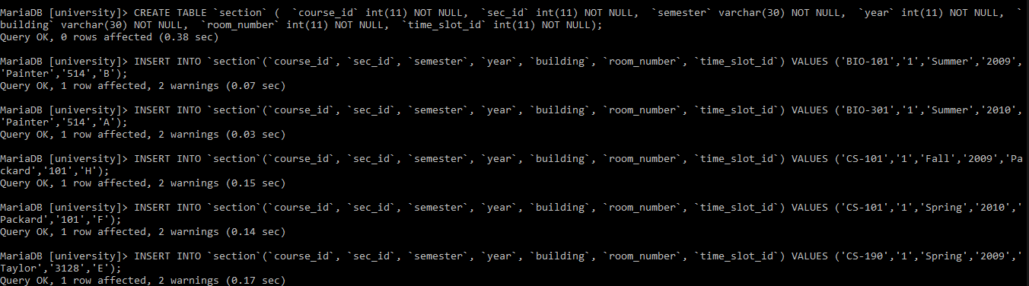

1. Create table teaches and insert records

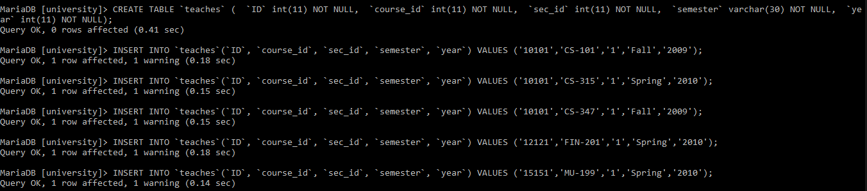

1. **CONCLUSION**

SQL DDL commands are executed using command prompt. Hence, we are able to create database university, tables department, course, instructor, prereq, section and teaches. Also we are able to insert records in each tables.