AGYA GUPTA 12016563

university student record management system

**TABLE OF CONTENTS**

|  |  |
| --- | --- |
| TOPICS | PAGE  NO. |
| 1. INTRODUCTION  2. OBJECTIVE  3.PROJECT WORKFLOW  4.SOURCE CODE  5. OUTPUT SCREENS  6. FUTURE SCOPE  7. REFERENCES | 1  2  3  4-10  11-12  13  14 |

**INTRODUCTION**

This is a student record management system project, which enables you to create student data and there are student login portal , faculty portal for assigning marks, and admin portal as well. It utilizes file handling and shows the class and object of the programming language. It is a very effective and simple understanding of beginners.

This system is based on a concept to store and generate all the records of the students. Also, this program has a simple database of students for a school where the user can add student details safely and it’s not time-consuming. This System makes it easy to store records of each. Moreover, the user can view all the records, modify and remove the details. Also, this project is easy to operate and understand by the users.

1

**OBJECTIVE**

University Student Record Management system is a management information system for education establishments to manage student data.

It provide capabilities for registering students in courses , assigning them marks, viewing their data through faculty and admin portal.

2

**PROJECT WORKFLOW**

This project works by registering students with their proctor ids and registration numbers. There is also a faculty login portal which contain currently two subjects only for assigning marks and viewing the data through admin portal secured with a password as well.

3

**SOURCE CODE**

4

**#include <fstream>**

**#include <iostream>**

**#include <stdio.h>**

**#include <string.h>**

**using namespace std;**

**int main()**

**{**

**char data[15];**

**int n = 0, option = 0, count_n = 0;**

**string empty = "00";**

**string proctor = "";**

**ifstream f("ffc.txt");**

**string line;**

**for (int i = 0; std::getline(f, line); ++i) {**

**count_n++;**

**}**

**while (option != 6) {**

**cout << "\nUniversity management system \n1. Add New "**

**"Students\n2."**

**<< "Student Login\n3. Faculty Login\n4. "**

**"Proctor Login\n5. Admin View\n"**

**<< "6. Exit\nEnter option: ";**

**cin >> option;**

5

if (option == 1) {

cout << "Enter the number of students: ";

cin >> n;

count_n = count_n + n;

for (int i = 0; i < n; i++) {

ofstream outfile;

outfile.open("ffc.txt", ios::app);

cout << "Enter your registration number: ";

cin >> data;

outfile << data << "\t";

cout << "Enter your name: ";

cin >> data;

int len = strlen(data);

while (len < 15) {

data[len] = ' ';

len = len + 1;

}

outfile << data << "\t";

outfile << empty << "\t";

outfile << empty << "\t";

cout << "Enter your proctor ID: ";

cin >> proctor;

outfile << proctor << endl;

}

} else if (option == 2) {

char regno[9];

cout << "Enter your registration number: ";

cin >> regno ;

6

ifstream infile;

int check = 0;

infile.open("ffc.txt", ios::in);

while (infile >> data) {

if (strcmp(data, regno) == 0) {

cout

<< "\nRegistration Number: " << data

<< endl;

infile >> data;

cout << "Name: " << data << endl;

infile >> data;

cout << "C++1001 mark: " << data

<< endl;

infile >> data;

cout << "java102 mark: " << data

infile >> data;

cout << "Proctor ID: " << data << endl;

infile.close();

check = 1;

}

}

if (check == 0) {

cout << "No such registration number found!" << endl;

}

}

7

else if (option == 3) {

char subcode[7];

cout << "Enter your subject code: ";

cin >> subcode;

string code1 = "C++1001", code2 = "java102", mark = "";

ifstream infile;

int check = 0;

cout << "\nAvailable operations: \n1. Add data " "about marks\n"<< "2. View data\nEnter option: ";

cin >> option;

if (option == 1) {

cout << "Warning! You would need to add mark" << "details for all the students!"<< endl;

for (int i = 0; i < count_n; i++) {

if (strcmp(subcode, code1.c_str()) == 0) {

file.seekp(26 + 37 * i,

std::ios_base::beg);

cout << "Enter the mark of student#" << (i + 1) << " : ";

cin >> mark;

file.write(mark.c_str(), 2);

} if (strcmp(subcode, code2.c_str())

== 0) {

file.seekp(29 + 37 * i,

std::ios_base::beg);

cout << "Enter the mark of student#"

<< (i + 1) << " : ";

cin >> mark;

file.write(mark.c_str(), 2);

} } }

8

else if (option == 2) {

infile.open("ffc.txt", ios::in);

if (strcmp(subcode, code1.c_str()) == 0) {

cout << "Registration number - Marks\n” << endl;

while (infile >> data) {

cout << data;

infile >> data;

infile >> data;

cout << " - " << data << endl;

infile >> data;

infile >> data;

check = 1;

} }

infile.close();

infile.open("ffc.txt", ios::in);

if (strcmp(subcode, code2.c_str()) == 0) {

cout << "Registration number - Marks\n" << endl;

while (infile >> data) {

cout << data;

infile >> data;

infile >> data;

infile >> data;

cout << " - " << data << endl;

infile >> data;

check = 1;

} } }

infile.close();

if (check == 0) {

cout << "No such subject code found!” << endl;

} }

9

cout << "No such subject code found!" << endl;

} }

else if (option == 4) {

char procid[7];

cout << "Enter your proctor ID: ";

cin >> procid;

int check = 0;

char temp1[100], temp2[100], temp3[100];

char temp4[100], id[100];

ifstream infile;

while (infile >> temp1) {

infile >> temp2;

infile >> temp3;

infile >> temp4;

infile >> id;

if (strcmp(id, procid) == 0) {

cout << "\nRegistration Number: " << temp1 << endl;

cout << "Name: " << temp2 << endl;

cout << "C++1001 Mark: " << temp3 << endl;

cout << "java102 Mark: " << temp4 << endl;

check = 1;

} } if (check == 0) {

cout << "No such proctor ID found!" << endl;

} }

else if (option == 5) {

char password[25];

cout << "Enter the admin password: ";

cin >> password;

10

string admin_pass = "admin";

if (strcmp(password, admin_pass.c_str()) == 0) {

cout << "Reg No. "

"\tName\tC++1001\tjava102\tProctor "

"ID"

<< endl;

ifstream infile;

infile.open("ffc.txt", ios::in);

char data[20];

while (infile >> data) {

cout << data << "\t";

infile >> data;

cout << data << "\t";

infile >> data;

cout << data << "\t";

infile >> data;

cout << data << "\t";

infile >> data;

cout << data << endl;

}

}

}

}

}

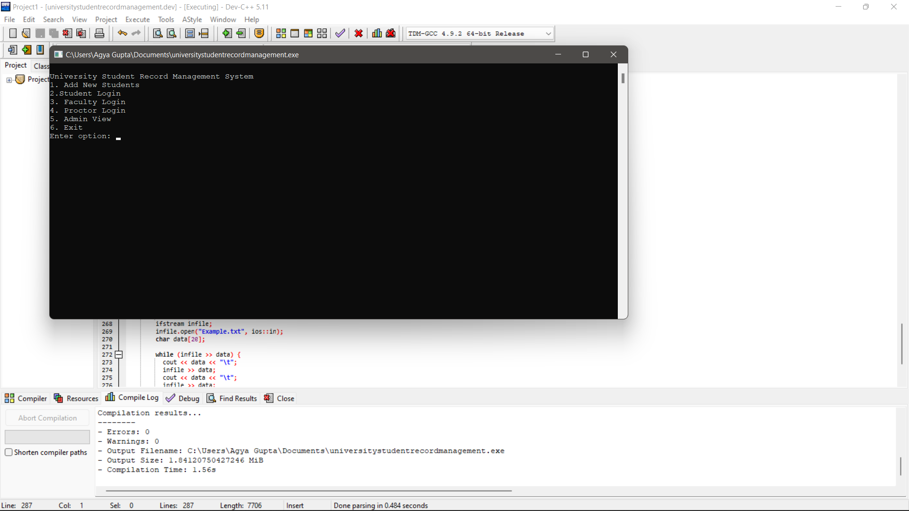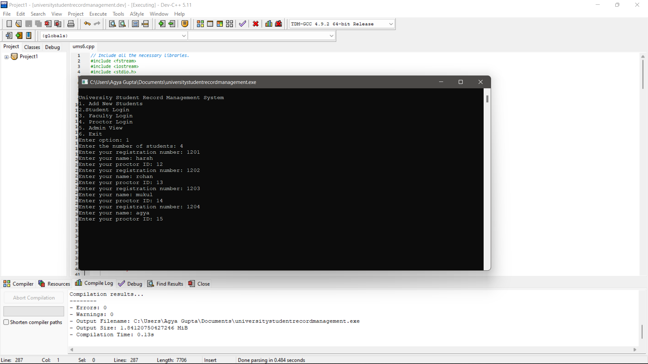**OUTPUT SCREENS**

11

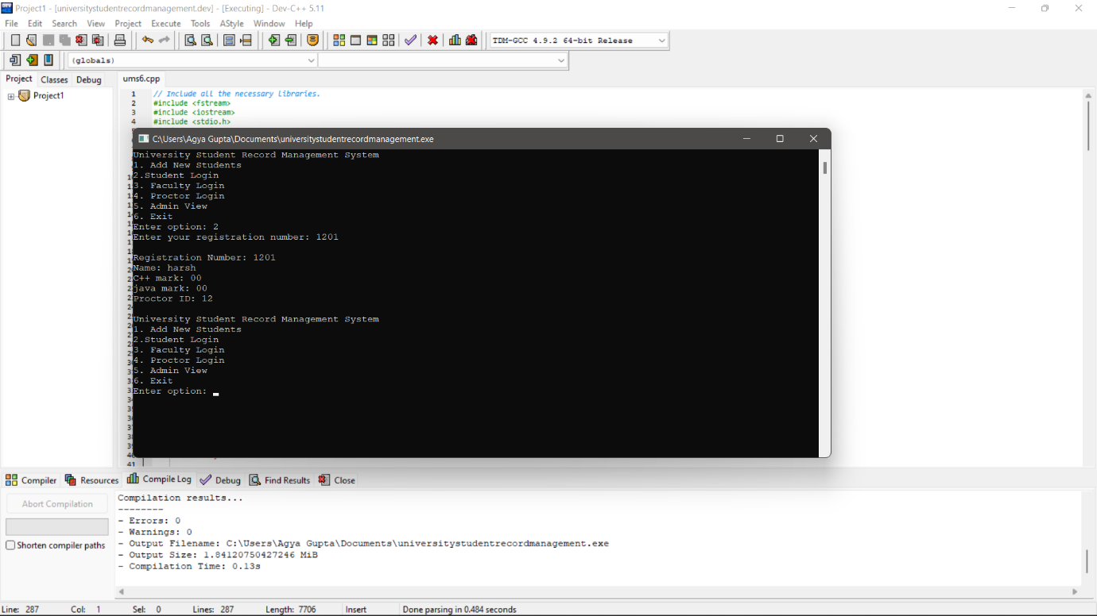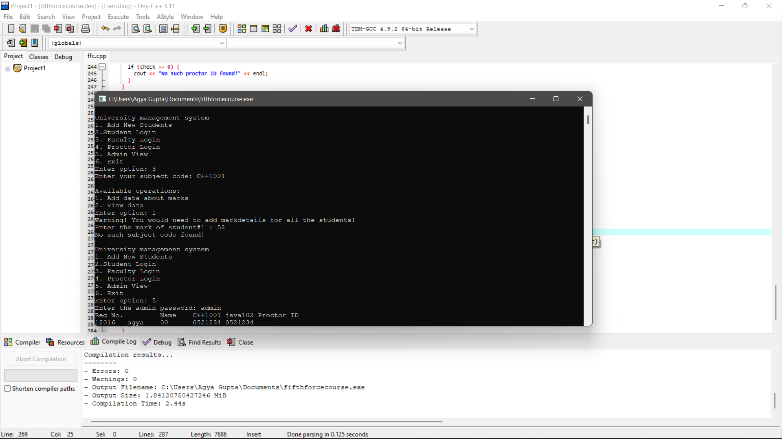

12

**FUTURE SCOPE**

The project can be upgraded at a higher level with the help of many other programming languages and also in the form of an application as and when required to introduce new features. In future this project can be used by educational institutions to manage the records of students.

13

**REFERENCES**

1. **GOOGLE**
2. **C++ WITH DSA CLASSES BY FIFTH FORCE**
3. **YOUTUBE**

14

**THANK YOU**