## Whack A Mole

CA3 Project Report

Submitted to **: Dr. Allam Mohan**

Course Name **: Front End Web Developer**

Course Code **: INT 219**



**Submitted by**

Name : **Agya Gupta**

Registration no. : **12016563**

Section : **KM112**

# ACKNOWLEDGEMENT

I take this opportunity to express my profound gratitude and warm regards to our faculty Dr. Allam Mohan for giving this project to me where I can work on this project and enhance my skills that will definitely help me in my future.

# About Game :-

The game Name is Whack A Mole in this there are 6 holes and from each hole when you click the start button a creature known as Mole comes out we have to click it thorough mouse and if we are able to click it the scoreboard increases this will continue till some time and in this time we have to increase our score .

To make this project, I have used HTML, CSS and JavaScript.

**HTML -** For basic layout of the page. **CSS -** For Styling and beautifying. **JS -** For creating logic.

## The main page goes like this:

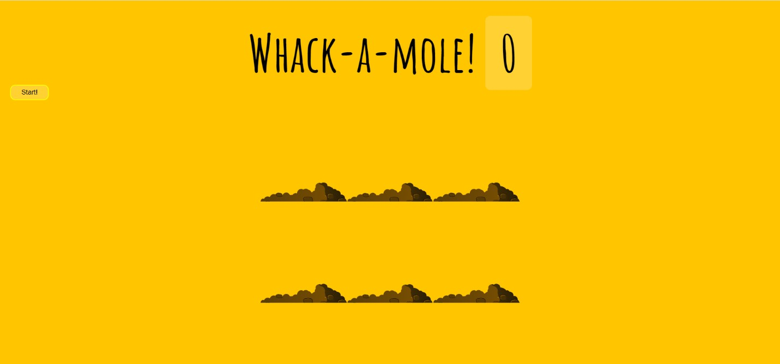

**BACKGROUND** - The background is a solid color which is a shade of yellow (#ffc600).

**BUTTON** - In the page the player will get One Start button by clicking that button on the left hand side the player can start the Game.

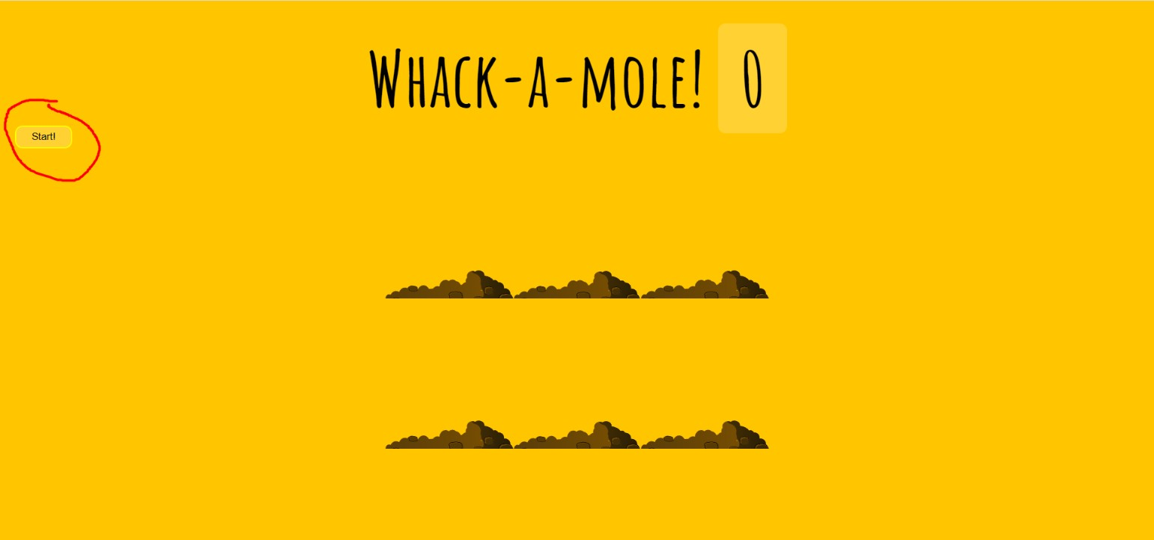

**START BUTTON** - If the player clicks on the “START” button, the mole start coming out of the bush holes and they come for a certain time period and you can start clicking them .

**This Will look like this :**

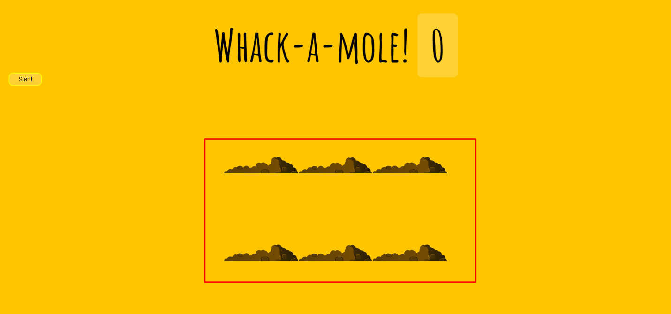

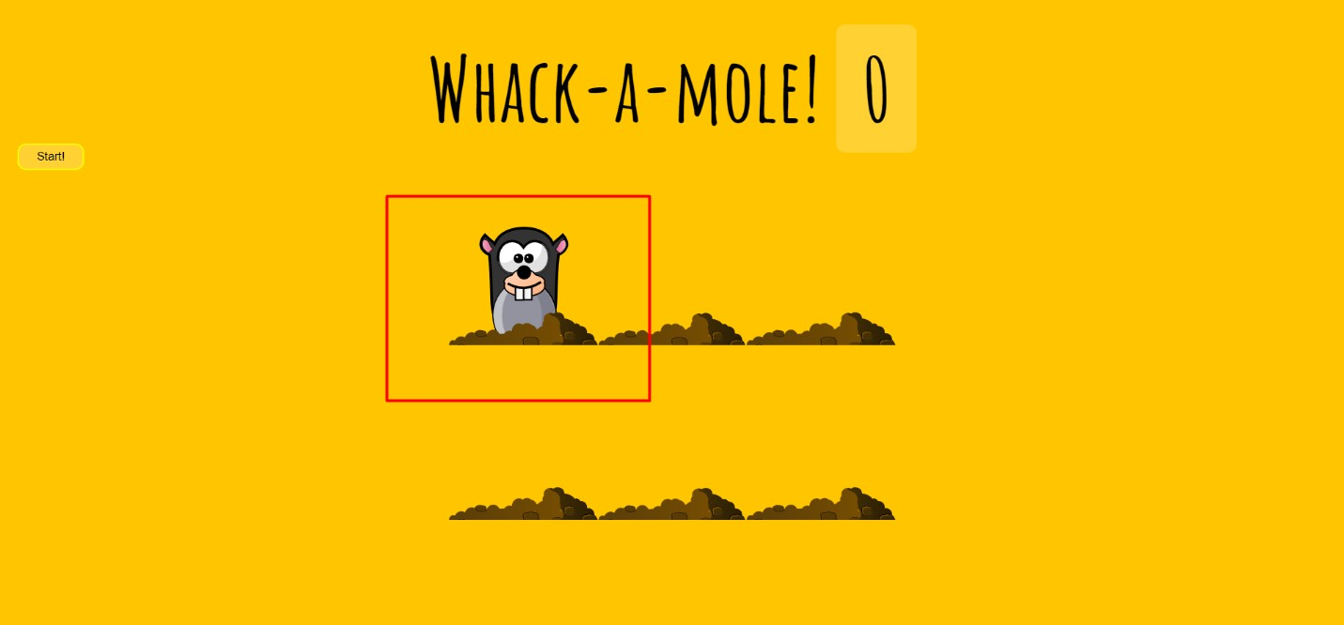

**After** clicking the start button when the moles start coming out from the bush holes they come

in different time interval and speed some time they is only one mole and sometimes there are two we have to click on them in order to increase our score the Score updates in real time as when we whack one mole the score gets updated to one whenever we whack a mole the score increase and this all looks likes this ….

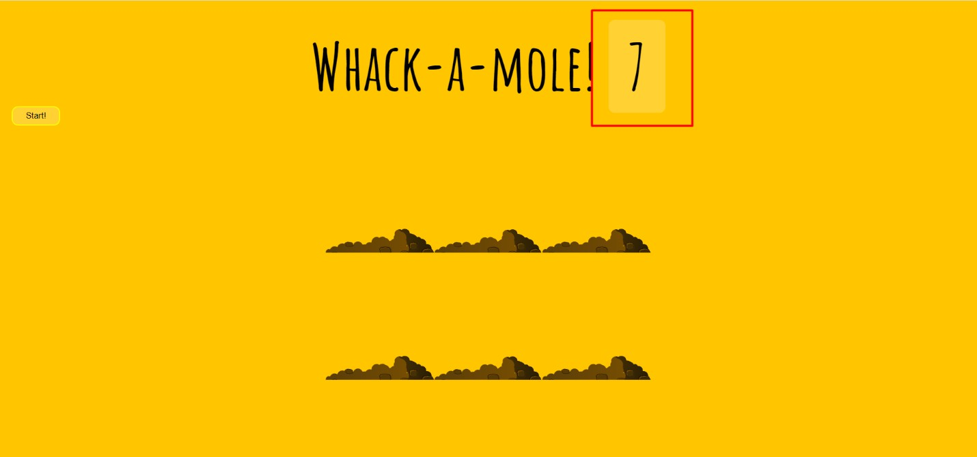

In this image the the highlighted part is Score of the player (For example in this image the player only got 7 score ).

## The Code:

**HTML & JAVASCRIPT:**

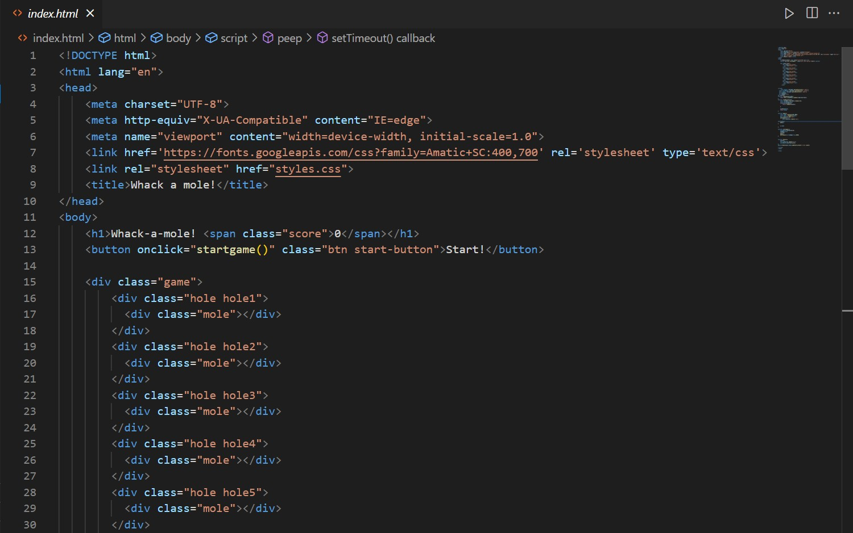

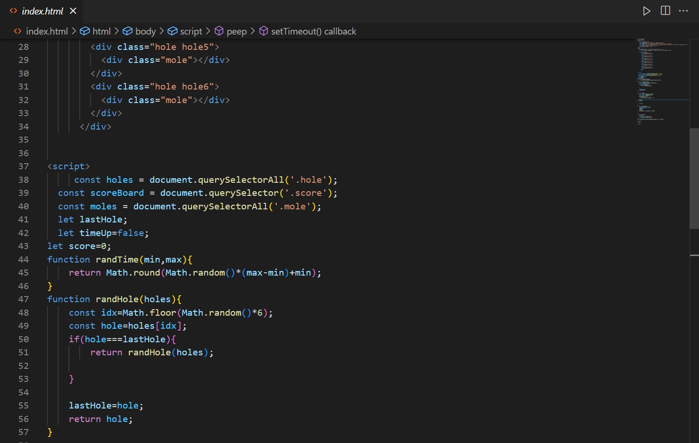

# Text Description automatically generatedCSS :

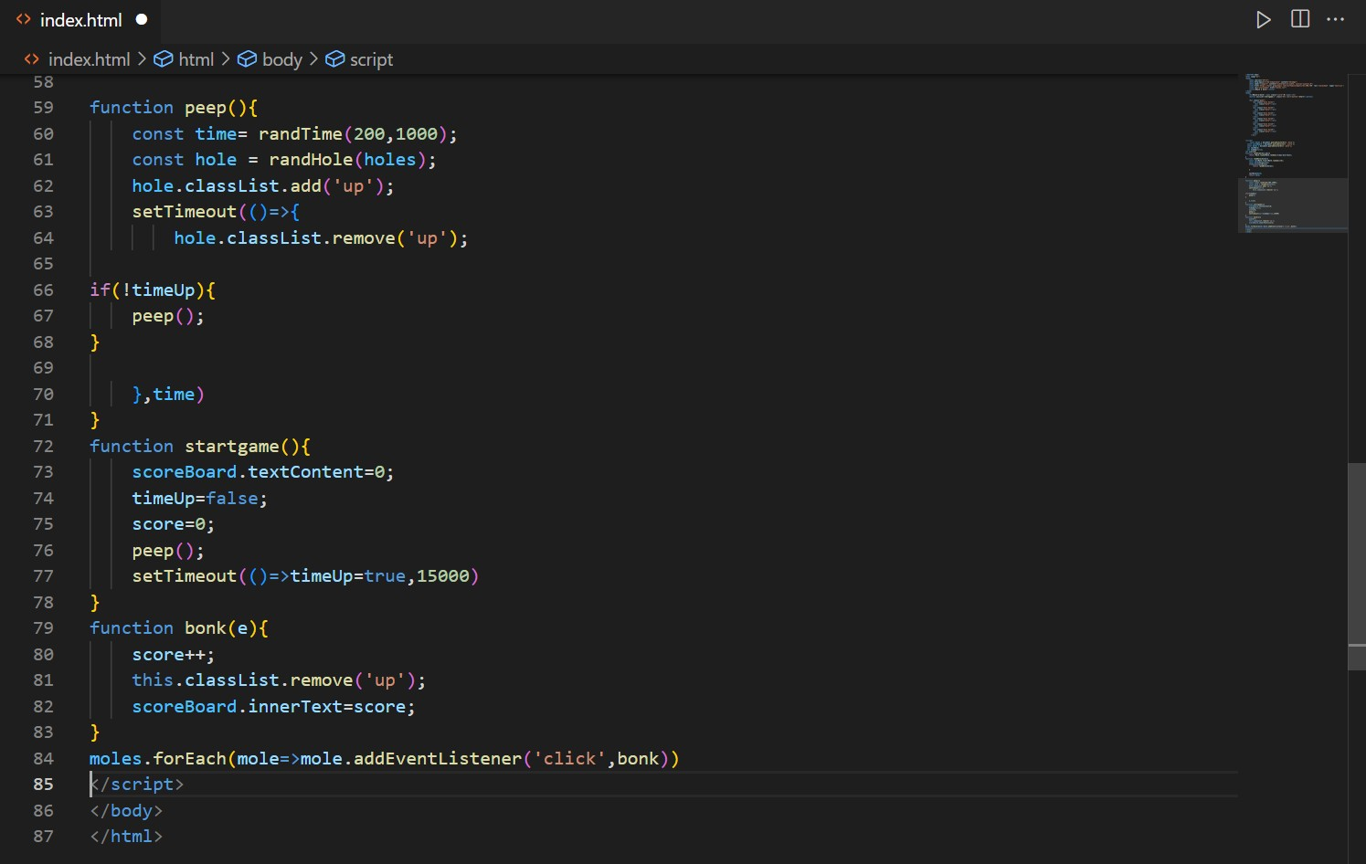

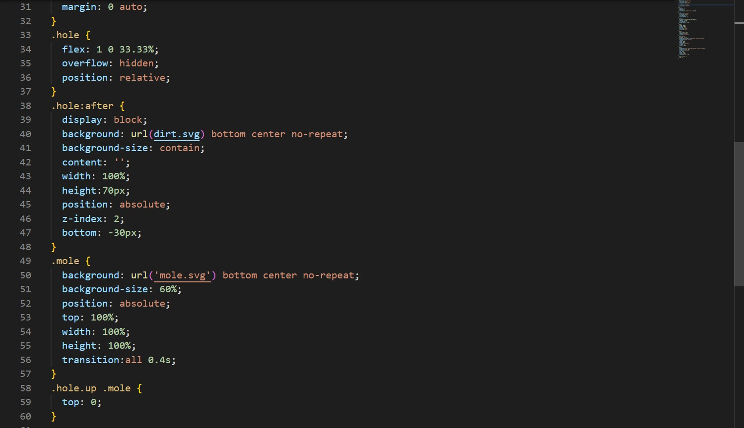

**CONCLUSION**

It was a great experience working on this project. It helps in enhancing the knowledge about real time projects, how to solve a problem statement and find a best possible solution out of it.

It allows users to play the game in their laptops or phones in whichever device they are comfortable.

Working on this project gave me immense knowledge about HTML, CSS and JavaScript and I will keep working on it to enhance it.