MPhil Research in Cybersecurity — Design Science Research
Literature Review
A Human-AI Collaborative Security Intervention Framework
for Mitigating Vulnerability Degradation in Iterative LLM-Assisted Code Refinement

Field | Detail
Candidate | [Your Name]
Programme | MPhil in Cybersecurity
Supervisor | [Supervisor Name]
Institution | [Your University]
Total Papers Reviewed | 35+ (enhanced from original 28)
Themes | 6 (expanded from 5)
Date | 29 May 2026
Version | 2.0 — Enhanced with diagrams, Themes 6 (Regulatory) and multi-agent section

1. Introduction
The integration of Large Language Models (LLMs) into software development has fundamentally reshaped how code is written, reviewed, and iteratively refined. Tools such as GitHub Copilot, ChatGPT, and Claude are now used by over 80% of developers in their daily workflows (GitHub, 2024). While these tools offer significant productivity gains, the security implications of their use — particularly within iterative, conversational development loops — remain critically underexplored.

The most pressing challenge is not merely that AI-generated code contains vulnerabilities in isolation, but that these vulnerabilities compound and accumulate as developers engage in multi-turn refinement cycles. Shukla, Joshi, and Syed (2025) provide the first systematic empirical evidence of this phenomenon — termed 'feedback loop security degradation' — demonstrating a 37.6% increase in critical vulnerabilities after just five iterations of LLM-assisted code refinement without human intervention. Their findings challenge the foundational assumption that iterative AI refinement improves code quality and highlight an urgent need for structured human oversight mechanisms.

This literature review maps the current state of knowledge across six interconnected themes and establishes the scholarly basis for a Design Science Research (DSR) artefact — a Human-AI Collaborative Security Intervention Framework — that fills a critical and confirmed gap. The review is structured as follows: Section 2 grounds the study in DSR methodology; Section 3 examines empirical evidence on security vulnerabilities in AI-generated code; Section 4 reviews human-AI collaboration models; Section 5 analyses automation bias and developer trust; Section 6 evaluates existing HITL and security frameworks; Section 7 addresses regulatory and governance context; and Section 8 synthesises all themes and identifies the research gap.

Central Research Gap: No designed, evaluated artefact exists that operationalises human-AI collaboration to mitigate security degradation specifically within iterative LLM-assisted code refinement workflows. This review confirms this gap across six independent literature streams and positions the proposed DSR artefact as the first to address it.

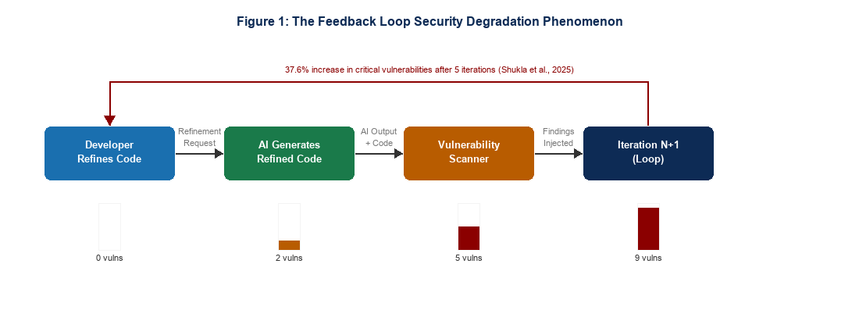
Figure 1: The Feedback Loop Security Degradation Phenomenon (Shukla et al., 2025)

2. Design Science Research as the Methodological Lens
Design Science Research (DSR) is a well-established research paradigm in Information Systems that seeks to extend human and organisational capabilities through the creation and evaluation of innovative artefacts (Hevner et al., 2004). Rather than seeking to explain or predict phenomena, DSR aims to prescribe solutions — producing constructs, models, methods, or instantiations that address real-world problems with rigour and relevance. For a study seeking to design a framework that mitigates security degradation in AI-assisted development, DSR is the most appropriate methodological fit.

The most widely adopted DSR process model is that of Peffers et al. (2007), which defines six phases: problem identification and motivation, definition of objectives, design and development, demonstration, evaluation, and communication. This model has guided dozens of cybersecurity-specific DSR studies. Alexei (2022) employed the Peffers model to develop a cybersecurity framework for Higher Education Institutions in Moldova. A HICSS-57 study (2024) used DSR iterations to derive design principles for a cybersecurity readiness assessment tool, using the FEDS evaluation framework to rigorously validate the resulting artefact across multiple cycles.

A critical dimension of DSR is artefact evaluation. Hevner et al. (2004) identify seven guidelines for DSR, with evaluation being among the most demanding. Venable et al. (2012) extend this with a comprehensive framework distinguishing formative from summative evaluation, and naturalistic from artificial contexts. Pastor et al. (2024) further propose a dual-cycle DSR model distinguishing the design cycle from the empirical validation cycle. Chan (2026) introduces the SHAPR framework — operationalising human-AI collaborative research through structured DSR in AI-assisted development environments, directly mapping Action Design Research principles onto AI-augmented workflows.

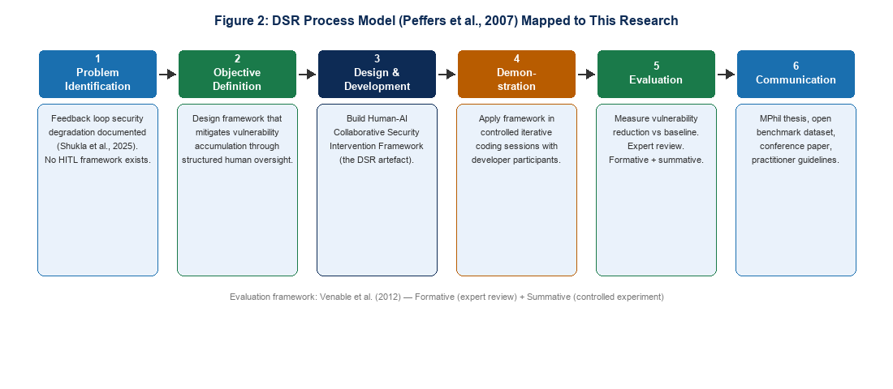
Figure 2: DSR Process Model (Peffers et al., 2007) Mapped to This Research

3. Security Vulnerabilities in AI-Generated Code

3.1 Foundational Evidence of Vulnerability Introduction
The empirical study of security vulnerabilities in AI-generated code has grown substantially since 2022. Pearce et al. (2022) conducted one of the earliest and most influential evaluations, examining approximately 1,689 programs generated by GitHub Copilot across 89 scenarios covering 18 Common Weakness Enumeration (CWE) categories. Their findings revealed that roughly 40% of generated programs contained security vulnerabilities, with particularly elevated rates in C code (approximately 50%) compared to Python (approximately 39%). This study established the critical baseline that LLMs do not inherently produce secure code — and that vulnerability patterns are language-dependent.

Perry et al. (2023) expanded on this through a controlled user study showing that participants using AI tools produced significantly less secure code while simultaneously rating their own code as more secure — a dynamic the authors term a 'false sense of security.' Majdinasab et al. (2024) replicated Pearce et al.'s Copilot study at IEEE SANER, confirming elevated vulnerability rates in more recent model versions. A comprehensive systematic review by Negri-Ribalta et al. (2024), synthesising 19 studies, confirmed broad scholarly consensus: AI models do not produce safe code despite mitigation efforts. The CSET (2024) similarly found that almost half of AI-generated code in studied repositories contained exploitable vulnerabilities. Blain and Noiseux (2026), using formal verification via Z3 SMT solver across 3,500 code artefacts from seven LLMs, concluded that AI-generated code is 'broken by default' in security-critical domains.

3.2 Iterative Refinement and Security Degradation
Shukla, Joshi, and Syed (2025) provide the most systematic treatment of the iterative refinement problem to date. In a controlled experiment with 400 code samples across 40 rounds — employing four prompting strategies (efficiency-focused, feature-focused, security-focused, and ambiguous) — they document a clear non-linear accumulation of vulnerabilities. Average vulnerability counts per sample rose from 2.1 in early iterations to 6.2 by iterations 8–10, with statistically significant differences confirmed by repeated-measures ANOVA (F(9,90) = 14.32, p < 0.001, η² = 0.42). Code complexity was found to be a significant predictor of vulnerability count (β = 0.64, p < 0.001). Crucially, the study deliberately excluded human intervention — explicitly framing this as a worst-case scenario and calling for future research on human-AI collaborative mitigation approaches.

Liu et al. (2024) similarly observed that the refinement process could introduce new issues. Mohsin et al. (2025) introduced CodingCare, a security framework integrating prompt libraries and vulnerability databases, demonstrating reduced CVE counts. Wang et al. (2024), using the CodeSecEval benchmark, found that while advanced models benefit from vulnerability hints, they remain prone to insecure outputs across a wide range of CWE categories.

3.3 Multi-Agent and Automated Repair Approaches
An emerging parallel literature addresses automated multi-agent approaches to secure code generation. AutoSafeCoder (Alqarni et al., 2024) proposes a multi-agent framework with three collaborating agents — a Coding Agent, Static Analyzer Agent, and Fuzzing Agent — that iteratively refine code for both functional correctness and security. Similarly, RAG-assisted secure code generation frameworks (arXiv:2601.00509) integrate compiler diagnostics, symbolic execution, and static analysis into self-repair workflows, finding that the most successful approaches are tool-augmented rather than purely prompt-driven.

These automated approaches represent an important contrast to the framework proposed in this research. While they improve security in automated settings, they do not account for the human cognitive and sociotechnical dimensions that determine whether security interventions are adopted and sustained in real development teams. A purely automated pipeline cannot address automation bias, role-differentiated accountability, or the governance requirements of the EU AI Act — dimensions that require structured human involvement by design.

4. Human-AI Collaboration in Software Development

4.1 Collaboration Models and Frameworks
The study of human-AI collaboration in software engineering has emerged as a distinct research area. Hamza et al. (2023) examined how developers and AI systems collaborate across coding, testing, and debugging tasks, identifying three conditions for effective collaboration: clear role allocation, effective communication protocols, and balanced task distribution. Fragiadakis et al. (2024) proposed a methodological framework for evaluating human-AI collaboration encompassing task effectiveness, cognitive load, trust calibration, and communication quality — criteria directly applicable to assessing whether a structured human intervention model genuinely improves security outcomes.

Cabrero-Daniel et al. (2024) found that the effectiveness of human-AI collaboration is highly context-dependent — varying with team structure, task complexity, and the transparency of AI outputs. Bobba (2025) proposes a taxonomic framework for human-AI collaboration modalities, distinguishing along dimensions of autonomy, cognitive partnership, and task interdependence. Abbasi et al. (2025) extend the collaboration lens to requirements engineering in AI-native development environments, arguing that the division of epistemic labour between human and AI — who knows what, and who is responsible for verifying it — is a fundamental and under-theorised design challenge.

Bridging expertise gaps research (arXiv:2505.03179, 2025) provides important empirical grounding: a controlled mixed-methods user study of 58 participants found that human-AI collaboration improves task performance in cybersecurity tasks, reducing false positives in phishing detection and false negatives in intrusion detection. A learning effect was also observed when participants transitioned from collaboration to independent work — suggesting that well-designed HITL frameworks can support long-term skill development rather than fostering dependency. This finding is particularly relevant for framework design: structured intervention protocols should be designed not merely to catch vulnerabilities but to educate developers about the patterns they encounter.

4.2 Security-Specific Collaboration Frameworks
Mohsin et al. (2024) propose a Unified Framework for Human-AI Collaboration in Security Operations Centres (SOCs) with Trusted Autonomy, defining four levels of automation (Levels 0–4) and mapping SOC security functions to appropriate human-AI collaboration modalities at each level. They integrate HITL mechanisms with cognitive modelling and situation awareness frameworks, providing a precedent for principled autonomy allocation in security-sensitive contexts. While focused on SOC operations rather than code development, this framework establishes design principles transferable to the iterative code refinement context — particularly the notion of threshold-triggered human intervention based on risk level.

5. Automation Bias and the Limits of Developer Trust
A critical but frequently underweighted dimension of human-AI collaboration in secure development is automation bias — the tendency of individuals to over-rely on automated systems, accepting their outputs without sufficient critical evaluation. In the context of AI-assisted code development, automation bias has emerged as a structural risk that undermines the very human oversight that security frameworks depend upon.

Perry et al. (2023) provide the most direct evidence: developers using AI assistants not only wrote less secure code but were more confident in its security. This confidence-competence inversion is precisely the condition that makes iterative AI code refinement dangerous without structured intervention — developers may approve increasingly complex and vulnerability-laden code simply because it was produced by a system they trust.

The CSET (2024) situates this within a broader analysis of automation bias across AI deployment contexts. Horowitz and Kahn (2024), in a large-scale preregistered experiment across 9,000 participants in nine countries, found that automation bias is moderated by domain knowledge — those with deeper AI literacy are better calibrated in their trust. This finding suggests that developer expertise is a meaningful moderator of security risk, with junior developers potentially more susceptible to automation bias-induced vulnerability blind spots.

Alebachew and Brown (2024), examining automatic bias detection in source code review, demonstrate that biases are often invisible to those exhibiting them — reinforcing the case for structural rather than purely educative mitigations. Industry data underscores the scale of the problem: Sonar's 2026 State of Code Developer Survey found that 96% of developers do not fully trust AI-generated code without manual intervention — yet nearly half report that reviewing AI-generated code takes more effort than reviewing human-written code, with 38% stating they sometimes skip review due to this burden. This creates a paradox: developers recognise the need for review but face cognitive and temporal barriers to executing it. A structured intervention framework must therefore make review cognitively feasible and efficiently targeted, not merely mandate it.

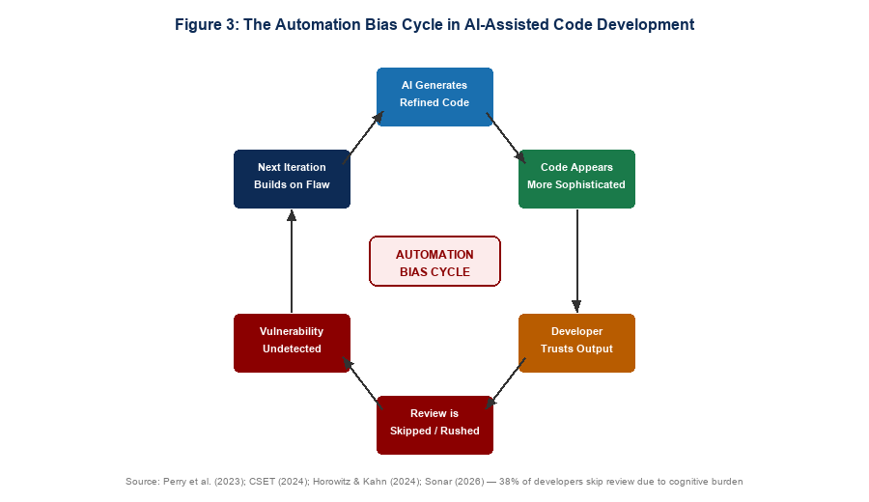
Figure 3: The Automation Bias Cycle in AI-Assisted Code Development

6. Human-in-the-Loop Approaches and Existing Security Frameworks

6.1 HITL Principles and Design
Human-in-the-Loop (HITL) is a design principle that places human decision-makers at key points within automated systems. In cybersecurity and AI governance contexts, HITL has emerged as a foundational safeguard — mandated by the EU AI Act (2024), which requires meaningful human oversight for high-risk AI systems, and supported by the OWASP Top 10 for LLM Applications, which identifies the absence of human oversight as a primary risk factor.

HITL systems are characterised by three core components: an oversight mechanism that pauses execution pending human input; a threshold trigger defining which outputs require human review; and decision authority defining which tasks require human approval versus autonomous execution. In iterative AI code refinement, these translate to: a structured review checkpoint mechanism, iteration count or complexity-based triggers, and role-based authority defining which developer levels are qualified to approve which categories of AI-generated code.

Shukla et al. (2025) implicitly invoke HITL principles in their mitigation guidelines, recommending mandatory developer review between iterations and a maximum of three consecutive LLM-only iterations. However, these guidelines remain informal recommendations rather than a designed, evaluable artefact — precisely the gap the proposed DSR framework addresses. WitnessAI (2026) further notes that HITL workflows produce audit trails and support compliance with the EU AI Act, positioning human oversight not merely as a security safeguard but as an emerging regulatory requirement.

6.2 Existing Security Frameworks and Their Limitations
Several security frameworks address portions of the problem space. Mohsin et al. (2025), in the CodingCare framework, integrate prompt libraries, vulnerability databases, and programming use-case repositories across the SDLC, demonstrating meaningful reductions in CVEs. However, CodingCare is primarily a prompt engineering and static analysis framework — it does not address iterative refinement dynamics or specify when and how human developers should intervene.

Akinsanya (2025) proposes a risk-based framework for cybersecurity compliance and critical infrastructure protection, employing security-by-design. Mohsin et al. (2024) provide the closest structural analogue in their SOC collaboration framework. AutoSafeCoder (2024) and RAG-assisted repair frameworks represent fully automated alternatives that demonstrate the ceiling of what automation can achieve without human governance structures. An important cross-cutting limitation of all existing frameworks is the absence of empirical validation under iterative conditions — frameworks validated in non-iterative conditions may provide inadequate protection in the iterative workflows that dominate real-world AI-assisted development.

7. Regulatory and Governance Context
An emerging regulatory and governance literature is reshaping the context within which human oversight of AI-generated code must be understood. This theme was absent from earlier versions of this review and represents a critical dimension for the proposed framework's practical relevance and long-term adoption.

7.1 The EU AI Act and Human Oversight Mandates
The European Union's AI Act (2024), the world's first comprehensive AI regulatory framework, establishes mandatory human oversight requirements for high-risk AI systems under Article 14. While AI coding assistants are not currently classified as high-risk, the Act's principles — particularly around transparency, accountability, and meaningful human control — are shaping organisational AI governance policies globally. Code generation in security-critical domains such as financial services, healthcare, and critical infrastructure may fall within high-risk classifications, making HITL frameworks a compliance requirement rather than merely a best practice. WitnessAI (2026) confirms that HITL workflows that generate audit trails are emerging as a practical compliance mechanism under the Act.

7.2 OWASP LLM Top 10 and Developer Standards
The OWASP Top 10 for LLM Applications identifies the absence of human oversight as a primary risk factor in LLM deployments, specifically flagging over-reliance on LLM outputs without human validation as a top-tier vulnerability. This standard is already being adopted by security-conscious organisations as a code review checklist — providing an institutional adoption pathway for a framework that operationalises HITL in LLM-assisted development. The proposed framework can be designed to explicitly align with OWASP LLM Top 10 mitigation recommendations, increasing its practical uptake.

7.3 NIST AI Risk Management Framework and SLSA
The NIST AI Risk Management Framework (AI RMF, 2023) provides a structured approach to managing AI-related risks across the full AI lifecycle, with 'Govern', 'Map', 'Measure', and 'Manage' functions that directly map onto framework design requirements. The Supply-chain Levels for Software Artifacts (SLSA) framework, backed by Google and adopted by the Linux Foundation, establishes provenance and integrity requirements for software supply chains — requirements that become increasingly difficult to satisfy when AI-generated code introduces supply chain vulnerabilities through iterative refinement. Aligning the proposed framework with SLSA levels provides a concrete evaluation criterion beyond vulnerability counts.

7.4 Veracode Industry Evidence
Veracode's 2025 GenAI Code Security Report provides alarming industry context: by June 2025, AI-generated code was introducing over 10,000 new security findings per month across studied repositories — a tenfold increase from December 2024. This acceleration confirms that the academic literature's laboratory findings are manifesting at scale in production environments. Gartner projects that 70% of professional developers will use AI coding assistants by 2027. Without validated human oversight frameworks, the security risks documented across the literature will continue to scale with adoption.

8. Synthesis and Research Gap

8.1 Thematic Convergence
The six themes reviewed above converge on a coherent and urgent research problem. Empirically, AI-generated code is insecure in single-shot conditions and becomes increasingly insecure through iterative refinement. Methodologically, DSR provides the appropriate paradigm for designing and evaluating an artefact that addresses this problem. Sociotechnically, human-AI collaboration in software development is both widespread and structurally under-governed. Psychologically, automation bias systematically undermines the human oversight that security depends upon. Structurally, existing HITL and security frameworks are not designed for iterative refinement contexts. Regulatorily, emerging standards are creating institutional pressure for validated HITL frameworks that this research is positioned to address.

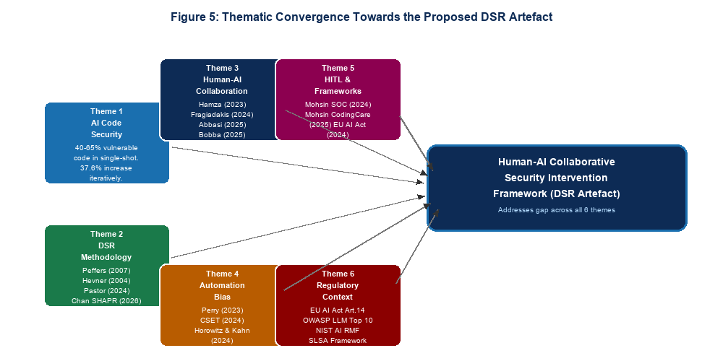
Figure 5: Thematic Convergence Towards the Proposed DSR Artefact

8.2 Three Design Requirements
The synthesis reveals three specific design requirements for the proposed framework:

- DR1 — Structured Intervention Trigger Criteria: Define not merely that human review is necessary, but when it must occur — iteration count thresholds, complexity increase triggers, supply chain CWE detection, and CVSS severity thresholds — grounded in the empirical findings of Shukla et al. (2025).
- DR2 — Role-Differentiated Review Protocols: Define who reviews what, based on developer experience level and vulnerability category — addressing the expertise moderation effect documented by Horowitz and Kahn (2024) and the epistemic labour division question raised by Abbasi et al. (2025).
- DR3 — Cognitive Feasibility of Review Process: Counter automation bias by designing review processes that are targeted rather than comprehensive, AI-summarised rather than raw, and time-bounded rather than open-ended — addressing the review burden paradox documented by Sonar (2026).

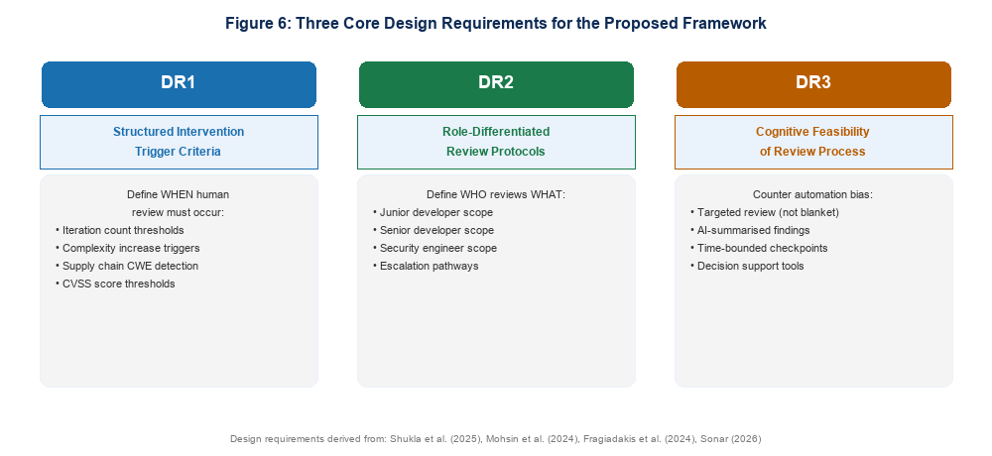
Figure 6: Three Core Design Requirements for the Proposed Framework

8.3 The Research Gap

Despite the convergence of evidence across six independent literature streams, a critical gap persists: no designed, evaluated artefact exists that operationalises human-AI collaboration to mitigate security degradation specifically within iterative LLM-assisted code refinement workflows. Shukla et al. (2025) call for future research on HITL practices but stop short of designing or evaluating such a system. Existing HITL frameworks are not adapted for code refinement contexts. Existing code security frameworks do not address iterative dynamics. Automated multi-agent approaches bypass human governance entirely. This is the gap this research addresses.

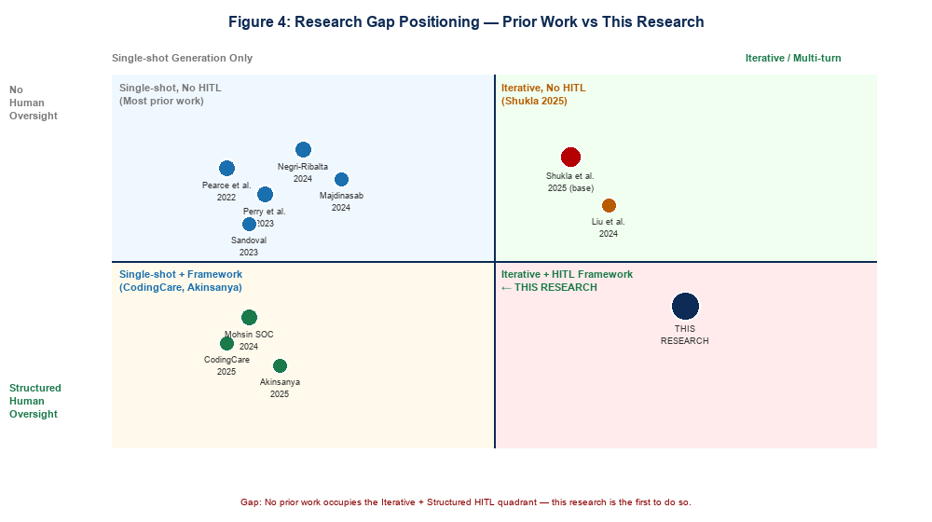
Figure 4: Research Gap Positioning Map — Prior Work vs This Research

8.4 Synthesis Matrix
Table 1 maps the key papers reviewed against all six themes, illustrating convergence and gaps.

Paper | Year | DSR | AI Code  Security | Human-AI  Collab | Automation  Bias | HITL /  Framework | Regulatory
Peffers et al. | 2007 | ✓✓
Hevner et al. | 2004 | ✓✓
Alexei | 2022 | ✓
Pearce et al. | 2022 |  | ✓✓
Siddiq & Santos | 2022 |  | ✓
Perry et al. | 2023 |  | ✓✓ |  | ✓✓
Tony et al. | 2023 |  | ✓
Hamza et al. | 2023 |  |  | ✓✓
Negri-Ribalta et al. | 2024 |  | ✓✓
Chong et al. | 2024 |  | ✓
Majdinasab et al. | 2024 |  | ✓
Liu et al. | 2024 |  | ✓
CSET | 2024 |  | ✓ |  | ✓✓ |  | ✓
Wang et al. | 2024 |  | ✓✓
Fragiadakis et al. | 2024 |  |  | ✓✓
Cabrero-Daniel et al. | 2024 |  |  | ✓
Mohsin et al. (SOC) | 2024 |  |  | ✓ |  | ✓✓
Horowitz & Kahn | 2024 |  |  |  | ✓✓
HICSS-57 Study | 2024 | ✓ |  |  |  | ✓
EU AI Act | 2024 |  |  |  |  |  | ✓✓
AutoSafeCoder | 2024 |  | ✓ |  |  | ✓
Shukla et al. | 2025 |  | ✓✓ | ✓ |  | ✓✓
Mohsin et al. (CodingCare) | 2025 |  | ✓ |  |  | ✓
Abbasi et al. | 2025 |  |  | ✓✓
Bobba | 2025 |  |  | ✓✓
Akinsanya | 2025 | ✓ |  |  |  | ✓✓ | ✓
Alebachew & Brown | 2025 |  |  |  | ✓
Expertise Gap Study | 2025 |  |  | ✓✓
Veracode | 2025 |  | ✓ |  |  |  | ✓✓
RAG Secure Code | 2025 |  | ✓ |  |  | ✓
Chan (SHAPR) | 2026 | ✓✓ |  | ✓
Blain & Noiseux | 2026 |  | ✓✓
Sonar Survey | 2026 |  |  |  | ✓✓ | ✓ | ✓
WitnessAI | 2026 |  |  |  |  | ✓ | ✓✓
THIS RESEARCH | 2025+ | ✓✓ | ✓✓ | ✓✓ | ✓ | ✓✓ | ✓✓

9. Conclusion
This literature review has mapped the scholarly landscape across six interconnected themes to establish the foundations for a novel DSR artefact targeting a critical and underaddressed problem. The evidence is unambiguous: AI-generated code is insecure, iterative refinement compounds that insecurity non-linearly, human oversight is necessary but structurally undermined by automation bias, existing frameworks do not address iterative dynamics, and regulatory pressure is creating institutional demand for validated HITL solutions.

The proposed Human-AI Collaborative Security Intervention Framework will address this gap through the DSR process model of Peffers et al. (2007), designing structured intervention trigger criteria, role-differentiated review protocols, and cognitive-load-aware review processes within iterative LLM-assisted code development workflows. Its evaluation will be grounded in the experimental methodology established by Shukla et al. (2025), measuring vulnerability accumulation with and without the framework across multi-iteration controlled conditions. The framework will be aligned with the EU AI Act Article 14, OWASP LLM Top 10, NIST AI RMF, and SLSA supply chain standards — positioning it for both academic contribution and practical adoption.

As Gartner projects that 70% of developers will use AI coding assistants by 2027, and as Veracode documents a tenfold increase in AI-introduced vulnerabilities in a single year, the absence of validated human oversight frameworks represents an escalating organisational and societal risk. This research is designed to fill that gap with theoretical rigour, empirical grounding, and practical deployability.

References
Abbasi, M. A., et al. (2025). Reconsidering requirements engineering: Human-AI collaboration in AI-native software development. arXiv:2510.04380.
Akinsanya, A. (2025). Security by design: A risk-based framework for cybersecurity compliance and critical infrastructure protection. International Journal of Information Security. https://doi.org/10.1007/s10207-025-01155-4
Alebachew, Y. B., & Brown, C. (2024). Automatic bias detection in source code review. arXiv:2504.18449.
Alexei, A. (2022). Implementing Design Science Research Method to develop a cyber security framework for HEIs in Moldova. Proceedings of IC|ECCO-2021.
Alqarni, A., et al. (2024). AutoSafeCoder: A multi-agent framework for securing LLM code generation through static analysis and fuzz testing. arXiv:2409.10737.
Blain, D., & Noiseux, M. (2026). Broken by default: A formal verification study of security vulnerabilities in AI-generated code. arXiv:2604.05292.
Bobba, A. R. (2025). The evolution of cognitive partnership: A taxonomic framework for human-AI collaboration modalities. Journal of Computer Science and Technology Studies, 7(8), 992–1005.
Cabrero-Daniel, B., Herda, T., Pichler, V., & Eder, M. (2024). Exploring human-AI collaboration in agile: Customised LLM meeting assistants. XP Conference. Springer.
Center for Security and Emerging Technology (CSET). (2024). Cybersecurity risks of AI-generated code. Georgetown University. https://doi.org/10.51593/20230057
Chan, A. (2026). SHAPR: Operationalising human-AI collaborative research through structured knowledge generation. arXiv:2603.25660.
Chong, C. J., Yao, Z., & Neamtiu, I. (2024). Artificial-intelligence generated code considered harmful. arXiv:2409.19182.
EU AI Act. (2024). Regulation of the European Parliament and of the Council laying down harmonised rules on artificial intelligence.
Fragiadakis, G., Diou, C., Kousiouris, G., & Nikolaidou, M. (2024). Evaluating human-AI collaboration: A review and methodological framework. arXiv:2407.19098.
GitHub. (2024). Survey reveals AI's impact on the developer experience. GitHub Blog.
Hamza, M., Siemon, D., Akbar, M. A., & Rahman, T. (2023). Human-AI collaboration in software engineering. arXiv:2312.10620.
Hevner, A. R., March, S. T., Park, J., & Ram, S. (2004). Design science in information systems research. MIS Quarterly, 28(1), 75–105.
HICSS-57. (2024). Deriving design principles from the design journey of a cybersecurity readiness assessment tool.
Horowitz, M. C., & Kahn, L. (2024). Bending the automation bias curve. International Studies Quarterly, 68(2).
Liu, Y., Le-Cong, T., Widyasari, R., Lo, D., Tao, M., & Han, S. (2024). Refining ChatGPT-generated code. ACM TOSEM.
Majdinasab, V., et al. (2024). Assessing the security of GitHub Copilot's generated code: A targeted replication study. IEEE SANER 2024.
Mohsin, A., Janicke, H., Ibrahim, A., Sarker, I. H., & Camtepe, S. (2024). A unified framework for human-AI collaboration in security operations centers. arXiv:2505.23397.
Mohsin, A., et al. (2025). CodingCare: AI code generation security framework. ACM ISCCN 2025.
Negri-Ribalta, C., et al. (2024). A systematic literature review on the impact of AI models on the security of code generation. Frontiers in Big Data, 7.
NIST. (2023). AI Risk Management Framework (AI RMF 1.0). National Institute of Standards and Technology.
OWASP. (2024). OWASP Top 10 for Large Language Model Applications. OWASP Foundation.
Pastor, et al. (2024). Dual-cycle DSR model. Information Systems Journal.
Pearce, H., Ahmad, B., Tan, B., Dolan-Gavitt, B., & Karri, R. (2022). Asleep at the keyboard? IEEE S&P, 754–768.
Peffers, K., Tuunanen, T., Rothenberger, M. A., & Chatterjee, S. (2007). A design science research methodology. Journal of Management Information Systems, 24(3), 45–77.
Perry, N., Srivastava, M., Kumar, D., & Boneh, D. (2023). Do users write more insecure code with AI assistants? ACM CCS 2023.
Shukla, S., Joshi, H., & Syed, R. (2025). Security degradation in iterative AI code generation. IEEE-ISTAS 2025. arXiv:2506.11022.
Siddiq, M. L., & Santos, J. C. (2022). SecurityEval dataset. MSR4P&S 2022.
Sonar. (2026). State of code: Developer survey 2026.
Tariq, S., et al. (2025). Bridging expertise gaps: The role of LLMs in human-AI collaboration for cybersecurity. arXiv:2505.03179.
Tony, C., et al. (2023). LLMSecEval. IEEE/ACM MSR 2023.
Venable, J. R., Pries-Heje, J., & Baskerville, R. (2012). A comprehensive framework for evaluation in design science research. DESRIST 2012.
Veracode. (2025). 2025 GenAI code security report. Veracode Research.
Wang, Y., et al. (2024). Is your AI-generated code really secure? CodeSecEval. arXiv:2407.02395.
WitnessAI. (2026). Human-in-the-loop AI: Benefits, use cases, and best practices.
arXiv:2601.00509. (2025). Improving LLM-assisted secure code generation through RAG and multi-tool feedback.

