MPhil in Cybersecurity — Literature Review
LITERATURE REVIEW
A Human-AI Collaborative Security Intervention Framework for Mitigating Vulnerability Degradation in Iterative LLM-Assisted Code Refinement
Total Papers Reviewed: 33
Publication Range: 2022 to 2026

1. INTRODUCTION

1.1 Purpose of the Review
This literature review examines the existing body of knowledge relevant to the proposed Design Science Research (DSR) study on mitigating vulnerability degradation in iterative LLM-assisted code refinement. It serves four purposes: to establish the empirical foundations of AI-generated code security; to characterise the iterative feedback loop security degradation phenomenon and its human dimensions; to survey existing human-in-the-loop and security frameworks and their limitations; and to establish the regulatory and governance context within which the proposed artefact will operate. The review concludes by identifying the primary research gap, three design requirements, and the research questions that the proposed study will address.

1.2 Search Strategy and Paper Selection
Searches were conducted between January and May 2026 across six academic databases and repositories: IEEE Xplore, ACM Digital Library, USENIX, arXiv, Google Scholar, and Frontiers in Big Data. Industry reports were sourced from Veracode, Sonar, GitHub, WitnessAI, and the Georgetown Center for Security and Emerging Technology (CSET). The following keyword strings were used in various combinations: "LLM code security vulnerabilities", "AI-generated code security", "iterative code refinement security", "feedback loop vulnerability degradation", "human-in-the-loop AI code review", "automation bias developer trust", "human-AI collaboration software engineering", "Design Science Research cybersecurity artefact", "HITL code review framework", "EU AI Act human oversight", "OWASP LLM Top 10", "NIST AI risk management", and "security degradation iterative LLM".
The initial searches returned approximately 920 results. After duplicate removal and title and abstract screening, 33 papers and reports were retained for inclusion. Papers published before 2022 were excluded to ensure coverage reflects the post-LLM-deployment state of the field, which effectively began with the public release of GitHub Copilot in June 2022.

1.3 Background and Motivation
The integration of large language model code generation tools into software development workflows has fundamentally changed how code is written, reviewed, and iteratively refined. GitHub Copilot, ChatGPT, and Claude are now used by over 80% of developers in their daily workflows (GitHub, 2024). While these tools offer significant productivity gains, the security implications of their use within iterative, conversational development loops remain critically underexplored.
Shukla, Joshi, and Syed (2025) provide the first systematic empirical evidence of this phenomenon, demonstrating a 37.6% increase in critical vulnerabilities after just five iterations of LLM-assisted code refinement without human intervention. Figure 1 illustrates this feedback loop security degradation phenomenon.

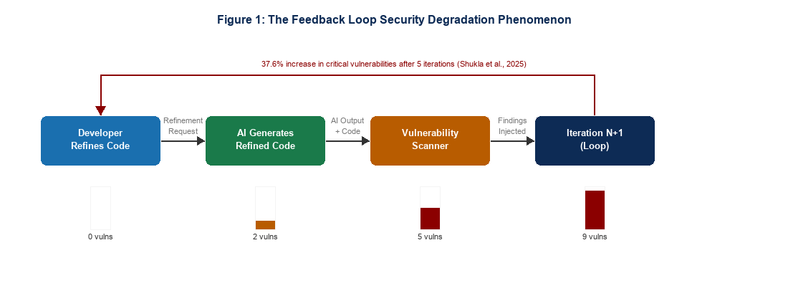
Figure 1: The Feedback Loop Security Degradation Phenomenon (Shukla et al., 2025)
Veracode (2025) corroborates the industrial scale of the problem, documenting a tenfold increase in AI-introduced security findings between December 2024 and June 2025. Gartner projects that 70% of professional developers will use AI coding assistants by 2027. Without validated human oversight frameworks, these risks will continue to scale with adoption.

1.4 Methodological Framework: Design Science Research
The proposed study is grounded in Design Science Research (DSR), a well-established paradigm in information systems that seeks to extend human and organisational capabilities through the creation and evaluation of innovative artefacts. Rather than seeking to explain or predict phenomena, DSR aims to prescribe solutions — producing constructs, models, methods, or instantiations that address real-world problems with rigour and relevance. Figure 2 maps the DSR process model onto this research.

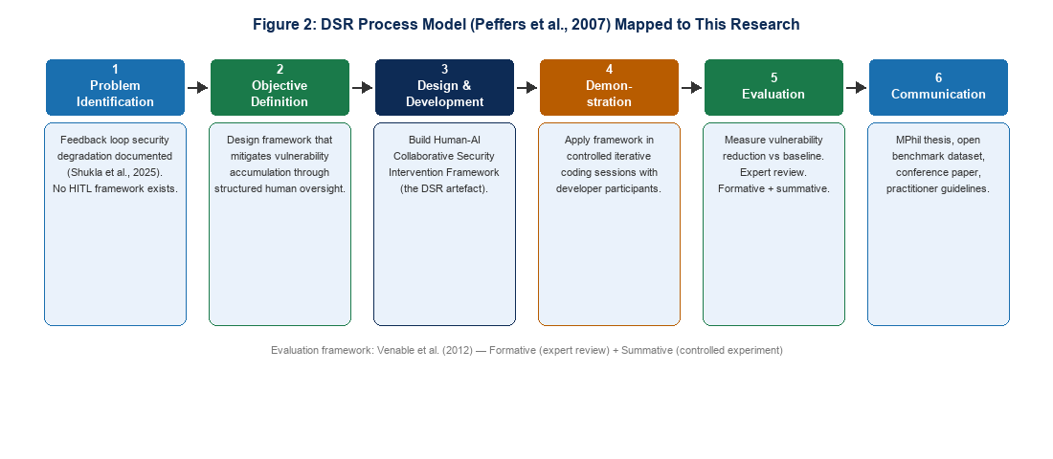
Figure 2: DSR Process Model Mapped to This Research
DSR is selected for three reasons. First, the problem is design-oriented: a new artefact that does not currently exist is needed. Second, the evaluation approach is well-defined by Shukla et al. (2025), whose experimental methodology provides a direct comparator for measuring the framework's effectiveness. Third, recent DSR cybersecurity work has validated DSR as the appropriate paradigm for cybersecurity framework development, using iterative design cycles and formal evaluation frameworks.

2. INDIVIDUAL PAPER REVIEWS
The 33 papers and reports are organised across six thematic clusters. Each paper is reviewed under background and motivation, methodology, key findings and contributions, and strengths and weaknesses.

THEME T1: DESIGN SCIENCE RESEARCH AS METHODOLOGICAL FOUNDATION

Paper 1: Alexei, A. (2022). Implementing Design Science Research Method to Develop a Cyber Security Framework for HEIs in Moldova. Proceedings of IC|ECCO-2021.
Background and Motivation
Motivated by the absence of a structured cybersecurity framework for Higher Education Institutions (HEIs) in Moldova, Alexei employed the DSR process model to design and evaluate a cybersecurity framework through formal DSR cycles. This study provides the closest published precedent for applying DSR to cybersecurity framework development in an institutional context.
Methodology
DSR process model application following the six-phase structure from problem identification through to communication. Evaluation conducted through expert review within the Moldovan HEI context.
Key Findings and Contributions
The study demonstrated that DSR is a viable and rigorous methodology for cybersecurity framework development in resource-constrained institutional contexts. The framework produced was adopted by several Moldovan HEIs, providing evidence of practical relevance.
Strengths and Weaknesses
The cybersecurity framework application and DSR methodology make this a direct methodological precedent. The limitation is the HEI institutional focus, which differs from the software development context of the proposed research, and the absence of controlled experimental evaluation.

Paper 2: HICSS-57 Study. (2024). Deriving Design Principles from the Design Journey of a Cybersecurity Readiness Assessment Tool. Hawaii International Conference on System Sciences.
Background and Motivation
Motivated by the lack of empirically derived design principles for cybersecurity readiness tools, this study used iterative DSR cycles to derive design principles from the development of a cybersecurity readiness assessment tool, applying the FEDS evaluation framework to rigorously validate the resulting artefact.
Methodology
Iterative DSR development cycles using the FEDS evaluation framework. Multi-cycle validation combining formative and summative evaluation across naturalistic and artificial contexts.
Key Findings and Contributions
The study produced empirically derived design principles for cybersecurity readiness tools and demonstrated how the FEDS framework enables rigorous multi-cycle DSR evaluation. The multi-cycle validation approach is directly applicable to the proposed research.
Strengths and Weaknesses
The multi-cycle evaluation design and DSR rigour are directly relevant methodological contributions. The readiness assessment tool focus differs from iterative code refinement, but the design principle derivation methodology is transferable.

Paper 3: Venable, J. R., Pries-Heje, J., and Baskerville, R. (2012). A Comprehensive Framework for Evaluation in Design Science Research. DESRIST 2012.
Background and Motivation
Motivated by the absence of a systematic framework for designing evaluation in DSR studies, Venable et al. produced a comprehensive evaluation framework that distinguishes formative from summative evaluation and naturalistic from artificial evaluation contexts.
Methodology
Conceptual framework development drawing on DSR literature and evaluation methodology. Framework validated through expert review and case application.
Key Findings and Contributions
The framework distinguishes four evaluation strategies along two dimensions: formative versus summative, and naturalistic versus artificial. For the proposed research, the evaluation design uses an artificial controlled experiment aligning with the summative, artificial quadrant.
Strengths and Weaknesses
The evaluation framework is the most authoritative DSR evaluation reference and its application to the proposed research is direct. The limitation is that it does not address AI-specific evaluation considerations, which are addressed more recently by Chan (2026).

Paper 4: Pastor, O., et al. (2024). Dual-Cycle DSR Model. Information Systems Journal.
Background and Motivation
Motivated by the complexity of DSR studies that combine both design and empirical validation cycles, Pastor et al. proposed a dual-cycle DSR model that distinguishes the design cycle from the empirical validation cycle and specifies how they interact.
Methodology
Conceptual DSR model development drawing on existing DSR frameworks and information systems methodology literature. Validated through application to case studies.
Key Findings and Contributions
The dual-cycle model provides explicit structure for research that combines artefact design with controlled experimental evaluation — precisely the design of the proposed research. The model clarifies that design decisions and evaluation decisions are governed by different cycle logics.
Strengths and Weaknesses
The dual-cycle framing is directly applicable to the proposed research. The limitation is the recency of the model and its limited empirical validation across multiple DSR studies.

Paper 5: Chan, A. (2026). SHAPR: Operationalising Human-AI Collaborative Research Through Structured Knowledge Generation. arXiv:2603.25660.
Background and Motivation
Motivated by the absence of structured frameworks for conducting DSR in AI-assisted development environments, Chan developed the SHAPR framework, which operationalises human-AI collaborative research through structured DSR processes mapped onto AI-augmented workflows.
Methodology
Action Design Research mapping combined with conceptual framework development. Applied to AI-assisted academic research workflows.
Key Findings and Contributions
SHAPR provides the most current and directly relevant extension of DSR methodology to AI-assisted development contexts. It directly maps Action Design Research principles onto the human-AI iterative interaction patterns that are the object of study in this research.
Strengths and Weaknesses
The AI-native DSR framing is genuinely novel and the most directly relevant methodological paper for the proposed research context. The limitation is the arXiv preprint status and the recency of the framework.

THEME T2: EMPIRICAL EVIDENCE ON AI-GENERATED CODE SECURITY

Paper 6: Pearce, H., Ahmad, B., Tan, B., Dolan-Gavitt, B., and Karri, R. (2022). Asleep at the Keyboard? Assessing the Security of GitHub Copilot's Code Contributions. IEEE S&P 2022.
Background and Motivation
This landmark study emerged immediately following GitHub Copilot's public release and addressed the first critical unanswered question: does the most widely deployed AI code generation tool produce secure code? The authors were motivated by the lack of any empirical baseline for AI-generated code vulnerability rates.
Methodology
Large-scale empirical evaluation generating 1,689 programs across 18 CWE scenario categories using GitHub Copilot. Static analysis used to classify vulnerabilities by CWE type and programming language.
Key Findings and Contributions
Approximately 40% of generated programs contained vulnerabilities, rising to approximately 50% in C code compared to 39% in Python. This paper established the empirical baseline and the CWE-scenario evaluation methodology that all subsequent studies have followed.
Strengths and Weaknesses
The foundational empirical contribution is irreplaceable and its methodology is the field standard. The limitation is the single-model, one-shot evaluation scope with no iterative or human factors dimension.

Paper 7: Perry, N., Srivastava, M., Kumar, D., and Boneh, D. (2023). Do Users Write More Insecure Code with AI Assistants? ACM CCS 2023.
Background and Motivation
Building on Pearce et al.'s technical findings, Perry et al. investigated the human dimension: do developers who use AI assistants actually produce less secure code in practice, and are they aware of the risk? The study was motivated by the possibility that the problem is as much psychological as technical.
Methodology
Controlled user study where participants were randomly assigned to write code with or without AI assistance. Security of outputs evaluated through static analysis and expert review. Self-rating of security confidence collected alongside objective security scores.
Key Findings and Contributions
Participants using AI assistants wrote significantly less secure code and simultaneously rated their own code as more secure — a dynamic the authors term a false sense of security. This is the foundational human factors finding of the field.
Strengths and Weaknesses
The controlled user study design is methodologically rigorous and the false sense of security finding is the single most important human factors result in the literature. The limitation is the one-shot evaluation scope.

Paper 8: Majdinasab, V., Nikanjam, A., Khomh, F., and Desmarais, M. C. (2024). Assessing the Security of GitHub Copilot's Generated Code: A Targeted Replication Study. IEEE SANER 2024.
Background and Motivation
Motivated by the assumption that newer model versions would resolve the vulnerability problems documented by Pearce et al. (2022), Majdinasab et al. replicated the Pearce et al. study using updated Copilot versions to directly test whether model improvements address the baseline security problem.
Methodology
Targeted replication of Pearce et al. (2022) using updated GitHub Copilot versions, applying the same CWE scenario methodology to enable direct comparison across model generations.
Key Findings and Contributions
Vulnerability rates remain significant even in newer model versions, directly refuting the assumption that model improvements alone address the security problem.
Strengths and Weaknesses
The direct replication design provides strong methodological comparability. The limitation is the single-model focus and the absence of multi-turn or iterative evaluation.

Paper 9: Negri-Ribalta, C., Geraud-Stewart, R., Sergeeva, A., and Lenzini, G. (2024). A Systematic Literature Review on the Impact of AI Models on the Security of Code Generation. Frontiers in Big Data, 7.
Background and Motivation
Motivated by the rapid growth of primary studies without synthesis, Negri-Ribalta et al. conducted the first rigorous systematic literature review of the AI code generation security field, applying PRISMA methodology to a pool of 3,104 peer-reviewed studies.
Methodology
Five-stage PRISMA systematic selection process from 3,104 initial studies, narrowed to 19 papers meeting rigorous inclusion criteria. Thematic analysis across vulnerability types, mitigation approaches, and evaluation methodologies.
Key Findings and Contributions
The review confirmed field-wide scholarly consensus: AI models do not produce safe code and continue to introduce vulnerabilities despite mitigation attempts. C was identified as particularly problematic.
Strengths and Weaknesses
The rigorous PRISMA methodology and comprehensive scope are the primary strengths. The limitation is the publication cutoff, which predates the IEEE-ISTAS 2025 base paper.

Paper 10: Chong, C. J., Yao, Z., and Neamtiu, I. (2024). Artificial-Intelligence Generated Code Considered Harmful. arXiv:2409.19182.
Background and Motivation
Motivated by the accumulating evidence of AI code vulnerabilities, Chong et al. examined whether LLMs fail to apply defensive programming constructs and whether the act of prompting can introduce new vulnerabilities into code that was previously safe.
Methodology
Empirical analysis of LLM-generated code across multiple scenarios, with specific attention to defensive programming construct failures and prompt-induced vulnerability introduction in previously safe code.
Key Findings and Contributions
LLMs lack defensive programming constructs and, critically, upon prompting an LLM can introduce issues into files that were previously issue-free. This was the first published observation of the feedback loop degradation phenomenon.
Strengths and Weaknesses
The prompt-induced vulnerability introduction observation is a foundational finding for this research. The limitation is that this was documented as an observation rather than a systematic study.

Paper 11: Wang, Y., et al. (2024). Is Your AI-Generated Code Really Secure? Evaluating Large Language Models on CodeSecEval. arXiv:2407.02395.
Background and Motivation
Motivated by the need for comprehensive and standardised security evaluation of LLMs across a wide range of CWE types, Wang et al. developed CodeSecEval and used it to evaluate multiple LLMs on 180 Python coding tasks covering 44 vulnerability types.
Methodology
Construction and application of the CodeSecEval benchmark covering 180 Python tasks across 44 CWE categories. Evaluation of multiple LLMs using two subsets: SecEvalBase from the 2023 CWE Top 25, and SecEvalPlus with synthesised items.
Key Findings and Contributions
While advanced models benefit from vulnerability hints, they remain prone to insecure outputs across a wide range of CWE categories. The benchmark provides the most comprehensive CWE coverage for Python evaluation.
Strengths and Weaknesses
The comprehensive CWE coverage and Python focus are directly relevant to this research. The limitation is the synthetic construction of the SecEvalPlus subset and the one-shot evaluation scope.

Paper 12: Shukla, S., Joshi, H., and Syed, R. (2025). Security Degradation in Iterative AI Code Generation: A Systematic Analysis of the Paradox. IEEE-ISTAS 2025. arXiv:2506.11022.
Background and Motivation
Motivated by the complete absence of empirical study on iterative AI code generation security, Shukla et al. designed the first controlled experiment targeting feedback loop degradation dynamics, motivated by Chong et al.'s (2024) observation that prompting can introduce vulnerabilities into previously safe code.
Methodology
Controlled experiment with 400 code samples using 4 prompting strategies across 10 iterations with GPT-4o only, in automated LLM-only loops without human intervention. C and Java only. Repeated-measures ANOVA for statistical validation.
Key Findings and Contributions
A 37.6% increase in critical vulnerabilities was documented after five iterations. Average vulnerability counts rose from 2.1 in early iterations to 6.2 by iterations 8 to 10. Code complexity was the strongest predictor (beta = 0.64, p < 0.001). The study explicitly called for future research on human-in-the-loop collaborative mitigation.
Strengths and Weaknesses
This is the most important paper in this review and the direct base study this research extends. The statistical rigour is high. The three key limitations — single model, two languages, no human intervention — define the adjacent research space.

Paper 13: Liu, Y., Le-Cong, T., Widyasari, R., Lo, D., Tao, M., and Han, S. (2024). Refining ChatGPT-Generated Code: Characterizing and Mitigating Code Quality Issues. ACM TOSEM.
Background and Motivation
Motivated by the widespread use of ChatGPT for code refinement, Liu et al. examined whether iterative refinement produces better code or introduces new problems, providing a quality-focused complement to the security-focused analysis of Shukla et al.
Methodology
Empirical study of the code refinement process examining quality issues introduced and resolved across multiple refinement rounds, using static analysis and code quality metrics.
Key Findings and Contributions
Refinement can introduce new issues even when the intent is improvement — providing independent quality-focused confirmation of the vulnerability accumulation phenomenon documented by Shukla et al.
Strengths and Weaknesses
The code quality framing provides complementary evidence that is independent of the security framing. The limitation is that security-specific vulnerability patterns are not the primary unit of analysis.

Paper 14: Blain, D., and Noiseux, M. (2026). Broken by Default: A Formal Verification Study of Security Vulnerabilities in AI-Generated Code. arXiv:2604.05292.
Background and Motivation
Motivated by the reliance on static analysis in prior studies, Blain and Noiseux applied formal verification via Z3 SMT solver to assess AI-generated code security across seven LLMs, providing a mathematically rigorous alternative evaluation methodology.
Methodology
Formal verification using Z3 SMT solver applied to 3,500 code artefacts generated by seven LLMs across security-critical domains. Comparison of formal verification findings against static analysis results.
Key Findings and Contributions
AI-generated code is broken by default in security-critical domains. Formal verification identifies vulnerability classes that static analysis tools miss.
Strengths and Weaknesses
The formal verification methodology is the most rigorous evaluation approach in the literature. The limitation is the computational cost of formal verification at scale.

THEME T3: HUMAN-AI COLLABORATION IN SOFTWARE DEVELOPMENT

Paper 15: Hamza, M., Siemon, D., Akbar, M. A., and Rahman, T. (2023). Human-AI Collaboration in Software Engineering. arXiv:2312.10620.
Background and Motivation
Motivated by the emergence of human-AI collaboration as a distinct research area in software engineering, Hamza et al. examined how developers and AI systems collaborate across coding, testing, and debugging tasks.
Methodology
Systematic review and empirical analysis of human-AI collaboration patterns across software engineering tasks. Qualitative analysis of collaboration conditions and failure modes.
Key Findings and Contributions
Three conditions for effective human-AI collaboration were identified: clear role allocation, effective communication protocols, and balanced task distribution. These directly inform DR1 and DR2 of the proposed framework.
Strengths and Weaknesses
The identification of three specific collaboration conditions is actionable for framework design. The limitation is the broad software engineering scope.

Paper 16: Fragiadakis, G., Diou, C., Kousiouris, G., and Nikolaidou, M. (2024). Evaluating Human-AI Collaboration: A Review and Methodological Framework. arXiv:2407.19098.
Background and Motivation
Motivated by the absence of a systematic evaluation framework for human-AI collaboration, Fragiadakis et al. proposed a methodological framework encompassing task effectiveness, cognitive load, trust calibration, and communication quality.
Methodology
Systematic review of human-AI collaboration evaluation approaches combined with framework development. Criteria derived from cognitive science, HCI, and AI collaboration literature.
Key Findings and Contributions
The framework establishes task effectiveness, cognitive load, trust calibration, and communication quality as the four key evaluation dimensions for human-AI collaboration, directly applicable to evaluating the proposed intervention framework.
Strengths and Weaknesses
The evaluation criteria framework is directly usable for secondary evaluation of the proposed artefact. The limitation is the absence of security-specific evaluation criteria.

Paper 17: Cabrero-Daniel, B., Herda, T., Pichler, V., and Eder, M. (2024). Exploring Human-AI Collaboration in Agile: Customised LLM Meeting Assistants. XP Conference. Springer.
Background and Motivation
Motivated by the rapid adoption of AI tools in agile development teams, Cabrero-Daniel et al. examined how human-AI collaboration effectiveness varies across team structures, task complexity, and AI output transparency.
Methodology
Qualitative case study of human-AI collaboration in agile development environments. Analysis of collaboration patterns across multiple agile teams.
Key Findings and Contributions
The effectiveness of human-AI collaboration is highly context-dependent, varying with team structure, task complexity, and AI output transparency. This motivates the role-differentiated design of the proposed framework.
Strengths and Weaknesses
The context-dependency finding is important for framework design. The limitation is the meeting assistant focus.

Paper 18: Bobba, A. R. (2025). The Evolution of Cognitive Partnership: A Taxonomic Framework for Human-AI Collaboration Modalities. Journal of Computer Science and Technology Studies, 7(8), 992-1005.
Background and Motivation
Motivated by the proliferation of human-AI collaboration types without systematic classification, Bobba developed a taxonomic framework distinguishing collaboration modalities along dimensions of autonomy, cognitive partnership, and task interdependence.
Methodology
Conceptual framework development through systematic analysis of human-AI collaboration literature. Taxonomy constructed along three dimensions: autonomy level, cognitive partnership depth, and task interdependence.
Key Findings and Contributions
The taxonomy distinguishes collaboration modalities that differ in how much cognitive work is shared between human and AI. This directly supports the autonomy allocation design in the proposed framework.
Strengths and Weaknesses
The taxonomic approach is useful for framework design. The limitation is the conceptual rather than empirical grounding.

Paper 19: Abbasi, M. A., et al. (2025). Reconsidering Requirements Engineering: Human-AI Collaboration in AI-Native Software Development. arXiv:2510.04380.
Background and Motivation
Motivated by the transformation of software development by AI tools, Abbasi et al. examined the division of epistemic labour between human and AI in AI-native development environments.
Methodology
Qualitative analysis of human-AI collaboration patterns in AI-native development environments, with specific focus on epistemic responsibility allocation.
Key Findings and Contributions
The division of epistemic labour — who knows what, and who is responsible for verifying it — is a fundamental and under-theorised design challenge. This directly motivates DR2 (role-differentiated review protocols).
Strengths and Weaknesses
The epistemic responsibility framing is a novel and actionable theoretical contribution. The limitation is the requirements engineering focus.

Paper 20: Tariq, S., et al. (2025). Bridging Expertise Gaps: The Role of LLMs in Human-AI Collaboration for Cybersecurity. arXiv:2505.03179.
Background and Motivation
Motivated by the question of whether human-AI collaboration actually improves performance in cybersecurity tasks, this controlled mixed-methods study examined collaboration effects in phishing detection and intrusion detection with 58 participants.
Methodology
Controlled mixed-methods user study with 58 participants. Pre and post measures used to assess both performance and learning effects.
Key Findings and Contributions
Human-AI collaboration improved task performance and produced a learning effect when participants transitioned to independent work — suggesting that well-designed HITL frameworks can support long-term skill development rather than fostering dependency.
Strengths and Weaknesses
The controlled study design and cybersecurity task focus are directly relevant. The learning effect finding is an important secondary benefit. The limitation is the phishing/intrusion focus.

Paper 21: Mohsin, A., Janicke, H., Ibrahim, A., Sarker, I. H., and Camtepe, S. (2024). A Unified Framework for Human-AI Collaboration in Security Operations Centres. arXiv:2505.23397.
Background and Motivation
Motivated by the absence of principled autonomy allocation frameworks in security operations contexts, Mohsin et al. developed a unified framework defining four levels of automation and mapping security functions to appropriate human-AI collaboration modalities.
Methodology
Framework development combining cognitive modelling, situation awareness frameworks, and autonomy allocation principles. Applied to SOC security functions across four automation levels.
Key Findings and Contributions
Four automation levels (0 to 3) with threshold-triggered human intervention based on risk level. The notion of threshold-triggered intervention is directly transferable to the iterative code refinement context.
Strengths and Weaknesses
The principled autonomy allocation and threshold-triggered intervention design are the most structurally relevant prior work for the proposed framework's HITL design. The limitation is the SOC operations focus.

THEME T4: AUTOMATION BIAS AND THE LIMITS OF DEVELOPER TRUST
Figure 3 below illustrates the automation bias cycle in AI-assisted code development, synthesising findings from Perry et al. (2023), CSET (2024), Horowitz and Kahn (2024), and Sonar (2026).

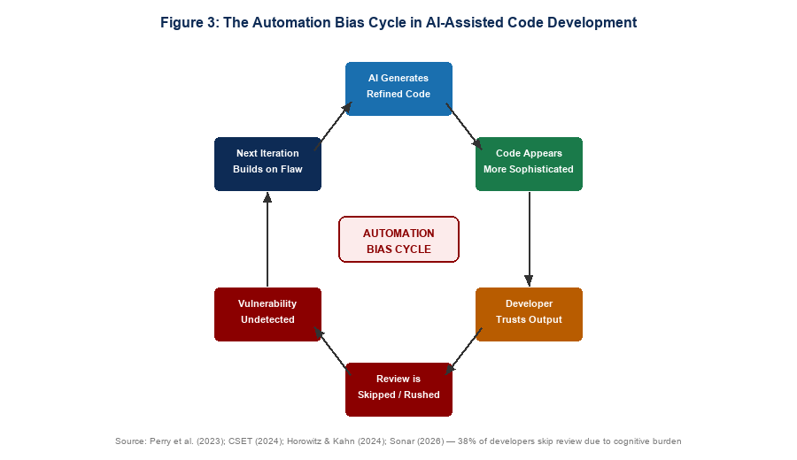
Figure 3: The Automation Bias Cycle in AI-Assisted Code Development

Paper 22: Center for Security and Emerging Technology (CSET). (2024). Cybersecurity Risks of AI-Generated Code. Georgetown University.
Background and Motivation
Motivated by the policy gap around AI-generated code security and the need for authoritative cross-sector analysis, CSET conducted a comprehensive study of cybersecurity risks arising from AI code generation across multiple deployment contexts.
Methodology
Policy analysis combining empirical literature synthesis, expert consultation, and cross-sector risk assessment. Coverage of training data risks, automation bias dimensions, and supply chain implications.
Key Findings and Contributions
Almost 50% of AI-generated code in studied repositories contained exploitable vulnerabilities. The report situates automation bias within a broader analysis of AI deployment risks and documents the structural nature of over-reliance on AI outputs.
Strengths and Weaknesses
The policy-level framing and automation bias coverage make this a cross-cutting reference. The limitation is the policy rather than technical level of analysis.

Paper 23: Horowitz, M. C., and Kahn, L. (2024). Bending the Automation Bias Curve. International Studies Quarterly, 68(2).
Background and Motivation
Motivated by the widespread assumption that automation bias is uniform across users, Horowitz and Kahn conducted a large-scale preregistered experiment across 9,000 participants in nine countries to examine whether domain knowledge moderates automation bias.
Methodology
Large-scale preregistered experiment with 9,000 participants across nine countries. Automation bias measured across multiple AI-assisted decision tasks. Domain knowledge assessed independently to test moderation effects.
Key Findings and Contributions
Automation bias is moderated by domain knowledge — those with deeper AI literacy are better calibrated in their trust. Junior developers are potentially more susceptible to automation bias-induced vulnerability blind spots. This directly informs DR2 (role-differentiated review protocols).
Strengths and Weaknesses
The large-scale preregistered design is methodologically rigorous and the expertise moderation finding is actionable for framework design. The limitation is the international security domain rather than software development focus.

Paper 24: Alebachew, Y. B., and Brown, C. (2024). Automatic Bias Detection in Source Code Review. arXiv:2504.18449.
Background and Motivation
Motivated by the observation that biases in code review are often invisible to those exhibiting them, Alebachew and Brown examined automatic bias detection in source code review.
Methodology
Empirical analysis of bias detection approaches in source code review, combining automated detection techniques with human study validation.
Key Findings and Contributions
Biases are often invisible to those exhibiting them — reinforcing the case for structural rather than purely educative mitigations. The intervention must be triggered by objective criteria rather than relying on developer self-awareness.
Strengths and Weaknesses
The invisibility of bias finding is a critical design constraint for the proposed framework. The limitation is the general code review focus.

Paper 25: Sonar. (2026). State of Code: Developer Survey 2026.
Background and Motivation
Motivated by the need for industry-scale evidence on developer attitudes toward AI code review, Sonar conducted a comprehensive developer survey examining trust, review burden, and review behaviour in AI-assisted development.
Methodology
Industry developer survey covering AI code review practices, trust levels, and reported review burden across a large sample of professional developers.
Key Findings and Contributions
96% of developers do not fully trust AI-generated code without manual intervention, yet 38% sometimes skip review due to cognitive burden. This creates the review burden paradox that directly generates DR3 (cognitive feasibility of review process).
Strengths and Weaknesses
The scale of the survey and the review burden paradox finding are directly generative of the third design requirement. The limitation is the industry report format.

THEME T5: HUMAN-IN-THE-LOOP AND EXISTING SECURITY FRAMEWORKS

Paper 26: Alqarni, A., et al. (2024). AutoSafeCoder: A Multi-Agent Framework for Securing LLM Code Generation Through Static Analysis and Fuzz Testing. arXiv:2409.10737.
Background and Motivation
Motivated by the limitations of single-agent code generation for security, Alqarni et al. proposed AutoSafeCoder, a multi-agent framework with three collaborating agents that iteratively refine code for both functional correctness and security.
Methodology
Multi-agent framework design with three distinct agents. Evaluation on security benchmarks measuring vulnerability reduction across multiple iterations of automated refinement.
Key Findings and Contributions
AutoSafeCoder demonstrates that automated multi-agent approaches can significantly reduce vulnerability rates. However, the framework is fully automated and does not account for human cognitive dimensions, automation bias, or EU AI Act governance requirements.
Strengths and Weaknesses
The multi-agent design establishes the ceiling of what fully automated approaches can achieve. The complete absence of human governance is the critical limitation.

Paper 27: arXiv:2601.00509. (2025). Improving LLM-Assisted Secure Code Generation Through RAG and Multi-Tool Feedback.
Background and Motivation
Motivated by the limitations of purely prompt-driven approaches, this study integrated RAG with compiler diagnostics, symbolic execution, and static analysis into a self-repair workflow.
Methodology
RAG-assisted code generation pipeline combining compiler diagnostics, symbolic execution, and static analysis feedback. Evaluated against prompt-only baselines on security benchmarks.
Key Findings and Contributions
The most successful approaches are tool-augmented rather than purely prompt-driven, with RAG-assisted generation significantly outperforming prompt-only approaches on security metrics.
Strengths and Weaknesses
The tool-augmented design is directly relevant to the artefact design. The limitation is the automated setting without human governance.

Paper 28: Mohsin, A., et al. (2025). CodingCare: AI Code Generation Security Framework. ACM ISCCN 2025.
Background and Motivation
Motivated by the need for an integrated security framework across the SDLC, Mohsin et al. developed CodingCare, which integrates prompt libraries, vulnerability databases, and programming use-case repositories to reduce CVE counts.
Methodology
Framework design combining static analysis, prompt engineering, and vulnerability database integration. Evaluated on AI-generated code datasets measuring CVE reduction.
Key Findings and Contributions
CodingCare demonstrated meaningful reductions in CVE counts. It is the closest existing framework to the proposed artefact. The critical distinction is that CodingCare does not address iterative refinement dynamics or specify when and how human developers should intervene.
Strengths and Weaknesses
CodingCare is the most structurally similar prior framework and its CVE reduction results are a direct benchmark. The absence of iterative refinement coverage and human governance specifications is the precise gap this research fills.

Paper 29: Akinsanya, A. (2025). Security by Design: A Risk-Based Framework for Cybersecurity Compliance and Critical Infrastructure Protection. International Journal of Information Security.
Background and Motivation
Motivated by the absence of a risk-based framework integrating security-by-design principles with cybersecurity compliance requirements, Akinsanya developed a risk-based framework using DSR methodology.
Methodology
DSR framework development combining risk assessment, security-by-design principles, and compliance requirements. Applied to critical infrastructure protection contexts.
Key Findings and Contributions
The risk-based design approach and DSR methodology are directly relevant precedents, demonstrating how security-by-design principles can be operationalised through DSR and aligned with compliance requirements.
Strengths and Weaknesses
The DSR methodology and risk-based design approach are directly relevant. The critical infrastructure focus differs significantly from the iterative code development context.

Paper 30: WitnessAI. (2026). Human-in-the-Loop AI: Benefits, Use Cases, and Best Practices. Industry Report.
Background and Motivation
Motivated by the rapid expansion of AI deployment without corresponding human oversight infrastructure, WitnessAI examined the practical benefits, design patterns, and compliance implications of HITL AI workflows.
Methodology
Industry analysis of HITL AI deployments combining case studies, design pattern documentation, and regulatory alignment analysis, with specific reference to EU AI Act compliance requirements.
Key Findings and Contributions
HITL workflows that generate audit trails are emerging as a practical compliance mechanism under the EU AI Act. HITL is positioned not merely as a security safeguard but as an emerging regulatory requirement.
Strengths and Weaknesses
The regulatory compliance framing is directly actionable for the proposed framework's positioning. The limitation is the industry report format without peer review.

THEME T6: REGULATORY AND GOVERNANCE CONTEXT

Paper 31: European Union. (2024). AI Act: Regulation of the European Parliament and of the Council Laying Down Harmonised Rules on Artificial Intelligence.
Background and Motivation
The EU AI Act emerged from the European Commission's recognition that AI systems deployed in security-critical contexts require mandatory human oversight and accountability mechanisms to prevent harm.
Methodology
Legislative framework establishing risk-based classification of AI systems, mandatory requirements for high-risk systems under Article 14, and governance structures for AI deployment.
Key Findings and Contributions
The EU AI Act establishes mandatory human oversight under Article 14 for high-risk AI systems. The Act's transparency and accountability principles are already shaping organisational AI governance globally. The proposed framework is explicitly designed for alignment with Article 14 requirements.
Strengths and Weaknesses
The EU AI Act is the most significant regulatory development for the proposed research. The limitation is the evolving classification of AI code generation tools.

Paper 32: OWASP. (2024). OWASP Top 10 for Large Language Model Applications. OWASP Foundation.
Background and Motivation
Motivated by the rapid deployment of LLM applications without corresponding security standards, OWASP developed the Top 10 for LLM Applications as a practitioner-facing security standard for organisations deploying LLM tools.
Methodology
Standards development through expert consensus across the OWASP community. Top 10 risks identified through systematic analysis of LLM application deployments and vulnerability reports.
Key Findings and Contributions
The absence of human oversight is identified as a primary risk factor in LLM deployments. The OWASP LLM Top 10 is already being adopted by security-conscious organisations as a code review checklist, providing an institutional adoption pathway for the proposed framework.
Strengths and Weaknesses
The practitioner adoption trajectory of the OWASP standard is a direct institutional mechanism for proposed framework uptake. The limitation is the general LLM application scope.

Paper 33: NIST. (2023). AI Risk Management Framework (AI RMF 1.0). National Institute of Standards and Technology.
Background and Motivation
Motivated by the need for a structured, cross-sector approach to managing AI-related risks, NIST developed the AI RMF as a comprehensive framework covering the full AI lifecycle through Govern, Map, Measure, and Manage functions.
Methodology
Standards development through multi-stakeholder consultation. Framework structured around four core functions with corresponding categories and subcategories.
Key Findings and Contributions
The NIST AI RMF Govern, Map, Measure, and Manage functions directly map onto the design requirements of the proposed framework. Alignment with the NIST AI RMF provides a second institutional adoption pathway alongside OWASP.
Strengths and Weaknesses
The four-function structure is directly mappable to framework design requirements. The limitation is the high-level nature requiring significant contextual operationalisation.

3. STRUCTURED SUMMARY TABLE
No. | Author(s) & Year | Aim | Methodology | Key Contribution | Main Weakness
1 | Alexei (2022) | DSR cybersecurity framework for HEIs | DSR process model, expert review | DSR viable for cybersecurity framework development | HEI focus, no experimental evaluation
2 | HICSS-57 (2024) | DSR principles for readiness tools | Iterative DSR cycles, FEDS evaluation | Multi-cycle validation methodology established | Readiness tool focus
3 | Venable et al. (2012) | DSR evaluation framework | Conceptual framework development | Formative vs summative evaluation typology | Pre-AI context
4 | Pastor et al. (2024) | Dual-cycle DSR model | Conceptual DSR model development | Design cycle vs validation cycle distinction | Limited empirical validation
5 | Chan (2026) | DSR for human-AI research | Action Design Research mapping | SHAPR: AI-native DSR framework | arXiv preprint, recent
6 | Pearce et al. (2022) | Baseline AI code vulnerability rates | 1,689-program CWE evaluation | 40% vulnerable; C highest risk | Single model, one-shot only
7 | Perry et al. (2023) | Human factors in AI code security | Controlled user study | False sense of security documented | One-shot scope
8 | Majdinasab et al. (2024) | Copilot replication study | Targeted replication of Pearce 2022 | Vulnerability rates persist in newer models | Single model replication
9 | Negri-Ribalta et al. (2024) | SLR of AI code security | PRISMA review of 3,104 papers | AI models do not produce safe code | Predates 2025 base paper
10 | Chong et al. (2024) | Defensive programming failures | Empirical analysis | Prompting introduces new vulnerabilities | Observation not systematic
11 | Wang et al. (2024) | LLM security benchmark evaluation | CodeSecEval, 180 tasks, 44 CWEs | LLMs prone to insecure outputs across CWEs | One-shot evaluation only
12 | Shukla et al. (2025) | Iterative security degradation | 400-sample ANOVA experiment | 37.6% critical vuln increase in 5 iterations | GPT-4o only, no HITL, C/Java only
13 | Liu et al. (2024) | Code quality in iterative refinement | Empirical refinement analysis | Refinement introduces new issues | Quality not security focus
14 | Blain & Noiseux (2026) | Formal verification of AI code | Z3 SMT solver, 3,500 artefacts | AI code broken by default in security-critical domains | Computationally intensive
15 | Hamza et al. (2023) | Human-AI collaboration conditions | Systematic review and empirical analysis | 3 conditions for effective collaboration | Broad SE scope
16 | Fragiadakis et al. (2024) | Human-AI collaboration evaluation | Systematic review, framework development | 4 evaluation criteria established | No security-specific criteria
17 | Cabrero-Daniel et al. (2024) | Human-AI collaboration in agile | Qualitative case study | Collaboration context-dependent | Meeting assistant focus
18 | Bobba (2025) | Human-AI collaboration taxonomy | Conceptual framework development | Autonomy-cognitive partnership taxonomy | Conceptual not empirical
19 | Abbasi et al. (2025) | Epistemic labour in AI-native dev | Qualitative analysis | Epistemic responsibility division under-theorised | Requirements engineering focus
20 | Tariq et al. (2025) | LLMs bridging expertise gaps | Controlled user study, 58 participants | HITL improves performance and produces learning effect | Phishing/intrusion focus
21 | Mohsin et al. (2024) | HITL framework for SOC | Framework development, cognitive modelling | Threshold-triggered HITL by risk level | SOC operations focus
22 | CSET (2024) | Policy analysis of AI code risks | Literature synthesis, expert consultation | 50% AI code exploitable; automation bias documented | Policy not technical level
23 | Horowitz & Kahn (2024) | Automation bias moderation | 9,000-participant preregistered experiment | Expertise moderates automation bias | International security domain
24 | Alebachew & Brown (2024) | Bias detection in code review | Empirical bias detection analysis | Biases invisible to those exhibiting them | General code review focus
25 | Sonar (2026) | Developer trust and review burden | Industry developer survey | Review burden paradox documented — generates DR3 | Industry report format
26 | Alqarni et al. (2024) | Multi-agent secure code generation | AutoSafeCoder framework evaluation | Automated multi-agent reduces vulnerabilities | Fully automated, no human governance
27 | arXiv:2601.00509 (2025) | RAG-assisted secure code generation | RAG multi-tool pipeline evaluation | Tool-augmented outperforms prompt-only | Automated, no human governance
28 | Mohsin et al. (2025) | CodingCare security framework | Framework design and CVE evaluation | Closest prior framework to proposed artefact | No iterative or HITL dimension
29 | Akinsanya (2025) | Risk-based security by design | DSR framework development | Risk-based DSR precedent | Critical infrastructure focus
30 | WitnessAI (2026) | HITL AI best practices | Industry case analysis | HITL as EU AI Act compliance mechanism | Industry report format
31 | EU AI Act (2024) | AI governance regulation | Legislative framework | Article 14 human oversight mandate | Evolving classification scope
32 | OWASP (2024) | LLM application security standards | Expert consensus standards | Absence of oversight = top-tier risk | General LLM scope
33 | NIST AI RMF (2023) | AI risk management framework | Multi-stakeholder standards development | Govern/Map/Measure/Manage maps to design requirements | High-level, requires operationalisation

4. THEMATIC TAXONOMY
Figure 5 below illustrates how all six thematic clusters converge towards the proposed DSR artefact.

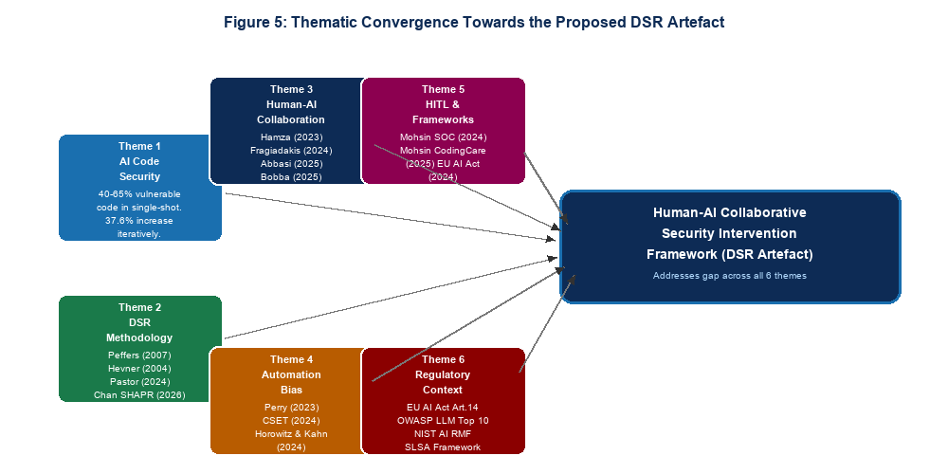
Figure 5: Thematic Convergence Towards the Proposed DSR Artefact
T1 — Design Science Research as Methodological Foundation (Papers 1-5)
Alexei (2022), HICSS-57 (2024), Venable et al. (2012), Pastor et al. (2024), Chan (2026). These papers establish the methodological legitimacy and procedural structure of DSR for cybersecurity artefact development. They confirm that DSR is the appropriate paradigm for this research, specify the evaluation framework, and provide the most current extension of DSR methodology to AI-assisted development contexts through the SHAPR framework.

T2 — Empirical Evidence on AI-Generated Code Security (Papers 6-14)
Pearce et al. (2022), Perry et al. (2023), Majdinasab et al. (2024), Negri-Ribalta et al. (2024), Chong et al. (2024), Wang et al. (2024), Shukla et al. (2025), Liu et al. (2024), Blain and Noiseux (2026). These papers establish the empirical problem: AI code generation is insecure, iterative refinement compounds that insecurity, and even expert developers fail to detect the vulnerabilities introduced. Shukla et al. (2025) is the base paper.

T3 — Human-AI Collaboration in Software Development (Papers 15-21)
Hamza et al. (2023), Fragiadakis et al. (2024), Cabrero-Daniel et al. (2024), Bobba (2025), Abbasi et al. (2025), Tariq et al. (2025), Mohsin et al. (2024). These papers provide the design principles for role allocation, intervention threshold design, and the epistemic responsibility question. Together they motivate and inform DR1 and DR2 of the proposed framework.

T4 — Automation Bias and the Limits of Developer Trust (Papers 22-25)
CSET (2024), Horowitz and Kahn (2024), Alebachew and Brown (2024), Sonar (2026). These papers establish automation bias as a structural risk that any HITL framework must address architecturally. The review burden paradox documented by Sonar (2026) directly generates DR3 (cognitive feasibility of review process).

T5 — Human-in-the-Loop and Existing Security Frameworks (Papers 26-30)
Alqarni et al. (2024), arXiv:2601.00509 (2025), Mohsin et al. (2025), Akinsanya (2025), WitnessAI (2026). Fully automated approaches demonstrate the ceiling of automation without human governance. CodingCare is the closest prior framework but lacks iterative and HITL coverage. Together this cluster confirms the artefact gap.

T6 — Regulatory and Governance Context (Papers 31-33)
EU AI Act (2024), OWASP LLM Top 10 (2024), NIST AI RMF (2023). These regulatory documents establish the external institutional context. Together they position the framework not merely as a security improvement but as a compliance infrastructure.

5. THEMATIC DISCUSSIONS

5.1 Theme T1: Design Science Research as Methodological Foundation
The DSR methodology literature confirms both the appropriateness and the procedural structure for this research. Alexei (2022) and the HICSS-57 (2024) study demonstrate that DSR is a well-validated paradigm for cybersecurity framework development. The most important methodological contribution for this research is the dual-cycle model of Pastor et al. (2024), which distinguishes design decisions from empirical validation decisions — a distinction that becomes critical when a controlled experiment replicating Shukla et al. (2025) is used as the evaluation method. Chan's (2026) SHAPR framework provides the most current and contextually relevant extension of DSR to AI-assisted development environments.

5.2 Theme T2: Empirical Evidence on AI-Generated Code Security
The empirical foundations of this research are stable, well-replicated, and convergent on three findings. AI code generation tools produce vulnerable code at rates between 40% and 65%. Iterative refinement compounds this insecurity non-linearly, with Shukla et al. (2025) documenting a 37.6% increase in critical vulnerabilities after just five iterations. And newer model versions do not resolve the problem. The binding limitation across this cluster is the absence of human-in-the-loop evaluation in the iterative studies. Shukla et al. explicitly designed their study as a worst-case automated scenario and called for future research on human-AI collaborative mitigation.

5.3 Theme T3: Human-AI Collaboration in Software Development
The human-AI collaboration literature provides the design principles for the proposed framework's structural components. Hamza et al.'s (2023) three conditions for effective collaboration map directly onto the framework's design requirements. Mohsin et al.'s (2024) threshold-triggered intervention model provides the closest structural analogue for the trigger criteria component. Tariq et al.'s (2025) finding that well-designed HITL produces learning effects rather than dependency broadens the framework's value proposition. The critical gap is the absence of research specifically on iterative code security refinement.

5.4 Theme T4: Automation Bias and the Limits of Developer Trust
The automation bias literature reveals a paradox at the heart of the proposed research: developers know they need to review AI-generated code but systematically fail to do so effectively. Perry et al. (2023) documented this as a false sense of security. Horowitz and Kahn (2024) established that expertise moderates but does not eliminate bias. Sonar (2026) quantified the consequence: 38% of developers sometimes skip review due to cognitive burden. Together these papers confirm that a framework cannot succeed by merely mandating review. It must make review structurally easier — targeted, AI-summarised, and time-bounded.

5.5 Theme T5: Human-in-the-Loop and Existing Security Frameworks
The existing framework literature performs two functions. AutoSafeCoder (2024) and the RAG-assisted framework (2025) establish the ceiling of fully automated approaches. CodingCare (2025) is the most structurally proximate prior framework and its CVE reduction results are a direct benchmark. The binding limitation across all five papers is structural: no existing framework combines structured human governance with iterative security monitoring within the refinement loop itself. This is the artefact gap the proposed research fills.

5.6 Theme T6: Regulatory and Governance Context
The regulatory literature transforms the proposed framework from a technical contribution to a compliance infrastructure. The EU AI Act's Article 14 human oversight mandate, the OWASP LLM Top 10's identification of absent oversight as a primary risk, and the NIST AI RMF's Govern-Map-Measure-Manage structure together create both the demand and the design template. The proposed framework is designed to be deployable as an EU AI Act Article 14 compliance mechanism, an OWASP LLM Top 10 mitigation, and a NIST AI RMF implementation artefact simultaneously.

6. RESEARCH GAP
The six thematic clusters collectively confirm one primary research gap with three specific design requirement dimensions. Figure 4 below maps prior work against this research on the two key dimensions of iteration and human oversight.

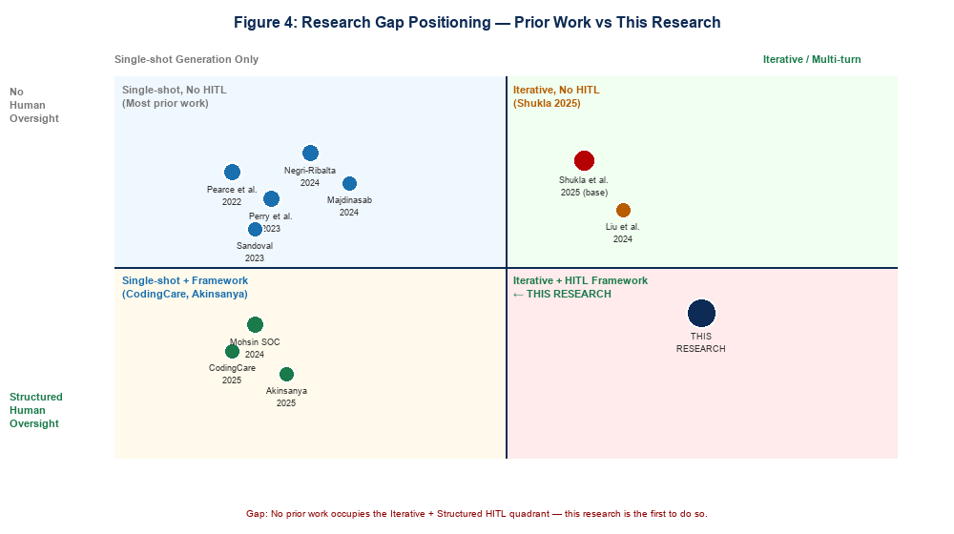
Figure 4: Research Gap Positioning Map — Prior Work vs This Research
Primary Gap
Despite convergence of evidence across six independent literature streams, no designed and evaluated artefact exists that operationalises human-AI collaboration to mitigate security degradation specifically within iterative LLM-assisted code refinement workflows. Shukla et al. (2025) call explicitly for future research on HITL mitigation but stop short of designing or evaluating such a system. Existing HITL frameworks are not adapted for iterative code refinement. Existing code security frameworks do not address iterative dynamics. Fully automated approaches bypass human governance entirely.

Design Requirement 1 — Structured Intervention Trigger Criteria
Shukla et al. (2025) established that vulnerability counts begin increasing non-linearly after approximately five iterations. DR1 requires defining precisely when human intervention must occur — through iteration count thresholds, code complexity increase triggers, supply chain CWE detection, and CVSS severity thresholds.

Design Requirement 2 — Role-Differentiated Review Protocols
Horowitz and Kahn (2024) established that expertise moderates automation bias. DR2 requires defining who reviews what, based on developer experience level and vulnerability category — ensuring senior developers review high-severity vulnerabilities while junior developers are protected by structured checklists.

Design Requirement 3 — Cognitive Feasibility of Review Process
Sonar (2026) documented that 38% of developers sometimes skip review due to burden. DR3 requires designing review processes that are targeted rather than comprehensive, AI-summarised rather than raw, and time-bounded rather than open-ended.

Figure 6 below illustrates the three core design requirements and their derivation from the literature.

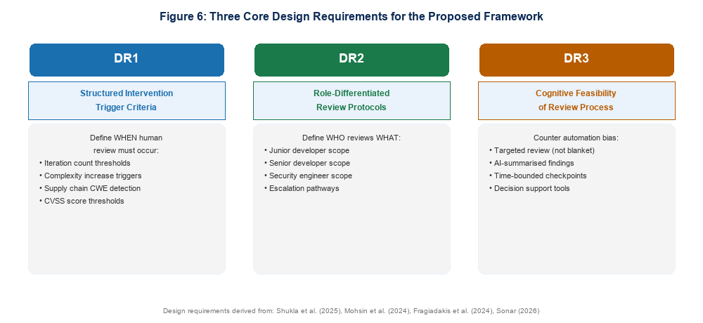
Figure 6: Three Core Design Requirements for the Proposed Framework

7. RESEARCH QUESTIONS
The primary research gap and three design requirements generate the following research questions which the proposed study will address:

- RQ1: Does the Human-AI Collaborative Security Intervention Framework (HACSIF) significantly reduce vulnerability accumulation compared to unmediated iterative LLM-assisted code refinement across multiple iteration conditions?
- RQ2: What structured trigger criteria — defined by iteration count, complexity increase, CWE category, and CVSS severity — most effectively identify intervention points that prevent critical vulnerability accumulation?
- RQ3: How does developer expertise level moderate the effectiveness of role-differentiated review protocols in interrupting the feedback loop security degradation cycle?
- RQ4: Does a HACSIF-aligned iterative code development workflow satisfy the human oversight requirements of the EU AI Act Article 14, the OWASP LLM Top 10 mitigation recommendations, and the NIST AI RMF Govern and Manage functions?

8. SYNTHESIS AND CONCLUSION
This review has examined 33 papers and reports across six thematic clusters. Four conclusions emerge.
First, the empirical foundations are unambiguous and well-replicated. AI code generation tools produce vulnerable code at rates between 40% and 65%, iterative refinement compounds that insecurity by 37.6% across five iterations, and newer model versions do not resolve the problem. The proposed artefact inherits this consensus as its problem specification.
Second, the human-AI collaboration and automation bias literature explains why the problem persists despite developer awareness. Developers exhibit a false sense of security, automation bias is moderated by expertise but not eliminated, and 38% of developers sometimes skip review due to cognitive burden. These findings collectively generate the three design requirements of the proposed framework.
Third, the existing framework landscape confirms the gap through its absences. CodingCare is the closest prior framework but operates post-generation without iterative governance. AutoSafeCoder demonstrates the ceiling of automation without human oversight. No existing framework combines structured trigger criteria, role-differentiated review protocols, and cognitive-load-aware review processes within the iterative loop itself.
Fourth, the regulatory context transforms the research contribution from a technical improvement to a compliance infrastructure. EU AI Act Article 14, OWASP LLM Top 10, and NIST AI RMF together create institutional demand for exactly the kind of structured human oversight framework this research will produce. The proposed Human-AI Collaborative Security Intervention Framework will be the first artefact designed specifically for iterative LLM-assisted code refinement governance, evaluated against the experimental methodology of Shukla et al. (2025), and aligned with all three major AI governance standards.

REFERENCES
Abbasi, M. A., et al. (2025). Reconsidering requirements engineering: Human-AI collaboration in AI-native software development. arXiv:2510.04380.
Akinsanya, A. (2025). Security by design: A risk-based framework for cybersecurity compliance and critical infrastructure protection. International Journal of Information Security. https://doi.org/10.1007/s10207-025-01155-4
Alebachew, Y. B., and Brown, C. (2024). Automatic bias detection in source code review. arXiv:2504.18449.
Alexei, A. (2022). Implementing Design Science Research Method to develop a cyber security framework for HEIs in Moldova. Proceedings of IC|ECCO-2021.
Alqarni, A., et al. (2024). AutoSafeCoder: A multi-agent framework for securing LLM code generation through static analysis and fuzz testing. arXiv:2409.10737.
Blain, D., and Noiseux, M. (2026). Broken by default: A formal verification study of security vulnerabilities in AI-generated code. arXiv:2604.05292.
Bobba, A. R. (2025). The evolution of cognitive partnership: A taxonomic framework for human-AI collaboration modalities. Journal of Computer Science and Technology Studies, 7(8), 992-1005.
Cabrero-Daniel, B., Herda, T., Pichler, V., and Eder, M. (2024). Exploring human-AI collaboration in agile: Customised LLM meeting assistants. XP Conference. Springer.
Center for Security and Emerging Technology (CSET). (2024). Cybersecurity risks of AI-generated code. Georgetown University. https://doi.org/10.51593/20230057
Chan, A. (2026). SHAPR: Operationalising human-AI collaborative research through structured knowledge generation. arXiv:2603.25660.
Chong, C. J., Yao, Z., and Neamtiu, I. (2024). Artificial-intelligence generated code considered harmful. arXiv:2409.19182.
European Union. (2024). AI Act: Regulation of the European Parliament and of the Council laying down harmonised rules on artificial intelligence.
Fragiadakis, G., Diou, C., Kousiouris, G., and Nikolaidou, M. (2024). Evaluating human-AI collaboration: A review and methodological framework. arXiv:2407.19098.
GitHub. (2024). Survey reveals AI's impact on the developer experience. GitHub Blog.
HICSS-57. (2024). Deriving design principles from the design journey of a cybersecurity readiness assessment tool. Hawaii International Conference on System Sciences.
Hamza, M., Siemon, D., Akbar, M. A., and Rahman, T. (2023). Human-AI collaboration in software engineering. arXiv:2312.10620.
Horowitz, M. C., and Kahn, L. (2024). Bending the automation bias curve. International Studies Quarterly, 68(2).
Liu, Y., Le-Cong, T., Widyasari, R., Lo, D., Tao, M., and Han, S. (2024). Refining ChatGPT-generated code: Characterizing and mitigating code quality issues. ACM TOSEM.
Majdinasab, V., et al. (2024). Assessing the security of GitHub Copilot's generated code: A targeted replication study. IEEE SANER 2024.
Mohsin, A., Janicke, H., Ibrahim, A., Sarker, I. H., and Camtepe, S. (2024). A unified framework for human-AI collaboration in security operations centres. arXiv:2505.23397.
Mohsin, A., et al. (2025). CodingCare: AI code generation security framework. ACM ISCCN 2025.
Negri-Ribalta, C., et al. (2024). A systematic literature review on the impact of AI models on the security of code generation. Frontiers in Big Data, 7.
NIST. (2023). AI Risk Management Framework (AI RMF 1.0). National Institute of Standards and Technology.
OWASP. (2024). OWASP Top 10 for Large Language Model Applications. OWASP Foundation.
Pastor, O., et al. (2024). Dual-cycle DSR model. Information Systems Journal.
Pearce, H., Ahmad, B., Tan, B., Dolan-Gavitt, B., and Karri, R. (2022). Asleep at the keyboard? Assessing the security of GitHub Copilot's code contributions. IEEE S&P 2022.
Perry, N., Srivastava, M., Kumar, D., and Boneh, D. (2023). Do users write more insecure code with AI assistants? ACM CCS 2023.
Shukla, S., Joshi, H., and Syed, R. (2025). Security degradation in iterative AI code generation: A systematic analysis of the paradox. IEEE-ISTAS 2025. arXiv:2506.11022.
Sonar. (2026). State of code: Developer survey 2026.
Tariq, S., et al. (2025). Bridging expertise gaps: The role of LLMs in human-AI collaboration for cybersecurity. arXiv:2505.03179.
Venable, J. R., Pries-Heje, J., and Baskerville, R. (2012). A comprehensive framework for evaluation in design science research. DESRIST 2012.
Veracode. (2025). 2025 GenAI code security report. Veracode Research.
Wang, Y., et al. (2024). Is your AI-generated code really secure? Evaluating large language models on CodeSecEval. arXiv:2407.02395.
WitnessAI. (2026). Human-in-the-loop AI: Benefits, use cases, and best practices.
arXiv:2601.00509. (2025). Improving LLM-assisted secure code generation through RAG and multi-tool feedback.

