The Guide v2.0
poc
Codename: Janice

The starting scenario page 2
Mailbox situation page 3
Prepare the destination on-prem server page 3
Change the jd0e.com MX record to point to the agzsolt.com on-prem server page 4
Disable Federation page 5
Cut jd0e.com dirsync (can take up to 72 hours to complete), or… page 7
Create jd0e.com users in the agzsolt.com local AD in a non-synced OU page 8
Configure the cross-forest hybrid environment page 10
Sync the MSOL attributes into the agzsolt.com local AD accounts page 11
Migrate users to agzsolt.com on-prem page 12
Strip down the old tenant page 17
Sorting the post-migration tasks: permissions check, distribution lists and contacts creation page 18
MIGRATE BACK TO THE CLOUD page 19
Tidying up page 21

These days it’s a common scenario when a company acquires another, and having both hosting their mail service in the cloud using Office 365. Unfortunately Microsoft doesn’t provide us with easy to use tools and ways to simply merge the two cloud tenants, which gives other companies room to offer their cloud migration services using their software, which is probably a convenient way for the administrators but surely not ideal for mailflow or for the users. They technically use their proprietary software to connect to both organizations, create the corresponding new mailboxes in the target tenant, copy the data over and after a final synchronization they remove the old version and finalize the target. Now the first of the two biggest problems with this approach is that we need to purchase extra licenses for the target tenant to accommodate the new mailboxes until the other tenant is demoted and those licenses can be transferred over: it’s inconvenient, costs extra and it’s hard to rely on Microsoft to make the transfer faster – which can be delayed by many things. The other thing is the fact that we cannot have the same domain name in two tenants at the same time, you can’t use the source company’s existing email addresses on the target tenant until all the mailboxes are migrated over and the domain is removed from the source.

Luckily with a little effort there is a way to maintain perfect mailflow during the migration while users are able to use their original email addresses, the same mailbox profile in their Outlook with no need to purchase extra licenses not even temporarily and with this method we only use the built-in functions of Microsoft EOL and Exchange 2013.

So enough talking, let’s just jump into it!

This guide is made to simulate a scenario where a company called “Jd0e Inc” in our case was acquired by “Agzsolt Inc). They both are using a hybrid Office365 environment, however in this guide we only deal with the mail service. Our goal is to merge Jd0e into the Agzsolt tenant while we maintain mail- and workflow the whole time.

To make the situation a little more complex, the source Jd0e tenant is using ADFS for single sign-on functionality. Also the Jd0e users are still using the the 2010 version of Outlook so we stick with it here.

In our example agzsolt.com is the destination tenant and jd0e.com is the organization to be moved the mailboxes from.

The starting scenario
Destination:
agzsolt.com
Hybrid
O365: agzsolt.onmicrosoft.com tenant, agzsolt.com as the default domain
Onprem: Exchange 2013 CU18 server: 51.143.185.87
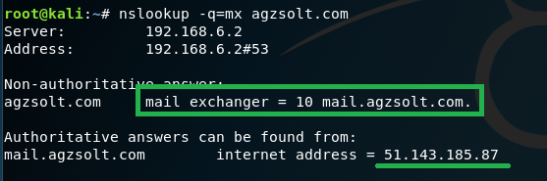

Source:
Jd0e.com
Hybrid and ADFS federated
O365: jdoe.onmicrosoft.com tenant; jd0e.com as the default domain
Onprem: Exchange 2013 CU18 server+DC: 51.143.157.86
Adfs proxy: 51.143.188.208
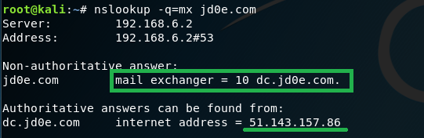

As expected, the incoming emails are taken to the corresponding on-prem mail server, where they are forwarded if the target mailbox is hosted in the cloud with the help of to the hybrid setup. To visualize the mail flow now:
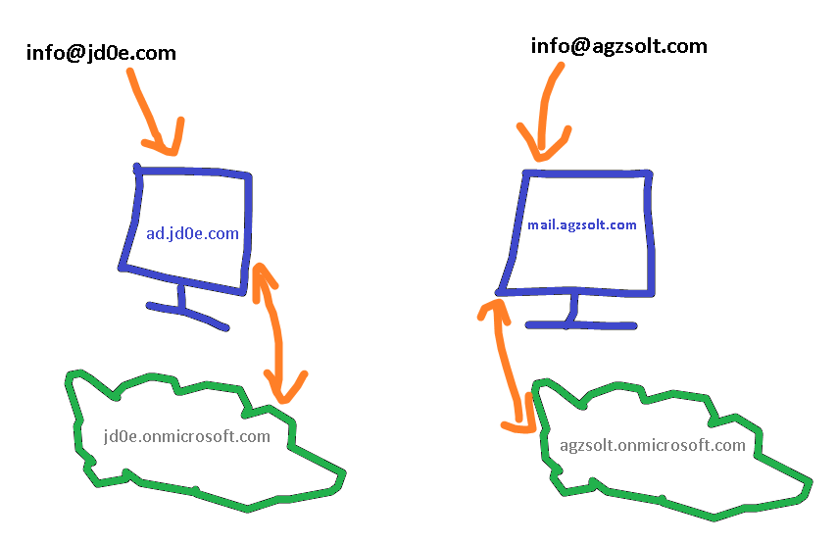
Mailbox situation:
Destination – agzsolt.com:
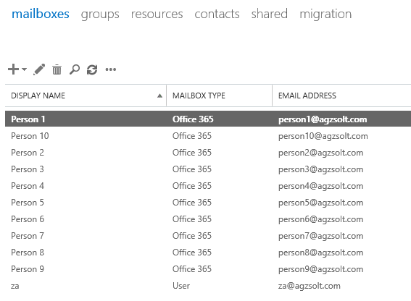

Source – jd0e.com:
Ok, let’s start!

Prepare the destination on-prem server
- Put jd0e.com in the accepted domain list
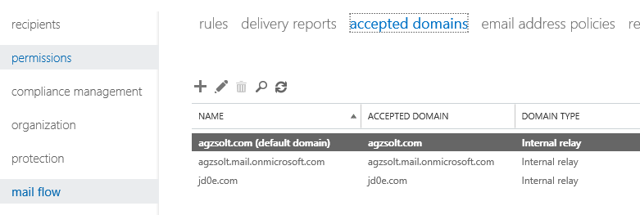
- If not already done, create a send connector to the cloud
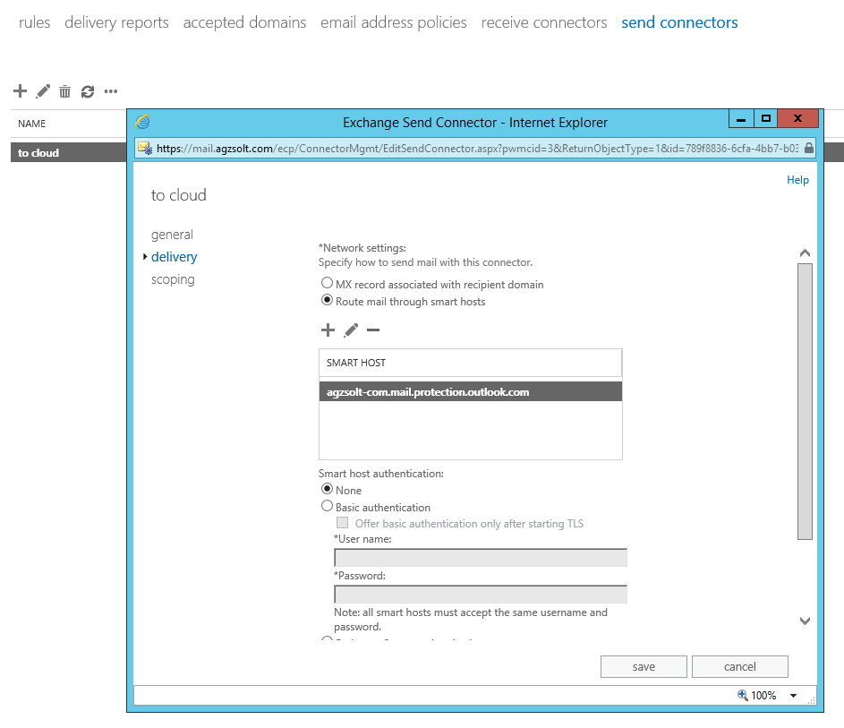

Change the jd0e.com MX record to point to the agzsolt.com on-prem server
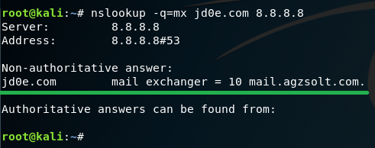

Because of this change the incoming mails to @jd0e.com will be directed to the mail.agzsolt.com server where the migrated mailboxes will sit or if no local mailbox is found by the server it forwards them to the cloud where the cloud servers will find the route to the correct tenant.
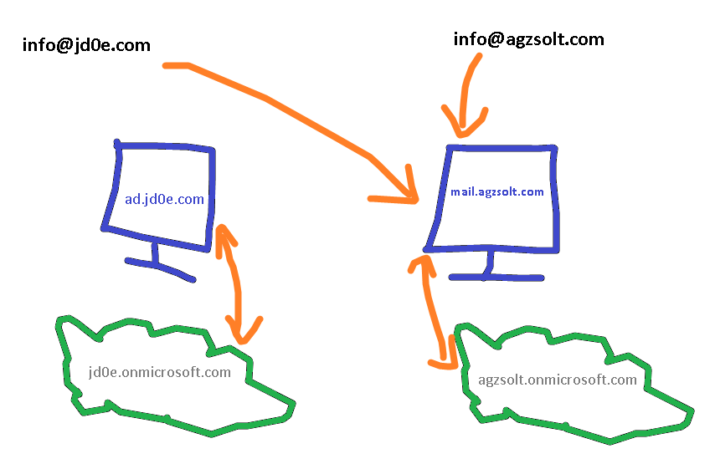
Now test the mail flow to verify the emails are still arriving to the @jd0e.com mailboxes: we send an email from a Gmail address to a jd0e mailbox. Note that the jd0e MX record has already been directed to the destination on-prem server (mail.agzsolt.com). Also the SPF record is updated accordingly to prevent the sent emails to be put in the recipient’s junk folder.

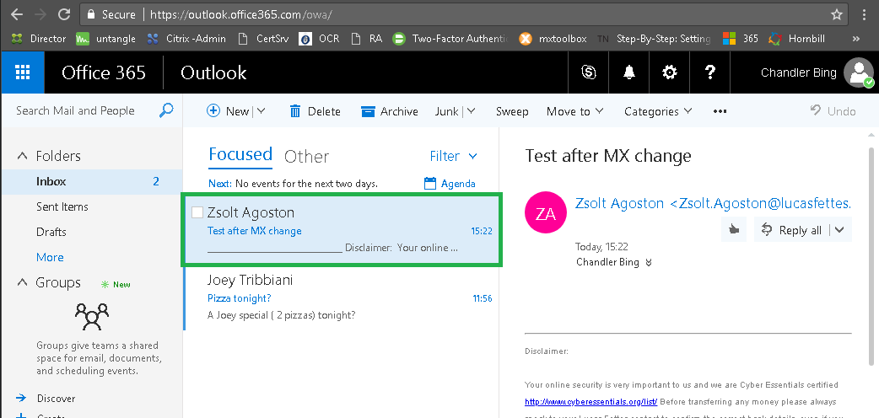

The email has arrived without an issue!

Disable Federation

First we need to disable ADFS before we can proceed and cut dirsync to make the mailboxes fully cloud-managed.

Let’s see how the OWA portal behaves. As soon as we try to log in on https://out.look.office365.com it redirects us the the local ADFS proxy server for authentication
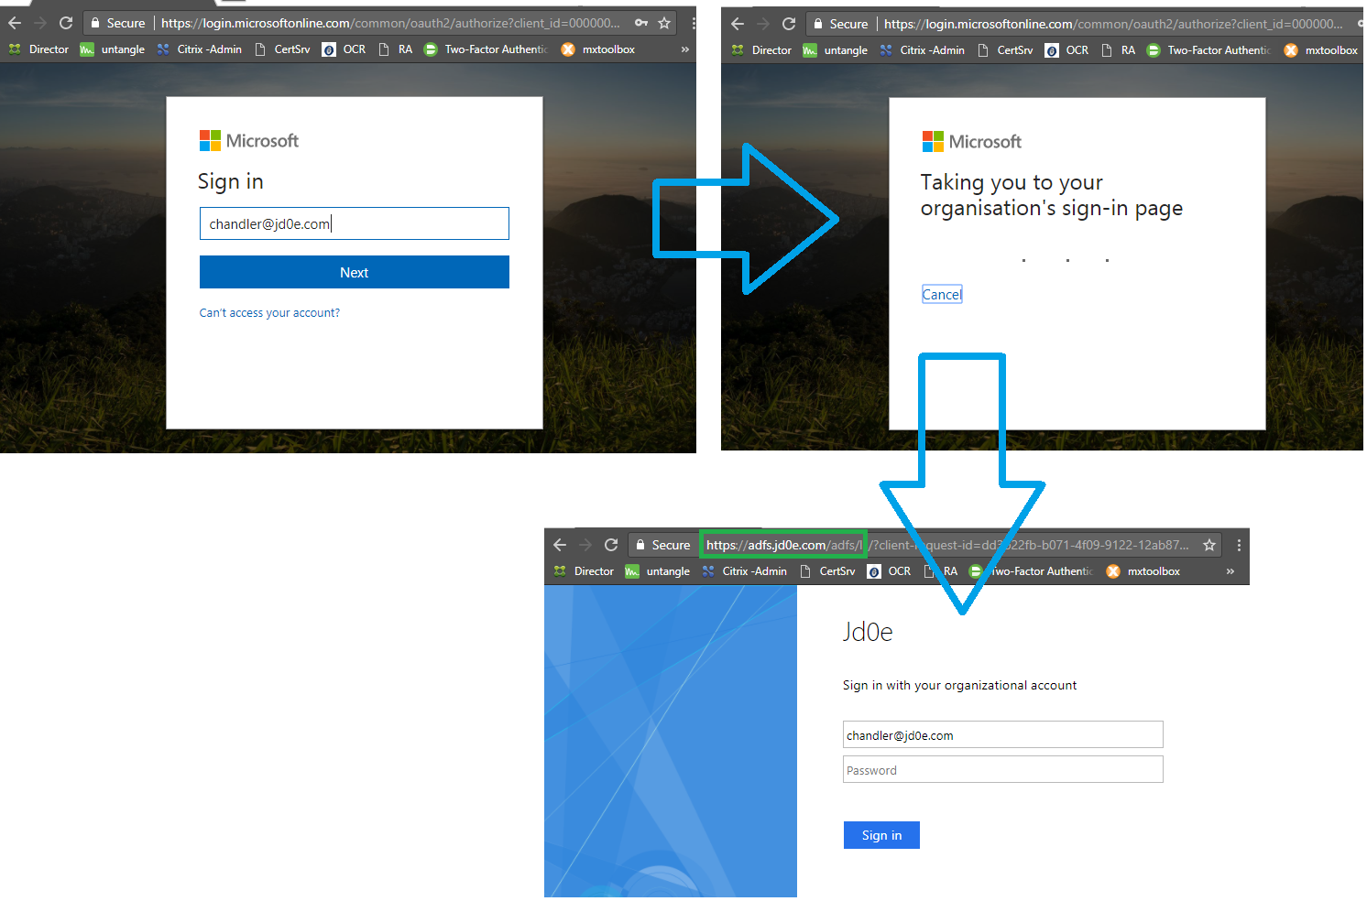

We can see on dc.jd0e.com server that the domain is federated:

Now we make the domain standalone. First we connect to the adfs server
Set-MsolADFSContext -Computer adfs.jd0e.com

And set the domain to standard:
Convert-MsolDomainToStandard -DomainName jd0e.com -SkipUserConversion:$true -PasswordFile c:\passwdfile.txt
And set the authentication method as well:
Set-MsolDomainAuthentication -Authentication managed -DomainName jd0e.com

At this point the domain becomes cloud-managed again, that we will confirm

To see if the authentication works we check the login interface again:
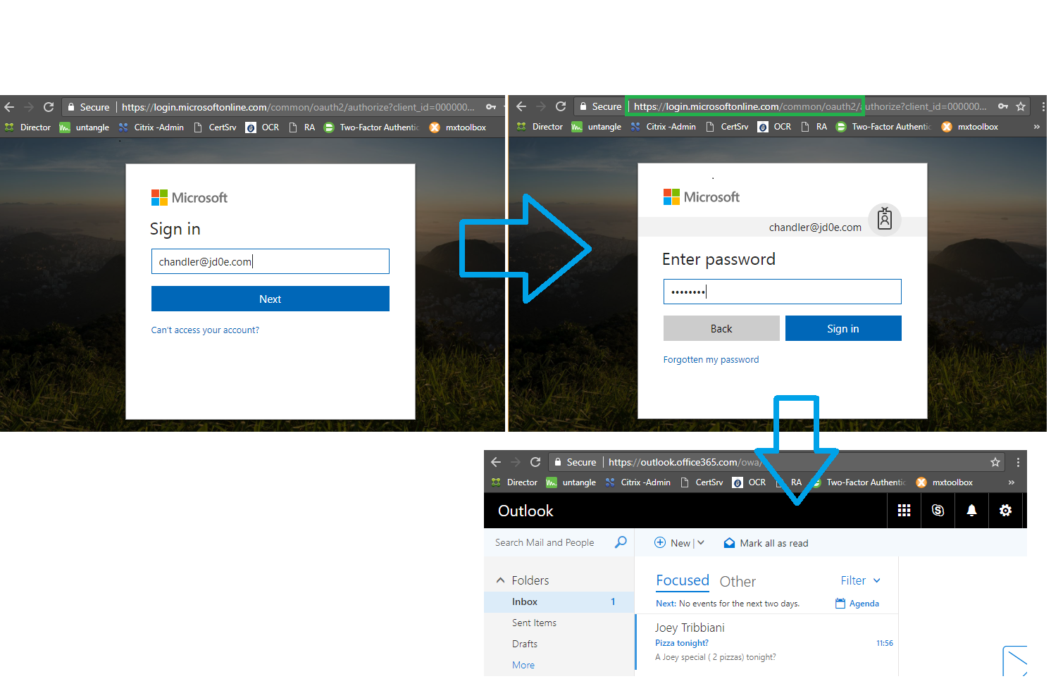

We are in, the authentication is happening in the cloud with the AD password that is synced with DirSync! Excellent!

Cut jd0e.com dirsync (can take up to 72 hours to complete), or…
In this step we convert accounts to purely cloud account while keeping their original password
Before:

Set-MsolDirSyncEnabled -EnableDirSync:$false

Check if the process has run:
(Get-MSOLCompanyInformation).DirectorySynchronizationEnabled

Note, if the process takes very long there’s another way: simply move the user accounts to an OU that is not synced to the cloud, and wait for or force a sync cycle. That will soft delete the cloud accounts, after which they can be restored using the following command (the cloud system will restore them as cloud accounts, preserving the original passwords, permission settings as well):
Get-MsolUser -ReturnDeletedUsers | Restore-MsolUser
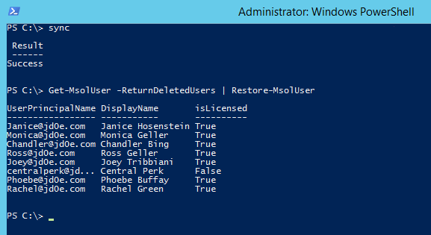
After which:
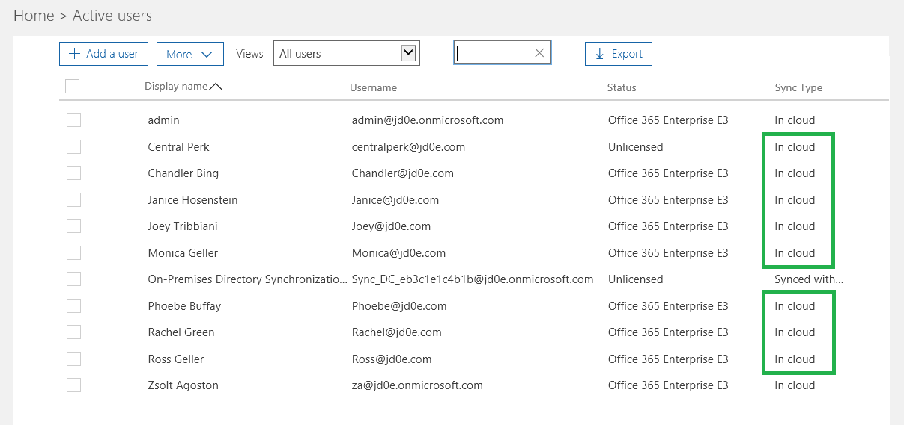

Now we check the permissions on the shared mailboxes to make sure they are not lost like after a license unassign-reassign scenario. As seen below the permission structure is preserved post-cloudization
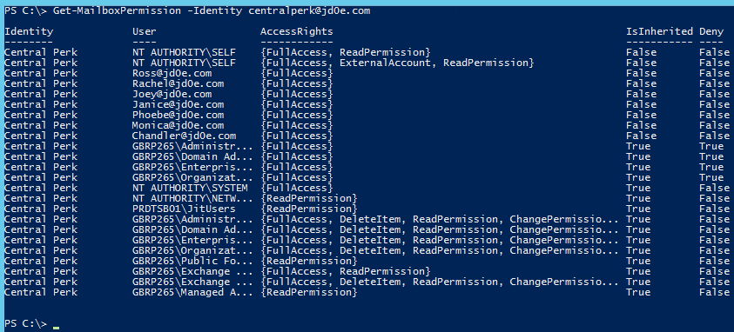

Create jd0e.com users in the agzsolt.com local AD in a non-synced OU

First, we add the jd0e.com domain to the Active Directory Domains and Trusts temporarily to make the transition simpler for the users. This way they will be able to log in using the underlying kerberos ticketing system – meaning no password prompts (at least while the mailboxes are sitting on the on-prem server)
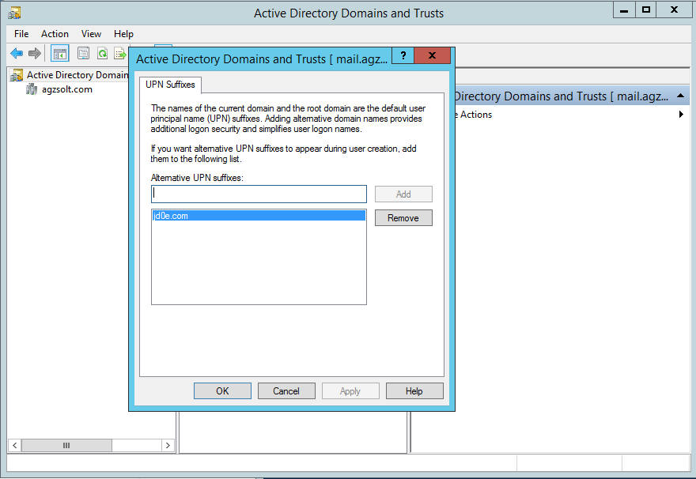

We run the following script to create the users, which will be created from users.csv
Users.csv
FirstName | LastName
Ross | Geller
Joey | Tribbiani
Monica | Geller
Rachel | Green
Chandler | Bing
Phoebe | Buffay
Janice | Hosenstein
CentralPerk

Script:
New-ADOrganizationalUnit -Name "jd0e" -Path "OU=My Business,DC=agzsolt,DC=com" –Verbose

import-csv users.csv | foreach {
$fn=$_.FirstName
$ln=$_.LastName
New-ADUser -Name "$fn $ln" -DisplayName "$fn $ln" -GivenName "$fn" -Surname "$ln" -UserPrincipalName $fn@jd0e.com -Path "OU=jd0e,OU=My Business,DC=agzsolt,DC=com" -Enabled:$true -EmailAddress "$fn@jd0e.com" -AccountPassword(ConvertTo-SecureString "Password12345!" -AsPlainText -Force)
Enable-RemoteMailbox -Identity $fn@jd0e.com -RemoteRoutingAddress $fn@jd0e.onmicrosoft.com
Set-RemoteMailbox -Identity $fn@jd0e.com -EmailAddressPolicyEnabled:$false
}

After the commands being run we check the results on the agzsolt.com server:
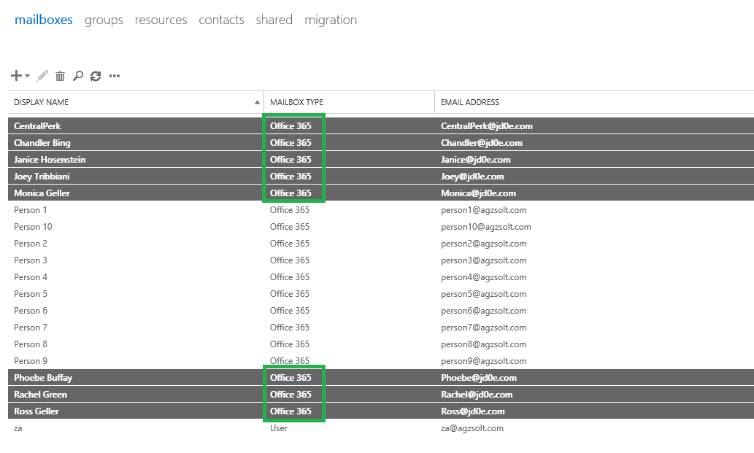
Configure the cross-forest hybrid environment

To make the servers able to move jd0e.com mailboxes to the agzsolt.com server we need to create a migration endpoint in the jd0e.com cloud server. It is done in recipients/migration/migration endpoints, as the new endpoint’s type we use is “exchange remote"
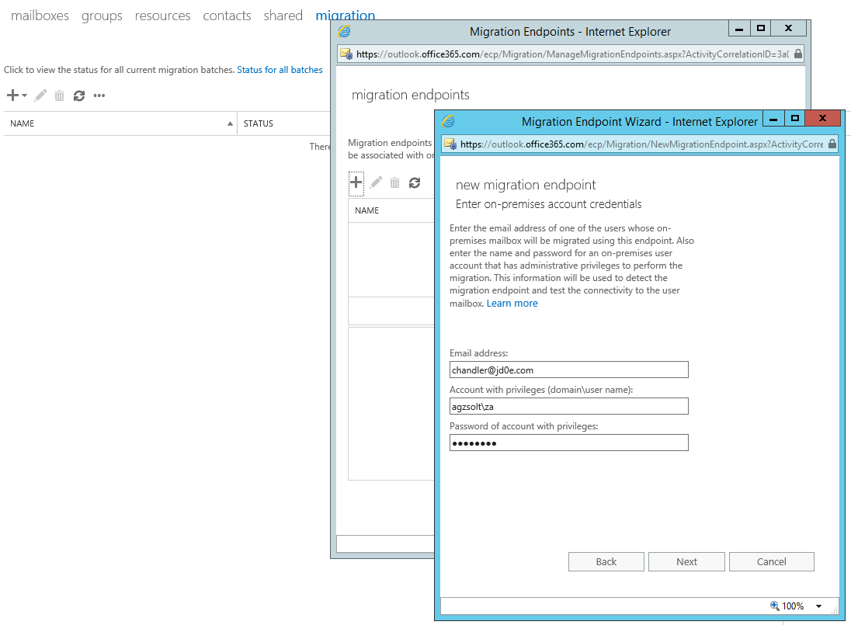
It will fail because the server tries to determine the destination FQDN using autodiscover which points to the wrong location of course. We put the right server manually:
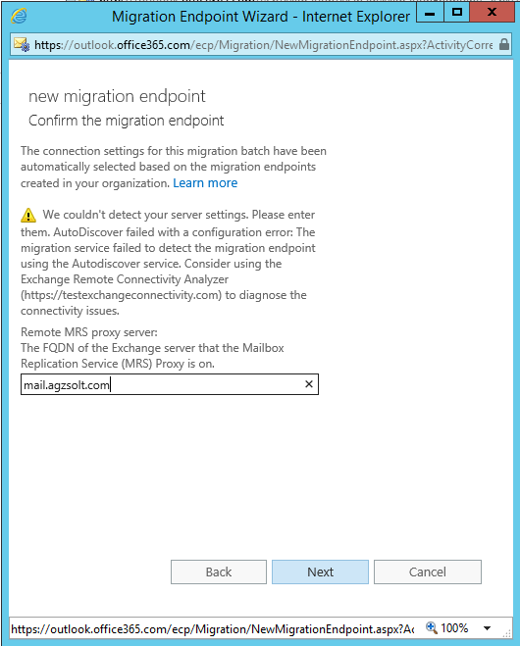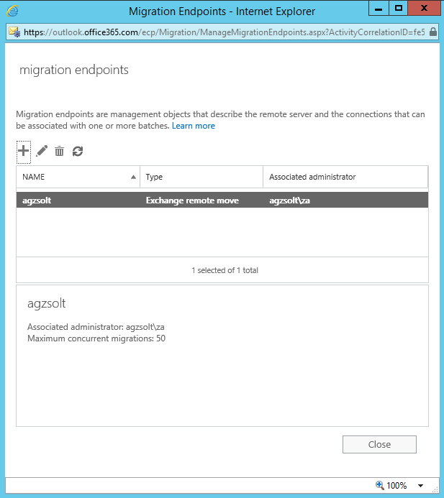

In our example we will call the connector “agzsolt”

Sync the MSOL attributes into the agzsolt.com local AD accounts

Here the most important thing is that the ExchangeGUID attribute of the accounts on the destination on-prem server must match the ExchangeGUID, WindowsEmailAddress and PrimarySMTPAddress attributes of the actual cloud mailboxes. We can sync it doing the following:
- On the cloud server we run the following command that will create a file called mailboxes.csv, with all the mailboxes and with the attributes we need:
Get-Mailbox -ResultSize Unlimited | select userprincipalname,windowsemailaddress,alias,exchangeGUID | Export-Csv mailboxes.csv
Now we import the important attributes into the on-prem server for compliance:
import-csv mailboxes.csv | foreach {
$name=$_.userprincipalname
$winname=$_.windowsemailaddress
$alias=$_.alias
$guid=$_.exchangeGUID
Set-RemoteMailbox -Identity $name -ExchangeGuid $guid -WindowsEmailAddress $winname -EmailAddresses @{add="$name"}
Set-RemoteMailbox -Identity $name -PrimarySmtpAddress $name
write-host "$name has given GUID: $guid"
}

- To save the mailbox permission structure, we create a backup file that stores that information, called perm.csv
Get-Mailbox -ResultSize Unlimited | Get-MailboxPermission | where {$_.isinherited -like "FALSE"} | where {$_.user -notlike "NT AUTHORITY\SELF"} | where {$_.user -notlike "Discovery Management"} | select identity,user,accessrights | Export-Csv perm.csv
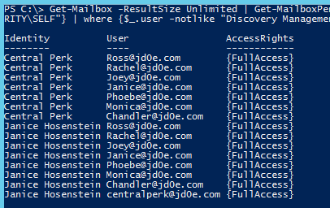
We do the same with send-as permissions (sendasperm.csv):
Get-Mailbox -ResultSize Unlimited | Get-RecipientPermission | where {$_.isinherited -like "FALSE"} | where {$_.trustee -notlike "NT AUTHORITY\SELF"} | select identity,trustee,accessrights | Export-Csv sendasperm.csv
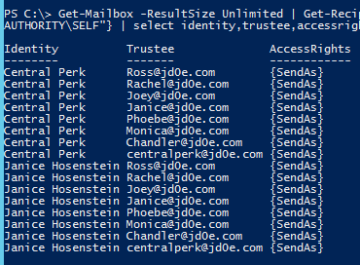
- Next, we save the distribution groups and members as well in a file called distro.csv
$distro = Get-DistributionGroup -ResultSize unlimited
$distro | select samaccountname,displayname,windowsemailaddress | Export-Csv distro-list.csv
$members = foreach ($m in $distro) { Get-DistributionGroupMember -Identity $m.Identity | Select @{Name="Group";Expression={$m.name}},PrimarySMTPAddress}
$members | export-csv distro.csv
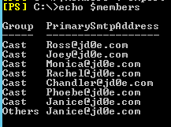

- Let’s export the contacts:
Get-Contact -ResultSize unlimited | select identity, name,displayname,firstname,lastname,windowsemailaddress | export-csv contacts.csv
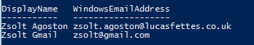

- As the public folder migration is a little cumbersome between O365 and on-prem, even with modern public folder mailboxes, we simply export all the public folders from an Outlook client into a PST file for future ingestion
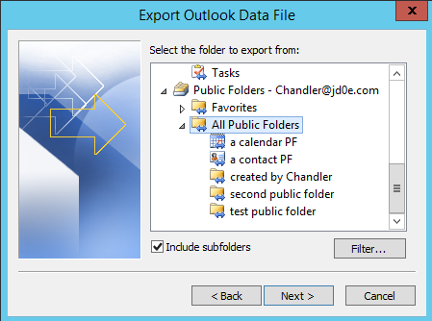

Migrate users to agzsolt.com on-prem

Now we create a migration batch that will synchronize and move the jd0e.com mailboxes to the on-prem endpoint. We create our first batch called “First Ones” from first.csv:
first.csv
EmailAddress
Ross@jd0e.com
Joey@jd0e.com
Monica@jd0e.com
Rachel@jd0e.com
Chandler@jd0e.com
Phoebe@jd0e.com
Janice@jd0e.com
CentralPerk@jd0e.com
Script
New-MigrationBatch -Name "First Ones" -TargetEndpoint "agzsolt" -BadItemLimit unlimited -TargetDeliveryDomain agzsolt.com -CSVData ([System.IO.File]::ReadAllBytes("C:\first.csv")) -TargetDatabases "edebdf60-047b-4542-a36c-e923f9f14d9d" -Verbose

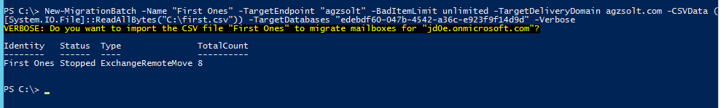
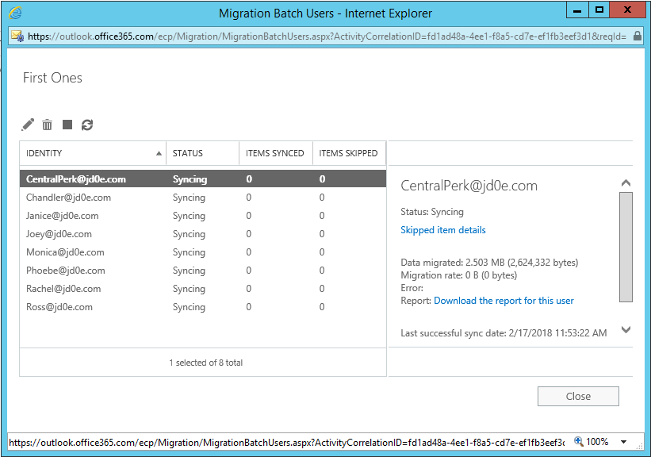
When it’s done we are ready to finish the whole batch (or just specific mailboxes, it depends on our needs)
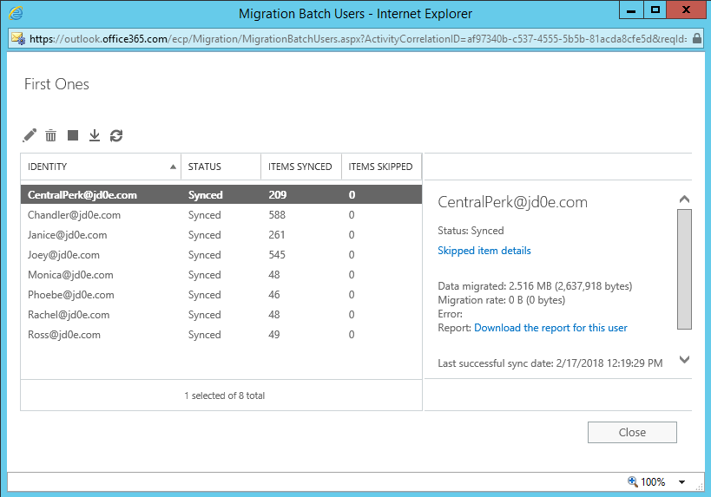

We complete the migration batch and make sure the users can access their mailboxes and they are functional

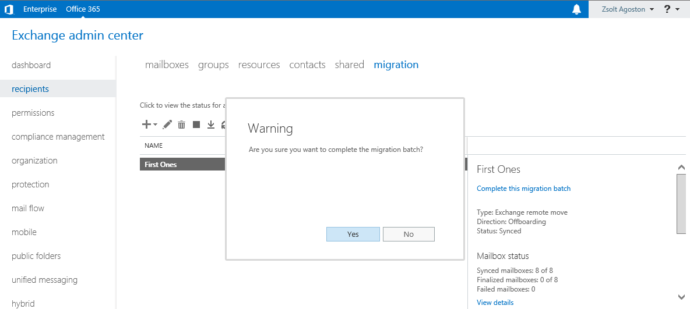

Just to mention: the shared mailboxes need a license assigned to them
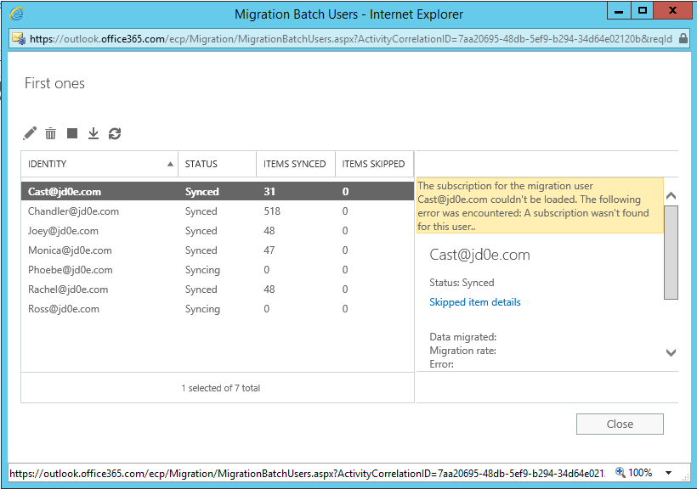

After the migration, we see that the on-prem server handles the mailboxes as local mailboxes:
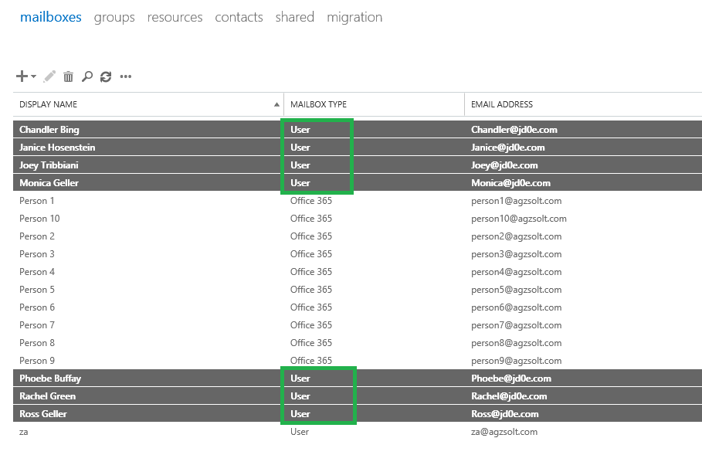

Now we change the local SCP record for autodiscover on the jd0e.com (source) domain controller, because this is the first place the server is looking for the autodiscover.xml data file which will not return the right values, we change that to point to the agzsolt.com (destination) autodiscover file:
https://mail.agzsolt.com/Autodiscover/Autodiscover.xml

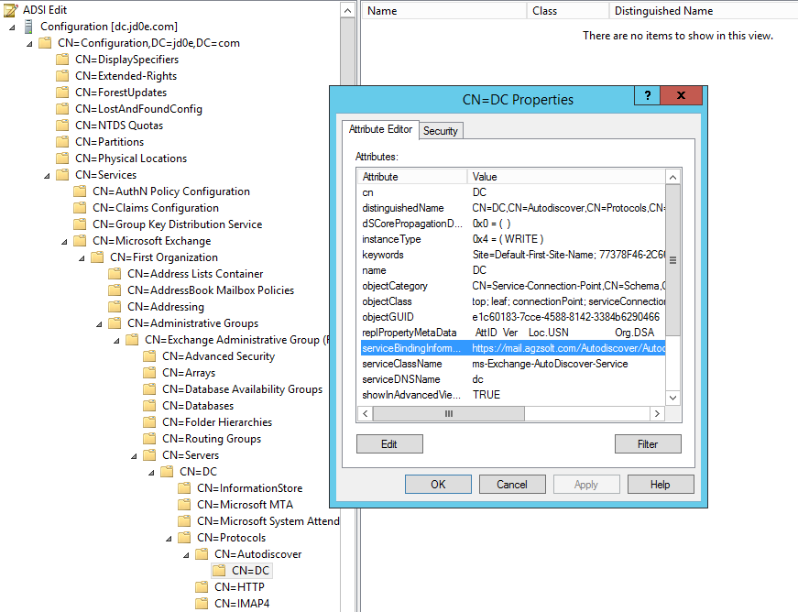
Note that the windows Outlook client is relying on the autodiscover record to locate public folders and it checks the SCP record first when it’s opened. If we changed it before moving the publicfolder mailbox to the new server, it would give us an error message on the client side!

Once the users try to log in, Outlook notifies them of the changes in the background - the server name will be updated in the profile - and the users will be asked to close and open Outlook again, just like after a cloud migration:
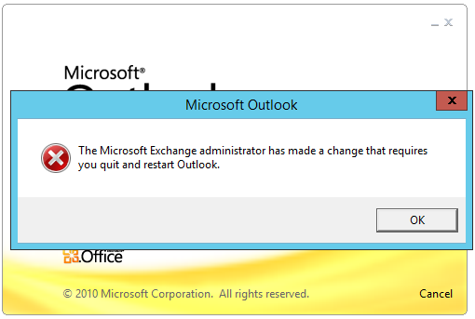

Now another good news, from this point if a user needed to re-create his/her Outlook profile on a domain-joined client (even on the source-side in the jd0e.com domain), they won’t be prompted for their password, as long as the passwords match on the original jd0e.com and the new agzsolt.com forest the Kerberos ticketing will work flawlessly

After logging in, we test the mail flow:
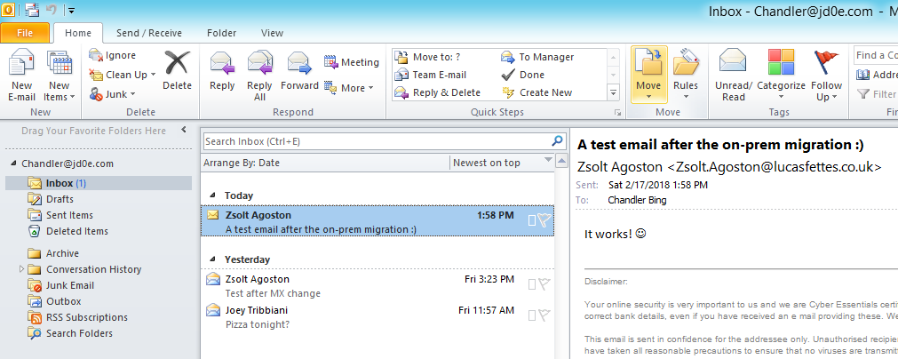

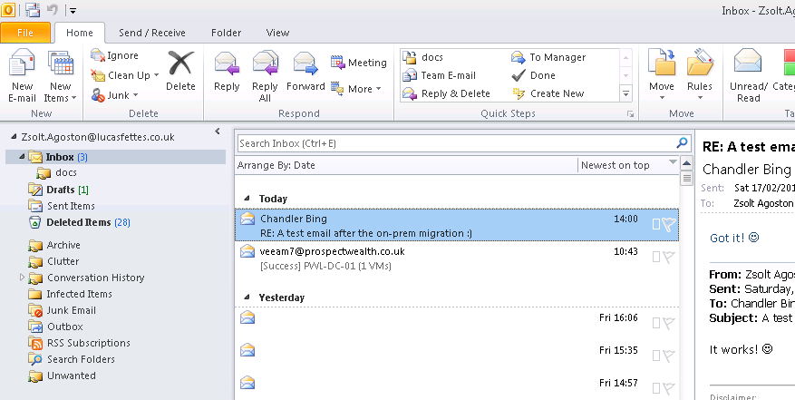

Excellent! The mail flow works in both directions!

Before we forget, we remove the old jd0e.onmicrosoft.com STMP addresses from the moved mailboxes.
import-csv users.csv | foreach {
$name=$_.FirstName
Set-Mailbox -Identity $name -EmailAddresses @{remove="$name@jd0e.onmicrosoft.com" }
}

Strip down the old tenant

As a next step we remove of our business domains from the source tenant and add them to the target. In our example it is a single domain: jd0e.com
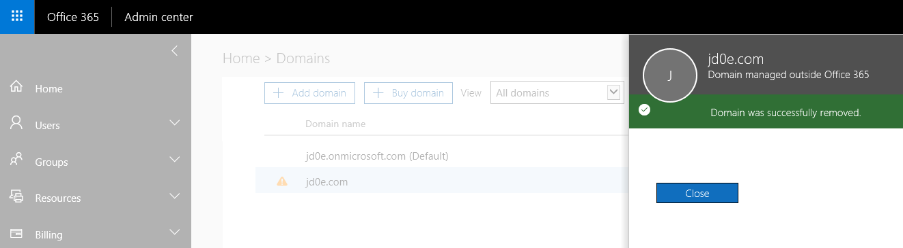
After removing jd0e.com domain from the jd0e.onmicrosoft.com tenant and add that to agzsolt.onmicrosoft.com
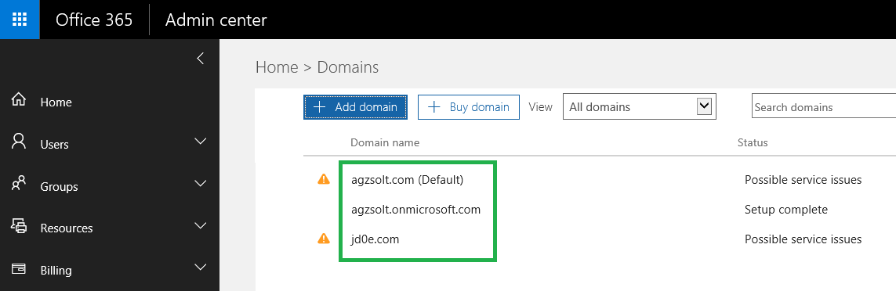

Now we simply create a jd0e subfolder in the local Public Folder system and import the PF.pst file there
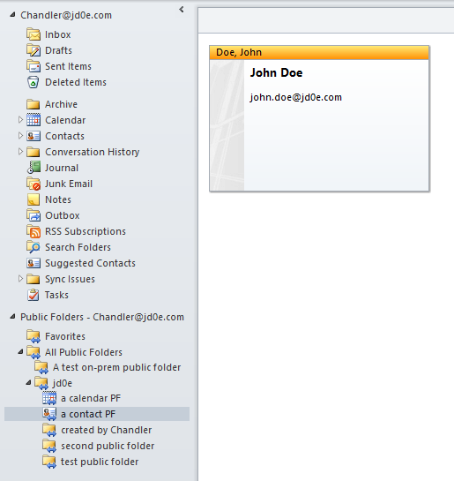

Perfect!

Sorting the post-migration tasks: permissions check, distribution lists and contacts creation

Amazing news that the mailbox permissions are inherited, they were mirrored during the migration so we don’t need to worry about that
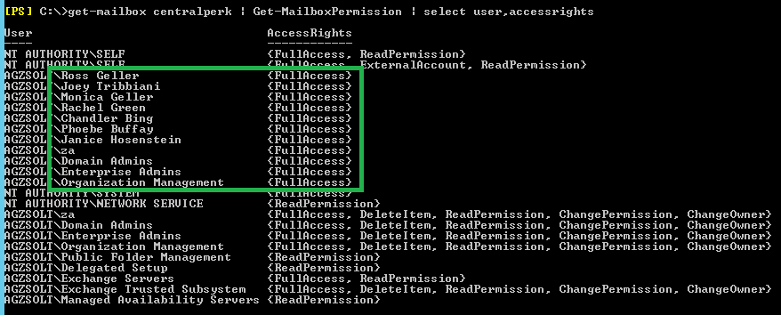
Send-as permissions are moved through as well:
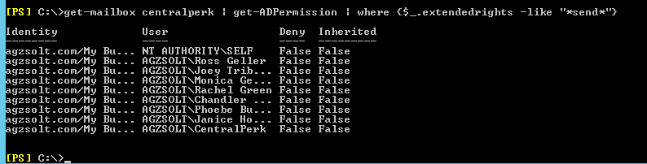

Now we create the distribution groups with the right users
import-csv distro-list.csv | foreach {
$SAM=$_.SamAccountName
$name=$_.DisplayName
$win=$_.WindowsEmailAddress
New-DistributionGroup -Name $name -DisplayName $name -PrimarySmtpAddress $win -Type distribution -IgnoreNamingPolicy:$true -ModerationEnabled:$false -OrganizationalUnit "OU=DGs,OU=jd0e,OU=My Business,DC=agzsolt,DC=com" -Confirm:$false
Set-DistributionGroup -Identity $win -RequireSenderAuthenticationEnabled:$false
}

Populate with the members:
import-csv distro.csv | foreach {
$group=$_.Group
$member=$_.PrimarySmtpAddress
Add-DistributionGroupMember -Identity $group -Member $member -Confirm:$false
}

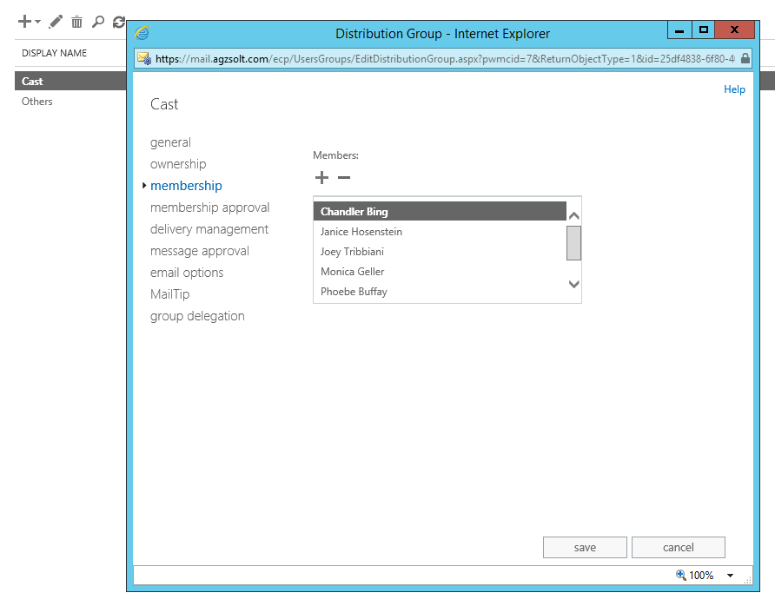

And to finish the process, we create the contacts:
import-csv contacts.csv | foreach {
$name=$_.Name
$disp=$_.DisplayName
$fn=$_.FirstName
$ln=$_.LastName
$email=$_.WindowsEmailAddress
New-MailContact -Name $name -DisplayName $disp -FirstName $fn -LastName $ln -ExternalEmailAddress $email -OrganizationalUnit "OU=Contacts,OU=jd0e,OU=My Business,DC=agzsolt,DC=com" -Confirm:$false
}

From this point it’s a normal migration to the cloud scenario.

MIGRATE BACK TO THE CLOUD

That’s the easy and well documented part of our job, first we create the migration endpoint in the cloud server just like we did the first time on the source tenant. This time we do the exact same steps, and we call this endpoint “agzsolt” as well.

An important thing is to move the OU that contains all the moved accounts to an AD that is a synced OU so the users will appear in the tenant

We create a file called UpToTheCloud.csv and start the migration batch:
UpToTheCloud.csv
EmailAddress
Ross@jd0e.com
Joey@jd0e.com
Monica@jd0e.com
Rachel@jd0e.com
Chandler@jd0e.com
Phoebe@jd0e.com
Janice@jd0e.com
CentralPerk@jd0e.com

Script:
New-MigrationBatch -Name "Up Back To The Cloud" -SourceEndpoint "agzsolt" -BadItemLimit unlimited -TargetDeliveryDomain agzsolt.mail.onmicrosoft.com -CSVData ([System.IO.File]::ReadAllBytes("C:\UpToTheCloud.csv"))
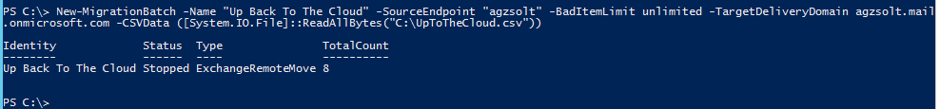

Start the migration
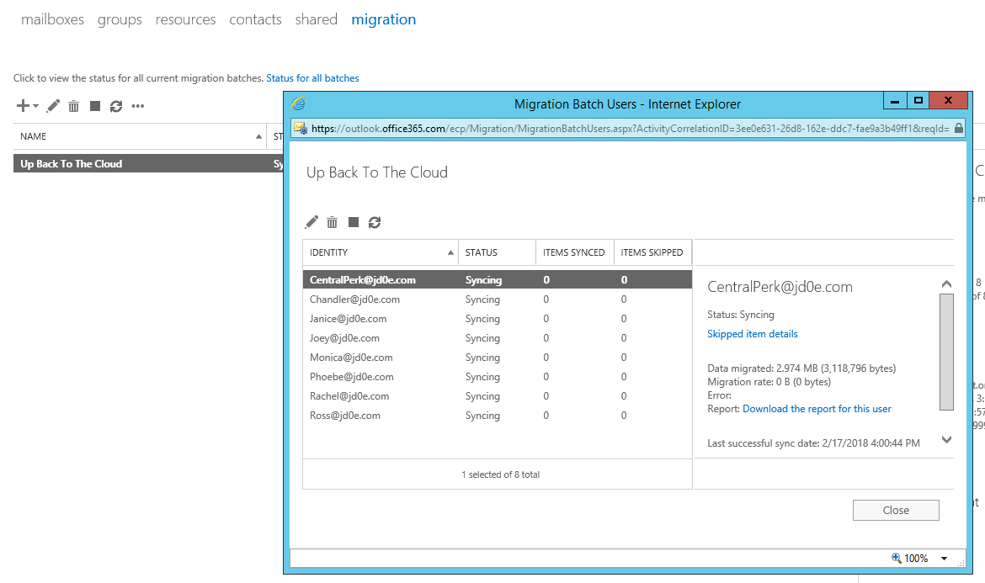

Now it’s time to complete the batch
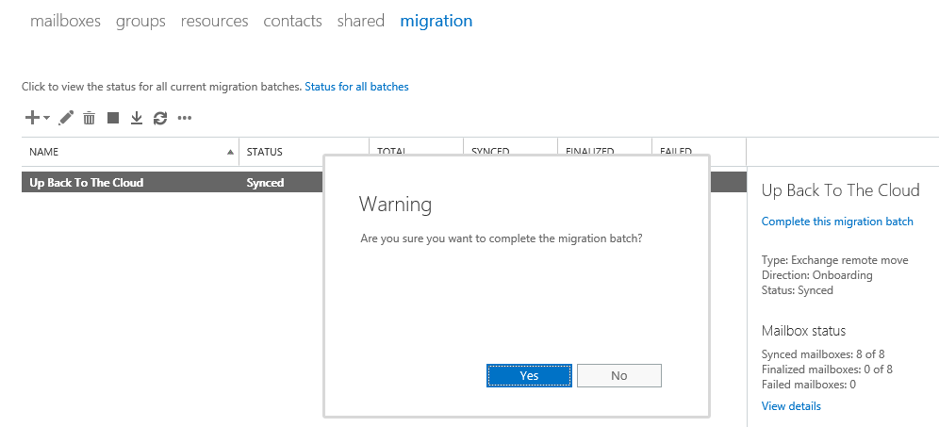

After the batch is done we can see the mailboxes finally appearing in the cloud
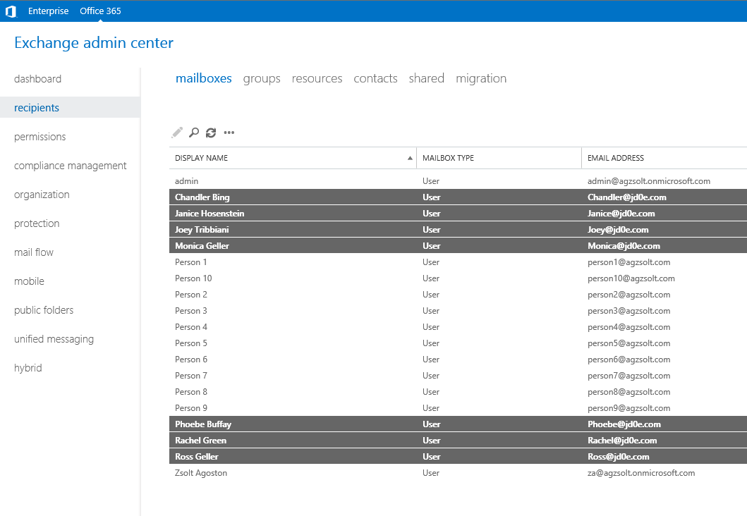

I personally like to change the SCP domain for autodiscover in the jd0e domain to https://autodiscover-s.outlook.com/Autodiscover/Autodiscover.xml which makes faster discovery at later profile creations, but this step can be omitted.

The clients will receive another notification of the background changes after which they need to restart Outlook again and we are done!

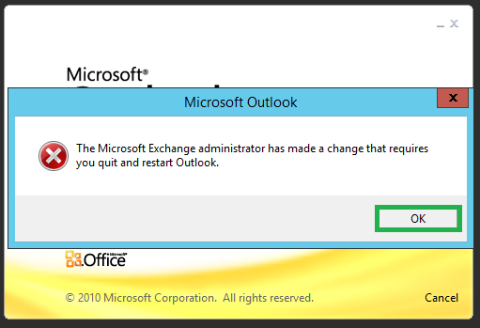

Tidying up

We still have a few things to sort:
- We assign the appropriate licenses to the migrated accounts
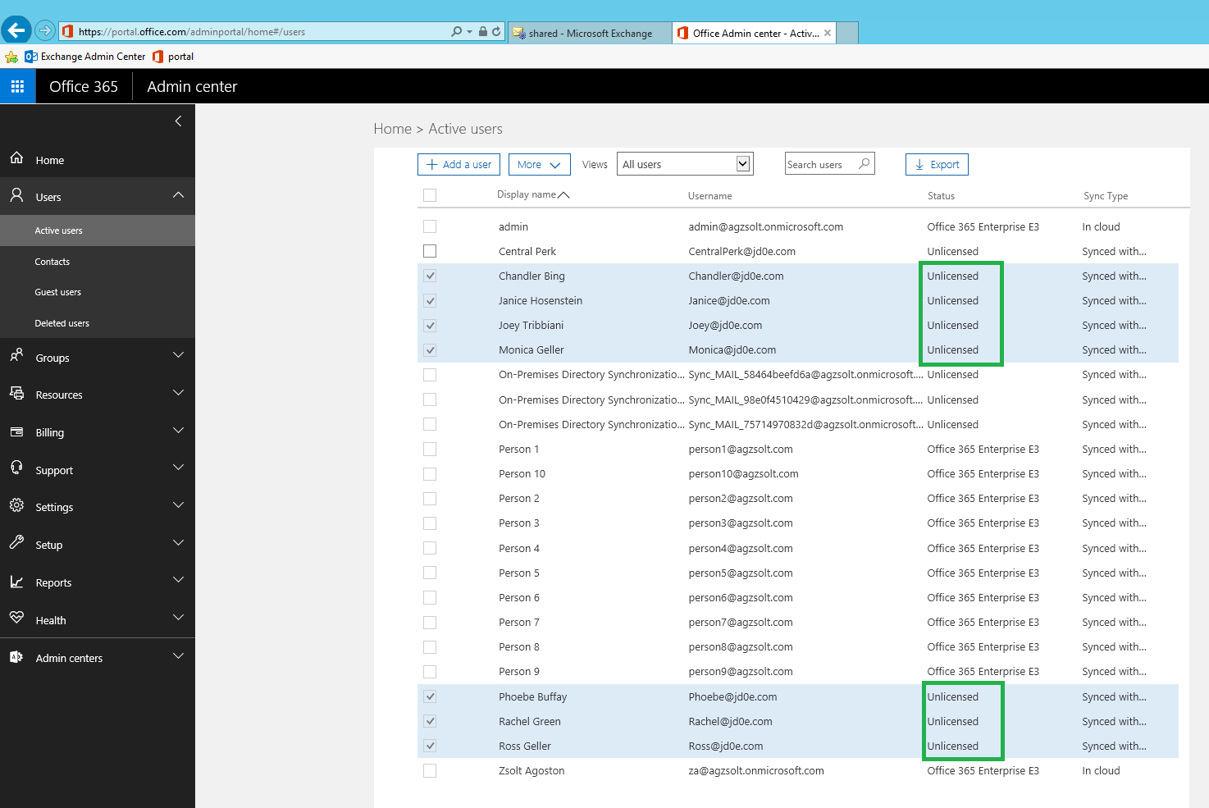
import-csv users.csv | foreach {
$fn=$_.FirstName
Set-MsolUser -UserPrincipalName "$fn@jd0e.com" -UsageLocation "GB"
Set-MsolUserLicense -UserPrincipalName "$fn@jd0e.com" -AddLicenses "agzsolt:ENTERPRISEPACK"
}

- The public folders need to be moved to the cloud. Again, Microsoft’s solution is a pretty cumbersome way, since the mailbox database is pretty small I use a simple client to export them in a PST file and import it back to a cloud managed PF mailbox.

After migrating back to the cloud, the mobile phones will start working again. In few cases users are prompted for their passwords by the device after which the connection goes back to normal.

Samsung S7 phone
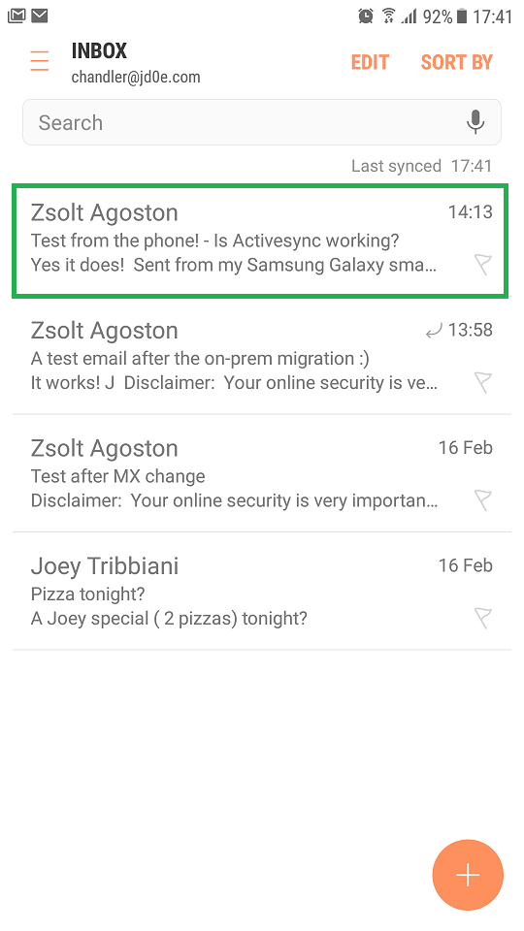
We are done!

Z.

