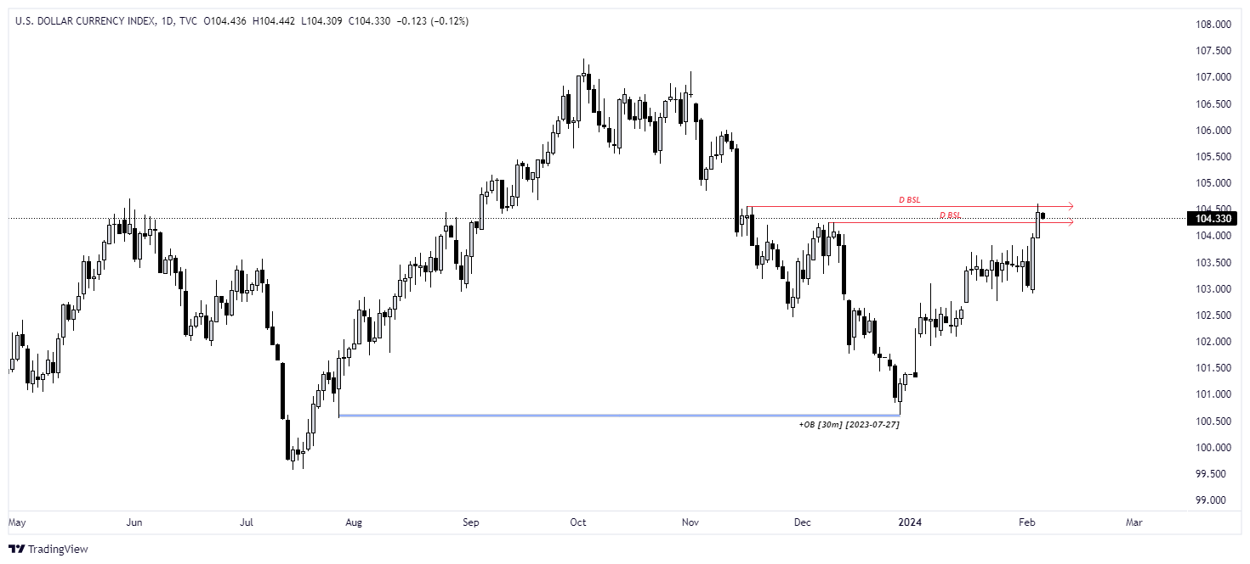

🟢 [https://www.tradingview.com/x/BiGH6u9g/] DXY HTF - Cluster of PDH

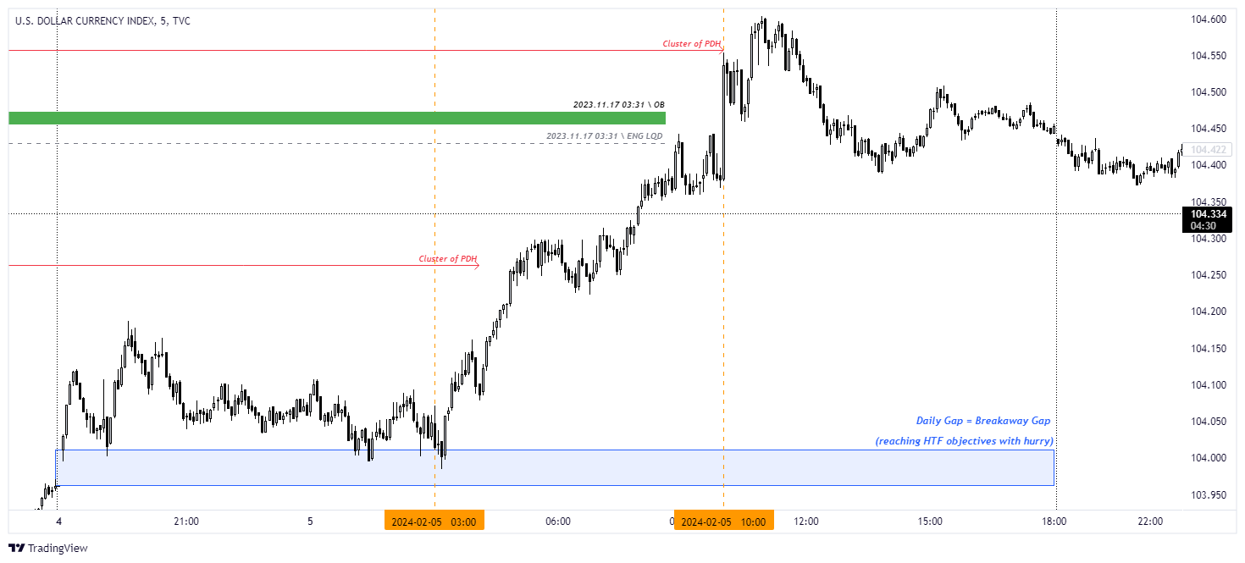

🟢 [https://www.tradingview.com/x/tZUNBtET/] DXY LTF - Breakaway Gap

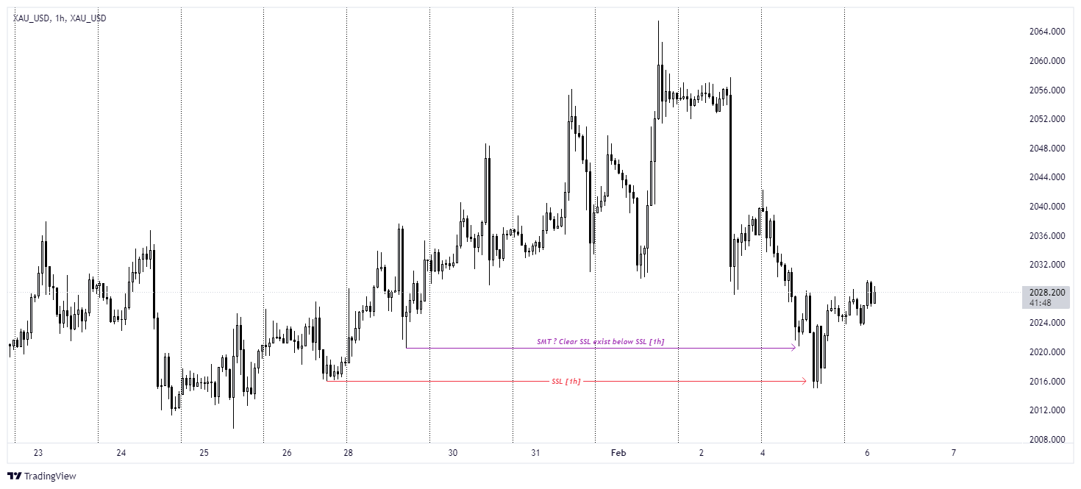

🟡 [https://www.tradingview.com/x/DXazL0eW/] XAU HTF - SMT ? Clear SSL exist below SSL [1h]

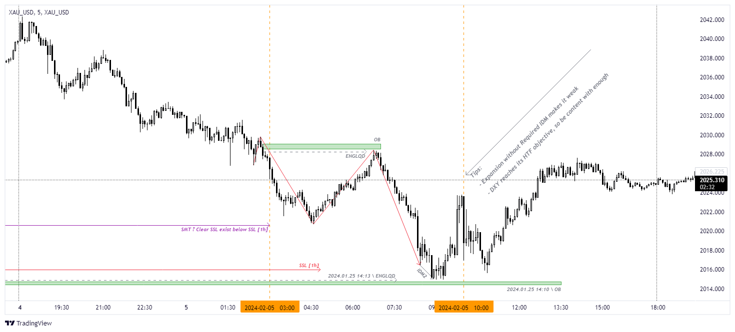

🟡 [https://www.tradingview.com/x/vg0hbEfp/] XAU LTF - Expansion Before Required IDM makes it weak