Mushroom CNN and RNN Classification
+ Hugging Face NLP Tokenization
AIP301 Assignment - Jupyter Notebook Screenshots

Student Name: ______________________________
Student ID: ________________________________
Date of Submission: _________________________

GitHub repository: mushroom-cnn-rnn-classification
Tools: Python, TensorFlow/Keras, scikit-learn, Hugging Face Transformers, matplotlib, Jupyter Notebook

Contents
Overview and Results Summary
Notebook Title
1. Objective
2. Import Libraries
3. Download / Verify Dataset
4. Load Mushroom Dataset
5. Dataset Exploration
5.2 Missing values
5.3 Basic descriptive information
5.4 Identify the target column
5.5 Class distribution
5.6 Unique values of the categorical columns
6. Data Preprocessing
6.1 Separate features (X) and target (y)
7. Train/Test Split
7.1 Encode the features and the target (fitted on the training data only)
7.2 Reshape the data to 3D for the CNN and RNN
7.3 Choose the output layer from the actual number of classes
8. CNN Model
9. CNN Training
10. CNN Evaluation
11. CNN Predictions
12. CNN Confusion Matrix
13. CNN Classification Report
14. RNN Model
15. RNN Training
16. RNN Evaluation
17. RNN Predictions
18. RNN Confusion Matrix
19. RNN Classification Report
20. CNN vs RNN Comparison
21. Final Recommendation
Why can the accuracy be so high?
22. Generative AI / NLP Task
23. Load exercise_text.json
24. Hugging Face Tokenization
25. Final Summary
Conclusions

Overview and Results Summary
This document contains screenshots of the executed Jupyter Notebook (notebooks/mushroom_cnn_rnn_assignment.ipynb). A CNN (Conv1D) and an RNN (SimpleRNN) were built with TensorFlow/Keras on the Mushroom dataset using a 70/30 stratified train/test split (random_state = 42), and the text in exercise_text.json was tokenized with the Hugging Face bert-base-uncased tokenizer.
All values below were produced by running the notebook. They are read from outputs/reports/cnn_vs_rnn_comparison.csv.
Model | Optimizer | Batch Size | Epochs | Test Accuracy
CNN | Adam | 30 | 10 | 100.00%
RNN | RMSprop | 40 | 20 | 100.00%
Based on the test accuracy, the recommended model is CNN. Both models reached the same test accuracy, so the model with the shorter training time (CNN: 9.2s vs 30.1s) is recommended.
Note: random seeds are fixed, but neural-network results can vary slightly with hardware, operating system and TensorFlow version.

Notebook Title
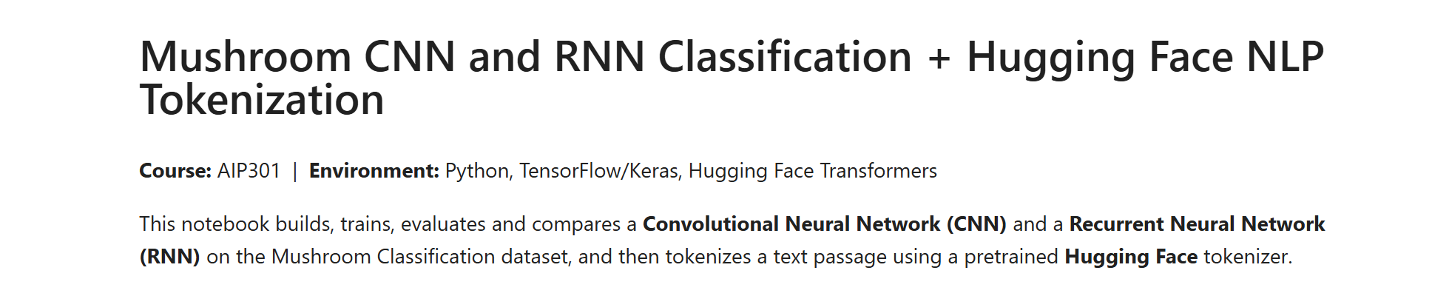
Figure 1: Mushroom CNN and RNN Classification + Hugging Face NLP Tokenization

1. Objective
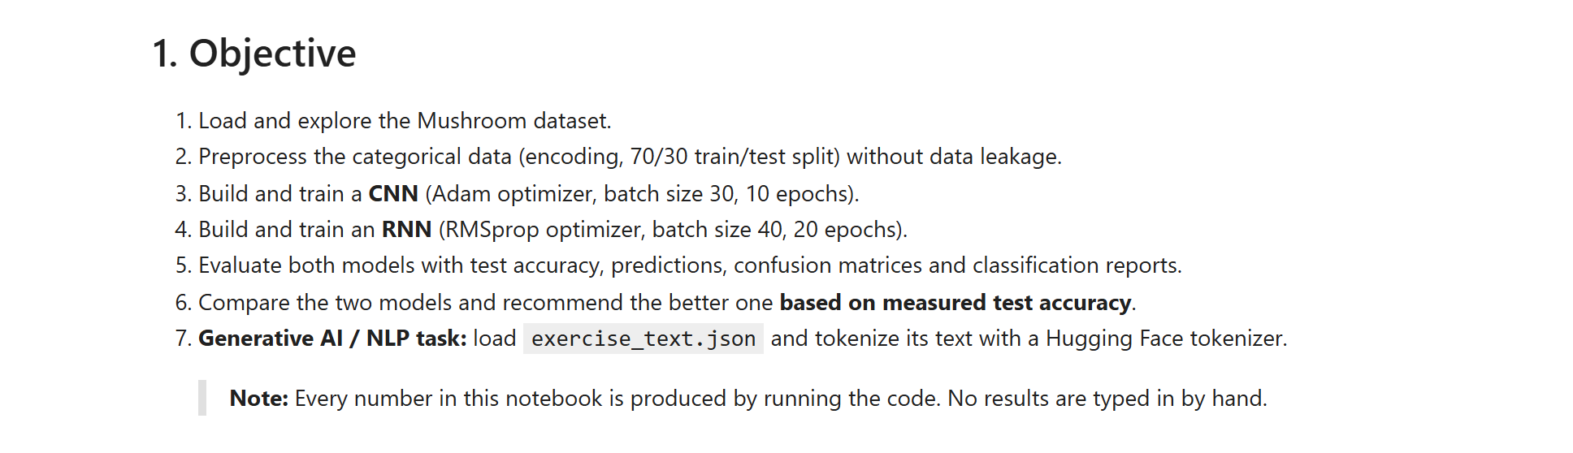
Figure 2: 1. Objective

2. Import Libraries
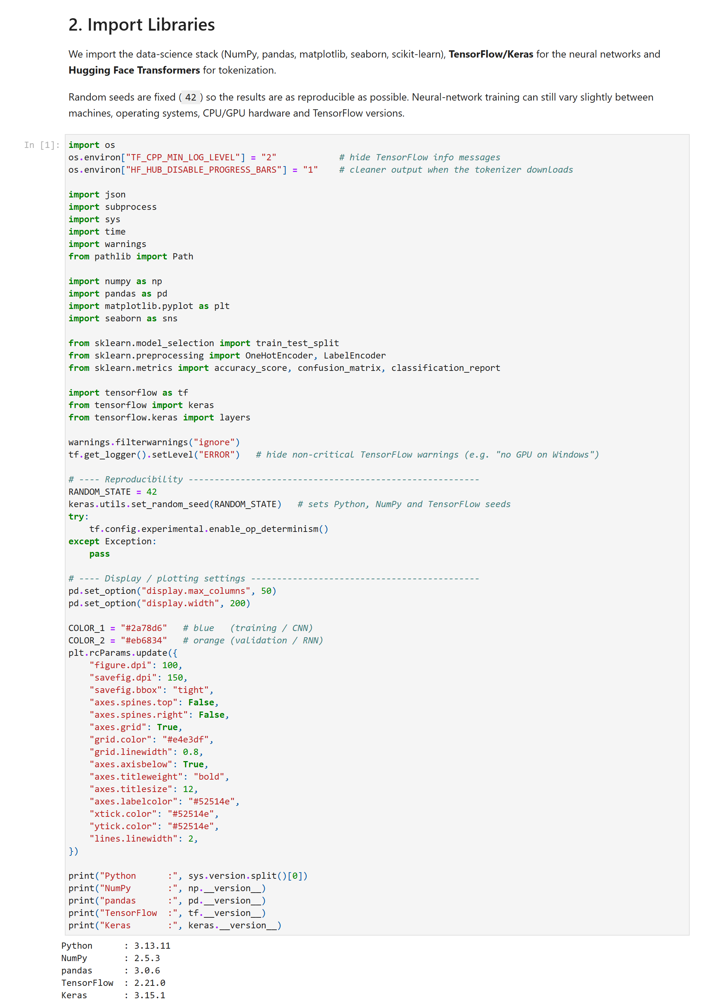
Figure 3: 2. Import Libraries

3. Download / Verify Dataset
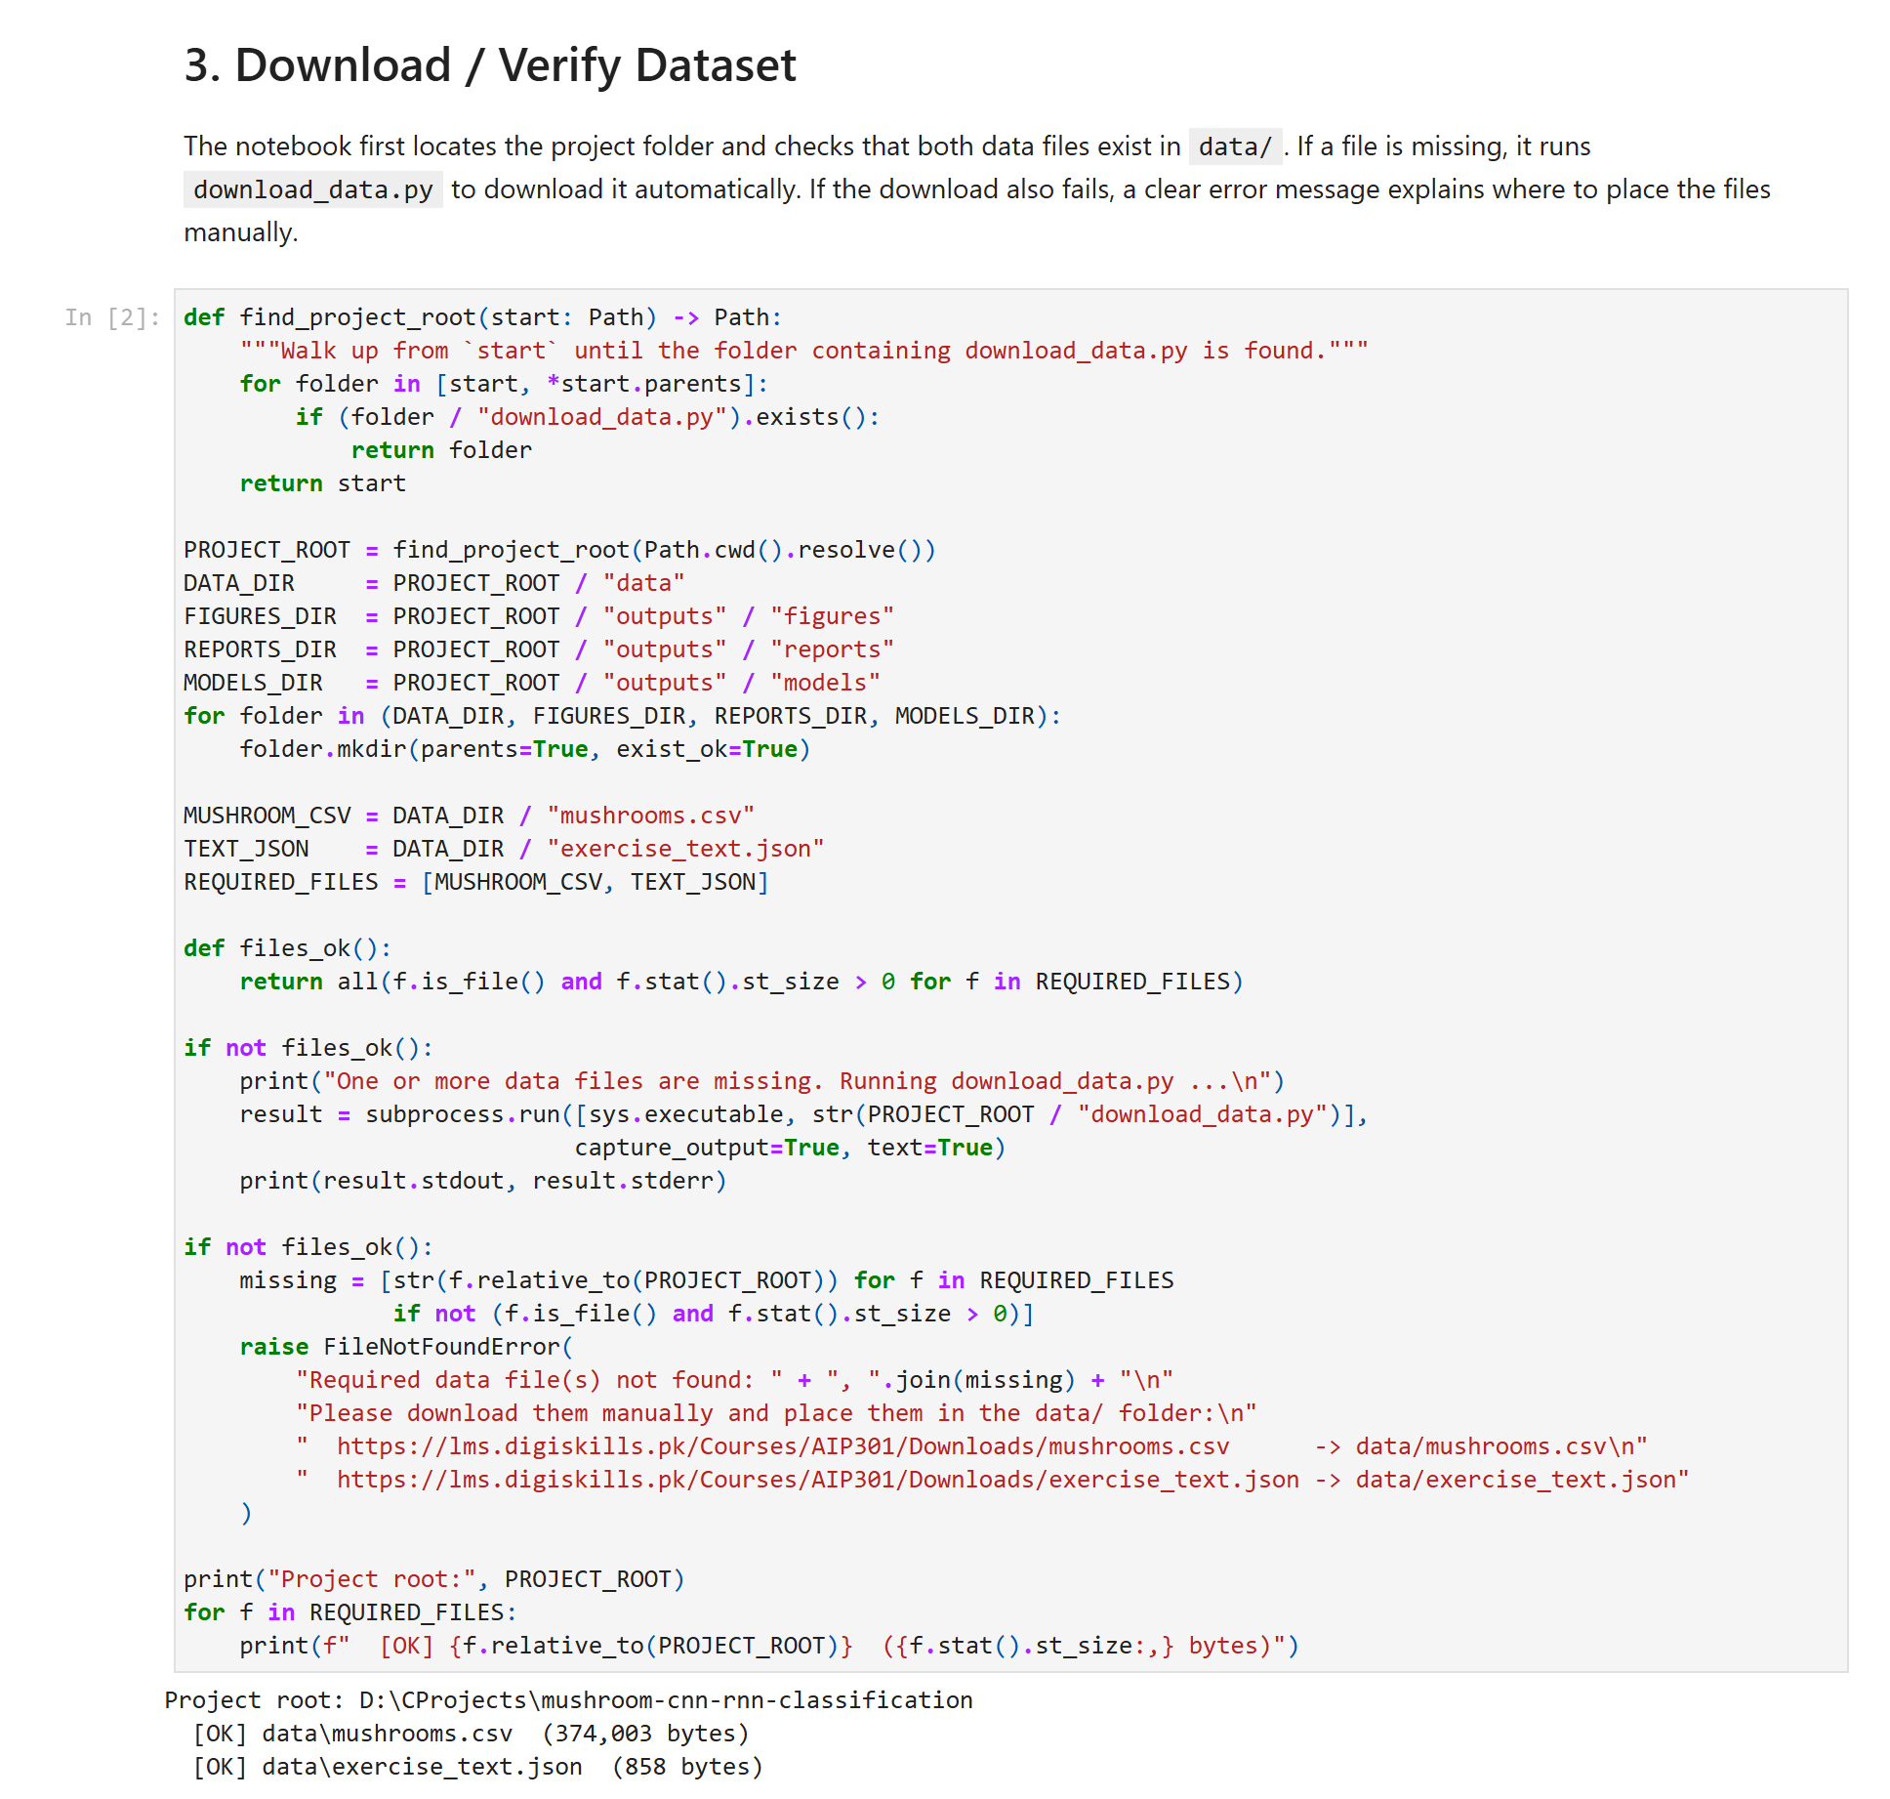
Figure 4: 3. Download / Verify Dataset

4. Load Mushroom Dataset
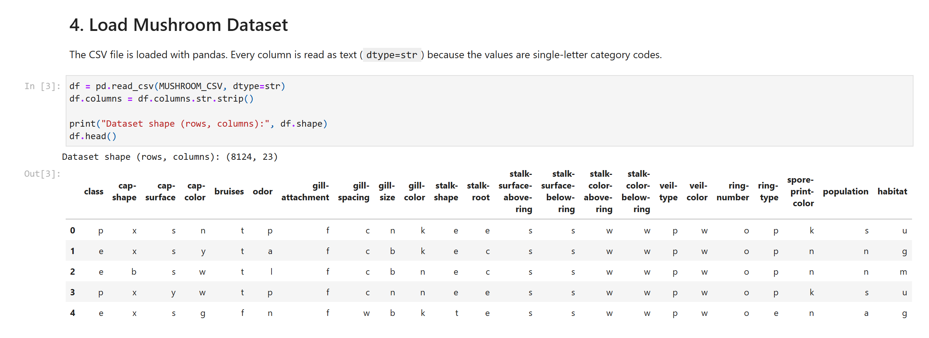
Figure 5: 4. Load Mushroom Dataset

5. Dataset Exploration
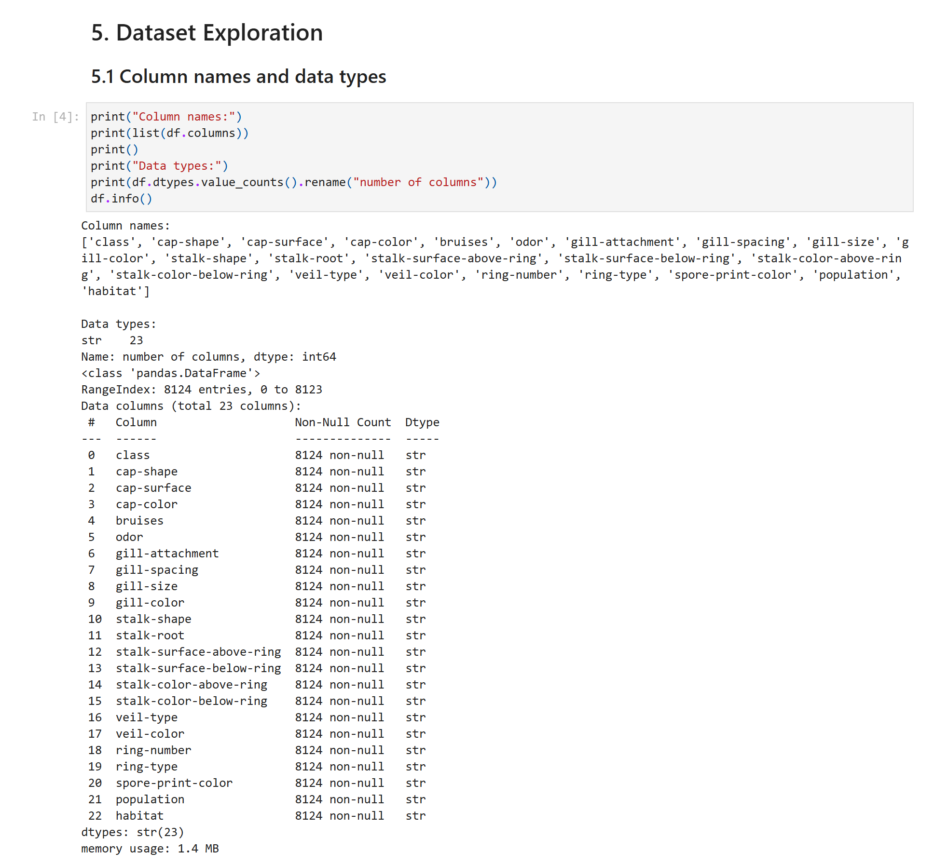
Figure 6: 5. Dataset Exploration

5.2 Missing values
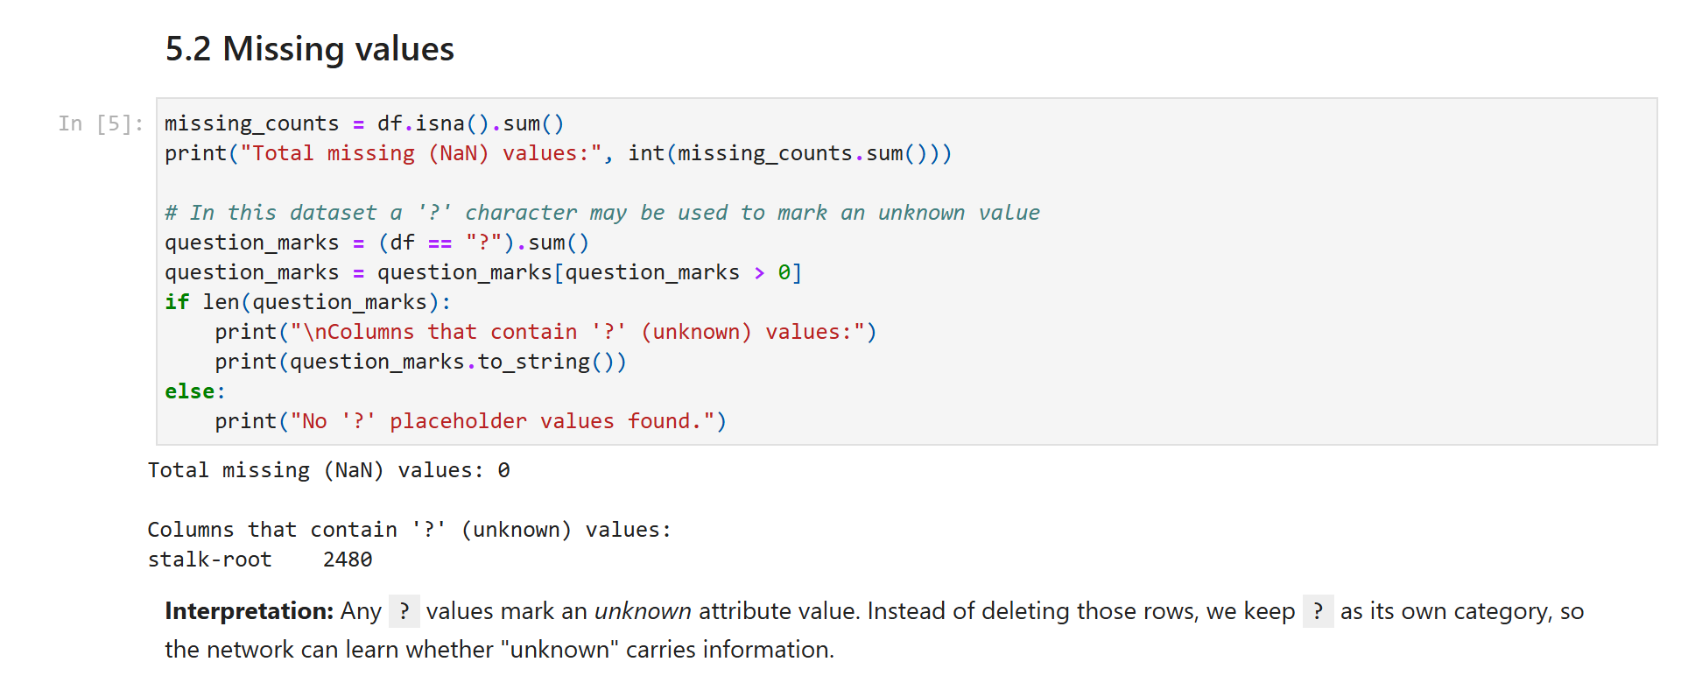
Figure 7: 5.2 Missing values

5.3 Basic descriptive information
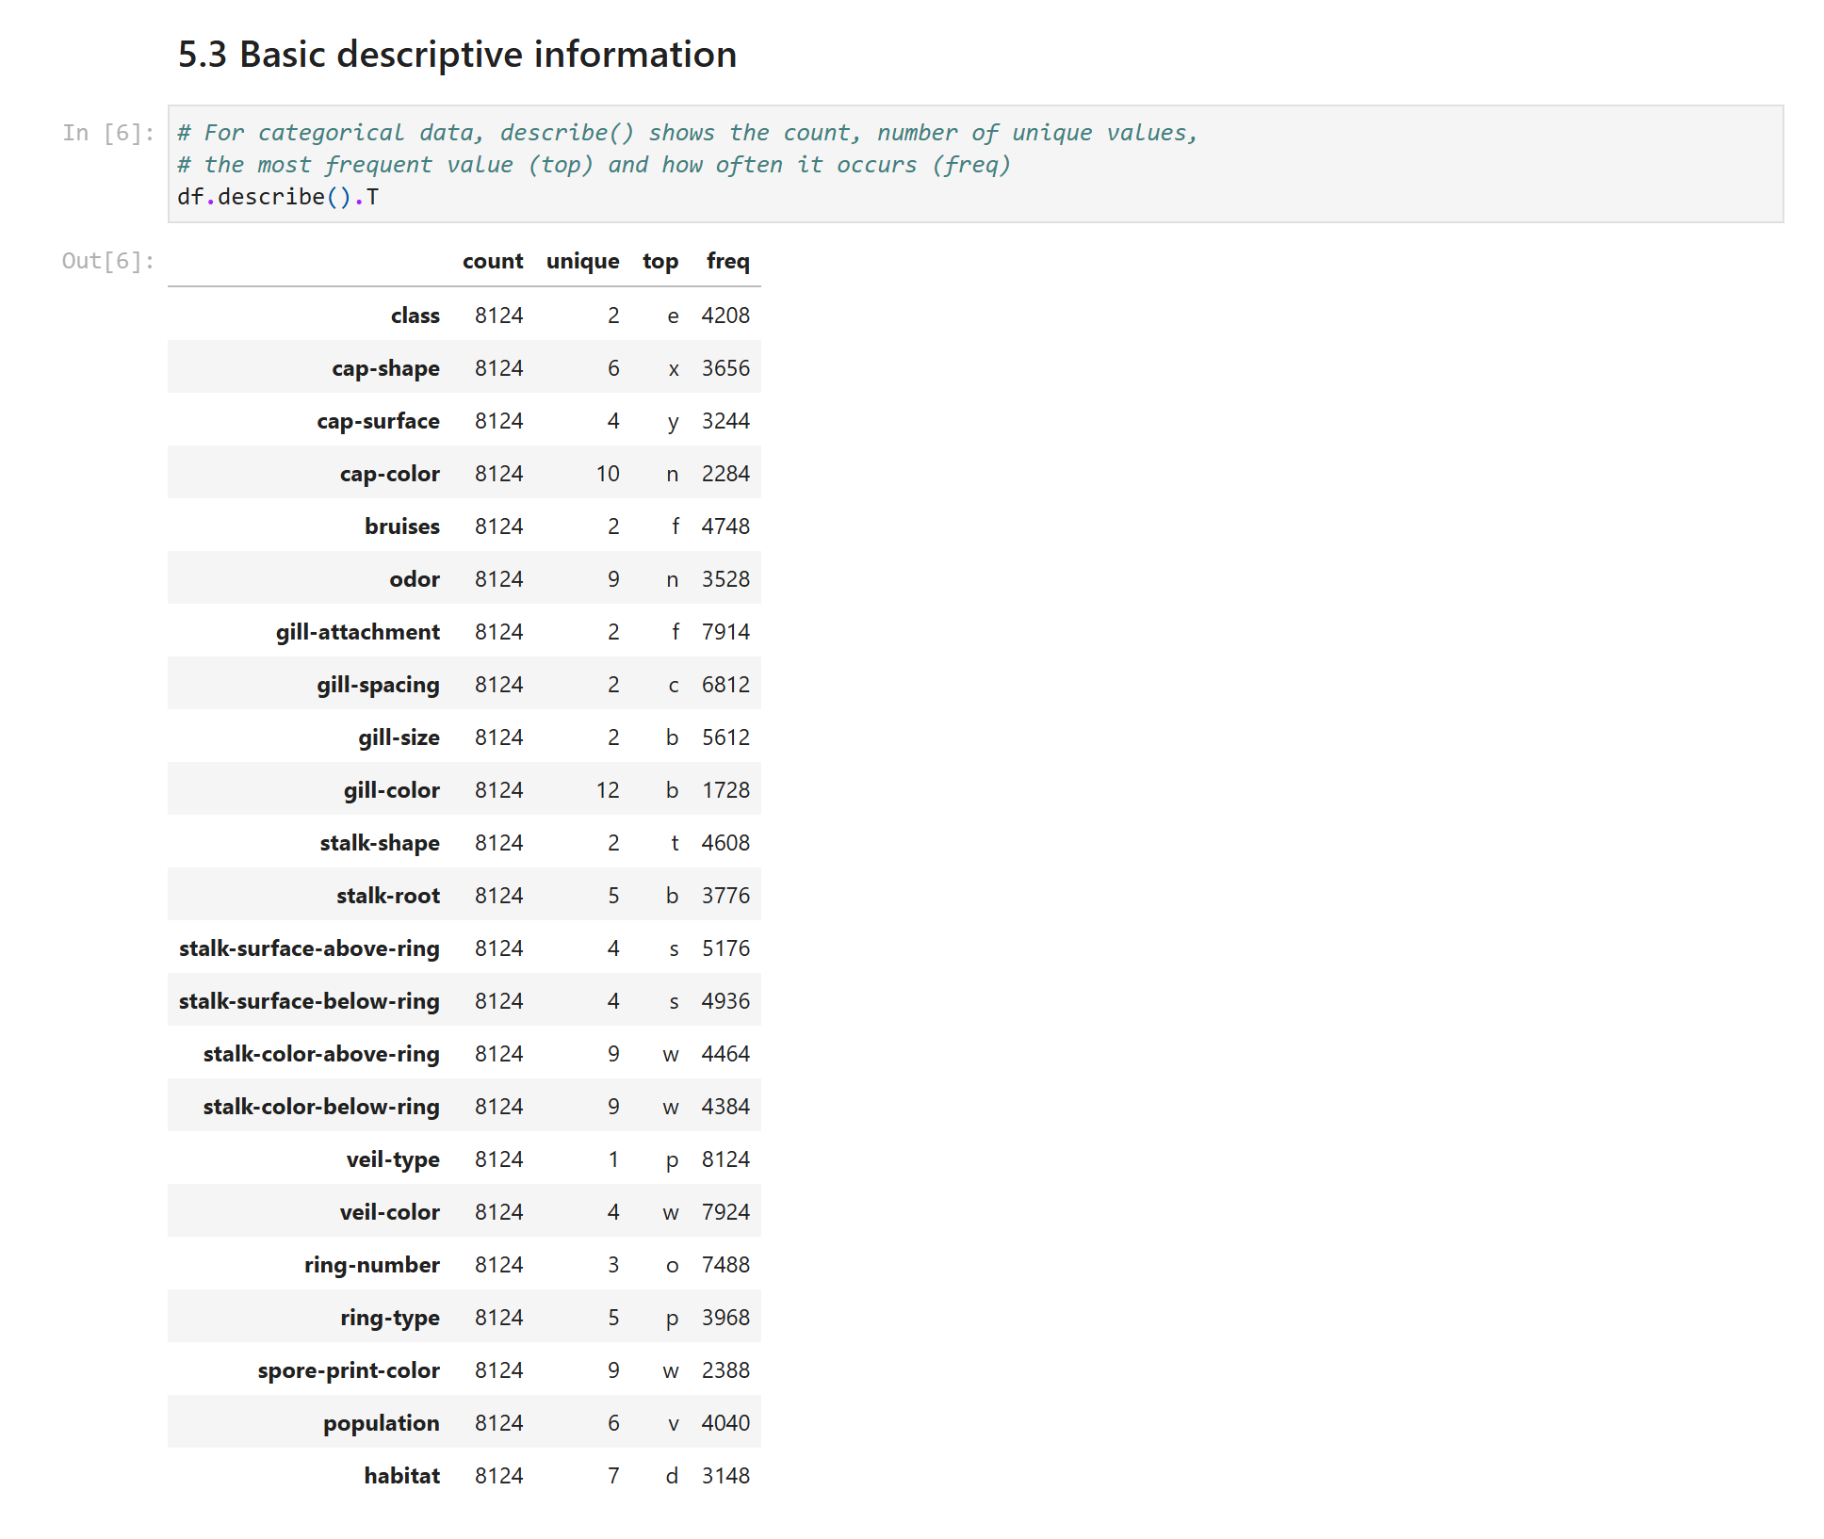
Figure 8: 5.3 Basic descriptive information

5.4 Identify the target column
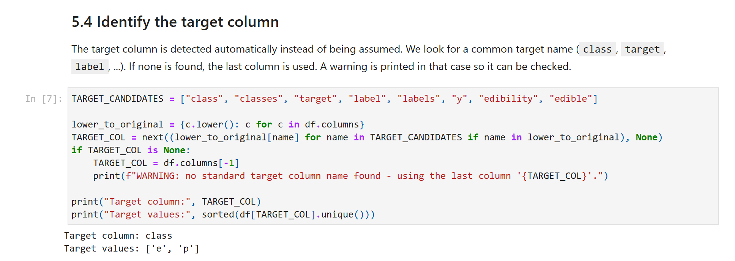
Figure 9: 5.4 Identify the target column

5.5 Class distribution
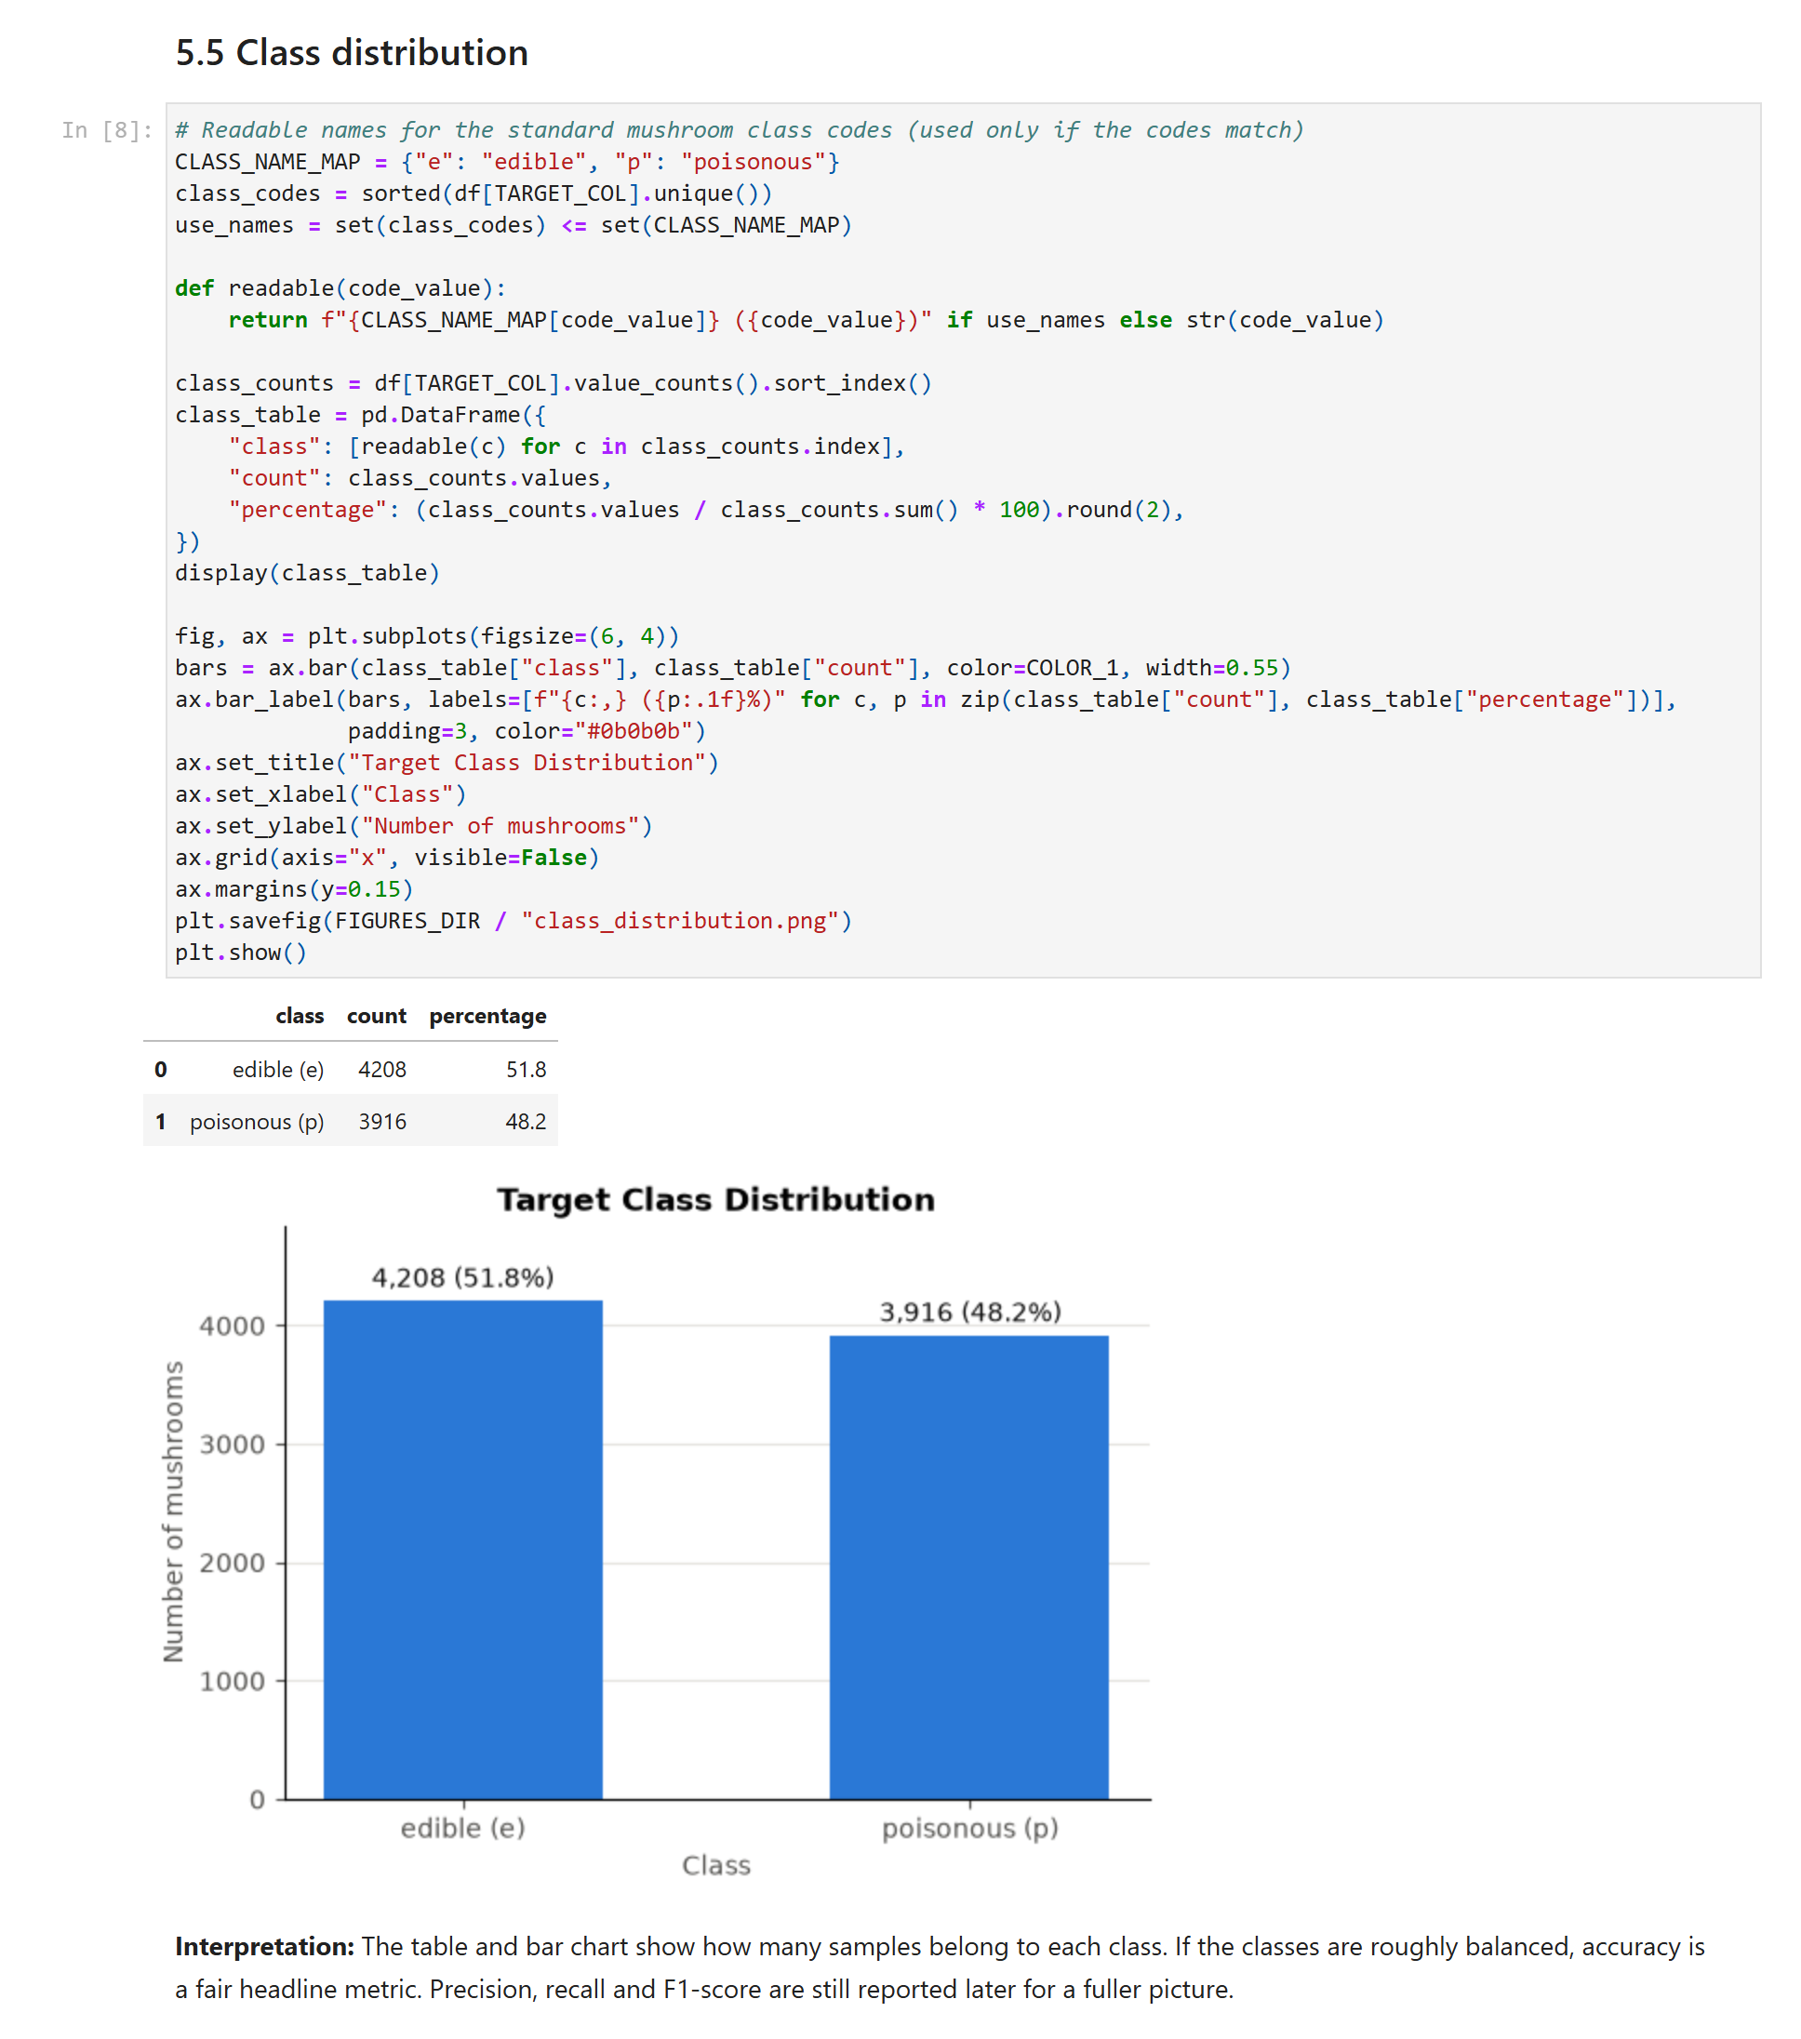
Figure 10: 5.5 Class distribution

5.6 Unique values of the categorical columns
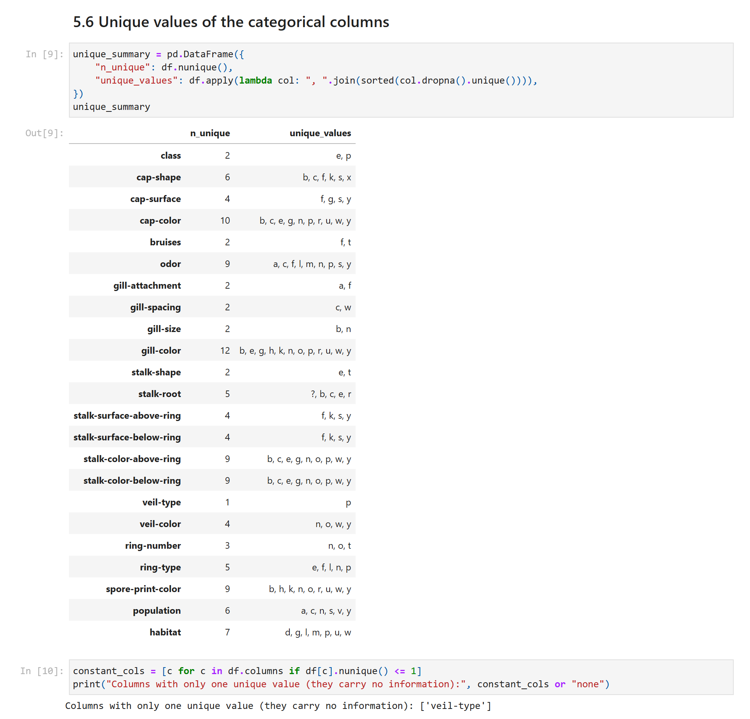
Figure 11: 5.6 Unique values of the categorical columns

6. Data Preprocessing
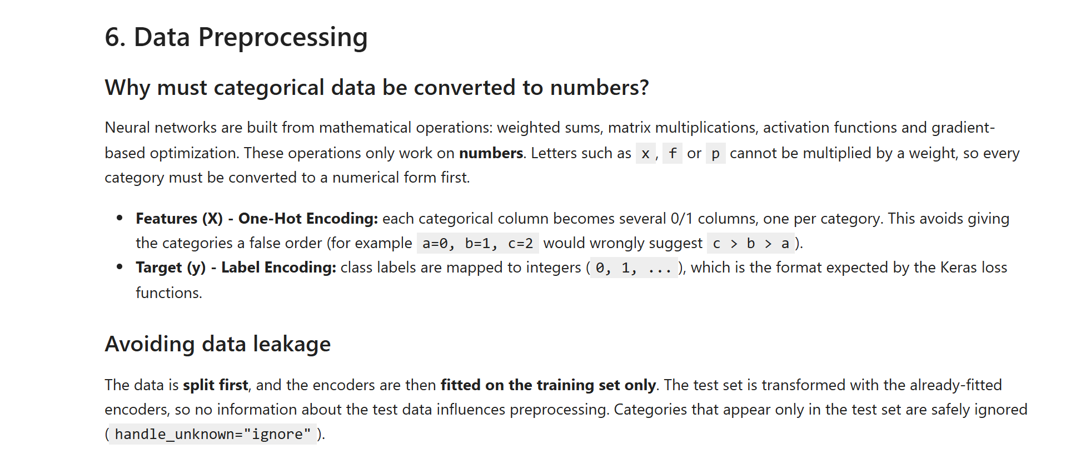
Figure 12: 6. Data Preprocessing

6.1 Separate features (X) and target (y)
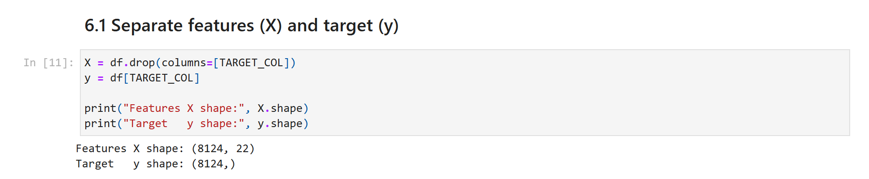
Figure 13: 6.1 Separate features (X) and target (y)

7. Train/Test Split
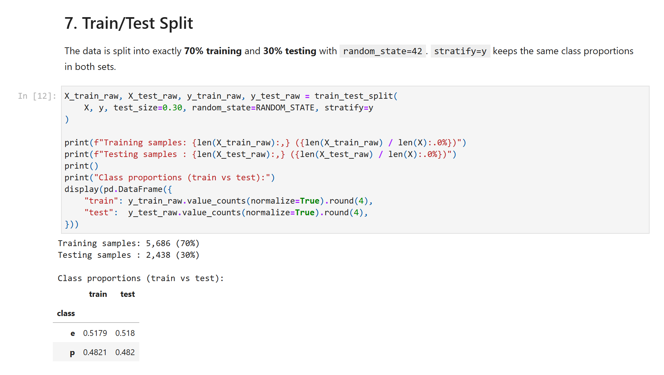
Figure 14: 7. Train/Test Split

7.1 Encode the features and the target (fitted on the training data only)
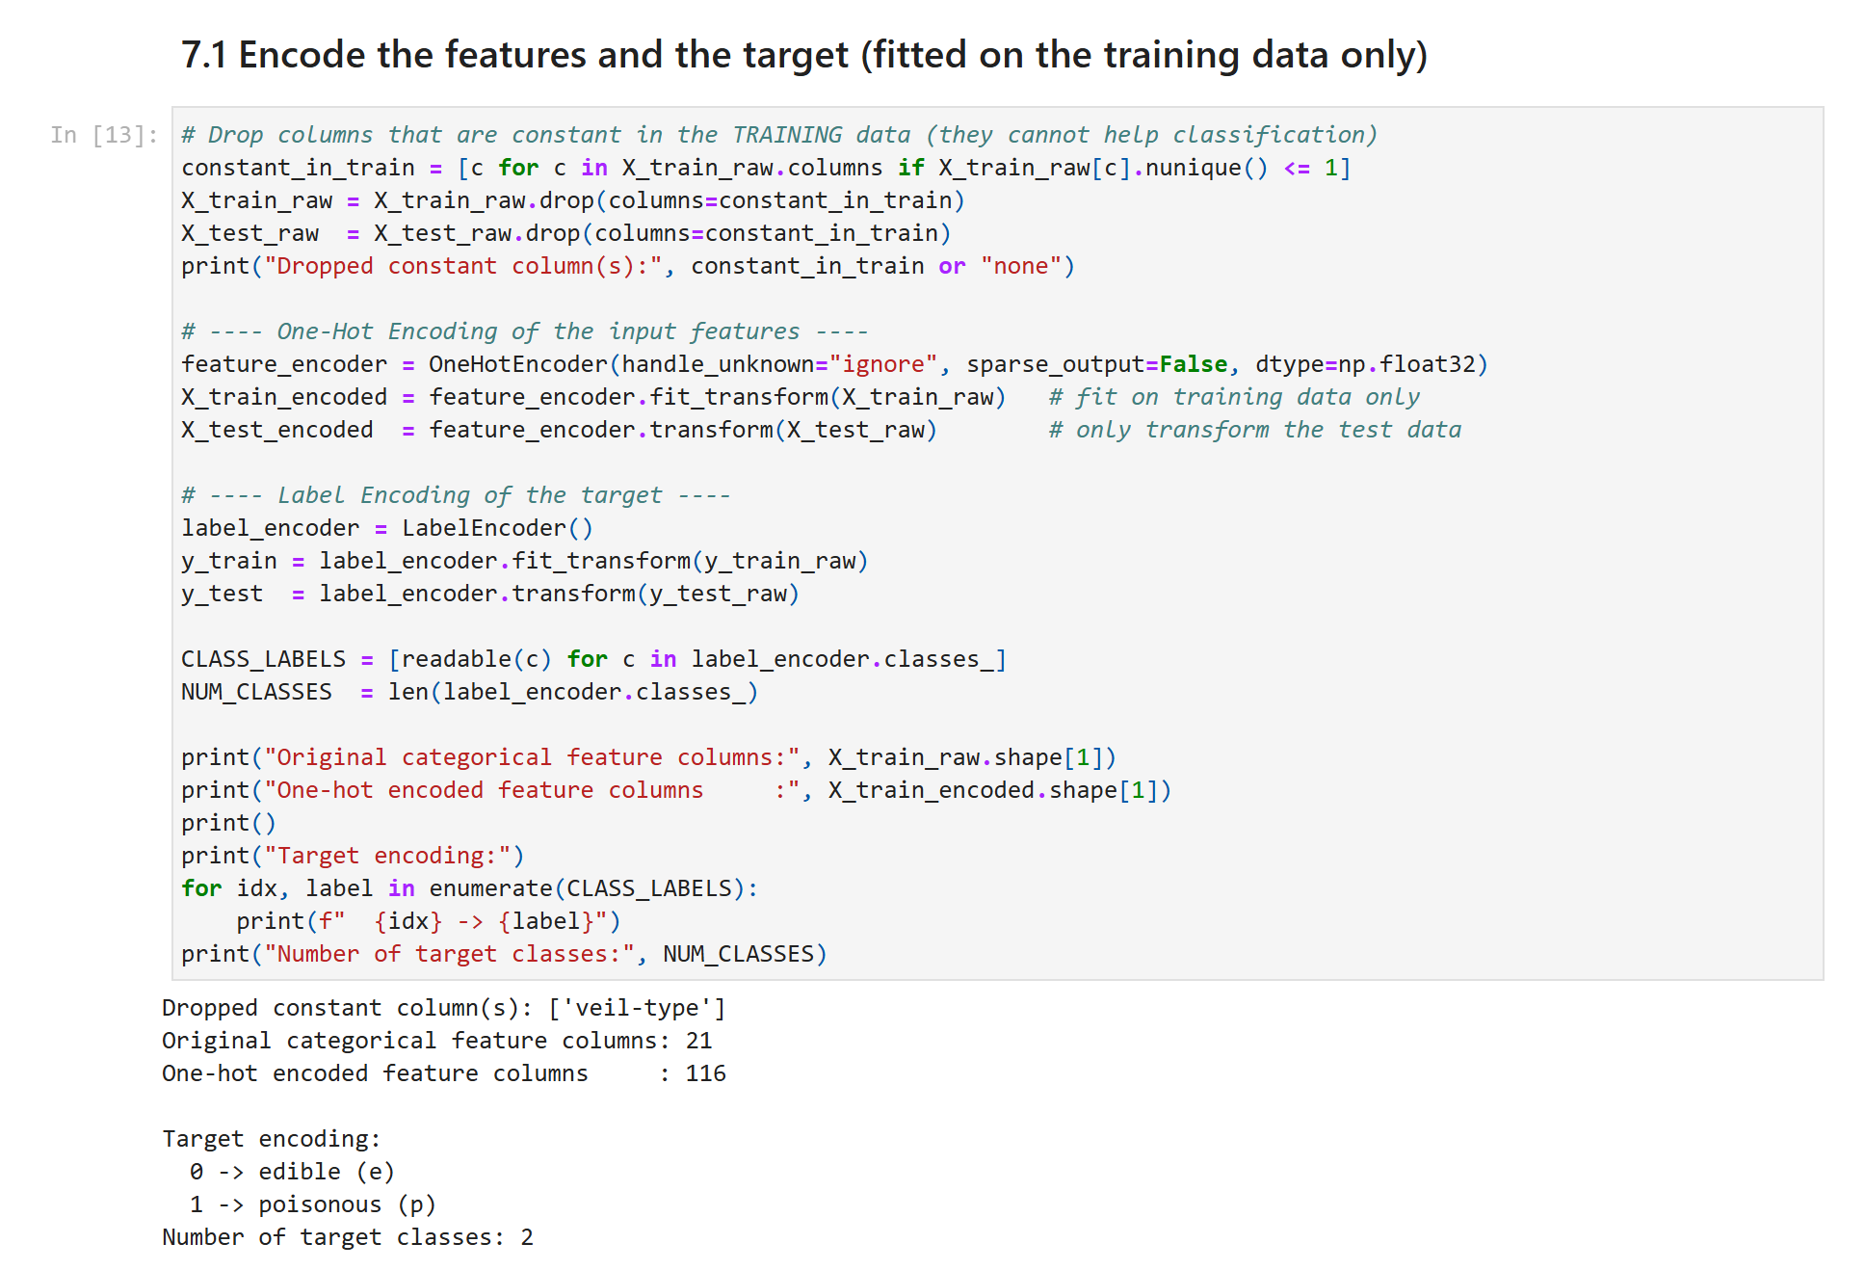
Figure 15: 7.1 Encode the features and the target (fitted on the training data only)

7.2 Reshape the data to 3D for the CNN and RNN
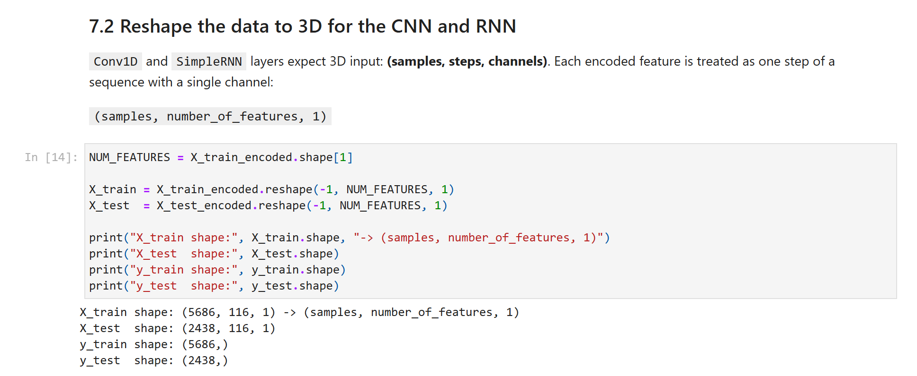
Figure 16: 7.2 Reshape the data to 3D for the CNN and RNN

7.3 Choose the output layer from the actual number of classes
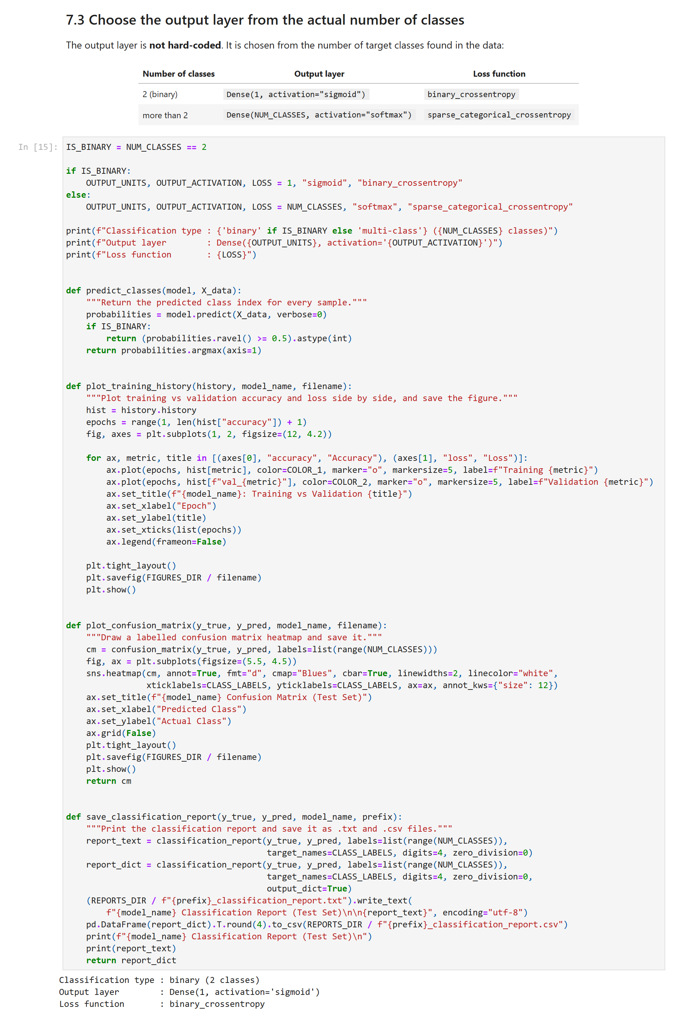
Figure 17: 7.3 Choose the output layer from the actual number of classes

8. CNN Model
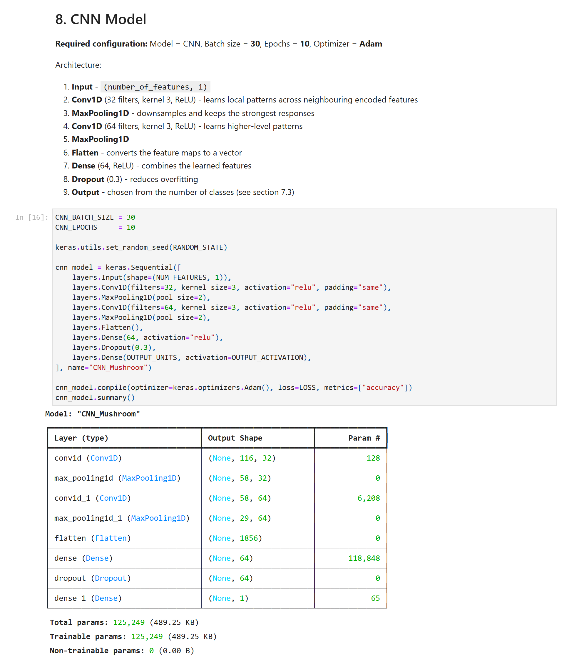
Figure 18: 8. CNN Model

9. CNN Training
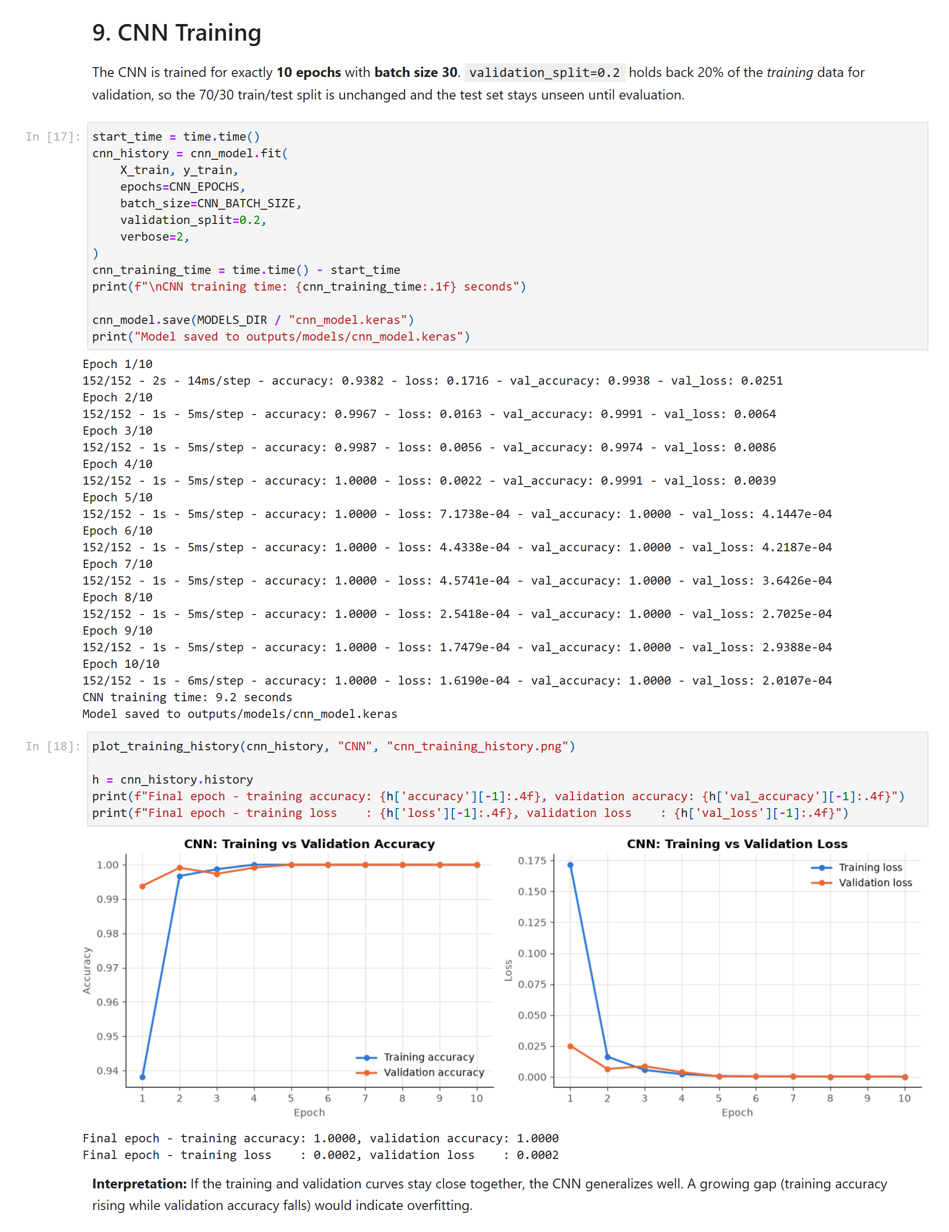
Figure 19: 9. CNN Training

10. CNN Evaluation
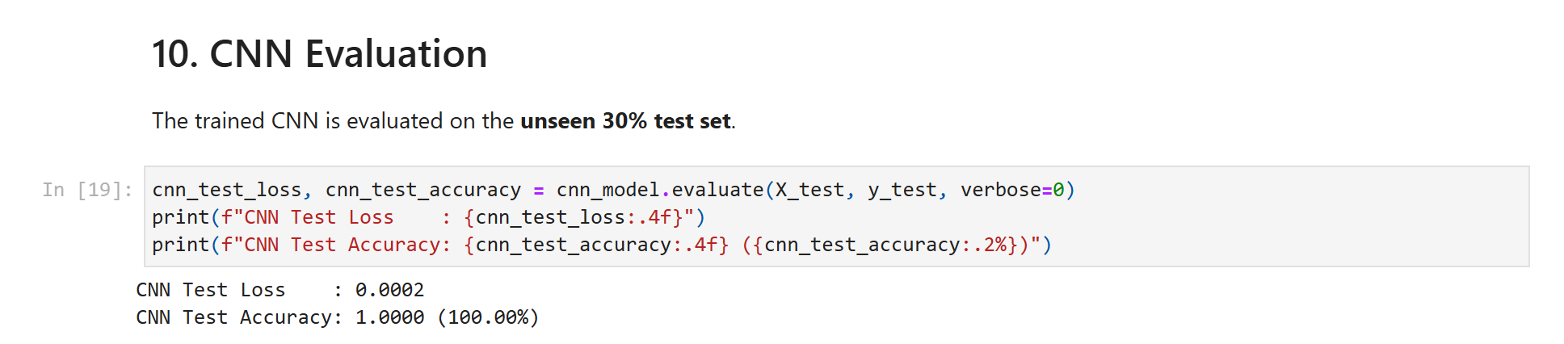
Figure 20: 10. CNN Evaluation

11. CNN Predictions
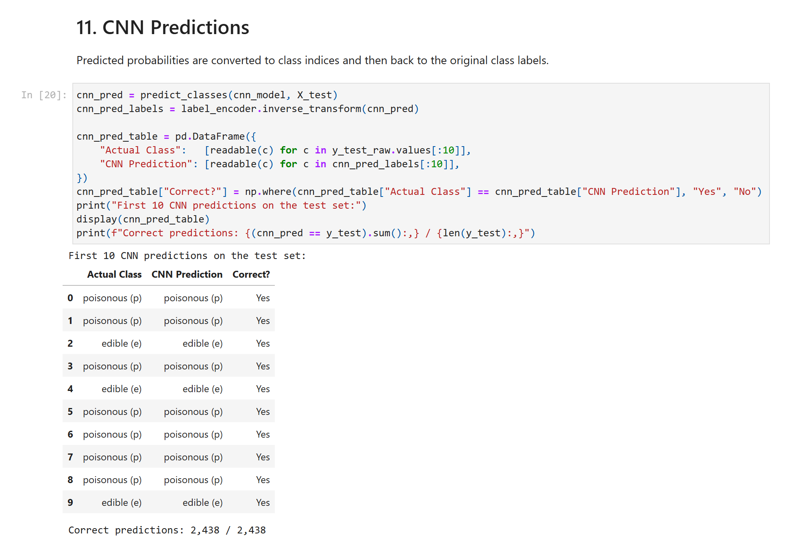
Figure 21: 11. CNN Predictions

12. CNN Confusion Matrix
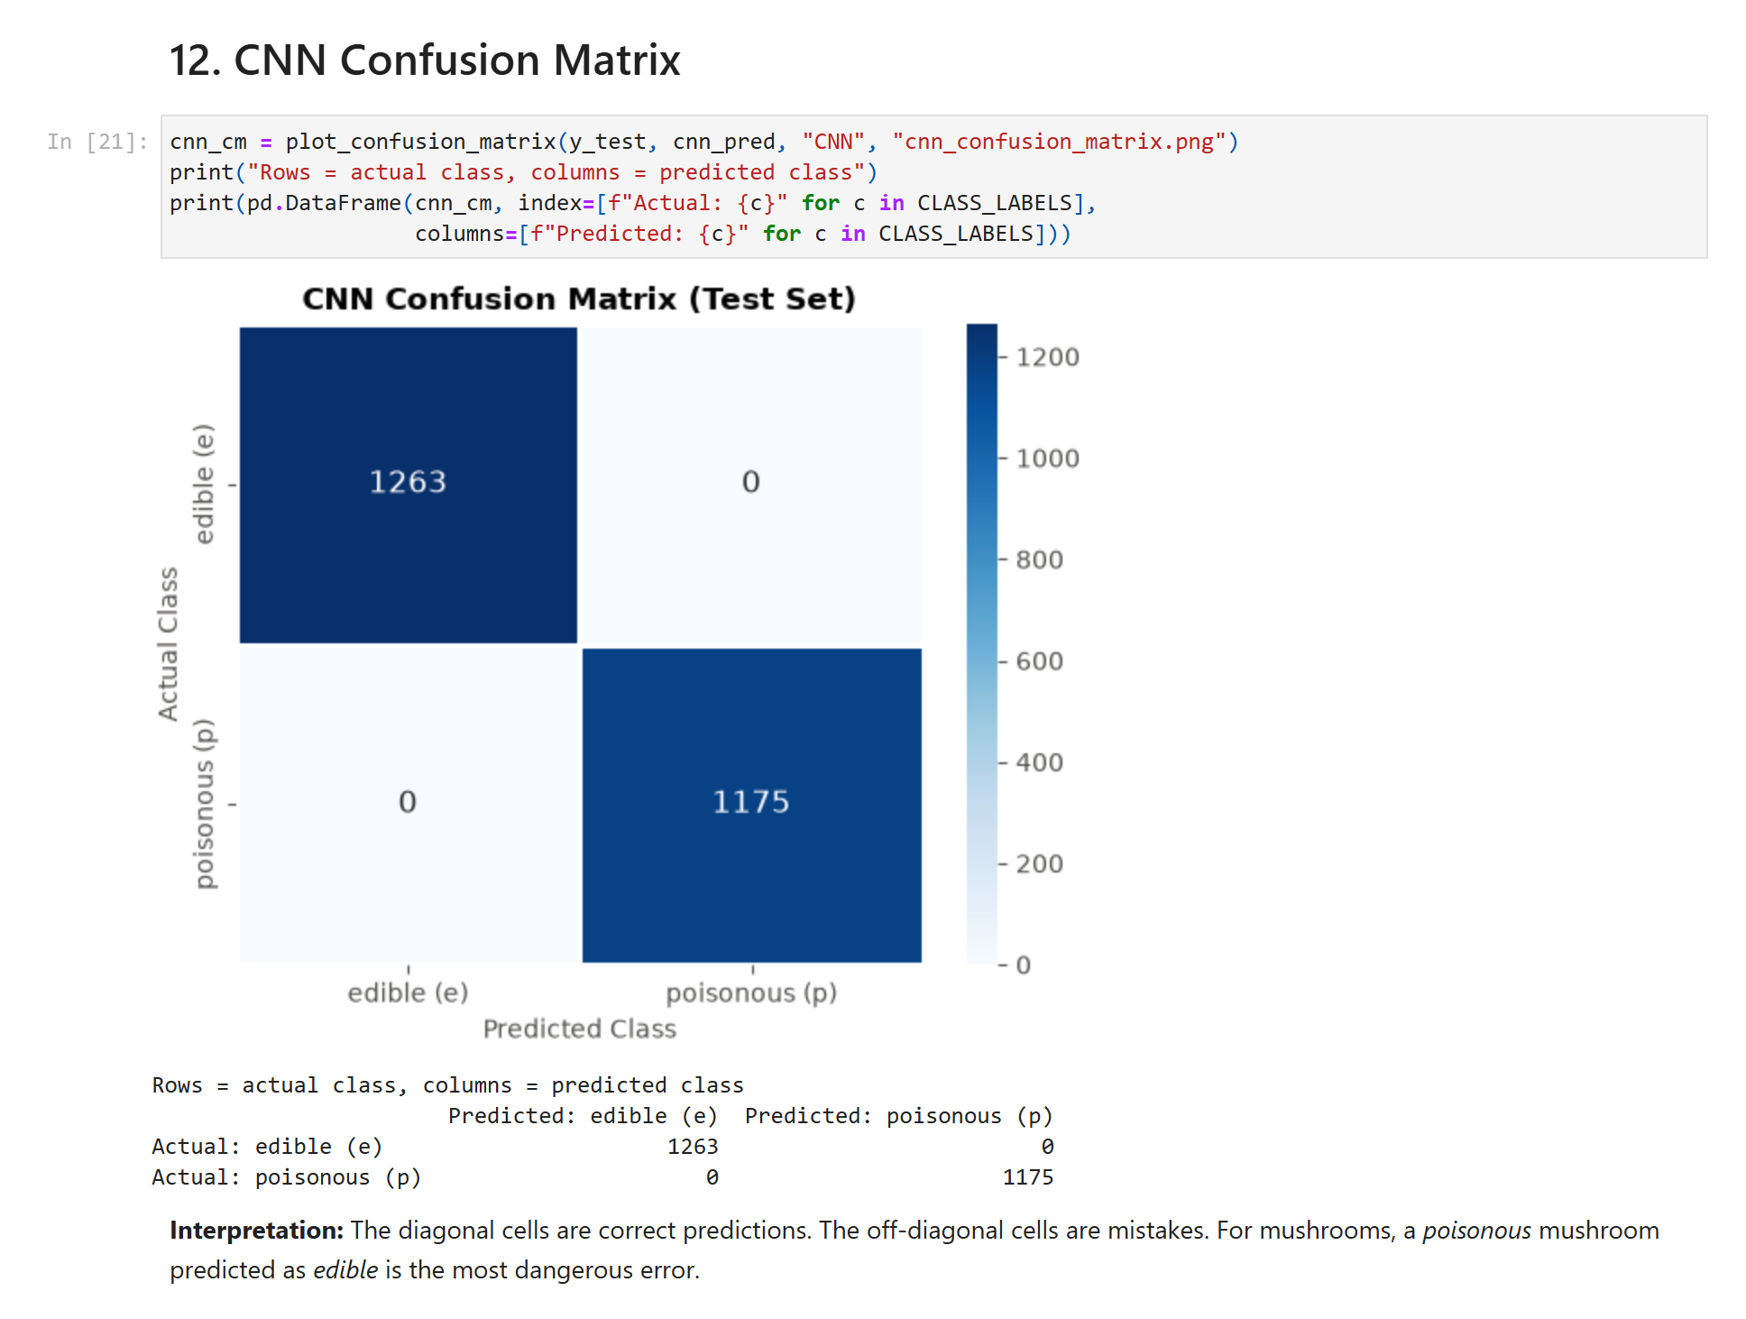
Figure 22: 12. CNN Confusion Matrix

13. CNN Classification Report
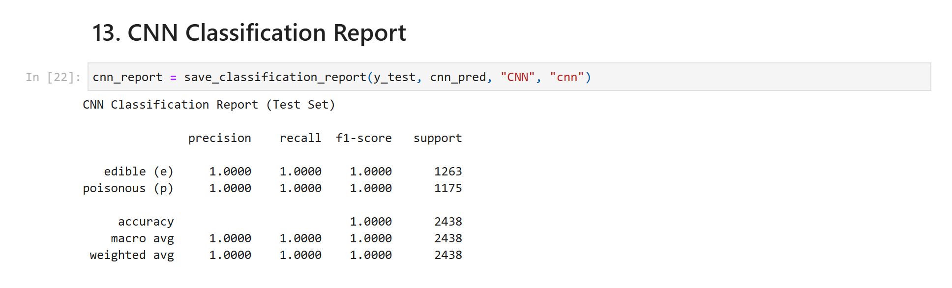
Figure 23: 13. CNN Classification Report

14. RNN Model
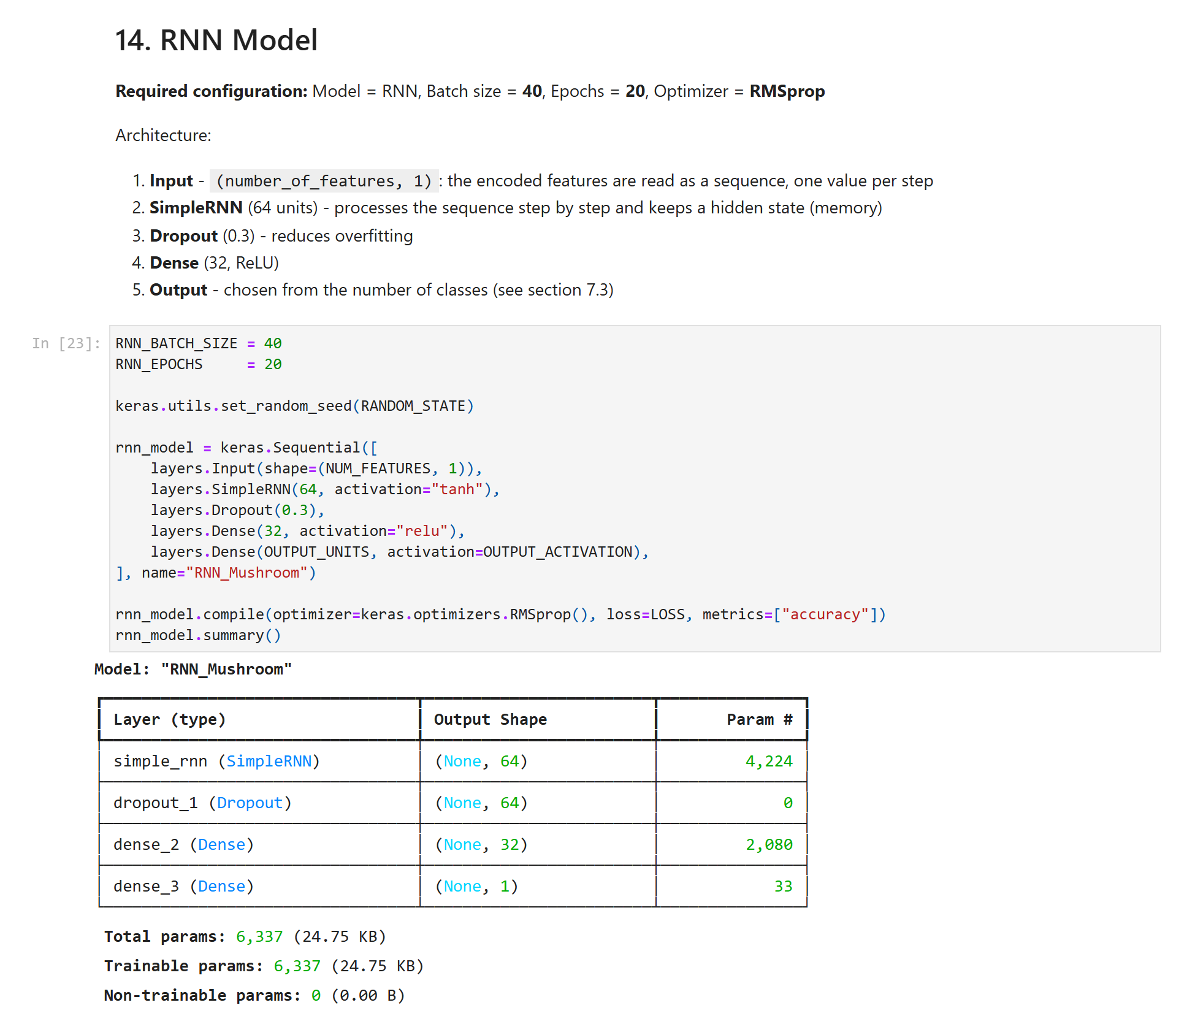
Figure 24: 14. RNN Model

15. RNN Training
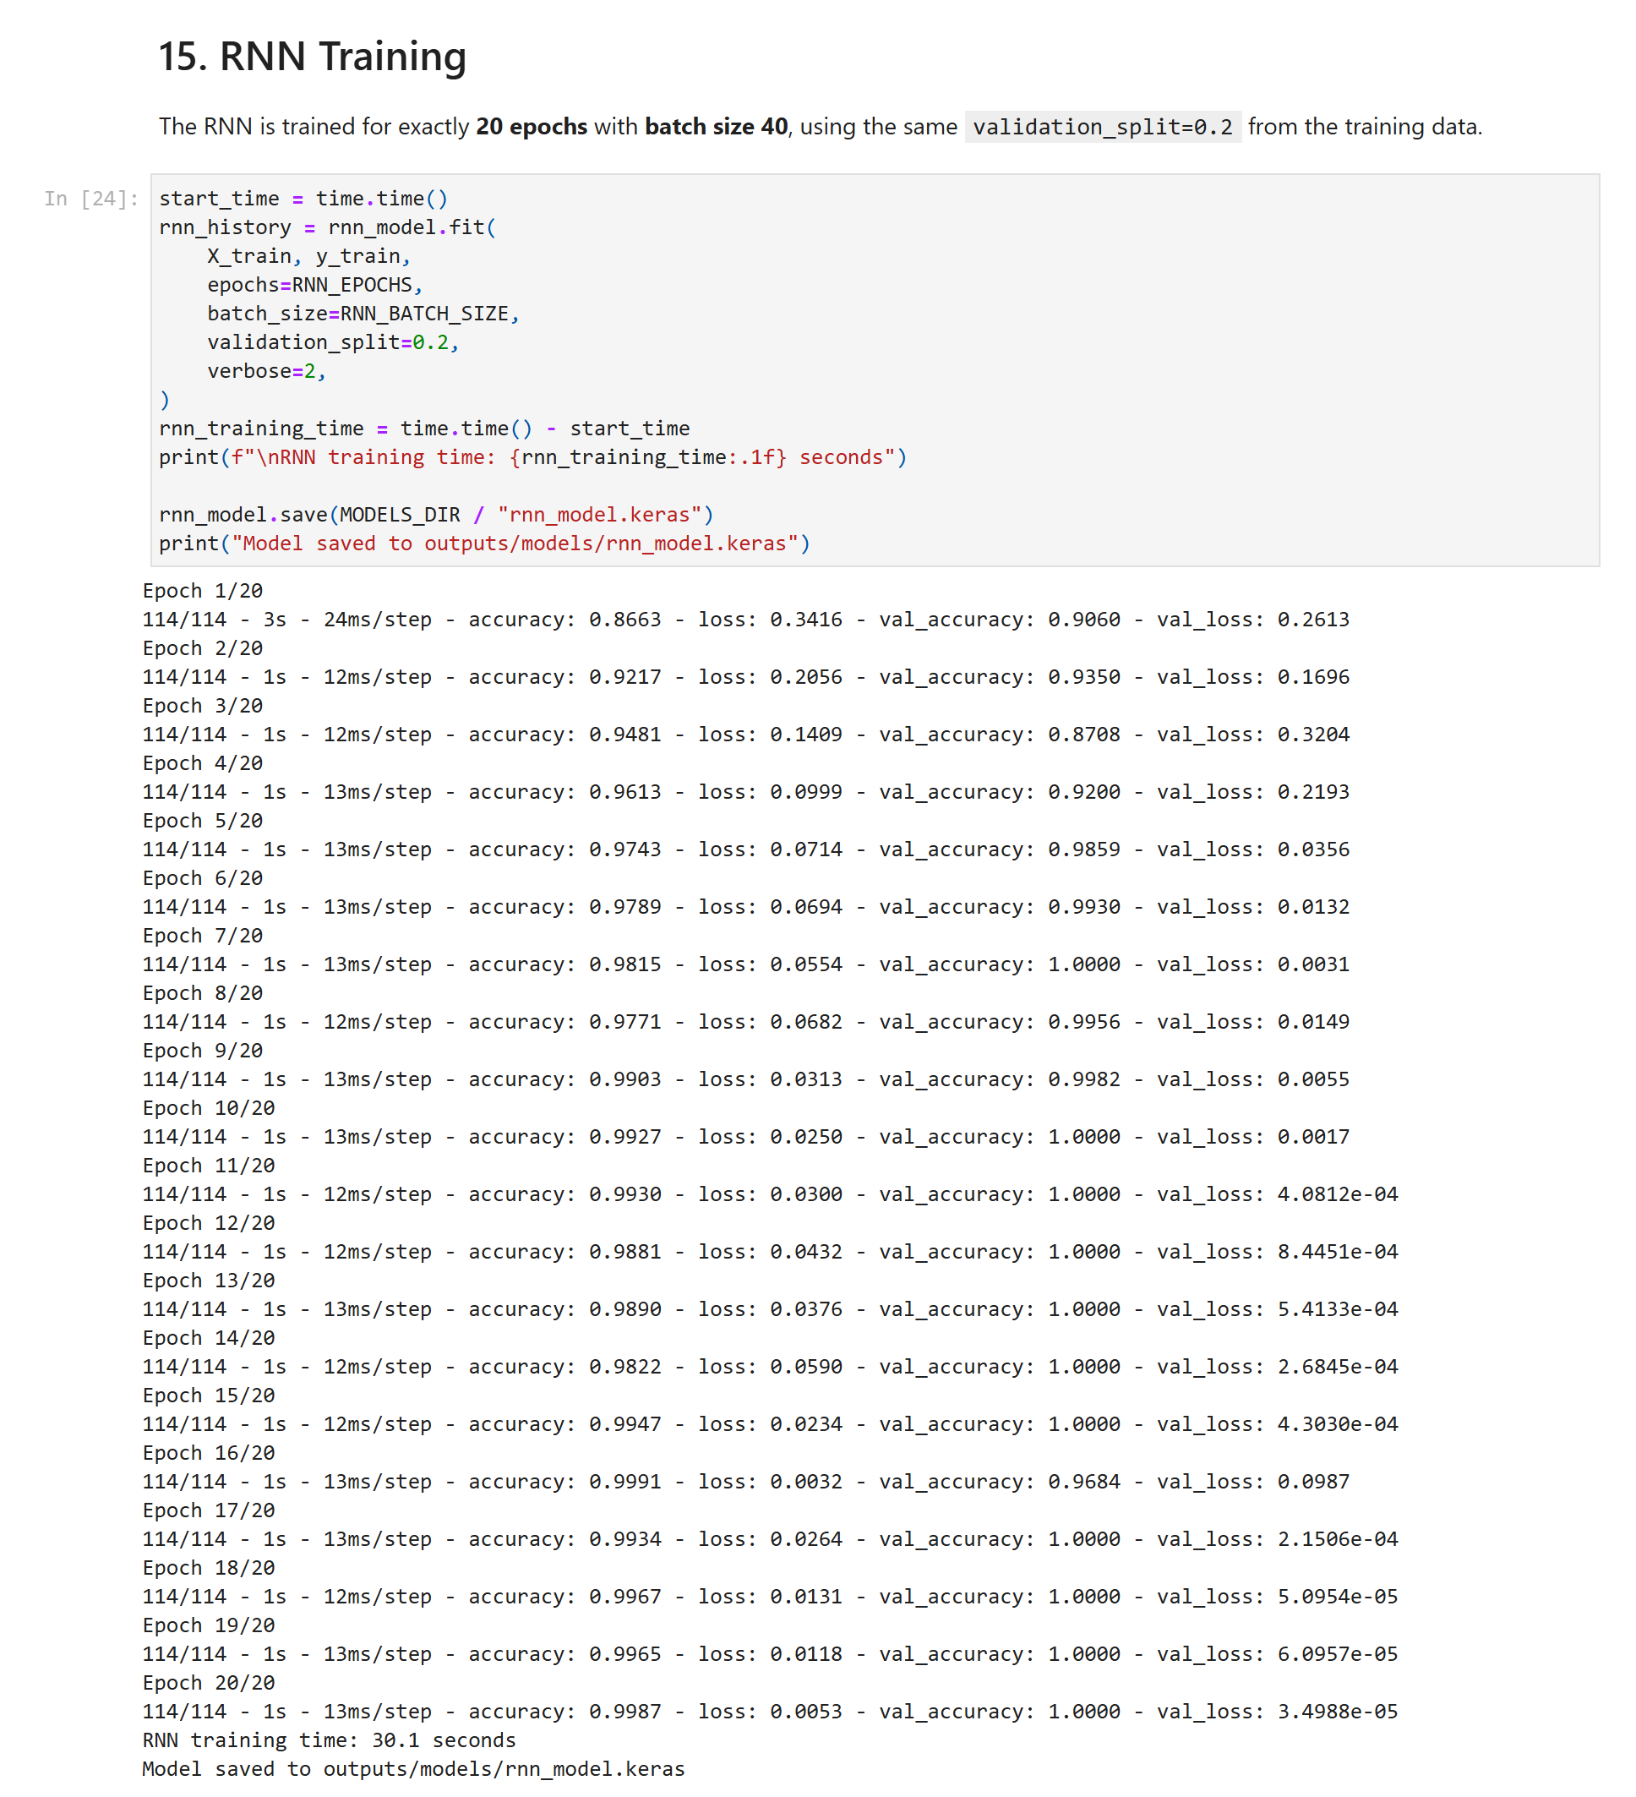
Figure 25: 15. RNN Training (part 1 of 2)
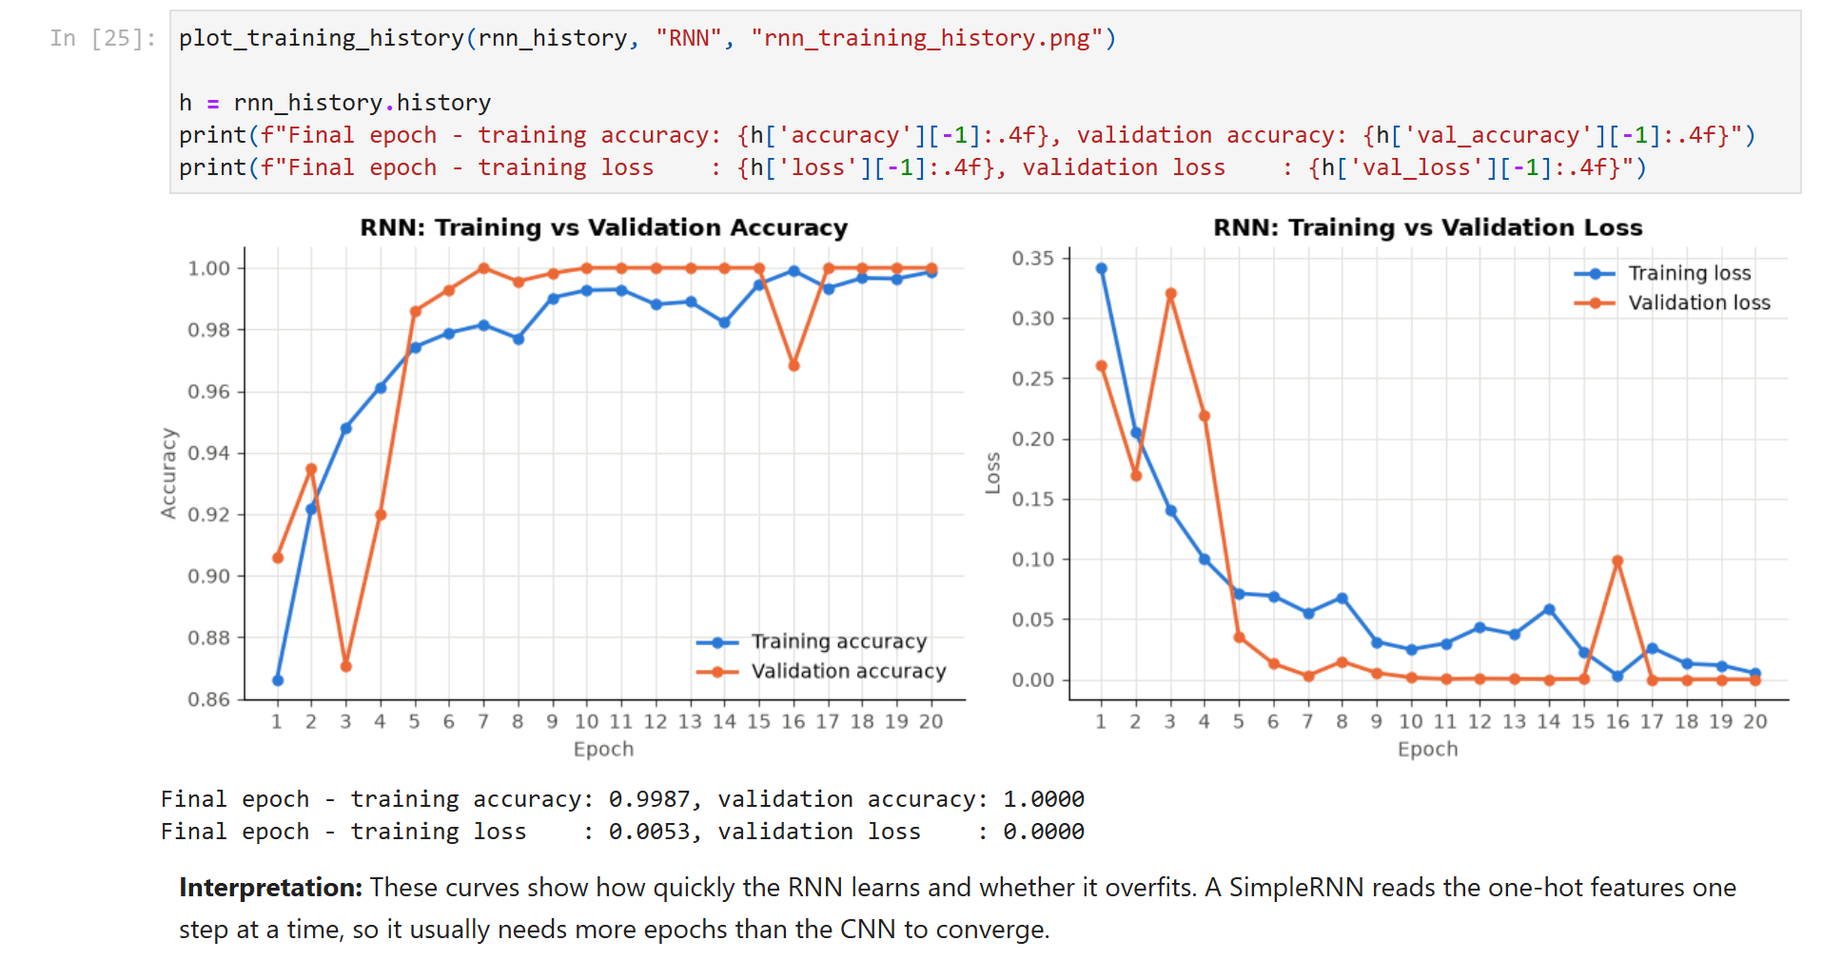
Figure 26: 15. RNN Training (part 2 of 2)

16. RNN Evaluation
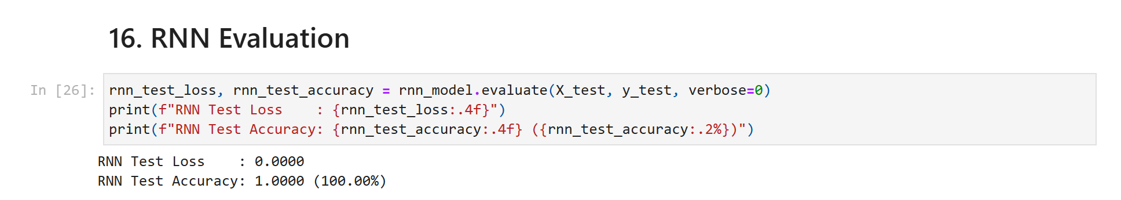
Figure 27: 16. RNN Evaluation

17. RNN Predictions
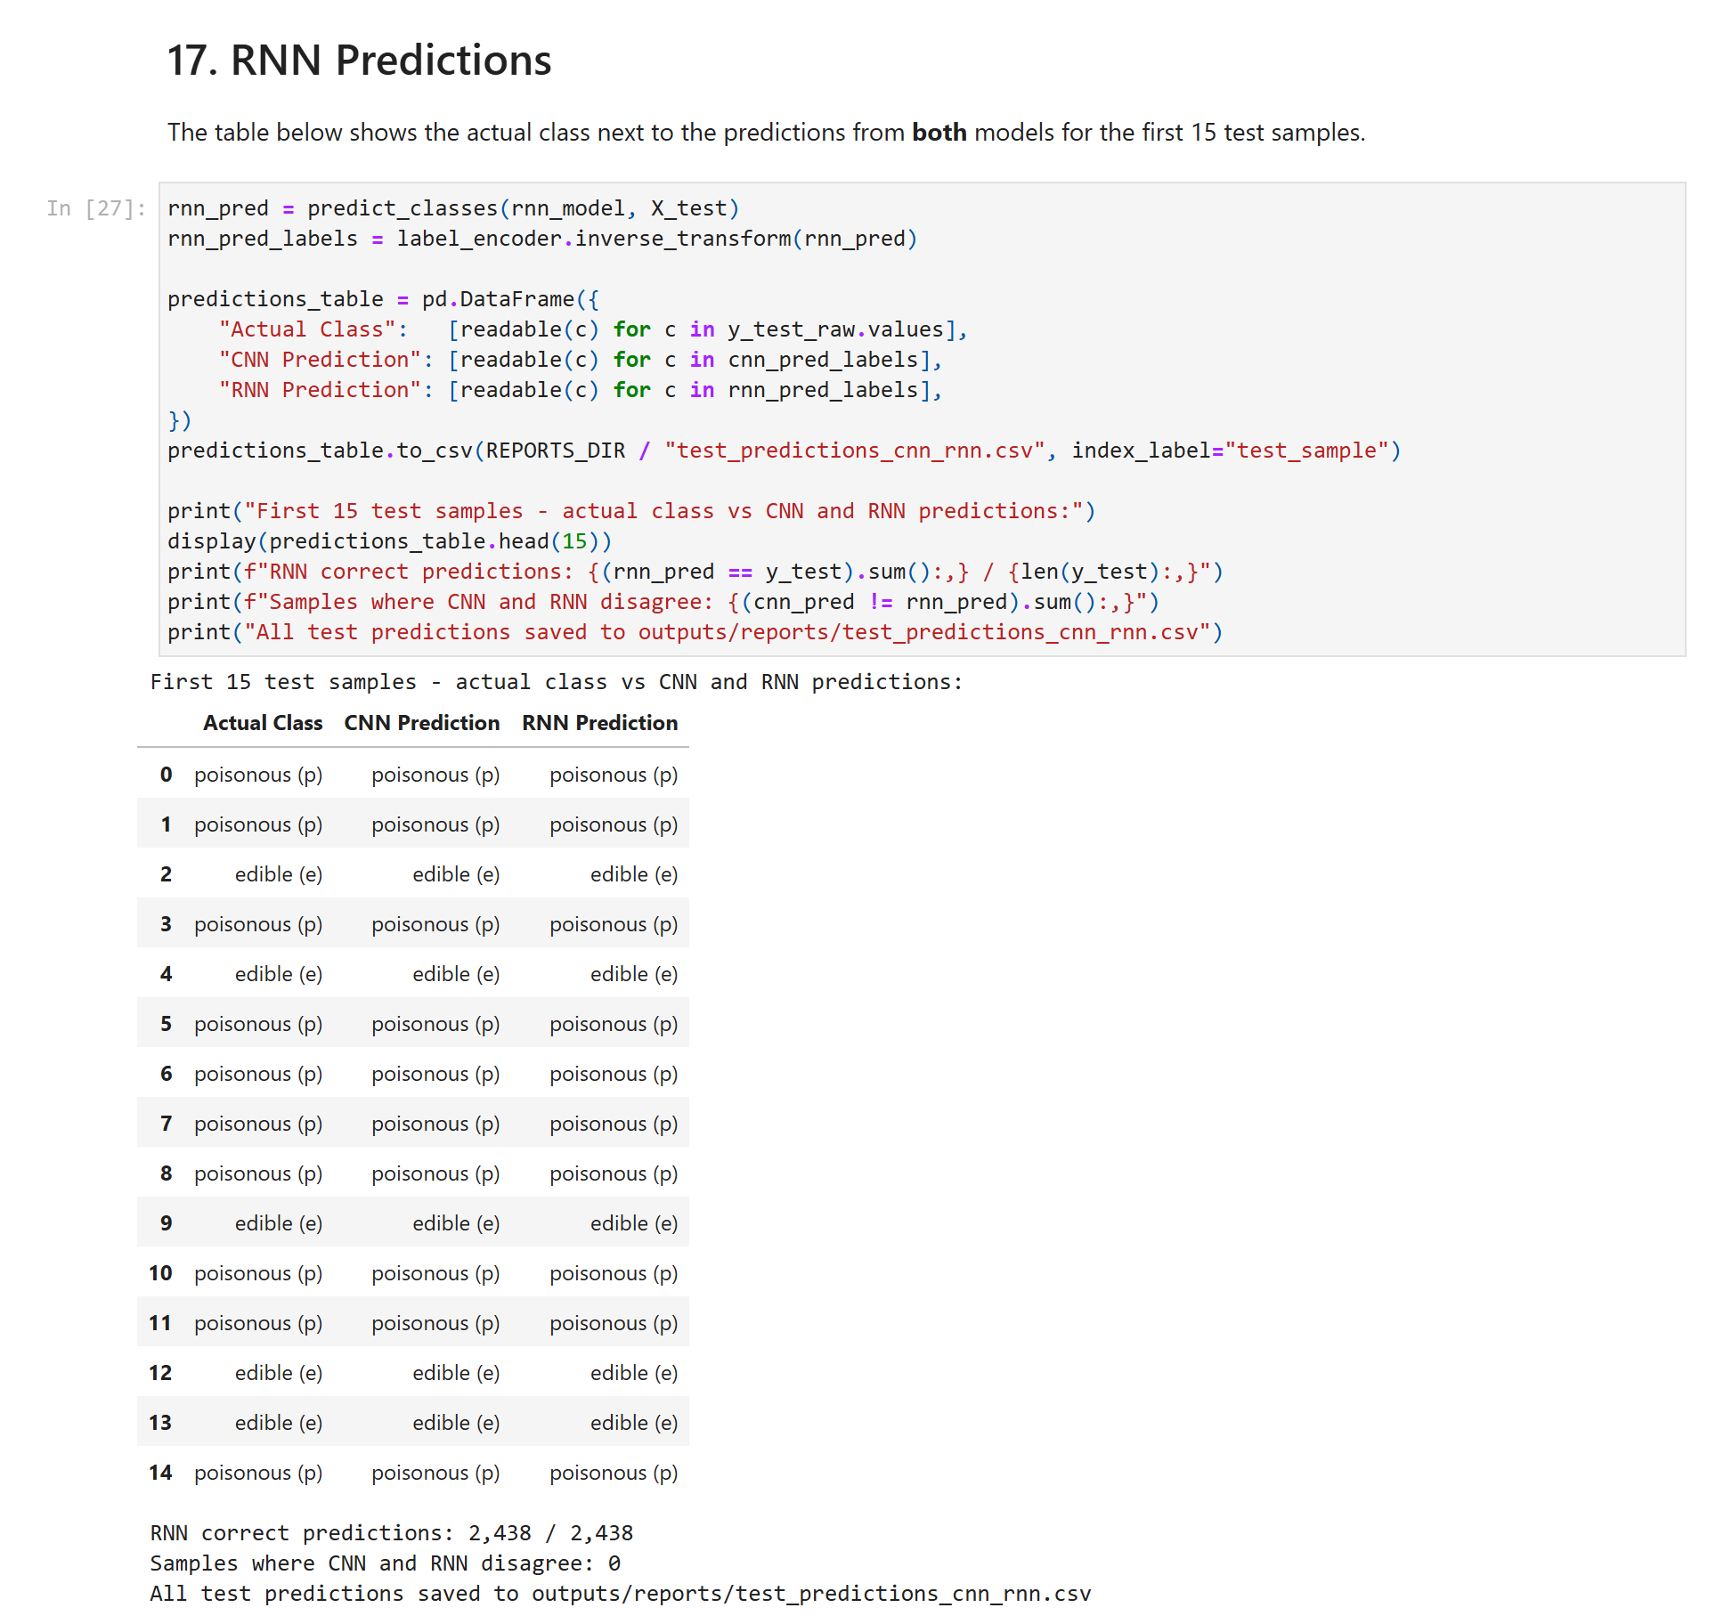
Figure 28: 17. RNN Predictions

18. RNN Confusion Matrix
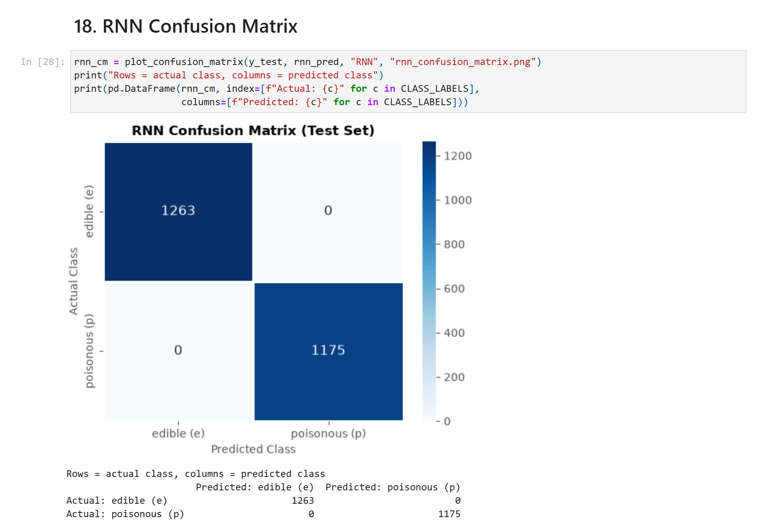
Figure 29: 18. RNN Confusion Matrix

19. RNN Classification Report
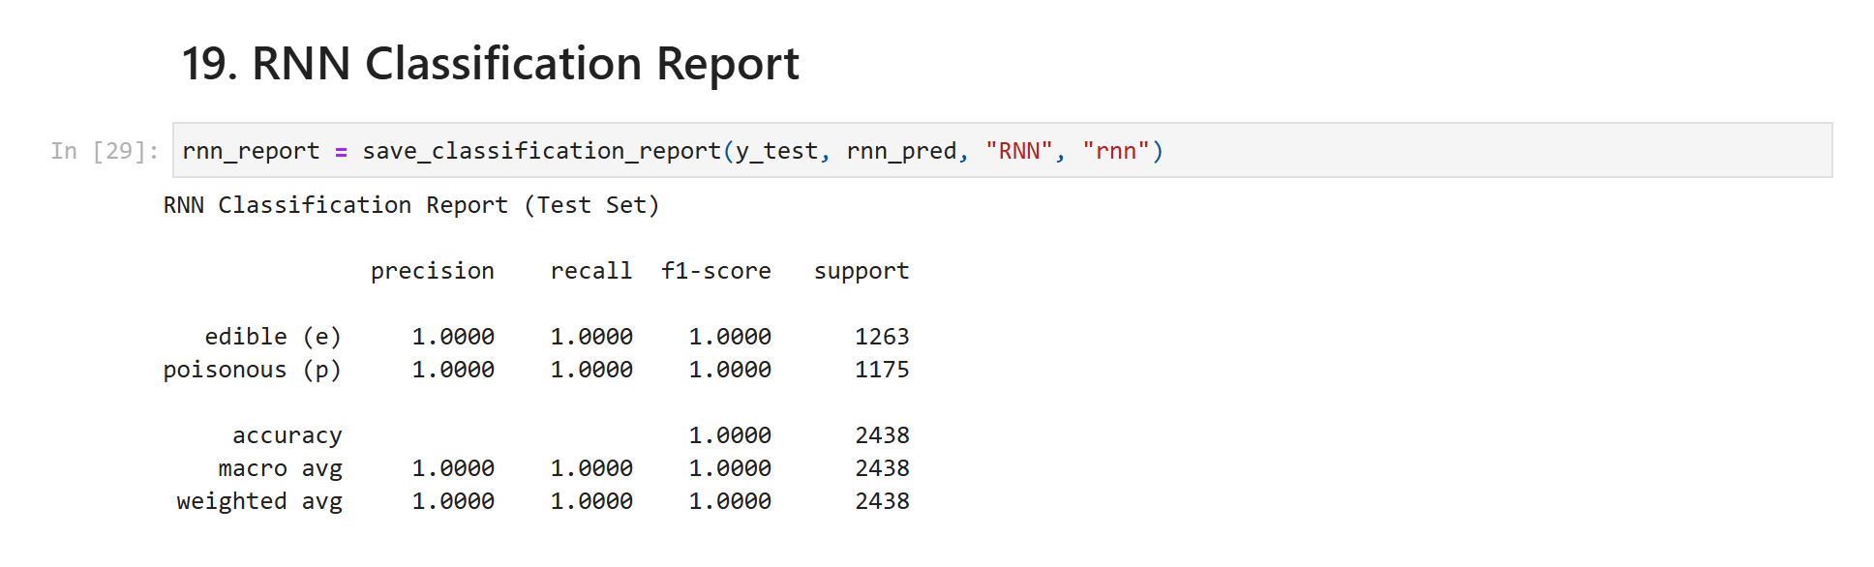
Figure 30: 19. RNN Classification Report

20. CNN vs RNN Comparison
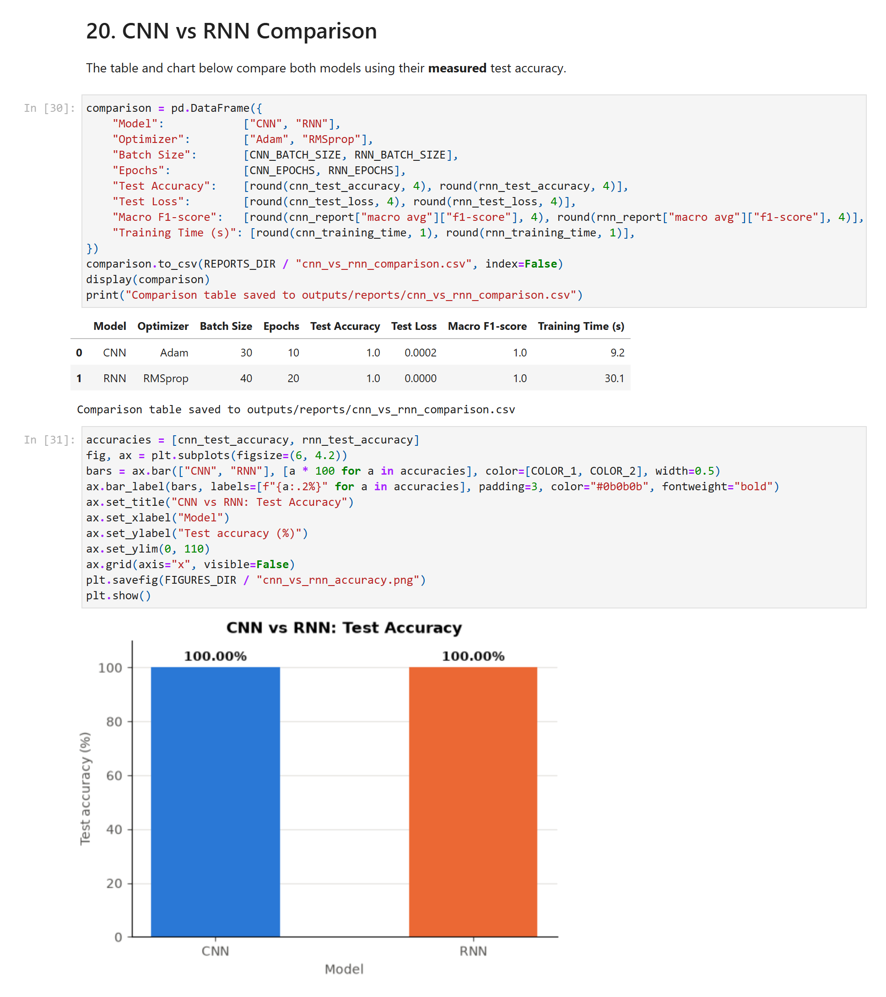
Figure 31: 20. CNN vs RNN Comparison

21. Final Recommendation
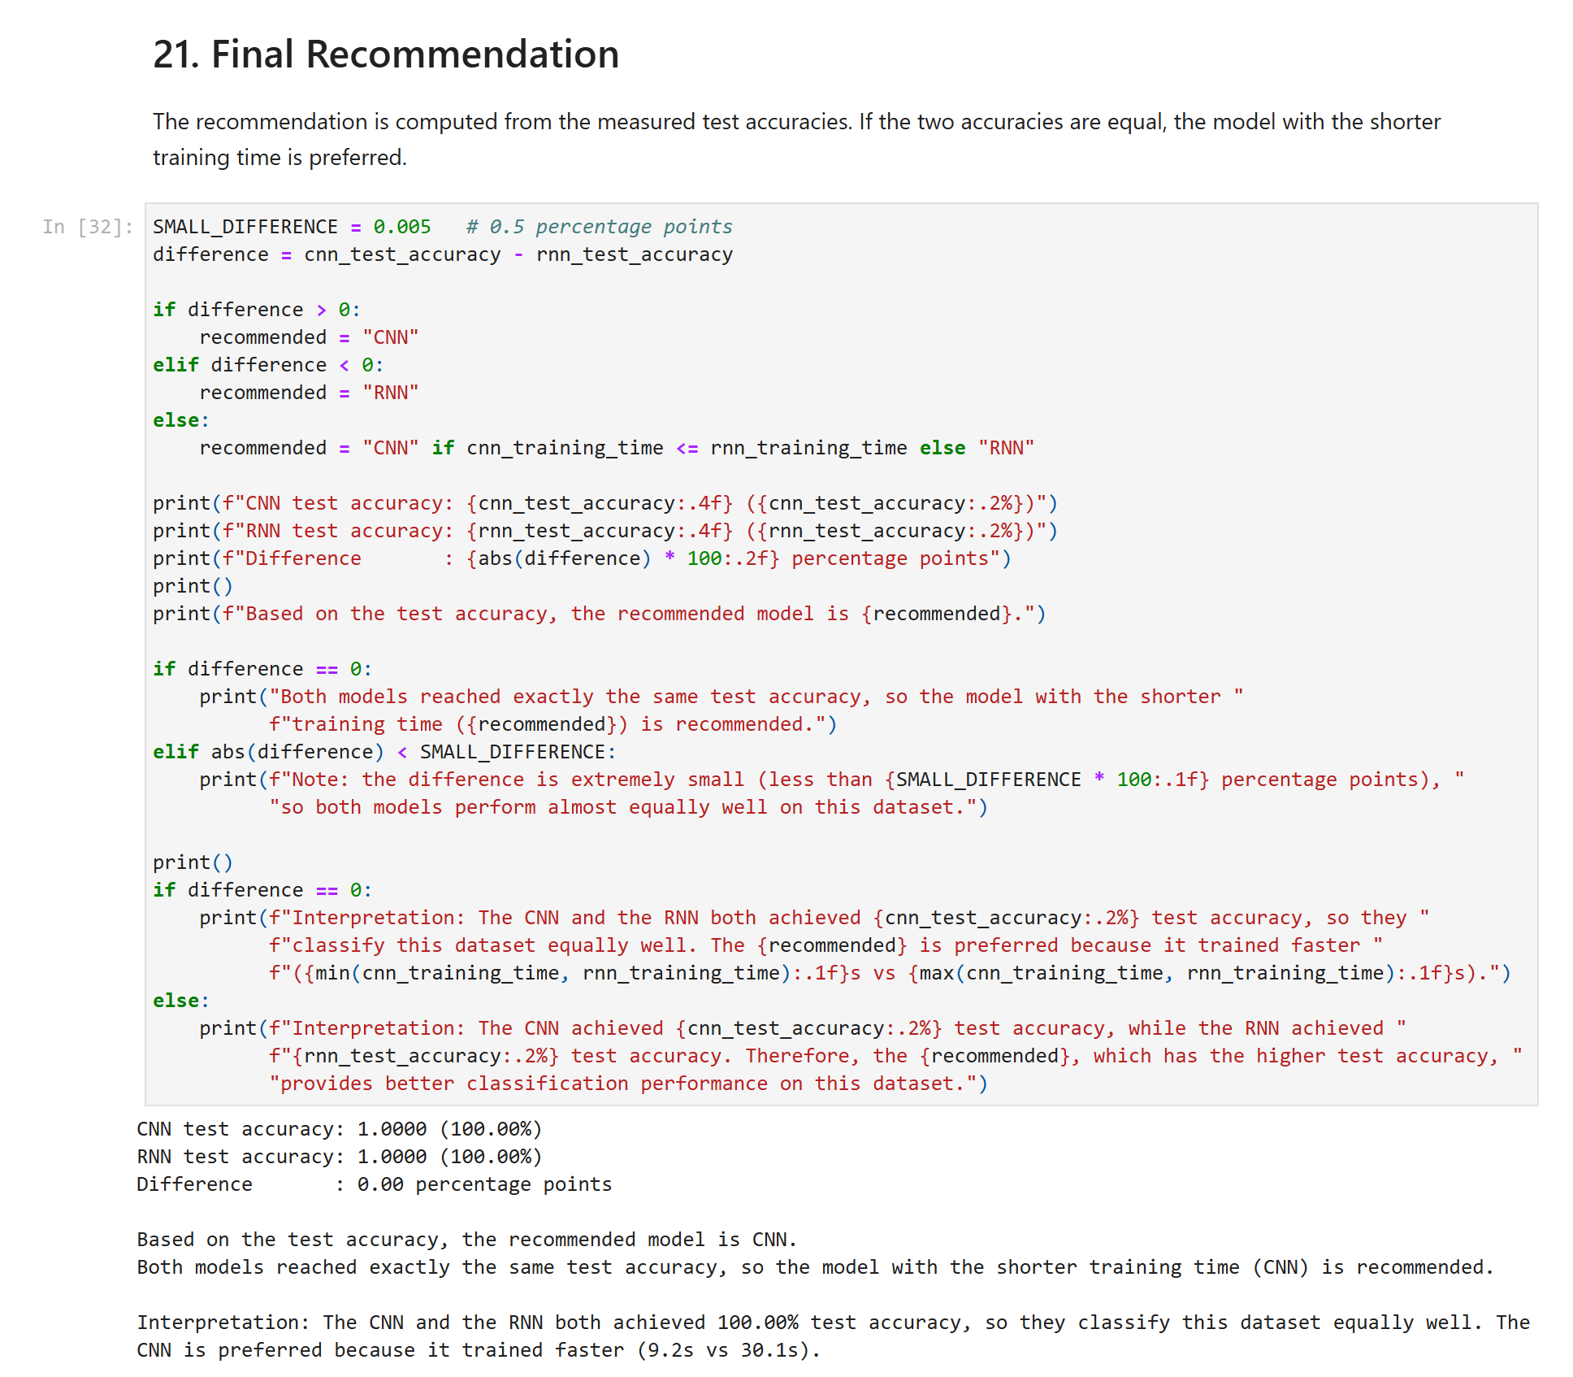
Figure 32: 21. Final Recommendation

Why can the accuracy be so high?
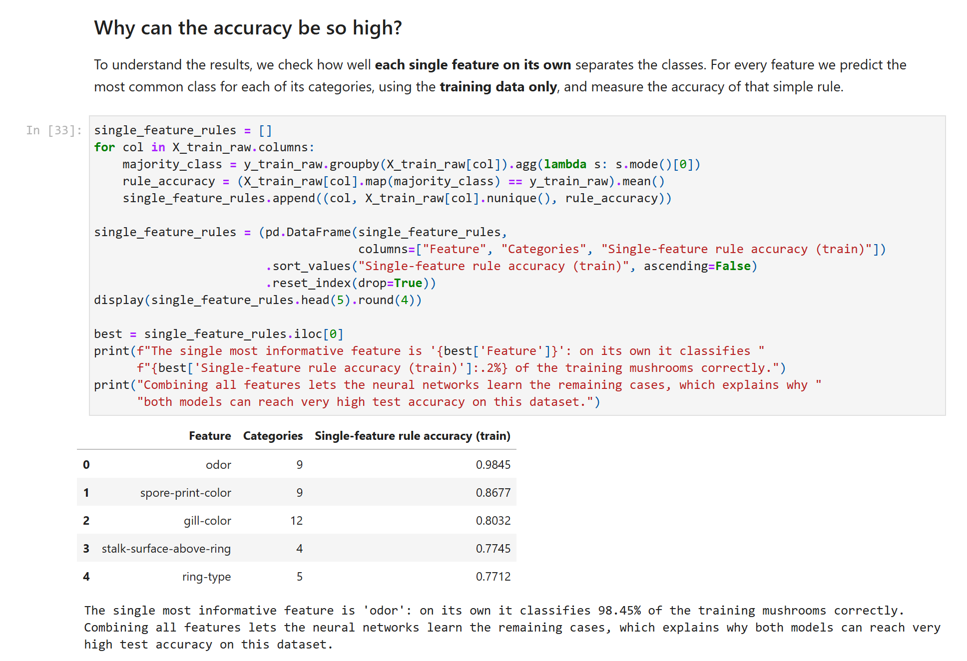
Figure 33: Why can the accuracy be so high?

22. Generative AI / NLP Task
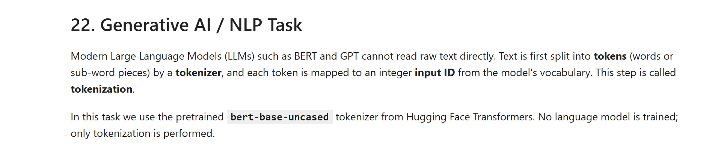
Figure 34: 22. Generative AI / NLP Task

23. Load exercise_text.json
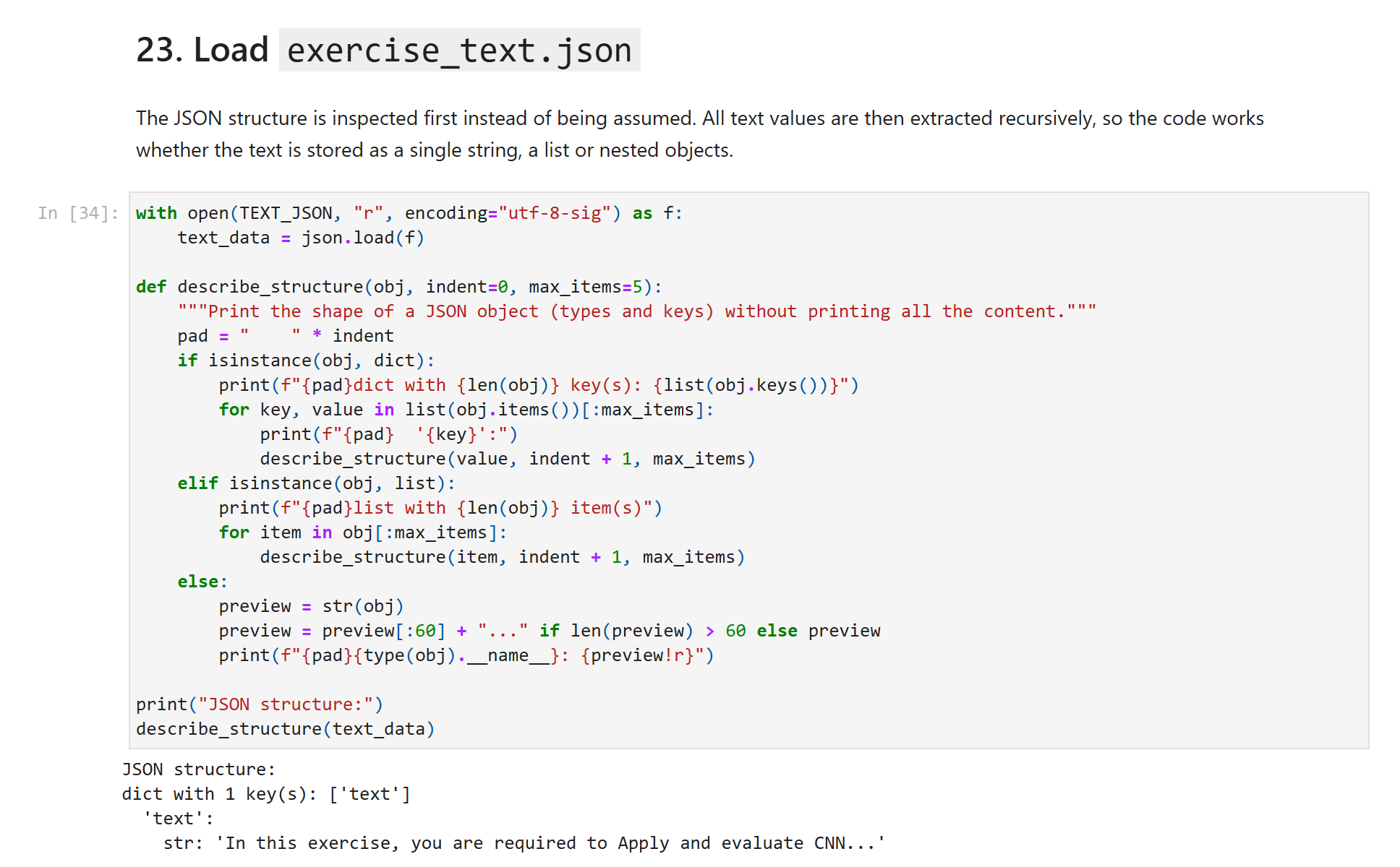
Figure 35: 23. Load exercise_text.json (part 1 of 2)
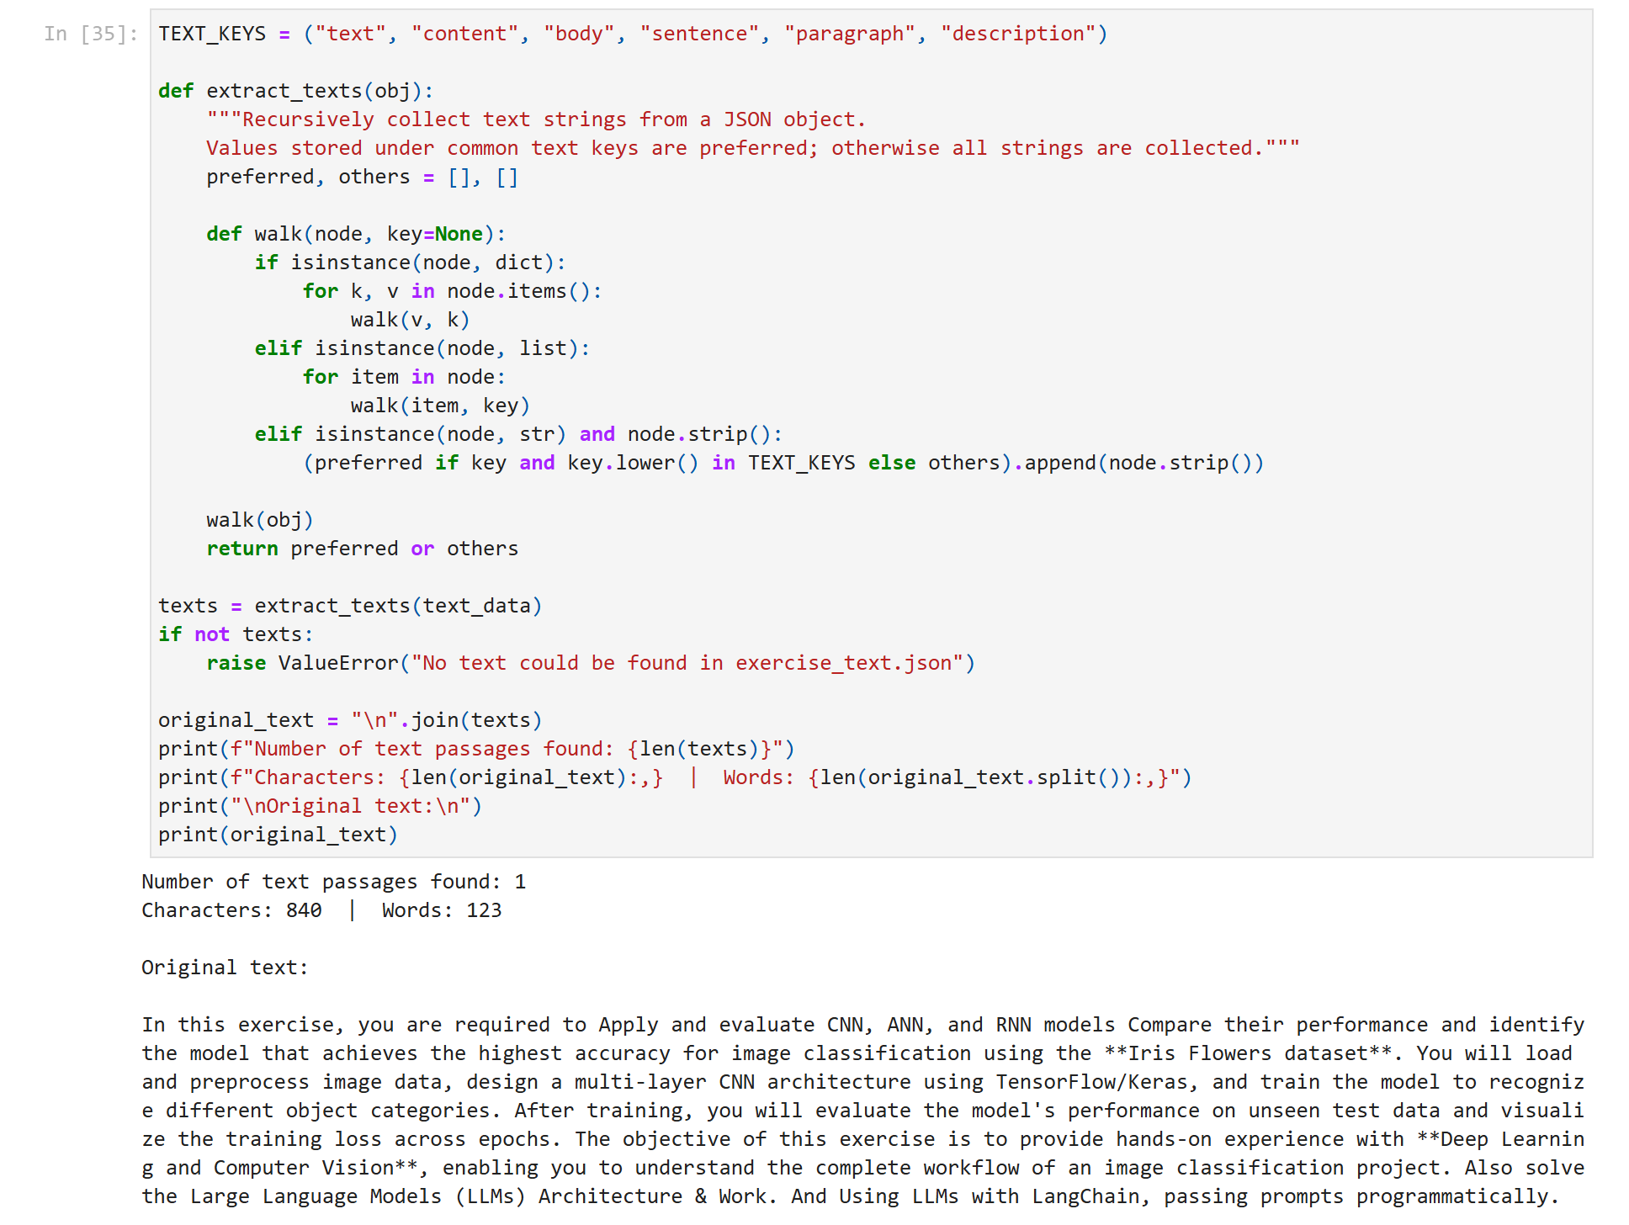
Figure 36: 23. Load exercise_text.json (part 2 of 2)

24. Hugging Face Tokenization
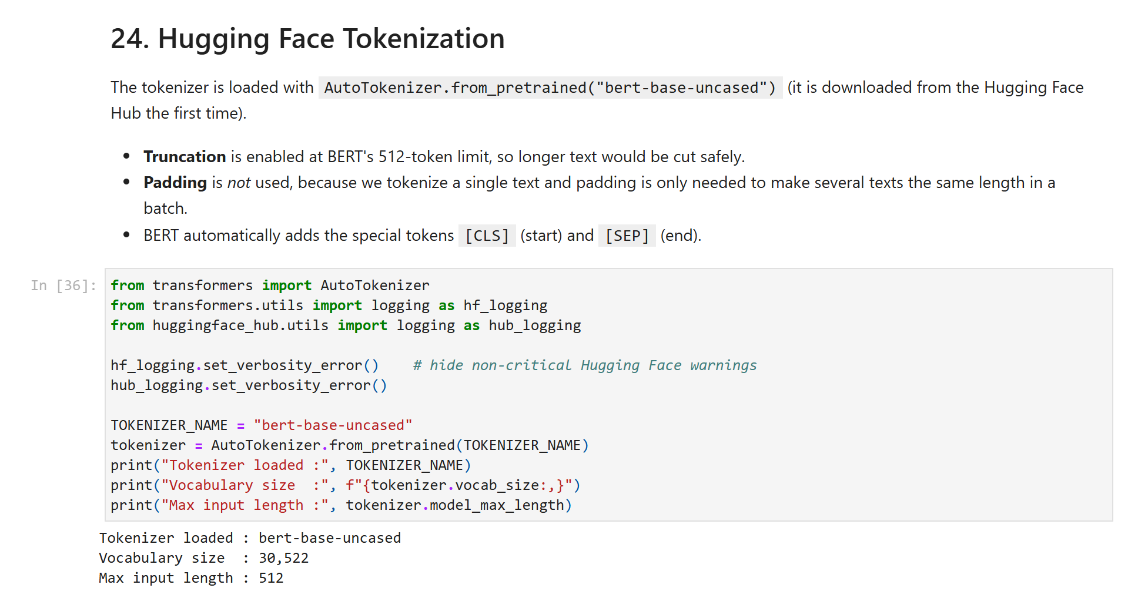
Figure 37: 24. Hugging Face Tokenization (part 1 of 4)
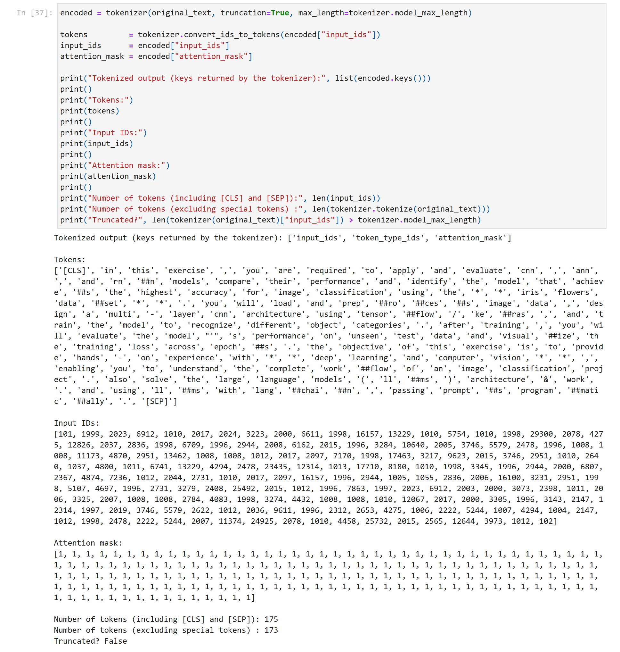
Figure 38: 24. Hugging Face Tokenization (part 2 of 4)
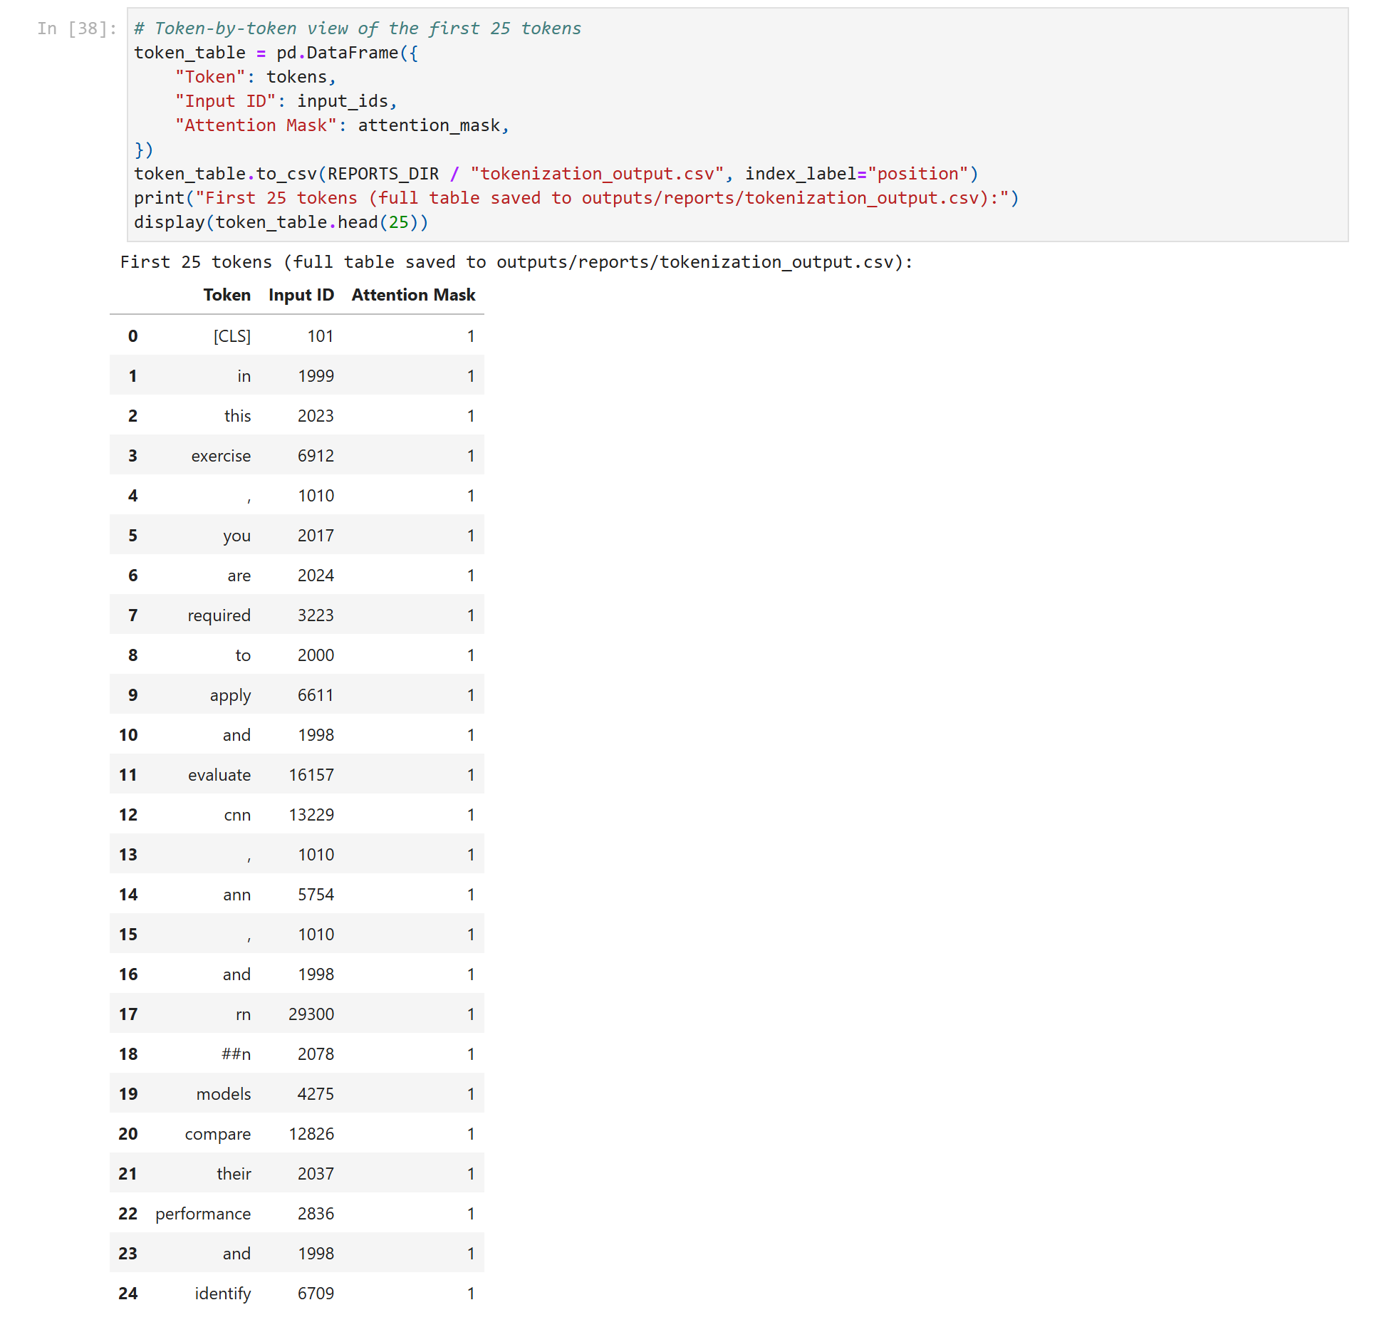
Figure 39: 24. Hugging Face Tokenization (part 3 of 4)
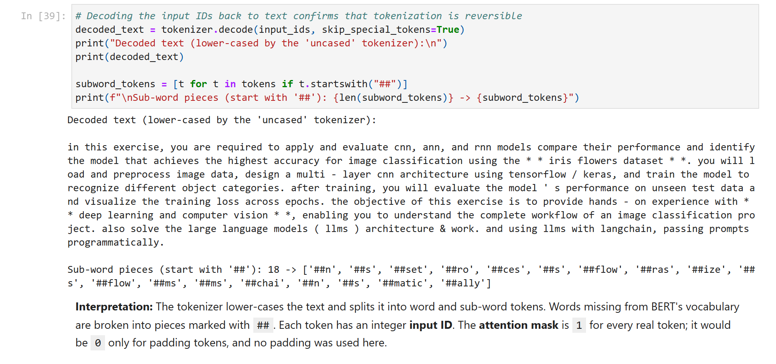
Figure 40: 24. Hugging Face Tokenization (part 4 of 4)

25. Final Summary
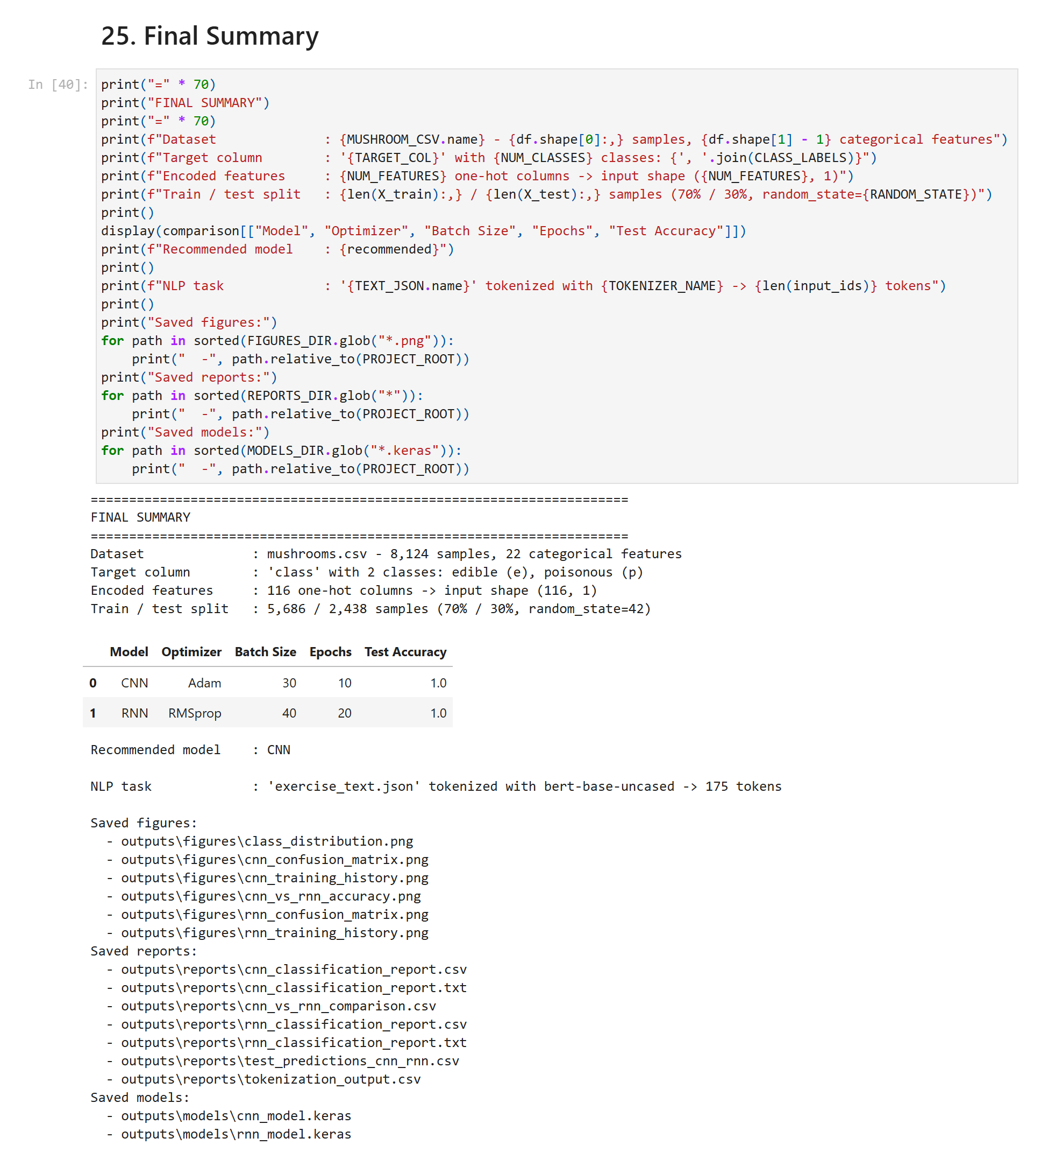
Figure 41: 25. Final Summary

Conclusions
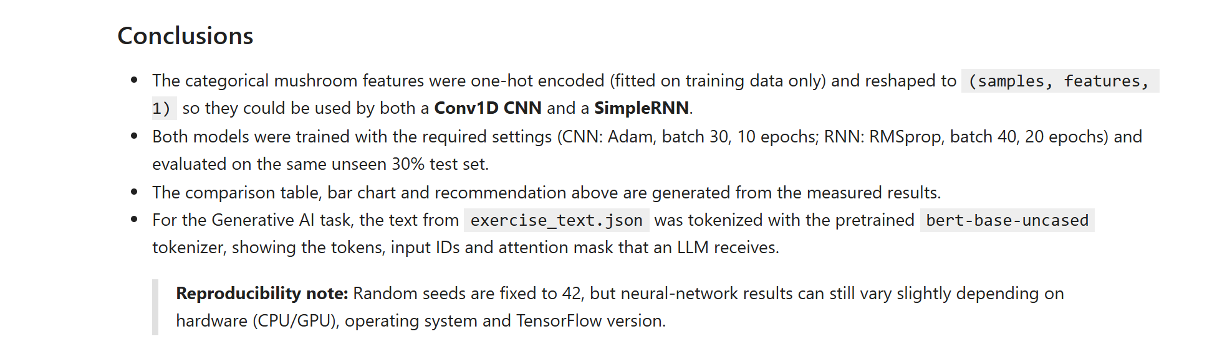
Figure 42: Conclusions

