OUM
Template User’s Guide

Release 6.4
September, 2016



OUM Template User’s Guide, Release 6.4

Copyright © 2006, 2016, Oracle and/or its affiliates. All rights reserved. This document is provided for information purposes only, and the contents hereof are subject to change without notice. This document is not warranted to be error-free, nor subject to any other warranties or conditions, whether expressed orally or implied in law, including implied warranties and conditions of merchantability or fitness for a particular purpose. We specifically disclaim any liability with respect to this document, and no contractual obligations are formed either directly or indirectly by this document. This document may not be reproduced or transmitted in any form or by any means, electronic or mechanical, for any purpose, without our prior written permission. Oracle and Java are registered trademarks of Oracle and/or its affiliates. Other names may be trademarks of their respective owners.
Authors: Oracle's Global Methods Team

Contents
1 Overview 1
2 Creating a New OUM Word Work Product 2
2.1 Step 1: Select Page Size 2
2.2 Step 2: Show Bookmarks 3
2.3 Step 3: Open Styles Window 4
2.4 Step 4: Substitute Values for Highlighted Variables 5
2.5 Step 5: Substitute Values for Non-Highlighted Variables 6
2.6 Step 6: Update Field Codes 6
2.7 Step 7: Modify Headers and Footers (Optional) 7
2.8 Step 8: Add Document Content 7
2.9 Step 9: Remove Sample Data 8
2.10 Step 10: Insert New Sections and Renumber Pages (optional) 8
2.11 Step 11: Remove Yellow Notes 8
2.12 Step 12: Update the Table of Contents 9
2.13 Step 13: Save the Document 9
3 Creating a New PowerPoint Work Product 10
4 Creating a New Excel Work Product 11
5 Standard Word Template Sections 12
5.1 Title Page 12
5.2 Change Record 12
5.3 Reviewers 13
5.4 Table of Contents 13
5.5 Components 13
6 Standard Template Variables 14
7 Standard Word Template Styles 15

Overview
OUM templates provide starting points for documenting task outputs. The OUM 6.3 Word templates come with a set of standard styles. You can use these styles, modify some styles or even apply your own Word template.
The 6.3 templates no longer use the Oracle Method Template Engine (OMTE). However, if you currently have templates or work products created prior to OUM 6.3, the OMTE can still be used with these documents, but it is no longer supported and will not be enhanced. Refer to the Retired Oracle Method Template Engine (OMTE) Template User’s Guide for information on working with those templates.

Creating a New OUM Word Work Product
To get started, you need a work product template.
To save a template from OUM:
- Locate the template needed and click on the link.
- Save the template to another directory on your computer using the “Save As” option.
- Close the document.
- Re-open the document in its new location.
To create your customized work product document using Word:
Step 1: Select Page Size
Step 2: Show Bookmarks
Step 3: Show Yellow Notes in Templates
Step 4: Open Styles Window
Step 5: Substitute Values for Automatic Replacement Variables
Step 6: Enter Project-Specific Information
Step 7: Update Field Codes
Step 8: Modify Headers and Footers (optional)
Step 9: Add Document Content
Step 10: Remove Sample Data
Step 11: Insert New Sections and Renumber Pages (optional)
Step 12: Remove Yellow Notes
Step 13: Update the Table of Contents
Step 14: Save the Document

Step 1: Select Page Size
The OUM 6.3 templates no longer use the Oracle Method Template Engine and therefore, the page size defaults to Letter 8.5” x 11”. If necessary, update the page size.
To update the page size:
- Open your saved document.
- Choose the Page Layout tab.
- Select Size and select the page size.

Step 2: Show Bookmarks
The templates use Word bookmarks so that key information in the cover page appears consistently in the headers and footers. Be careful not to accidentally delete these bookmarks. In order to not delete the bookmarks, you need to be able to see them.
To show bookmarks:
- Open your saved document.
- Choose Office Button > Word Options > Advanced.
- Select Show Bookmarks and click OK.
Bookmarked text shows between gray brackets. By showing the bookmarks, you can avoid deleting them.
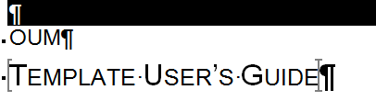

Step 3: Open Styles Window
OUM Word templates use Word 2007 and come with a set of built in formatting instructions that provide the styles. When you open an OUM Word template, you can see some of the OUM styles in the Styles ribbon on the Home tab. You can also use the Styles Box to see a list of all the OUM styles. To show the Styles window, use ALT + CTL +Shift + S or click on the arrow on the bottom right of the Styles ribbon.
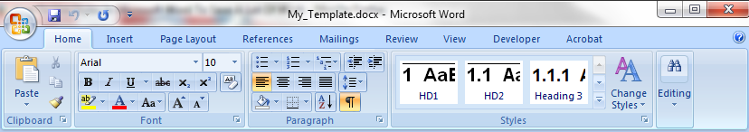
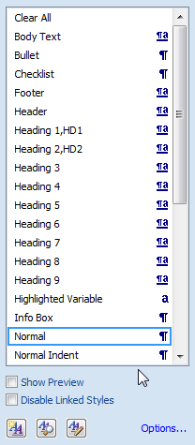
It is important that you use the styles to format your document as much as possible. Instead of using individual formatting for a paragraph, assign the paragraph a style from the Styles window.
You can still use individual formatting as necessary. However, if later you apply a style to the paragraph, you will lose that formatting.
You can also modify any of the styles by right-clicking on the style in the Styles window and selecting either “Update to Match Selection” or “Modify…”.

Step 4: Substitute Values for Highlighted Variables
The templates often include variables for which you can substitute project-specific values to customize your work product document. Non-Highlighted Variables are not designated with a special character style.
There are two types of variables: Highlighted Variables and Non-Highlighted Variables.
Highlighted Variables are designated with a character style of Highlighted Variable, with blue font and contained within angled less than and greater than brackets (< >). There can be many of these variables and each of these variables may appear more than once in the document, but there is only one substitution value for all occurrences.
To substitute values for Highlighted Variables:
- Open your saved document.
- Open the Find and Replace window.
- Enter the Highlighted Variable name including the brackets in the Find what: box, for example <Company Long Name>.
- Enter the replacement text in the Replace with: box.
- Optionally, if you want to change the font from blue to black, with the cursor in the Replace with: box, select the Format option (bottom left of window), and choose Font….
- In the Find Font pop-up window, select your font and click OK.
- Select Replace, Replace All or Find Next and update the variables.
- Repeat for each Highlighted Variable.
To find all variables, simply do a search using < or >. To specifically find all Highlighted Variables, use the More>> option in the Find window to expand the search options. Once expanded, use the Format options to select Style. This will pop up the Find Style box. Scroll through the list and select Highlighted Variable. Now you can search for each Highlighted Variable. To clear the style from future searches, use the No Formatting option.
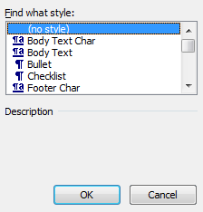
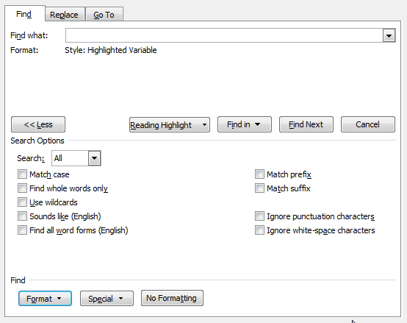

Step 5: Substitute Values for Non-Highlighted Variables
Non-Highlighted Variables (and sample data) are not designated with a special character style but are also contained within angled less than and greater than brackets (< >). Generally, these are used for project-specific content that is different for each occurrence. For the most part, replace these variables as you customize your document.
When you are finished editing your document, check that there are no variables left in your document. To find any variables that you have not updated, simply do a search using < or >.

Step 6: Update Field Codes
The OUM templates use Word field codes to automate page numbering and other features.
Field codes are internal data stored by Word that can be inserted into your document. Some examples are Creation Date and Last Updated (Date), as well as the Table of Contents.
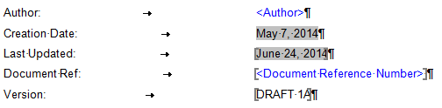
To view field codes in the document:
- Choose Office Button > Word Options > Advanced.
- Select Field Shading drop down value of “Always” and click OK.
- To view the underlying field code logic, select Show field codes instead of their values and click OK. Alternatively, you may choose not to select this and use either ALT F9 to toggle showing and hiding field codes as needed, or place the cursor in the field code text and right-click and choose Toggle Field Codes from the pop-up menu.
To update field codes in the document:
- Place your cursor in the field code text you want to update and press F9. Alternatively, right-click and choose Update from the pop-up menu.
To update ALL field codes in the document:
- Save your document.
- On the Home tab, Editing ribbon, choose Select.
- Choose Select All, or alternatively use CNTL A.
- Press F9.
- When the Update Table of Contents pop-up appears, choose either Update page numbers only or Update entire table and click OK.
To set Word to automatically update field codes in the document whenever you print:
- Choose Office Button > Word Options > Display.
- Under Printing Options, select Update fields before printing and click OK.

Step 7: Modify Headers and Footers (Optional)
The headers and footers of a document can offer important navigational indicators to the reader. In OUM, field codes are used in the headers and footers and can be updated by using the instructions in the previous section for updating the field codes. Other than updating the field code variables, specifically modifying the information in headers and footers is not necessary. If you do need to change the template headers and footers to reflect specific requirements for your project, make sure you do not delete the field codes.
To modify the headers or footers of a template:
- Open your document.
- If your document is not in Print Layout view, choose the View tab > Print Layout.
- Double-click in the grayed area of the header or footer that you want to modify.
- The header or footer area becomes active.
- Change the information to reflect your requirements.

Step 8: Add Document Content
Add the content for your work product based on the specifics of your project. Modify sample test and add appropriate detail.
Use the following items to copy and paste into your document:

Icons with Text

Attention: <Enter Text>

Suggestion: <Enter Text>

 | Warning: <Enter Text>

Form Reference: <Enter Text>

Document Reference: <Enter Text>

Report Reference: <Enter Text>

Suggestion: <Enter Text>

List Table without Borders

Column One | Column Two
Tip: Use Table Tools > Layout > View Gridlines in order to see the borders while editing.

Formatted Table

Step 9: Remove Sample Data
Templates sometimes contain sample data to help you complete the work product correctly. Be sure to remove this sample data.
Identify sample data as follows:
- Search for angled less than and greater than brackets (< >). Non-Highlighted Variables, sample data, helpful information, etc. may be contained within the brackets. Remove or update as appropriate.
- Check tables for sample entries, seeded content not needed or any other content. Remove or update as appropriate.

Step 10: Insert New Sections and Renumber Pages (optional)
You may want to insert new sections in either portrait or landscape orientation to accommodate your content. Remember that Word restarts page numbering when you insert section breaks, and you need to renumber the document.
To insert a new section:
- Ensure that the headers and footers are set to Same as Previous.
- Place the cursor in the exact location where you want the new section to being.
- Choose Page Layout > Breaks > Next Page. Word inserts a new section. The new section will have the same headers and footers as the previous section and once you update the field codes in the footer the section name will be updated.

Step 11: Remove Yellow Notes
Suggestions, advice and other important information appear in yellow note fields throughout the Word templates. Once your template is completed, you need to remove the yellow notes.
To remove the yellow notes:
- With your document open, open the Find and Replace window.
- Expand the Find and Replace window using the More>> button.
- Place the cursor in the Find what: field.
- Choose Format > Style.
- When the Find Style box opens, scroll through the list and select Note and click OK.
- Leave the Replace with: field blank.
- Select Replace, Replace All or Find Next to remove the yellow notes.
- Repeat using the Note Wide style if there are any landscape sections that contain wide yellow notes.

Step 12: Update the Table of Contents
When you finish your work product, update the table of contents.
To update the table of contents:
- Click to the left of, or within, the table of contents
- Press F9.
- Choose the appropriate update option. Select “Update Page Numbers Only” if you’ve not added or deleted any sections. Select Update Entire Table if you’ve inserted new sections, deleted sections, or changed headings that should be reflected in the Table of Contents.
- Click OK

Step 13: Save the Document
Use the Save command. Template files are read-only files. If you neglected to save to a new document before editing, you will receive a message informing you that the file is read-only and you are prompted to enter a new file name and saving location.

Creating a New PowerPoint Work Product
To create a new PowerPoint work product:
- Open the PowerPoint template you want to use.
- Save the template to another directory on your computer using the “Sava As” option.
- Enter project-specific information.
- Remove any sample data.
- Search for information contained in less than and greater than brackets (< >). Replace this information with values specific to your project or remove this information if it is not relevant.
- Save the presentation.

Creating a New Excel Work Product
To create a new Excel work product:
- Open the Excel template you want to use.
- Save the template to another directory on your computer using the “Sava As” option.
- Enter project-specific information.
- Remove any sample data.
- Search for information contained in less than and greater than brackets (< >). Replace this information with values specific to your project or remove this information if it is not relevant.
- Save the presentation.

Standard Word Template Sections
OUM Word templates are made up of various sections. These sections are consistent throughout the template collection.
- Title Page
- Change Record
- Reviewers
- Table of Contents
- Components

Title Page
The Title Page contains:
Component | Description of Contents
Method Abbreviation | OUM
Title | Name of the work product
Company Long Name | Name of the company
Subject | Brief description of the work product or type of information contained in document.
Author | Author of the document
Creation Date | Date the document was originally created.
Last Updated | Date the information contained in the document was last updated.
Document Ref: | For more formal templates with front matter, the Document Ref: number will show up in the Header. If you delete it, be sure to delete the reference in the Header.  This can be used to reference the location of the document in the Project Library or a number by which the document is controlled. For example, ACME/TA010/001 for the first version of the task TA.010 document on the ACME project.Manually maintained code or number that uniquely identifies the document.
Version | Manually maintained number sequentially incremented with each publication of the document. Equals the version number in the last change record row.
Approvals | Area for handwritten acceptance by designated approvers.

Change Record
Use the Change Record to maintain a revision history, using one row for each revision. The Date and Version in this table should correspond the Last Updated date and Version indicated on the cover page.
The change record contains:
Component | Description of Contents
Date | Date the change was made to the document
Author | The person, group, or role responsible for the change.
Version | Version number that the change was published under.
Change Reference | Description of the change made to the document.

Reviewers
Use the Reviewers list to identify the individuals who must review the document. If your document is not controlled, then delete the Reviewer list, and remove the Copy Number field from the cover page.
The reviewer list specifies:
Component | Description of Contents
Name | Name of reviewer
Position | Position and role of the reviewer.

Table of Contents
The Table of Contents lists the contents of the document. The default style is to display the first two levels of headings, but you can change the number of levels displayed, as appropriate, for your document.

Components
Each work product has sections or components. Components vary for each work product. These sections contain the details for the work product.

Standard Template Variables
OUM uses the following standard highlighted variables in Word templates:
Variable Name | Description
Company Long Name | The full name of the company, for example, ACME Corporation.
Subject | The Subject will show up in the Footer. If you delete it, be sure to delete the reference in the Footer.  Enter a descriptive phrase for the document, such as the functional area within the business or application that the document addresses. For work products that you produce only once during a project, use the project name as the subject.
Document Reference Number in Templates with Front Matter | For more formal templates with front matter, the Document Ref: number will show up in the Header. If you delete it, be sure to delete the reference in the Header.  This can be used to reference the location of the document in the Project Library or a number by which the document is controlled. For example, ACME/TA010/001 for the first version of the task TA.010 document on the ACME project.
Ref #: in Form Templates | For Form templates, Ref #: is not a highlighted variable.  Update the Ref # with the Project Library location for the Form, if appropriate. If not, you can delete the Ref #.
Approver 1 | The name or description of the first approval signature. You can set this to a project role (such as Project Manager) or to the name of the approver.
Approver 2 | The name or description of the second approval signature.

Standard Word Template Styles
This section lists the primary styles used in the OUM templates:
Paragraph Style | Description of Use
Normal | Standard style that all other styles in the template are based upon. Any changes made to the Normal style (such as font) will be reflected in most other styles.
Body Text | Used for standard paragraphs throughout all templates.
Title Bar | Used for the horizontal bar that appears on the title page and on the first page of a chapter in multichapter documents. It should be a single, empty paragraph.
Subject | Used for Subject on Title Page.
Heading 1, HD1 | Indicates a major section that begins on a new page. This style has a horizontal bar above the text that extends the width of the page. Most template components begin with Heading 1. Includes the first level of outline numbering, e.g., 1, 2, 3, etc.
Heading 2,HD2 | Secondary heading in a section. Has a shorter horizontal bar above the text. Includes the second level of outline numbering, e.g., 1.1, 1.2, 1.3, etc.
Heading 3 | Third level of heading in a section. Includes the third level of outline numbering, e.g., 1.1.1, 1.1.2, 1.1.3, etc.
Heading 4 | Fourth level of heading in a section. Includes the fourth level of outline numbering, e.g., 1.1.1.1, 1.1.1.2, 1.1.1.3, etc.
Heading 5 | Fifth level of heading in a section. Includes the fourth level of outline numbering, e.g., 1.1.1.1, 1.1.1.2, 1.1.1.3, etc.
Heading 6 | Additional outline numbered heading, if needed.
Heading 7 | Additional outline numbered heading, if needed.
Heading 8 | Subheading without outline numbering. Same font size as Body Text, but is bold and underlined. It also has center and right tabs that are used for form field descriptions in design documents.
Heading 9 | Additional subheading and appears as Bold Italics.
Bullet | Used for unnumbered or non-sequential lists.
Number List | Use for numbered lists.
Checklist | Uses a shadowed box as a bullet for check-off lists.
Note | Appears as yellow field box. Used to provide helpful information for completing work products. Should be deleted for final document.
Note Wide | Appears as yellow field box, wider than Note style. Used to provide helpful information for completing work products. Should be deleted for final document.
Info Box | Encloses centered text in a box.
Table Text | Standard style for text appearing in a formatted table. It is slightly smaller than Body Text.
Table Heading | Style for the text in the heading of a formatted table.
tty80 | Used to simulate terminal or report output. Tabs are spaced at 8 character intervals.
tty80 indent | Like tty80, but is indented slightly more than the Body Text style. It is useful for describing system commands or files.
tty132 | Use for documenting 132 column reports.
tty180 | Use for documenting 180 column reports.
Highlighted Variable | Denotes substitution variables in templates.

