OUM
EOCM.030 Executive Business Objectives and Governance Rules
<Company Long Name>
<Subject>

When this template is completed, delete all the yellow notes as follows:
1. With your document open, open the Find and Replace window.
2. Expand the Find and Replace window using the More>> button.
3. Place the cursor in the Find what: field.
4. Choose Format > Style.
5. When the Find Style box opens, scroll through the list and select Note and click OK.
6. Leave the Replace with: field blank.
7. Select Replace, Replace All or Find Next to remove the yellow notes.
8. Repeat using the Note Wide style if there are any landscape sections that contain wide yellow notes.
Please refer to the OUM Template User’s Guide for detailed instructions for working with OUM templates.

Author: <Author>
Creation Date: May 11, 2014
Last Updated: June 26, 2014
Document Ref: <Document Reference Number>
Version: DRAFT 1A

Title, Subject, Last Updated Date, Reference Number, and Version are marked by a Word Bookmark so that they can be easily reproduced in the header and footer of documents. When you change any of these values, be careful not to accidentally delete the bookmark. You can make bookmarks visible by selecting the Office Button>Word Options>Advanced> and checking the Show bookmarks option in the Show document content region.

Approvals:
<Approver 1>
<Approver 2>
To add additional approval lines, press [Tab] from the last cell in the table above.
You can delete any elements of this cover page that you do not need for your document.

Document Control

Change Record
4
Date | Author | Version | Change Reference
28-Nov-05 | <Author> | Draft 1a | No Previous Document

Reviewers

Name | Position

Contents
1 Document Control iii
1.1 Change Record iii
1.2 Reviewers iii
2 Introduction 1
2.1 Purpose 1
2.2 Overview 1
3 Project Vision and Business Objectives 2
3.1 Project Vision 2
3.2 Project Rationale 2
3.3 Project Objectives 2
4 Project Direction 3
4.1 Sponsorship Program 3
5 Reporting Structure 4
6 Roles 5
6.1 Sponsorship Approach 5
6.2 Steering Committee 5
6.3 Advisory Committee 7
7 The Communication Strategy 8
7.1 Why Focus on Communications? 8
7.2 Communication Strategy Description 8
8 Open and Closed Issues 10
8.1 Open Issues 10
8.2 Closed Issues 10

To update the table of contents, put the cursor anywhere in the table and press [F9]. To change the number of levels displayed, select the menu option Insert->Index and Tables, make sure the Table of Contents tab is active, and change the Number of Levels to a new value.

Introduction

Purpose
The purpose of this document is to provide the project governance defined by the <Company Name> Executives during the Executive Alignment Workshop. This document provides the information on the project vision aligned with the business objectives, project success criteria and also it define the steering committee structure role and rules.
The high-level project risks are also identified with the key actions to put in place to mitigate them.

Overview
This document includes the following components:
Component | Description
Project Vision and Business Objectives | Shows the alignment of the project vision with the business strategy and identifies the rational for the project and expected business objectives and benefits.
Project Direction | Identifies the high-level project risks and challenges. Includes action items to manage the impact, mitigate the risks, support key project roles and manage the project at the executive level.
Roles | Documents roles within the project environment, including the executive sponsor, Steering Committee structure, role and rules

Project Vision and Business Objectives

Project Vision

Alignment of Project Vision with Business Strategy
This section documents the project vision developed by the Executives and its alignment with the corporate strategy. In today’s business climate, the introduction of new enabling technology requires serious consideration to both the business drivers making the change necessary and the impact the change will have on the individuals and business units impacted by it. Visions must be clear, concise, compelling and aligned.
The corporate vision for <Company Name> is:

A PowerPoint slide of the vision can be found in Appendix 1, which contains the presentation used in the Executive Alignment Workshop.

Project Rationale

Reasons for implementing the <Company Name>
The <Company Name> <Project Name> will address many of the problems of our current systems, which:

Project Objectives
The business objectives and benefits we expect from the project are shown below and will be measured as described:

Business Objectives for Project | Benefits | Measurement

Project Direction
The <Company Name> Executives are committed to remove project barriers and fully support the porject.

Project Risks/Barriers
The Executives recognize that the implementation will involve major challenges for business processes and culture, and surfaced the following risks/barriers to the project were identified during the Executive Alignment Workshop:

Sponsorship Program
The Executives discussed the challenges above and identified actions that could be taken at the executive level to address these challenges and support the implementation team. The following strategies were identified:
The “VPs’ Actions” column identifies the individual actions that the VPs will have to realize to support the project, and involves the following leaders:
- CEO
- CFO
- COO
- Market Segment Site Leaders

Project Challenges | Actions | Accountability | Next Level | Date | Status

Reporting Structure
The following chart illustrates the initial reporting structure for the project:
Insert project-appropriate chart.

Roles

Sponsorship Approach
As Executive Sponsor, <Executive Sponsor Name> has overall responsibility for the project and has set overall objectives for the project. To support the implementation he will:
Tailor the criteria to fit your project.
- provide policy guidance
- mobilize the resources to implement the project
- participate in establishing major practices for the new system
- remove barriers
- facilitate communications
- chair the Steering Committee

This section includes 7 parts. Clarify rules of engagement for all the parties involved in the implementation. Some are intended for both executive and steering committee participants while others are targeted at steering committee members only, as indicated below:
1. Sponsorship Roles (for executives and steering committee members)
2. Steering Committee Charter Roles (for executives and steering committee members)
3. Steering Committee Group Operating Norms (for steering committee members only)
4. Project Team Environment (for steering committee members only)
5. Project Environment (for steering committee members only)
6. Communication Roles (for executives and steering committee members)
7. Executive Action Plan (for steering committee members only)

Steering Committee
The purpose of the steering committee for the <Project Name> is to create an environment conducive to a successful implementation. The steering committee will provide strategic direction, allocate resources, remove barriers, protect the project from internal politics, make decisions at the appropriate level, resolve issues which have been escalated from the Executives and project team, serve as the link to the project with stakeholders external to the project, and keep the project focused on the business objectives it is intended to meet.
The following specific responsibilities were presented during the workshop:
Update the responsibilities with ones for your project.
- Work with their groups to support the implementation
- Make major project decisions
- Implement decisions made by the Steering Committee
- Set expectations
- Build confidence
- Push if required
- Raise project risks
As a result of the discussion, the Steering Committee developed the following additional roles and responsibilities for themselves:
Update the roles with ones for your project.
- Alignment role
- Act as communication agents for the project within our own areas
- Serve as role models and ambassadors – lead by example
- Champion the implementation within our own areas
- Enforce “zero-tolerance” for non-compliance
- Celebrate the successes of the organization related to the implementation
- Use the decisions made at the workshop relating to project vision, benefits, objectives, and direction to align the project team, and support their success in their mandate.

Steering Committee Rules of Engagement
In discussions during the workshop, the Steering Committee determined the following conditions for their success:
Update the rules of engagement with ones for your project.
- Participate actively in the process
- Open and regular communication
- Demonstrate personal commitment
- Address issues in an open and timely way
- Support those involved in the implementation process

Steering Committee Roster
The following people were identified as Steering Committee members.
Member | Title

Advisory Committee
The Advisory Committee <for global project only> that will be chaired by <Advisory Committee Chair Name> is comprised of <Number of Committee Members> people representing different stakeholder groups within the organization. They will meet regularly, as a group and in sub-committees, to develop the new system and address implementation issues. The following Advisory Committee responsibilities were presented during the workshop:
Update the responsibilities with ones for your project.
- Design and format the new system
- Develop processes
- Develop procedures
- Work with the Project Management Office to improve the development and implement process
During workshop discussions the Steering Committee also identified the following roles and responsibilities for the Advisory Committee:
Update the responsibilities with ones for your project.
- Set expectations for end-users
- Act as ambassadors for the project
- Work with reviewers representing all areas of the organization (cross-practice, geographical, etc.) to ensure that specific groups’ requirements and needs are addressed

Advisory Committee Roster
The following people were selected to be Executive members.
Member | Title

The Communication Strategy
Update this section as appropriate for your project.
Communication is a key element to support the project. A communication plan will follow the communication strategy, and will involve key players in the project.
The Executive advocates two-way communication to foster openness, answer questions, encourage discussion, and thus create a favorable context for acceptance of the project.

Why Focus on Communications?
- Support the technology implementation.
- Help people tie individual & team efforts to a larger cause – vision, goals, corporate benefits.
- Feed the hunger for information – the right information at the right time in the right way to the right people.
- Create a momentum for change.
- Prepare individuals for change.
- Manage expectations – create room for ambiguity without chaos.
- Create a change momentum.
- Avoid rumors.
The Communication Strategy is tied to the <Company Name> culture and respects the Executive and Steering Committee communication preferences. It is also aligned with the project structure and leverages the communication channels in place.

Communication Strategy Description
Our strategy incorporates planned two-way communication with a variety of audiences representing diverse needs and concerns. These audiences include: all stakeholders, specific groups within those stakeholders, the Project Team, and the Steering Committee. Key messages, based on unique needs, will be delivered to each of these audiences at regular intervals. <Company Name> and <Facilitating Organization> Communication Specialists will provide support in both crafting and delivering messages.
At the broadest level, general messages will be delivered to all stakeholders through such vehicles as the monthly newsletters, <Company Name> website, <Company Name> articles and web casts. This will provide a common level of understanding and information throughout the duration of the project.
Based on our risk assessment, specific messages will be delivered to the pilot sites, key entities, and business unit leaders. Key messages will also be communicated to additional target groups, such as project managers, and functional personnel, including HR personnel, to address their unique requirements. The purpose of these communications is to manage expectations, calm fears, and garner support for the change.
The Project Team will function as Communication Agents with their entities and will be given key messages to deliver weekly. Communication Specialists will provide assistance through presentations and weekly orientations. Concurrently, the Steering Committee will deliver key messages to business unit leaders as well as solicit input from them to ensure alignment.
Issues that require escalation, due either to their global impact or lack of consensus, will be directed to the Steering Committee through the PMO. The Steering Committee in turn escalates to the Sponsors as appropriate.
The picture below summarizes the Communication Strategy.
Update the slide with one appropriate for your project.

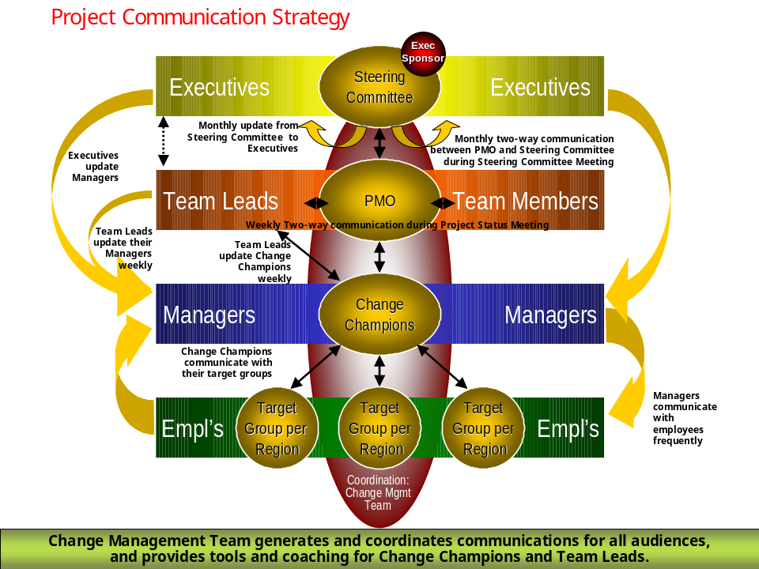
A Communication Strategy will be used to document a Communication Campaign that will list communication activities and key messages per target group with the schedule and responsible person.

Open and Closed Issues
Add open issues that you identify while writing or reviewing this document to the open issues section. As you resolve issues, move them to the closed issues section and keep the issue ID the same. Include an explanation of the resolution.
When this work product is complete, any open issues should be transferred to the project- or process-level Issue Log (PJM) and managed using a project level Issue Form (PJM). In addition, the open items should remain in the open issues section of this work product, but flagged in the resolution column as being transferred.

Open Issues

ID | Issue | Resolution | Responsibility | Target Date | Impact Date

Closed Issues

ID | Issue | Resolution | Responsibility | Target Date | Impact Date

