Method_Desktop_Patch_README.doc

WARNING: This Readme file and the associated Method_Desktop_Patch-v2.0.doc file should only be used for Word documents using the omguide.dot template. Do not use the associated Method_Desktop_OUMGuide_Patch.doc on files using omguide.dot or they will become associated with the oumguide.dot. If you apply the wrong patch file, you can simply run the correct patch and associate the correct template to your documents.

This readme file is intended to:
- Explain the purpose of the Method_Desktop_Patch-v2.0.doc
- Describe when Method_Desktop_Patch-v2.0.doc should be applied
- Describe how to apply the Method_Desktop_Patch-v2.0.doc

Purpose of Method_Desktop_Patch-v2.0.doc: Method_Desktop_Patch-v2.0.doc contains macro logic that will be applied to all the Word documents using the omguide.dot that are contained with a “user designated” directory and subdirectories. When applied, the macro logic within Method_Desktop_Patch-v2.0 will update macro logic that was used in Word templates of Oracle method offerings.

Once this patch has been successfully applied, templates from OUM and legacy method offerings can be shared between users that have Oracle Method offerings installed in different locations. This will allow users to collaborate on MS Word deliverables across different computers with a mixture of legacy and current method offerings installed.

In addition, the patch will allow users who do not have Oracle Method offerings installed to use the templates, without the Oracle Method Template Engine functions, and without error.

The Method_Desktop_Patch-v2.0.doc is the same as the previous Method_Desktop_Patch.doc, but is also compatible with Word 2007.

When should Method_Desktop_Patch-v2.0.doc be executed?

This patch is recommended for:
- Users who are experiencing Visual Basic (VB) errors when opening OUM work product templates or OUM deliverables prepared from a work product template should apply this patch.
- Users with prior releases of OUM (e.g., 4.3, 4.4, 4.5), or users with legacy Oracle method offerings (e.g., ABF, AIM, etc.) should run the Method_Desktop_Patch-v2.0.doc against the …\METHOD directory where it exists on their machine (e.g., C:\METHOD, or D:\METHOD).
- Users with existing documents that were prepared using Oracle Method templates in any other directories on their computer should apply this patch to those directories as well.
- Users that have project deliverables that they intend to shared with other users that have Oracle method offerings installed in a different location on their computer should apply this patch.
- Running this patch is a precaution to eliminate potential for VB errors from occurring when a user attempts to open a deliverable that was originally created on another computer.

Please Note: VB errors do not impact the use of the MS Word documents.

How to apply Method_Desktop_Patch-v2.0.doc using Word 2003: To successfully use the Method_Desktop_Patch-v2,0.doc, perform the following steps:
- Locate the directory(s) where deliverables created from Oracle method templates reside. ALL files in the directory will be updated. If you have non-Word files in this directory or other Word files that you do not wish associated to the omguide.dot, you should move these files before running the patch against the directory.
- In the OMTE folder, locate and double click on Method_Desktop_Patch-v2.0.doc, and the following will appear:

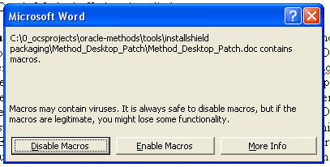

- Click “Enable Macros” button
- Select the location the directory where Word based deliverables reside, and click “OK”

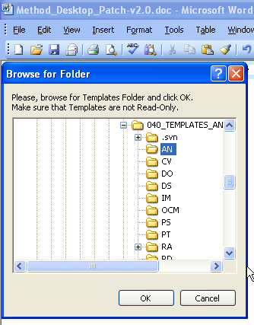

- The following will be displayed when the updates being performed by the patch macro logic have completed. Please be patient, as this may take a few minutes, depending on the number of documents in the selected directory.

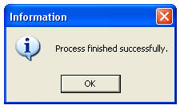

- Select OK. You should be able to open and share your documents without conflicts due to the install locations. You can collaborate on any MS Word documents prepared with other users that might have been causing a Visual Basic error when attempting to open the document(s).

How to apply Method_Desktop_Patch-v2.0.doc using Word 2007: To successfully use the Method_Desktop_Patch-v2,0.doc, perform the following steps:
- Locate the directory(s) where deliverables created from Oracle method templates reside. ALL files in the directory will be updated. If you have non-Word files in this directory or other Word files that you do not wish associated to the omguide.dot, you should move these files before running the patch against the directory.
- In the OMTE folder, locate and double click on Method_Desktop_Patch-v2.0.doc.
- Word 2007 opens with a blank document. A Security Warning, “Macros have been disabled.” appears under the Tool Bar.

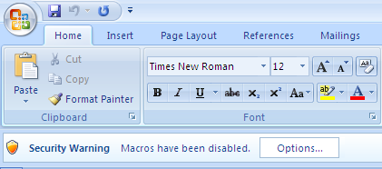

- Select Options.

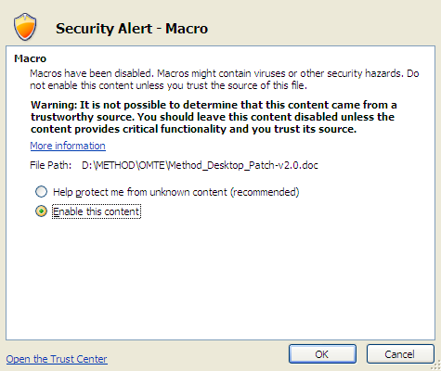

- Select “Enable this content” and “OK”
- The Browse for Folder pop-up appears. Select the location the directory where Word based deliverables reside, and click “OK”

- The following will be displayed when the updates being performed by the patch macro logic have completed. Please be patient, as this may take a few minutes, depending on the number of documents in the selected directory.

- Select OK. You should be able to open and share your documents without conflicts due to the install locations. You can collaborate on any MS Word documents prepared with other users that might have been causing a Visual Basic error when attempting to open the document(s).

