OUM
TA.150 Final Platform and Network Architecture
<Company Long Name>
<Subject>

When this template is completed, delete all the yellow notes as follows:
1. With your document open, open the Find and Replace window.
2. Expand the Find and Replace window using the More>> button.
3. Place the cursor in the Find what: field.
4. Choose Format > Style.
5. When the Find Style box opens, scroll through the list and select Note and click OK.
6. Leave the Replace with: field blank.
7. Select Replace, Replace All or Find Next to remove the yellow notes.
8. Repeat using the Note Wide style if there are any landscape sections that contain wide yellow notes.
Please refer to the OUM Template User’s Guide for detailed instructions for working with OUM templates.

Author: <Author>
Creation Date: May 14, 2014
Last Updated: September 16, 2016
Document Ref: <Document Reference Number>
Version: DRAFT 1A

Title, Subject, Last Updated Date, Reference Number, and Version are marked by a Word Bookmark so that they can be easily reproduced in the header and footer of documents. When you change any of these values, be careful not to accidentally delete the bookmark. You can make bookmarks visible by selecting the Office Button>Word Options>Advanced> and checking the Show bookmarks option in the Show document content region.

Approvals:
<Approver 1>
<Approver 2>
To add additional approval lines, press [Tab] from the last cell in the table above.
You can delete any elements of this cover page that you do not need for your document.

Document Control

Change Record
5
Date | Author | Version | Change Reference
14-May-14 | <Author> | Draft 1a | No Previous Document

Reviewers

Name | Position

Contents
1 Document Control iii
1.1 Change Record iii
1.2 Reviewers iii
2 Introduction 1
2.1 Purpose 1
2.2 Scope 1
2.3 Architecture Requirements 1
3 Platform and Network Standards 2
3.1 Platform Standards 2
3.2 Network Standards 2
4 Enterprise Platform and Network Architecture 4
4.1 Technical Configuration 4
4.2 Platform Deployment 12
4.3 Network Connections 16
5 Platform and Network Architecture for <Data Center Location> 17
5.1 Technical Configuration 17
5.2 Database/Application Tier 17
5.3 Data Center Network Configuration 19
6 Application Map for <Data Center Location> 20
7 Client Desktop Tier for <Deployment Site Name> 21
8 Assumptions Made AT <PROJECT NAME> 22
8.1 Architecture Assumptions 22
8.2 Business Assumptions 22
8.3 Technical Assumptions 22
9 Technical Architecture Framework For <PROJECT NAME> 23
9.1 Interfaces 23
9.2 Security 23
9.3 Physical Locations of Systems 23
9.4 Network Considerations 23
9.5 Migration Strategies and Processes 24
9.6 Exception and Error Handling 25
9.7 System Availability and Backup/Recovery 25
9.8 Performance Monitoring and Scalability 25
10 Open and Closed Issues 26
10.1 Open Issues 26
10.2 Closed Issues 26

To update the table of contents, put the cursor anywhere in the table and press [F9]. To change the number of levels displayed, select the menu option Insert->Index and Tables, make sure the Table of Contents tab is active, and change the Number of Levels to a new value.

Introduction

Purpose
The purpose of the Platform and Network Architecture document is to describe the physical platform and network configuration to support the final Platform and Network architecture. It includes the map of the physical application and database server architecture onto specific computing platforms included in the scope of the <Project Name> Application and Technical Architecture process.
The document provides a detail overview of the overall Siebel Architecture and the various components that are part of the Oracle Siebel application. It also talks about the various Siebel Server components and Siebel Product modules that are planned to be included as part of the Siebel solution for <Customer Name>. The document also talks about the other application that are part of the solution for <Customer Name>, and it describes the various integration techniques used for interfacing with these applications. The document also highlights the technical and non-technical assumptions behind the architectural solution.
The document also addresses the various environments that the Oracle Siebel application will pass through the life-cycle of the project. It describes the role each environment plays during the various stages of the project life-cycle.
This document should be reviewed and approved by the appropriate sponsors and project team members.

Scope
The <Project Name> platform and network architecture work covers the following topics:

Architecture Requirements
The Platform and Network architecture was designed to meet the architecture requirements specified in the Architecture Requirements and Strategy (TA.020). Since the Architecture Requirements and Strategy was published, the following additional requirements have been identified:

Platform and Network Standards
Depending on how much work on this was done in the Architecture Requirements and Strategy (TA.020), this work product may only need to copy or reference work done previously in this section.

Platform Standards
This section describes the standards that the <Project Name> project platforms should meet.
These standards were arrived at by:
Describe the process used for creating Platform Standards.
The platforms standards cover the following components and hardware types:
Modify as appropriate to your project.
- hardware platform servers
- Internet/web servers
- data storage media
- networking devices
- networking protocols
The standards for platform servers are summarized in the following table:
Platform Server Class | Hardware Standard | Vendor | Operating System | Platform Resources | Comments
Database Server
Concurrent Management
Administration
Web
Forms
Printing

Network Standards
This section describes the standards that the <Project Name> project networks should conform to.
These standards were arrived at by:
Describe the process used for creating Network Standards.
The network standards cover the following network components:
- Wiring
- Protocols
- Routers
- Bridges
- Modems

Enterprise Platform and Network Architecture

Technical Configuration
Describe the salient features of the overall enterprise technical configuration here.
Diagrams are an effective way to present information in architecture work, so use them wherever possible to reduce the need for lengthy description.

Siebel Environment
The Oracle Siebel Application environment consists of three entities as listed in the table below:
Entity | Description
Siebel clients | Includes Siebel Web client, Dedicated Web Client, Wireless Client, Mobile Web Client, handheld client, and Siebel Tools Client.
Siebel Web Server Extensions (SWSE) | Installed on third-party Web server. Identifies requests for Siebel data and forwards them to the Siebel Servers. Receives data from Siebel Servers and helps format it into Web pages for Siebel clients.
Siebel Enterprise Server | Includes the logical grouping of Siebel Servers for a multiple server deployment (for a single Siebel Server and single Web server deployment, the Siebel Enterprise Server contains a single Siebel Server and the Siebel Gateway Name Server). The Siebel Enterprise Server, collectively with the Siebel Gateway Name Server, provides both batch mode and interactive services to and on behalf of Siebel clients.
Siebel Gateway Name Server | Includes the connection broker and name server for a single server deployment. (The name server is a separate entity for multiple server deployments.)
Siebel Database Server | Includes the RDBMS client software and Siebel tables, indexes, and seed data.
Siebel File System | Stores the data and physical files used by Siebel clients and Siebel Enterprise Server.
The Siebel Enterprise Server environment represents the middle tier within the three-tiered Oracle Siebel Applications environment. The following diagram is an example of a medium to large scale Siebel deployment.
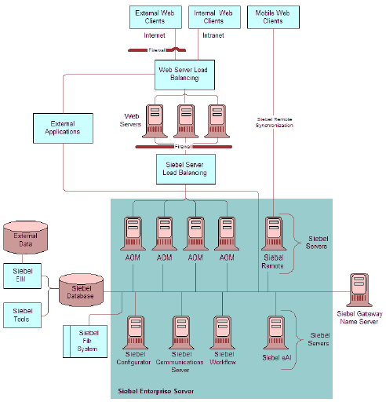
Siebel components in a typical deployment

The sections below describe the function of each of the Siebel components listed above.

Siebel Gateway Name Server
The Siebel Gateway Name Server is a logical entity, not a physical server consisting of a Name Server. The name server is the primary service of the Siebel Gateway Name Server, which coordinates the Siebel Enterprise Server and Siebel Servers. A single Siebel Gateway Name Server can now support multiple Siebel Enterprise Servers.
The Name Server provides the persistent backing of Siebel Enterprise Server configuration information, including:
- Definitions and assignments of component groups and components
- Operational parameters
- Connectivity information
As this information changes it is written to the siebns.dat file on the Name Server. At startup, the Siebel Server obtains its configuration information from the Name Server’s siebns.dat file. The Name Server also serves as the dynamic registry for Siebel Server and component availability information. At startup, a Siebel Server within the Siebel Enterprise Server notifies the Name Server of its availability and stores its connectivity information - such as network addresses, in the Name Server’s non-persistent (volatile) store. Periodically, the Name Server also flushes its current state to the siebns.dat file.
Enterprise components (including the Server Manager) query the Name Server for Siebel Server availability and connectivity information. When a Siebel Server shuts down, this information is cleared from the Name Server.
A single Name Server can potentially serve several databases in an environment (such as multiple development and test environments). For purposes of mitigating dependencies and improving recoverability, you should keep the Siebel production environment separate from other Siebel environments (development or test) by using a separate Name Server.

Siebel Enterprise Server
The Siebel Enterprise Server is a logical grouping of Siebel Servers that supports a group of users accessing a common Siebel Database Server. The Siebel Enterprise Server can be configured, managed, and monitored as a single logical group, allowing the Siebel administrator to start, stop, monitor, or set parameters for Siebel Servers within a Siebel Enterprise Server.
You can set some Siebel Server parameters at the Siebel Enterprise Server level, and these parameters will apply to every Siebel Server and component operating within that Siebel Enterprise Server; other parameters can be adjusted at the Siebel Server or component level to support fine-tuning. If a parameter is set at the server level, then the server-specific value overrides the Siebel Enterprise Server setting for the parameter on that server.
Each Siebel Server belonging to a Siebel Enterprise Server should connect to the same schema in the same database server.
The Siebel Enterprise Server itself has no processes and, therefore, cannot have a state. However, you can start and shut down operations at the Siebel Enterprise Server level, and these actions will apply to every Siebel Server within that Siebel Enterprise Server.

Siebel Server
The Siebel Server is the middle-tier platform that supports both back-end and interactive processes for every Siebel client. These processes are components within the Siebel Server architecture and support functions such as:
- Mobile Web client synchronization
- Operation of business logic for Siebel Web clients, as well as connectivity and access to the Siebel
- Database Server and Siebel File System
- Integration with legacy or third-party data
- Automatic assignment of new accounts, opportunities, service requests, and other records
- Workflow management
The Siebel Server supports both multiprocess and multithreaded components, and can operate components in background, batch, and interactive modes. Many of the Siebel Server components can operate on multiple Siebel Servers simultaneously to support an increased number of users or larger batch workloads.
The Siebel Server runs as a system service that monitors and controls the state of every Siebel Server component operating on that Siebel Server. Each Siebel Server is an instantiation of the Siebel Server System Service within the current Siebel Enterprise Server.
The Siebel Server System Service performs the following sequential steps during startup:
- Retrieves configuration information from the Siebel Gateway Name Server
- Creates a shared memory file located in the Administration subdirectory of the Siebel Server root directory on Windows and the Sys subdirectory on UNIX. The Siebel Server System Service deletes this file when it shuts down.
- Siebel Connection Broker (alias SCBroker) server component opens a TCP port to accept inbound application object manager (AOM) requests. If there are multiple instances of SCBroker on this Siebel Server, all instances listen on the same port.
- Opens TCP ports dynamically for non-AOM components as necessary, such as Workflow Process Manager.
- Forks single-threaded and multithreaded processes for background mode components enabled on the Siebel Server. The previously created ports are inherited to these processes.
- As server component processes start, each process updates the shared memory table with component availability and status information. SCBroker and SRBroker use this information for load balancing and routing purposes.
- Archives log files by moving the current log folder to the log archive folder.

Siebel Server Manager
The Siebel Server Manager is the native management and administration interface for the Siebel Server and Siebel Enterprise Server. The Siebel Server Manager allows you to configure the parameters governing the operation of each component, and determine which Siebel Servers a given component can operate. Use the Siebel Server Manager to:
- Start, stop, pause, and resume Siebel Servers, components, and tasks.
- Monitor the status and collect statistics across the Siebel Enterprise Server, Siebel Servers, components, and tasks.
- Manage the configuration of the Siebel Enterprise Server, Siebel Servers, components, and tasks.
You can operate the Server Manager using one of two interfaces:
- Graphical user interface, or GUI, by using the Server Administration views in the Siebel application client.
- Use the Server Manager GUI for most administrative duties because it includes greater user interface functionality (including the ability to search for and sort various fields within views) and a more intuitive view into the operation of Siebel Servers than does the command-line interface.
- Command-line interface, or the srvrmgr program.
- Use the command-line interface for batch-mode processing, because it can run from batch scripts by invoking script files with administration commands that need to run on a regular basis.
The Server Manager connects to the Siebel Gateway Name Server, which contains availability and connectivity information for the Siebel Servers within the Siebel Enterprise Server. The Server Manager then connects with each of the Siebel Servers and starts a Server Manager component task. If you access the GUI, Server Manager creates a task on every running Siebel Server; if you access the command-line interface without specifying a specific Siebel Server, Server Manager creates a task on every running Siebel Server; and if you start the command-line interface while specifying a specific Siebel Server (using the /s flag), Server Manager creates a task on that specific Siebel Server alone, and all commands are targeted to that Siebel Server at the server level.

Siebel Server Components
The various programs that operate on the Siebel Server are implemented as components. A component represents only a specific type of program; a component is executed or operated as a task, or instantiation of a component, on a specific Siebel Server.

Server Component Modes
Components can execute tasks in one of three run modes.background, batch, or interactive.
- Background mode components
Background mode components execute tasks to perform background operations for the Siebel Server. After a background mode component task starts, it runs until you explicitly stop the task, or until the Siebel Server itself is shut down. You can manually start a background mode component by using the Siebel Server Manager. Components with a Default Tasks parameter set to a value greater than zero may start automatically when the Siebel Server is started. Examples of background mode components include Transaction Router, Replication Agent, and Workflow Monitor Agent.
- Batch mode components
You must manually start these components by using the component job process in the Server Manager GUI or by the Server Manager command-line interface. Batch mode components end after the task has been performed. Examples of batch mode components include Database Extract and Enterprise Integration Manager.
- Interactive mode components
Interactive mode components start tasks automatically in response to client requests. Interactive mode component tasks execute for as long as the client maintains the session, and end when the client disconnects. Examples of interactive mode components include Synchronization Manager and Application Object Managers.

Server Component Types
Siebel Server supports multiple component types; each type performs a specific function or job. A component type is configured with a set of parameters that determine its behavior to create an entity called a defined component (or simply component). Components are defined at the Siebel Enterprise Server level in component groups. Component groups are then assigned to one or more Siebel Servers within the Siebel Enterprise Server on which they can execute tasks.
When the Siebel Enterprise Server is installed, predefined components are automatically configured for each component type. These predefined components are then automatically assigned to each Siebel Server within the Siebel Enterprise Server. You can run your entire Siebel applications deployment using these predefined components, or you can modify their definitions and create new defined components to fine-tune your Siebel configuration.
The defined components feature allows you to create multiple defined components for a given component type, simplifying the process of starting various types of tasks using different parameters, and managing components across multiple Siebel Servers. For example, you may create one defined component for an Object Manager running in the Siebel Sales Enterprise application in English, and another for an Object Manager running the Siebel Service Enterprise application in French. Although these defined components use the same component type, they service distinct sets of users with different functionality requirements, and are distinct entities that can be individually managed, configured, and administered.

Server Component Groups
Component groups are functional areas that involve logical groupings of Siebel Server components and multiple operating system processes. A component group consists of one or more components, which may be running in one or more operating system processes. Component groups act as:
- The unit of deployment on, or assignment to, a Siebel Server. In general, you include in a Siebel Server the group of components that are deployed on one or more servers.
- A unit for monitoring functionality of the interrelated components within the group (you can get a summary of the operational status at the component group status, which is determined by the individual states of the constituent components).
- A unit of control, whereby you can make available or unavailable the interrelated components in a single step, such as Siebel Remote or Workflow Management.
Oracle Siebel Applications provide a number of predefined component groups and you can also create your own component groups.

Siebel Web Server Extensions
The Siebel Web Server Extension (SWSE) is a plug-in for third-party Web servers. It identifies requests for Siebel information coming from Web clients and flags these requests for routing to a Siebel Server. When information is sent from the Siebel Server back to the Web client, the SWSE helps complete the composition of the Web page for forwarding to the client.
Included in the SWSE is the Siebel load balancing module. This module provides round-robin load balancing for Application Object Managers running on Siebel Servers.
All language packs installed on Siebel Servers must also be installed on your Web servers. However, you do not need to install all language packs on all Web servers. If you do not install all languages on all Web servers, you must provide a means for routing user requests to Web servers that have the correct language support.

Siebel Client
If there are enterprise-wide standard architecture strategies and configurations for the desktop clients and application client file servers, mention them here, or else reserve the discussion for the data centers.
Clients will be primarily PCs running Microsoft Windows located at the work sites.
The Siebel Client runs the Siebel Enterprise Applications client software. Oracle Siebel application supports the following types of clients.
- Siebel Web Client
- Siebel Mobile Web Client
- Siebel Dedicated Web Client
- Siebel Tools Client
- Siebel Handheld Client
- Siebel Wireless Client
For the current project in progress we intend to use the Siebel Web Client, Siebel Mobile Web Client, and the Siebel Tool Client, a brief description of which is provided below.

Siebel Web Client
Siebel Web Client runs in a standard browser from the client personal computer and does not require any additional persistent software installed on the client. The browser connects through a Web server to the Siebel Server, which executes business logic and accesses data from the Siebel Database. Siebel Web Client provides a number of benefits to the deployment of the Siebel applications:
- Central management and universal support means reduced IT and deployment costs while implementing Siebel Systems software on a heterogeneous assortment of desktop computers. No complex installation, changes, or upgrades are required on client machines.
- No Siebel software installation required on the client PC.
- Reduced hard disk, CPU, and memory requirements on client machines.
- Intuitive, Web-based user interface while providing high interactivity and direct keyboard control.

Siebel Mobile Web Client
Siebel Mobile Web Client is a portable Microsoft Windows client delivered through a Web browser that is designed for local data access and does not need to be connected to a server. Siebel Mobile Web Client meets the needs of field professionals who do not have continuous access to a network. Siebel Mobile Web Client uses a local database on each mobile machine. Periodically, the client must access the Siebel Remote Server through a dial-up, WAN, or LAN connection to synchronize data changes with the Siebel Database on the database server and Siebel File System. This client requires installation of Siebel software on the user’s personal computer.

Siebel Tools Client
Siebel Tools Client is a dedicated Microsoft Windows client for users of Siebel Tools. This provides an object-oriented, Windows-based environment for developing or modifying Siebel applications, business services, and other Siebel objects.

Siebel Database Server
The Siebel File System consists of a shared directory that is network-accessible to the Siebel Server that contains the physical files used by Siebel clients. To gain access to files, Web clients connect directly to the appropriate Siebel Server to request file uploads or downloads. The Siebel Server then accesses the Siebel File System using the File System Manager (FSM) component.

Siebel File System and File System Manager
The Siebel File System consists of a shared directory that is accessible to all Siebel Servers in the Siebel Enterprise. It contains the physical files used by the Siebel clients and Siebel Servers. To gain access to files, Web clients connect to the appropriate Siebel Server to request file uploads or downloads. The Siebel Server then accesses the Siebel File System using the File System Manager (alias FSMSrvr) component. File System Manager processes these requests through interaction with the Siebel File System directory.

Siebel Object Architecture
The metadata that defines Siebel applications, objects, and other files such as Web templates and style sheets, can be divided into the following architectural layers:
Physical User Interface layer
The physical user interface layer consists of physical files, such as templates, Siebel tags, style sheets, and other file-based metadata, that control the layout and the look and feel of the user interface. The physical user interface layer separates style and layout definitions from user interface objects in the repository. This allows you to propagate style and layout definitions across multiple user interface objects.
Logical User Interface Objects layer
The Logical User Interface Objects layer consists of object definitions that determine the visual interface that the user interacts with in a Web browser. User interface objects expose data from the business object layer and provide users with controls that allow them to navigate, view, and modify data.
Business Objects layer
The Business Objects layer consists of objects that define business logic and organize data from underlying tables into logical units.
Data Objects layer
Object definitions in the Data Objects layer provide a logical representation of the underlying physical database (constructs like table, column, and index), and are independent of the installed DBMS. This creates a layer of abstraction over the DBMS, insulating the application and the developer from database administration and restructuring.
Relational database management in Siebel applications is implemented through the layers of Siebel object definitions. The Siebel applications generate queries in response to user actions, in combination with the context established by relevant object definitions. The relational DBMS holds the data, and processes the queries originating in the Siebel application. Query results that are returned from the DBMS are processed up through the relevant object definitions in the Siebel applications architecture, and presented to the user.
The four-layer architecture is shown below.
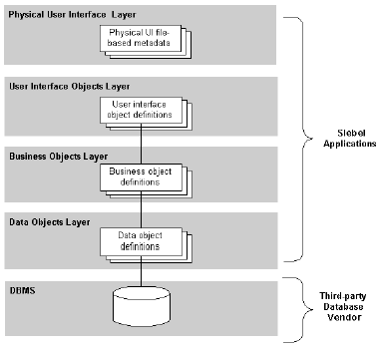
Four layers of Siebel Object architecture

Integration Architecture

Siebel EAI

Business Integration Manager

External Business Components (EBC)

Virtual Business Components (VBC)

Enterprise Integration Manager (EIM)

Siebel Recommended Environments FOR <PHASE 1> in <PROJECT NAME>
This section provides an overview of the recommended logical Siebel environments for <Phase Name> of the project <Project Name>. Each environment contains hardware, software, and data. Using this structure prevents the activities in one environment from interfering with activities in another environment. For example, configuration work in the development environment does not interfere with QA testing activities in the QA environment.

Development Environment
The environment is used for developing customized applications and configurations. It typically consists of a server machine, several client machines, development tools, and a small set of data (repository data, seed data, and sample transactional data). The server machine in the development environment is often called the development server.

System Integration Test (SIT) Environment
The system integration test (SIT) environment is a separate machine (or several machines) with business data but no development tools. This environment is used by the development team and the business analysts to test the application with data that simulates the live production environment. A system integration test environment is used to test customizations, patches, and version upgrades, before applying them to the production environment.

QA Environment
The QA environment is a separate environment which serves a similar function as the SIT environment. This environment is used by the dedicated QA team to test the application with data created/populated by them. The QA team has full control of this environment which is use for functional as well as integration testing. The development, training, and, production support teams do not have access to this environment.

Performance Test Environment
This environment is primarily used to emulate actual production environment. This environment is normally used to test the response time of the various pieces of the Siebel application in a pseudo-live environment. This environment configuration should be as close as possible to the actual production environment. The test results from this environment configuration can then be scaled to the appropriate factor to arrive at performance numbers for the Production configuration.
At <Project Name>, since there won’t be any users or data in the production environment prior to going live, the real production environment will be used for conduction performance and scalability tests.

Training Environment
The training environment is used for conducting training for the end-user community. This environment is generally refreshed with training data before commencement of every new training session. The training team has full control of this environment. The development, QA, and, production support teams do not have access to this environment.

User Acceptance Test (UAT) Environment
The UAT environment is used for conducting user review sessions with the appropriate business users. This environment is controlled by the business analyst within the development team.

Production Environment
The production environment is the live Siebel operational environment. A production environment might be very similar to the test environment at the end of testing, but ultimately it consists of hundreds or even thousands of users and live business data.
The sections below will provide details about the physical infrastructure required to support the above logical Siebel environments.

Platform Deployment

Servers
The main database servers will be located at: <Location>.
The configuration of each server is detailed below.
Server | Model | Number of CPUs | Disk Space | Disk Controller | Total RAM | Backup Media

Production System Configuration

Web Server(s)

Siebel Gateway Server

Siebel Server(s)

Actuate Report Server

ChartServer

End-user machine

QA/Training System Configuration

Web Server(s)

Siebel Gateway Server

Siebel Server(s)

Actuate Report Server

ChartServer

Performance Testing Tools

End-User Machine

Integration Test System Configuration

Web Server(s)

Siebel Gateway Server

Siebel Server(s)

Actuate Report Server

ChartServer

End-User Machine

Development System Configuration
As mentioned earlier this environment is used for developing customized applications and configurations. The figure below shows the infrastructure used to support the development environment at <Project Name>. It assumes a development team size of around <Team Size>.

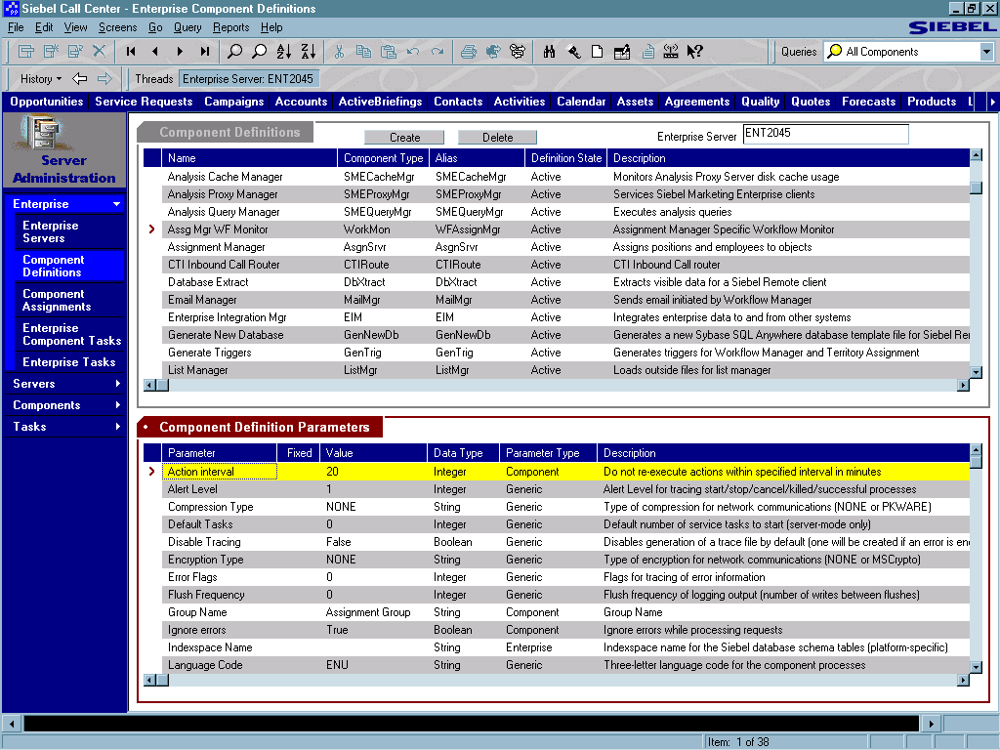
Development Environment
Siebel
Web Server
Extension
Web Server
Siebel Server
Object Manager
•
Business Objects
•
Business
Components
RDBMS
Data Manager
RDBMS
Data Manager
- Synchronization Manager
- Assignment Manager
- Workflow Manager
- Replication Manager
Siebel Enterprise
User Interface
RDBMS
Object Manager
Data Manager
Siebel Tools
Siebel Dedicated Client
Siebel Database
Siebel
File
System
LAN / WAN
Internet / Dialup
Gateway Server
Siebel Server
Manager
Oracle 9i
Database
Siebel Anywhere
2CPUs @ 700 MHz with 4 GB memory.
HP-UX 11i
40 GB Hard Disk.
Web Browser
HTML Thin Client
Windows XP Service Pack 1
Intel Pentium 4 CPU 1.8GHz
512MB RAM
2 GB Hard Disk
Sun Solaris 9 Update 3
1 GB memory
2 GB Hard Disk
Two Pentium 4 processors @ 1.8 GHz
2 GB memory. 40 GB Hard Disk.
(Siebel Gateway, Siebel Server, Actuate Report Server
Windows XP Service Pack 1
Intel Pentium 4 CPU 1.8GHz
1GB RAM
20 GB Hard Disk

Web Server(s)
The following are the details for the machine hosting the Web Server and Siebel Web Server Extensions (SWSE).
Web Server: | Sun ONE Web Server Enterprise Edition 6 with Service Pack 6 or above
Operating System: | Sun Solaris 9 Update 3.  Recommended Patch Cluster (kernel at level 112233-08 or above). Must include C++ Run time patch level 111711-06 and Linker Patch level 112963-09 or above running on UltraSPARC processors or SPARC64 processors compatible with the V9 plus instruction set
Number of processors: | 1 CPUs – 700 MHz
RAM: | 1 GB
Disk Space: | GB Free space.

Siebel Gateway Server
The following are the details for the machine hosting the Siebel Gateway Server, Siebel Application Server and Siebel File System.
Operating System: | Microsoft Windows 2000 Server/Advanced/Datacenter Server Service Pack 3  OR  Microsoft
Number of processors: | 4 CPUs – 1.8 GHz
RAM: | 2 GB
Disk Space: | 30 GB Free space

Siebel Server
The Siebel Server and Siebel File System will be hosted on the same machine as the Gateway Server the specifications of which are listed above.

Actuate Report Server
The Actuate Report Server will also be hosted on the same machine as the Gateway Server the specifications of which are listed above.

Siebel Database Server
The following are the details for the machine running the Oracle instance to support the Siebel database:
Database Server: | Oracle 9i Enterprise Server (Version 9.2.0.4)
Code Page: | AL32UTF8 OR WE8MSW OR IN1252 OR JA16SJIS
Sort Order: | Binary
Operating System: | HP-UX 11.11 (11i) + All patches required by Oracle
Number of processors: | 1 CPUs – 700 MHz
RAM: | 4 GB
Disk Space: | 40 GB Free space.

Developer Workstation
The specifications for the developer’s workstation are listed below:
Database Connectivity Software: | Oracle Net Service 9.2.0.4
Operating System: | Microsoft Windows XP Professional with Service Pack 1
Browser: | Internet Explorer 6.0
Number of processors: | 1 CPUs – 1.8 GHz
RAM: | 1 GB
Disk Space: | 20 GB Free space.

Network Connections
The Enterprise Network Architecture of <Company Short Name>‘s network is of the <Network Type> type.
Describe Network Topology.
Characterize main network connections - protocol, bandwidth, latency, # of routers or bridges and so on.
Describe the salient features of the enterprise network architecture. Focus on the most important network connections that link data centers or major offices.
Site 1 | Site 2 | Network Type | Protocol | Band width | Latency | Network Hops | Comments

Platform and Network Architecture for <Data Center Location>
Repeat this section for each Data Center/Hosting Facility in the architecture.

Technical Configuration
Describe the salient features of the data center technical configuration here.
Diagrams are an effective way to present information in architecture work so use them wherever possible to reduce the need for lengthy description.

Database/Application Tier

Server Mapping
This section describes the servers that support each application.
Application Type | Application Environment | Platform Type | Platform DNS Name | O/S Version | Facility
Database | PROD | Sun E-1250 | PROD1 | Solaris 7.5 | Corporate
Concurrent | PROD | Sun E-1250 | PROD1 | Solaris 7.5 | Corporate
Administration | PROD | Sun E-1250 | PROD1 | Solaris 7.5 | Corporate
Web | PROD | Compaq Proliant 2300 | PRODW1 | NT3000 | Corporate
Web | PROD | Compaq Proliant 2300 | PRODW2 | NT3000 | Corporate
Web | PROD | Compaq Proliant 2300 | PRODW3 | NT3000 | Corporate
Forms | PROD | Compaq Proliant 2300 | PRODW1 | NT3000 | Corporate
Forms | PROD | Compaq Proliant 2300 | PRODW2 | NT3000 | Corporate
Forms | PROD | Compaq Proliant 2300 | PRODW3 | NT3000 | Corporate

Include only the new data servers or both existing and new servers depending on the use of this work product. Data servers could be for OLTP systems, reporting systems, standby servers, and data warehouses.

Platform Server Configuration
The configuration of each platform is detailed below.
Server | Model | No. of CPUs | Disk Space | Disk Controller | Total RAM | Backup Media
PROD1 | Sun E-1250 | 8 | 32GB | 4-Ch/SCSI | 4GB | 12GB DLT
PRODW1 | Compaq Proliant | 4 | 12GB | 2-Ch/SCSI | 2GB | 12GB DLT
PRODW2 | Compaq Proliant | 4 | 12GB | 2-Ch/SCSI | 2GB | 12GB DLT
PRODW3 | Compaq Proliant | 4 | 12GB | 2-Ch/SCSI | 2GB | 12GB DLT

Data Center Network Configuration

Network Specifications
Description of basic network architecture and topology.
Site 1 | Site 2 | Network Type | Protocol | Band width | Latency | Network Hops | Comments

Application Map for <Data Center Location>
Repeat this section for each Data Center/Hosting Facility. Provide a diagram showing how the application components will be mapped to the physical server architecture. If special circumstance exist that require further explanation, include a section to discuss those.

Client Desktop Tier for <Deployment Site Name>
Repeat this section for each deployment site for the Client Desktop Tier in the architecture

Client Desktop Environment
Describe the architecture of the client desktop environment, including desktop client. The text here is an example.
Clients will be primarily PCs running Microsoft Windows located at the work sites. The diagram above illustrates the locations of all components. These systems will be running <browser version> and will have a minimum configuration of <insert specifics here>. They will be connected to the corporate LAN/WAN at <insert specifics here>.

Printer Deployment
The printers that will be used for the production system report printing are of the types:

The specifications of the printers are:

The printer deployment strategy is:
Describe how the printers will be distributed and what the minimum size is for unit of the business to get its own printer, for example, a printer on every floor of a building.

Peripheral Devices
The types of peripheral devices that are part of <Company Short Name>‘s <Project Name> technical architecture are:
- Modems

The impact of the peripheral devices on the technical architecture is:

Assumptions Made AT <PROJECT NAME>

Architecture Assumptions

Business Assumptions

Technical Assumptions

Technical Architecture Framework For <PROJECT NAME>

Interfaces

Options and Recommendations for Data Exchange

Real-Time Interfaces

Batch Interfaces

Initial Data Load

On-Going Data Load

Security

Authentication

Authorization

Physical Locations of Systems

Development System

Integration Test System

Training System

Performance Test System

Production System

Network Considerations

Network Components

Minimum Network Requirements

Network Traffic Design Guidelines

Migration Strategies and Processes

Release Manager Responsibilities

Code-Migration Strategy

Stored Procedures

eScript Objects

Siebel Reference Data

List of Values

Responsibilities

Predefined Queries

Correspondence Templates

Workflow Policies and Processes

Assignment Rules

EIM related files (ifb, sql, etc)

Version Control Software

Checklist For Release

Exception and Error Handling

Client/Browser Errors

Web Server Errors

EAI Errors

Assumptions

System Availability and Backup/Recovery

Performance Monitoring and Scalability

Open and Closed Issues
Add open issues that you identify while writing or reviewing this document to the open issues section. As you resolve issues, move them to the closed issues section and keep the issue ID the same. Include an explanation of the resolution.
When this work product is complete, any open issues should be transferred to the project- or process-level Issue Log (PJM) and managed using a project level Issue Form (PJM). In addition, the open items should remain in the open issues section of this work product, but flagged in the resolution column as being transferred.

Open Issues

ID | Issue | Resolution | Responsibility | Target Date | Impact Date

Closed Issues

ID | Issue | Resolution | Responsibility | Target Date | Impact Date

