OUM
AN.100 Analysis Specification
Ski-NOW
Recycled Packaging Rebate Processing

Author: Global Methods
Creation Date: November 30, 2005
Last Updated: May 6, 2014
Document Ref: Ski-NOW AN.100.0001
Version: DRAFT 1A

Approvals:
<Approver 1>
<Approver 2>

Document Control

Change Record
3
Date | Author | Version | Change Reference
30-Nov-05 | A N Other | Draft 1a | No Previous Document

Reviewers

Name | Position

Contents
1 Document Control ii
1.1 Change Record ii
1.2 Reviewers ii
2 Overview 1
2.1 Business Objectives 1
2.2 Major Features 1
2.3 Definitions 1
2.4 Scenarios 2
2.5 Examples 2
2.6 Business Rules 2
2.7 Assumptions 2
3 User Interface Descriptions 3
3.1 Surface Feature Descriptions 8
3.2 User Interface Flow Descriptions 8
4 Data and Behavior Analysis 9
4.1 Data Analysis 9
4.2 Behavior Analysis 9
5 Interface Analysis 10
6 Open and Closed Issues 11
6.1 Open Issues 11
6.2 Closed Issues 11

Overview
The Rebate Processing Package allows you to:
- Record the details of Recycled Packaging that was used for each supplier delivery including
  - Type of material used
  - Percentage of recycled packaging that was used
- Apply rebates to a Supplier Invoice based on the percentage of Recycled Packaging that was used for each delivery, along with additional rebates for suppliers who have consistently used Recycled Packaging for the past six months.
The Rebate Processing Package contains:
- UC002 Acknowledge Product Receipt
- UC005 Apply Rebates
Human Actors
- A/P Specialist
System Actors
- Procurement System

Business Objectives
Rebate Processing provides you with the features you need to satisfy the following basic business objectives. You will be able to address the following:
- Automate the process of proving Ski-NOW suppliers with an financial incentive (in the form of a Rebate) for consistently delivering goods using recycled packaging materials

Major Features

UC002 Acknowledge Product Receipt
The use case begins when the receiving agent selects the option to record the receipt of the incoming shipment.
The system responds verifying that there is a PO for the goods being received. The system captures the shipping agent (i.e., UPS), and the quantity received using a standard COTS Purchase order and whether or not the recyclable packing materials were used.
The use case ends when the system has updated the PO with the receipt information and generates the financial entries related to the receipt.<Use Case Brief Description>

UC005 Apply Rebates
The use case begins when the A/P specialist selects the option to manage recyclable shipping material rebates.
The system responds by presenting the supplier invoice, and the receiving information showing the confirmation of recyclable packaging material, and applies the rebate.
The use case ends when the A/P specialist has processed all rebates.

Definitions
None identified

Scenarios
The following Use Cases Specifications contain scenarios that describe the sequence of steps and the collaborating actors participating to accomplish the functions within this package:
- Reference to Use Case Specification (RA.024) for UC002 Acknowledge Product Receipt
- Reference to Use Case Specification (RA.024) for UC005 Apply Rebates

Examples
None identified

Business Rules
Business Rules inventory for this use case package:
- BR.110 – Defines the standard rebate percentage to be used when suppliers deliver good using recycled packaging.
- BR.120 – Defines the qualification criteria, and additional discount percentage, that shall be applied for suppliers who qualify for an additional rebate

Assumptions
- Development work will be completed used Oracle ADF

User Interface Descriptions
The following defines the user interface elements of the Rebate Processing Package

Purchase Order
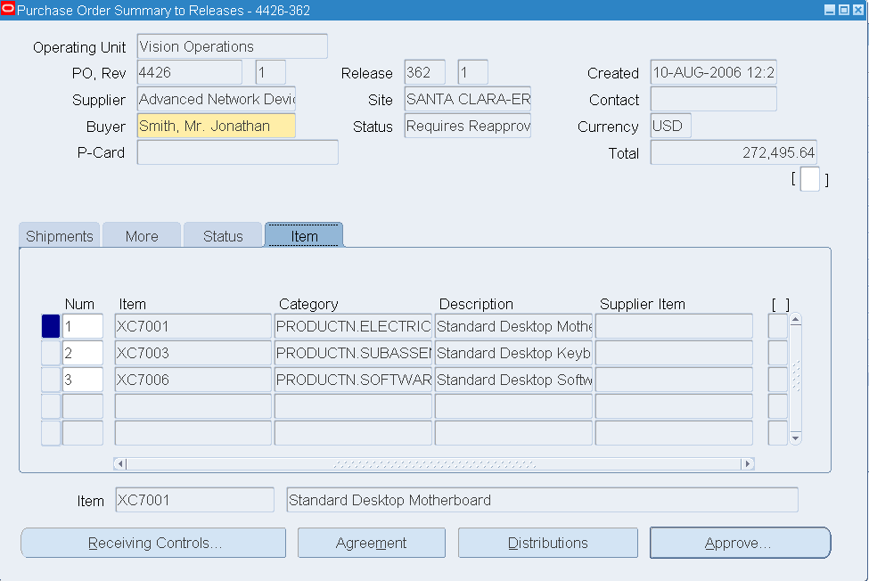

This is the standard Oracle Purchase Order Form. This is shown for reference only, no changes are required here.

Enter Receipt #1
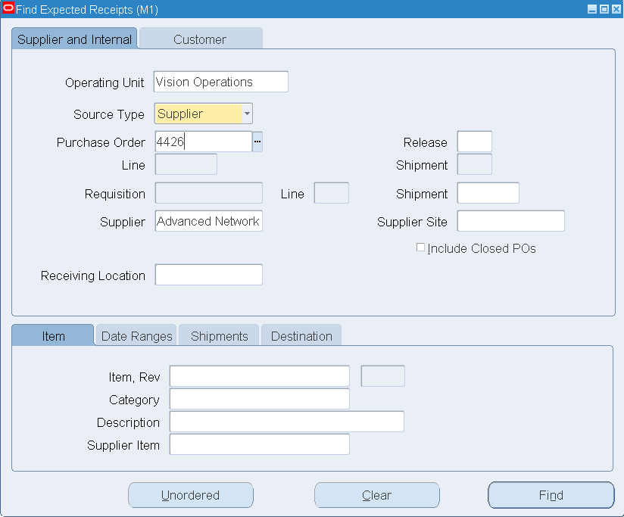

This is the standard Oracle inventory receiving (Header) Form. No changes are required here.

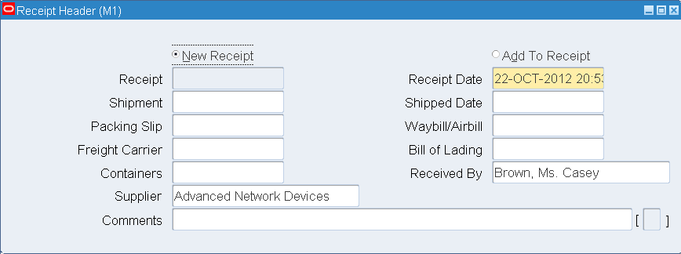

On the standard detailed Inventory Receipt Form, two new fields are required (shown above in Red)

Pkg Type – the user will choose from a List of Values that display the acceptable types of recylaed packing materials

% Used – the user will be allowed to enter one of two possible values, 50% or 100%

Enter AP Invoice #1
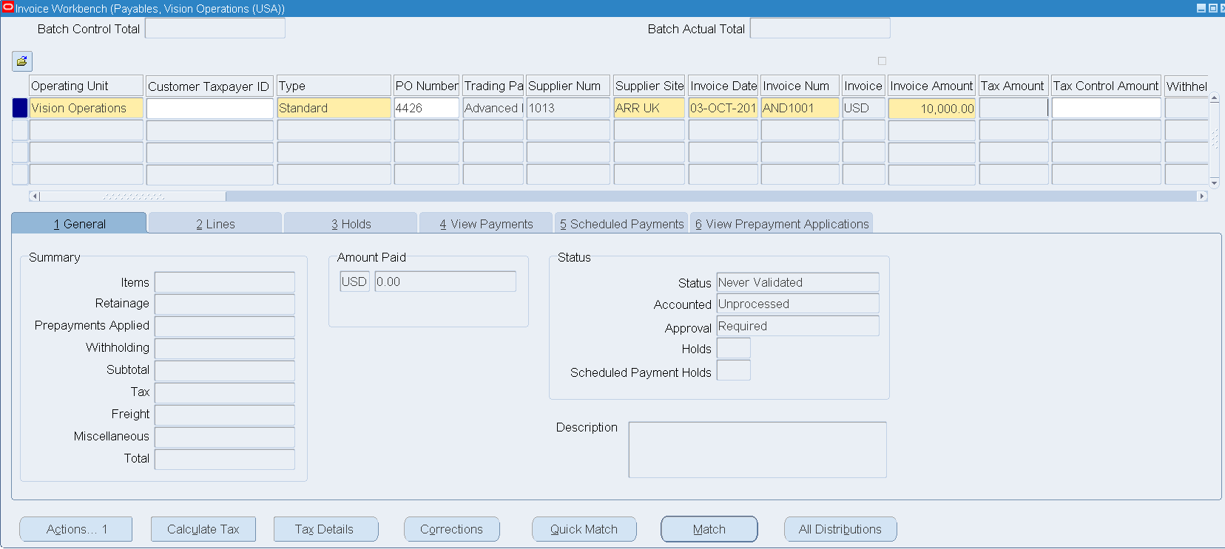

This the standard Oracle Supplier Invoice entry Form. No changes are required here.

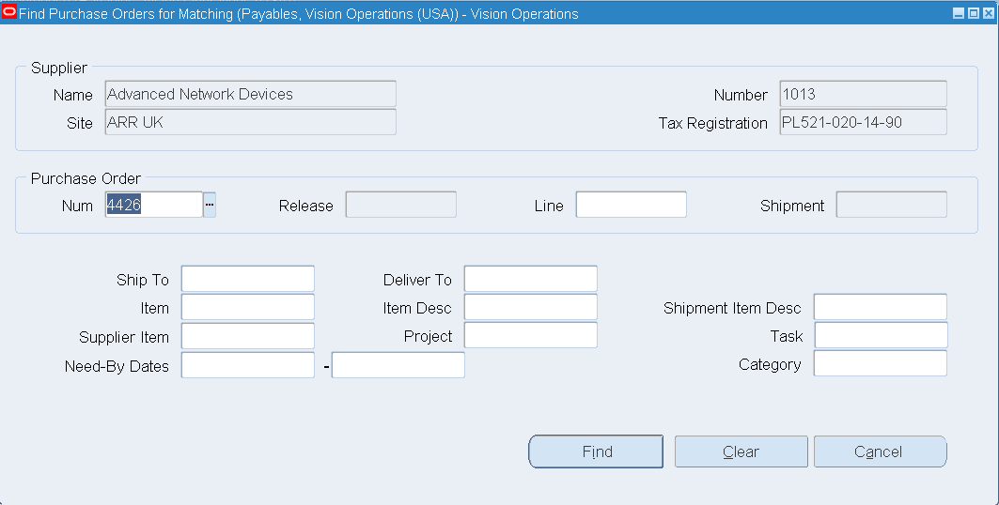

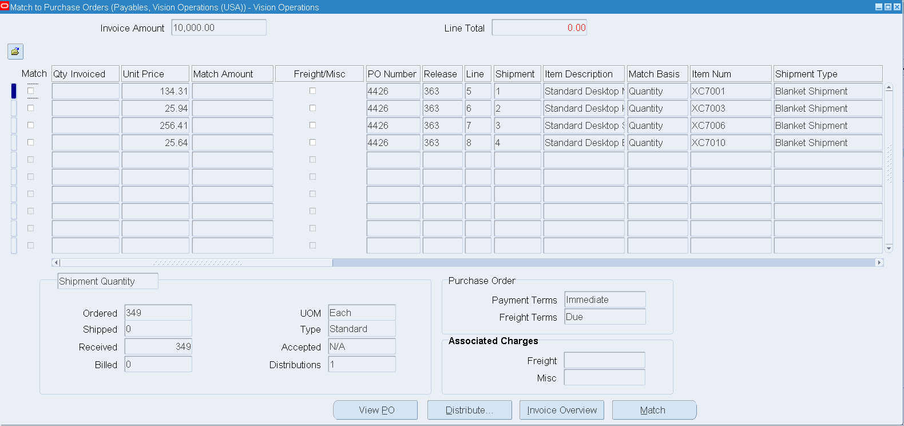



On the standard detailed Invoice Match Form, four new fields are required (shown above in Red)

% Recly Pkg Used – this field will be read-only and display the value as entered at the time the inventory was received

Rebate to Apply? – this field will allow the user to enter one of 4 possible values:

- Y = Yes, apply the standard recyaled packaging rebate amount
- N = Do not apply the standard recyaled packaging rebate amount
- 50% = Apply 50% of the normal recyaled packaging rebate amount
- X = Apply the standard rebate, plus the additonal rebate when the supplier has consistently used recyaled packaging for the prior 6 months (as derived from BR.120)

Recycled packaging Alerts – Automatically display a message in this box if the system detects that the Supplier has consistently used recycled packaging for the past 6 months (or whatever value is dervied from BR.120)

Verify Delivery History – when the user selects this option, and new form displays the previous 6 months of delivery history or the current supplier including details of recyaled packaging that was used.

Surface Feature Descriptions
None identified

User Interface Flow Descriptions
None identified

Data and Behavior Analysis

Data Analysis

Entity (Class) | Attribute (Data Field) | Minimum Value | Maximum Value | Default Value | Comments
Inventory Receipt Form | Pkg Type |  |  | Green | List of Values (to be determined)
Inventory Receipt Form | % Used |  |  | 50% | One of two values allowed  50%  100%
Invoice Match Form | % Recly Pkg Used |  |  |  | Display only field
Invoice Match Form | Rebate to Apply? |  |  | Y | Only default a value of “Y” if “% Used” is not Null  Other allowed values:  N  50%  X

Behavior Analysis
None identified

Interface Analysis

Open and Closed Issues

Open Issues

ID | Issue | Resolution | Responsibility | Target Date | Impact Date

Closed Issues

ID | Issue | Resolution | Responsibility | Target Date | Impact Date

