OUM
RA.023 Use Case Model
<Company Long Name>
<Subject>

When this template is completed, delete all the yellow notes as follows:
1. With your document open, open the Find and Replace window.
2. Expand the Find and Replace window using the More>> button.
3. Place the cursor in the Find what: field.
4. Choose Format > Style.
5. When the Find Style box opens, scroll through the list and select Note and click OK.
6. Leave the Replace with: field blank.
7. Select Replace, Replace All or Find Next to remove the yellow notes.
8. Repeat using the Note Wide style if there are any landscape sections that contain wide yellow notes.
Please refer to the OUM Template User’s Guide for detailed instructions for working with OUM templates.

Author: <Author>
Creation Date: May 7, 2014
Last Updated: June 26, 2014
Document Ref: <Document Reference Number>
Version: DRAFT 1A

Title, Subject, Last Updated Date, Reference Number, and Version are marked by a Word Bookmark so that they can be easily reproduced in the header and footer of documents. When you change any of these values, be careful not to accidentally delete the bookmark. You can make bookmarks visible by selecting the Office Button>Word Options>Advanced> and checking the Show bookmarks option in the Show document content region.

Approvals:
<Approver 1>
<Approver 2>
To add additional approval lines, press [Tab] from the last cell in the table above.
You can delete any elements of this cover page that you do not need for your document.

Document Control

Change Record
4
Date | Author | Version | Change Reference
7-Apr-09 | <Author> | Draft 1a | No Previous Document

Reviewers

Name | Position

Contents
1 Document Control iii
1.1 Change Record iii
1.2 Reviewers iii
2 Introduction 1
2.1 Scope and Purpose 1
2.2 How to Review 1
3 Actors 2
3.1 <Actor Name One> 2
3.2 <Actor name Two> 2
4 Use Cases Packages 3
4.1 Use Case Packages Diagram 3
4.2 <<use case package>> <Use Case Package One> 4
4.3 <<use case package>> <Use Case Package Two> 6

To update the table of contents, put the cursor anywhere in the table and press [F9]. To change the number of levels displayed, select the menu option Insert->Index and Tables, make sure the Table of Contents tab is active, and change the Number of Levels to a new value.

Introduction

Scope and Purpose
This document presents the Use Case Model of the <Application Name> System. A Use Case Model describes a system’s functional requirements in terms of use cases. It is a model of the system's intended functionality and its environment. The Use Case Model serves as a contract between the customer and the developers. Because it is a very powerful planning instrument, the Use Case Model is generally used in all phases of the development cycle.
The Use Case Model is also used to identify the actors that interact with the system. Because they represent system users, actors help delimit the system and give a clearer picture of what it is supposed to do. Use cases are developed on the basis of the actors' needs, ensuring that the system turns out to be what the users expected.

How to Review
Please use the following criteria when reviewing the Use Case Model:
- Is the Use Case Model understandable?
- By studying the Use Case Model, can you form a clear idea of the system's functions and how they are related?
- Have all functional requirements been identified?
- Does the Use Case Model contain any superfluous behavior?
- Is the division of the model into use case packages appropriate?
- Have all actors been identified?
- Is each actor involved with at least one use case?
- Is each actor really a role? Should any be merged or split?
- Do two actors play the same role in relation to a use case?
- Do the actors have intuitive and descriptive names? Can both users and customers understand the names?
- Is each use case involved with at least one actor?
- Do any use cases have very similar behaviors or flows of events?
- Do the use cases have unique, intuitive, and explanatory names so that they cannot be mixed up at a later stage?
- Do customers and users understand the names and descriptions of the use cases?

Actors
An actor defines a role that an user can play when interacting with the system. An user can either be an individual or another system.
List actors and provide a brief description.
The following questions may be useful when identifying actors:
- Who will supply, use, or remove information?
- Who will use this functionality?
- Who is interested in a certain requirement?
- Where in the organization is the system used?
- Who will support and maintain the system?
- What are the system’s external resources?
- What other systems will need to interact with this one?
There are several different aspects of a system's surroundings that you will represent as separate actors.
- Users who execute the system's main functions
- Users who execute the system's secondary functions
- External hardware the system uses
- Other systems interacting with the system

<Actor Name One>
<Brief Description>

<Actor name Two>
<Brief Description>

Use Cases Packages

Use Case Packages Diagram
Apply the following heuristics to organize UML Use Case diagrams into package diagrams:
1. Keep associated use cases together: included, extending, and inheriting use cases belong in the same package as the base/parent use case.
2. Group use cases based on the needs of the main actors.
Remove the example diagram provided with the template and replace it with a diagram for your project.

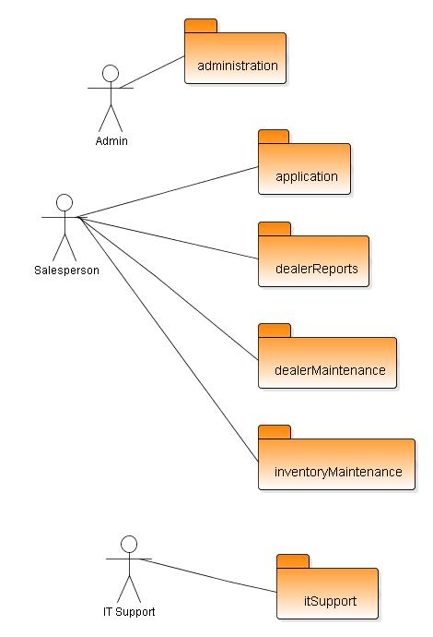

<<use case package>> <Use Case Package One>

Package Description
A brief description explaining the package's function and role in the system. The description must be understandable to any developer who wants to use the package.

Use Case Diagram
A use-case diagram provides a view of a use-case model. Many use-case diagrams can be used to view and provide different perspectives on a single use-case model. A use-case diagram may contain only actors, only use cases, or any combination of the two.
Remove the example diagram provided with the template and replace it with a diagram for your project.

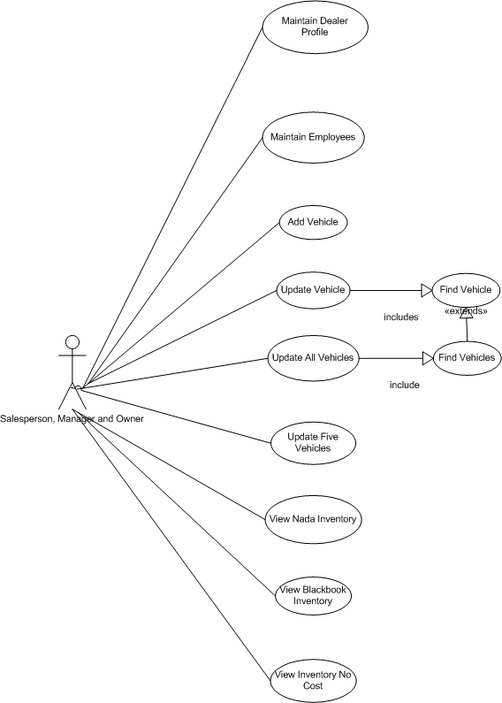

Actors
A list of actors owned by the package, including the name and brief description (role involved) of each actor in this package

Actor Name | Actor Description

Use Cases
A list of use cases owned by the package, including the name and brief description of each use case in this package

Use Case Name | Use Case Description
UCnnn <Verb-Noun> | <“This use case begins when” <actor> <does something>  “The system responds by…..”  “This use case ends when…”>

<<use case package>> <Use Case Package Two>

Package Description

Use Case Diagram

Actors

Actor Name | Actor Description

Use Cases

Use Case Name | Use Case Brief Description
UCnnn <Verb-Noun> | <“This use case begins when” <actor> <does something>  “The system responds by…..”  “This use case ends when…”>

