OUM
RD.065 Domain Model
<Company Long Name>
<Subject>

When this template is completed, delete all the yellow notes as follows:
1. With your document open, open the Find and Replace window.
2. Expand the Find and Replace window using the More>> button.
3. Place the cursor in the Find what: field.
4. Choose Format > Style.
5. When the Find Style box opens, scroll through the list and select Note and click OK.
6. Leave the Replace with: field blank.
7. Select Replace, Replace All or Find Next to remove the yellow notes.
8. Repeat using the Note Wide style if there are any landscape sections that contain wide yellow notes.
Please refer to the OUM Template User’s Guide for detailed instructions for working with OUM templates.

Author: <Author>
Creation Date: May 8, 2014
Last Updated: June 26, 2014
Document Ref: <Document Reference Number>
Version: DRAFT 1A

Title, Subject, Last Updated Date, Reference Number, and Version are marked by a Word Bookmark so that they can be easily reproduced in the header and footer of documents. When you change any of these values, be careful not to accidentally delete the bookmark. You can make bookmarks visible by selecting the Office Button>Word Options>Advanced> and checking the Show bookmarks option in the Show document content region.

Approvals:
<Approver 1>
<Approver 2>
To add additional approval lines, Press [Tab] from the last cell in the table above.
You can delete any elements of this cover page that you do not need for your document.

Document Control

Change Record
4
Date | Author | Version | Change Reference
8-May-14 | <Author> | Draft 1a | No Previous Document

Reviewers

Name | Position
 | Senior Practice Director

Contents
1 Document Control iii
1.1 Change Record iii
1.2 Reviewers iii
2 Introduction 1
2.1 Scope and Purpose 1
2.2 How to Review 1
3 Concept Model 2
4 Concept Definitions 3
4.1 Synonym List 4
4.2 Attribute List 5
4.3 Domain List 6

To update the table of contents, put the cursor anywhere in the table and press [F9]. To change the number of levels displayed, select the menu option Insert->Index and Tables, make sure the Table of Contents tab is active, and change the Number of Levels to a new value.

Introduction

Scope and Purpose
This document presents the Domain Model constructed for the <Application Name> system. The Domain Model is the first cut of the business object-class type model. The main objective of this work product is to capture concepts related to the problem domain and identify relationships among them. It does not contain information about the software. It is described via an UML class diagram and class textual description. Normally, the classes representing this model are marked with the <<concept>> stereotype.
Enter any project-specific introduction information.

How to Review
Please use the following criteria when reviewing the Domain Model:
- Does the model conform to the Requirements Standards and Guidelines?
- Have all of the identified concepts been described?
- Are the concepts descriptions clear, concise and consistent?

Concept Model
Remove the sample Domain Model and insert the model for your project. You may also choose to use the multiplicity table to accompany your domain model

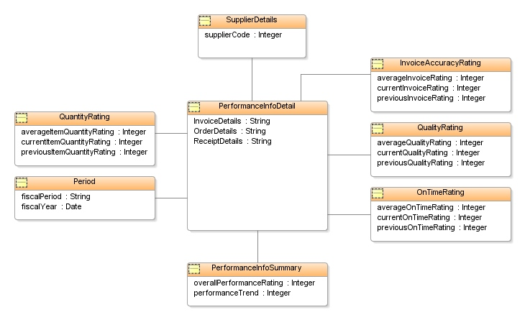

Multiplicity
Indicator | Meaning
0..1 | Zero or one
1 | One only
0..* | Zero or more
1..* | One or more
n | Only n (where n > 1)
0..n | Zero to n (where n > 1)
1..n | One to n (where n > 1)

Concept Definitions
Enter any additional information which might be helpful, such as a description of the reports.

Synonym List

Attribute List

Following this page insert the Attribute Definition, if any.

Domain List
Following this page insert the domains, if any.

